Check against delivery

Opening address by

Ms. Navi Pillay
United Nations High Commissioner for Human Rights

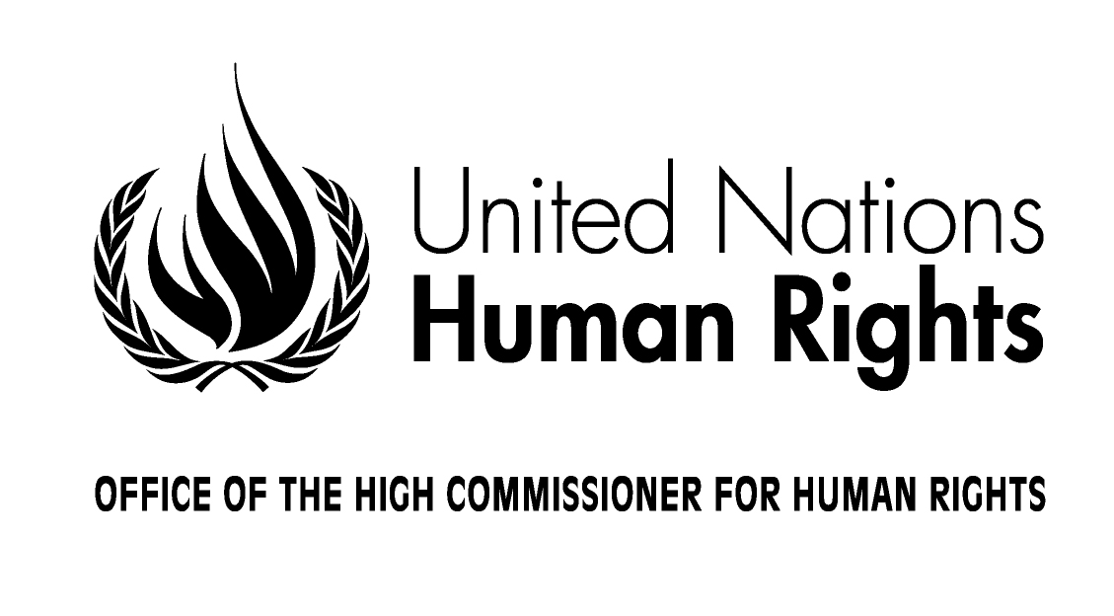

Treaty body strengthening
Informal technical consultation for States parties

12 May 2011
Sion, Switzerland
Excellencies,
Distinguished Experts,
Ladies and Gentlemen,

I am very honoured to co-host, along with all the current Chairpersons of the now ten human rights treaty bodies, this important consultation of States parties on the strengthening of the treaty body system.

At the outset, I wish to take this opportunity to warmly thank the International Institute for the Rights of the Child for hosting this important event and the Swiss federal and local authorities for providing their support.

It is now well over one year since I called upon all stakeholders to initiate a process of reflection on ways to strengthen the treaty body system. Eighteen months later, I now realize with great satisfaction that we have come a long way as several consultations have taken place among different actors, including treaty bodies’ experts, national human rights institutions and civil society. The outcomes of these consultations have resulted in many and varied proposals that you can find in the Dublin, Marrakesh, Poznan and Seoul statements as well as in other submissions notably from NGOs.

I find it very timely that the consultation process is now dedicating the attention of the States parties to the international human rights treaties, and your presence in strong numbers here in Sion is reflecting the interest that you all have in reinforcing the treaty body system. The role of States is fundamental, not only because States are the creators of the treaty body system and at the same time the major beneficiaries of its outcomes, but also because realizing human rights treaty obligations monitored by expert bodies is a pillar of human rights protection for which States bear the primary responsibility. Based on their legal commitments under these treaties, States parties report periodically and publicly to the treaty bodies, who in turn assess the degree of fulfillment in implementing the treaties. This ongoing dynamic reporting function cannot be reduced to a mere formality or described as simply a burden. Rather, when done properly, reporting allows for a participatory process at the national level, which places human rights at the center of governance. The treaty body reporting process, with a follow-up function built into its periodicity, represents a crucial element to ensure the effective protection of all rights holders everywhere in the world.
At the same time, the treaty bodies’ independence guarantees a non-selective approach to all human rights and its legal nature keeps it removed from risks of politicisation. The accuracy and quality of the recommendations made by treaty bodies are crucial attributes that need to be maintained and enhanced so that treaty body recommendations can be used effectively by all stakeholders to promote change at the national level.

But how can we all ensure that this central pillar for human rights protection meets the challenges in terms of coherence and sustainability inevitably posed by the sustained growth in numbers of treaty bodies and their individual approaches?

Since 2004, the human rights treaty body system has grown enormously. It has doubled in size with the addition of four new treaty bodies [CMW, CRPD, SPT, and the CED], two new optional protocols for individual complaints [CRPD and ICESCR], and one in the making [CRC]. Today, the core international human rights treaties total the impressive number of 1536 ratifications.

Who would have thought back in 1969 at the establishment of the first treaty body – the Committee on the Elimination of Racial Discrimination (CERD) – that international human rights law would become so comprehensive? Initially, it was believed by many that the two human rights Covenants adopted in 1966, respectively on civil and political rights, and on economic, social and cultural rights, would suffice to protect all human rights of all human beings. With time however, the protection of rights specific to many groups – such as women, children, persons with disabilities or migrants – was given more specific attention in the form of new treaties. Enhanced protection of specific groups of rights holders is certainly a positive development. However, increased human rights protection through a multi-treaty approach requires priority attention to coherence and resourcing.

Today, the reality of the treaty bodies is that with the first elections in the coming weeks of a 10th treaty body (on enforced disappearances), the system is close – if not already at - reached its limits both in terms of coherence and sustainable functioning within currently available resources.

With respect to coherence, the fragmentation of the treaty body system and the multiplication of procedures certainly continue to call for continuous, ongoing harmonization in order to achieve efficiency, accessibility and impact on the ground. While the Inter-Committee Meetings (ICM) have over the years produced a number of useful recommendations that go towards harmonization of working methods among the treaty bodies, optimal system-wide results respectful of normative specificities have not yet been reached. What is required is stricter adherence to, and implementation of those recommendations as well as of the recommendations generated in this process including the Sion meeting. Also, we need to recognize that the harmonization exercise, while important, does have natural limits in addressing the challenges posed by the growth of the treaty body system.

With respect to resourcing, it is clear is that the growth in volume and workloads has not been matched with adequate funding of the system especially in terms of treaty body activities that are necessary to fulfill their mandates, staffing and documentation. Treaty body experts’ main complaints to me relate to these three issues. While I pay tribute to the dedicated and hard-working OHCHR staff supporting the treaty bodies, their numbers do not match these ever-increasing workloads. I also continue to maintain that staff supporting the core activities of supporting treaty bodies should be funded from the regular budget. It is neither sustainable nor appropriate that nearly a third of my treaty body staff is funded from voluntary contributions. Beyond traditional support functions, some direct treaty body activities, such as training and capacity building at country level, expert consultations in the context of elaboration of General Comments or new Optional Protocols, are also funded from voluntary contributions. In addition, problems as to the timely translation of documents impede effective work by the treaty bodies and I am very pleased that we will be joined tomorrow by colleagues from the Department of Conference Management to reflect more on this issue.

We are all aware of the financial constraints that the world is currently facing. However, the international community cannot afford weakening the treaty body system simply for lack of resources - not only because respect for the treaties is a legal obligation but also to maintain the integrity of the treaty bodies as cornerstones of the human rights system constructed since the Universal Declaration of Human Rights. To illustrate the need for fundamental changes to how business is done, if all current States parties were to report on time as they are obliged under the treaties, treaty bodies would have to meet for over 200 weeks a year. How then are we going to ensure that all States ratify all core international human rights treaties, report on time, and are reviewed without delay by the respective treaty bodies when this would require the system to triple its work annually?
This two-day consultation here in Sion provides a valuable opportunity to exchange fresh ideas and proposals, based on your experiences and expectations at the national level on ways to ensure that the multiplication of new treaties and related bodies reaches its primary objective of increased and effective human rights protection. Indeed, we need a vision that captures lessons from the past, addresses present challenges and prepares for the future of the treaty body system which represents one of the major achievements in the history of the human rights movement.

After this Sion meeting, the consultation process will continue with more consultations foreseen for academics in Lucerne, Switzerland, for civil society in Pretoria, for United Nations entities and other mechanisms again in Lucerne, and a final wrap-up meeting in Dublin. Thereafter, I will prepare a compilation of proposals in early 2012.

But for now, I am all yours: I am here in listening mode and look forward and will take note of all proposals and suggestions you will make.

Thank you.

