“How-to Guide” for the use of the “On-line UPR Submissions Registration System”
(https://uprdoc.ohchr.org)
(6 August 2015)
This “How-to Guide” is issued in relation to the “On-line UPR Submissions Registration System” for submitting written contributions for the UPR documentation by “Other Stakeholders” (including civil society and national human rights institutions), regional organizations and United Nations entities.
The technical guidelines for stakeholders submissions issued by OHCHR remain unchanged, and are available at OHCHR website (http://www.ohchr.org/EN/HRBodies/UPR/Pages/NgosNhris.aspx). Additional information on stakeholders’ participation in the UPR can also be found on the OHCHR Website.
The Guide describes how to use the “On-line UPR Submissions Registrationn System” and addresses the following steps:
Step one – Registering in the system.  (a) Creating an organizational profile.  (b) Log in.  (c) Resetting your Password and changing your User name/profile details. | Pages 2 - 8
Step two – Deadlines to submit contributions. | Pages 9-10
Step three – Viewing your contributions history and submitting new contributions.  (a) Viewing your contribution history.  (b) Submitting Individual contributions.  (c) Submitting Joint contributions. | Pages 11-14
Annex - Frequently Asked Questions. | Pages 15-16

UPR Submissions Helpdesk: Should organizations encounter technical problems using the on-line system, please contact the UPR Submissions Helpdesk by email: uprsubmissions@ohchr.org. Organizations can also contact the UPR Submissions Helpdesk (preferably by e-mail) at any time to ask questions with regard to the UPR documentation.

Step one – Registering in the system

(a) Creating an organizational profile

If your organization has not sent any previous contributions using the “On-line UPR Submissions Registration System”, you need first to create an organizational profile to be able to submit a contribution. You can create a profile at any time (not only when submitting contributions) through the “On-Line UPR Submissions Registration System” available from https://uprdoc.ohchr.org

Click on the “Register” icon, found in the login section in order to create an account. See red arrows below.

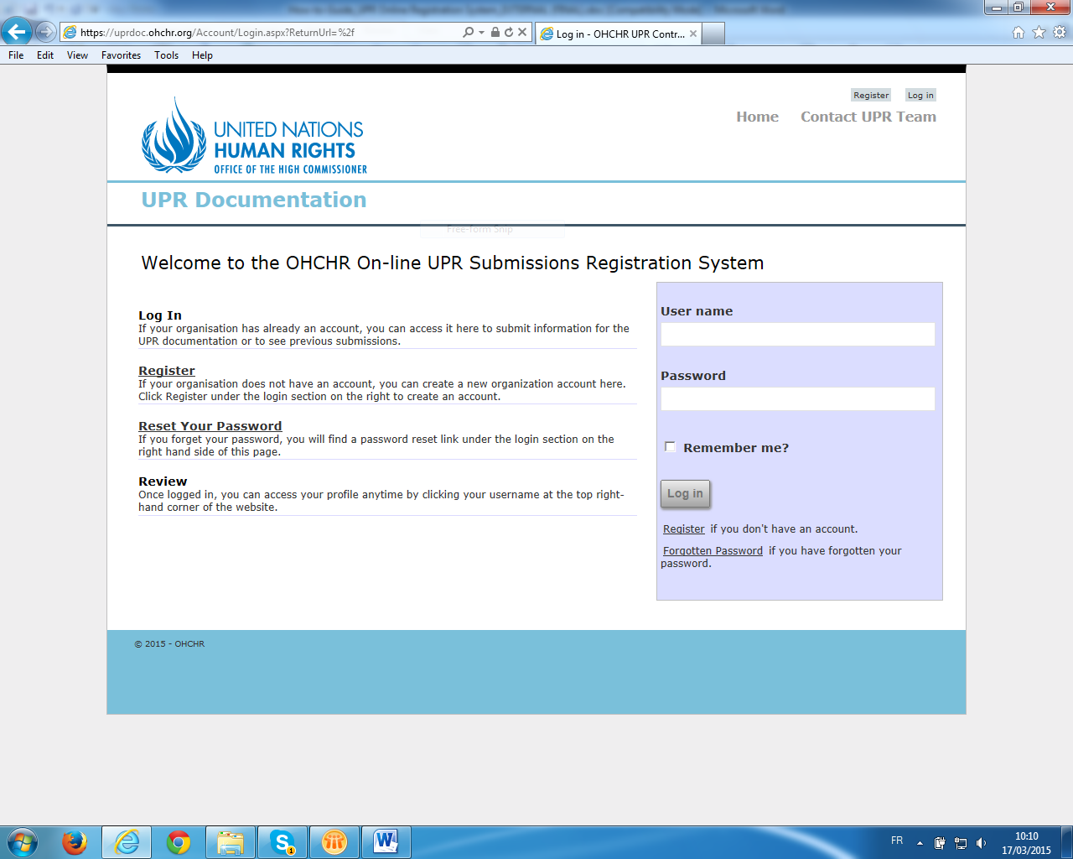

To register, follow the instructions to fill in the form.

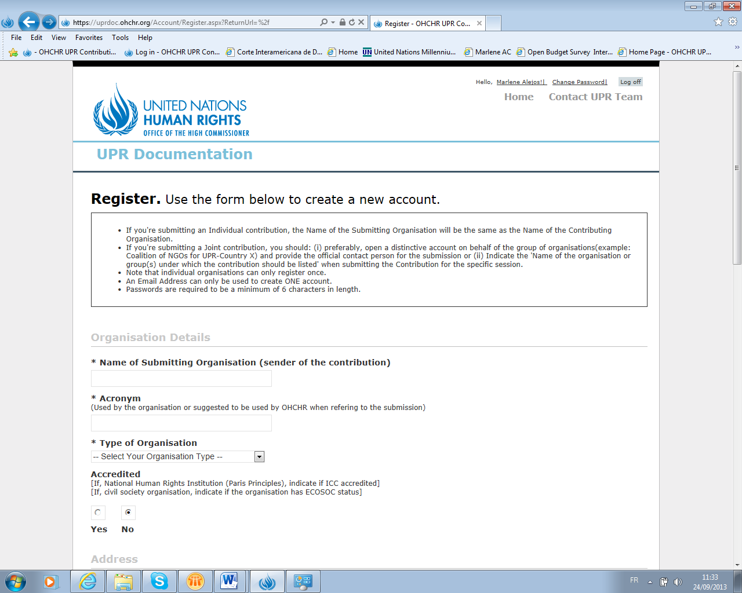
- If you're submitting an individual contribution, the name of the Submitting Organization (“Sender”) will be the same as the name of the Contributing Organization (“Contributor”).
- If you're submitting a joint contribution (more than one organization), when submitting the Contribution, you should: (i) preferably, open a distinctive account on behalf of the group of organizations (example: Coalition of NGOs for UPR-Country X) and provide the official contact person for the submission; or (ii) indicate the “Name of the organization (s) under which the contribution should be listed”.
- Note that individual organizations can only register once.
- An e-mail address can only be used to create ONE account.
- Passwords are required to be a minimum of 6 characters in length.

Once you have completed the registration form, click on “Register”. See red arrow below.

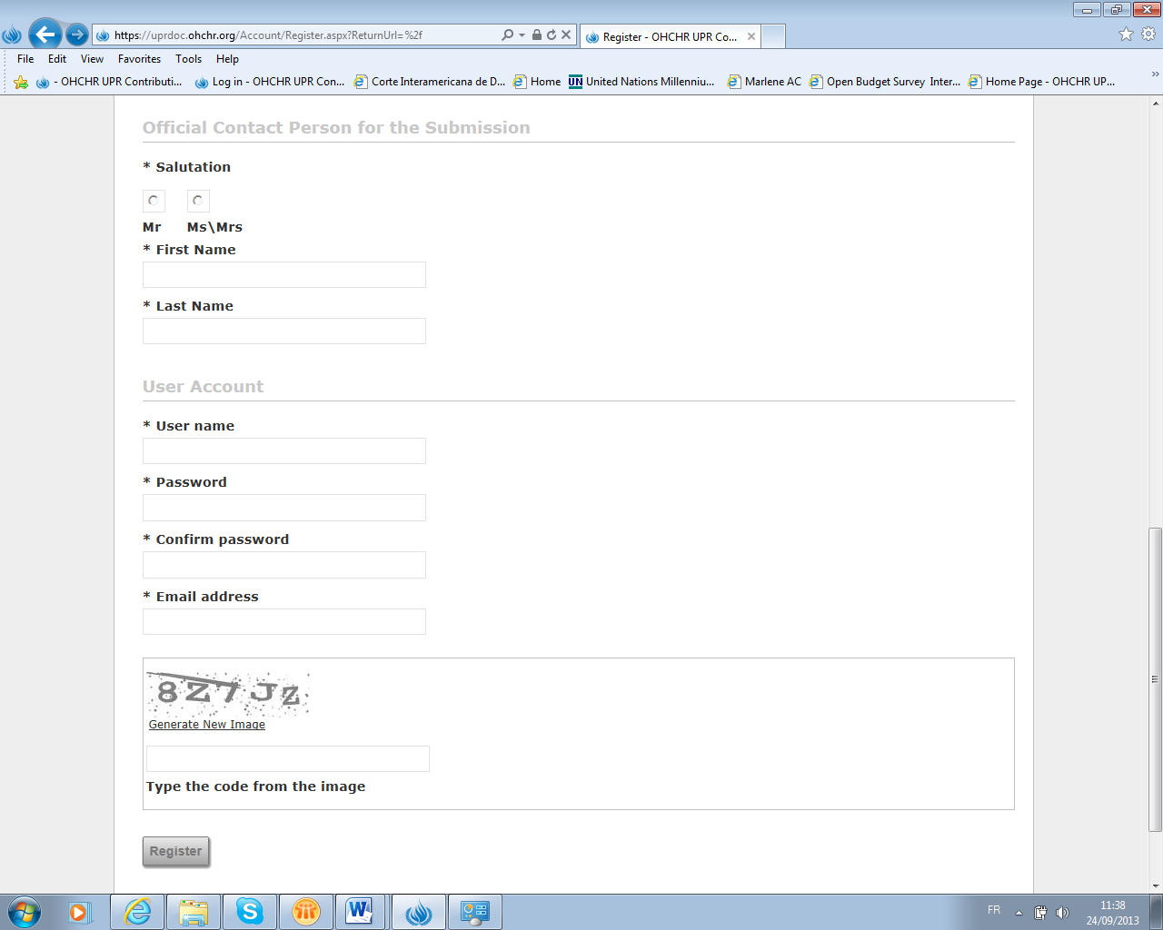

Once you have registered, you will get an automated message confirming that your registration has been successful.

In order to prevent the duplication of organizational profiles, the system has been set up to automatically alert the OHCHR Submissions Helpdesk when organizations have similar names or acronyms. You will be contacted by the OHCHR Submissions Helpdesk if that is the case. Once your registration has been approved and activated you will be able to upload your contribution.

It is suggested that organizations keep a record of their Password and Username as these are required to submit other contributions for other countries/sessions.

(b) Log in

If your organization has already an account, you should access the system by using your Username and Password in order to be able to submit information for the UPR documentation or to see your Contributions history (previous submissions).

Click on the “Log in” icon, found in the login section on the right side of the screen or on the right top of the screen. See red arrows below.

You can also consult your organizational profile by clicking on your “organizational name” icon that appears on the top right hand of the welcoming page. See red arrow below.

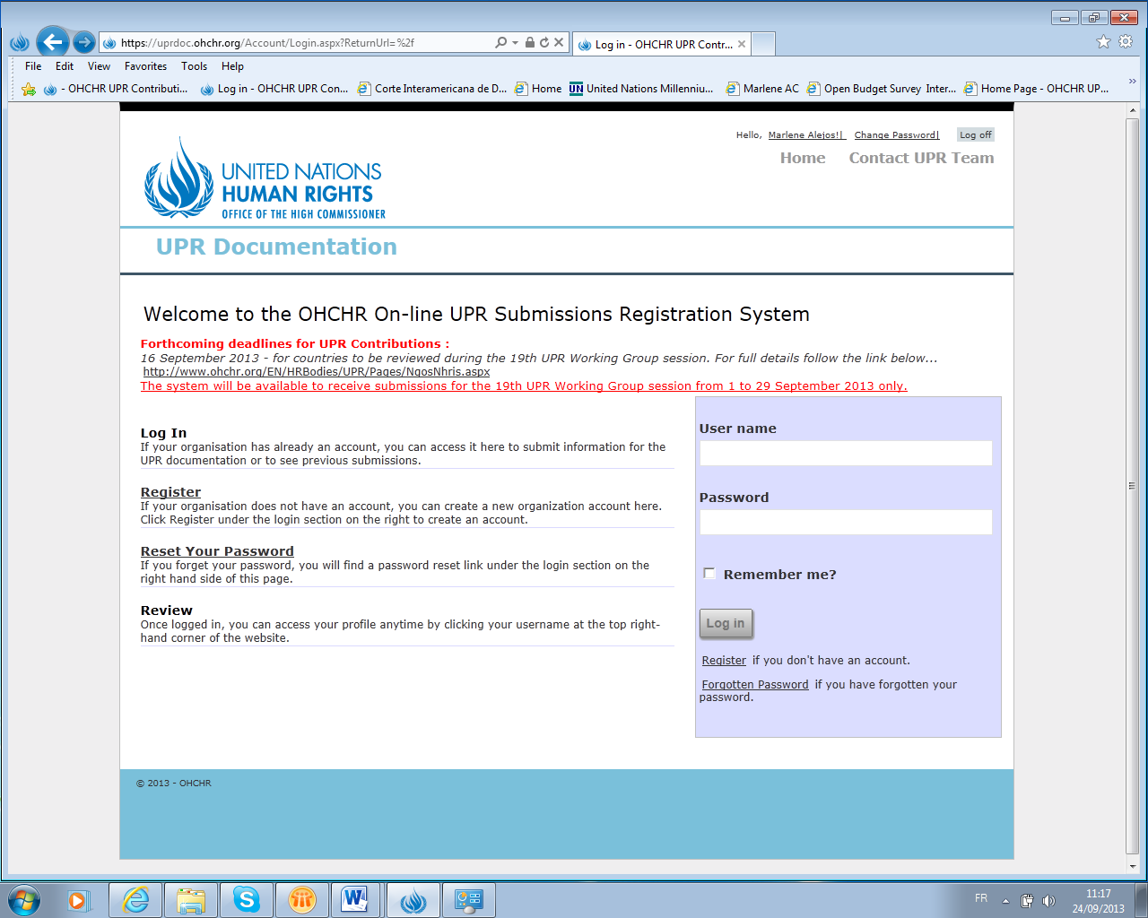

(c) Resetting your Password or changing your User name/profile details

If you forget your Password, click on the “Forgotten Password” icon and follow the instructions. See red arrow below.

If you want to change your Password, click on the “Change Password” icon, found on the right top of the screen. See red arrow below.

If you want to change your User name or want to make changes to your User name/profile details, you will need to contact the UPR Submissions Helpdesk uprsubmissions@ohchr.org.

Step two – Deadlines to submit contributions

Deadlines to submit contributions for the UPR documentation for each session are announced by OHCHR on the following webpage: http://www.ohchr.org/EN/HRBodies/UPR/Pages/NgosNhris.aspx.
Note: tentative deadlines to submit written contributions for all sessions of the second UPR cycle have been announced. We suggest, however, that stakeholders check regularly the above-mentioned webpage, in case extensions and updates are announced. We also suggest that stakeholders subscribe to email updates from the OHCHR Civil Society Section (http://www.ohchr.org/EN/AboutUs/Pages/CivilSociety.aspx) so that they can be kept informed on developments on the UPR.
All written contributions must be submitted and received, through the “On-line UPR Submissions Registration System”, not later than the day of the given deadline (11:59 p.m.). Late submissions (after the “closing date”) will not be considered.
The database will normally be available to receive contributions on the first calendar day of the month of the announced deadlines and (for technical reasons) will close two weeks (“closing date”) after the announced deadline. A notice in this regard can also be seen in the cover page of the “On-line UPR Submissions Registration System”. See red arrow below.
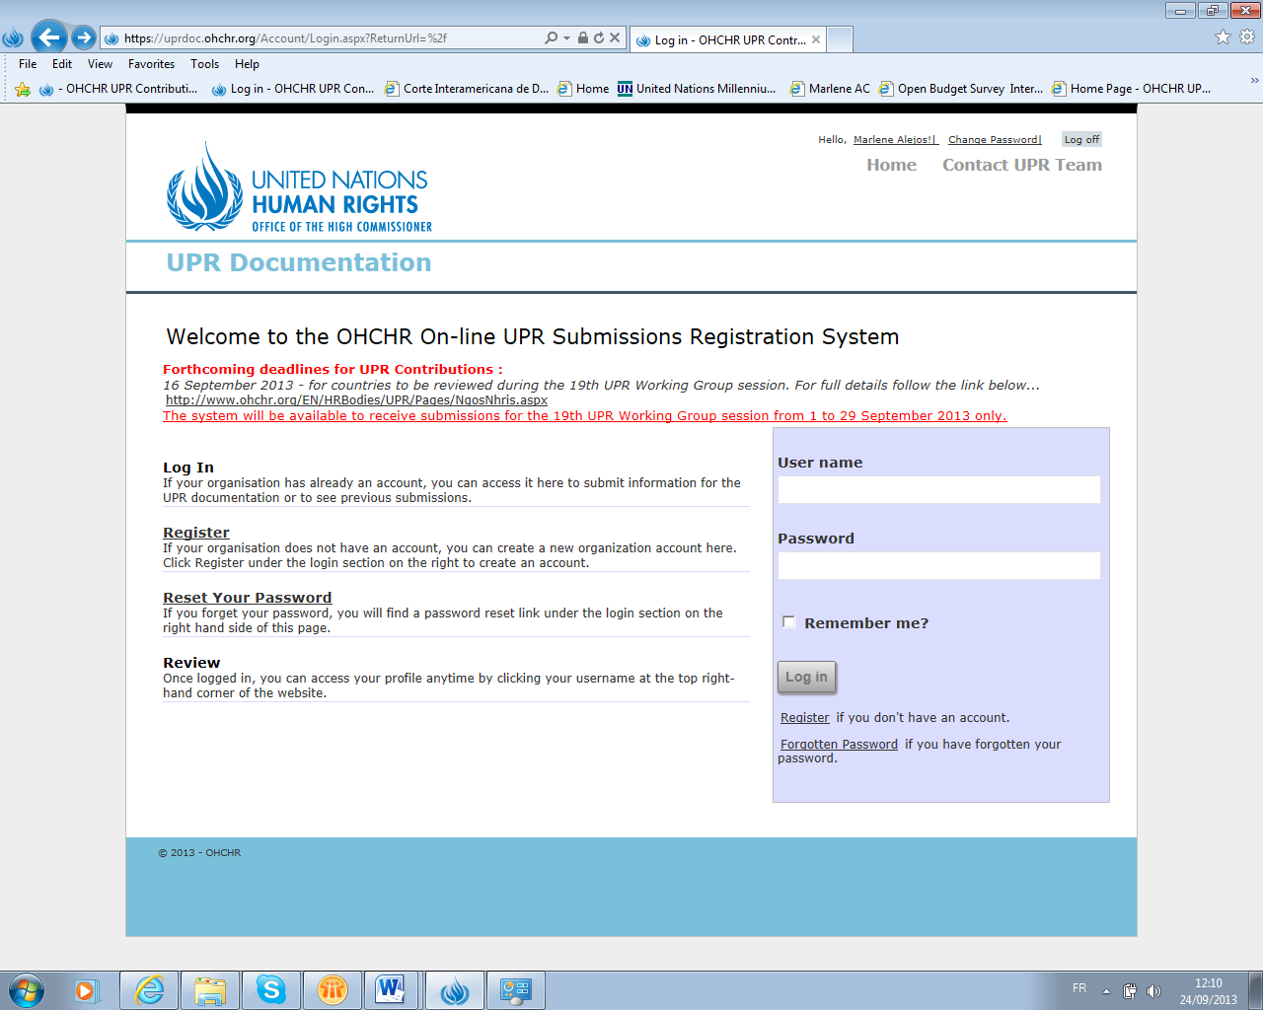

Step three – Viewing your contributions history and submitting new contributions
Once you have created an organizational profile, you can view your contributions history and/or submit new contributions.
Log in to the database using your User name and Password. See red arrow below.

(a) Viewing your contribution history

Your contributions history, for all sessions, will be displayed on your screen. See red arrow below.

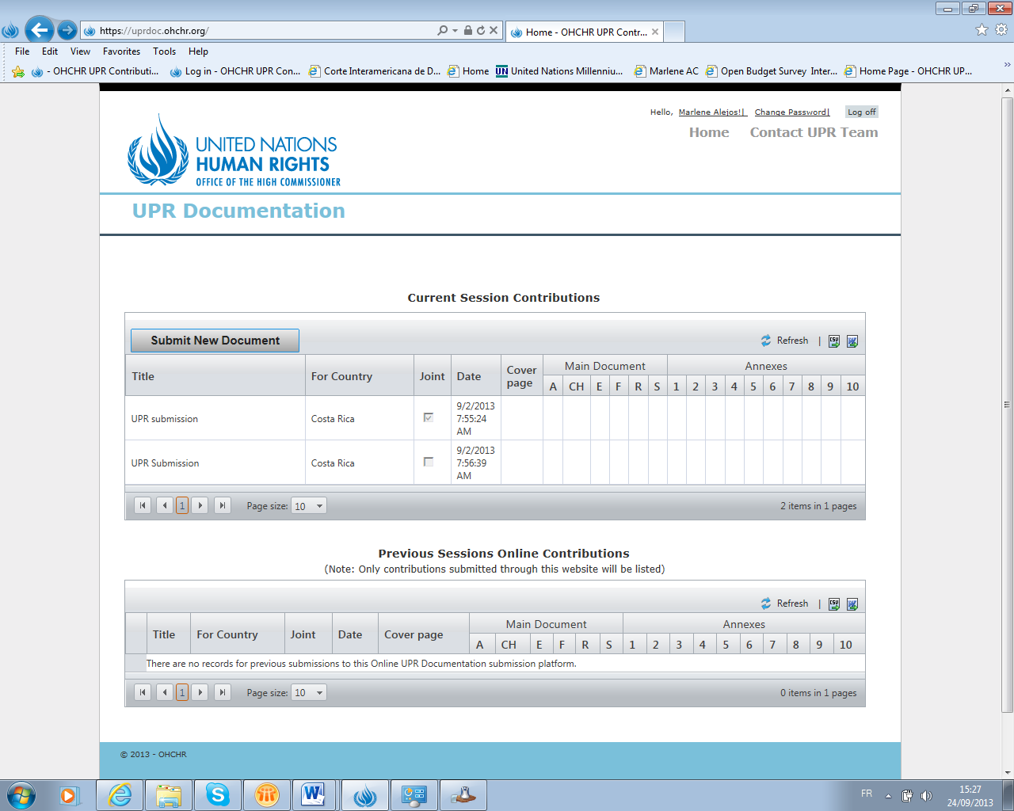

(b) Submitting Individual contributions

Click on the “Submit New Document” icon and follow the instructions. See red arrow below.

(c) Submitting Joint contributions

Under type of organizations, select “Joint Submission”. Add the name of all “Participating Organizations”. See red arrows below.

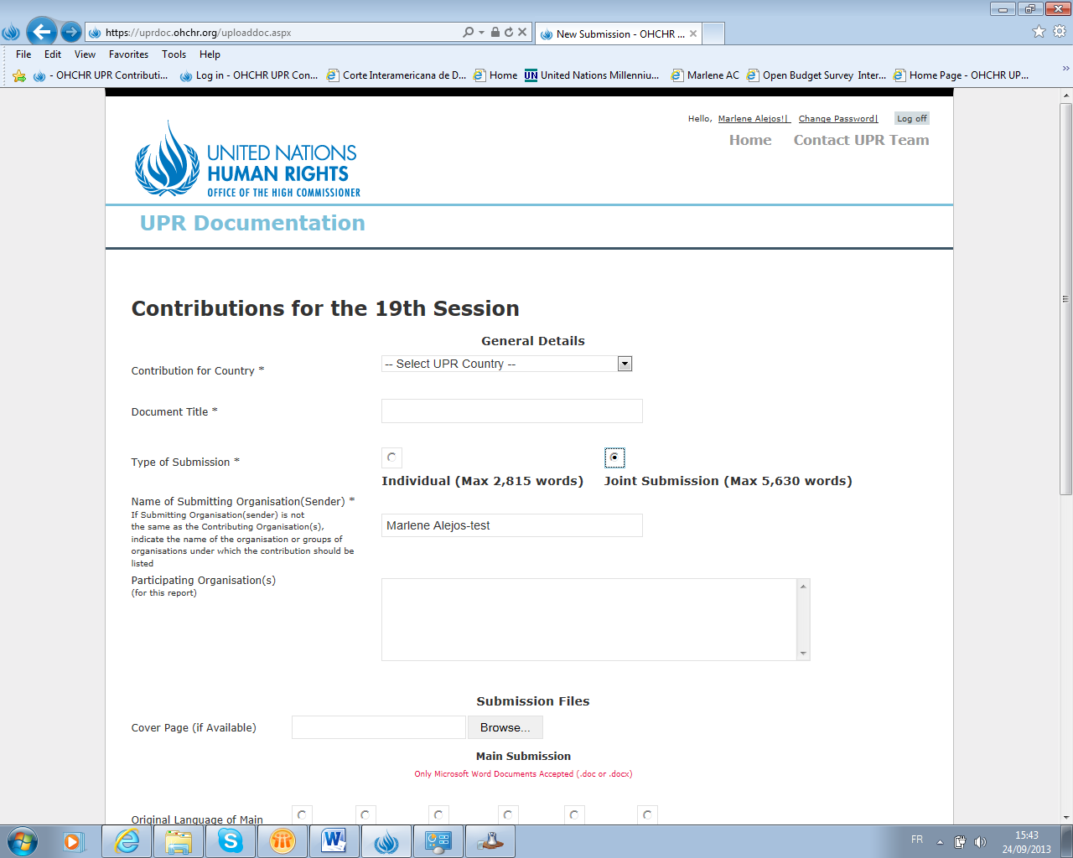
Annex - Frequently Asked Questions

- How do I correct a mistake in the organizational profile that I have created? Only the OHCHR Administrator can change organizational profiles. You should send an email to the UPR Submissions Helpdesk (uprsubmissions@ohchr.org) requesting the changes to be made.

- Can my organization send several submissions for the same country? Organizations can only submit one individual contribution by country. You can however, acting as a “Sender”, also submit the contribution of any coalition that you have taken part in and for which you are the contact person.

- Should I register several times if I need to send an individual contribution and also a joint submission for the same country? Organizations should only register once. Duplicated organizational profiles, with different contact e-mail addresses, will be deleted.

- Can I use the same e-mail more than once? No.

- What is the acronym for and why wasn’t the acronym I registered used in the Summary report? The acronym is used to identify the organization in the summary reports. However, and due to the space limitation in the reports, drafting teams often try to use a one-word acronym.

For individual submissions, we suggest you indicate the acronym normally used by the organization.

Joint submissions are often referred to by number, due to the space limitation in the reports. For example: “Joint submisison No.1 (JS1)”. All joint submissions will be numbered and listed with a number in the Endnote 1 of the Summary reports.

- Can organizations submit revised versions of the documents sent? Revised versions are in principle not accepted. If you have concerns regarding your submission, you can however contact the UPR Submissions Helpdesk (uprsubmissions@ohchr.org).

- How can I send a translation of the main document in other UN official languages so that it can be posted on the OHCHR webpage also? You can upload the main document in different UN languages, but once the process for submitting your contribution has been completed, you will not be able to add more documents. You can however send the translations of the main documents to the UPR Submissions Helpdesk (uprsubmissions@ohchr.org), so that it can also be posted on the UPR country page later.

- When should I expect the documents to be posted on the OHCHR webpage? Written contributions used for the UPR documentation will normally be posted on the UPR country pages about 6 weeks before the sessions.

- Why wasn’t the contribution of my organization used for the UPR documentation? The technical guidelines for stakeholders submissions issued by OHCHR provide information on admissibility of written contributions (http://www.ohchr.org/EN/HRBodies/UPR/Pages/NgosNhris.aspx)

- Whom should I contact if I have questions with regard to the report of the country that I sent a contribution for? All queries regarding your written contribution should be sent to the UPR submissions email address (uprsubmissions@ohchr.org).

- I was not aware of the deadline to submit written contributions. Can I send the contribution late? Tentative deadlines for all sessions of the second UPR cycle have been announced. Stakeholders should regularly check the OHCHR webpage (http://www.ohchr.org/EN/HRBodies/UPR/Pages/NgosNhris.aspx), in case extension of deadlines are announced. Late submissions are unfortunately not accepted.

- How can I be kept informed about UPR developments? We suggest that stakeholders suscribe to the e-mail updates from the OHCHR Civil Society Section to stay informed about UN human rights activities and developments, including UPR.
(http://www.ohchr.org/EN/AboutUs/Pages/CivilSociety.aspx)

The Civil Society Section is the unit in OHCHR dedicated to strengthening engagement between civil society and the United Nations human rights programme. You can contact them by e-mail or phone.

OHCHR Civil Society Section
Office of the High Commissioner for Human Rights
Telephone: + 41 (0)22 917 9656
Email: civilsociety@ohchr.org

