Western Shoshone Film Screening
American Outrage: Our Land, Our Life
Followed by Q & A
Produced by Beth Gage & George Gage
Music by Joanne Shenandoah

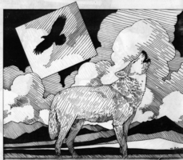

Tuesday, 6 October, 2009
1:00 – 3:00 p.m.
Room XVI Palais Nations

Film on the Western Shoshone story - told from the lives of Mary and Carrie Dann, Western Shoshone sisters who have taken their struggle for indigenous rights in the United States to the U.S. Supreme Court and beyond. Includes footage of events leading to the 2006 CERD Urgent Action Decision, interviews with CERD members, the 2006 Permanent Forum on Indigenous Populations and reflections on the impact of transnational corporations in the ongoing human rights violations.

Awarded Best Feature Documentary in San Luis Obispo International Film ; Best Documentary, American Indian Film Festival; Grand Prize, Présence Autochrone Film Festival Montreal; Festival; Spirit and Advocacy and People’s Choice Awards, Mountainfilm Telluride

