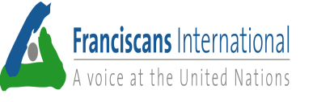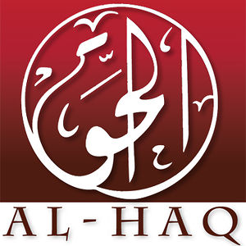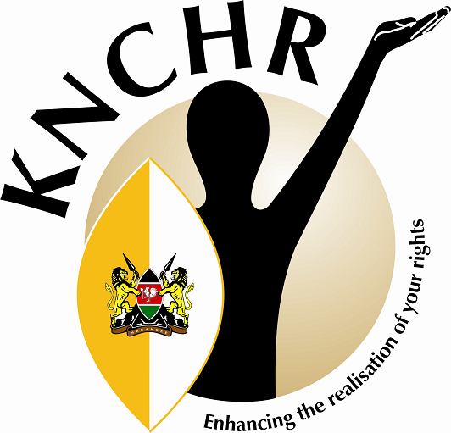
Second UN Annual Forum on Business and Human Rights
2 – 4 December 2013
Feedback from the “Shared Space: Cases in the Extractive Sector” of 04 December 2013
We thank you for the opportunity to host the side event “Shared space: cases in the extractive sector” on 04 December 2013 as part of the main programme of the 2nd Annual Forum on Business and Human Rights. There was overwhelming attendance and interest in the subject by civil society organisations, the private sector and governments. In brief, we hereby present to you some of the concerns and affirmations, and recommendations from this 90 minutes interactive dialogue.
Concerns and affirmations:
- We affirm the need to continue engaging with the UN Working Group on Business and Human Rights, but we must not lose sight that this is only one track of the possibilities of "engagements" that Civil Society Organisations (CSOs) must pursue. Other tracks include exposing the impunity of transnational corporations (TNCs), countering efforts of states to be willing partners or complicit in abusing human rights in the pursuit of the interests of industries and continually building solidarity among the victims and defenders of human rights.
- We affirm that the UN Guiding Principles are a minimum standard that the international community has so far been able to agree on, but we have to recognize that they have serious limitations, especially when we want to hold corporations accountable for violations or abuses of human rights.
- We affirm new initiatives such as the Nairobi process and hope that it will be inclusive of local communities.
- We are concerned that there are no established links between human rights obligations and the contents of free trade agreements (FTAs), and some bilateral investment treaties (BITs).
- We are concerned that in certain jurisdictions Free, Prior, and Informed Consent (FPIC) is voluntary and not a constitutional or legal requirement.
- We are concerned that business is not applying human rights due diligence as required in pillar two of the UNGPs. In particular we see a lack of implementation throughout all stages of the production and supply chain.
- We are concerned about the continuing criminalization of human rights defenders speaking up against corporate interests and the collaboration between state actors and the private sector in silencing these voices.
- We are concerned about the numerous obstacles to justice, for example the lack of access to information privy to multinational companies, the length and costs of judicial proceedings, the difficulty to hold the parent company accountable and the lack of binding human rights due diligence regulations.
- We are concerned that in most cases Extractive Industries are failing to consider climate change variables.
- We are concerned with the many sink holes left by mining with no rehabilitation plans. Many of the culprits have left and cannot be found.
- We are concerned with the violations of international human rights law, and international humanitarian law in occupied territories such as Palestine by the extractives sector.
Recommendations:
- We recommend that the next thematic report of the Working Group on Business and Human Rights focuses on the “Extractive Sector”, through the lens of the United Nations Guiding Principles on Business and Human Rights. In our side event we heard horrifying stories linked to the Extractive Industries including extra-judiciary killings, displacements, complicity of multinational enterprises, violations of FPIC principles that show the very weak link between human rights and business in practice;
- We see the need to adopt an internationally legally-binding instrument to hold corporations accountable for their behavior, especially in relation to human rights and access to and control of natural resources;
- We expect the working group to provide guidance and clarification on the use of the Guiding Principles in situations of occupation such as in Palestine, especially in relation to domestic legislation;
- We expect the working group to provide guidance to Third States on how to ensure that their corporations are not involved in violations of international law, including guidance to corporations on their due diligence processes to ensure rigorous assessment of their operations, so that they do not contribute to violations of the rights of the occupied population;
- We recommend the establishment of an international tribunal to receive, investigate and judge accusations against TNCs and sanction TNCs with legally binding indictment, in the broader context of the Human Rights framework;
- We recommend the creation of a Center on Transnational Corporations, to analyse, investigate and inspect practices of TNCs.
Contacts:
ACT Alliance - Gorden Simango: Senior Programme Officer for Southern Africa and Development, Geneva (gorden.simango@actalliance.org)
Franciscans International - Budi Tjahjono: Advocacy Officer, Geneva (b.tjahjono@fiop.org)
AL HAQ - Elisabeth Koek: Legal Researcher: (elisabeth@elisabethkoek.com)
Kenya National Commission on Human Rights: Patricia Mande Nyaundi – Commission Secretary (pmande@knchr.org)

