Development Finance Institutions
and the operationalization of the Guiding Principles

Side event- Third UN Forum on Business and Human Rights

Organiser: European Bank for Reconstruction and Development (EBRD)
Date and time: 3 December 2014, 11.30- 13.00
Location: TBC

Development finance institutions (DFIs) provide finance to the private sector for investments in countries where there is a limited access to credit. Most DFIs have policies in place requiring clients to comply with social and environmental standards as a condition for financing. These policies, which undergo regular review processes, make implicit and explicit references to human rights obligations and some reflect the spirit of the Guiding Principles on Business and Human Rights in a number of requirements. The review of environmental and social policies provide an opportunity for these institutions to enhance their commitments on human rights while ensuring a practical approach to investment projects in the countries where they operate. At the project level some DFIs work to identify human rights issues through environmental and social due diligence, though with varying levels of effectiveness. On the one hand this helps private sector clients to address existing or potential shortcomings and on the other hand provide guidance on how to maximise the positive impact of business activities on human rights.
Objective: The discussion panel will look into the experience of European and national development financial institutions in responding to challenges and opportunities provided by the operationalization of the Guiding Principles at level of DFIs policies and environmental and social due diligence of projects.
Format: Panel discussion and Q&A session
Target audience: Human rights practitioners and representatives from the private sector interested in having a broader understanding about how DFIs requirements on human rights standards.
Moderator:
- Lisa Misol, Senior Advisor on Business and Human Rights, Human Rights Watch
Discussant:
- Bennet Freeman, Senior Vice President for Social Research, Calvert Group
Panellists:
- Eleni Kyrou, Social Development Specialist, European Investment Bank
- Lars-Olle Larsson, Senior Manager, Environmental, Social and Governance Affairs, Swedfund
- Margarate Kuhlow, Vice President, Office of Investment Policy, Overseas Private Investment Corporation
- Michaela Bergman, Chief Social Counsellor, European Bank for Reconstruction and Development

Speakers’ profile:
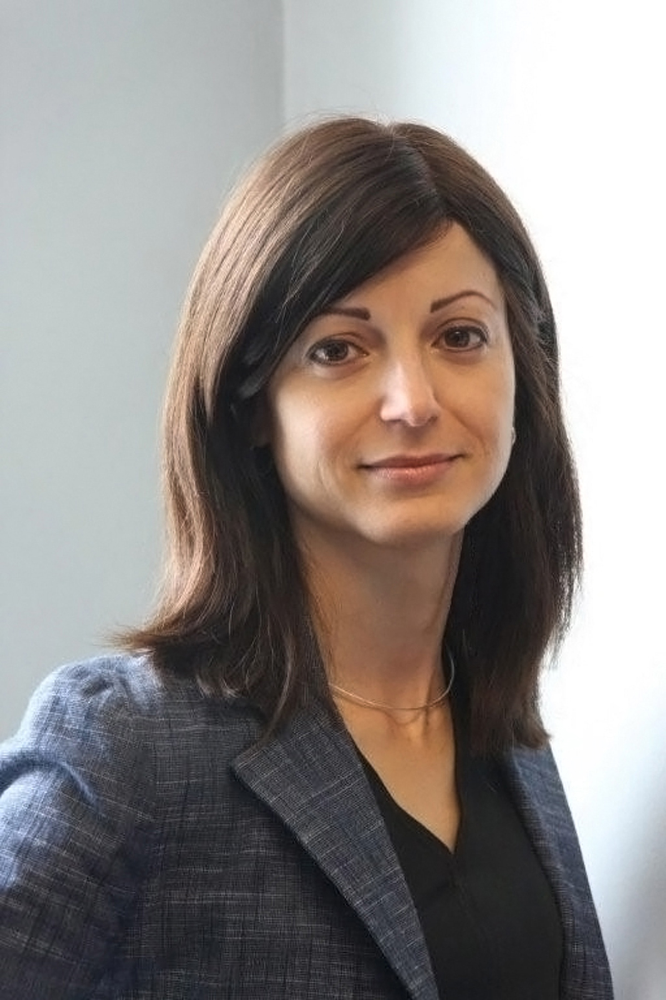
Lisa Misol is Senior Advisor on Business and Human Rights at Human Rights Watch. She previously worked for the organization as a Senior Researcher. She has carried out field investigations in about a dozen countries and written reports on a variety of topics, including military businesses in Indonesia, oil and gas investment in Burma, political violence in Kenya, and global patterns of human rights abuses implicating companies. More recently, Ms Misol’s research and advocacy has addressed the nexus between human rights, business activity and government corruption in resource-rich countries, including Azerbaijan and Equatorial Guinea. Ms Misol is a former Harry S. Truman National Fellow who holds a Bachelor of Arts degree from Duke University and a Master in Public Administration from the Woodrow Wilson School of Public and International Affairs at Princeton University.

Discussant’s profile:


Bennett Freeman is Senior Vice President for Sustainability Research and Policy at Calvert Investments, for which he leads the environmental, social and governance analysis, shareholder advocacy and public policy work of the largest U.S. family of sustainable and responsible (SRI) mutual funds. Over the last 15 years of a three decade-long career, Mr Freeman has worked at the intersection of governments, international institutions, multinational companies, investors and NGOs to improve corporate conduct and to promote human rights and sustainable development around the world. Mr Freeman is Chair of the Advisory Board of Global Witness; a Trustee of the Institute for Human Rights and Business; Board Secretary of the Global Network Initiative; and a member of the Governing Board of the Natural Resources Governance Institute. He previously served on the boards of Oxfam America and the Extractives Industries Transparency Initiative. Mr Freeman served as Clinton presidential appointee in three positons in the U.S. Department of State, most recently as Deputy Assistant Secretary of State for Democracy, Human Rights and Labor. As Senior Advisor to Under Secretary for Business and Economic Affairs Stuart Eizenstat, he directed the Department’s diplomacy and historical research related to Holocaust-era assets. He also served as Chief Speechwriter for Secretary of State Warren Christopher. Before joining the State Department, he was Manager-Corporate Affairs for General Electric from 1985-1993 working on a range of domestic and international public affairs, public policy and corporate responsibility initiatives. He began his career as a presidential campaign speechwriter and aide to former Vice President Walter Mondale from 1982-84.


Eleni Kyrou is Social Development Specialist at the European Investment Bank and she is responsible for the appraisal and identification of social impacts in potential investment projects. As part of her job, Ms Kyrou is also involved in internal safeguards and corporate responsibility policy development and the elaboration of associated procedures and tools, as well as in the provision of training on social impact assessment and the Bank’s social due diligence framework. She has led the human rights work stream in the Bank since early 2011 and oversaw the revision of the Bank’s social safeguards which concluded late in 2013. Over the period 2013-2015 she is managing the elaboration of a Gender Agenda in the Bank’s policies. A development practitioner by training, previous to her current post Ms Kyrou worked across the global South with civil society organizations, academic institutions and multilateral/international agencies. Her fields of engagement were those of urban development planning and urban governance; access to housing for low income population groups at scale; participatory resettlement and relocation of informal settlers; relief aid and post-conflict reconstruction and rehabilitation. She holds a particular interest in the promotion of socially just development; collaborative planning; and, gender in development.

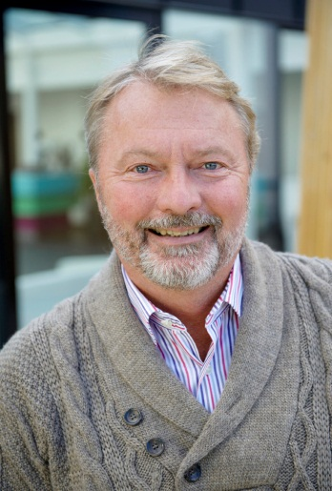
Lars-Olle Larsson is Senior Manager Environmental, Social and Governance Affairs at Swedfund, the Swedish Development Finance Institution. He is also the Swedish Ambassador for the International Integrated Reporting Council (IIRC) and has worked since 1977 with the management of environmental, social and governance issues in major Swedish corporations and large organisations. Mr Larsson has worked in audit and advisory assignments regarding environmental and sustainability reporting with clients in almost all types of industry sectors and services at KPMG and as partner at PwC. Furthermore, Mr Larsson is an appreciated author of a number of books addressing communication, sustainable business development and corporate governance.

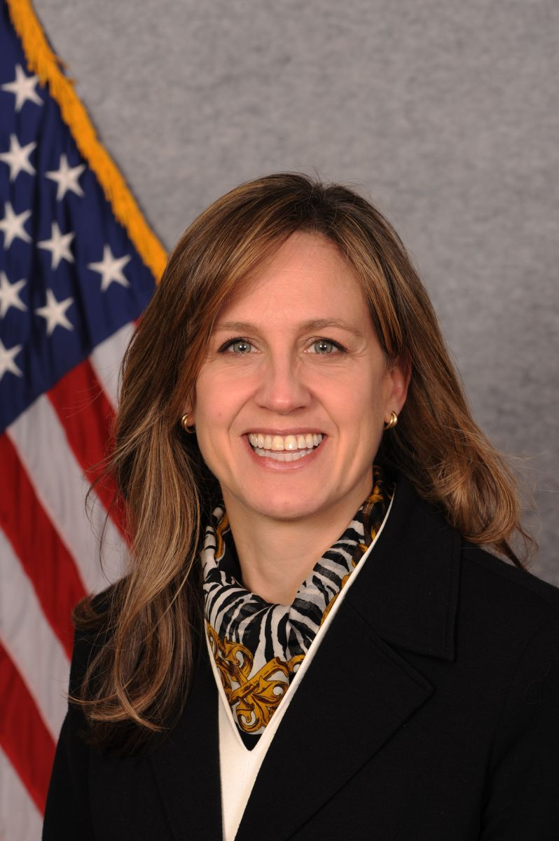
Margaret L. Kuhlow is Vice President, Office of Investment Policy at the Overseas Private Investment Corporation (OPIC), which is the U.S. development finance institution. Previously she served as head of the Economic Analysis and Monitoring and Reporting groups in the Office of Investment Policy, where she assessed the effects on the U.S. economy as well as the local development impacts of OPIC’s broad portfolio of finance, insurance, and investment funds projects. Prior to joining OPIC, Ms. Kuhlow served Deputy Vice President of the Department of Accountability at the Millennium Challenge Corporation (MCC), overseeing the assessment of economic logic and growth impact of country proposals, establishment of monitoring and evaluation plans including performance measurement data, assessing environmental and social impacts of MCC-funded activities, and evaluating fiscal accountability and procurement procedures. Ms. Kuhlow joined MCC from the U.S. Department of the Treasury, where she had been the interim head of the Office of Quantitative Policy Analysis, helping to develop the Millennium Challenge Account and country selection system. She also served as senior advisor to the U.S. Executive Director at the European Bank for Reconstruction and Development (EBRD), senior advisor to the Assistant Secretary for International Affairs, and international economist in the Office of Multilateral Development Banks. She holds a Master in Public Policy from Harvard University, and a BA summa cum laude from DePaul University in her hometown of Chicago.

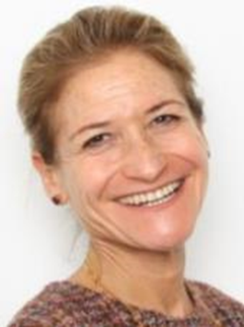
Michaela Bergman is Chief Counsellor for Social Issues at the European Bank for Reconstruction and Development. She is a social anthropologist and lawyer, with 20 years’ work experience with multi-lateral, International Financial Institutions, bi-laterals and civil society in over 40 countries, including East and Central Europe, Central, East and South Asia and the Middle East. Her expertise and experience lies in policy and project related activities related to gender, involuntary resettlement, poverty alleviation, protection and empowerment of vulnerable and socially excluded groups, Indigenous Peoples, community development, disability, provision of community based services, support of civil society, human rights and labour laws; particularly in post-conflict countries and transitional economies. Ms Bergman joined EBRD nine years ago. As Chief Counsellor for Social issues she is the most senior social specialist of the Bank and as such provides support and strategic advice to the institution, Environment and Sustainability Department, Banking, Office of the Chief Economist, Clients and Human Resources and clients on gender and social issues.. The Chief Counsellor for Social issues also heads the Gender team which is responsible for delivering the Bank’s Strategic Gender Initiative.

