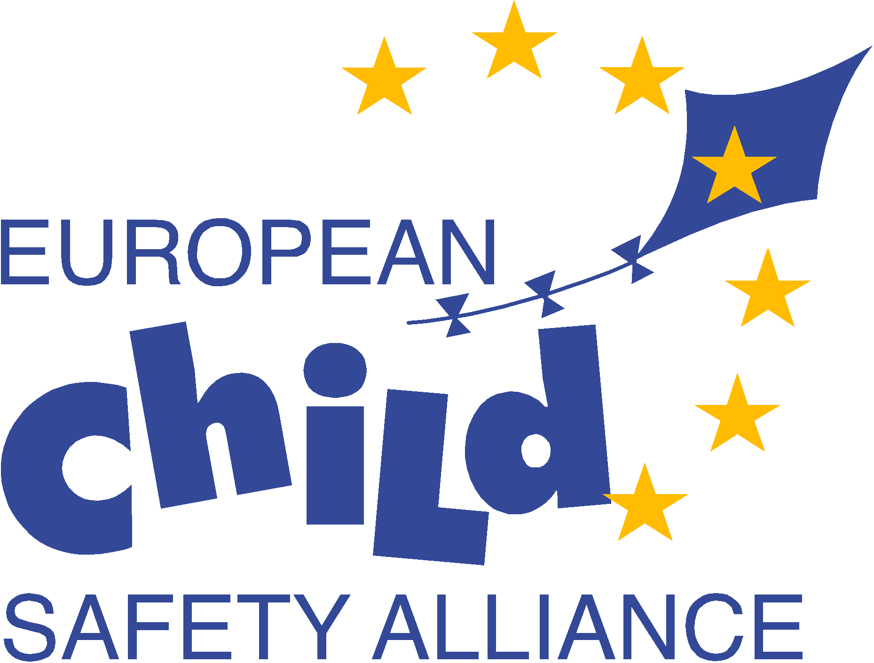

European Child Safety Alliance’s contribution to the OHCHR Study on children’s rights to health – Human Rights Council resolution 19/37
The European Child Safety Alliance was launched in 2000 with the ambition to make the lives of children living in Europe safer. Today, more than 30 countries across Europe are working together to reduce the leading cause of death, disability, burden and inequalities to children in every Member State in the region - injury.
Our child safety experts from across Europe come from diverse fields and settings, including medicine, public health, psychology, education, engineering and government, to share and advocate for what works in child injury prevention to benefit children and their families.
Our mission is to enhance the quality of children’s lives through the power of rights, reason and solidarity.
Rights – putting children first
Reason – using evidence and good practice
Solidarity – many countries and professions speaking with one voice
For more information please see www.childsafetyeurope.org

The European Child Safety Alliance (ECSA) welcomes the opportunity offered by the United Nations Human Rights office of the High Commissioner to contribute information relevant to the report preparation on the right of the child to the enjoyment of the highest attainable standard of health.
- Information on what your organization considers to be the main health challenges related to children.
As experts in child injury prevention the focus of our contribution will provide information on the area of injury prevention and safety promotion.
ECSA strongly believes that children have the right to a loving, caring and safe environment in which to live, learn, grow and play.
This is every parent’s first responsibility and also a major concern of caregivers, schools, governments, businesses and society as a whole. It is our common concern. Yet injury is the leading cause of death, disability, burden and inequality for children in every Member State in Europe, with the greatest burden on children from the most disadvantaged groups and in the countries undergoing the greatest socioeconomic change. Injury has the largest environmental disease burden for children compared to outdoor/indoor contaminants, water, sanitation and hygiene issues or lead. The United Nations Convention on the Rights of the Child states that every child from birth till 18 years has the right to the highest attainable level of health and the right to a safe environment. Therefore, we have a duty to ensure children’s rights to safety.
Injury and violence is a major killer of children throughout the world, responsible for over 900,000 deaths in children and young people under the age of 18 years each year. For every child that dies as a result of an injury, it has been estimated that 129 are hospitalised and 1635 present to an emergency department. In the European Union a child dies every hour of everyday as a result of injury. Many injured children suffer permanent disabilities and mental challenges that create an enormous burden in social and economic terms on both families and society. The leading causes of both fatal and non-fatal injuries to European children occur in the areas of unintentional injuries - road traffic crashes, drowning, falls, burns and scalds, poisonings, suffocation, and choking, as well as intentional injuries - violence and suicide. Boys are more likely to die of an injury than girls and also have higher non-fatal injury rates in most injury areas. Injury is also highly associated with age and risk of injuries rises as children become more mobile and begin to explore their world. For more injury data information see: http://www.childsafetyeurope.org/publications/europeanpolicy/injury-reports.html
All children are at risk of injury and some factors which put them at risk include: poverty, stage of physical and social environment, stage of development, availability of policies and legislation to protect children and minority status. Evidence indicates that the poorest in society are at greater risk for certain injuries. This includes not only children in low and middle income countries, but also poor children in high income countries. There is a seven fold difference between countries with the highest and lowest injury death rates, and up to nine-fold differences in the variations within countries, demonstrating the great inequalities to children’s health that result from injury. A study in England and Wales showed, for example, that the risk of children dying from fire was 16 times greater for the lowest occupational group compared to the highest. This unequal distribution of injuries threatens to further widen the gap in health inequalities between and within countries and as most of these injuries are preventable results in social injustice.
See pages 46 -47, for more information on child injuries, inequalities and inequity: http://www.childsafetyeurope.org/publications/info/child-safety-report-cards-europe-summary-2012.pdf

- Examples of good practices to undertaken to protect and promote children’s rights to health, particularly in relation to children in especially difficult circumstances.
Injury is a major health problem that is preventable. There are proven effective strategies that prevent injury or reduce death and disability. The most effective of these tend to be strategies that adopt a combined approach, where enforcement and/or environmental change are backed up by an effective programme of education and training. This has occurred with child resistant packaging to reduce poisonings, lowered temperatures on water heaters to reduce scalds, window guards to reduce falls, smoke alarms to allow timely exits to reduce carbon dioxide inhalation and injuries from burns, traffic calming to reduce pedestrian injuries, child passenger restraints to reduce motor vehicle related injuries and bicycle helmets to reduce head injuries.
Examples of effective strategies to reduce unintentional injuries
Strategy | Demonstrated effectiveness
Rear facing child passenger restraint systems | 90-95% reduction in injuries
Forward facing child passenger restraint systems | 60% reduction in injuries
Introduction of 32 kph speed limit zones | 70% reduction in deaths
Correctly fitted bicycle helmets | 63-88% reduction in head and brain injuries
Barrier fencing (4-sided) around private pools | 95% more protection against drowning
Window bars | 35% reduction in deaths
Child-resistant packaging for chemicals | 50% reduction in hospital admissions
Regulating flammability of children’s sleepwear | 75% reduction in sleepwear related hospital admissions

For a more information on child unintentional injury prevention evidence-based good practice please see the Child Safety Good Practice Guide at: http://www.childsafetyeurope.org/publications/goodpracticeguide/index.html

In addition to prevention strategies that have been proven to reduce deaths and disabilities, financial savings have also been demonstrated through the adoption and implementation of good practices in injury prevention.
Financial savings from selected injury prevention interventions
Expenditure of 1 Euro each | Savings (Euro)
Smoke alarms | 69.0
Car child restraints | 29.0
Bicycle helmets | 29.0
Motorcycle helmets | 16.0
Upgraded marked pedestrian crossings | 14.0
Roadside lighting | 10.7
Guardrails on roadsides | 10.4
Prevention counselling by paediatricians | 10.0
Area wide speed and traffic management | 9.7
Poison control centres | 7.0
Daytime running lights (normal bulbs) | 4.4
Pedestrian bridges or underpasses | 2.5

Unfortunately many countries in Europe have not yet capitalised on this knowledge and as a result have not ensured children’s right to safety.
Examples of inconsistent adoption of evidenced based good practices across 31 European countries was highlighted in the recent release of the 2012 Child Safety Report Cards:
- Only 13 countries (42%) have a national helmet law requiring use of a bicycle helmet while cycling, with seven of those laws coming into effect since the first report card assessments. However, only 8/13 report that the law is fully implemented and enforced.
- No country has a law requiring children to use a rear facing child passenger restraint to age 4, although this is normal practice in Sweden where child passenger deaths in this age group have been reduced to almost zero.
- Only 7 countries (23%) have a national law requiring barrier fencing for private pools, but in only one (France) is the law fully implemented and enforced and that law allows a choice of prevention measures of which barrier fencing is only one.
- Only 15 countries (48%) have a national law requiring child resistant packaging of medications and of those, three report the law is not fully implemented and enforced
- Only 16 countries (52%) have a national law requiring environmental changes to prevent children from falling out of windows in buildings with more than one storey/level (e.g. window guards), but for over half of those the law only applies to new buildings or renovations.
More information on the 2012 child safety report cards can be viewed at: http://www.childsafetyeurope.org/reportcards/
A series of good practices has also been indentified for intentional injuries to children that when adopted, implemented and adequately enforced, should reduce children’s risk to child maltreatment/abuse/neglect, peer-to-peer violence, suicide/deliberate self harm. These include a mix of individual approaches, family support approaches, health service approaches, therapeutic/treatment approaches, legal and related policies, community-based efforts and societal approaches (Krug EG et al., eds. World report on violence and health. Geneva, World Health Organization, 2002.)

- Please indicate what you would consider the main barriers when we are trying to implement children’s rights to health.
A number of barriers come to the forefront when trying to implement children’s rights to health:
- Failure to put children first and foremost: leadership and commitment to prioritise children’s right to health and safety by local, regional, national and international governments and agencies is paramount however it is often compromised by other demands with louder voices than children, such as private sector interests or budget cuts. Of the risks to children from societies actions, children have a greater proportion imposed on them involuntarily, yet they have the least power to avoid them.
- Lack of invest in the human capital of children: financial and human resources to provide children’s essential services and needs (i.e. health, safety, education, research, data) are not appropriately and adequately dedicated and protected. Health and safety provisions need to be viewed as an investment in the human capital of children, where the returns will come over a lifetime, not in the immediate future.
- Failure to create and implement a plan of action: many countries do not have a dedicated action plan with quantitative targets to address the leading causes of death and disability for children, ensuring a clear roadmap to providing a coordinated and effective approach to children’s right to health and safety.
- Failure to take up what has proven to work: evidence-based good practices do exist for many areas of children’s health and safety, yet they are not adequately adopted, implemented and/or enforced. And this includes measures that would have the greatest impact on families and children with the greatest need and take on the largest burden, such as providing smoke detectors in poorer housing environments. Decision making and policy need to be more evidence based at all levels of government and in major institutions/agencies that have an impact on families and children.
- Lack of capacity: “It takes a village to raise a child”... and building the capacity of all in the village (i.e. education to create healthier /safer environment, services and products) will go a long way to improve the health and safety of not only children but the entire community. Local knowledge, expertise and skills are required to support families and children as well as better inclusion specifically of children in the capacity building process. This in turn will support families and children’s growth and learning, which will then enable families to build and live in a healthy and safe environment.
The heart of the matter is that children play an important role in the present and future of our societies. It is in everyone’s interest that we invest real resources to support their needs – and not just talk about them.

