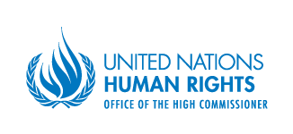

Special Rapporteur in the field of cultural rights

WHOSE HISTORY?
TEACHING HISTORY IN DIVIDED SOCIETIES

Friday, 25 October 2013
Room CR 7 NLB, United Nations Headquarters, New York
13:15 to 14:30 pm

An event organized by OHCHR and
co-sponsored by Germany and Switzerland

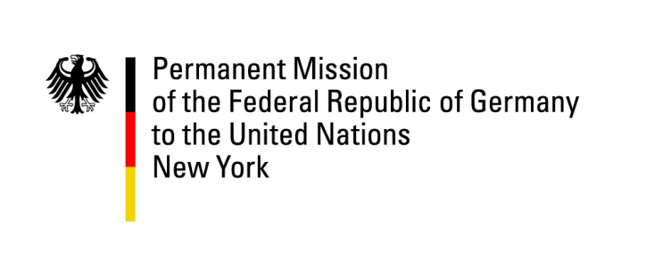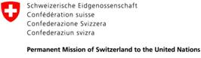

Panellists

- Ms. Farida Shaheed, Special Rapporteur in the field of cultural rights
- Mr. Frank La Rue, Special Rapporteur on the right to freedom of opinion and expression
- Mr. Pablo de Greiff, Special Rapporteur on the promotion of truth, justice, reparation and guarantees of non-recurrence
- Ms. Dubravka Stojanović, Professor, History Department, Faculty of Philosophy, Belgrade University, Serbia
- Ms. Jane Connors, Chief, Special Procedures Branch, OHCHR, Moderator

Experts invited to participate in the discussion also include

- Mr. Sami Adwan, Professor of Education and Teachers training, Bethlehem University; Co-Founder & Co-Director, Peace Research Institute in the Middle East

For inquiries and media requests, please contact Ms. Mylène Bidault (+ 41 79 444 37 07 /mbidault@ohchr.org)

