PANEL DISCUSSION

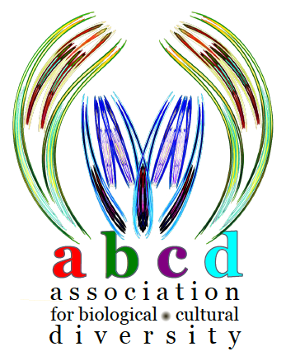
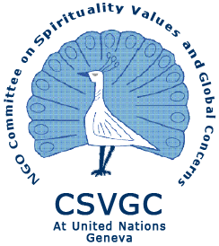  PACE 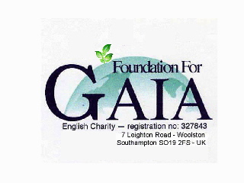Co-sponsors

Co-ordinated and Facilitated by

NGO Committees on Environment (COE) and on Spirituality, Values, Global Concerns (CSVGC)
of the Conference of NGOs in Consultative status with the UN (CoNGO)

In parallel with the 17th session of the Human Rights Council

ACCESS TO and ENJOYMENT OF

CULTURAL HERITAGE

Wednesday, 1st June, 2011

13:00-15:00, Room XXV

Palais des Nations, Geneva

Refreshments will be served

Farida Shaheed

United Nations Independent Expert in the field of Cultural Rights

Gonzalo Oviedo
Social Policy Advisor, International Union for Conservation of Nature (IUCN)

Susanne Schnuttgen
Programme Specialist & Team Leader Section of Policies for Culture, UNESCO

Amund Sinding-Larsen
International Council on Monuments and Sites (ICOMOS), National Norwegian Committee, Norway

Beatriz Schulthess
Co-ordinator, Indigenous Peoples Ancestral Spiritual Council, Costa Rica

Moderator: Vita de Waal

… the right to cultural life and cultural development as an essential and inherent right of all individuals and peoples … cultural rights must celebrate the diversities that define our collective humanity.
The challenge is to ensure that the right to pursue, develop and preserve culture in all its manifestations is in consonance with and serves to uphold the universality, indivisibility and interdependence of all human rights.
(Farida Shaheed, Independent Expert in the field of cultural rights)

CULTURAL RIGHTS
On March 26, 2009, the Human Rights Council adopted Resolution A/HRC10/23 to establish a new special procedure mandate dealing with cultural rights. In October 2009 Ms. Farida Shaheed was appointed as Independent Expert in the field of Cultural Rights. Pursuant to Resolution 10/23 this mandate is to:

• Identify best practices in the promotion and protection of cultural rights at the local, national, regional and international levels;
• Identify possible obstacles to the promotion and protection of cultural rights, and to submit proposals and/or recommendations to the Council on possible actions in that regard;
• Work in cooperation with States in order to foster the adoption of measures at the local, national, regional and international levels aimed at the promotion and protection of cultural rights through concrete proposals enhancing subregional, regional and international cooperation in that regard;
• Study the relationship between cultural rights and cultural diversity, in close collaboration with States and other relevant actors, including in particular the United Nations Educational, Scientific and Cultural Organization, with the aim of further promoting cultural rights;
• Integrate a gender and disabilities perspective into his and her work;
• Work in close coordination, while avoiding unnecessary duplication, with intergovernmental and non-governmental organizations, other special procedures of the Council, the Committee on Economic, Social and Cultural Rights and the United Nations Educational, Scientific and Cultural Organization, as well as with other relevant actors representing the broadest possible range of interests and experiences, within their respective mandates, including by attending and following up on relevant international conferences and events.

The second annual report by the Independent Expert to the 17th Session of the Human Rights Council investigates the extent to which the right of access to and enjoyment of cultural heritage forms part of international human rights law. Stressing the need for a human rights-based approach to cultural heritage matters, the independent expert explores the concept of cultural heritage from the perspective of human rights and presents a non-exhaustive list of human rights issues related to cultural heritage. A compilation of references in international law on the rights of individuals and communities in relation to cultural heritage and a summary of information received regarding national initiatives are included. The report further contains an analysis of the right of access to and enjoyment of cultural heritage, in particular regarding its normative content, related State obligations and possible limitations. The report’s final section contains conclusions and recommendations. A/HRC/17/38
Reports can be viewed: www2.ohchr.org/english/issues/cultural_rights/annual.htm
For more information on the mandate, see http://www2.ohchr.org/english/issues/cultural_rights/index.htm

Ms. FARIDA SHAHEED

Ms. Farida Shaheed is a Pakistani sociologist who took up her functions as Independent Expert in the field of cultural rights on 1 August 2009. She has worked for more than 25 years promoting and protecting cultural rights by fostering policies and projects designed in culturally sensitive ways to support the rights of marginalized sectors, including women, peasants, and religious and ethnic minorities. She has also been the recipient of several national and international human rights awards, and is an experienced participant in negotiations at international, regional and national levels. Ms. Shaheed has brought her distinctive perspective on the integration of culture and rights to her work as an independent expert/consultant to numerous UN and development agencies as well as to the government of Pakistan since 1980.

Ms. Shaheed just completed 4 years as Deputy Director of a research project on Women’s Empowerment in Muslim
Contexts: gender, poverty and democratization from the inside out, as a visiting fellow at the City University of
Hong Kong. She is the Director of research in Shirkat Gah – Women’s Resource Centre, in Pakistan.

