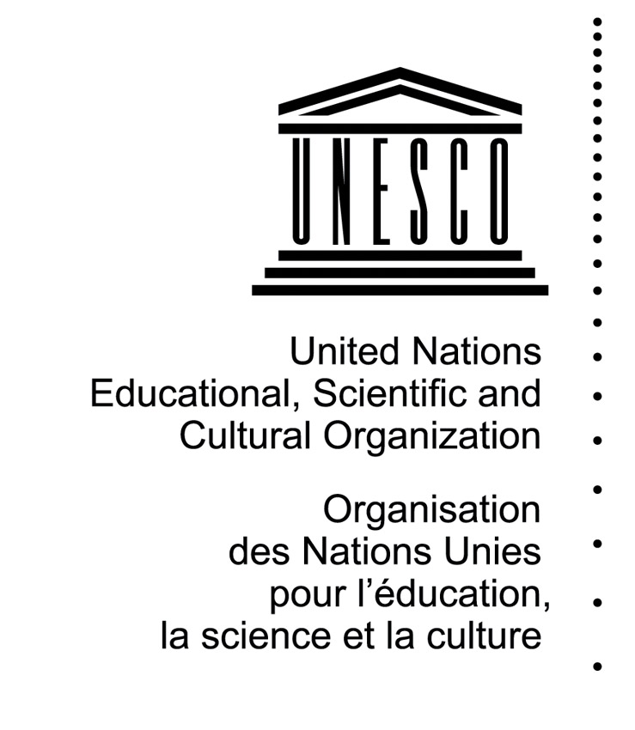

UNESCO contribution to the 1st Forum on

Human Rights, Democracy and the Rule of Law
“Widening the Democratic Space: the role of youth in public decision-making”

(Geneva, November 2016)

- Overview of relevant international instruments

Human Rights Council Resolution 28/14 (2015) established the first Forum on Human Rights, Democracy and the Rule Law (Democracy Forum) “to provide a platform for promoting dialogue […] and to analyze best practices, challenges and opportunities for States in their efforts to secure respect for human rights, democracy and the rule of law”. The theme of the 2016 session is “Widening the Democratic Space: the role of youth in public decision-making”.

OHCHR recalls that in resolution 68/130 (2014), the UN General Assembly urged “Member States and entities of the United Nations System, in consultation with youth-led organizations, to explore avenues to promote full, effective, structured and sustainable participation of young people and youth-led organizations in decision-making processes”.

This international umbrella is reinforced by Human Rights Council Resolution 32/L.1 (2016) which encourages the identification of “challenges, best practices and lessons learned in the exercise of human rights by young people, as well as relevant opportunities for the empowerment of youth in the exercise of their rights”.

In the context of rising extreme violence and terror attacks, UN Security Council Resolution 2250 (2015) on youth, peace and security is particularly relevant as it urges Member States “to consider ways to give youth a greater voice in decision-making at the local, national, regional and international levels”. Focusing entirely on the role of young women and men in peacebuilding and countering violent extremism, the Resolution positions youth and youth-led organizations as important partners in global efforts to address the challenges at hand.

- UNESCO’s role in shaping an international and a regional agenda for youth

UNESCO has a longstanding commitment to youth, materialized by its Operational Strategy on Youth (2014-2021) which was endorsed by its 195 Member States and is articulated around three areas of support: (i) policy formulation with the participation of youth, (ii) capacity building for the transition to adulthood, and (iii) civic engagement and democratic participation. Within this framework, UNESCO is working with policy actors, youth organizations and other civil society groups to build policy environments and processes that are both enabling and conducive to inclusive youth participation in public decision-making. These efforts are coupled by significant investment in strengthening youth competencies to engage more efficiently and meaningfully in such processes.

Moreover, for UNESCO, the protection and promotion of pluralism and diversity are key components of human rights standards. The Sustainable Development Goals stress the importance of cross-cutting values and standards, including human rights, for ensuring the inclusivity of development. UNESCO’s role is hence to deepen cooperation through education, the sciences, culture and communication and to provide support to Member States, civil society actors, academia, private sector and media in order to promote a pluralistic and inclusive participation of youth in all aspects of public decision-making, from the local to the global. Such engagement and involvement is all the more critical in addressing some of the core causes for at risk behaviors, including in preventing and reducing youth involvement in violent extremism. It is also fundamental in engaging young people in promoting and consolidating peace. Within the UN working Group on youth and peacebuilding, UNESCO is supporting a progress study on Youth, Peace and Security mandated by the Security Council Resolution 2250. This study will propose a thorough review and in-depth analysis of young people’s positive role for peace, which will lead to the identification of priorities and recommendations towards a newly defined vision for the Youth, Peace and Security agenda towards the year 2030.

In the context of the uprisings witness since 2011, UNESCO has conducted pilot experiences to accompany the democratic transition dynamics in concerned countries, and particularly in Tunisia. Eight youth-focused capacity building cycles, based on a contextualized training toolkit “Manuel d’apprentissage de la démocratie pour les jeunes en Tunisie” were implemented in disadvantaged localities of Centre-West and South-West Tunisia, benefitting to about 500 young women and men, most of them are active in local youth organizations. Among key topics addressed: youth civic engagement and political participation, youth contribution to electoral processes (monitoring, observation), youth cultural and social rights. These experiences led to the adoption by the Tunisian Ministry of Education and partner CSOs of the National Human Rights Education Strategy within the schooling system, with the support of the UN Task Force on Citizenship Education, and following which more than 50 citizenship school clubs were created. This pilot experience is being replicated in Mauritania and Morocco where contextualized toolkits have also been developed.

UNESCO’s work with and for youth has taken a new impetus with the launch of the flagship regional project Networks of Mediterranean Youth (NET-MED Youth). This three-year project, implemented by UNESCO and funded by the European Union (8,8 million Euros), aims at creating an enabling democratic environment for young women and men to exercise their rights and duties, and to engage as active citizens in policy-making. The project allows partner youth organizations to acquire the necessary skills, tools and capacities in order to amplify their voices, share their experiences and knowledge with youth stakeholders and media. In 2016, NET-MED Youth reached substantive achievements and confirmed an unprecedented dynamic modality of work, combining research, trainings, coaching, networking, strategic policy planning and partnership-building in beneficiary countries. Among the project’s key achievements are the following: the emergence within seven countries (Israel, Jordan, Lebanon, Libya, Morocco, Palestine and Tunisia) of powerful networks of independent youth organizations acting as credible actors vis-à-vis policy makers and reaching to about 2.000 young women and men; the revision of national youth policies with the active participation of youth in five countries; reinforced policy dialogue, advocacy and interaction with media to enhance youth public representation; support to youth’s freedom of expression, online engagement and networking, etc.

One of the main platforms that UNESCO is capitalizing on is the International Coalition of Inclusive and Sustainable Cities - ICCAR (formerly the International Coalition of Cities against Racism). Launched by UNESCO in 2004, ICCAR promotes international cooperation between cities to strengthen advocacy for global solidarity and collaboration, and promote inclusive urban development free from all forms of discrimination, by sharing good practices, knowledge and expertise, and by advancing joint action through the development of participatory city-level policies and initiatives. With seven regional and national coalitions, ICCAR now counts more than 500 cities around the world as members. A number of ICCAR members collaborate closely with youth city councils to enhance youth’s role in inclusive local decision-making processes. Cities, as vibrant spaces for social, cultural, economic and political interactions, provide the ideal landscape for youth participation. Due to its proximity to its citizens, the city lends itself to being a forum for young men and women to be proactive participants in local governance.

- Proposed contributions based on UNESCO’s work

The work carried by UNESCO in the area of youth development, and notably the NET-MED Youth project, could easily feed the Democracy Forum at three levels by:
- Sharing evidence-based findings and nurturing discussions on key thematic issues in order to stimulate creative thinking and further articulate debates on increased youth democratic participation;
- Highlighting challenges and showcasing good practices in the field of youth political participation, notably in the context of the Mediterranean region, in order to advocate for more coordinated investment in specific areas (policy frameworks, participation mechanisms, knowledge management, youth-friendly governance, promotion of freedom of expression and partnerships with media, etc.);
- Suggesting potential young speakers and youth organizations from Youth national networks and their associated partners, as well as youth councils from ICCAR member cities, in order to share their perspectives and expertise in relation to the thematic sessions of the Forum

The Democracy Forum provides a key opportunity to look into crucial issues and questions that affect the quality and efficiency of youth participation in public decision-making processes. Building on its past and current work in this field, UNESCO would propose the following themes for Panel discussions during the Forum.

- Optional Panel Discussion 1: How can youth online platforms and Information and Communication Technologies (ICTs) open-up new spaces for youth organizations to contribute to democratic reforms, decision-making and the rule of law?

In 2016, UNESCO produced an unprecedented study on existing youth online platforms and related online behaviors in Southern Mediterranean countries. It includes a comprehensive literature review and an analytical benchmarking of eleven selected platforms, while also drawing-up an inventory of the issues and themes addressed by young women and men in the region within different types of online spaces. In addition, the study puts forward operational recommendations for the consolidation of existing youth online platforms that could help increasing youth public and political participation in the region. The Geneva Democracy Forum could be a great opportunity to disseminate these recommendations, and to facilitate a discussion on how youth online platforms can empower young women and men in the exercise of their rights, while advancing the understanding of youth online civic participation, including from a gender perspective.

In relation to UN SCR 2250, participants could also discuss how young people can contribute to preventing violent extremism and promoting tolerance and respect for diversity online. In this respect, it is noteworthy that UNESCO organized in June 2015, an international conference entitled “Youth and the Internet: Fighting Radicalization and Extremism”. Bringing together researchers, policy-makers, youth NGOs, experts and practitioners from a range of institutional types and disciplines, this initiative served to share successes as well as to highlight policy gaps and deficiencies in view of reducing the use of the Internet as a tool for youth extremism. In the context of this conference UNESCO launched its intersectoral integrated Framework of Action – Empowering Youth to Build Peace: Youth 2.0 Building skills, Bolstering Peace. Subsequently, the Organization led several efforts in this thematic field; an important one to be held right before the Geneva Forum in cooperation with the Government of Quebec, the International Conference “Internet et la radicalization des jeunes : prévenir, agir et vivre ensemble” (Quebec, Canada, 30 October- 1 November 2016).

Importantly, as the UN agency with a specific mandate to defend freedom of expression, UNESCO has also commissioned several other studies that discussions at the Forum could take insights from. Most notably, recent reports on countering online hate speech and the role of Internet Intermediaries, along with ongoing research on social media and online radicalization, will be of particular relevance for the proposed session.

Under the NET-MED Youth project in particular, UNESCO has empowered youth to contribute to peace and the prevention of violent extremism through efforts to promote intercultural dialogue, youth’s media and information literacy, their representation in the media and communication skills- thus serving to amplify their voices in the public sphere and building positive, alternative narratives to extremism-focused ones.

Building on the abovementioned research, debates and activities facilitated by UNESCO, the session will showcase testimonies and good practices from NET-MED Youth members who are listed in the table below; with a focus on harnessing the power of Internet and online platforms as drivers of democratic participation, dialogue and peace.

- Optional Panel Discussion 2: What are the basic policy frameworks, participation mechanisms and pre-requisite skills that could enhance the political participation of young women and men as well as their representation in the national/local public arena, including at city level?

Given insufficient coordination and the recurrent absence of credible actors facing public authorities, the effective influence of youth organizations and their contribution to nourishing democratic reforms are often minimized. Building an enabling environment for civic engagement requires a clear vision and common agenda for participating youth, but also for well-structured, informed and connected youth organizations. NET-MED Youth is notably supporting the establishment of two national youth councils/coalitions in two pilot countries (Jordan and Tunisia) aimed at enabling sustainable consultation mechanisms and frameworks through which youth representatives could systematically contribute to analyze public policies and formulate recommendations in this regard.

Youth networks and coalitions are also implementing actions to establish linkages with media, create media products to advance their advocacy and, more generally, promote the free expression of young women and men and their representation in media in their countries. These efforts have included youth-led research (media monitoring focused on youth, and surveys on youth and media); discussions with media actors and development/pitching of new programme ideas that reflect the needs and aspirations of youth; reinforcement of skills for strategic communications; involvement in broadcasts and creation of multimedia content by youth themselves. Recognizing the relevance of fostering a critical understanding of the functions of media, internet and information providers, the project has also facilitated Media and Information Literacy trainings enabling youth to better search, critically evaluate, use and contribute information and media content wisely. Moreover, NET-MED Youth networks have also led actions to raise awareness of freedom of expression, and the project has also facilitated capacity-building among young journalists and bloggers, including on core professional skills and the protection of their safety in the digital age.

Other recent UNESCO-led interventions across the globe have shown promising results by developing innovative mechanisms which foster the inclusive participation of young people in the public sphere, from the local to the national level. For instance, in Mongolia, the UNESCO Beijing joined forces with the Mongolian Education Alliance to develop a peer training programme for responsible youth leaders. Eventually, peer trainers were empowered to organize trainings in their respective communities and built the capacity of more than 450 young women and men from 14 provinces in the areas of youth rights; leadership and management; good governance and civic participation; non-violent conflict resolution, and; dealing with adversity and challenges. The programme resulted in the development of youth partnerships with local authorities, advocacy activities on various social and environmental issues, as well as the production of video clips on Human Rights awareness. Another example comes from El Salvador, where a Multi-Partisan Group of Young Parliamentarians was established with a twofold objective: to promote mechanisms for youth participation in public decision-making and to reinforce the mainstreaming of youth issues in legislative processes. To this end, the Group has been playing a coordination role by intervening in each sectoral parliamentarian commission working on issues affecting youth (e.g. education, health, employment, etc.), thus bringing the perspective of young people to negotiations touching upon all policy areas.

In the ICCAR platform, youth councils and youth organizations are being mobilized by member cities in order to enhance inclusive participation of young men and women in urban governance. The youth council of Montréal (Canada) is composed of 15 members appointed by the City Council to advise the Mayor and the Executive Committee on all issues relating to youth and to ensure that youth concerns are taken into consideration in the decisions made by Municipal Administration. “A place with many faces” is a municipal partnership between Çair (FYR Macedonia) and Botkyrka (Sweden) that involves a group of city officials and youth councils aiming to involve youth in local decision making through cultural exchanges. The Durban Youth Council in South Africa encourages active participation in youth-relevant issues and implements sustainable projects and programmes to empower the youth and the community.

Experiences carried-out so far highlighted challenges and lessons learnt that could inspire and guide the organization of a brainstorming workshop during the Forum. Focus could be put on how to scale-up and replicate what have shown to be good practices. Some guiding questions could be the following:
- What are the issues (budget, administration, and facilitation) facing the establishment of effective and sustainable youth networks?
- How to gain credibility, recognition and influence while interacting with national authorities and how to institutionalize consultations at the national level?
- What are the main challenges facing youth organizations’ contribution to policy dialogue at national level? How could youth organizations conduct a joint advocacy to promote youth-friendly legislation?
- How can we increase trust and collaboration between youth CSOs, policy makers and media actors, to contribute to an enabling environment for youth´s freedom of expression and participation in public life? What legal/policy frameworks and capacities need to be strengthened; and how can we open new spaces for dialogue?
- To what extent and how are young women and men represented in media, based on the experience of efforts deployed in Southern Mediterranean countries and elsewhere? What can be the role of CSOs in amplifying young voices and disseminating a positive image of youth and their achievements through media?

http://ap.ohchr.org/documents/dpage_e.aspx?si=A/HRC/28/L.24
http://www.un.org/en/ga/search/view_doc.asp?symbol=A/RES/68/130
http://www.un.org/ga/search/view_doc.asp?symbol=A/HRC/32/L.1
http://www.un.org/press/en/2015/sc12149.doc.htm
http://www.unesco.org/new/en/social-and-human-sciences/themes/youth/strategy/
Task Force led by UNESCO and including OHCHR, UNFPA, UNDP, UNICEF and UNHCR.
Morocco Manual: http://unesdoc.unesco.org/images/0023/002344/234423f.pdf , Mauritania Manual: http://unesdoc.unesco.org/images/0023/002344/234424F.pdf
Read more about the NET-MED Youth Project here: http://www.netmedyouth.org/
UNESCO instructed by its Constitution to promote “the free flow of ideas by word and image”, and is accordingly committed to enabling a free, open and accessible Internet space as part of promoting comprehensive freedom of expression online and offline. Read more about UNESCO’s research on Internet freedom here: http://www.unesco.org/new/en/communication-and-information/resources/publications-and-communication-materials/publications/publications-by-series/unesco-series-on-internet-freedom/
See: http://www.unesco.org/new/en/communication-and-information/resources/publications-and-communication-materials/publications/full-list/countering-online-hate-speech/.
See: http://www.unesco.org/new/en/communication-and-information/resources/publications-and-communication-materials/publications/full-list/fostering-freedom-online-the-role-of-internet-intermediaries/
See: http://fr.unesco.org/node/255934
These efforts have built on UNESCO’s expertise on promoting the safety of journalists (http://en.unesco.org/themes/safety-journalists) an area in which cooperation with OHCHR has been key, including in the framework of the implementation of the UN Plan of Action on the Safety of Journalists and the Issue of Impunity, spearheaded by UNESCO and endorsed by the UN Chief Executives Board.

