Mandate of the United Nations Special Rapporteur on the right to development

Regional consultation on the practical implementation of the right to development: Identifying and Promoting good practices
Panama City, Central Hotel Panama, 11-12 October 2018

The Right to Sustainable Development: A Latin American perspective

by Roberto Bissio

The 2030 Agenda of Sustainable Development is a global agreement to which the LAC region actively contributed, as illustrated by its roots in the Rio 2012 Conference and by having two Latin American countries (Colombia and Guatemala) as initial proponents and early champions of the Sustainable Development Goals.

The SDGs are not an update of the MDGs but a radical revision of the goals and targets of development. They are not aimed exclusively at the poorest of the poor (while keeping “leave no one behind” as a priority) but are instead universal. They apply to all countries and they explicitly require in several aspects for developed countries to take the lead (for example in changing unsustainable consumption and production patterns). They introduce issues of governance and justice (SDG 16) and of inequalities (SDG 10). The recognition of planetary boundaries is implicit (in the goals on climate, forests, oceans...), the redefinition of poverty as multidimensional is explicit (SDG 1) and thus “no country can deem itself to be sustainably developed and having already done its part to meet the SDGs”.

The adoption of the 2030 Agenda in 2015 an be seen as an application of Article 4 of the Declaration on RtD: “States have the duty to take steps, individually and collectively, to formulate international development policies with a view to facilitating the full realization of the right to development” (Article 4.1 of the Declaration on RtD).

The reframing of development away from a purely income-based definition and the placing of “sustainable development” at the heart of the UN agenda is very relevant for Latin America, where the classification of countries by the World Bank exclusively based on per cápita income already has 18 countries above the “high income” threshold of USD 12.000 per capita/year.

Only four countries are in the “lower middle income” category and Haiti is the only country in the region classified as low income and also as a “least developed country”.
After three years in the “high income” group, countries are deleted from the OECD list of development cooperation beneficiaries. Any assistance from OECD members will not be accounted as ODA any more, which led Uruguayan president Tabaré Vázquez to complain at the recent UNGA meeting last September that “our progress is recognized but it seems like those that do things right are punished."

Table 1: Is Latin America developed?
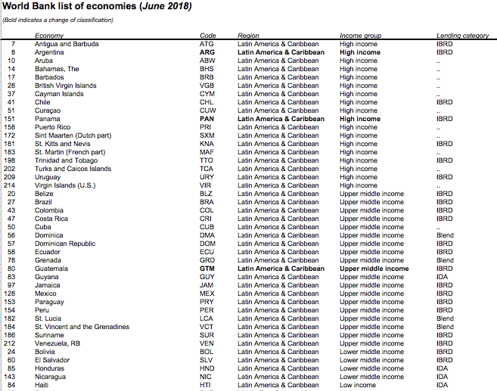
----

While understandable, such a plea is unlikely to produce effects. The SDG framework and its reconceptualization of development allows the LAC region to position itself in another light as shown in Graph 1:

Graph 1: Child mortality and CO2 emissions
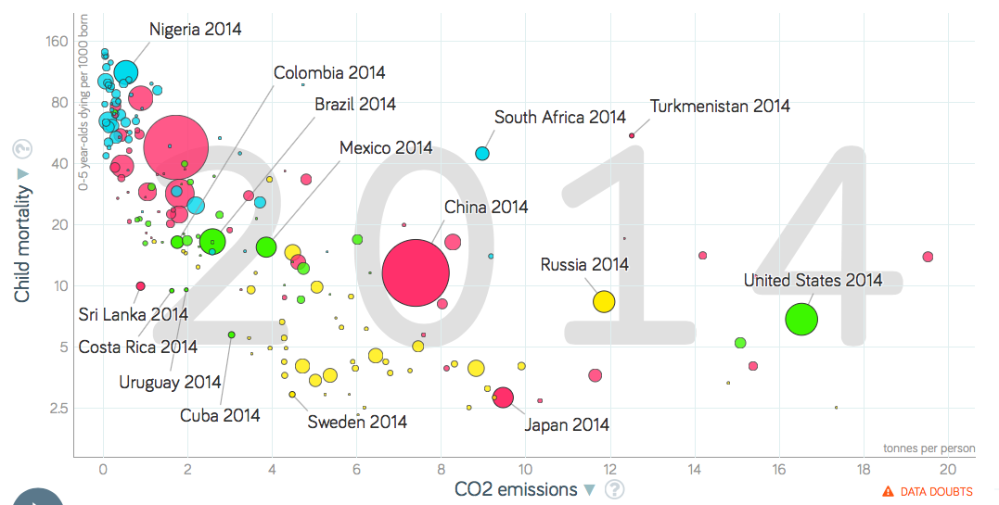
The size of the bubbles is proportional to population.
Graph based on free material from Gapminder.org, CC-BY LICENSE

Most of the population of Latin America and the Caribbean lives in countries placed in the “virtuous corner” with infant mortality rates below 20 per thousand born and CO2 emissions below 4 tons of carbon equivalent per capita per year.

The “social efficiency” of carbon emissions is therefore very high and the region should claim some “credit” for it, as it can show social achievements without the high “cost” in terms of carbon emissions that most industrialized countries have.

But the LAC region does not do as well in other two new dimensions introduced by the SDGs in its goals 10 and 16: inequalities and peacefulness.

The following graph shows inequalities in the vertical axis, as indicated by the Palma ration (income ratio of the upper 10% to the bottom. 40%). The horizontal axis shows the yearly rate of homicides. There is an obvious correlation between the two: more unequal countries have higher homicides rates. And countries from the LAC region are among the worse of the world, both in terms of income inequalities as well as in terms of homicides rates.

Graph 2: Palma ratio and homicides per 100,000 population

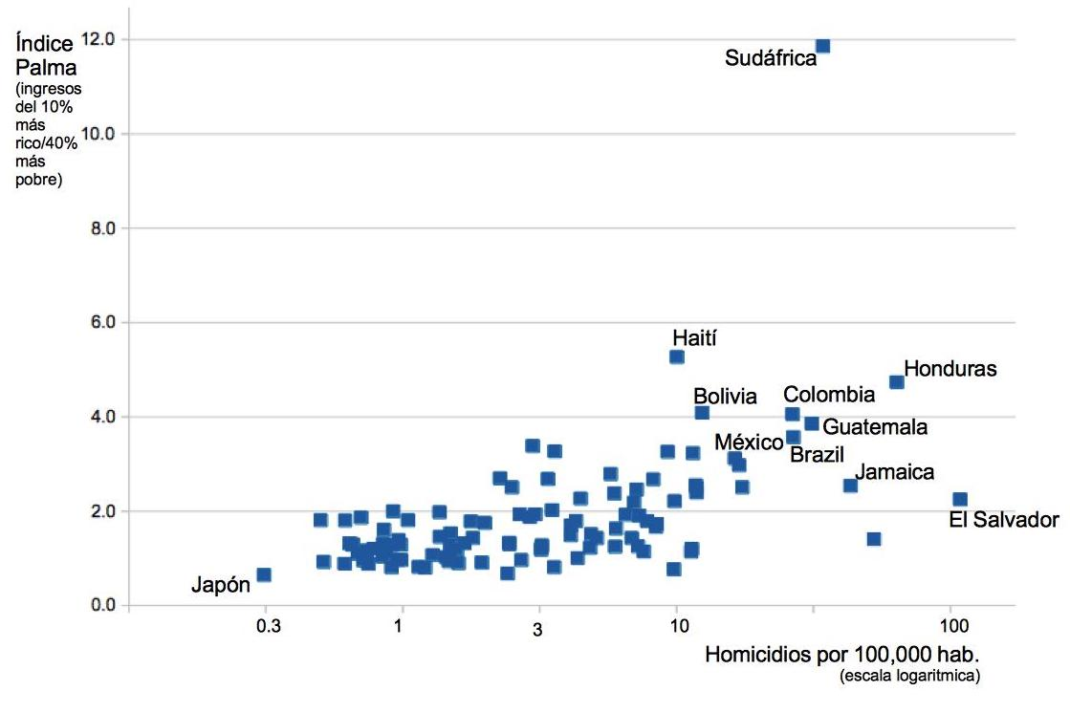
Graph by the author with latest avilable data from UNU-WIDER and the UN Office on Drugs and Crime

This graph is indicative of the enormous socio-economic challenges that the LAC region faces, in spite of its higher average income.

Key Right to Development issues in Latin America and the Caribbean

Article 1.2 of the RtD declaration, on “the exercise of their inalienable right to full sovereignty over all their natural wealth and resources” is very dear to the LAC region, that has struggled for decades to exercise sovereignty over its resources. Yet, as the graph above shows, the region has failed to implement Article 2.3 that requires “the fair distribution of the benefits resulting therefrom.”

Article 3.3 of RtD Declaration stipulates that “States have the duty to co-operate with each other in ensuring development and eliminating obstacles to development.” Among those obstacles that the LAC region cannot solve by itself, we find inter alia:

- conditionalities imposed by multilateral institutions (IMF, World Bank) where the region is not adequately represented in its decision-making. Two major examples are: a) austerity policies, frequently unnecessary, that affect directly Article 8.1 of RtD, and b) imposition by the World Bank of a model of Private-Public Partnerships (PPPs) that led to a generalization of corruption and the subsequent weakening of democratic institutions

- investor-state dispute resolution mechanisms imbedded in plurilateral and bilateral trade and investment agreements that delegate the authority of legitimate national courts to international arbitration panels that ignore human rights

- an international financial non-system where national monetary policy decisions in reserve currency emitting countries (in particular the US) have enormous extraterritorial impact, with minor variations in the interest rate of the US Federal Reserve leading to massive outflows in investment from Latin America earlier in 2018

- an international “shadow banking” system that deviate much needed finances out of the countries of origin and stimulate corruption. The benefits obtained by some countries of the region for hosting secrecy jurisdictions that play a secondary role in this system are minimal when compared with the regional losses, which makes the case for cooperation.

- the “war on drugs” policy that unilaterally imposes the burden of combatting this global public bad on the supply side, with catastrophic results in the LAC region in terms of violence and erosion of state authority

- global unsustainable production and consumption patters, addressed by Goal 12 of the SDGs, impose on the region environmentally disastruous large scale plantations and similarly damaging extractivist practices (like fracking or open air mining). Best practice counter example: El Salvador prohibiting all mining activities in the country.

- disproportionate Intellectual Property Rights benefitting mainly multinational corporations based in developed countries impose a heavy burden on the sustainable development of the region. Best counter example: Ecuador law and policiy on access to drug managed to lower dramaticaly the cost of HIV-AIDS treatment.

- Finally, climate change is an obvious global obstacle to sustainable development and it affects the region in different ways, with the Caribbean islands states threatened in their very survival. The LAC region is a victim of climate change but also a contributor to it, with fossil fuel exports, expansion of the agricultural frontier (mostly to produce non-food commodities) to the detriment of the forests and large-scale meat production.

The existence of these obstacles and the lack of the “effective international co-operation” envisaged in Article 4.2 of the RtD Declaration does not in any way exempt Latin American and Caribbean governments from meeting their obligations under Article 6.3: “States should take steps to eliminate obstacles to development resulting from failure to observe civil and political rights, as well as economic, social and cultural rights.”

As the obscene inequalities (and the resulting violence) in the LAC region is frequently associated with discrimination against women, afro-descendants and indigenous peoples, the regional case for improved international cooperation and strenghtened multilateralism can only find ethical legitimacy if the governments of the region simultaneously show commitment to make RtD a reality for their peoples.

Coordinator of Social Watch. See: http://www.socialwatch.org
UNDP Study Guide. Available at http://formun.fccsocieties.org/wp-content/uploads/2016/12/UNDP-B-Reevaluation-of-Sustainable-Development-Goals.docx
See https://www.youtube.com/watch?v=7l-EWluw6CU
See “The Decade of Adjustment: A Review of Austerity Trends 2010-2020 in 187 Countries” by Isabel Ortiz, Matthew Cummins, Jeronim Capaldo and Kalaivani Karunanethy, ESS Working Paper No. 53, published by The South Centre, Initiative For Policy Dialogue (IPD), Columbia University and International Labour Office, Available at: https://www.social-protection.org/gimi/RessourcePDF.action?ressource.ressourceId=53192
Article 8.1: “States should undertake, at the national level, all necessary measures for the realization of the right to development and shall ensure, inter alia, equality of opportunity for all in their access to basic resources, education, health services, food, housing, employment and the fair distribution of income. Effective measures should be undertaken to ensure that women have an active role in the development process. Appropriate economic and social reforms should be carried out with a view to eradicating all social injustices.”
See “Leveraging corruption – how World Bank funds ended up destabilizing young democracies in Latin America” by Roberto Bissio, in Spotlight on Sustainable Development 2017. Available at: https://www.2030spotlight.org/en/book/1165/chapter/box-leveraging-corruption-how-world-bank-funds-ended-destabilizing-young
See the Report of the Independent Expert on the promotion of a democratic and equitable international order, available at https://www.ohchr.org/EN/NewsEvents/Pages/DisplayNews.aspx?NewsID=20473&LangID=E
See “Monetary Policy Dilemma In Latin America And The Caribbean: To Raise Or Not To Raise Policy Interest Rates” by Carlos Végh, International Banker, March 19, 2018 Available at: https://internationalbanker.com/banking/monetary-policy-dilemma-in-latin-america-and-the-caribbean-to-raise-or-not-to-raise-policy-interest-rates/

