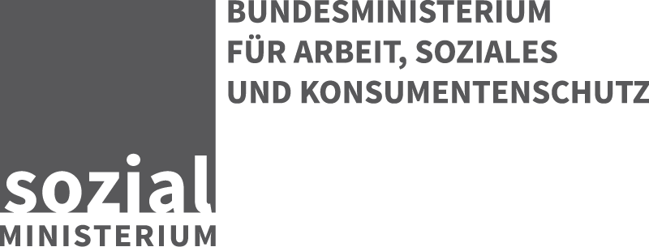

Stubenring 1, 1010 Wien
DVR: 0017001

AUSKUNFT
Mag. Hans Döller
Tel: (01) 711 00 DW 6162
Fax: +43 (1) 7158254
Hans.Doeller@sozialministerium.at

E-Mail Antworten sind bitte unter Anführung
der Geschäftszahl an die E-Mail Adresse
post@sozialministerium.at zu richten..
Bundesministerium für Europa, Integration und Äußeres
Minoritenplatz 8
1010 Wien

Per E-Mail: einlaufstelle@bmeia.gv.at; adrian.gasser@bmeia.gv.at

GZ: BMASK-46001/0014-IV/2015
Wien, 14.07.2015

Betreff: | Internationale Angelegenheiten  Anfrage des BMEIA im Zusammenhang mit Art. 11 CRPD

Sehr geehrte Damen und Herren!
Zum Informationsersuchen des OHCHR im Zusammenhang mit der Umsetzung der MRR-Resolution 28/4 wird für die Erstellung eines allfälligen österreichischen Beitrages folgende Stellungnahme abgegeben, wobei auch das BMI befasst wurde:
Although the Federal Ministry of the Interior (BMI) has the main competence of coordinating disaster control in Austria, it is the responsibility of other ministries and especially of the Federal States (“Länder”) to fulfil the tasks mentioned in the inquiry of OHCHR.
Austria has a nationwide civil protection system and one of the densest networks of facilities to meet the needs of the population in such circumstances. Disaster control plans are kept by all local and district authorities and by the Länder. They also include assistance for people with disabilities in an implicit way.
The legal system concerning risk management and disaster control does not deal with matters of people with disabilities in an explicit way. In such situations, the help which people require is established according to their needs given in the existing dangers, and assistance is provided accordingly. It should be noted that in these situations non-disabled people can effectively become disabled due to injuries and other circumstances, and thus require individual assistance.

If the plans, guidelines, catalogues of measures and so on based on the laws have specific regulations dealing with people with disabilities cannot be answered in detail because of the responsibility of the Länder and the implementation tasks of approximately 2100 municipalities and 100 administrative districts and respectively 4800 fire departments, 500 rescue departments with more than 300.000 volunteers. A special research program would be needed to get the correct and complete information in this case.

Mit freundlichen Grüßen
Für den Bundesminister:
Dr. Max Rubisch
Elektronisch gefertigt.

