Bundesverband - ISL e.V.
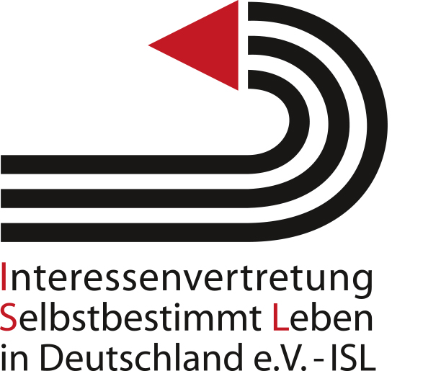

Mitglied bei
„Disabled Peoples´ International”
- DPI -

Bankverbindung:
Sparkasse Kassel
IBAN: DE80520503530001187333
BIC: HELADEF1KAS

Berlin, July 2019
Leipziger Str. 61
10117 Berlin
Tel.: 030/4057-1409
FAX: 030/3101 1251
E-Mail: info@isl-ev.de

ISL e.V. * Leipziger Str. 61 * 10117 Berlin

Contribution to prepare an OHCHR-study on the topic:
Awareness - raising, Art. 8 CRPD
(Human Rights Council resolution 37/22)

Submitted by Interessenvertretung Selbstbestimmt Leben in Deutschland e.V. – DPI Germany. DPI Germany is a human rights based Disabled Persons´ Organization (DPO) and the umbrella organization of the Centers of Independent Living of persons with disabilities in Germany.

1(a). Does your country have laws, policies, plans, strategies or guidelines at any level of government relating to raising awareness about persons with disabilities, in particular initiatives to:
- foster respect for the rights and dignity of persons with disabilities;
- combat stereotypes, prejudices and harmful practices relating to persons with disabilities; or
- promote awareness of the contributions of persons with disabilities?

In 2011 the Federal Ministry for Labour and Social Affairs started the media campaign “Behindern ist heilbar” (“barriers are curable”) to raise awareness for the UN-CRPD. Currently the work of the Federal Government has the slogan “gemeinsam einfach machen” (“simply do it together”).
With the legislative proposals such as the Federal participation act (BTHG) and a reform of the German equal opportunities for persons with disabilities act (BGG) the Federal Government claims to have introduced key demands of the UN committee for a sustainable strategy for awareness raising with participation. This strategy is invisible from the point of view of civil society. The overall policy including verifiable criteria for monitoring must be presented and agreed upon fully. The disability organizations are to be involved in the development of the strategy. Tailored strategies must be designed for all state-run facilities/services. Particularly in the area of education, a human rights based pedagogy must be anchored in syllabus and curricula modules to serve to eliminate prejudice and discrimination.

1(b). What are the challenges to implementing the above?

Challenges are the wrong translation of the CRPD into German language and the lack of participation of civil society, especially Disabled Persons Organizations (DPOs).
Translation: The incorrect official translation of the UN-CRPD into German still hasn’t been corrected, despite Austria making exemplary progress and presenting a corrected German translation (For example: inclusion is translated with “integration” instead of “Inklusion” and assistance is translated with “help” instead of “Assistenz”). The Federal Republic of Germany did not join the austrian initiative.
Participation: There has been an increase of quantitative but not of qualitative participation. Members of civil society organizations are invited to many conferences and committees. But still the demand of civil society for the participatory development of binding participation standards remains unfulfilled.
It is also a problem that the General Comments are only translated into German with a great delay.

2(a). What legislative and policy measures are taken to address hate crimes, hate speech and harmful practices against persons with disabilities?
There are no specific legislative or policy measures.

2(b). In particular, are there legal remedies available for persons with disabilities seeking compensation and reparation? Are there legal provisions to sanction perpetrators, including through criminal law? Please provide information on their application in practice (e.g. cases of persons condemned for hate crimes against persons with disabilities).

The reform of the law governing sexual offences in 2016 is to be considered as positive for policy pertaining to people with disabilities and policy pertaining to women.
The victims of sexual violence, who are, so-called, unable to resist, are finally put on equal footing as other victims. Furthermore, sexual violence can be more easily prosecuted: in the future a person will be liable for prosecution if they ignore the recognizable will of the victim (“no means no”). If the victim can only form or express their will with difficulty, due to their physical or mental condition, then the law requires that the person concerned must actually give consent to the sexual act (“only YES means yes”).
There is a horizontal non-discrimination clause in the German general act on equal treatment – AGG which, to our knowledge, has no effect.

3(a). What steps have been taken to establish standards and/or good practices on the representation and portrayal of persons with disabilities in broadcast media, including codes, guidelines and other measures (legal, co-regulatory or self-regulatory)?

German radio and television laws stipulate the representation of many societally groups - disabled persons and their representative organizations are mentioned in very few of these laws.
In its press code, the German Press Council prohibits discrimination against disabled persons in a horizontal non-discrimination clause. We do not know whether this clause has any effect.

3(b). In addition, what legal framework, measures or good practices exist to regulate social media in accordance with Article 8 and human rights standards on freedom of expression?
As far as we know there are no legal binding specific regulations.

4(a). Please provide information on the existence and implementation of the programmes and activities, including successful examples of campaigns, related to raising awareness about persons with disabilities and their rights, and combating negative attitudes including through initiatives of:
- training, including human rights education;
- research, including studies on perception and attitudes;
- surveys and data collection.

There exists a large data and knowledge deficit regarding the situation and quality of life of persons with disabilities, especially, the so called “difficult to interview groups”. Likewise this was also stated in the last participation report of the Federal Government.
It can be positively mentioned that the green light was given in January 2017 for the first representative survey of persons with disabilities in Germany. The project is ambitious. The assessment of the data gathered should be analyzed by 2021. There shall be annual reporting on the progress of the work and on the initial results.
However, there is a lack of sustainable human rights-based campaigns with objectives and indicators developed in a participatory process.
4(b). Please indicate their objective, scope, target audience, impact (including available data), partners and participants, particularly the participation of, and role of persons with disabilities and their representative organisations, and any key factors of success.

The representative survey should involve people with disabilities and their representative organizations in the preparation and implementation. It is to be a human rights-based survey that also includes persons with disabilities in institutions.

5. Please provide information on the role of persons with disabilities and their representative organisations, including children with disabilities, in the design, implementation, monitoring and evaluation of all measures relating to awareness raising. Please provide detail on concrete mechanisms and activities undertaken for consultation and active involvement (e.g. regular meetings, online consultations, etc.).
See above

ISL e.V.
Dr. Sigrid Arnade
sarnade@isl-ev.de
Tel.: 0049(0)30/4057-1412
Fax: 0049(0)30/31011-251

