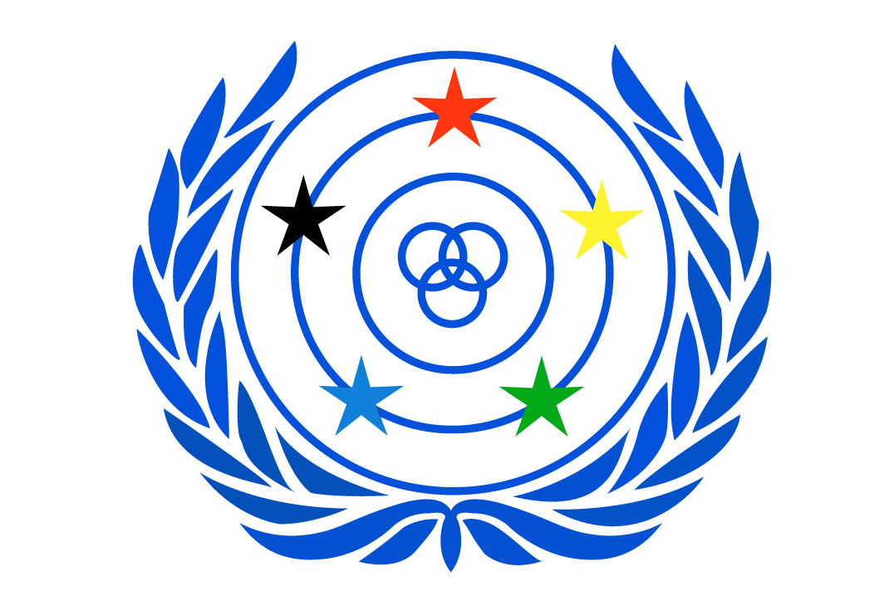

Legal Seat – Helsinki, Finland

WORLD FEDERATION OF THE DEAF
An International Non-Governmental Organisation in official liaison with ECOSOC, UNESCO, ILO,
WHO and the Council of Europe. WFD was established in Rome in 1951.
PO Box 65, 00401 Helsinki, FINLAND
www.wfdeaf.org

President

colin allen am
Email: info@wfd.fi

12 July 2019

WFD input to the Human Rights Council resolution 37/22 on Article 8 CRPD

The World Federation of the Deaf (WFD) welcomes the Human Rights Council resolution 37/22 requesting the Office of the High Commissioner for Human Rights (OHCHR) to prepare a study on the awareness-raising on the situation of persons with disabilities according to the Article 8 of the United Nations Convention on the Rights of Persons with Disabilities (CRPD).

The WFD is an international non-governmental organisation representing and promoting approximately 70 million deaf people's human rights worldwide. The WFD is a federation of deaf organisations from 122 nations; its mission is to promote the human rights of deaf people and full, quality and equal access to all spheres of life, including self-determination, sign language, education, employment and community life. WFD has a consultative status in the United Nations and is a founding member of International Disability Alliance (IDA).

The WFD believes awareness-raising to be capital in implementing both the social and human rights models of the CPRD to make the shift from the medical model to human rights model a reality. The social model of the CPRD envisions disability as the result of societal barriers hindering the full and equal participation of persons with disabilities in society, while the medical model sees disability as the result of physical, sensorial and psychical impairments. Ultimately, the human rights model of disabilities considers persons with disabilities as actors of their own lives and is the rationale of the motto “Nothing about Us without Us”.

Human rights of deaf people can only be achieved through sign language rights. Sign languages are full, complex natural languages with the same linguistic properties as spoken languages, including phonetic, phonemic, syllabic, morphological, syntactic, discourse, and pragmatic levels of organisation. They are the natural languages of deaf persons globally and the vector of their participation and inclusion in their communities.

Deaf communities have the specificity of belonging both to the group of persons with disabilities and the group of linguistic and cultural minority. The diversity goes through their own deaf culture and language, namely sign language. The rights of deaf people around the world are largely assured through disability policies, legislation and international instruments, as well as legislation and cultural instruments recognising their linguistic and cultural status. In addition, the United Nations’ Special Rapporteur on minority issues has explicitly highlighted that sign languages are minority languages.

From a disability approach, the CRPD is the cornerstone of the rights of the deaf. The Article 2 provides the definition of languages by including sign languages while Article 9 states that State Parties must ensure the provision of professional sign languages interpreters to safeguard the accessibility of deaf people in society. Article 21 recognises the rights of deaf people the right freedom of expression and opinion and access to information in sign language. The importance of providing bilingual education resides in Article 24. Ultimately, the Article 30 safeguards the rights for sign language and deaf culture to be recognised by State Parties.

Furthermore, the Resolution A/C.3/72/L.36/Rev.1 of 19 December 2017, the United Nations General Assembly recognised 23 September as the International Day of Sign Languages. This resolution is based inter alia on Article 2 of the CRPD recognising sign language as equal to spoken language and that States Parties must recognise, accept and promote the use of sign languages. The United Nations resolution was sought in order to promote awareness raising on sign language rights at international, national and local levels. The WFD initiated this campaign because national associations of the deaf shared that national governments do still not understand that sign languages are languages on their own. Instead, several governments view sign language rights through disability lens. For instance, education in sign language is not sufficiently implemented.

In addition to belonging to the disability movement, deaf people also belong to the linguistic and cultural group. No other disability or language/cultural group can claim similar intersectionality of rights. Deaf people have their own identity which manifests from different perspectives, such as personal experiences of being deaf, their use of sign language or one’s membership of a language community. However, deaf identity is mainly tied to sign languages and the social connection built on the shared experience with the use of sign language. The membership of the deaf community is not often defined by hearing loss but rather by identity with language.

Following what has been stated above, the conclusion can be reached that the CRPD recognises sign languages as the key to promote the human rights of the deaf. Deaf people have a fundamental right to sign languages to participate in their community and in society.

Strong global support and increasing interest for the International Week of the Deaf and International Day of Sign Languages is shown by States Parties. However, WFD and its 122 member organisations would like to see more of long term and effective commitments to promoting and ensuring the human rights of deaf people. Those commitments include e.g. promoting inclusive bilingual school in national sign language and national written language; funding, providing and training qualified professional sign language interpreters to ensure full and equal participation in society.

In addition, based on the long-lasting advocacy work of the WFD and the grassroots experience of its member organisations, sign language is not promoted by medical professionals as the first choice. Sign language is often recommended only after spoken language development fails instead of providing all options as early as possible to ensure that deaf children have access to language.

Noting that approximately 95% deaf children are born to hearing parents having no previous knowledge of sign language and the importance of its early-exposure. The first contact person the parents of deaf children have, are the doctors who have detected the deafness. Those doctors do not have assimilated the social model of the CRPD yet. Instead, they still approach deafness with a medical model. Recommendations are often made for the use of assistive technologies such as cochlear implantation or hearing aid without providing any information on the importance of learning sign language. The expectation of assistive technologies to “cure the deaf person” does not respect the human rights model of disability.

Early exposure to sign language and multilingualism, strong family support for sign languages, combined with the provision of quality bilingual education best prepare deaf children for their future effective participation in society. The training, provision and funding of professional sign language interpreters is capital to ensure equal opportunities to deaf people to ensure the accomplishment of their human rights.

The WFD would like to call the States Parties of the CRPD to design new policies and launch awareness-raising campaigns in close consultation with national associations of the deaf toward the public, particularly to the medical sector, for highlighting the importance of early-provision of sign language to deaf children. This would be a step forward to the full achievement of human rights for deaf children.

For more information, please contact WFD Human Rights Officer, Mr. Alexandre Bloxs at alexandre.bloxs@wfd.fi.

