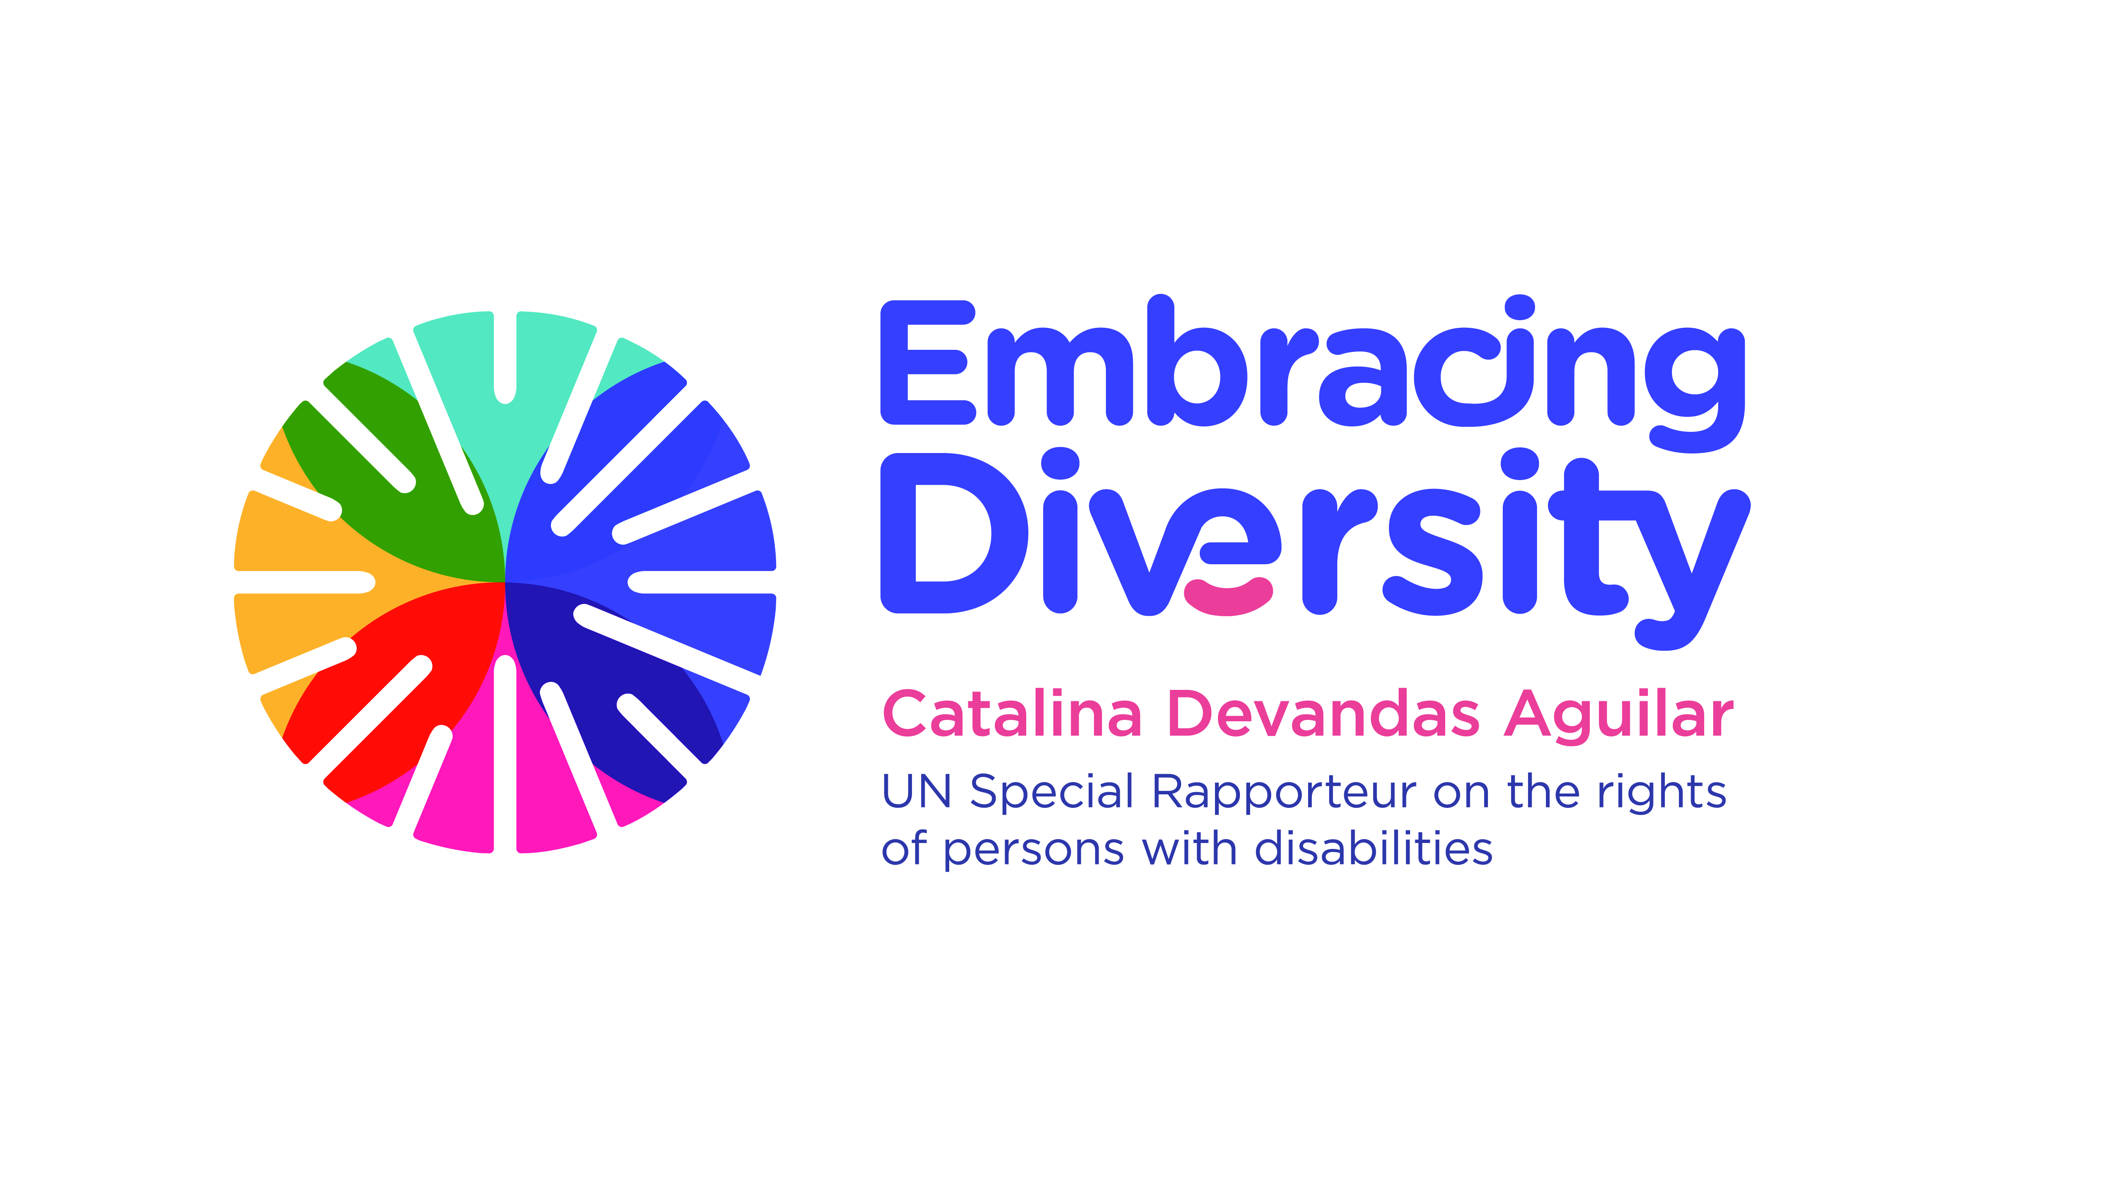


Technical Meeting
The role of the notary in the exercise of the legal capacity of persons with disabilities

23-24 April 2018, Geneva

AGENDA

Monday 23 April 2018

Time | Session | Moderator
09.45-10.00 | Arrival of participants and registration
10.00-10.30 | Opening and welcome remarks  - Ambassador Cristóbal González-Aller Jurado, Permanent Representative of Spain to the United Nations in Geneva  - Mr José Marqueño de Llano, President of the international Union of Notaries  - Philippe Lortie, First Secretary of The Hague Conference on Private International Law  - Ms. Catalina Devandas Aguilar, Special Rapporteur on the rights of persons with disabilities
10.30-10.45 | Presentation of participants and objectives of the meeting | Almudena Castro-Girnona
10.45-13.00 | The Convention on the Rights of Persons with Disabilities and the paradigm shift towards universal legal capacity  - The human rights-based approach to disability  - The importance and principles of the Convention  - The incorporation of the Convention in the domestic law  - The normative content of art. 12 of the Convention and the jurisprudence of the CRPD Committee  - Law reform trends on legal capacity | Moderator:  Catalina Devandas  Panellists:  Cristina Guilarte Facundo Chávez  Alberto Vásquez
13.00-15.00 | Lunch break
15.00-16.30 | Exploring the role of notaries in the promoting and respecting the right of persons with disabilities to exercise their legal capacity  - Entry points and challenges in the recognition of legal capacity of persons with disabilities in the exercise of the notarial function | Moderator: José Marqueño de Llano  Panellists:  Almudena Castro-Girona Martinez  Manuel Lora-Tamayo
16:30-18:00 | Accessibility requirements for exercising legal capacity  - Accessibility of information, communications and other services  - Facilitating the use of sign languages, Braille, augmentative and alternative communication, and all other accessible means, modes and formats of communication  - The duty to provide reasonable accommodation | Moderator:  Joel Schwachtgen  Panellists:  Almudena Castro-Girona Martinez.  Christine Morin

Tuesday 25 April 2018

Time | Session | Moderator
10.00-10.15 | Recap of the first day | Catalina Devandas
10.15-11.30 | Respecting the legal capacity of intervening parties  - The capacity assessment  - The duty to provide advice  - Access to support for decision-making  - Interpreting the will and preferences | Moderator:  Donatella Quartucho  Panellists:  Federico Cabello de Alba  Otilia Zito Fontan
11.30-13.00 | Facilitating alternatives to guardianship and curatorship  - Advance directives  - Powers of attorney  - Supported decision-making arrangements  - Trusteeship and protected assets | Moderator:  Philippe Lortie  Panellists:  Patricio Monzon Moreno  Rosalia Mejia Rosaco
13.00-15.00 | Lunch break
15.00-16.45 | Moving forward: enhancing the role of notaries  - Capacity building and awareness-raising  - Law reform opportunities  - Future actions | Cristina Guilarte
16:45-17:00 | Closing remarks  - Special Rapporteur on the rights of persons with disabilities, Ms. Catalina Devandas Aguilar | Catalina Devandas Aguilar

