INTERNATIONAL DISABILITY ALLIANCE (IDA)
Member Organizations:
Arab Organization of Persons with Disabilities,
Down Syndrome International, European Disability Forum,
Inclusion International, International Federation of Hard of Hearing People,
Latin American Network of Non-Governmental Organizations of Persons with Disabilities and their Families, Pacific Disability Forum,
World Blind Union, World Federation of the Deaf,
World Federation of the DeafBlind,
World Network of Users and Survivors of Psychiatry
Submission on Article 19
Reference: Letter dated 8.7.2014 from the OHCHR requesting information on Article 19 Living independently and being included in the community, to prepare a study on the topic in light of the HRC resolution 25/20

- Overview
- Link to other CRPD articles
- What does living independently and being included in the community mean for all persons with disabilities as per the CRPD?
- What actions can the States take to ensure that all persons with disabilities can live independently and be included in the community as per the CRPD?
- Glossary

1. Overview
Throughout history, persons with disabilities have been locked-up, hidden away and banished. This segregation and isolation has had long reaching and dangerous implications for the rights of persons with disabilities. Fundamentally, it has meant a denial of humanity; a sense that persons with disabilities could be treated differently; a sense that persons with disabilities were not the same as persons without disabilities.
Experiences of institutionalization and/ or isolation of persons with disabilities within their communities over centuries that have resulted in exclusion from the social, economic and political participation is one of the major reasons for the provisions of article 19 in the Convention.
Article 19 requires States to recognise and respect the right of persons with disabilities to live independently and be included in the community. It means that persons with disabilities should have the choice, on an equal basis with others, on the way they want to live in and participate in their community. This is not merely an issue of being in the community but having the legal right to exercise personal autonomy and having the means and necessary support to participate meaningfully to community ife and development on equal basis with others.
“Living independently” in the title of CRPD Article 19 does not necessarily mean living alone. It refers to the Preamble to the CRPD, paragraph (n) of which sets out that the global community recognise “the importance for persons with disabilities of their individual autonomy and independence, including the freedom to make their own choices” as well as build on the principle of “respect for inherent dignity, individual autonomy including the freedom to make one’s own choices, and independence of persons” (article 3(a) of the CRPD).
Article 19 articulates 3 key elements:
- Respect for choice on equal basis with others, of an individual about her/his living arrangement (where and with who) and about her/his participation in community
- Duty to provide access to necessary support services as conditions for free choice on equal basis with others. This implies availability, affordability and quality of services.
- Duty to ensure that all community services are inclusive, accessible and responsive to the needs of persons with disabilities (including labour market, housing, transportation, health care, education etc.) and devlop according to universal design.

Persons with disabilities must have the opportunity to choose their place of residence and where and with whom they live on an equal basis with others and are not obliged to live in a particular living arrangement.
This obligation can be violated in three ways. First, laws or practices may prevent persons with disabilities from exercising choice about their living arrangement – for example, when laws permit institutionalization of a person against his or her will or by consent of a substitute decision-maker, or when families or caregivers confine a person or restrict his or her choices. Second, housing opportunities for persons with disabilities may be limited because of financial resources or accessibility problems, and the individuals may be forced to live in an institution as a result. Third, certain living arrangements violate the right to live independently and be included in the community because of the restriction on personal autonomy and the control given over to caregivers who become in effect substitute decision-makers. These arrangements should be considered institutions whether or not they are named as such, and they must be phased out as recommended in Concluding Observations of the CRPD Committee. This includes many group homes, community residences and supportive housing arrangements provided through mental health services, and assisted living facilities, as well as nursing homes, social care institutions, psychiatric institutions, and residential institutions for people with intellectual disabilities and people with physical disabilities.
To enable all persons with disabilities to live independently, the State is required to provide a range of in-home, residential and community support services that may include community support and personal assistance services, respite services etc.. Those services should be made available and affordable (article 28) to support living and inclusion in the community, and to prevent isolation or segregation from the community;
Also the State is required to ensure that people with disabilities can access all community services and facilities on an equal basis with others and be responsive to their needs. This includes a wide range of services and facilities including schools, primary health care, work places, entertainment areas etc.
We know that children with disabilities become vulnerable to institutionalization and/or neglect when their families don’t have access the supports they need to enable their sons and daughters to live meaningful and inclusive lives in their family and community.

Link to other CRPD articles

Article 19 is interconnected intensively with most articles of the Convention, in particular:
- Article 5: non-discrimination including provision of reasonable accommodation is paramount to living independently and being included in the community
- Article 6 Women with disabilities: particular attention should be paid to gender equality in many instances women and girls with disabilities have their choices more restricted than men and boy with disabilities
- Article 7 Children with disabilities: respecting the evolving capacities of children with disabilities and supporting them having a say on choices that impact them is critical
- Article 8: awareness raising is essential to create open, enabling and inclusive community
- Article 9: accessibility implies general accessibility of all public places, transport and services open to public in the community
- Article 12 equal recognition before the law: article 19 is mostly about choice of people with disabilities and in that it is strongly linked to article 12 which ensure that all people with disabilities have the right to exercise their full legal capacity and therefore have the equal right to decide where they want to live and with whom they would like to live, in an arrangement that is suitable to them.
- Article 14 which prohibits forced placement and institutionalisation, as well as forced hospitalization and any short- or long-term detention in mental health facilities, is also a key precondition for the full implementation of article 19. The right to remain at liberty in the community and not be subject to discriminatory or otherwise arbitrary detention is essential for the participation and inclusion in the community on an equal basis with others.
- Article 15 prohibits compulsory medical treatment including compulsory psychiatric interventions. People with psychosocial disabilities have the right to live as they are and to be included in the community without being forced to undergo chemical, electrical, or surgical alteration of the mind and brain. Both inpatient and outpatient forced interventions must be prohibited.
- Article 20: personal mobility, without support to personal mobility living independently is considerably more difficult for many persons with disabilities
- Article 21: Freedom of expression and opinion, and access to information: persons with disabilities have the right to access all public information in accessible format and have the right to seek, receive and impart information and ideas on an equal basis with others and through all forms of communication of their choice,
- Article 23: right to home and family: support should be granted to parents with disabilities as well as children with disabilities and their families so that they can live independently in their community.
- Article 24,25,26,27: which describes how different services shall be available and responsive to needs of persons with disabilities
- Article 28: Adequate Standard of Living and Social Protection which stipulates that the State is required to take steps to ensure a adequate standard of living for people with disabilities – including the ability to live in housing that is comparable to others in the community – and to support them in accessing affordable disability related services and devices as well as getting assistance to face disability related extra cost if they are in poverty.
- Article 29: Participation in political and public life: in order to influence and to take part in decisions impacting the development of their community, all persons with disabilities should enjoy and exercise their rights to participation in political and public life on equal basis with others

Article 19 is more than the sum of all those rights as it affirms that all those rights should be exercised and enjoyed in the community where a person chooses freely to live in and to participate in.

What does living independently and being included in the community mean for all persons with disabilities?

Living and being included in the community means that persons with disabilities are able to live a “typical” life. It is a right for all persons. Living and being included in the community is not subject to proving one’s ‘ability’, ‘eligibility’ or ‘entitlement’.
“ Participants taking part in an Inclusion International regional forum in Nepal in 2012 defined community as: a place where you belong; a place where family, friends and neighbours enjoy life together; where people support one another. Living and being included in the community means having friends and living a typical life; it means being respected. Being included in community life – school, recreation etc – also strengthens social relations and networks.”

Various factors and multi-sectoral issues have resulted in persons with disabilities being denied the right to live and be included in the community. Prejudices, lack of awareness, lack of support services, omnipresent discrimination and barriers in the community have constantly contributed to isolation and restriction of participation of persons with disabilities in their community all other the world and through ages. In addition, in many countries, the development of residential institutions, small or large, and the placement of persons with disabilities, children, adults and elderly alike, have validated the “normality” of exclusion and segregation of persons with disabilities, making it in some countries a “right” and a “benefit” to be institutionalized.
Similarly, in most countries some form of confinement practices exist that deprive persons with disabilities of their liberty on the basis of their disability contrary to Articles 14 and 19. These practices are wrongfully legitimized in mental health laws which regulate the practice of commitment to psychiatric institutions or hospitals and forced interventions including the administration of mind-altering drugs as well as restraints. These laws too validate the “normality” of exclusion and treat acts of medical violence as a “right” and “benefit”. They also alienate the community from persons with psychosocial disabilities and create a situation of insecurity for persons with disabilities who are vulnerable to repeated instances of discriminatory detention at the behest of neighbors, family members, service providers and police. Many countries have also enacted laws allowing compulsory treatment in the community, which further encroaches on the security, integrity and autonomy of the person and isolates individuals under a regime of medical control.
In most countries of the global south there are few institutions but there is also very little support in the community for persons with disabilities and their families as well as very strong stigma leading to loss of choice and autonomy of persons with disabilities and isolation within their communities.
Article 19 addresses those different contexts and situation. While the starting point may be different, the outcomes should be the same: choice, access to support, as well as accessible and responsive community services enabling living independently and being included in the community.
“The world over, people live in various settings that together make up the range of living schemes in a given society. In some places, people of all ages live with their extended families; in other communities, members of nuclear families cohabitate only until a particular stage of life, after which they move out of their parents’ house to live alone, with housemates, or with their own newly-established families. In some societies, communal life is more common, while in others individual lifestyles are the norm. Whichever the scheme, living as a part our communities – from local to global – serves as the basis for everything we do in life. Living and being included in society is about being able to share in those schemes available and utilised by people in that society.”
Common principles but diversity of requirements for living independently and being included in the community
It is important to acknowledge also that persons with disabilities might have different requirements for support and inclusion and that policies and practices need to address this diversity while always respecting the principle of personal autonomy, including freedom to make one’s own choice.
- Blind persons

Blind persons may require training in mobility, specific daily living activities related skills, access to assistive devices and personal assistance, and of course accessibility, including information in most accessible formats such as braille, large print, audio, electronic text, of community services and places, including transportation.
- Deaf persons

Deaf persons need to receive community services in sign language and to be able to express themselves freely in sign language when interacting with e.g. support service personnel who should be proficient in sign language. Deaf persons may benefit from assistive devices in living independently.
- Deafblind persons

Deaf blind persons may require training in mobility, specific daily living activities related skills, access to assistive devices, personal assistance and interpreters, and of course accessibility of community services and places, including transportation
- Persons that are hard of hearing

Persons who are hard of hearing may require access to hearing aids, assistive devices, and captioning as well as accessibility of public places and accommodation.
- Person with intellectual disabilities

Persons with intellectual disabilities may require training and counseling in daily living skills, personal assistance or community support network. It implies also significant awareness and shift of attitudes within community to understand the different abilities and support needs that person with intellectual disabilities might have.
- Persons with low vision
Persons with low vision may require training in mobility, access to assistive devices, specific daily living activities related skills, availability of personal assistance at some point, and of course accessibility of community services, including access to information, and places, including transportation.
- Persons with physical disabilities

Persons with physical disabilities may require assistive devices, adaptation of their home, as well as personal assistance support and counseling for performing their activities of daily living depending of their level of support needs. It is important to note that while accessibility of housing, transport and other community services and facilities will progressively decrease the need for support for many of them, the provision of personal assistance according to person’s choice will always be a key element for those with higher support needs.
- Person with psychosocial disabilities

Persons with psychosocial disabilities may choose to access personal assistance, peer support or community support network, crisis planning, peer crisis respite, and a wide range of practices that meet the person on his or her own terms to provide meaningful support as an alternative to the medical model of mental health. Such practices include, for example, family group conferencing for supported self-decision in a crisis situation, personal advocacy (Personal Ombud/PO), and support groups for people who hear voices or who have unusual beliefs or fears (labeled as delusions or paranoia). They also include mental health services that are based in community organizing work and promotion of mental well-being as opposed to the medicalization of life problems and experiences of severe distress and altered reality. It implies also significant awareness and shift of attitudes within community to understand the support needs that person with psychosocial disabilities might have.

- What actions can the States take to fulfill article 19?

Examples of actions that the State may take may include:
- Always consult with DPOs under Article 4.3

- Modify existing legal framework to ensure that it is not discriminatory against any group of disabled people. This includes the abolishment of legislation allowing guardianship and forced institutionalization or hospitalization, including abolishment of detention in any kind of mental health facility.

- Ensure a cross government, coordinated approach to develop the necessary range of reforms and innovation needed from different sectors and ministries. It is also crucial to ensure coordination, planning monitoring and evaluation, in the frame of decentralization, as in many countries, the delivery of many community services are under the responsibility local authority level.

- Develop systems and provide adequate resources for development, and provision of affordable support services for persons with disabilities including for children with disabilities and their families. These supports may include personal assistance, income support and financial support for disability-related costs, In-home support and adaptations, accessible transportation…

- Provide timely, accurate and up to date information, in accessible format, essential for informed decision making on choices towards independent living in the community of their choice.

- Ensure awareness raising and support to families so that they are in better position to provide support to the persons with disabilities according to the principle of personal autonomy and freedom to make one’s own choice.

- Ensure availability of accessible and affordable housing in all communities.

- Unbundling of the access to support services and living arrangement

- De-institutionalization: Cease investments in the creation of new institutions, renovation of existing institutions for people with disabilities, and stop the inflow of persons with disabilities in those existing institutions. This includes congregate living situations in which personal autonomy and choice are restricted and caregivers exercise de facto substitute decision-making. Progressively close all segregating residential institutions and redirect funds into the development of community support services and affordable and accessible housing. Ensure that people leaving institutions have freedom of choice with respect to services of any kind, and that services are not bundled; for example, a person should be able to receive housing without having to accept case management, medication or day treatment services, or to accept any of these services while rejecting another.

- Develop, implement and monitor policies ensuring that mainstream community services and facilities are equally accessible and responsive to needs of persons with disabilities.

The full implementation of Article 19 cannot solely be secured through laws and services provisions. It is ultimately about community transformation. CRPD compliant laws, provision of support services and enforcement of non discrimination and accessibility are essential elements that can contribute to the creation of a virtuous cycle in which higher level of participation of persons with disabilities thanks to support services and greater accessibility generates more awareness and openness from communities, which in turn contribute to greater removal barriers and inclusion which in turn facilitate participation of persons with disabilities…

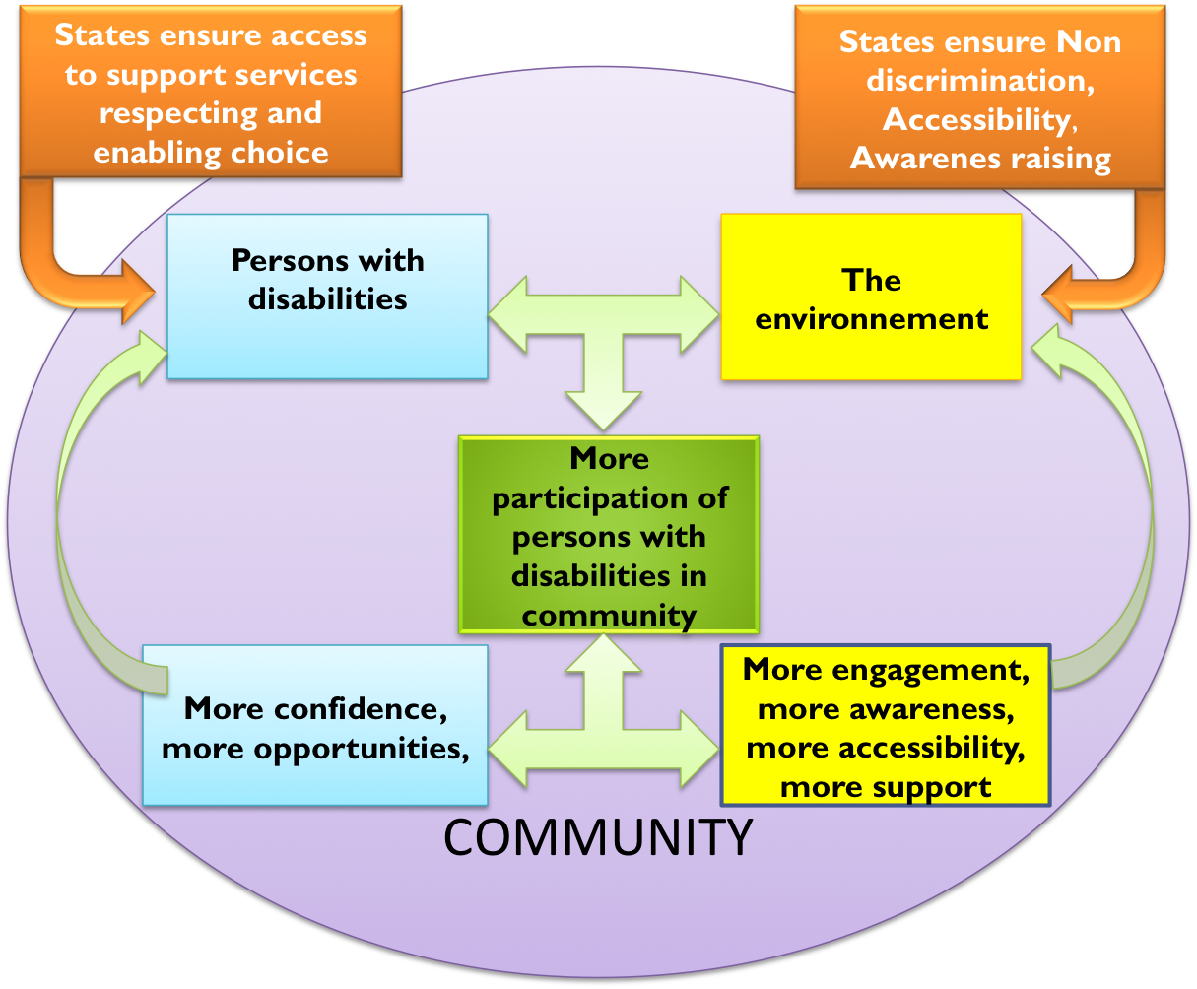
5. Glossary
- What is an institution?

According to the European coalition for community living, “an institution is any place in which people who have been labeled as having a disability are isolated, segregated and/or compelled to live together. An institution is also any place in which people do not have, or are not allowed to exercise control over their lives and their day-to-day decisions. An institution is not defined merely by its size”.
Trends in many countries have been to reduce the size of institution and the number of inmates but with no significant changes in the system. The level choice and control exercised by the person over her/his life choices as well as day to day activity is the criteria to assess institutionalization.
- What is a community support network?

For many persons with disabilities support to live in the community is not much about overcoming physical barriers rather than being supported in managing some interactions, in specific situations or getting support to make informed decision.
Community support network can take many different forms. The main idea depending on the support needs of the person is about having key people in the community, families, friends, frequently used service providers who know the person and some of the issues he/she might have in given circumstances and that can be supportive to him/her in managing daily living issues, making important decision or overcoming crisis moment. It is crucial that the person’s autonomy and choices are fully respected. A particular individual may want certain family members to be involved or to be kept out, to include service providers or avoid service providers, etc.
- What is personal assistance service?

Personal assistance service in the frame of article 19 does refer to a human support delivered to an individual with respect to his/her own choice.

There is not one definition of personal assistance. The independent living movement describes it as follows:

“The term personal assistance user refers to a disabled person choosing a personal assistant of their choice to aid them in everyday tasks and in negotiating environmental, transport and other social barriers. However, not all disabled people want or require personal assistance, but all disabled people including those that use or wish to use personal assistance want to exercise choice, control and self-determination over their own lives.

Dr Adolf Ratzka (Ratzka 2004) and the European Centre for Excellence in Personal Assistance (ECEPA), which sets key principles in place:
- The funding of [personal assistance] services follows the person and not the service provider
- Personal assistance users are free to choose their preferred degree of personal control over service delivery according to their needs, capabilities, current life circumstances, preferences and aspirations.
- Their range of options includes the right to custom-design their own services, which requires that the user decides who is to work, with which tasks, at which times, where and how.
- Therefore, a policy for “personal assistance”, among other solutions, enables the individual to contract the service of his or her choice from a variety of providers or to hire, train, schedule, supervise, and, if necessary, fire his or her assistants. Simply put, "personal assistance" means the user is customer or boss. (Ratzka 2004: 2-4)

- How can Community Based Rehabilitation support implementation of article 19?

While many support services have been made available in high income countries in recent years, in middle and low income countries, care is mostly provided by the family, friends or neighbors, with very little to no services supported by the state. NGO support services tend to be center based. CBR originally did not focus on support to living independently, but it now conceptually moving towards it with the new WHO/ILO CBR guidelines. For CBR programs, supporting living independently and being included in the community means that rehabilitation is not the focus anymore, while still provided, but rather meaningful participation and choice.

Some actions that the CBR programmes can undertake to support independent living of persons with disabilities include:

- Developing accepted standards with persons with disabilities, their families and the community in relation to personal assistance and support its development
- Initiate development of support network
- Support local community services in being accessible and responsive to the needs of persons with disabilities
- Ensure that programs being developed include people with psychosocial disabilities on an equal basis with other people with disabilities and that their needs are not translated into medical terminology but can be met on their own terms

The International Disability Alliance (IDA) is a network of eight global and four regional organisations of persons with disabilities and their families (DPOs), representing the estimated one billion persons with disabilities worldwide. Founded in 1999, as a network of international disability rights organisations, a unique composition, that allows IDA to act as an authoritative and representative voice of persons with disabilities in the United Nations (UN) system in New York, Geneva and worldwide. IDA’s Advocacy seeks to advance Human Rights utilising the UNCRPD and other Conventions, harnessing the strengthened united voice of its members, forging working relationships with partners to achieve common goals inclusive of persons with disabilities worldwide.

Geneva Office: 150 route de Ferney, PO Box 2100, CH 1211 Geneva 2, Switzerland
New York Office: 245 Park Avenue, 39th Floor, New York, NY 10167, United States
Contact email: info@ida-secretariat.org
IDA Website: http://www.internationaldisabilityalliance.org/en

“the right of people with disabilities to live independently and be included in the community” Issue paper commissioned and published by the European commissioner for human rights (2012).

