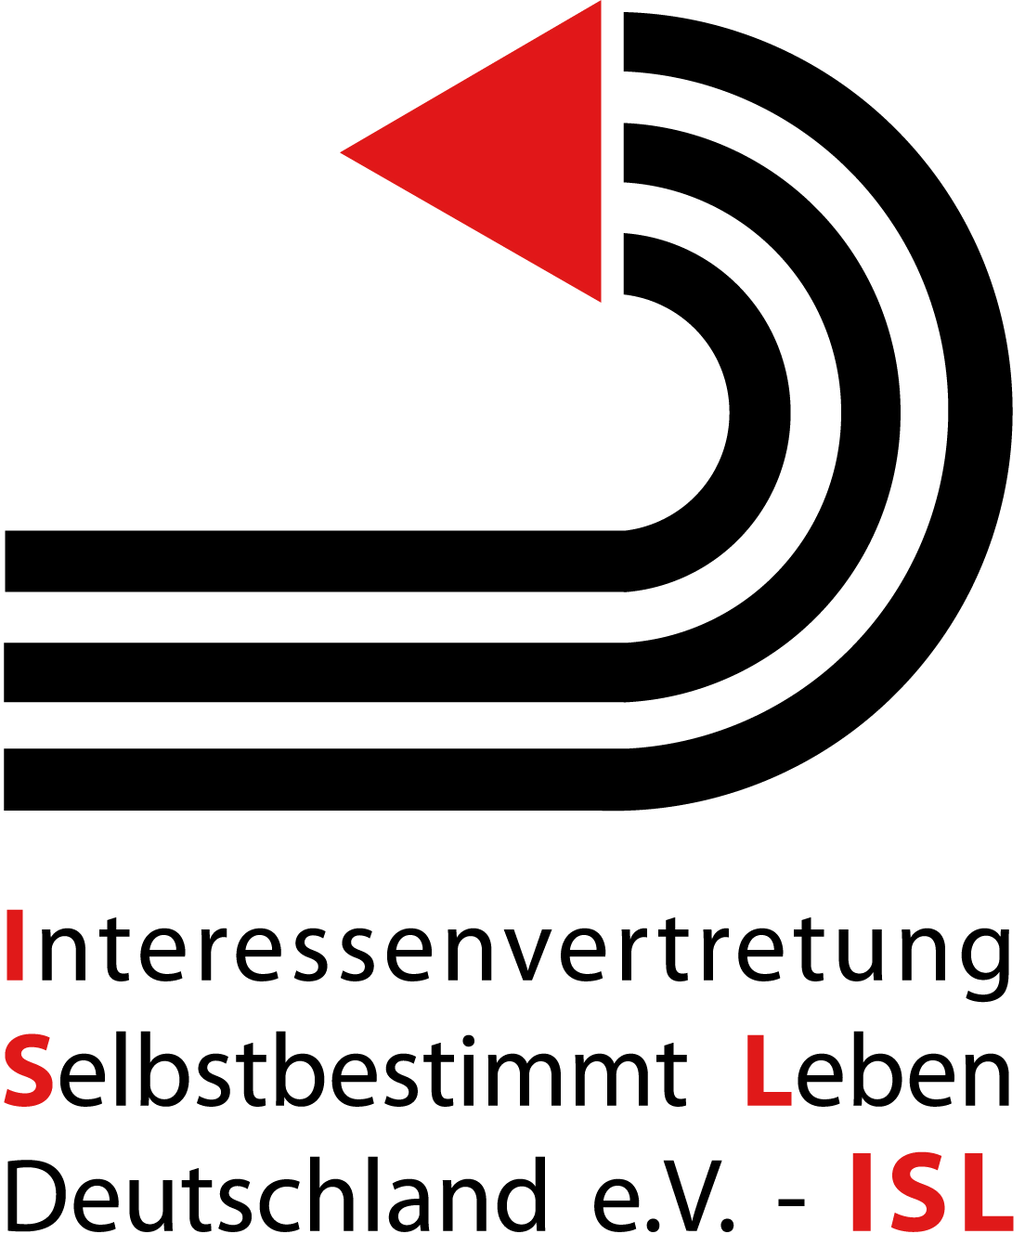

Submission of ISL e.V. (DPI-Germany): OHCHR Thematic Study on Participation of Persons with Disabilities in Political and Public Life

The Interessenvertretung Selbstbestimmt Leben in Deutschland e.V. (ISL) is the umbrella organisation of the German centers for independent living and the German branch of Disabled Peoples`International (DPI). ISL/DPI-Germany welcomes the efforts relating to the new OHCHR-Thematic Study on participation and wants to make a short contribution concerning the right to vote, missing standards for participation and the appreciation of DPOs.

- Right to vote in Germany – Persons under full guardianship

The Federal Electoral Law of Germany denies the right to vote in Article 13 for persons under full guardianship („alle Angelegenheiten“). The same exclusion is fixed in the relevant articles of the Electoral Laws of the sixteen Bundesländer. There is no official data how many persons are affected. There is only one unofficial estimation concerning the Bundesland Bremen: 0,032% of the population i.e. 136 persons under full guardianship in this Bundesland are not allowed to vote.

The total number of persons in Germany that are entiteld to vote is 62,5 million. An ISL/DPI-Germany-estimation for Germany in total considering the number of persons from Bremen says, there must be approximately 20.000 persons under full guardianship in Germany who are excluded from the right to vote.

ISL/DPI-Germany therefore claims the modification of the Electoral Laws in Germany in respect to article 12 and 29 CRPD: Persons under full guardianship shall no longer be excluded from the right to vote!

- Missing standards in participation

Article 4, (3) CRPD says „States Parties shall closely consult with and actively involve persons with disabilities, including children with disabilities, through their representative organizations“.

There are no standards existing in Germany relating to the meaning of this passage of Article 4. There are different opinions between the government and the organizations of persons with disabilities about the „involvement“. The Government uses the German word „Einbindung“ as „involvement“, but this word has the subtext „fixed“ or „tied“. Three examples from Germany: In the process of the translation of CRPD into the German language there was no good participation of the persons with disabilities and their organizations. The result: some key-words are translated incorrectly e.g. „inclusion“, „accessibility“ or „independent“. Therefore the German DPO „NETZWERK ARTIKEL 3“ created a so called „Shadow Translation“ which is broadly accepted in the German Civil Society. The official translation remains wrong with bad consequences for the process of awareness-raising (Article 8) in Germany.

Second example: The slogan of the National Action Plan had been developed without the persons with disabilities and their organizations. After massive protest of the organizations of persons with disabilitiesthe slogan could be altered.

Third example: The Civil Society was not involved in the process of the compilation of the initial State Report. Additionally there was only a short period of two weeks for the Civil Society to submit written comments on the draft of the first German State Report. There was no official hearing.

The German Government argues that the Civil Society had been involved in the development of the Natinal Action Plan and the creating of the Initial State report. Civil Society and DPOs were invited to conferences to create a National Action Plan, but only a small number of the proposals of the Civil Society were integrated in this action plan e.g. there was only a small number of modification of laws in order to implement the CRPD.

For the process of implementation and monitoring of the convention in Germany there are two bodies with different levels of participation: a working committee („Arbeitsaussschuss“) working at the Focal Point (Ministry for Social Affairs-BMAS) and an Advisory Board on Inclusion („Inklusionsbeirat) working with the Federal Commissioner for the Interests of Persons with Disabilities.

In general ISL/DPI-Germany requires the need for a detailed description of good participation, e.g. „Who invites whom? Who sets the agenda? Who can vote? Who can decide? Who can only advise? Should there be a veto? Whats about the resources for DPOs? etc.“

3. Appreciation of DPOs

In Germany there is a long lasting tradition of welfare and care. Great and mighty organizations are existing in this field. As well there are strong organizations resulting from world war I and II. In the 50th and 60th of the last century many organizations developed relating to one special diagnosis like a society referring to rheumatism or multiple sclerosis etc. Those organizations are often dominated by persons without disabilities.

Organizations founded and led by persons with disabilities didn´t arise before the 80th of the last century. Therefore they still have to fight a hard struggle to survive. Additionally their specific qualities are not appreciated and they are not supported. On the contrary: Often we have the impression that DPOs are only tolerated while they should be encouraged and promoted.

Berlin, 2011-08-31

Dr. Sigrid Arnade, CEO, DPI-Germany & H.- Günter Heiden, Press-Officer, DPI-Germany

