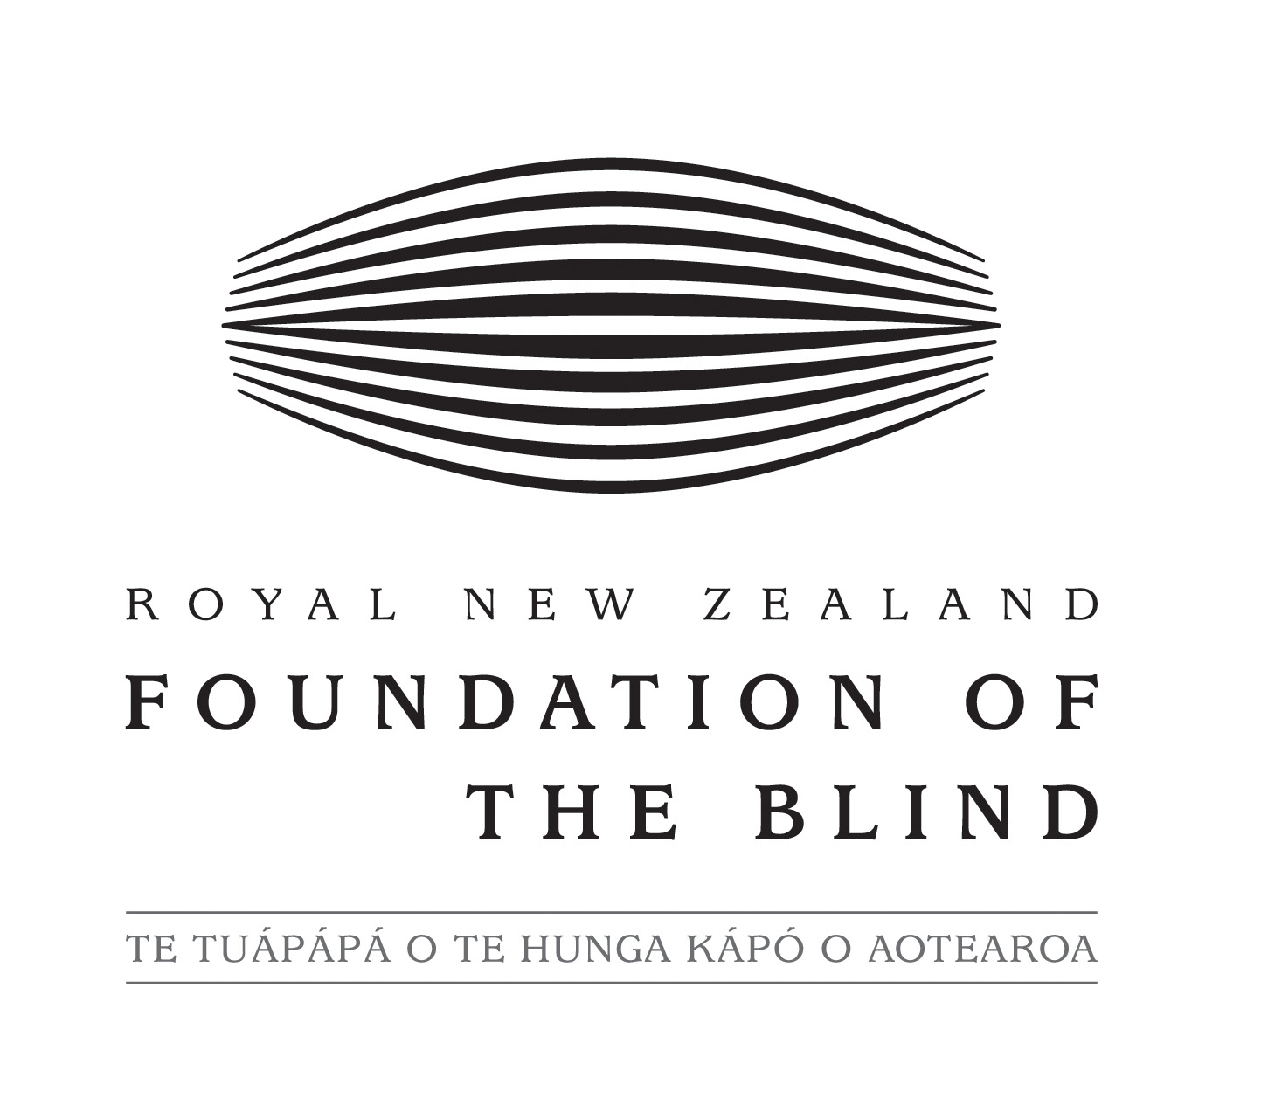

Response to the Thematic Study on Participation of Persons with Disabilities in Political and Public Life

Introduction
This is the Royal New Zealand Foundation of the Blind (RNZFB)’s response to the Office for the High Commissioner on Human Rights' Thematic Study on Participation of Persons with Disabilities in Political and Public Life. The RNZFB appreciates the opportunity to provide input to this study.

The Royal New Zealand Foundation of the Blind
The Royal New Zealand Foundation of the Blind (the RNZFB) is New Zealand's primary provider of vision-related habilitation and rehabilitation services to blind and partially sighted people. The RNZFB's vision is empowering and supporting blind and partially sighted New Zealanders to ensure that they have the same opportunities and choices as everyone else.
The RNZFB has about 11,500 blind and partially sighted members, including many who are deafblind. The RNZFB financially supports and works closely with a network of consumer organisations that directly represent the interests of blind and partially sighted people.
One of the RNZFB's strategic priorities is supporting an accessible and equitable society by removing barriers to full participation.

Questionnaire

1. Are you aware of any restrictions on the right of persons with disabilities to vote and be elected? If so, what are those restrictions?
The RNZFB is not aware of restrictions on the legal right for blind and partially sighted people to vote or be elected.
However, blind and partially sighted people can not fully express the right to vote "by secret ballot" as provided for in the New Zealand Bill of Rights Act 1990. Currently, most blind and partially sighted New Zealanders have to rely on friends, family or strangers to assist them with voting, as no independently accessible voting method is available such as electronic voting, telephone voting or braille voting cards.

2. Are you aware of any good practices to ensure that persons with disabilities participate in political and public life on an equal basis with others?
For blind and partially sighted people, good practices for inclusion include:
- proving accessible independent voting methods, which may include electronic voting, telephone voting or braille-based methods.
- ensuring that all relevant information is available in a range of accessible formats, which may include electronic formats, large print, audio and braille.
- allowing for accessible communication methods in consultation processes, for example receiving written submissions in a range of formats.
- ensuring that public meeting locations or voting places are physically designed to be accessed independently by blind and partially sighted people, for example including braille and tactile print signage.
- providing awareness training for people who are involved in public meetings or voting facilities, so that they are aware of the needs of blind and partially sighted people.

3. Are you aware of any good practices:
(a) to ensure close and active consultation with persons with disabilities and their representative organizations in decision-making processes. Examples could include decisions relating to law and policy as well as to development and humanitarian assistance?
(b) to promote participation in non-governmental organizations and associations?
For blind and partially sighted people, good practices for inclusion include:
- ensuring that all relevant information is available in a range of accessible formats, which may include electronic formats, large print, audio and braille.
- allowing for accessible communication methods in consultation processes, for example receiving written submissions in a range of formats.
- ensuring that meeting locations are physically designed to be accessed independently by blind and partially sighted people, for example including braille and tactile print signage.
- providing awareness training for people who are involved in meetings, so that they are aware of the needs of blind and partially sighted people.

4. Do you have any information on ways that persons with disabilities and their representative organizations are involved in monitoring the Convention? If so, please provide examples.
In New Zealand, the Government's framework to promote, protect and monitor implementation of the Convention includes the Convention Coalition, a grouping of six disabled people's organisations monitoring rights of disabled people. This group sits alongside the Human Rights Commission and the Ombudsmen in providing an independent mechanism for monitoring the Convention. More information about the Government's framework is available online at http://www.odi.govt.nz/what-we-do/un-convention/framework/index.html
The New Zealand Government invited public input to its first official report to the UN on implementing the Convention. This gave an opportunity for disabled people and disability groups outside of the Convention Coalition to provide official feedback on implementation.

5. Are statistics and data collected in relation to enjoyment of the political rights of persons with disabilities? Please provide relevant statistics and data if possible.
The RNZFB is not aware of statistics or data collected specifically in relation to the political rights of persons with disabilities.
New Zealand collects regular statistics on the demographics, living situations and the education and employment of persons with disabilities. This information is available through the Statistics New Zealand website at http://www.stats.govt.nz/browse_for_stats/health/disabilities/DisabilitySurvey2006_HOTP06.aspx

6. Is your organization involved in international cooperation programmes related to promoting political rights of persons with disabilities? Please describe the ways the programmes are inclusive of and accessible to persons with disabilities.
The RNZFB is involved in international partnership with other organisations representing and providing service to blind, partially sighted, deafblind and print-disabled people, including the World Blind Union.
Programmes of work include people with disabilities by specifically including representation from persons with disabilities, and by ensuring that documents and communications are provided in accessible formats.

7. Do you have any additional information you wish to provide?
No.

Further Information
The RNZFB would welcome opportunities to provide more information if required. Please direct any questions to:
Moira Clunie
Insights, Policy & Advocacy Manager
Telephone: +64 9 355 6938
Email: mclunie@rnzfb.org.nz
Royal New Zealand Foundation of the Blind
Private Bag 99941
Newmarket, Auckland

