REFERENCE: | LW/FCP/ky

17 February 2017
Dear Madam/Sir,

Subject: Human Rights Council resolution 31/6

I would like to draw your attention to Human Rights Council resolution 31/6 concerning the rights of persons with disabilities.

Through this resolution, the Human Rights Council requested the Office of the High Commissioner for Human Rights (OHCHR) to prepare a study on article 13 of the Convention on Rights of Persons with Disabilities in consultation with relevant stakeholders, including national human rights institutions, and to present the study to the Human Rights Council before its thirty-seventh session.

In this respect, I would like to encourage your organization to contribute information on any of the issues that you consider relevant to the study. In particular, views and information would be welcome in relation to the following questions:

1. Does your country have laws, policies or guidelines on access to justice, at any level of government, which ensure persons with disabilities, particularly women and children with disabilities:

a. to participate in judicial and administrative proceedings on an equal basis with others in their role as witness, juror, complainant, defendant or other, including through the provision of procedural and age-appropriate accommodations (please identify and share the text of those provisions);

b. to have individual legal standing in all administrative and judicial procedures, including the right to be heard as part of their right to fair trial;

c. to have access to effective remedies that are appropriately proportional to the right(s) infringed and which are tailored to their specific situation; and

d. to have effective access to justice in the context of disasters, migration and asylum-seeking, conflict and post-conflict situations and transitional justice, and formal or informal systems of customary, indigenous and community justice, among others.

1.1 The Constitution of South Africa, Act 106 of 1996 (the Constitution), ensures an environment conducive to the full and equal participation of men, women and children with disabilities in society, including equal access to opportunities, accessibility and the protection of the inherent dignity of the person. The Constitution specifically mentions the principles of non-discrimination based on disability, gender or age.

1.2 The Bill of Rights further provides for equal access to justice through the right to access courts, the right to a fair trial, the rights to appeal and the rights to an interpreter during trial.
1.3 Furthermore, the Promotion of Equality and Prevention of Unfair Discrimination Act 4 of 2000 (PEPUDA) guarantees equality and access to justice PEPUDA finds its constitutional imperative in s 9(2) and (4) of the Constitution. PEPUDA contains generous standing provisions which mean that specialised Equality Courts are open to all persons to institute proceedings. PEPUDA also contains ground-breaking remedies which include audits, special measures and interdicts, as well as reports to the court or another institution as to the progress made in implementing the remedies.

1.4 The Promotion of Administrative Justice Act 3 of 2000 (PAJA) give effect" to the right to just administrative action in the Bill of Rights by providing that everyone has a right to fair, lawful and reasonable administrative action; and to reasons for administrative action that affects them negatively.

2. Do you have examples from your country on:

a. how procedural and age-appropriate accommodations are provided and applied, including protocols or other guidelines;

b. training programmes on the right of access to justice for persons with disabilities for judges, lawyers, prosecutors, police, social workers, language and sign language interpreters, legal aid centres, other judicial and administrative bodies intervening in judicial or quasi-judicial instances;

c. education programmes on the right of access to justice for persons with disabilities for law students as well as in schools of social work, sign language interpretation, forensic science, psychiatry and psychology, among other relevant faculties; and

d. legal aid programmes, public and/or private, which include the right of access to justice for persons with disabilities in their practices, including the availability of support and liaison services for courts or other judicial or quasi-judicial instances.

2.1 With regard to age appropriate accommodations, the Criminal Procedure Second Amendment Act, 1995 (Act 75 of 1995) governs the judicial processes and procedures associated with all crimes including those against children. It also provides for the use of intermediaries in cases where children have to give evidence in court. The Children’s Act 38 of 2005 recognises the special needs of children with disabilities as one of its main objectives. Section 6 of the Act calls for all proceedings, actions or decisions in a matter concerning a child, to protect the child from unfair discrimination on the grounds of the disability of the child or a family member of the child, and calls for an enabling environment to respond to the special needs that the child might have. In addition, the State has created special Courts such as the Children’s Courts.

2.2 In terms of training programmes, the South African Judicial Education Institute Act of 2008 established the South African Judicial Education Institute (SAJEI) to provide for the education and training of judicial officers in a quest to enhance service delivery and the rapid transformation of the judiciary. Furthermore, the South African Police Service (SAPS) has prioritised the training and sensitisation of SAPS personnel towards the rights of persons with disabilities. A total of 9,555 staff members attended 527 workshops between the period 2010- 2011, and an additional 196 SAPS managers participated in 10 workshops during the same period. Over 17,571 participants participated in a total of 249 disability related calendar events.
However, there is a shortage of trained professionals for both the judiciary and legal professions.

2.3 South Africa has undertaken a number of actions in order to raise awareness of the rights of persons with disabilities and inform persons with disabilities and society in general about the obligations contained in the CRPD. The challenges in relation to accessing equality courts relate to the lack of information to persons with disabilities regarding its existence, despite on-going road shows and awareness campaigns among the general population conducted by the SA Human Rights Commission and the Department of Justice and Constitutional Development.

2.4 Government has created a range of institutions and mechanisms for facilitating equal access to justice. Among these institutions and programmes is Legal Aid, providing legal assistance at the expense of the State especially to impoverished persons. With regard to access to courts by persons with disabilities in rural areas, the Proximity of Courts Programme is noteworthy. This service provides periodic courts to rural and remote communities that would otherwise have no access.

3. Does your country have laws, policies and strategies to ensure the participation of persons with disabilities on an equal basis with others in the judiciary or other judicial or quasi-judicial instances, including in their role as judges, witnesses, jurors, lawyers or any other active party to judicial or quasi-judicial procedures?

3.1 The Constitution and the Promotion of Equality and Prevention of Unfair Discrimination Act (Act 4 of 2000) (PEPUDA) provide for equal enjoyment of all rights and prohibits unfair discrimination on several grounds including disability. The state has further passed the White Paper on the Rights of Persons with Disabilities which aims to reduce the marginalization of persons with disabilities. Additionally, the state has enacted the Employment Equity Act 55 of 1998 (EEA) and the Labour Relations Act 66 of 1995 (LRA). These Acts give effect to the equality clause, the right to fair labour practices, as well as the international and foreign norms in respect of fair labour treatment of persons with disabilities. They are intended to eliminate labour policies and practices that unfairly discriminate on the basis of disability, and they provide positive measures, including affirmative action, to advance persons with disabilities in the workplace.

4. Does your country monitor and collect disaggregated data with respect to access to judicial or quasi-judicial procedures concerning:

a. the participation of persons with disabilities in judicial or quasi-judicial procedures, including the number of complaints submitted, nature of complaints and outcomes;

b. persons with disabilities obtaining remedies and the nature of those remedies, whether they are adequate, effective, prompt and appropriate, responding to their specific situation;

c. persons with disabilities being convicted, the nature of their sentence, and whether they benefitted from safeguards of the right to fair trial on an equal basis with others; and

d. the opening and conduct of impartial and independent investigations of human rights violations of persons with disabilities, particularly those relating to the right to life, liberty and security of the person, freedom from violence, abuse and exploitation, and freedom from torture or cruel, inhuman or degrading treatment or punishment.

4.1 Disaggregation of disability-related statistics and data across all government institutions remains a challenge, including the reliability of such data where it exists, remains a challenge.

4.2 The South African Human Rights Commission (SAHRC), established by sections 181 and 184 of the Constitution, constitutes the independent monitoring mechanism envisaged in Article 33 of the Convention. The SAHRC has since developed a Disability Toolkit which contains manuals and other support materials for caregivers, businesses, trainers and other relevant stakeholders. The Disability Toolkit is aimed at spreading awareness about issues affecting persons with disabilities It is however acknowledged that the Commission’s current capacity does not enable it to meet its obligations as required by the CRPD sufficiently.

4.3 In terms of impartial investigations of human rights violations, in the financial year ending 31 March 2016, 16 percent of the total complaints received by the SAHRC alleged a violation of the right to equality. Of the 505 equality related complaints, 9% (45) were on the grounds of disability. However, the data in this regard does not indicate what the particular form of unfair discrimination. In terms of the nature of complaints, particularly those lodged at Equality Courts, it appears that complaints related to hate speech are especially prevalent, accounting for over 40 percent of overall grievances. Complaints of unfair discrimination represented the second largest proportion of Equality Court matters at 32 percent.

Table 3: Department of Justice Equality Court Complaints 2015/16
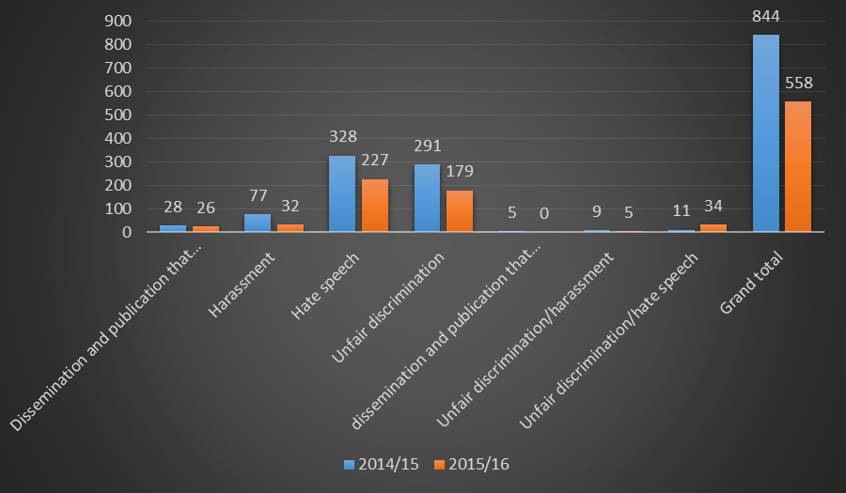

However, it is not clear as to how many of these complaints were opened by persons with disabilities.

I would be grateful if you could send your organization’s contribution to OHCHR at United Nations Office at Geneva, CH 1211 Geneva 10; fax. +41 22 917 90 08; e-mail: registry@ohchr.org; by 1 May 2017, in accessible format so that it can be posted on OHCHR’s website. Please do not hesitate to contact Mr. Facundo Chávez Penillas at disability@ohchr.org or Ms. Victoria Lee at vlee@ohchr.org for further information or clarification.

I thank you in advance for your contribution to this important thematic study.

Yours sincerely,

Bat-Erdene Ayush
Officer-in-Charge
Development and Economic and Social Issues Branch

Department of Justice and Constitutional Development, Annual Report, (2015/16) p. 34.
Department of Justice and Constitutional Development, Annual Report, (2015/16) p. 34.

