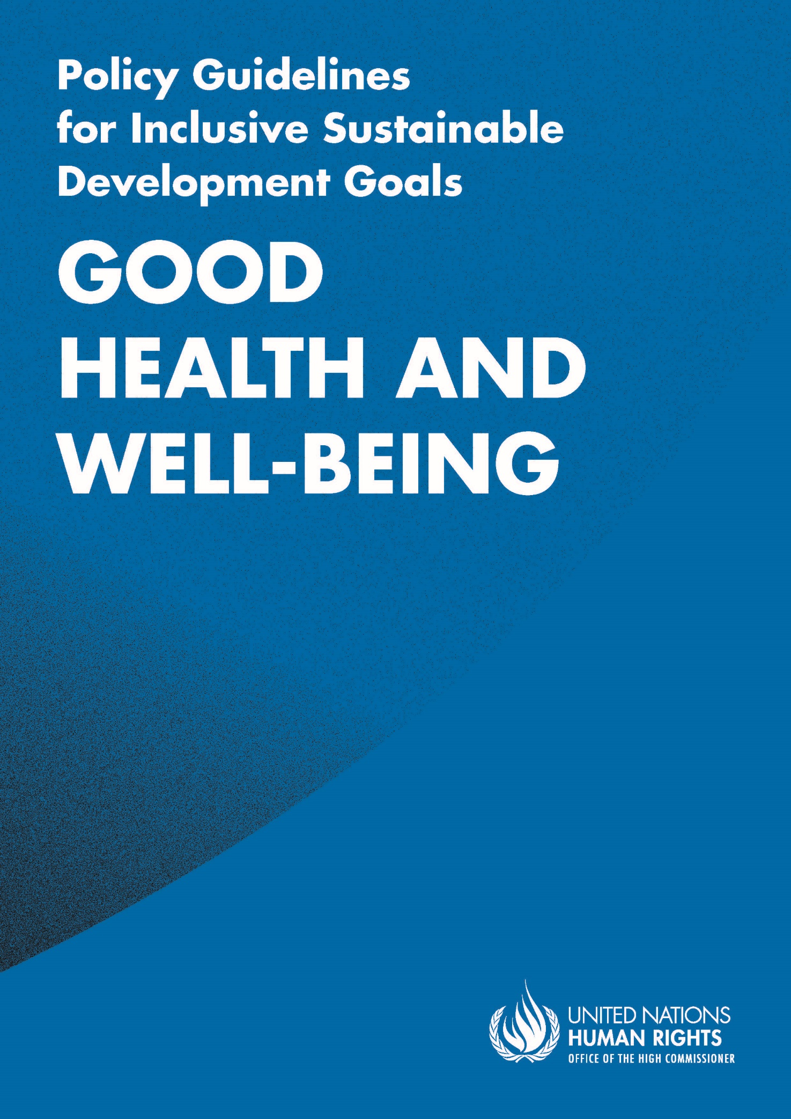

ADVANCE VERSION
© 2020 United Nations
The Policy Guidelines for Inclusive Sustainable Development Goals are a component of the SDG- CRPD Resource Package, developed by the Office of the United Nations High Commissioner for Human Rights (OHCHR). This is an advance version of the SDG-CRPD Resource Package. A final version will be issued upon completion of OHCHR review processes.
The designations employed and the presentation of the material herein do not imply the expression of any opinion whatsoever on the part of the Secretariat of the United Nations concerning the legal status of any country, territory, city or area, or of its authorities, or concerning the delimitation of its frontiers or boundaries.
Symbols of United Nations documents are composed of capital letters combined with figures. Mention of such a figure indicates a reference to a United Nations document.
Photography by Christian Tasso. The photographs featured within the Policy Guidelines were taken as part of the European Union project, Bridging the Gap II – Inclusive Policies and Services for Equal Rights of Persons with Disabilities, and were produced with the financial support of the European Union. They appear courtesy of the International and Ibero-American Foundation for Administration and Public Policies.
The Policy Guidelines for Inclusive Sustainable Development Goals were produced with the financial support of the European Union. Its contents are the sole responsibility of OHCHR and do not necessarily reflect the views of the European Union.

Ensure healthy lives and promote well-being for all at all ages.
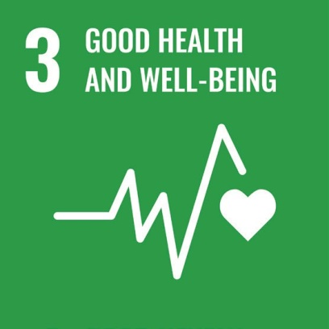

Contents
IN BRIEF 6
1. What is the situation? 7
2. What needs to be done? 10
3. DO’s and DON’Ts 14
IN DEPTH 18
1. Introduction 19
2. Connections to other tools 20
3. Why is Goal 3 important for persons with disabilities? 20
4. Ensure healthy lives and promote well-being for all at all ages: actions applicable across all Goal 3 targets 23
4.1 Leadership, governance and legal framework 24
4.2 Financing 25
4.3 Service Delivery 26
4.4 Health workforce 26
4.5 Medicines and technology 27
4.6 Health information systems 28
5. Other key actions by target 28
5.1 Universal health coverage and access to quality health services, medicines and vaccines: Targets 3.8 and 3.b 28
5.1.1 Ensure that health laws and policies include non-discrimination provisions and enable better access to quality health services 28
5.1.2 Increase access to quality health services, including rehabilitation services, medicines, health products and assistive technology 30
5.1.3 Prevent and mitigate financial hardship and catastrophic health expenses for persons with disabilities 32
5.1.4 Repeal restrictions to insurance schemes based on “pre-existing conditions” 33

5.2 Promote inclusive, human rights-based and community based mental health services: Target 3.4 35
5.2.1 Reform legislation and policy to eradicate discrimination, stigma, violence, coercion and abuse in mental health service provision 36
5.2.2 Develop and promote community-based, person-centred, rights-based and recovery-oriented mental health and psychosocial support services 40
5.2.3 Develop peer-support 40
5.3 Mobilize resources and develop the health workforce: Target 3.c 41
5.3.1 Mobilize and increase resources for the provision of quality health services, notably primary care 41
5.3.2 Build capacity in the health workforce to address barriers and improve quality of services for persons with disabilities 42
5.3.3 Promote the development and recruitment of specialized health and rehabilitation professionals for services for persons with disabilities 43
6. Additional Resources 45
7. Key Concepts Annex 46

IN BRIEF
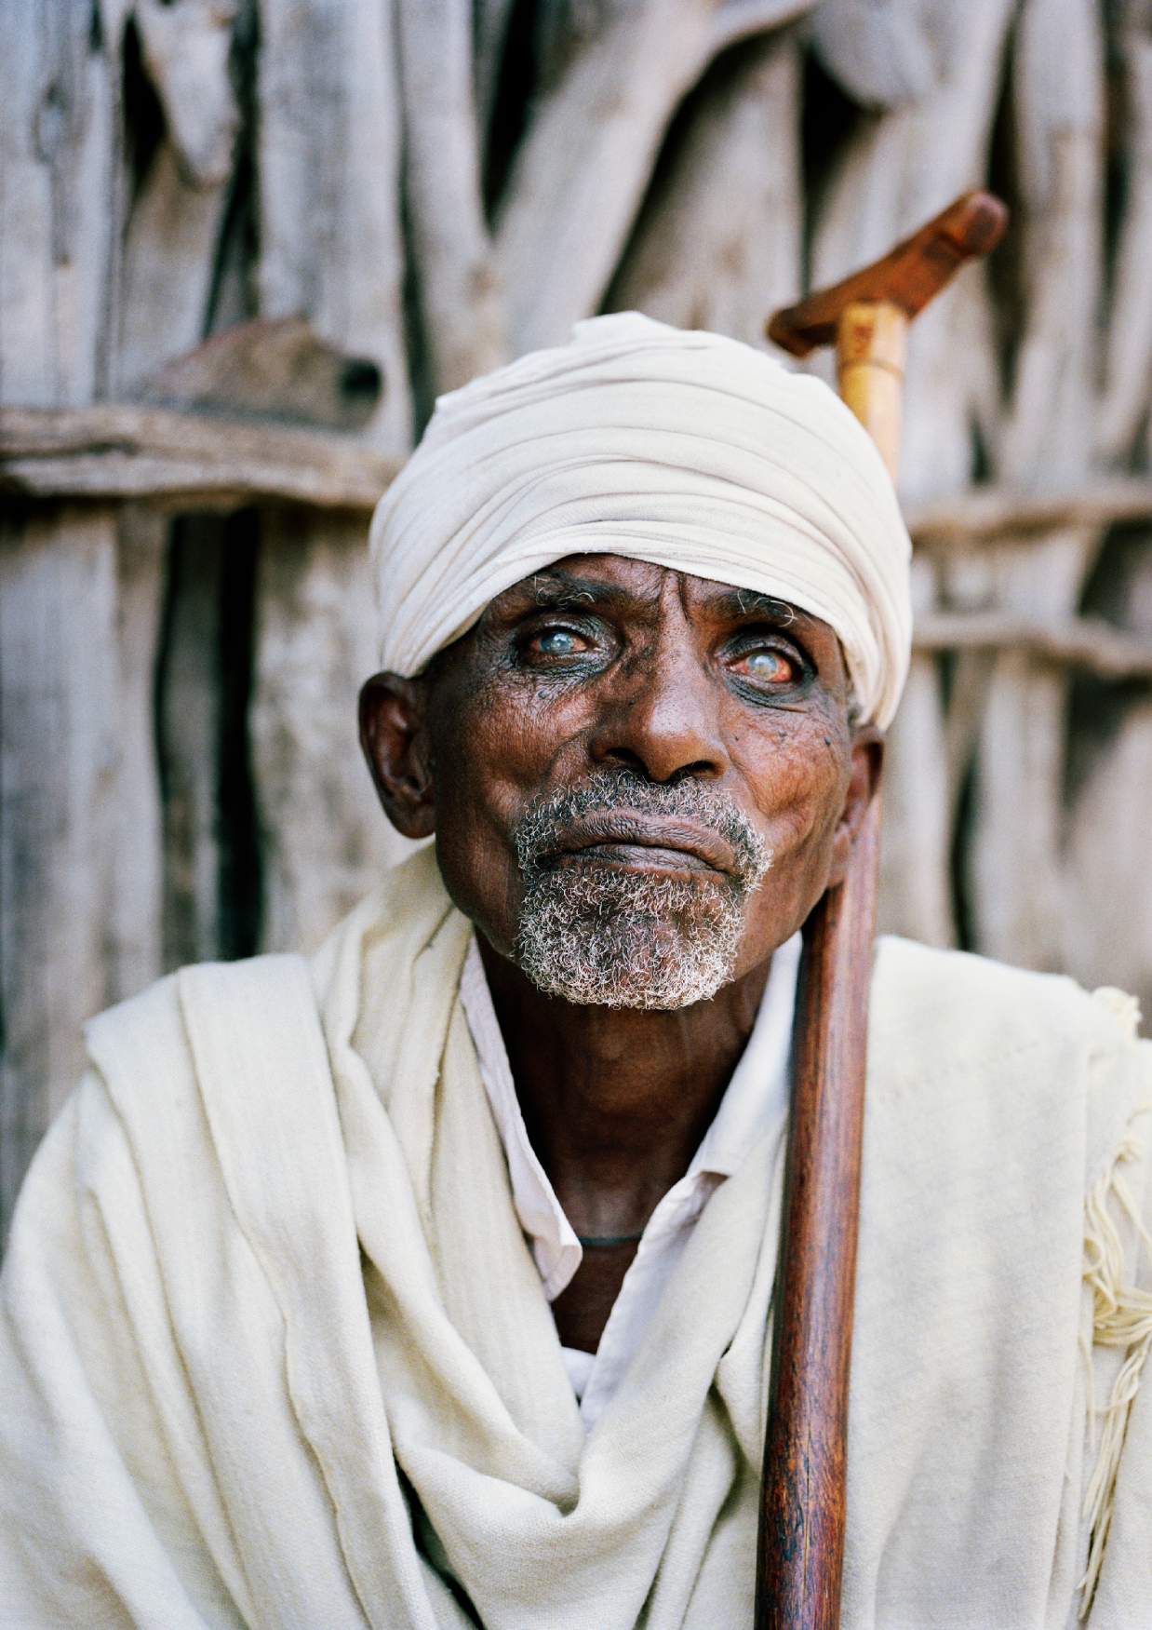

1. What is the situation?
Currently, persons with disabilities face many barriers to accessing the health services that they need. This situation contributes to poor health outcomes, furthering disadvantage and exclusion.
As outlined in the World Report on Disability, 2011, published by the World Health Organization and World Bank, persons with disabilities have higher healthcare requirements, on average, compared to the broader population. Whilst they require access to the same range of general health services as the rest of the population (such as vaccinations and sexual and reproductive health services), persons with disabilities may need access to specialist services and goods related to their disability (such as specific medication, surgery, assistive devices and rehabilitation). They are also more likely to develop further health conditions resulting from their disability (for example, a greater risk of cardiovascular disease for persons with mobility impairments who find it difficult to exercise) and have greater unmet health requirements (such as lower access to preventative care) – data is provided in figure I.
Despite their greater health requirements, persons with disabilities face barriers in accessing healthcare and, consequently, they have less access than others. These barriers include financial barriers; physical barriers related to infrastructure, equipment and transportation not being accessible; communication barriers, such as health information not being provided in accessible formats; and attitudinal barriers, including discrimination and lack of knowledge on disability issues amongst health workers.
figure i
Data from 37 countries show that persons with disabilities report three times more unmet healthcare requirements than others
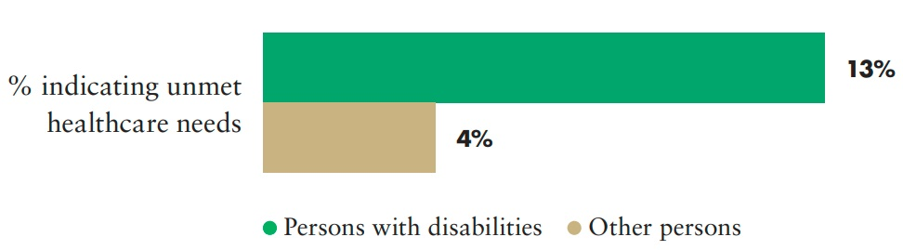
Source: United Nations Department of Economic and Social Affairs, Disability and Development Report, 2019. Figure II.13, p. 53.
Globally, a low percentage of persons with disabilities is able to access the rehabilitation services that they require – see figure II. Where rehabilitation services are available, they tend to be only available in urban areas.
figure ii
Access to rehabilitation services
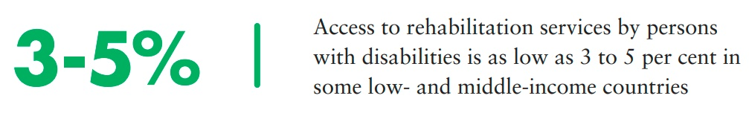
Source: T. Shakespeare, T. Bright and H. Kuper, “Access to health for persons with disabilities”, discussion paper commissioned by the Special Rapporteur on the rights of persons with disabilities (2018), p.23, as cited by United Nations, Report from the Special Rapporteur on the rights of persons with disabilities, Catalina Devandas-Aguilar, 16 July 2018, A/73/161. para. 24
Persons with disabilities find healthcare unaffordable and face catastrophic health expenditure in higher proportions than other persons, as can be seen in figure III.
figure iii
Persons with disabilities are more likely to (1) say they cannot afford health care and (2) to face catastrophic health expenditure, compared to persons without disabilities, across all countries
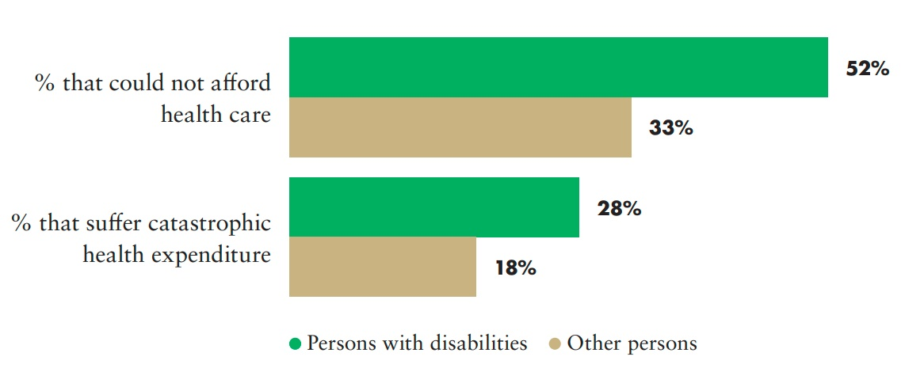
Source: WHO & World Bank, World Report on Disability, 2011, pp. 63, 69.
Assistive devices, which are key for enhancing the autonomy of persons with disabilities, are not always available and/or affordable. In low and middle-income countries, very few persons with disabilities have effective access to the assistive technology they require, as the data in figure IV shows.
figure iv
Access to assistive technologies
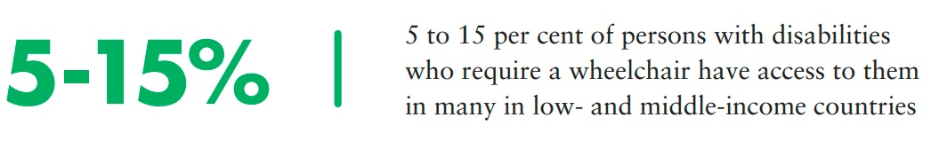
Source: WHO, Assistive technology, 2018.
Persons with psychosocial disabilities have limited choices of support and services for their mental health and well-being. Existing mental health laws and policies continue to restrict rights by authorising involuntary treatment and detention based on actual or perceived.
Data published by Mental Health Europe shows that within mental health services, persons with psychosocial disabilities and persons with intellectual disabilities often experience poor quality of care, coercive practices, unsanitary conditions, neglect and abuse (Ágnes Turnpenny and others, Mapping and understanding exclusion: Institutional, coercive and community-based services and practices across Europe (Brussels: Mental Health Europe, 2017)). Mental health services also have an overreliance on medical treatments and lack provision of other forms of support, as can be seen in figure V.
figure v
Lack of investment and community-based services in mental health services
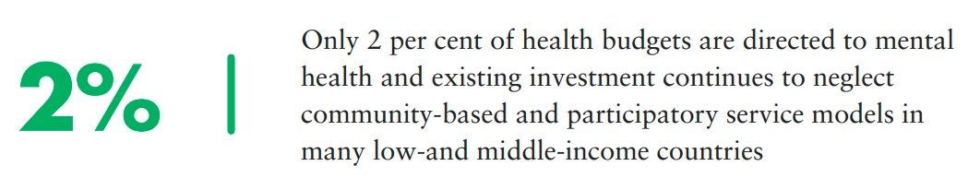
Source: WHO, Mental Health, The Global Heath Observatory, 2020.
Mental health policy does not enjoy parity with physical health policy, neither in national policies and budgets nor in medical education and practice. Data from WHO shows that investments also continue to favour in-patient care, with limited attention to providing community-based services which promote recovery, participation and rights-based support (Mental Health Atlas (2014)).
Globally, persons with psychosocial disabilities continue to experience human rights abuses in mental health services.

2. What needs to be done?
figure vi
What needs to be done to ensure good health and wellbeing?
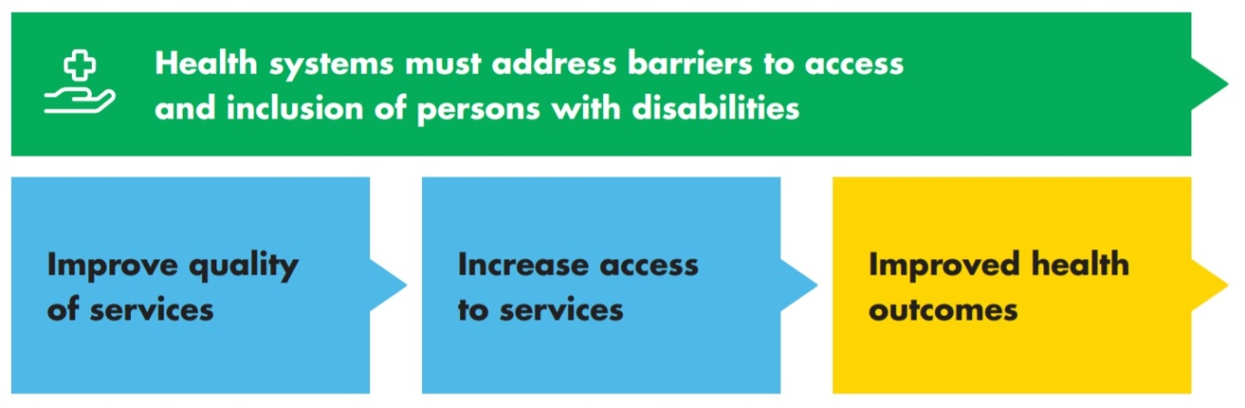
Main areas of intervention to realise Sustainable Development Goal 3
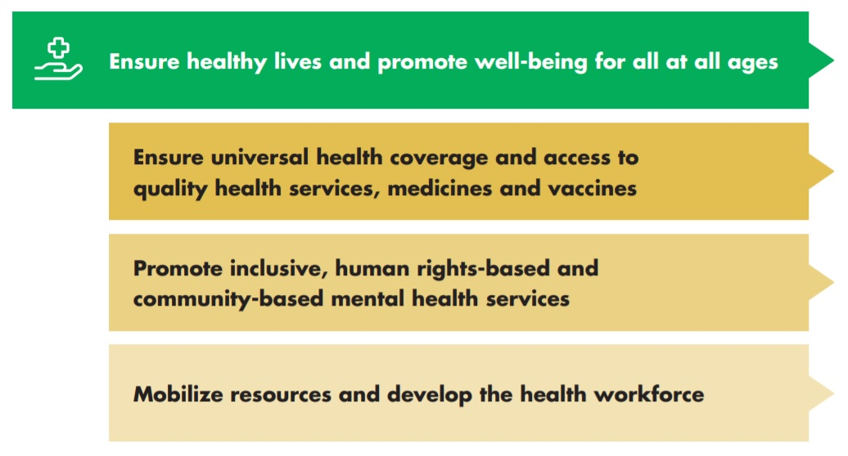
 Ensure healthy lives and promote well-being for all at all ages
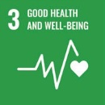 General actions applicable to all Goal 3 targets
Leadership, governance and legal framework: Set up a coordinated approach to policy development, implementation and monitoring, involving authorities at all levels, health service providers, civil society, households and individuals. Persons with disabilities must be meaningfully involved.

Financing: Ensure mobilization, accumulation and allocation of sufficient resources to reduce out-of- pocket expenses and prevent catastrophic expenditures for persons with disabilities.
Service delivery: Ensure the availability of services, including specialist services, that are affordable, acceptable and accessible for persons with disabilities and that are based on the principle of free and informed consent.

Health workforce: Take measures to build the capacity of health workers, remove barriers and enhance their skills to address the requirements of persons with disabilities, including women and girls with disabilities.
Medicines and technology: Ensure accessibility, affordability and availability of medicines, health products and assistive technology, using, among other tools, public procurement structures.

Health information systems: Collect and disaggregate information on service utilization and health outcomes, by disability.
CRPD indicators: 25.1, 25.3, 25.4, 25.5, 25.8, 25.9, 25.10, 25.12, 25.13, 25.14, 25.18, 26.6
figure vii
Building blocks of the health system
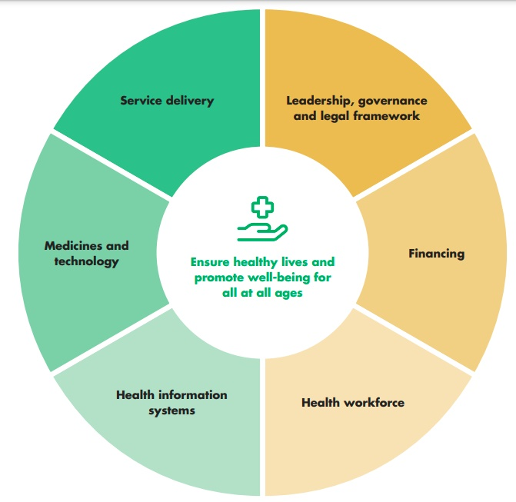
Ensure universal health coverage and access to quality health services, medicines and vaccines
3.8 Achieve universal health coverage, including financial risk protection, access to quality essential health-care services and access to safe, effective, quality and affordable essential medicines and vaccines for all
3.b Support the research and development of vaccines and medicines for the communicable and non-communicable diseases that primarily affect developing countries, provide access to affordable essential medicines and vaccines, in accordance with the Doha Declaration on the TRIPS Agreement and Public Health, which affirms the right of developing countries to use to the full the provisions in the Agreement on Trade- Related Aspects of Intellectual Property Rights regarding flexibilities to protect public health, and, in particular, provide access to medicines for all
Ensure that health laws and policies include non- discrimination provisions and enable better access to quality health services
Increase access to quality health services, including rehabilitation services, medicines, health products and assistive technology
Prevent and mitigate financial hardship and catastrophic expenses for persons with disabilities
Repeal restrictions to insurance schemes based on “pre- existing conditions”

CRPD indicators 25.1, 25.2, 25.3, 25.4, 25.5, 25.6, 25.14, 25.19, 25.23, 23.5, 26.1, 26.2, 26.11, 26.12, 26.13, 28.3
 Promote inclusive, human rights-based and community-based mental health services
3.4 By 2030, reduce by one third premature mortality from non-communicable diseases through prevention and treatment and promote mental health and well-being.
Reform legislation and policy to eradicate discrimination, stigma, violence, coercion and abuse in mental health service provision
Develop and promote community-based, person- centred, rights-based and recovery-oriented mental health and psychosocial support services
Develop peer-support services
CRPD indicators: 14.1, 14.2, 14.4, 14.13, 15/17.3, 15/17.5, 25.1, 25.3, 25.6, 25.7, 25.15, 19.10, 19.17, 19.32, 19.33 and 19.34
Mobilize resources and develop the health workforce
3.c Substantially increase health financing and the recruitment, development, training and retention of the health workforce in developing countries, especially in least developed countries and small island developing States
Mobilize and increase resources for the provision of quality health services, notably primary care
Build capacity in the health workforce to address barriers and improve quality of services for persons with disabilities
Promote the development and recruitment of specialized health and rehabilitation professionals for services for persons with disabilities

CRPD indicators: 25.8, 25.18, 25.19, 26.6

3. DO’s and DON’Ts
DO | DO NOT
Law, policy and programmes
Ensure that legislation enables persons with pre-existing conditions to access health insurance | Permit discrimination regarding the coverage of health conditions and/or unaffordable premiums based on impairment in health insurance
Identify and address barriers to accessing quality health services, particularly in rural communities | Assume that existing services present no barriers to persons with disabilities
Adopt and implement policies to ensure that the procurement, supply and distribution of medicines and health products prioritize persons with disabilities and persons with rare diseases, to reduce health gaps | Assume that current procurement, supply and distribution systems will provide the medicines and health products required by persons with disabilities and persons with rare diseases.
Ensure that procurement structures are established and that coverage in health-related social protection schemes includes assistive products, to guarantee access, in line with the WHO, Priority Assistive Products List (APL), 2020. | Assume that assistive products are currently available and affordable for persons with disabilities, in the open market, nor overlook the role public procurement can have on price determination in the open market.

DO | DO NOT
Governance, inter-institutional coordination
Support and engage with cross-sectoral disability inclusion coordination and governance mechanisms | Maintain an isolated or siloed approach to disability and health, which compounds fragmentation of services and supports for persons with disabilities
Allocate public funding and develop financing schemes to ensure access, by persons with disabilities, to general and specialised health services, including for the prevention of further/ secondary impairments | Include nor count budget allocated to policies that prevent primary impairments as disability-specific health-related funding
Adopt financing and payment structures that ensure that healthcare is made affordable for persons with disabilities, including those in poverty or with low incomes | Adopt nor maintain healthcare financing and payment structures that lead to catastrophic expenditure by persons with disabilities
Practice and implementation
Support the development of peer-led programmes in mental health services and ensure that services respond to the concerns of persons with disabilities, in all their diversity | Maintain existing health professional-led programmes nor overlook the lived experience and expertise of persons with disabilities
Ensure that private health insurance is affordable for persons with pre-existing conditions, including persons with disabilities and, in particular, women and girls with disabilities | Permit exclusion from health services based on impairments nor unaffordable premiums in health insurance schemes
Information, communication and awareness-raising
Make health services, health promotion, health literacy and disease prevention, policies and campaigns accessible to, and inclusive of, persons with disabilities (e.g. facilities, equipment, information), including through the provision of reasonable accommodation | Limit accessibility duties to disability-specific services and information.  Inhibit the participation of individuals who do not conform to traditional communication methods

DO | DO NOT
Training
Develop the capacity and knowledge of health policymakers and health on disability-inclusive health services, including on how to identify and address barriers that prevent access to services by persons with disabilities | Assume that a sufficient number of health workers, for the size of the population, suffices to improve the health outcomes of persons with disabilities
Promote the development of health and rehabilitation professionals and specialists and provide incentives for their distribution through the territory, notably to small cities and rural areas | Favour the concentration of the limited number of health and rehabilitation professionals and specialists in urban centres
Participation
Ensure persons with disabilities, including persons with psychosocial disabilities, are included across the programme cycle, namely in research, service design, implementation and monitoring and evaluation processes | Overlook the lived experiences of individuals with disabilities nor the transformative value of inclusive processes, by considering them as not central to services and health outcomes
Promote collaboration and resourcing of organisations representing persons with psychosocial and intellectual disabilities, emerging coalitions and civil society, taking into account the marginalization of persons with psychosocial and intellectual disabilities in the disability movement | Overlook opportunities to collaborate with, and include in decision making, less “official” representative networks and self-help groups
Research, data collection and disaggregation
Establish mechanisms to monitor and evaluate the quality, effectiveness and inclusiveness of health services for persons with disabilities | Assume that existing services and practices meet the requirements of persons with disabilities
Systematically collect disability data at all levels of health services and in population surveys; produce and use disability-disaggregated data on the access to health services and on health outcomes, to inform decision-making | Overlook the collection of disability data in health services or surveys; overlook the data that is collected, during the decision- making

DO | DO NOT
Accountability
Establish a comprehensive health sector disability inclusion strategy complete with accountability measures | Assume that a dedicated and comprehensive approach to disability inclusion is not required as sector contributes to disability through the prevention of impairment

IN DEPTH
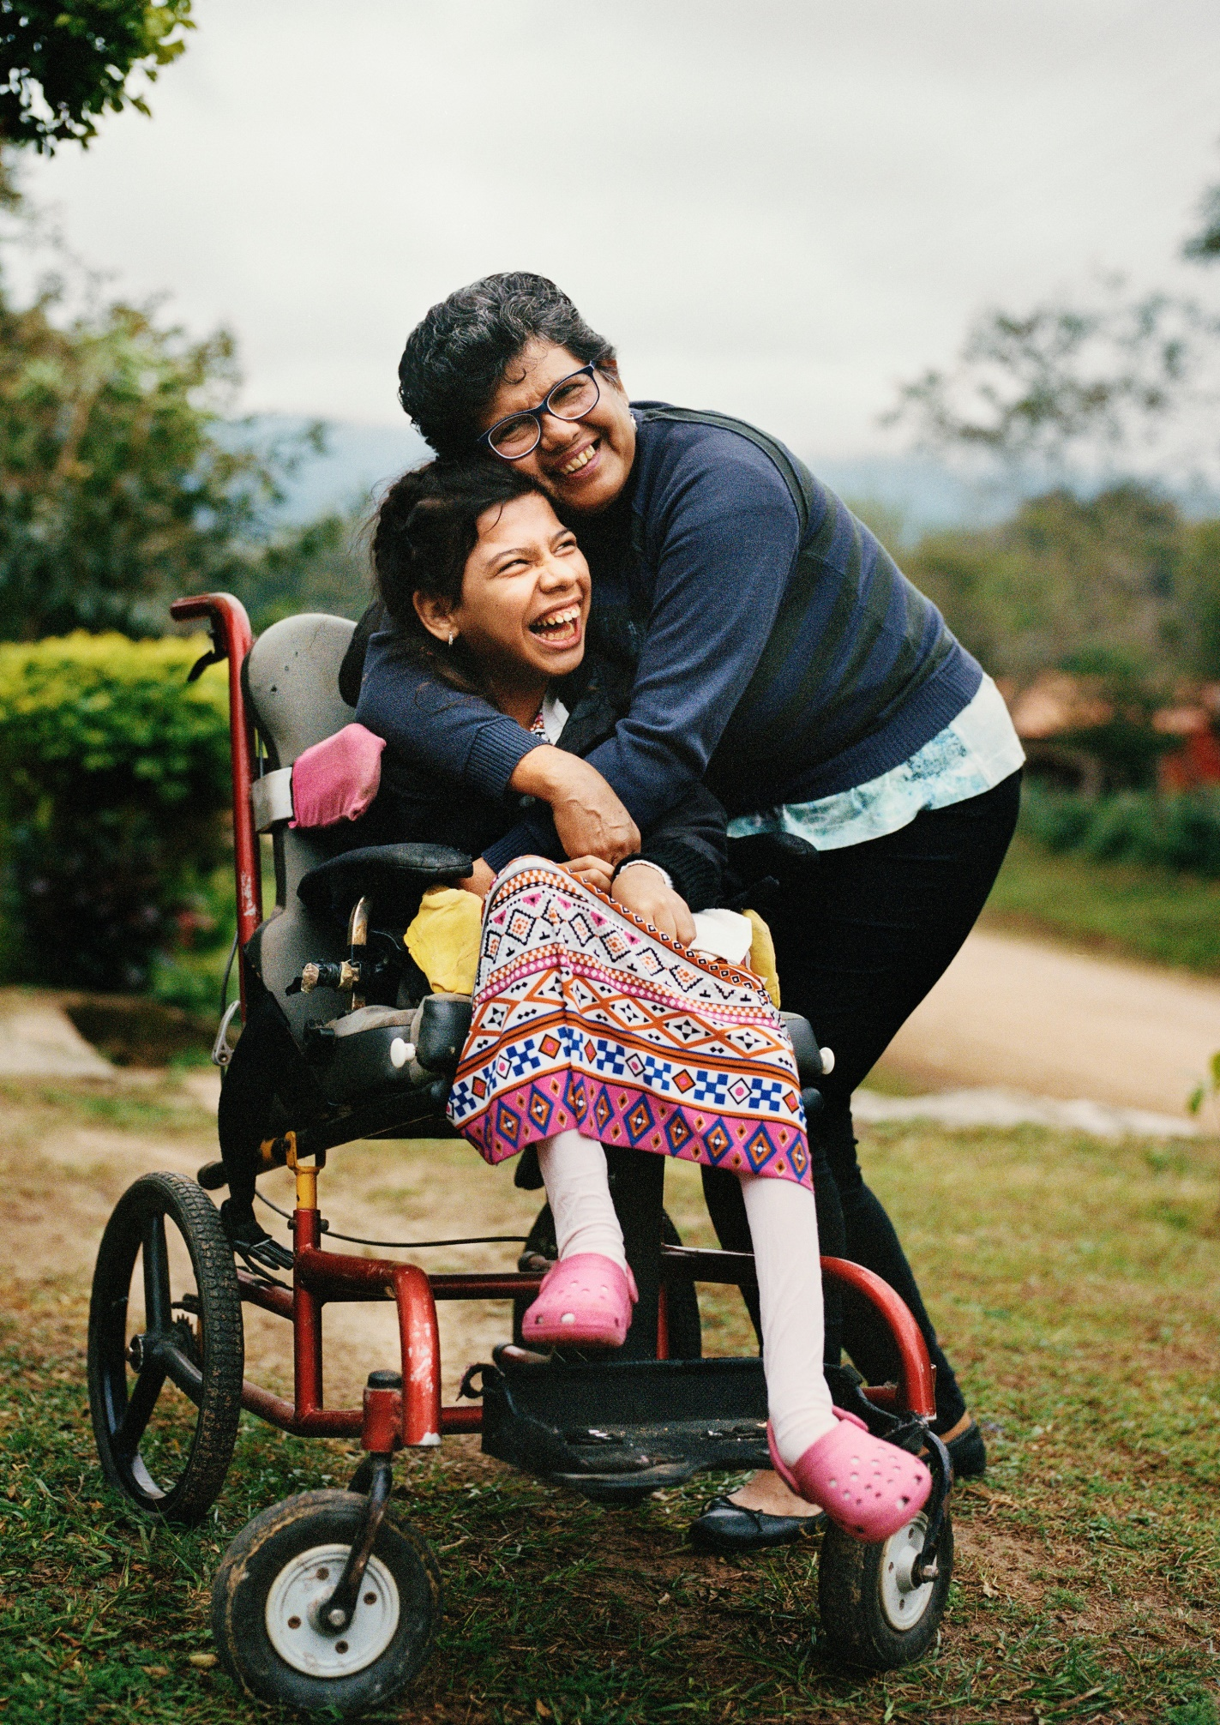

1. Introduction
This section provides detailed guidance for policymakers on measures that are required to implement Sustainable Development Goal (SDG) 3 in a way that is inclusive of persons with disabilities.
Section 2 shows the connection between the policy guidelines to achieve SDG 3 with other resources, including the human rights indicators under the Convention on the Rights of Persons with Disabilities (CRPD) and other related tools. Section 3 provides an overview of the disadvantaged situation of persons with disabilities with respect to access to health services and health outcomes.
Sections 4 and 5 provide guidance on policy measures and actions that should be adopted to achieve SDG 3 for all persons, including persons with disabilities.
In particular, Section 4 addresses structural measures for improving the responsiveness to, and inclusion of, persons with disabilities in health systems; and Section 5 provides considerations and guidance on key actions specific to each of the following SDG targets, to ensure the inclusion of persons with disabilities:
  - Target 3.8 and 3.b are grouped to address general issues related to universal coverage and access, such as non-discrimination, access to quality health services, medicines and products and financial hardship
  - Target 3.3 is specifically addressed in relation to HIV/AIDS
  - Target 3.4 is addressed in relation to inclusive mental health policies and services.
  - Target 3.c addresses resource mobilisation and capacity development of the health workforce for more inclusive health services, including the need for more rehabilitation professionals.
Other SDG targets are not specifically addressed in this chapter:
  - Target 3.6 is not addressed specifically as it is related to the prevention of primary impairments in road traffic accidents, which is not an issue pertaining exclusively to persons with disabilities (See box on “The prevention approach: primary prevention of impairments”).
  - Target 3.7 on sexual and reproductive health, while addressed in these guidelines, is given more in-depth attention in the guidelines on Goal 5.
Given the global lack of data disaggregated by disability which prevents an accurate understanding of the situation of persons with disabilities regarding certain health issues, SDG targets 3.1, 3.2 and 3.5 will not be addressed in these guidelines. However, given that persons with disabilities are at higher risk of exclusion from health systems, they will most likely also face barriers related to these targets- table 1 presents some of the issues and information required for these targets.
table 1
Issue and information required by SDG target
Target | Issue and information required
3.1 By 2030, reduce the global maternal mortality ratio to less than 70 per 100,000 live births | Available data is not disaggregated by disability. However, some research suggests that women and girls with disabilities are overrepresented among those with high-risk factors for complications during pregnancy. In addition, they have significant unmet health requirements. These factors could lead to higher maternal mortality rates.
3.2 By 2030, end preventable deaths of newborns and children under 5 years of age, with all countries aiming to reduce neonatal mortality to at least as low as 12 per 1,000 live births and under-5 mortality to at least as low as 25 per 1,000 live births | Available data is not disaggregated by disability. Disaggregation by disability of deaths of newborns and children under 5 years of age might present technical barriers, as there are challenges in identifying disabilities in children (particularly disabilities related to developmental delays).
3.5 Strengthen the prevention and treatment of substance abuse, including narcotic drug abuse and harmful use of alcohol | Available data is not disaggregated by disability. However, given the comorbidity between mental health conditions and substance abuse, further information on this issue can be found in section 5.2.1.

2. Connections to other tools
  - CRPD Indicators: Article 25 (Highest attainable standard of health).
  - Other related CRPD articles: Articles 1-4, 5, 6, 7, 8, 9, 10, 11, 12, 13, 14, 15/17, 16, 19, 23,
  - 26, 28 and 31
  - Data Sources Guidance: Article 25 and other related CRPD articles
  - Training materials: Goal 3
  - Video: Goal 3

3. Why is Goal 3 important for persons with disabilities?
Persons with disabilities report a lower health status, on average, than the broader population. Data cited by the Report of the Special Rapporteur on the rights of persons with disabilities on the right to health (A/73/161) indicate that some persons with disabilities live between 15 to 25 years less than the rest of the population. They are also, on average, higher consumers of healthcare services, compared to others, as they need access to the same general health services as the rest of the population and to services related to their disabilities (e.g. specialist services, rehabilitation).
Inequalities in access to healthcare, including primary care; lower health literacy; increased risk of secondary conditions and co-morbidities; and fewer economic resources, all contribute to lower the health outcomes of persons with disabilities.
The World Report on Disability outlines data showing that persons with disabilities are more likely to live in poverty and that around half of them cannot afford healthcare, including essential medicines, compared to one-third of persons without disabilities. In low-income countries, around 60 per cent of persons with disabilities reported that they could not afford healthcare, compared to 40 per cent for other persons. Data from the European Union indicates that 30 per cent of persons with disabilities report unmet health requirements due to lack of affordability (United Nations Department of Economic and Social Affairs – Disability, UN Disability and Development Report - Realizing the SDG by, for and with persons with disabilities, 3 April 2019.
The World Report on Disability reports that around 30 per cent of persons with disabilities face catastrophic health expenditure, compared to 20 per cent for others. Governments of low- and lower-middle-income countries spend less on health than on any other area of expenditure (6 and 8 per cent of expenditure, respectively, compared to 13 per cent for high-income countries).
Consequently, according to WHO, persons with disabilities in low- and middle-income countries report higher proportions of out-of-pocket expenditure when using health services: 39 and 56 per cent, respectively, compared to 14 per cent for high-income countries (WHO, “Out-of-Pocket expenditure on health as percentage of total health expenditure”, The Global Health Observatory, 13 February 2017).
Persons with disabilities are less likely to access health insurance and other forms of health-related social protection due to income constraints or restrictions based on “pre-existing conditions”. If they do have access, insurance are likely to apply higher premiums, more out-of-pocket expenses (such as co-payments) or exclude them from specific coverage due to “pre-existing conditions”.
The combination of often higher health-related expenses and lack of universal health coverage puts persons with disabilities at an increased risk of exclusion from health services. Data from the UNDESA, Disability and Development Report, 2019, indicates that persons with disabilities have, on average, three times less access to healthcare than others, with 40 per cent reporting exclusion from accessing services in low- and middle-income countries.
Exclusion from rehabilitation services (e.g. physiotherapy, occupational therapy) is even higher. Data from UNDESA, Disability and Development Report, 2019, indicates that, on average, 64 per cent of persons with disabilities report they cannot access the services they need, reaching up to 82 per cent in specific countries. A global review found that, in some locations in low- and middle-income countries, only 3 to 5 per cent of those needing rehabilitation services were able to access them (T. Shakespeare, T. Bright and H. Kuper, “Access to health for persons with disabilities”, 2018).
Similarly, access to assistive technology and products is very limited in low- and middle-income countries: WHO reports that only between 5 and 15 per cent of persons with disabilities who require a wheelchair have effective access to it (Assistive Technology, 18 May 2018).
Worldwide, persons with psychosocial disabilities face discrimination and exclusion, including with respect to access to healthcare. The CRPD stipulates that governments must prevent discrimination on the basis of disability. However, many national laws and policies continue to permit discrimination and, in 2017, 111 Governments reported having mental health legislation which permitted coercion, involuntary treatment and detention on the basis of impairment (WHO, Mental Health Atlas (2017). The Report of the Special Rapporteur on the rights of persons with disabilities (A/HRC/40/54) shows that involuntary admissions have increased in many countries from the American, the Middle East and East Asia regions. Meanwhile, mental health does not enjoy parity with physical health in national policies and budgets nor in medical education and practice. Mental health policies additionally favour in-patient care over community-based non-coercive services, as reflected in mental health expenditure.
Data from WHO suggests that more than 30 per cent of countries have less than 10 medical doctors per 10,000 population (“Health Workforce”, The Global Health Observatory). Further, health workers are distributed unevenly across the world: the African Region contains only 3 per cent of all health workers in the world. Healthcare workforces rarely receive training on disability and often lack the capacity to include persons with disabilities or manage their particular healthcare requirements. This is confirmed by the World Report on Disability, that found a higher proportion of persons with disabilities (16 per cent for both men and women with disabilities), compared to others (6 to 7 per cent for both men and women without disabilities), who reported that the skills of the health provider were inadequate.
Finally, the current health workforce is insufficient to satisfy the demand for rehabilitation services (WHO, “Rehabilitation 2030: A Call for Action”, 6-7 February 2017). This issue is especially relevant in the African, South-East Asian and Western Pacific regions, where the availability of rehabilitation professionals in particular specialisations represent only one-tenth of what is necessary.
These guidelines will not consider issues connected to end-of-life decisions, given that the related discourse and standards are still in development. Nonetheless, robust legal and institutional safeguards should be established to ensure that persons with disabilities are not discriminated against in the context of end-of-life decisions. This includes reviewing medical protocols on life-saving and life-sustaining procedures and verifying that medical professionals are complying with the free, informed, explicit and unambiguous decision of their patients, including persons with disabilities, to protect them from pressure and abuse, on an equal basis with others.
 Social determinants of health
Achievement of the highest attainable standard of health is a human right that it is both dependent on and contributes to the realization of many other human rights.
Health and well-being are determined by an array of social and environmental factors that largely sit outside the health system. Social determinants of health include access to adequate food and nutrition; transportation; housing; safe drinking water and adequate sanitation; healthy occupational and environmental conditions; safe livelihoods and access to health-related education and information.
For example, SDG indicator 3.9.2 measures the mortality rate linked to inadequate WASH services- 3.9.2 Mortality rate attributed to unsafe water, unsafe sanitation and lack of hygiene (exposure to unsafe Water, Sanitation and Hygiene for All (WASH) services)
Persons with disabilities have lower access to WASH services. This, coupled with their experience of higher levels of poverty, discrimination, violence and social exclusion, results in poorer health outcomes when compared to the general population.
Traditional definitions of basic services do not include support services (such as personal assistance) for persons with disabilities. Nevertheless, these services have proven to be lifesaving during the COVID19 pandemic and essential to overcome some of the disruptions created by it, such as restrictions in movement and transportation - that limit access to food, medicines and essential services. Support services should be included within the broader definition of basic services.
To promote health and well-being, it is necessary to protect persons from key risk factors for poor health, in and outside the health sector, including within the community, workplace, school and home.
 Given that there are different competencies across governments regarding the diverse social determinants of health, policymakers of health systems should:
- Take into account existing gaps and inequalities regarding social determinants of health (such as access to WASH) which result in poorer health outcomes for persons with disabilities, compared to others
- Ensure a multi-sectoral approach to address disability and the underlying social, economic and environmental determinants of health by coordinating policy design, monitoring and evaluation, across different areas of government
See United Nations. Report of the Special Rapporteur on the rights of persons with disabilities, Catalina Devandas-Aguilar. 16 July 2018. A/73/161, and the Policy Guidelines on Sustainable Development Goals 1, 4, 5, 8 and 11, which propose actions related to the social determinants of health.

4. Ensure healthy lives and promote well-being for all at all ages: actions applicable across all Goal 3 targets
The following subsections provide some general entry points for disability inclusion across the building blocks of health systems. Further guidance on key structural issues can be found under section 5.1 (other key actions by target) concerning targets 3.8 and 3.b.
Ensure healthy lives and promote well-being for all at all ages

4.1 Leadership, governance and legal framework
Strengthening leadership and governance of health systems is essential to ensure the inclusion of persons with disabilities and the responsiveness to their health requirements.
 Recommendations
As the main agency, Ministries of Health should:
    - Lead the development of strategic policy frameworks and related regulations that address barriers to access and inclusion, in health services, of persons with disabilities
    - Manage and articulate relationships among different stakeholders involved in health policy, including public authorities at different levels, private health service providers, civil society organizations, households and individuals. Persons with disabilities and their representative organizations should be actively involved in this process
    - Develop effective oversight and accountability mechanisms to track results
In regard to persons with disabilities, policymakers of health systems should seek to ensure:
    - health-related social protection schemes (such as social health insurance) which reflect the diverse requirements of persons with disabilities. The design of these schemes should ensure access to the same range of general health services available to the general population, as well as services specific to their impairment(s) (such as assistive products and rehabilitation)
Related CRPD Indicators: 25.1, 25.3, 25.12, 25.13
    - that no legal or regulatory provisions allow for the restricting, reducing or worsening of conditions of coverage on the basis of impairment (see sections 5.1.1 and 5.1.4)
Related CRPD Indicators: 25.5
 A twin-track approach to disability in sexual and reproductive health: W-DARE
Disability inclusion in health systems requires that mainstream goods and services are inclusive of persons with disabilities, while also calling for disability-specific actions. Following the enactment of the Responsible Parenthood and Reproductive Health Law (2014) in the Philippines, a three-year participatory action research project was conducted to support the access of women with disabilities
to sexual and reproductive health (SRH), as mandated by the law. The Women with Disability Taking Action on REproductive and Sexual Health (W-DARE) project involved women with disabilities as co-researchers in the design and implementation of all activities and included bringing together the key stakeholders required to help promote disability-inclusion within the law. Based on the findings of the research, W-DARE supported a series of pilot mainstream and disability-specific interventions, including:
- Working with selected health facilities to increase the awareness of breaches and obligations under physical access standards
- Development of resource manuals for peer facilitators providing SRH information to women with different disabilities
- Increasing facility management and service provider awareness of the need for adaption, through walkthroughs, accessibility audits and gender and disability training
- Supporting participatory action groups, to provide information on SRH and on the rights of persons with disabilities; raise awareness of violence services; develop peer-support
- Development of: policy briefs to support disability inclusion in relation to the law; resources and training for SRH service providers on inclusive communication; videos raising community awareness on the rights, capacities and vulnerabilities of women with disabilities
- The review of Violence Against Women referral pathways and training for providers, with a focus on disability
- Training sign language interpreters on SRH and gender sensitivity
- Supporting a participatory action-group for parents of children with disabilities and safety planning for women with disabilities
Source: W-DARE, Women with Disabilities taking Action on Reproductive and Sexual Health

4.2 Financing
To meet the health service requirements of persons with disabilities, the mobilization, accumulation and allocation of resources need to be sufficient and provided in a timely manner, irrespective of the structure of the health system. In line with this, regulations and schemes also need to set adequate financial incentives to health providers.
Recommendations
When designing financing schemes, policymakers of health systems should:
    - Avoid including funding for prevention of primary impairments in resources allocated to the specific benefit of persons with disabilities - instead, include investments that address the poorer health outcomes experienced by persons with disabilities (see box on “The prevention approach: primary and tertiary prevention of impairments”)
    - Ensure affordability of services and prevent catastrophic expenditures by persons with disabilities (see section 5.1.3)
Related CRPD Indicators: 25.1, 25.3, 25.14
The prevention approach: primary and tertiary prevention of impairments
General health policies include measures for the prevention of sicknesses, accidents and primary impairments, for the whole population (such as immunization campaigns). However, governments often present these policies, as well as related budget commitments and awareness campaigns, as interventions that support the rights of persons with disabilities. Consequently, governments tend to overestimate their investment in persons with disabilities’ health, under-allocating resources to provide inclusive health services that meet the requirements of this population.
In regard to prevention, health policies should:
- Include general measures for health promotion and for the prevention of disease and impairment for the whole population (primary prevention), which are inclusive of all persons with disabilities
- Include measures to prevent progression of health conditions and impairments, including secondary conditions (tertiary prevention), addressed specifically to persons with disabilities
See United Nations. Report of the Special Rapporteur on the rights of persons with disabilities, Catalina Devandas-Aguilar. 16 July 2018. A/73/161

4.3 Service Delivery
Improving health outcomes for persons with disabilities requires effective delivery of quality services. However, the availability of services for persons with disabilities is restricted due to limited workforce capacity to meet the requirements of persons with disabilities (including poor attitudes and limited knowledge) and insufficient resources. Access to services, in particular specialist services, is limited by poor geographic distribution, with services mostly concentrated in urban centres.
Persons with disabilities experience physical barriers such as inaccessible transportation, buildings, toilets and medical equipment; as well as communication barriers, that limit communication with service-providers and restrict access to health information. The affordability of services is also an important factor that impacts individual access. The quality of service delivery is further hampered by discrimination on the basis of disability, as well as by a lack of measures to ensure free and informed consent.
For service-delivery to benefit persons with disabilities, policymakers of health systems should seek to:
    - Identify and address the physical, informational, communicational and attitudinal barriers in service-delivery that persons with disabilities encounter, including through the provision of gender- and age-appropriate reasonable accommodation. This should be undertaken in partnership with persons with disabilities and their representative organisations (OPDs)
Related CRPD Indicators 25.3, 25.4, 25.9, 25.10, 25.13, 25.17
    - Improve the overall quality of all services to measurably improve health outcomes of persons with disabilities
Related CRPD Indicators 25.3

4.4 Health workforce
The health workforce, responsible for organizing and delivering health services, plays an integral role in upholding inclusion and ensuring responsiveness of the health system to persons with disabilities. Building the capacity of specialised and generalist practitioners on disability is an important step towards ensuring persons with disabilities can access healthcare.
Unfortunately, in many contexts, the size of the health workforce is insufficient to meet the requirements of the population, particularly in key areas for persons with disabilities (e.g. rehabilitation services), and/or not sufficiently trained to address the health requirements of persons with disabilities.
 Recommendations
Policymakers of health systems should:
    - Adopt measures for capacity building of health workers, to remove attitudinal barriers and enhance skills, allowing them to address the health requirements of persons with disabilities, in particular of women and girls with disabilities
Related CRPD Indicators: 25.8, 25.18, 23.12
    - Adopt measures to promote and increase the ratio of health workers to persons with disabilities, including in specialized and rehabilitation services
Related CRPD Indicators: 25.18 and 26.6
See also section 5.3.2 on building the capacity in the health workforce to address barriers and improve quality of services for persons with disabilities and 5.3.3 on promoting the development and recruitment of specialized health and rehabilitation professionals for services for persons with disabilities.

4.5 Medicines and technology
Equitable access to medicines, vaccines, health products and assistive technology is a basic element of a well-functioning health system. The provided goods should be scientifically tested, of good quality, safe, effective and affordable. However, persons with disabilities do not have equal access to either medicines or assistive technology. First, prices of medicines or lack of availability of generic medicines are likely to prevent access. Second, as previously noted, access to assistive technology and products is very limited in low- and middle-income countries.
Recommendations
In the areas of medicines and technology, policymakers of health systems should seek to adopt measures to:
    - Ensure that accessibility standards apply to all information related to medicines, vaccines, health products and assistive technology
    - Ensure the availability of medicines including through procurement, supply, storage, distribution mechanisms and production of generics. This is particularly relevant for persons with disabilities who may require medicines beyond the list of essential medicines (“WHO Model Lists of Essential Medicines”, 2020)
    - Ensure that procurement structures – e.g. within the health and/or social services – provide for guaranteeing access to assistive products in line with the WHO, Priority Assistive Products List (APL), 2020, and explore the coverage of more assistive products, (see World Health Assembly, Improving access to assistive technology, WHA71.8, 26 May 2018, and Policy Guideline on SDG 1)
Related CRPD Indicators: 25.3, 25.4, 9.4, 9.5, 9.6, 9.17, 9.18, 28.1, 28.2
See also the box on persons with rare diseases in section 5.1.2.

4.6 Health information systems
Health systems require comprehensive information management systems that track service utilization and outcomes, at all levels of service provision (primary, secondary and tertiary). Systems should collect information that allows for the assessment of the efficiency and effectiveness of measures and services provided and be able to monitor health outcomes of the population. When health information systems also collect data on disability, health utilization and outcome indicators can be disaggregated by disability to allow programme and service managers to assess the extent and nature of health gaps between persons with disabilities compared to the broader population and to evaluate whether persons with disabilities are accessing services at the expected rates.
However, as described in section 1, health-related information, including on health outcomes, is not broadly available disaggregated by disability.
 Recommendations
In regard to health information systems, policymakers of health systems should:
    - Ensure that data collection systems collect and disaggregate information by disability and that this information is used to inform decision-making
    - Ensure that data collection and disaggregation cover both service utilization and health outcomes for persons with disabilities
Related CRPD Indicators: 25.16, 25.12, 25.13, 25.14, 31.1, 31.7

5. Other key actions by target

5.1 Universal health coverage and access to quality health services, medicines and vaccines: Targets 3.8 and 3.b
3.8 Achieve universal health coverage, including financial risk protection, access to quality essential health-care services and access to safe, effective, quality and affordable essential medicines and vaccines for all
3.b Support the research and development of vaccines and medicines for the communicable and non-communicable diseases that primarily affect developing countries, provide access to affordable essential medicines and vaccines, in accordance with the Doha Declaration on the TRIPS Agreement and Public Health, which affirms the right of developing countries to use to the full the provisions in the Agreement on Trade- Related Aspects of Intellectual Property Rights regarding flexibilities to protect public health, and, in particular, provide access to medicines for all

5.1.1 Ensure that health laws and policies include non-discrimination provisions and enable better access to quality health services
Legislative and policy frameworks on health are key to the prevention of, and protection from, discrimination in accessing healthcare and health-related information, goods and services. The
explicit inclusion of the prohibition of discrimination based on disability establishes a legal obligation for health service providers and gives both legal entitlement and protection to persons with disabilities. In particular, the requirement for services to provide reasonable accommodation must be included in legislation and regulations of health services, as its denial constitutes discrimination based on disability.
However, health legislation and policy frameworks tend to be insufficient in preventing, and protecting from, discrimination against persons with disabilities. Legislation and policy also tend to overlook the requirements of persons with disabilities and the key legal concepts that would ensure access to services. For instance, accessibility requirements may not be routinely considered when procuring new infrastructure or equipment, or the requirements might be limited to physical accessibility, excluding communicational accessibility (e.g. sign language interpretation services).
Additionally, the requirements of marginalised groups, such as women or children with disabilities, need to be considered.
Health legislation and policy frameworks may also include provisions that discriminate based on actual or perceived impairments, restricting the right to health, as well as other rights, of persons with disabilities. For instance, some laws restrict the right to free and informed consent in the treatment of adults with disabilities, in favour of consent from guardians. Non-discrimination provisions for persons with disabilities should also address persons who may be disadvantaged on the basis of more than one of their identities or characteristics, e.g. women with disabilities, older persons with disabilities.
Recommendations
In the area of inclusion of non-discrimination in health laws and policies, policymakers of health systems should:
      - Conduct a comprehensive legislative and regulatory review to remove discriminatory provisions and to ensure responsiveness of the system in accordance to the CRPD; strengthen health system-related legislation and policy frameworks to include explicit provisions that prevent and protect from discrimination based on disability, including denial of reasonable accommodation. Legislation and policies must prohibit treatment without the free and informed consent of the person with disability, including in emergency or crises. The review of legislation and regulations should extend to those relating to bioethics committees in hospitals and research institutes
Related CRPD Indicators: 25.1, 25.6, 25.7, 12.2, 15/17.5, 23.5
      - Adopt accessibility standards applicable to all dimensions of the health system, including physical environment (facilities and equipment), transportation, information and communication, to reduce barriers to accessing healthcare
Related CRPD Indicators: 25.4
      - Adopt regulations and measures to ensure the provision of reasonable accommodation in practice, including reasonable accommodation funds in hospitals and health centres, and the attribution of support functions to health workers
Related CRPD Indicators: 25.1, 25.6

5.1.2 Increase access to quality health services, including rehabilitation services, medicines, health products and assistive technology
In addition to non-discriminatory provisions in legislation and policy frameworks, proactive policy measures are necessary to increase the access of persons with disabilities to quality health services, medicines, products and assistive technology. Leadership of health systems need to take initiative in identifying and addressing barriers to access by persons with disabilities.
As stated earlier, persons with disabilities have three times less access to healthcare than others, with 40 per cent of the population with impairments being excluded from healthcare in low- and middle- income countries (UNDESA, Disability and Development Report, 2019). Lack of affordability of health services is a key factor, as the cost of medicines or lack of availability of generic medicines prevent persons with disabilities from accessing them. Globally, the majority of persons needing rehabilitation services cannot access the services they require.
Access to assistive products is very limited in low- and middle-income countries: only between 5 and 15 per cent of persons with disabilities who require a wheelchair have effective access; this number is even lower for children (WHO, Assistive Technology 18 May 2018). There is also an over-reliance on medications in mental health service provision, that have serious adverse health effects, as well as a lack of alternative non-medical options (OHCHR, “Special Rapporteur on the right of everyone to the enjoyment of the highest attainable standard of physical and mental health”, 2020, A/HRC/44/48, para 43).
Persons with psychosocial and intellectual disabilities face additional barriers to having their physical healthcare requirements met, due to prejudice and discrimination from health workers on the basis of disability – such as making healthcare provisional on accepting psychiatric treatment, attributing physical symptoms to psychiatric origins and lack of provision of adequate physical healthcare within mental health facilities. Professional development and capacity building of the health workforce on disability, health and human rights is necessary to remove attitudinal barriers concerning persons with disabilities.
Quality of care, health outcomes and disability
Quality of care is “the extent to which health care services provided to individuals and patient populations improve desired health outcomes. In order to achieve this, health care must be safe, effective, timely, efficient, equitable and people-centred.” (WHO, Standards for Improving Quality of Maternal and Newborn Care in Health Facilities (Geneva, 2016)).
Quality of care is directly linked to health outcomes. Quality healthcare services are services that minimize risks and harm to service users; are based on scientific knowledge and evidence-based guidelines; do not differ in quality according to personal characteristics such as gender, race, ethnicity, geographical location, socioeconomic status, disability or other ground; take into account the preferences and aspirations of individual service users and the culture of their community.
WHO has developed multiple tools to measure health outcomes in the dimensions of health status, functionality and quality of life. Tools specifically designed to capture the experiences of persons with disabilities include: the International Classification of Functioning, Disability and Health (ICF),
which is the WHO framework for measuring health and disability at both individual and population levels; and the Quality of Life Module on Disability, which incorporates the individual’s perception of health status, psycho-social status and other aspects of life.
Persons with disabilities may present a higher prevalence of health conditions which may or may not be directly resulting from their impairments and/or the effects of the treatments prescribed for their conditions. These situations require proper medical analysis and diagnosis by knowledgeable and, if required, specialized professionals. However, it is important that health professionals do not assume that any health condition reported by persons with disabilities is related to their disability, as this can result in poor diagnosis and inappropriate treatments. Impairment-related assessments are important but should not be the sole source of information for diagnosis and treatment.
It is vital that when new treatment approaches are developed, they incorporate the views and experiences of persons with disabilities. Historically, this has not always been the case. For example, well-established practices on sexual and reproductive health services, such as menstrual management, have been identified as abusive against women with disabilities (OHCHR and others, “Eliminating forced, coercive and otherwise involuntary sterilization”, WHO, 2014). The WHO QualityRights Initiative, 2019, provides a package of training and guidance materials to implement a human
rights and recovery approach in the area of mental health, which aims to put an end to widespread violations in this context and to change mindsets to ensure high quality services in the future.
The CRPD, as every other human rights treaty, serves to bridge an imbalance of power. Recognizing the lived experience of the population concerned is identified as a priority by both the medical community and the human rights community, as it serves not only to avoid perpetuating practices that impede health outcomes, but also as guidance to advance practices that ensure equal rights for all.
Recommendations
In the area of increasing access to quality health services, including rehabilitation services, medicines, health products and assistive technology, policymakers of health systems should:
- Adopt measures to make all health services, programmes and campaigns (including those related to health literacy and disease prevention) accessible to, and inclusive of, persons with disabilities. This includes providing health information in plain language and a range of accessible formats (including Braille and large print). Inclusive consultation processes should ensure that the views and preferences of persons with disabilities are factored into the design and delivery of services
Related CRPD Indicators: 25.3, 25.4, 25.17
- Promote the inclusion of rehabilitation services at all levels of care, as an essential health service and as part of the efforts to achieve universal health coverage
Related CRPD Indicators: 25.1 and 25.3, 26.1, 26.2, 26.11, 26.12, 26.13
- Review and adapt procurement, supply, storage and distribution mechanisms related to medicines and health products, to ensure availability, affordability and access for persons with disabilities
Related CRPD Indicators: 25.2 and 25.3
Persons with rare diseases
Although they represent a small proportion of the population, persons with rare diseases often face significant challenges in accessing quality health services related to their disease.
The European Union considers “diseases to be rare when they affect not more than 5 per 10 000” (Commission of the European Communities, Communication from the Commission to the European Parliament, the Council, the European Economic and Social Committee and the Committee of the Regions on rare diseases: Europe’s challenges. SEC(2008)2713, SEC(2008)2712 (Brussels, 2008)).
This means that an estimated 29 million persons in Europe will be affected with rare diseases.
Persons with rare diseases face several specific barriers to accessing care, which are associated with the low prevalence and great diversity of their rare diseases, including:
        - Limited research evidence on specific diseases; low awareness of existing evidence amongst health professionals
        - Lack of access to, and delay of, a correct diagnosis
        - Lack of appropriate specialist healthcare and access to required medicines
The very low prevalence of rare diseases results in few incentives for private research and medicine development, improvement, commercialization and availability.
Therefore, governments should:
- Raise awareness on the rights of persons with rare diseases
- Undertake and promote scientific research on rare diseases
- Promote and incentivize the development, improvement, commercialization and availability of medicines required by persons with rare diseases
- Engage in international cooperation, including through multi-country procurement partnerships

5.1.3 Prevent and mitigate financial hardship and catastrophic health expenses for persons with disabilities
Affordability of health care is a key issue to accessing healthcare, for persons with disabilities. There are three types of costs associated with accessing healthcare: direct medical costs, such as health services, rehabilitation, assistive products and long-term care; direct non-medical costs, such as transportation, accommodation, personal assistance or interpretation to access healthcare; and indirect costs, such as loss of income or time for the individual or the family member who provides personal assistance.
Global estimates suggest that around half of all persons with disabilities cannot afford healthcare, compared to one-third of other persons (World Report on Disability, 2011). In particular, persons with disabilities are more likely to face catastrophic health expenditure, which is defined as out-of- pocket payments that exceed a household’s capacity to pay, often set at a threshold, e.g. 25 per cent of total household expenditure (J. Cylus, S. Thomson and T. Evetovits. Catastrophic health spending in Europe: equity and policy implications of different calculation methods. Bulletin of the WHO, vol. 96, No.9 (September 2018), pp. 599-609). Available data indicate that around one-third of persons with disabilities face catastrophic health expenditures, compared with less than one-fifth of others (World Report on Disability, 2011).
Recommendations
In regard to preventing and mitigating financial hardship and catastrophic health expenses for persons with disabilities, health policymakers should:
      - Promote reforms and regulations (in health systems and social protection schemes) that reduce the cost of healthcare for the service user, to prevent financial hardship and the occurrence of catastrophic health expenditure for persons with disabilities
      - Develop schemes, including subsidies, exemptions and payments schemes, which mitigate and/ or alleviate the financial burden of out-of-pocket health expenditure for persons with disabilities and their households. Depending on the structure of the health systems and social protection schemes, this can include the direct free provision of health services and/or free or subsidised health insurance schemes; disability allowances to meet out-of-pocket expenses; subsidised transportation and accommodation for those travelling to receive services. Carers’ allowances, as well as unemployment and sickness insurance schemes, can also offset indirect costs of accessing health care
Related CRPD Indicators: 25.1, 25.3, 25.14, 28.3

5.1.4 Repeal restrictions to insurance schemes based on “pre-existing conditions”
In line with sub-section 5.1.1, inclusive health systems require ensuring that no provision discriminates directly or indirectly on the basis of impairment – or, implicitly, leaves room for that kind of discrimination – in accessing medical insurance.
However, current health legislation and regulations throughout the world allow medical insurance providers and schemes to include provisions on “pre-existing conditions”, which exclude persons with disabilities from accessing medical insurance or allow for disadvantaged insurance conditions (e.g. higher premiums, exclusion from specific coverage), compromising their access to the healthcare services they may require.
Repealing provision(s) with disadvantageous conditions of insurance for persons with “pre-existing conditions” is particularly relevant for health systems based on mandatory private insurance. Public systems may be less prone to restrict access based on impairments.
In addition, available medical insurance may not fully cover all health conditions and associated services, for example, coverage may not include mental health services, comprehensive rehabilitation services, or assistive devices.
 Recommendations
To repeal restrictions to insurance schemes based on “pre-existing conditions”, governments should:
      - Promote legal reforms and regulations to explicitly prohibit health insurers from discriminating based on “pre-existing impairments” or health conditions; and repeal any provision excluding from or reducing coverage, or otherwise providing disadvantageous insurance conditions, based on “pre-existing conditions”
      - Explore mechanisms to supplement additional costs that persons with disabilities may face, such as the direct provision of disability-related health services, to avoid large impacts in small insurance schemes
      - Ensure full coverage for all health services within health-related social protection schemes Related CRPD Indicators 25.5, 5.1
HIV/AIDS and persons with disabilities
3.3 By 2030, end the epidemics of AIDS, tuberculosis, malaria and neglected tropical diseases and combat hepatitis, water-borne diseases and other communicable diseases
SDG target 3.3 calls for actions to end epidemics of communicable diseases, including HIV/AIDS.
In the past years, HIV prevalence and level of risk of contraction by persons with disabilities has been a matter of dedicated research. This research has identified a gap within HIV prevention policies that needs to be addressed.
In regard to persons with disabilities, the growing evidence suggests that:
- There is a higher prevalence of HIV infection in persons with disabilities than in others (Supa Pengpid and Karl Peltzer, HIV Status, knowledge, attitudes and behaviour of persons with and without disability in South Africa: evidence from a national population-based survey. The Pan African Medical Journal, vol.33, No. 302 (August 2019).)
- Persons with disabilities have less access to information and are less knowledgeable about HIV and its prevention (Toyin Aderemi, Basil Pillay and Tonya Esterhuizen, Differences in HIV knowledge and sexual practices of learners with intellectual disabilities and non-disabled learners in Nigeria, Journal of the international AIDS society, vol. 6, No. 1 (January 2013).)
- Persons with disabilities have a higher risk of HIV contraction than others, including due to the high risk of being subjected to sexual violence (Pierre de Beaudrap, Muriel Mac-Seing and Estelle Pasquier, Disability and HIV: a systematic review and a meta-analysis of the risk of HIV infection among adults with disabilities in Sub-Saharan Africa, AIDS Care, vol. 26, No. 12 (2014). pp. 1467-1476.)
- In some contexts, women with disabilities might be at higher risk than men (Joint United Nations Programme on HIV/AIDS, Disability and HIV (Geneva, 2017).)
- Women with disabilities might be more involved in paid sexual relationships than other women, and at higher risk of sexual violence (Pierre De Beaudrap and others, Prevalence of HIV infection among people with disabilities: a population-based study in Yaoundé, Cameroon (HandiHIV), The Lancet HIV, vol. 4, No. 4 (April 2017). E161-E168)
These research findings require that policymakers of health systems:
- Ensure that any awareness-raising campaign related to HIV/AIDS prevention is inclusive of, and accessible to, persons with disabilities
- Ensure that sexual and reproductive health services are available for, and accessible to, persons with disabilities, and are responsive to their requirements
Related CRPD Indicators: 25.3, 25.19 and 25.23
See also video on sexual reproductive rights and health of women and girls with disabilities developed by the Special Rapporteur on the rights of persons with disabilities.

5.2 Promote inclusive, human rights-based and community based mental health services: Target 3.4
3.4 By 2030, reduce by one third premature mortality from non-communicable diseases through prevention and treatment and promote mental health and well-being
Mental health, human rights and disability
In many countries, existing legislation on mental health undermines the exercise of rights, including free and informed consent, and enables forced treatment, such as restraints, medication and institutionalization on the basis of disability. These practices have been contested by the international human rights framework, and policies should be reframed towards immediate compliance with the CRPD.
There are many terms used to refer to persons with mental health-related experiences, whether they have used mental health services or not, such as persons with “mental illness”, “mental disorders” or “mental health conditions”; or labels according to diagnoses (“persons with schizophrenia”).
Many persons find these terms to be stigmatizing and pathologizing, and they self-identify in other ways, e.g.: “persons with lived experience”; “users” or “consumers” of mental health services; or “survivors of psychiatry”.
“Persons with psychosocial disabilities” is the preferred term used by international human rights mechanisms, as well as by representative organizations of persons with disabilities. It encompasses all persons who, regardless of their self-identification or diagnosis, experience discrimination and societal barriers based on actual or perceived mental health diagnosis or subjective distress. This term aims to reflect a social, rather than a medical, model approach to mental health conditions and experiences, placing the focus on the attitudinal and environmental barriers that restrict equal participation in society.
Mental health practices have historically ignored the lived experience of persons with psychosocial disabilities, leading to harmful practices that are now being recognized by the international human rights system, WHO and other institutions (“Consultation on Human Rights and mental health: “Identifying strategies to promote human rights in mental health”, OHCHR, 2018). Community- based non-coercive practices are evolving and developing rapidly all over the world as a response to the need for the reform of mental health systems.
Mental health systems are required by international law to shift from traditional practices to practices that respect and promote human rights standards, and to value mental health outcomes according to the will and preference of the individuals accessing services, without discrimination.
As for other types of health services, there is often a range of barriers, including communication and physical barriers, to persons with disabilities accessing mental health services. Availability, affordability, appropriateness and quality of mental health services are additional concerns. Given the lack of community-based services and recovery-oriented approaches, psychiatric hospitals
and institutions continue to be the only choice offered in many regions. Many persons who are hospitalised remain there indefinitely, due to the absence of support networks and services within the community.
There is a significant stigma attributed to persons who come into contact with the mental health system – where they are put at risk of involuntary treatment and detention, chemical and physical restraint, isolation and violence –, as well as discrimination and exclusion in other areas of life, including access to justice, housing, income, health, livelihood and participation in the community.
For more information, consult the WHO QualityRights Training and Guidance, in particular its module on mental health, disability and human rights– WHO, Mental health, disability and human rights. WHO QualityRights Core training – for all services and all people, Course Guide (Geneva: WHO, 2019); United Nations, A/HRC/43/L.19, A/HRC/39/36, A/HRC/44/48, A/HRC/41/34, A/HRC/35/21, A/HRC/40/54 and A/73/161.
USP-K findings have established that most discussions in a peer support group are not directly related to decision making with legal consequences, rather it’s about simple day to day decisions. However, peer support boosts agency and autonomy in the lives of persons with psychosocial disabilities. This is because autonomy is relational and the peer support group provides a safe space for people to share experiences, share information, develop collective knowledge, advice, and support in risk taking.
Michael Njenga, Executive Director, Users and Survivors of Psychiatry in Kenya
Statement to the Human Rights Council
The Human Rights Council hosted a consultation on mental health and human rights in Geneva, in 2018. There, a number of practitioners presented their practices promoting human rights-based mental health practices. These practices are compiled in the report - A/HRC/39/36 - and further information is available at the consultation website (“Consultation on Human Rights and mental health: identifying strategies to promote human rights in mental health”, OHCHR, 2018).

5.2.1 Reform legislation and policy to eradicate discrimination, stigma, violence, coercion and abuse in mental health service provision
Mental health laws usually contain provisions that allow for forced hospitalization and forced and/or harmful treatment (e.g. psychosurgeries, electroshocks without anaesthesia, seclusion, restraint, conversion therapies for lesbian, gay, bisexual, transgender and intersex persons). For example, involuntary treatment occurs when a person is deemed to lack capacity to make decisions about their health. This may occur whether their “lack of capacity” is legally declared or not, and/or in combination with other arguments, such as being a “medical necessity” or to avoid being a “danger to themselves or others”. These provisions disproportionally impact persons with intellectual disabilities, psychosocial disabilities and neurodiverse persons. They also legitimise violence and coercion and can result in arbitrary detentions in mental health facilities, which may be for long periods of time with little to no chance of challenging detention.
Deprivation of liberty based on a person’s impairment is prohibited by the CRPD, regardless of the duration or whether there are mechanisms for challenging the decision (see United Nations, Report of the Committee on the Rights of Persons with Disabilities, A/72/55, Annex “Guidelines on the right to liberty and security of persons with disabilities”).
Mental health policies that are developed following such legislation rely primarily, when not entirely, on forced institutionalization and treatment. This contributes to perpetuating stigma and discrimination against persons with psychosocial disabilities, intellectual disabilities and others who have, or are perceived to have, difficulty making decisions.
Deprivation of liberty based on impairment is a serious and widespread practice contrary to the rights of persons with disabilities. Many persons accessing the mental health system are institutionalized in mental health facilities, in part due to societal barriers, such as exclusion from employment, the absence of social protection, lack of housing, no social networks to support them in everyday life and, often, because mental health facilities will not release a patient unless they are signed-out by a guardian or a family member. Legal provisions in social protection, employment, health and housing that address barriers to persons with psychosocial and intellectual disabilities are needed to prevent institutionalization and the subsequent violation of rights.
Persons with disabilities who seek services for psychosocial support and addictions should have access to them, on an equal basis with others, and services should only be provided with the free and informed consent of the person concerned. Mental health services should be accessible and connected with communication services that account for the diverse requirements of persons with disabilities.
Recommendations
In regard to eradicating discrimination, stigma, violence, coercion and abuse in mental health service provision, policymakers of health systems should initiate a process to review and reform health legislation and policies to:
- Repeal any provision in any legislation that allows for forced hospitalisation and treatment based on mental health condition, including in situations considered an “emergency”, either alone or in combination with other criteria
- Explicitly ban deprivation of liberty based on impairment, including forced hospitalization
- Explicitly uphold the right of free and informed consent of the person concerned
- Develop and favour non-coercive practices towards persons with psychosocial disabilities, developing mental health services that are respectful of the free and informed consent of the person, and avoiding and sanctioning violence and abuse
Related CRPD Indicators: 25.1, 25.3, 25.6, 25.7, 14.1, 14.4, 12.2, 15/17.5
Mental health laws and disability
Today, most mental health specific legislation continue to place their focus on the restriction of rights. A fundamental shift is needed to create an enabling legal and policy environment for the promotion of human rights. Laws and policies should aim to develop mental health services that are respectful of the rights of persons with disabilities and that are focussed on mental health and wellbeing outcomes, without discrimination. They should prohibit coercive treatment practices and base all treatment decisions on the free and informed consent of the individual. They should also guide non-coercive services, offering rights-based, person-centred and recovery-oriented services.
These policy frameworks must acknowledge harmful practices, support mental health workers in learning how to develop alternatives to them, and establish safeguards to prevent further violations, both administratively and with the enforcement of the judiciary, when free and informed consent
is violated. When policies are aimed at targeting persons on the basis of risk and the alleged danger posed to themselves or others, and not specifically based on disability, they should recognize the disproportionate impact on persons with psychosocial and persons with intellectual disabilities. They should reflect the increased risk of rights violations and adopt dedicated measures to eliminate such risk.
DO | DON’T
Promote and develop rights-based, person- centred, recovery-oriented, community-based mental health services, which prioritise the person’s empowerment and active participation in their own recovery. | Restrict the availability of mental health services to psychiatric facilities and services which are limited to the diagnosis of mental health conditions and treatment through medication and internment.
Promote the provision of a range of community-based mental health services and supports by a range of professionals, including non-medical (e.g. community workers, social workers), adopting a multidisciplinary approach. | Limit the provision of services to only medical healthcare workers.
Establish a prohibition against forced treatment or hospitalization without free and informed consent, and promote practices that respect the individual’s will and preferences (i.e. supported decision-making), based on accurate information, inclusive communication directly with the individual and respect for the right to refuse services. | Restrict the exercise of legal capacity; nor permit the provision of consent or substituted decision-making by a third party; nor allow force and coercion to impose mental health hospitalization or treatment, for any period of time or any reason.
Explicitly recognize, within the legislation, the right to legal capacity of persons with psychosocial disabilities and persons with intellectual disabilities. | Introduce any restriction to the legal capacity of persons with psychosocial and intellectual disabilities, including within mental health legislation, thus allowing others to decide on their behalf.
Promote the adoption of protocols and training for health workers, emergency services, security forces and other community actors, to respect the individual’s free and informed consent and to avoid coercive or forced interventions. | Enable interventions of security forces or health workers, assuming that they will be non-coercive in practice.
Invest in, and enable the creation of, services and supports that are safe from coercion and forced treatment. | Allow for the establishment of services that provide involuntary treatment as an option, nor maintain funding and professional liability schemes that provide incentives toward coercive practices.
Promote the creation of self-help or peer- support networks, both in-service and independently from the health system. | Base mental health services only on professional support, nor inhibit the creation of user-led initiatives.

DO | DON’T
Set the framework to initiate a deinstitutionalization process in mental health facilities, ensuring the provision of adequate and appropriate economic and social support to living in the community. | Reinforce institutionalization in mental health facilities, including by continuing investments in institutional systems of care or by transferring persons from large institutions to smaller ones.
Ensure that the lived experience and expertise of persons with disabilities, particularly persons with psychosocial disabilities, is recognised and that they are closely consulted and actively involved in the design, development, monitoring and evaluation of mental health services. | Exclude persons with disabilities from consultative, monitoring and overseeing bodies.
Ensure free and informed consent with specific safeguards to protect against forced and/or harmful treatment, and prohibit invasive and irreversible practices on children. | Assume that persons with disabilities are incapable of giving consent, including for irreversible or invasive treatment, nor assume that they are immune to undue influence and the provision of incorrect information by third parties.
The recovery approach to mental health
Originating within the mental health service-user movement, the “recovery approach” proposes a human rights-based approach to mental health that is compatible with the CRPD and with the rights- based approach to disability. It puts the person at the centre of service delivery, prioritising their participation, personal autonomy and empowerment. In this sense, “recovery” indicates something that the person defines.
According to WHO, Recovery and the Right to Health. WHO QualityRights Core training: mental health and social services, Course guide (Geneva, 2019):
- Recovery is understood to be about helping people regain or stay in control of their lives, and having meaning and purpose in life. In the recovery approach, recovery may or may not involve treating or managing symptoms. Recovery is different for everyone. It is a deeply personal process; its significance and what it constitutes will vary from person to person.
Recovery-oriented mental health services consider non-technical clinical issues and stress the potential, capabilities, interests and life goals of the person concerned. The availability of peer- support groups, which bring together persons who have similar lived experiences, is an important aspect for ensuring recovery-oriented mental health services. Experiences are also an important element of recovery-oriented mental health programmes.
See WHO, Recovery and the Right to Health. WHO QualityRights Core training: mental health and social services, Course guide (Geneva, 2019)

5.2.2 Develop and promote community-based, person-centred, rights-based and recovery-oriented mental health and psychosocial support services
Mental health services should be voluntary (see 5.2.1) and community-based, in order to foster the inclusion of persons with disabilities and prevent their stigmatization, isolation and segregation from society. The delivery of non-coercive services within the community, rather than coercive institutional services, contributes to “effectively safeguard individuals from discriminatory, arbitrary, excessive, inappropriate and/or ineffective clinical care” (United Nations, Human Rights Council, Report of the Special Rapporteur on the right of everyone to the enjoyment of the highest attainable standard of physical and mental health, 28 March 2017, A/HRC/35/21).
In many countries, mental health services are largely provided in psychiatric institutions. Nevertheless, more and more services are being provided in general hospitals with emergency wards, that limit detention to short periods of time, are overseen by independent monitoring mechanisms and adopt detention as a last resort. While these practices may be deemed to cause less harm than long-term unmonitored detention, they are still not in line with the CRPD and should be replaced by community-based, non-coercive services. The transition from psychiatric institutions or hospital care to community-based mental health and social care services is a key component of deinstitutionalization and one that requires adequate budget allocation and expenditure (WHO, Mental Health Atlas (2017)). This should be accompanied by economic and social supports related to housing and employment, as well as by the establishment of mutual support networks within the community.
Community based-services may include a great variety of services, e.g. primary care, community mental health centres, peer-support services or arts-based therapies. While many of these services are usually provided in health-settings, non-health settings and providers play an important role in delivering a diversity of options which can contribute to the recovery and empowerment of the individual and their inclusion in the community.
 Recommendations
In regard to developing and promoting community-base, person-centred, rights-based and recovery- oriented mental health and psychosocial support services, policymakers of health systems should:
      - Develop community-based mental health and social care services, in consultation with persons with psychosocial disabilities, prioritising their views and ensuring provision alongside other programmes and services (housing programmes, social services, adult education, etc.)
      - Reallocate resources towards deinstitutionalization, voluntary (non-coercive) community-based mental health services – based on a recovery approach – and peer-to-peer support
Related CRPD Indicators: 25.1, 25.3, 25.6, 19.10, 19.17, 19.32, 19.33, 19.34

5.2.3 Develop peer-support
Peer-support services (also known as mutual support groups) contribute to supporting persons with disabilities to manage situations of distress and disturbance and to prevent further situations of distress. They are developed by peers, for peers, in order to redress power imbalances (present between health professionals and service users) and to better reflect the will and preferences of the persons.
As described by WHO, “peer support groups bring together people who have similar concerns so they can explore solutions to overcome shared challenges and feel supported by others who have had similar experiences and who may better understand each other’s situation.” (“Peer support groups by and for people with lived experience: WHO QualityRights guidance module: module slides”, 2020). Hence, they are built on the lived experience of going through these situations and “allow members to benefit from naturally occurring social support and networks in the community”.
They also provide a safe space to find solutions among peers, without the threat of being forcibly treated or institutionalized. Peer-support is not limited to acute situations of distress – it can also operate as a platform to engage with other support and independent-living services, such as independent peer-support, personal assistance or supported housing. Peer-support services include peer-support networks, recovery colleges, clubhouses and peer-led crisis houses.
Peer-support services are a useful measure to support deinstitutionalization, manage medication use and cessation, prevent coercive treatment and promote independent living. Peer-support services can be developed within mental health services; alternatively, mental health services can provide an opportunity or platform to encourage their creation. However, given that the use of forced treatment is still prevalent in situations of distress and disturbance, it is advisable to develop peer-support services independently from the mental health system, including developing independent resources to support their operations. Mental health systems can still benefit from these services by working collaboratively with them, while refraining from intervening in their operations and respecting their independence.
Recommendations
In regard to developing peer-support, policymakers of health systems should:
- Support and enable the development of peer-support services, including by facilitating their exchange with other groups engaging in peer-support, and by benefiting from training delivered by such groups
- Actively coordinate with peer-support services and networks, as well as with independent living services, to expand the scope of peer-support
Related CRPD Indicators: 25.1, 25.3, 25.6, 25.17, 19.10, 19.17

5.3 Mobilize resources and develop the health workforce: Target 3.c
3.c Substantially increase health financing and the recruitment, development, training and retention of the health workforce in developing countries, especially in least developed countries and small island developing States

5.3.1 Mobilize and increase resources for the provision of quality health services, notably primary care
Mobilising and increasing resources for health systems is required to increase the availability of quality health services and their distribution throughout the territory. This will ensure geographical accessibility to all persons, including persons with disabilities – who disproportionally face barriers when travelling to health services. Resources are also necessary to ensure that accessibility standards are implemented in healthcare facilities and services.
Accessible quality primary healthcare is essential and should be distributed evenly throughout the territory. Quality primary care and strong referral pathways to higher levels of care (where needed) increases the efficiency of the system and ensure that persons receive the best possible care, closest to home.
Specialised services (secondary and tertiary healthcare) and rehabilitation services relevant for persons with disabilities tend to be concentrated in health centres in urban areas. This can compromise and/or prevent access by persons with disabilities from other areas, including rural and remote areas, who may not be able to cover transportation and accommodation costs.
Recommendations
To bridge this gap and mobilize and increase resources for the provision of quality health services, policymakers of health systems should:
- Allocate more resources to increase the availability and accessibility of primary and specialised health and rehabilitation services for persons with disabilities, throughout the territory, including through telemedicine and outreach
- Adopt measures to reduce any indirect costs related to disability when seeking access to health services (e.g. cost of accessible transportation, personal assistance); in particular, when seeking health services which are not available where the person resides
- Establish a disability marker in order to track expenditure benefiting persons with disabilities, both in inclusive and in disability-specific programmes
Related CRPD Indicators: 25.18, 1/4.6, 5.4

5.3.2 Build capacity in the health workforce to address barriers and improve quality of services for persons with disabilities
The health workforce can and should play an active role in removing barriers and improving the quality of service for persons with disabilities. More disability-aware health workers mean better healthcare that is responsive to the requirements of persons with disabilities.
However, education and in-service/in-job training for the diversity of health workers (e.g. doctors, nurses, medical assistants, orderlies) tend to overlook disability-related issues, including a rights- based approach to healthcare and the specific concerns and inclusion requirements of persons with disabilities (World Report on Disability, 2011). This prevents health workers from becoming fully equipped to provide inclusive health services. Further, health workers may not be otherwise exposed to persons with disabilities and may hold negative attitudes and prejudices against them, especially towards individuals from groups who are particularly marginalised (such as persons with psychosocial disabilities). For example, in the area of sexual and reproductive health, beliefs that women with disabilities are asexual or hypersexual may prevent health workers from providing information about contraception, or worse, support coercive and harmful practices such as forced sterilisation (Carolyn Frohmader, Dehumanised: The forced sterilisation of women and girls with disabilities in Australia, WWDA Submission to the Senate Inquiry into the involuntary or coerced sterilization of people with disabilities in Australia (Rosny Park, Tasmania: Women with Disabilities Australia, 2013)).
This lack of exposure and training on disability may provoke discomfort among health workers or make them overlook relevant aspects of care when facing a patient with an impairment. This might explain the fact that more persons with disabilities report that the skills of the health provider were inadequate when compared to persons without disabilities: 16 per cent for both men and women with disabilities against 6-7 per cent for other men and women (World Report on Disability, 2011).
 Recommendations
In regard to building capacity in the health workforce to address barriers and improve quality of services for persons with disabilities, policymakers of health systems, in coordination with health workers unions, should:
- Adopt measures for capacity-building of health workers to enhance their competences, skills and attitudes for addressing the health requirements of persons with disabilities in the delivery of health services, including for identifying the need for assistive products and providing adequate referrals to related services
Related CRPD Indicators: 25.8, 25.15, 25.18, 23.12, 26.8
- Disseminate information and provide training to health workers on the right of persons with disabilities to access health care and be provided with reasonable accommodation
Related CRPD Indicators: 25.18, 5.10
- Develop awareness-raising campaigns on the right to health of persons with disabilities, in healthcare facilities and services, directed to persons with disabilities, their families and healthcare workers, to promote respect for rights and quality service delivery
Related CRPD Indicators: 25.19, 23.16, 8.2

5.3.3 Promote the development and recruitment of specialized health and rehabilitation professionals for services for persons with disabilities
Low ratios of medical doctors and health workers to the population is a great challenge for health systems worldwide, especially in remote areas and in middle- and low-income countries. This problem becomes particularly acute when it comes to specialised medical services and rehabilitation professionals, particularly in some regions of the world (WHO, “Rehabilitation 2030: A Call for Action”, 6-7 February 2017).
Estimates suggest that, currently, only one-tenth of the rehabilitation professionals required to service the population with disabilities are available. In countries of the Sub-Saharan Africa and the South- East Asia regions, there are less than 10 physiotherapists per 1 million population. In the Eastern Mediterranean and South-East Asia regions, psychiatrists amount to less than one per 1 million population. Finally, while some developed countries may have more than 300 speech and language therapists per 1 million population, some countries in the African region have none (WHO, “Rehabilitation 2030: A Call for Action”, 6-7 February 2017).
Overall, there is a scarcity of required professionals (T. Jesus and others, Human resources for health (and rehabilitation): Six Rehab-Workforce Challenges for the century, Human Resources for health, vol. 15, No.1 (January 2017), p. 8).
 Recommendations
To promote the development and recruitment of specialized health and rehabilitation professionals for services for persons with disabilities, policymakers of health systems, in coordination with educational authorities, should:
- Collect data to input into a needs-assessment of the diversity of professionals required for specialised medical and rehabilitation services for persons with disabilities, as well as their required distribution throughout the territory
- Adopt measures to promote the development of professionals that provide specialised medical, mental health and rehabilitation services to persons with disabilities, including through financial and non-financial incentives (scholarship programmes, in-kind benefits, etc.)
- Develop programmes for training on specialised medical and rehabilitation services, which systematically include components on the rights of persons with disabilities, and for the retention of health workers already working in critical areas, e.g. financial incentives, career development opportunities, distance learning
- Explore developing remote specialised medical and rehabilitation services for persons with disabilities, to reach persons with disabilities in rural or remote areas, whenever feasible through accessible technological means
Related CRPD Indicators: 25.8, 25.18, 26.6

6. Additional Resources
T. Shakespeare, T. Bright and H. Kuper, “Access to health for persons with disabilities”, discussion paper commissioned by the Special rapporteur on the rights of persons with disabilities (2018).
United Nations. Rights of persons with disabilities. Report of the Special Rapporteur on the rights of persons with disabilities on the right to health, Catalina Devandas-Aguilar. 16 July 2018. A/73/161.
United Nations, Human Rights Council. Report of the Special Rapporteur on the rights of persons with disabilities on sexual and reproductive health and rights of girls and young women with disabilities, Catalina Devandas-Aguilar. 14 July 2017. A/72/133.
United Nations, Human Rights Council. Mental health and human rights. Report of the United Nations High Commissioner for Human Rights. 24 July 2018 A/HRC/39/36.
United Nations. Mental health and human rights. Report of the United Nations High Commissioner for Human Rights. 31 January 2017. A/HRC/34/32.
United Nations, Human Rights Council. Report of the Special Rapporteur on the right of everyone to the enjoyment of the highest attainable standard of physical and mental health. 28 March 2017. A/HRC/35/21.
United Nations, Human Rights Council. Report of the Special Rapporteur on the right of everyone to the enjoyment of the highest attainable standard of physical and mental health. 12 April 2019.
A/HRC/41/34.
United Nations, Human Rights Council. Report of the Special Rapporteur on the right of everyone to the enjoyment of the highest attainable standard of physical and mental health. 15 April 2020.
A/HRC/44/48.
United Nations. Report of the Special Rapporteur on the rights of persons with disabilities on deprivation of liberty, Catalina Devandas-Aguilar. 11 January 2019. A/HRC/40/54.
United Nations Department of Economic and Social Affairs – Disability, UN Disability and Development Report - Realizing the SDG by, for and with persons with disabilities, 3 April 2019.
World Health Organization. Assistive technology. 18 May 2018. United Nations. Priority Assistive Products (APL). 2020.
United Nations. WHO QualityRights materials for training, guidance and transformation (Geneva: World Health Organization, 2019).
World Health Organization and World Bank. World Report on Disability (Geneva: WHO, 2011).

7. Key Concepts Annex
Below are key foundational concepts referred to throughout the Policy Guidelines for Inclusive Sustainable Development Goals (SDG). The guide below is designed as a quick reference and refresher for readers as they use the guidelines. It is recommended that the guideline “Foundations for inclusive Sustainable Development Goal Implementation: Key concepts and structural requirements” is read prior to, or together with, other guidelines, for a deeper understanding of the required foundations for inclusion.
Concepts
Ableism considers certain typical characteristics of body and mind as essential for living a life of value. Ableist perspectives view impairments as undesired, which leads to unconscious bias, prejudice, discrimination and exclusion. Ableism is usually behind negative perceptions and stereotypes about persons with disabilities. See also Foundations Guideline, section 1.3
Accessibility is the quality that allows persons with disabilities to access and enjoy physical environments, transportation, facilities, services, information and communications, including new technologies and systems. When planning for accessibility, the principles of universal design should be used. See also Foundations Guideline, section 2.2.
Assistive technology, devices and mobility aids are external products (devices, equipment, instruments, software), specially produced or generally available, that maintain or improve an individual’s functioning and independence, participation, or overall well-being. Examples of assistive devices and technologies include wheelchairs, prostheses, hearing aids, visual aids and specialized computer software and hardware that improve mobility, hearing, vision, or the capacity to communicate. See also Foundations Guideline, section 2.3.
Awareness-raising actions are those that aim at informing about rights and changing negative attitudes towards persons with disabilities. They include training, campaigns, mass-media communications and more. Awareness-raising activities should target persons with disabilities and others and should involve persons with disabilities in their design and delivery. See also Foundations Guideline, section 2.5.
Barriers: Disability results from the interaction between persons with impairments and the barriers in the environment around them. Barriers can be broadly categorised into the following:
- Environmental barriers: those that are imposed by the context. They can be sub-categorized as:
- Physical barriers: such as the presence of steps, preventing access for someone using a wheelchair, or others with mobility difficulties.
- Communication barriers: such as the barriers to participation for a sign language user in a meeting if sign language interpreters are not provided, or the barrier to accessing information experienced by blind persons with written text, if accessible formats are not provided.
- Policy barriers: such as educational systems that prevent the enrolment of children with disabilities in their local school.
- Attitudinal barriers: such as the belief that persons with disabilities cannot learn or work. Attitudinal barriers can lead to apathy or inertia towards addressing other barriers. Attitudinal barriers can lead to apathy or inertia towards addressing other barriers.
In order for persons with disabilities to fully participate and access opportunities for development, the barriers that limit their participation should be systematically addressed. Persons with disabilities themselves are experts on identifying barriers and the solutions to overcome them. See also Foundations Guideline, section 1.1.
Disability assessment is the process of collecting information about persons with disabilities, in their context, for the purposes of policymaking and planning, budget allocation and to determine eligibility to certain benefits and entitlements. A disability assessment can also be used solely for the purpose of providing services such as rehabilitation or education. See also Foundations Guideline, section 3.2.2 and Policy Guideline on SDG 1.
Disability determination refers to the official decision (using assessment findings) about whether someone is identified as a person with disability, often also categorized according to their functional ability. In some countries, this can become an official status, symbolised by a disability card, registration, or similar, which can provide access to various services and benefits. There are often additional and/or different processes to determine eligibility for different types of social protection, insurance, health and support services. See also Foundations Guideline, section 3.2.2 and Policy Guideline on SDG 1.
Disability discrimination is described in the Convention on the Rights of Persons with Disabilities (Article 2) as “any distinction, exclusion or restriction on the basis of disability which has the purpose or effect of impairing or nullifying the recognition, enjoyment or exercise, on an equal basis with others, of all human rights and fundamental freedoms in the political, economic, social, cultural, civil or any other field. It includes all forms of discrimination, including denial of reasonable accommodation.” See also Foundations Guideline, section 2.1.
Disability mainstreaming is the process of ensuring that the rights of persons with disabilities are embedded in all policy, assessing policy implications for persons with disabilities, and ensuring their meaningful participation. It is the way of making the concerns and experiences of persons with disabilities an integral dimension of the design, implementation, monitoring and evaluation of policies and programmes in all political, economic and societal spheres so that persons with disabilities have equal benefits, and inequality is not perpetuated. The ultimate goal is to achieve equality of outcomes and foster an inclusive culture. Disability mainstreaming should be combined with disability-specific actions (see Twin-Track Approach). See also Foundations Guideline, section 3.2.1.
Extra-cost of disability refers to the higher expenditure of persons with disabilities and their households, when compared to the rest of the population. Extra-costs commonly stem from specific goods and services (e.g. mobility aids, personal assistance, accessible housing) and/or lack of access to general goods and services (e.g. more expensive health insurance, using taxis where public transport is not accessible). Disability extra-costs affect different policies. For more information, access the Centre for Inclusive Policy’s videos, “Understanding disability extra costs” and “Addressing disability extra costs”. See also Policy Guideline on SDG 1.
International cooperation is the interaction of persons or groups of persons representing various nations and diverse international and regional organisations striving towards the common goal of realizing the rights of persons with disabilities and the Convention on the Rights of Persons with Disabilities. Persons with disabilities, the organisations that represent them, and policymakers, collaborate through their ministries of international affairs, to receive technical and financial support from international organisations and development banks. Financial support designated for international cooperation shall not be used for measures contrary to the Convention on the Rights of Persons with Disabilities and shall be planned to be substituted with national funds, to ensure policy continuation. Technical cooperation among countries with similar realities is important to identify effective solutions. See also Foundations Guideline, section 8.
Intersectional discrimination refers to situations where discrimination is occurring on the basis of multiple and intersecting factors, including sex, gender, ethnicity, age, caste, class, faith, sexual orientation or any other characteristic. Persons with disabilities also have a gender identity, may come from an indigenous group, be young, old, a refugee or living in poverty. See also Foundations Guideline, section 5.3.
Legal capacity is the right to autonomously make legally valid decisions. Some countries restrict the right for adults with disabilities to manage their own financial affairs, including ownership of property, choose where to live and work, and manage their relationships, health and wellbeing.
Restricting or denying this right is against the Convention on the Rights of Persons with Disabilities and has negative effects across all policies. See also Foundations Guideline, section 5.5.
Organisations of persons with disabilities are led, directed, and governed by persons with disabilities. They are established at the local, national, regional or international level to promote and/ or defend the rights of persons with disabilities. A clear majority of the membership of such organisations should be recruited among persons with disabilities themselves. See also Foundations Guideline, section 2.4.
Participation of persons with disabilities refers to the action of allowing and enabling persons with disabilities to take part directly, or through organizations of persons with disabilities, in decision- making processes, including the design, implementation, monitoring and evaluation of policies. To do this, persons with disabilities should be closely consulted and actively involved in all decision-making processes, by being invited to give their opinions and take part in implementation processes.
Participation is an obligation to be met under the Convention on the Rights of Persons with Disabilities for all aspects of policy. “Nothing about us, without us” is the motto that promotes this obligation, and it means that no policy should be developed or implemented without persons with disabilities. See also Foundations Guideline, sections 2.4 and 4.
Persons with disabilities include those who have long-term physical, psychosocial, intellectual or sensory impairments which, in interaction with various barriers, may hinder their full and effective participation in society on an equal basis with others. Hence, persons with disabilities are persons with impairments who experience barriers that restrict their participation. See also Foundations Guideline, section 1.2.
Reasonable accommodation refers to modifications or adjustments made for a person with disability who requires them in a particular case, to facilitate participation on an equal basis with others. Reasonable accommodation must be provided on demand - that is, entities responsible for providing it cannot deny it by saying that they are progressively implementing measures. If arbitrarily denied, this constitutes discrimination.
Some examples include adjustments to the school hours of a student, extended breaks to rest, acquisition of computer software to read screens, a foldable ramp to overcome step(s) or providing a sign language interpreter in a work meeting. See also Foundations Guideline, sections 2.1 and 5.2.
Support for persons with disabilities encompasses a wide range of formal and informal interventions, including live assistance and intermediaries, mobility aids and assistive devices and technologies. It also includes personal assistance; support in decision-making; communication support, such as sign language interpreters and alternative and augmentative communication; mobility support, such as assistive technology or service animals; living arrangements services for securing housing and household help; and community services. Persons with disabilities may require support to perform daily life activities and/or use general services, such as health, education and justice, on an equal basis with others. See also Foundations Guideline, section 2.3.
Supported decision-making is a type of support given to persons with disabilities in relation to legal decisions. This mechanism guarantees that: (i) persons with disabilities exercise their legal capacity (see above) and can make their own decisions in every aspect of life; and (ii) their decisions are not replaced by the decisions of guardians or others. Supported decision-making is voluntary and can include informal and formal support arrangements. For example, a person with disability may choose a trusted person to support them in making certain types of legal decisions. They may also resort to peer support or self-advocacy networks. Some persons with disabilities may access support to help in the communication of their will and preference. See also Foundations Guideline, section 5.5.
Twin track approach is a strategy to develop policies that:
- systematically mainstreams the interests and rights of persons with disabilities in policy design and implementation, across all sectors and areas of life
- adopts targeted policy and programming measures aimed specifically at persons with disabilities
The balance between mainstreaming strategies and targeted support strategies should be tailored to address the needs of specific communities. See also Foundations Guideline, section 3.2.1.
Universal design is the design and composition of products, environments, programmes and services so that they can be accessed, understood and used to the greatest extent possible by all people, regardless of their age, size, ability or disability, and without the need for adaptation or specialized design. The principles of universal design facilitate accessibility, including for persons with disabilities. See also Foundations Guideline, section 2.2.
The Washington Group Short Set is a set of six questions on functioning, designed to be used within national censuses and surveys. The questions are designed to provide comparable data cross- nationally, for populations living in a variety of cultures, with varying economic resources. While not exhaustive, the basic actions represented in this set of six questions are those that are most often found to limit an individual, and result in participation restrictions. The information that results from the use of these questions will (a) represent the majority of, but not all, persons with limitation in basic actions, (b) represent the most commonly occurring limitations in basic actions, and (c) be able to capture persons with similar difficulties across countries. See also Foundations Guideline, section 3.5.


Office of the United Nations
High Commissioner for Human Rights (OHCHR)
Palais de Nations
CH 1211 Geneva 10 – Switzerland
Email: disability@ohchr.org
Website: www.ohchr.org

