
HELLENIC REPUBLIC
GREEK NATIONAL COMMISSION FOR HUMAN RIGHTS
Neofytou Vamva, GR 106 74 Athens, Greece, Tel: +30 210 7233221-2; Fax: +30 210 7233217; E-mail: info@nchr.gr, Website: www.nchr.gr

Ms Catalina Devandas-Aguilar

Special Rapporteur on the rights of persons with disabilities

Office of the High Commissioner for Human Rights

United Nations

Athens, 19 May 2015
Prot. No 185

Dear Ms Devandas-Aguilar,

The Greek National Commission for Human Rights (hereinafter GNCHR) warmly welcomes your appointment as a Special Rapporteur on the rights of persons with disabilities and expresses the hope that the establishment of the new mandate will contribute to the advancement and the promotion of the rights of persons with disabilities.
The GNCHR, which was established by Law 2667/1998, constitutes an advisory body of the State on matters pertaining to human rights protection. The main rationale behind the establishment of the GNCHR was to ensure the constant monitoring of developments concerning human rights and the briefing of both the administration and public opinion on the dangers posed to human rights. The founding law of the GNCHR has been based on the Paris Principles adopted by the United Nations Organization and it has been accredited status A by the International Coordinating Committee of National Institutions for the Promotion and Protection of Human Rights.
The GNCHR mandate covers the whole spectrum of human rights in terms of ratione materiae and, since its establishment, the GNCHR has dealt with a broad range of human rights issues. In view of the fundamental role played by the GNCHR in promoting and protecting human rights – particularly those of vulnerable groups, such as children, physically and mentally disabled persons, migrant workers or refugees – safeguarding the rights of persons with disabilities has always been high on the GNCHR agenda.
Some of the GNCHR Recommendations and Comments on this matter, which you will also find attached herewith, are the following:
- Protection of the rights of older persons, 20.11.2014 (Questions 1, 3 and 4 of the Questionnaire);
- International Convention on the Rights of Persons with Disabilities: Problems regarding its implementation, 9.10.2014 (Questions 1, 2 and 3 of the Questionnaire);
- ICC: First Meeting between the CRPD Committee and NHRIs Greek National Commission for Human Rights Oral statement, 23.9.2014 (Questions 1, 2 and 3 of the Questionnaire);
- GNCHR Recommendations on the Bill on Special Education, 10.7.2014 (Questions 1 and 3 of the Questionnaire);
- GNCHR Recommendations of the National Commission for Human Rights (NCHR) for Childhood Protection: «Health and Welfare», 8.5.2014 (Questions 1, 3 and 4 of the Questionnaire);
- GNCHR Comments regarding Law 3304/2005 on “Implementation of the principle of equal treatment irrespective of racial or ethnic origin, religious or other beliefs, disability, age or sexual orientation”, 18.2.2010 (Questions 1 and 3 of the Questionnaire);
- GNCHR Proposals regarding the implementation of Law 3699/2008 Special Education of Persons with Disabilities or Special Educational Needs, 9.4.2009 (Questions 1 and 3 of the Questionnaire).
Moreover, within the framework of its mission, the GNCHR had recommended to the Greek Government to proceed with the ratification of the International Convention on the Rights of Persons with Disabilities and its Optional Protocol, which were signed by Greece on 3.30.2007 and on 9.27.2010 respectively. Further to the GNCHR Recommendations, Law 4074/2012 on the “Ratification of the UN Convention on the Rights of Persons with Disabilities and the Optional Protocol to the Convention on the Rights of Persons with Disabilities” (OJ 88 A΄), which came into force on 6.30.2012, ratified both the Convention and its Protocol. Taking into account, the need for the effective promotion application monitoring of the Convention on the Rights of Persons with Disabilities and its Optional Protocol, the GNCHR has also recommended the creation of a special Department within the Greek Ombudsman.
The competent authorities of the Ministry of Health and the Ministry of Labour, Social security and Social solidarity should provide you with more information and data in relation to legislation and policies concerning mainstream and/or specific social protection programmes with regard to persons with disabilities, including, as well as to difficulties and good practices on the design, implementation and monitoring of such programmes.

The GNCHR remains vigilant when it comes to safeguarding the full enjoyment without discrimination of the rights and freedoms of persons with disabilities and is at your disposal for any further information. Looking forward to a fruitful collaboration with you.

Yours sincerely,

Lillian Argyropoulos
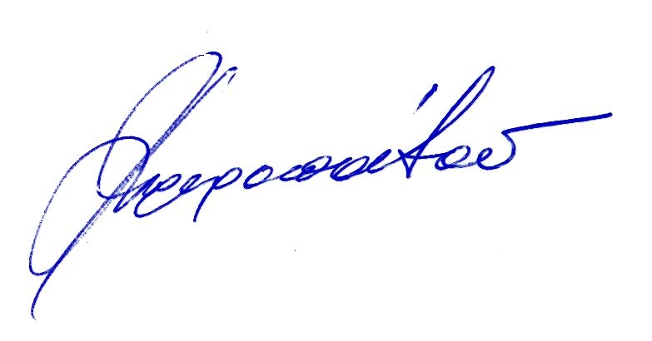
1st Vice President of the Greek National Commission for Human Rights

GNCHR, “Proposals regarding the implementation of Law 3699/2008 Special Education of Persons with Disabilities or Special Educational Needs”, Annual Report 2009.
Idem.

