CENTRUL PENTRU DREPTURILE OMULUI DIN MOLDOVA
 |  | ЦЕНТР ПО ПРАВАМ  ЧЕЛОВЕКА В  МОЛДОВЕ |  |  |  |  | THE CENTER FOR  HUMAN RIGHTS  OF MOLDOVA
MD-2012, Moldova, Chişinău, |  |  |  |  |  |  | Tel: 234 – 800; Fax: 225 – 442
str. Sfatul Ţării, 16 |  |  |  |  |  |  | E-mail: cpdom@mdl.net
 |  |  | nr.
la nr. |  |  | din |  |  |  |  |  | Unofficial translation

Special Rapporteur on the rights of persons with disabilities
Catalina Devandas -Aguilar

The National Institution for the Promotion and Protection of Human Rights in Moldova offers, to your request, the answers to the questionnaire on the right to social protection of persons with disabilities.
- Please provide information in relation to the existence of legislation and policies concerning mainstream and/or specific social protection programmes with regard to persons with disabilities.

By Law no. 166 from 09.07.2010, the Republic of Moldova ratified the UN Convention on the Rights of Persons with Disabilities.
UN Convention on the Rights of Persons with Disabilities serves as a reference framework for the successful implementation of social protection reform, underway in our country.
The first step towards implementing of the Convention was the adoption of the Strategy for social inclusion of persons with disabilities (2010-2013), by Law no.169 from 09.07.2010. The first stage of implementation of the Strategy was the adoption of the Law on social inclusion of people with disabilities, no. 60 from 30.03.2012.
This law establishes a general framework for security and social services in accordance with international standards on social inclusion of persons with disabilities. In general, the law provides equally for persons with disabilities as for other citizens, the right to social protection, health care, rehabilitation, education, employment, public life, physical environment, transport, information technologies and systems, communication and other utilities and services accessible to the public.
- The Law no. 60 from 30.03.2012 establishes, in Chapter VIII, the authorities responsible for the inclusion of people with disabilities, as follows:
- The National Council for the Rights of Persons with Disabilities is a collegial consultative body, set up to monitor the implementation and promotion of state policy in the field (laws, strategies, programs, action plans, etc.) in accordance with the UN Convention on the Rights of Persons with disabilities, to provide equal opportunity for this population for the achievement of rights and fundamental freedoms at the same level with other members of society.
- Ministry of Labor, Social Protection and Family, is the central body of government, empowered to develop, promote and conduct state policy on social protection of persons with disabilities, to ensure coordination and evaluation of the system functionality for social inclusion of these people. The other central public administration authorities are responsible for the social inclusion of people with disabilities according to their functional skills.
- The local authorities, in collaboration with civil society, ensures the social assistance policy for the persons with disabilities, and enforcement of legislation at the local level. The social assistance of persons with disabilities is ensured by local authorities through its structures (sections / departments of social assistance and family protection, education, culture, sport).
- Compliance with the UN Convention on the Rights of Persons with Disabilities by central and local public authorities, by institutions and enterprises irrespective of ownership type, by public associations and persons in positions of responsibility at all levels is monitored by civil society and by the Advocate people (Ombudsman).

The next step was the elaboration of amendments to the regulatory framework for its connection to the new law. Social services have been developed with the aim to assists the most vulnerable categories of people with disabilities.
Social protection of persons with disabilities is ensured through the social insurance system (pensions) and various social benefits and social services.
Persons with disabilities are entitled to social security insurance in accordance with Law no. 156 from 14.10.1998 on state social insurance pensions. The evidence of people with disabilities, beneficiaries of social insurance is carried out by the National Social Insurance House and its regional structures. The next step was the drafting of the amendments to the regulatory framework for its connection to the new law. Social services have been developed with the aim to assist the most vulnerable categories of persons with disabilities.
If they do not meet the conditions for granting social security benefits, people with disabilities benefits from social assistance.
People with disabilities are entitled to allowance, benefits, compensation, welfare and other social assistance services, in order to minimize or eliminate the consequences of the effects of the social risks.
The Law no. 499 from 14.07.1999 on state social allowances for certain categories of citizens, sets state social allowance for persons with disabilities, including children with disabilities who do not qualify for obtaining entitlement for pension from state social insurance budget.
The Law no.133 on social assistance from 13 June 2008 provides a guaranteed minimum income for families in need, including persons with disabilities, by providing social aid and aid for the cold season to disadvantaged families, including persons with disabilities.

The evidence of persons with disabilities, who are beneficiaries of social assistance, is carried out by local authorities, if the benefits are paid from the local budgets, or by the National Social Insurance House and its regional structures, if benefits are paid from the state budget.
The funding of social assistance benefits is provided from the state budget, local budgets and extra-budgetary sources (donations, sponsorships).
Following the ratification of the Convention have been developed new social services with the aim to overcome the difficult situations and to prevent marginalization and social exclusion of people with disabilities. In this context, have been adopted a number of laws, as follows:
- Government Decision no. 711 from 09.08.2010, for the approval of the Framework Regulation on the organization and functioning of social Service "sheltered housing", and of the minimum quality Standards;
- Government Decision no. 936 from 08.10.2010, for the approval of the Framework Regulations on the organization and functioning of the social service "Community House", and of the minimum quality standards;
- Government Decision no. 722 from 22.09.2011, for the approval of the Framework Regulations on the organization and functioning of social service "Mobile Team";
- Government Decision no. 567 from 26.07.2011, for the approval of the Regulation on how to ensure certain categories of citizens with technical aids;
- Government Decision nr.314 from 23.05.2012, for the approval the Framework Regulation on the organization and functioning of social service "Personal Assistance", and of the minimum quality standards;
- Government Decision nr.413 from 14.06.2012, for the approval of the Framework Regulation on the organization and functioning of social service "Respiro", and of the minimum quality standards;
- Government Decision No. 65 from 23.01.2013, on the determination of disability and working capacity;
- Government Decision no. 75 from 03.02.2014, for the approval of the Framework Regulation on the organization and functioning of social service "Adult family Placement", and of the minimum quality standards;
- Government Decision no. 760 from 17.09.2014, for the approval of the Framework Regulation on the organization and functioning of the Foster care Service, and of the minimum quality standards;
- Government Decision no. 333 from 05.14.2014, for the approval of the Regulation on communication services using sign language / sign language with help of the interpreter.

Under the subordination of Ministry of Labor, Social Protection and Family are functioning following institutions:
- 4 neurological boarding houses (social institutions for persons with disabilities)
- 2 social institutions for elderly and people with disabilities: Republican Asylum from Chisinau for elderly and people with disabilities, and Republican rehabilitation center from Cocieri, Dubasari, for people with disabilities, war and labor veterans.
According to national law the local public administration authorities have a list of attributions, as follow:
a) to analyze and to evaluate the social problems of persons with disabilities from the ascribed territory, and depending of the outcomes, to approve and to develop local programs for social assistance for this category of persons, and to exercises the control over their fulfillment;
b) to establish, independently or in partnership with civil society representatives, primary social services and specialized social services for persons with disabilities, providing human, material and financial resources necessary for their proper functioning;
c) may provide additional facilities for the persons with disabilities on access to medical, social, commercial, transport, telecommunications and other social services.
- Please provide information on how persons with disabilities are consulted and actively involved in the design, implementation and monitoring of social protection programmes.
Non-governmental organizations active in the field of people with disabilities, including persons with disabilities, are involved in consultation and monitoring of the implementation of social protection programs.
At the stage of elaboration of the draft of the Strategy and the draft of the Law on the social inclusion of persons with disabilities, Ministry of Labor, Social Protection and Family has consulted the opinion of the representatives of NGOs in the field of protection of persons with disabilities, as well as directly of the persons with disabilities.
Currently it is not formally established the independent monitoring mechanism according to art. 33, paragraph (2), of the Convention. These tasks are accomplished according to art. 10, paragraph (2) of the Law on social inclusion of persons with disabilities, no. 60 from 30.03.2012, which states that, " the compliance of the provisions of the UN Convention on the Rights of Persons with Disabilities by central and local public authorities, by enterprises and institutions regardless of ownership type, by public associations and persons in positions of responsibility at all levels is ensured by civil society and Ombudsman".
It should be noted that since 2012 have been conducted several meetings with the participation of the Ombudsman, representatives of active organizations in protecting the rights of persons with disabilities, in order to establish an independent mechanism for the monitoring of the implementation of the Convention.
Also, the Ombudsman Institution is permanently organizing working meetings with representatives of civil society concerned with the protection of persons with disabilities, persons with disabilities, and invites the representatives of public authorities in the field, where are discussed problematic issues for persons with disabilities, and are identified optimal solutions.
In particular, during the period 1-10 December 2014, the Ombudsman Institution held a thematic decade to promote the rights of persons with disabilities.
Meetings of this decade had topics regarding: Ensuring accessibility to public transport for people with physical, hearing and sight disabilities; Providing prosthesis, special footwear for persons with physical disabilities; Implementation of the Regulation on communication services using sign language / sign language with help of the interpreter, approved by Government Decision no. 333, from 14.05.2014. In another meeting the officials of the Ombudsman’s Institution presented a report on the theme: " The Impact assessment of the social services for community integration of persons with disabilities ". Thematic Report is placed on the official website of the institution.
Regarding discussions with civil society representatives in the field and with persons with disabilities have been adopted a resolution, by which the signatories expressed their intention to bring back the attention of central and local authorities the importance of our state obligations, following ratification of the Convention on the Rights of Persons with disabilities.
In 2015 consultations in this regard were continued. Thus, on 5th May Ombudsman Institution held a similar meeting, where was discussed the question of compliance of electoral rights of persons with disabilities, in the context of local elections from 14th June 2015. The meeting launched a joint appeal to the competent public authorities, requesting to ensure the necessary conditions for the exercise of the rights to vote of persons with special needs, without any impediments.
- Please provide information in relation to difficulties and good practices on the design, implementation and monitoring of mainstream and/or specific social protection programmes with regard to persons with disabilities.
Development of social services has become one of the key objectives in implementing the national policy of social inclusion of persons with disabilities. Since 2010 there were created more social services designed to assist the most vulnerable categories of persons with disabilities.
As a best practice examples we can mention the following types of specialized social services for support of persons with disabilities in the community:
- The service "sheltered housing" is a placement service that provides support for adults with mild mental disabilities, offering them housing and regular social assistance in order to ensure minimal living conditions and social autonomy;
- The social service "Community House" is a placement service for children and adults with severe and profound disabilities with a high degree of dependence. The service "Community House" requires specialized care, being provided in the community by a team of specialists with socio-medical profile. The service aims to provide ongoing support to help increase their capacity to integrate into the community and family, also to increase their capacity of self-service and socialization of beneficiaries;
• „Community Center for Mental Health " is a distinct socio-medical service, which provides psychosocial rehabilitation and assistance to persons with mental health problems, support and mediation in family and community relationships;
• The service "Personal Assistant" helps people with disabilities who can’t fend for themselves in daily life, and serves as an alternative to residential care system from Moldova. The personal assistant is the person who supervises, and provides care and assistance to the child or adult with severe disabilities;
• „Mobile Team” is a community support service for people with disabilities and their families, created at the district level within the Department of social assistance and family protection. The role of "mobile team" is to provide individualized social, medical, psychological and other home services to beneficiaries who do not have access to specialized services. The primary purpose of "mobile team" is to prevent the institutionalization of children with disabilities and contribute to their social integration;
• The social service "Respiro" - the goal of service is to provide specialized assistance for 24 hours to persons with severe disabilities on a maximum of 30 days per year, during which their families, relatives or persons caring for them have a period of rest.

Social service type which will be provided to disabled person is determined by the recommendations contained in the individual rehabilitation program and its social inclusion. Individual program based on initial assessment and / or complex assessment of person / family, which is conducted by the social worker, employed by the territorial structure of Social Assistance within the municipality, and by the multidisciplinary team, and adapted to the needs of the concerned person.
Specialists of the directorates / departments for social assistance and family protection are obliged to manage cases of the beneficiaries at all stages, according to legal procedures and using the approved work tools. In this regard, Minister of Labour and Social Protection has developed guidelines for social workers on assessment, monitoring and support of the beneficiary and his family, and on the mechanisms for reference of the case to social services.
Another example is the changes recently approved by the Parliament in the regulatory framework to ensure the implementation of the article 12 of the Convention. In particular, have been excluded restrictions regarding persons incapacitated by a final court judgment, concerning the realization of voting rights, through the provisions of article 13 para. (1) b) of the Election Code of Republic of Moldova, and to ensure access to justice for these categories.
In the context of best practices, we should mention that at the initiative of the Ombudsman, the official websites of the government authorities contain an application which facilitate the access to information for people with visual impairments.
Also, we noticed certain difficulties in achieving the full extent of the right to social protection of persons with disability. Taking into account that expenditure related to the organization and functioning of social services are largely borne by local government and NGO sector, one of the core issues raised by directorates / departments of social assistance and family protection are the insufficient financial means for the support / development of this services.
According to information gathered by the Ombudsman Institution from territorial subdivisions of social assistance services, but also in the examination process of petitions from persons with severe disabilities, we found that social services do not cover the needs of individuals / families in difficulty.
Regarding physical accessibility, there are some backlogs in terms of implementation of the law. The lack or the existence of inadequate ways of access to public institutions, and to their homes, is a barrier in the achievement of rights of persons with locomotors disabilities, and persons with impaired hearing and sight.
At the meetings organized by the Institution of the Ombudsman was emphasized that ensuring the functionality of approved laws, and the monitoring of their implementation is a challenge that requires consolidated efforts from public authorities.
In this context, we note that the Action Plan on implementation of measures to ensure accessibility for people with disabilities to social infrastructure, contains concrete short term actions, and establishes authorities and output indicators.
According to the Action Plan approved by Government Decision no. 599, until December 2013 the local authorities should draft and approve local action plans on adapting buildings to the needs of persons with disabilities, with the provision of financing the actions from administrative-territorial units budgets, building owners etc.. From the information presented at the request of the Ombudsman Institution, the situation in January 2015, we found that many local authorities have not approved such a plan.
Thus, according to the generalized report developed by the Ministry of Regional Development and Construction, on the inventory of public institutions and existing social institutions, from 5137 objects which were subject of the inventory in terms of accessibility, 3440 objects are not adapted to existing standards.
In the public appeal of the Ombudsman and participants at the meeting from 5th May 2015, the central and local public authorities were called to ensure strict observance of Law no. 60 from 30.03.2012, which refers to the obligation to ensure accessibility conditions, adapting new buildings to the needs of persons with disabilities; establishment of a special division within the State Construction Inspectorate, which would follow this process and would take measures as required to curb admitted irregularities.
Raising public awareness about the rights of persons with disabilities is one of the objectives of the Ombudsman’s Institution activity. In this context, it is permanently performed various training activities in human rights, including the rights of persons with disabilities. Currently, Ombudsman's Institution jointly with the Council for prevention and elimination of discrimination and ensuring equality performed a series of trainings for central public and law enforcement authorities representatives, etc. in the field of non discrimination, including persons with disabilities.
- Please provide any information or data available, disaggregated by impairment, sex, age or ethnic origin if possible.

The information on the situation of people with disabilities can be accessed on official website of the National Bureau of Statistics.

Number of persons with disabilities at the evidence of the state social insurance authorities

 | 2009 | 2010 | 2011 | 2012 | 2013
Total of persons with disabilities, thousands | 176,7 | 179,1 | 179,8 | 183,7 | 183,4
Inclusively with (%):
severe disabilities | 14,9 | 14,8 | 14,8 | 14,9 | 15,1
accentuated disabilities | 65,9 | 65,8 | 66,0 | 66,1 | 65,7
average disabilities | 19,2 | 19,4 | 19,2 | 18,9 | 19,2
Inclusively children, thousands | 15,2 | 15,1 | 14,1 | 14,7 | 14,0
Inclusively with (%):
severe disabilities | 40,1 | 41,1 | 42,6 | 42,9 | 43,6
accentuated disabilities | 50,0 | 49,0 | 47,5 | 46,9 | 45,0
average disabilities | 9,9 | 9,9 | 9,9 | 10,2 | 11,4
Rate of total disability by gender, number of cases per 10 000 inhabitants
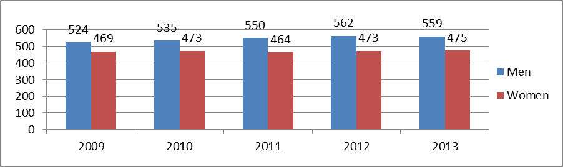
Beneficiaries of specialized social services, in 2013
 | Total developed services | Number of beneficiaries
Mobile teams | 16 | 481
Sheltered housing | 3 | 10
Community House | 6 | 32
Respiro | 5 | 102
Inclusive education resource center | 15 | 444

The standard of living of households with disabled people
According to data of the selective study in households, Household Budget Survey, 41.4% of persons with disabilities aged 15 years and over are employed in the labor market, comparing with 65.9% of people without disabilities. The level of employment of people with disabilities is determined by the severity, so that if people with average disabilities are employed in proportion of 57.6%, people with increased disabilities at a rate of 44.8%, while those with severe disability at a rate of 11.2 %.
In general, households with disabled persons remain to be less advantageous terms regarding the level of equipment and housing comfort, even if compared with 2012 the access of households with disabled to the main utilities has improved.
The structure of persons with disabilities by occupational status in 2013.
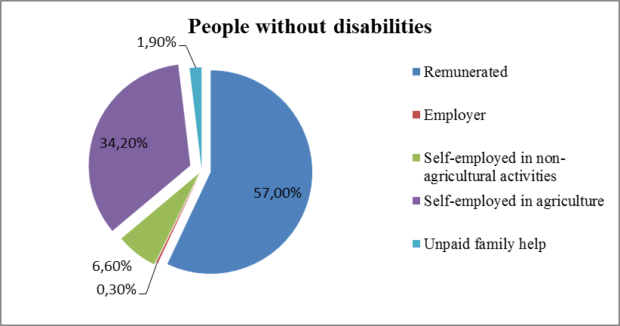

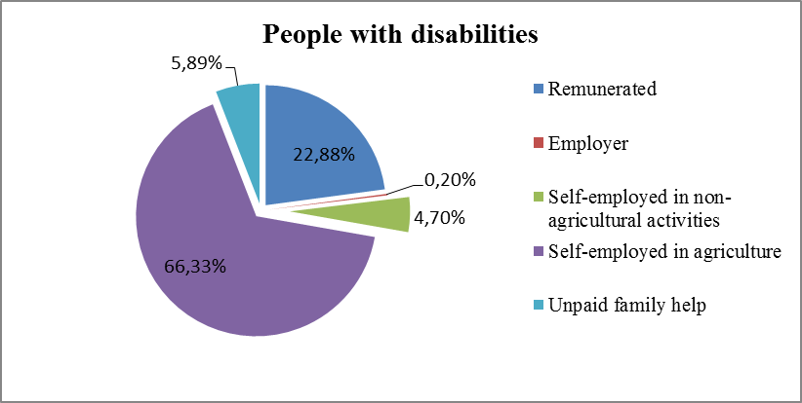

As regards payment of expenses for utilities, the survey highlights that about 27 percent of households with persons with disabilities have difficulties in paying electricity, and practically every third at payment for gas.
Also for 44.4% of households incomes are not sufficient to meet food products needs.
The share of households that had difficulty in paying / ensuring the following goods and services in 2013
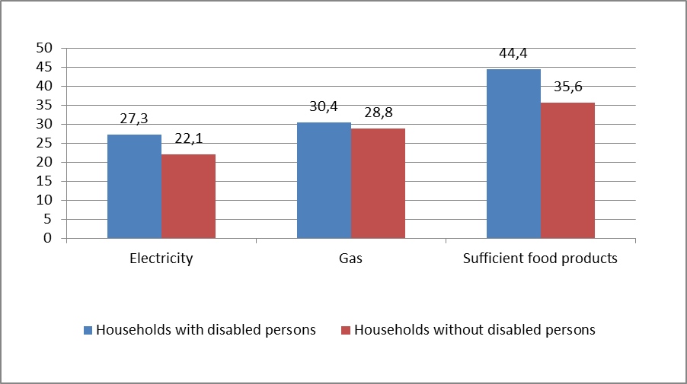

According to the National Social Insurance House, at 01.04.2015 the disability average pension amounted to 937.9 lei, and the average state social allowance for persons with disabilities - 161.45 lei, and for people with disabilities from childhood - 442 58 lei.
However, according to the National Bureau of Statistics, in 2014 the size of the minimum subsistence per month for one person was 1627.1 lei.

- Please provide information in relation to the eligibility criteria used for accessing mainstream and/or specific social protection programmes with regard to persons with disabilities.

According to Law no. 60 from 30.03.2012, disability means - generic term for impairments / deficiencies, activity limitations and participation restrictions, which denotes the negative aspects of the interaction between the individual (who has a health problem) and contextual factors it is found (environmental factors and personal ones).
When determining the access of persons with disabilities and their families to social assistance programs take into account the monthly minimum guaranteed income (in 2015-765 lei), representing the calculated monthly minimum income guaranteed by state for a family.
It is mentioned that currently the eligibility criterion for different social protection programs is the degree of severity of disability and the minimum guaranteed monthly income.

Respectfully, Mihail COTOROBAI
Ombudsman of Republic of Moldova

Government Decision no. 599 from 13.08.2013, on Action Plan on implementation of measures to ensure accessibility for people with disabilities to social infrastructure.
http://www.statistica.md/newsview.php?l=ro&id=4566&idc=168

