
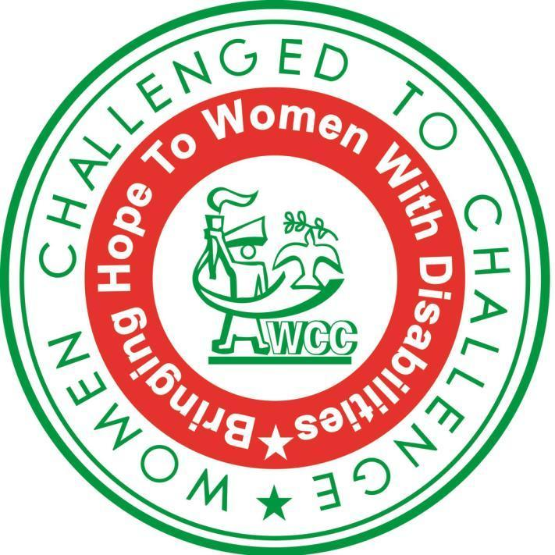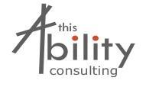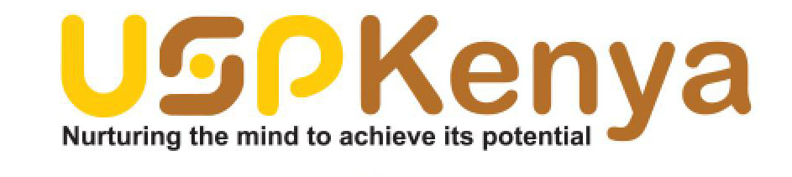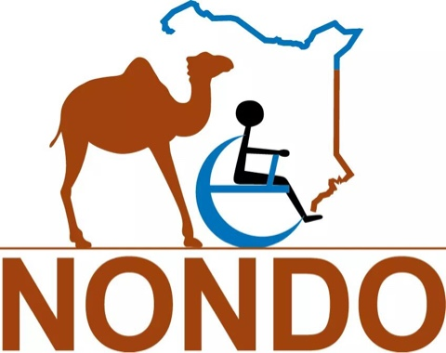

QUESTIONNAIRE ON THE RIGHT OF PERSONS WITH DISABILITIES TO THE HIGHEST ATTAINABLE STANDARD OF HEALTH

SUBMISSION TO THE SPECIAL RAPPORTEUR ON THE RIGHT OF PERSONS WITH DISABILITIES BY KENYAN NETWORK ADVOCATING FOR THE RIGHTS OF WOMEN AND GIRLS WITH DISABILITIES IN KENYA
Organizations: Women Challenged to Challenge, This Ability Consulting, Users and Survivors of Psychiatry in Kenya, Kenya Association for the Intellectually Handicapped, Positive Exposure Kenya, Kenya Deaf Women Peace Network, Women and Realities of Disability, Kabras Self Help group, Association for the Physically Disabled of Kenya, Kilo Disabled Advocacy group, Northern Nomadic Disabled Persons Organization
Individual experts: Salome Muigai, Elizabeth Kamundia, Everlyn Milanoi Koiyiet

Introduction
The Kenyan Network Advocating for the Rights of Women and Girls with Disabilities (hereinafter the Network) brings together organizations and experts working in Kenya on the rights of women and girls with disabilities. The Network was started as a result of women and girls with disabilities in Kenya falling within the cracks of women’s rights and disability rights movements making the rights of women and girls with disabilities left out in many discussions on human rights.

According to the 2009 Kenyan Census, there are 682,623 women with disabilities in Kenya. The number is much higher but due to the fact that not all women with disabilities are registered as persons with disabilities, invisible disabilities, stigma and cultural factors surrounding disability and the lack of awareness and training of census administrators and government officials on disability.

The Network therefore seeks to amplify the voices of women and girls with disabilities from Kenya at the national, regional and international level to ensure that women and girls with disabilities are included and participate in all spaces and discussions on women’s rights and disability rights to ensure issues affecting women and girls with disabilities in Kenya are addressed.

- Please provide information on existing or planned legislation and policies to ensure the realization of the right to health of persons with disabilities, including current challenges and good practices.
Kenya has made some steps in providing for laws and policies for the right to health including sexual and reproductive rights. This includes the Kenyan Constitution 2010, Kenya Health Policy 2012-2030, National Reproductive Health Policy 2007, the National Reproductive Health Strategy 2009-2015, Kenya National Adolescent Sexual and Reproductive Health Policy of 2015 and the current Reproductive Health Care Bill, 2014. Even with these law and policies women and girls with disabilities continue to suffer stigma and discrimination when they seek reproductive health services.

Constitution of Kenya
It provides for the right to health for all, including persons with disabilities. Section 43(1) (a) of the Constitution states that Every person has the right to the highest attainable standard of health, which includes the right to health care services, including reproductive health care.

Persons with Disabilities Act
Section 20 of the Persons with Disabilities Act addresses ‘health’. The Section states that the National Council for Persons with Disabilities ‘shall be represented in the implementation of the national health programme under the Ministry responsible for health’. Section 20 highlights the following as the purposes for which the National Council for Persons with Disabilities shall be represented in the implementation of the national health programme: prevention of disability; early identification of disability; early rehabilitation of persons with disabilities; enabling persons with disabilities to receive free rehabilitation and medical services in public and privately owned health institutions; availing essential health services to persons with disabilities at an affordable cost; availing field medical personnel to local health institutions for the benefit of persons with disabilities; and prompt attendance by medical personnel to persons with disabilities. However, section 20 does not provide for the right to the highest attainable standard of health.

Reproductive Health Bill of 2014
The Bill has a strong definition of informed consent that ensures that women themselves make the decision to undergo reproductive health procedures, but under the section on abortion, the bill would still allow guardians or parents to make the decision for a “mentally unstable person”—which often includes women with intellectual or psychosocial disabilities—to undergo what amounts to a forced abortion. Furthermore, the bill does not address the issue of sterilization without the informed consent of women with disabilities, an all-too-common occurrence in Kenya and a serious human rights violation, including a violation of the right to found a family and a violation of the right to be free from torture or ill-treatment.

Kenya National Adolescent Sexual and Reproductive Health Policy of 2015
It provides implementation of policy shall be guided by respect for human rights and fundamental freedoms including equality and freedom from discrimination on the basis of disability. It also provides that the policy shall support provision of disability friendly sexual and reproductive health information and services. Even with policy there is still lack of disability friendly health services not only to adolescents but to women with disabilities as well.

Mental Health Act 1989
It has three categories of mental healthcare situations: voluntary, involuntary and emergency admission. All of these categories allow for the making of substitute decisions, relating to health care on behalf of the individual and in particular, allow mental health treatment without the free and informed consent of the person.

- Please provide any information and statistical data (including surveys, censuses, administrative data, literature, reports, and studies) related to the exercise of the right to health of persons with disabilities in general, as well as with particular focus in the following areas:
- Availability of barrier-free general healthcare services and programmes, which take into account all accessibility aspects for persons with disabilities;
- access to free or affordable general healthcare services and programmes, including mental health services, services related to HIV/AIDS and universal health coverage;
- access to free or affordable disability-specific healthcare services and programmes; and
- access to free or affordable health-related habilitation and rehabilitation goods and services, including early identification and intervention.
The Committee on the Rights of Persons with Disabilities in its concluding observation to Kenya in 2015 under Article 25 on Health stated its concern on the barriers that exists for persons with disabilities in accessing information and services on sexual and reproductive health. The Committee also stated its concern on the lack of information on accessible health facilities for persons with disabilities in rural areas and that the mental health care in Kenya is based on the medical model. It recommended for the State to ensure accessible health policies with a gender perspective, accessible health facilities and community based services responsive to the needs of persons with disabilities that respect autonomy, choice, dignity and privacy including peer support as an alternative to the medical model of mental health.
An inquiry report by Kenya National Commission on Human Rights(KNCHR) reveals that women with disabilities face stigma and discrimination where women with physical disabilities suffer abuses from health service providers who stigmatise them and assume that women with disabilities are sexually inactive. Further, health service providers perform invasive procedures without their consent. Women with disability have difficulty in accessing health facilities due to physical infrastructure, high cost of health services, sexual harassment and mistreatment where some have been slapped by nurses in labour wards, difficulty in accessing information especially women with visual and hearing impairments.
A 2008 Kenya national survey on persons with disabilities states that:
- 16% of women with disability aged 12- 49 years use some form of family planning.
- A large proportion of the population (69%) cannot access health services. 73% rural areas and 64% in urban areas.
- Persons with disabilities in Nyanza 81%, North Eastern 80% experienced the most difficult problems in accessing health services.
- For persons with disabilities with university education, 85% reported a major problem in access to health care and medical services. Those with with college level education were 70%, secondary (61%) and primary (40%).
- Please provide information on discrimination against persons with disabilities in the provision of healthcare, health insurance and/or life insurance by public or private service providers.
In Kenya, we have the National Health Insurance Policy (NHIF) that is provide by government. Government has started providing NHIF to Kenyans who can afford even though not employed by government where the minimal cost is Kshs500 equivalent to 5$ per month but there are higher rates as well depending on the package. There is information that Government agreed to start providing NHIF to persons with disabilities and pay for them but at the same time many persons with disabilities are not aware. Those who are aware say they have been told to pay Kshs. 500 per month while some have been able to get without paying any amount monthly. There is therefore lack of clarity as information is not shared effectively or at all to those who need it most. More needs to be done to ensure government provides proper information and ensure it reaches persons with disabilities and that it is consistent in providing NHIF to all persons with disabilities especially those who do not have access to private insurance or do not have any insurance at all. There is need for government to share information in accessible formats to all Kenyans and ensure it reaches all including those in rural areas.
We also have numerous private insurance companies but it is costly most people who have is because employers pay for them. For private insurance, most insurance companies deny insurance to persons with disabilities especially persons with intellectual disabilities and those that accept will charge a really high cost to accept to cover them.

- Please provide information on the observance of the right to free and informed consent of persons with disabilities regarding healthcare, including sexual and reproductive health and mental health services.

Women with disabilities are often denied reproductive healthcare information and services and at times are even subjected to forced sterilization. In fact, there are a number of reported cases in Kenya of forced sterilization, and with regards to women and girls with disabilities, it is the guardians who are consenting to sterilization on behalf of the women and girls with disabilities without their consent.

Several research reports suggest that forced sterilization is a common occurrence in Kenya; unfortunately, findings are that the State has not taken concrete action to prohibit such practices. In a study conducted by the Mental Disability Advocacy Centre, one of the female interviewees stated:
“I don’t think I would get children. I will tell you something; you see here [lifts up the blouse and reveals a scar on her stomach] here I was made an operation. This is contraceptive, all of us had been done like this, we cannot get children. Nobody asked me. They should have asked me, because I love children […]. I feel bad, but what can I do now.

A case of forced sterilization has been reported and is currently being challenged in the Kenyan courts; this proves that indeed women in Kenya are being sterilized against their will yet nothing is being done to address this violation. Evidence received by organizations of persons with disabilities points to women with intellectual disabilities and psychosocial disabilities having contraception administered to them against their will within the community.

A study conducted by the Kenya National Commission on Human Rights on the rights of persons with disabilities found that:
Others [nurses] doubted their [women with disabilities] capability to deliver through the normal procedures and instead suggested they undergo caesarean process without their consent. Further, persons with disabilities were not being allowed to make choices on the mode of family planning with nurses dictating which methods to use

Inquiry by KNCHR shows lack of funding contributing to not realizing reproductive health and services. The State is yet to meet its obligations of dedicating 15% of budget to health as per the Abuja Declaration.

The Health Act 2017
Under the Act, there are provisions relating to people who have capacity, and provisions directed at those who lack capacity. section 8(1) of the Act on health information provides that where the user of the information is an ‘incapacitated’ person, the health information shall be provided to that person’s guardian. Further, section 9(3) of the Act states that ‘informed consent’ means consent for the provision of a specified health service given by a person with legal capacity to do so’. Hence, under the Health Act persons with psychosocial disabilities still run the risk of being treated as individuals who lack legal capacity in health settings.

The Mental Health Act provides that people suspected of having a “mental disorder” may be involuntarily admitted into a psychiatric hospital. Police officers are allowed to detain someone they believe to have such a condition who they perceive as dangerous to themselves or others, likely to act in a manner offensive to public decency, and those not under proper care and control, or who are being cruelly treated or neglected.

Family members and communities in collaboration with police officers normally take persons with psychosocial disabilities to psychiatric hospitals against their will while purporting to act in their best interest. Further to this, medical professionals will also administer forced treatment within the home setup. This is compounded by the lack of alternatives in the mental health system where the only option which is available is medical treatment and also the lack of support systems that would enable people to exercise the right to choose.

Some communities will randomly round up persons with psychosocial disabilities especially those who are homeless and take them to the hospital against their free and informed consent.

The Constitution of Kenya provides the right to the highest attainable standard of health, including reproductive health care. It also provides for equality and freedom from discrimination on any ground including disability Despite these laws, there is a general lack of disability mainstreaming within public healthcare institutions as there are inaccessible beds, toilets and washrooms, lack of Sign language interpretation, inaccessible gender based violence recovery centers, a lack of privacy and confidentiality and a general lack of awareness on the needs of women with disabilities. The lack of accessible infrastructure brings about poor sanitation especially for women and girls with physical disabilities because most toilets in public institutions are pit latrines and inaccessible therefore posing a health risk for girls with physical/multiple disabilities getting in contact with the dirty floor of the latrine as they are forced to crawl.

There are cases of women and girls with disabilities especially intellectual and psychosocial disability not getting proper medical attention in government facilities after sexual violence. This results to cases failing in court as medical personnel provide insufficient reports, do not handle the matter urgently to get good evidence to ensure successful prosecution; evidence is lost in hospitals or police stations.

- Please describe to what extent and how are persons with disabilities and their representative organizations involved in the design, planning, implementation and evaluation of health policies, programmes and services.
In Kenya women with disabilities and their organizations have not been involved in any health polices implementation, evaluation, nor in design of programmes and services. This is to some extend proven by the resent assessment study that was done by National Council on Population and Development in 2015. The study was meant to find out how reproductive Health/Family Planning services are available and accessed by all women. Further the report showed that the uptake of these services is low despite the efforts of Kenyan government committing to ensure that Reproductive Health (RH) /family planning (FP) services are available and accessed by all as spelt out in the National Reproductive Health policy. The report shows that most health facilities lack supplies, and efficient logistics management systems that would ensure adequate and timely supplies are done. The report did not disaggregate data by disability to find out to what extend women with disabilities are accessing these service and therefore bring out the barriers. If programmes are going to be put in place based on the study it will be hard to cater for the special needs of women and girls with disabilities.

After realizing the maternal deaths were on the rise, the First Lady Mrs. Margaret Kenyatta initiated a mobile clinic project targeting women in rural areas and those hard to reach. The trucks used are very high and a woman with physical disability cannot access them. Once inside the examination room, the seats and examination tables are also high. These are but few examples to show how women and girls with disabilities are left out in any health programme. National Council for Population and Development should take a deliberate move and carry out a study on disability and uptake of health services.

REFERENCES

Laws
- Constitution of Kenya. ( 2010) URL: http://www.kenyalaw.org/lex/actview.xql?actid=Const2010 accessed 29th March 2018

- Persons with Disability Act. (2003) URL: http://www.kenyalaw.org/lex//actview.xql?actid=No.%2014%20of%202003 accessed 29th March 2018

- Persons with Disabilities Bill. (2016) URL: http://www.udpkenya.or.ke/publications/prototype-new-final-persons-with-disabilities-bill-2016-sent-to-ps-final.pdf accessed 29th March 2018

- The Reproductive Health Care Bill. (2014) URL: http://kenyalaw.org/kl/fileadmin/pdfdownloads/bills/2014/ReproductiveHealthCareBill2014__1_.pdf accessed 29th March 2018

- Health Act. (2017) URL:
http://kenyalaw.org/kl/fileadmin/pdfdownloads/Acts/HealthActNo.21of2017.pdf accessed 29th March 2018

- Mental Health Act. (1989) URL:
http://www.kenyalaw.org/lex/actviewbyid.xql?id=KE/LEG/EN/AR/M/CHAPTER%20248/sec_38#part_IV accessed 29th March 2018

- Kenya National Adolescent Sexual and Reproductive Health and Policy. (2015)URL: http://www.popcouncil.org/uploads/pdfs/2015STEPUP_KenyaNationalAdolSRHPolicy.pdf accessed 29th March 2018

- Kenya Health Policy. (2012-2030) URL: https://www.healthresearchweb.org/files/KenyaHealthpolicyfinalversion.pdf accessed 29th March 2018

Reports

- Kenya National Commission on Human Rights. (2014). From norm to practice a status report on the implementation of the rights of persons with disabilities in Kenya, Nairobi: Kenya National Commission on Human Rights. URL: http://www.knchr.org/Portals/0/Reports/Disability%20Report.pdf
accessed 29th March 2018

- Kenya National Commission on Human Rights. (2012) ‘Realizing Sexual and Reproductive Health Rights in Kenya: A myth or a Reality?’ A Report of the Public Inquiry into Violations of Sexual and Reproductive Health Rights in Kenya.URL: <http://www.knchr.org/Portals/0/Reports/Reproductive_health_report.pdf> accessed 29th March 2018

- United Nations. (2015) CRPD Committee Concluding Observations to Kenya.URL: http://tbinternet.ohchr.org/_layouts/treatybodyexternal/Download.aspx?symbolno=CRPD%2fC%2fKEN%2fCO%2f1&Lang=en accessed 29th March 2018
- NCAPD. (2008). Kenya National Survey for Persons with Disabilities- Preliminary Report. National Coordinating Agency for Population and Development. URL: http://www.afri-can.org/CBR%20Information/KNSPWD%20Prelim%20Report%20-%20Revised.pdf accessed 29th March 2018

- The Rights to Legal Capacity in Kenya. (2014) URL:
http://mdac.info/sites/mdac.info/files/mdac_kenya_legal_capacity_2apr2014.pdf accessed 29th March 2018

Kenya National Commission on Human Rights Realizing Sexual and Reproductive Health and Rights in Kenya: A myth or reality? (April 2012) pg. 24.
Act 14 of 2003
The National Council for Persons with Disabilities is established under section 3 of the Persons with Disabilities Act. The Council is ‘mandated to formulate and implement policies that are geared towards mainstreaming Persons with Disabilities into the National economy’ for more information on the Council, see: National Council for Persons with Disabilities <http://ncpwd.go.ke/> accessed 14 November 2017.
The Reproductive Health Care Bill 2014 (Kenya), sec. 2, available at http://kenyalaw.org/kl/fileadmin/pdfdownloads/bills/2014/ReproductiveHealthCareBill2014__1_.pdf accessed on 14th September 2017.
The Reproductive Health Care Bill 2014 (Kenya), sec. 20, available at http://kenyalaw.org/kl/fileadmin/pdfdownloads/bills/2014/ReproductiveHealthCareBill2014__1_.pdf accessed on 14th September 2017.
CEDAW Committee, A.S. v. Hungary case; Human Rights Council, Report of the Special Rapporteur on torture and other cruel, inhuman or degrading treatment or punishment, Juan E. Méndez, paras. 32 & 48, U.N. Doc. A/HRC/22/53 (2013).
National Adolescent sexual and reproductive health policy of 2015. pg. 8 accessed at http://www.popcouncil.org/uploads/pdfs/2015STEPUP_KenyaNationalAdolSRHPolicy.pdf
Id at pg. 20
Section 10(3) of the Mental Health Act 10 of 1989
Section 14(1) of the Mental Health Act 10 of 1989;
Section 16(1) of the Mental Health Act 10 of 1989
UN CRPD Committee Concluding Observations for Kenya,2015 page accessed at https://documents-dds-ny.un.org/doc/UNDOC/GEN/G15/223/37/PDF/G1522337.pdf?OpenElement on 28th March 2018
Id
Kenya National Commission on Human Rights, ‘Realizing Sexual and Reproductive Health Rights in Kenya: A myth or a Reality?’ A Report of the Public Inquiry into Violations of Sexual and Reproductive Health Rights in Kenya (2012) pg. 111-115 <http://www.knchr.org/Portals/0/Reports/Reproductive_health_report.pdf> accessed 30 August 2017
National Coordinating Agency for Population and Development – NCAPD and Kenya National Bureau of Statistics (KNBS), Kenya National Survey for Persons with Disabilities Main Report. Nairobi (2008
Id pg. 35
Id pg. 36
Mental Disability Advocacy Center, The Right to Legal Capacity in Kenya, March 2014 pg. 5; An NGO based in Kenya, KELIN has documented instances where women with disabilities have been forcefully sterilized https://profiles.uonbi.ac.ke/kihara/files/report-on-robbed-of-choice-forced-and-coerced-sterilization-experiences-of-women-living-with-hiv-in-kenya.pdf
Mental Disability Advocacy Center, The Right to Legal Capacity in Kenya, March 2014 pg. 46 and 71
An NGO based in Kenya, KELIN has documented instances where women with disabilities have been forcefully sterilized https://profiles.uonbi.ac.ke/kihara/files/report-on-robbed-of-choice-forced-and-coerced-sterilization-experiences-of-women-living-with-hiv-in-kenya.pdf.
Mental Disability Advocacy Center, The right to Legal Capacity in Kenya (Budapest: 2014, MDAC)
The right to Legal Capacity in Kenya (Budapest: 2014, MDAC), p. 46, 66. A full testimony from this interviewee is contained in the report
Kenya Legal and Ethical Issues Network on HIV (KELIN), ‘5 cases of forced and coerced sterilization filed in the High Court of Kenya’, news article available at: http://gem.or.ke/5-cases-of-forced-and-coerced-sterilization-filed-in-the-highcourt-of-kenya/ accessed 26th January 2017, Petition 605 of 2014 SWK & 5 others v Medecins Sans Frontieres- France & 10 others (2016) eKLR available at http://kenyalaw.org/caselaw/cases/view/125001/ accessed 26th January 2017
Women Challenged to Challenge, Users and Survivors of Psychiatry – Kenya, Kenya Association of the Intellectually Handicapped who are Network members
National Survey on Disability by National Council for Population and Development, 2007
Kenya National Commission on Human Rights, ‘From Norm to Practice: A Status Report on Implementation of the Rights of Persons with Disabilities in Kenya’ (2014) pg. 25 <http://knchr.org/Portals/0/Reports/Disability%20Report.pdf> accessed 30 August 2017
Kenya National Commission on Human Rights Realizing Sexual and Reproductive Health and Rights in Kenya: A myth or reality? (April 2012) pg. 26
Article 43 (1) Constitution of Kenya
Article 27 Constitution of Kenya

