TANZANIA EMPOWERMENT FOR PERSONS WITH DISABILITY AND GENDER HEALTH ORGANIZATION.
(TEPDGHO)

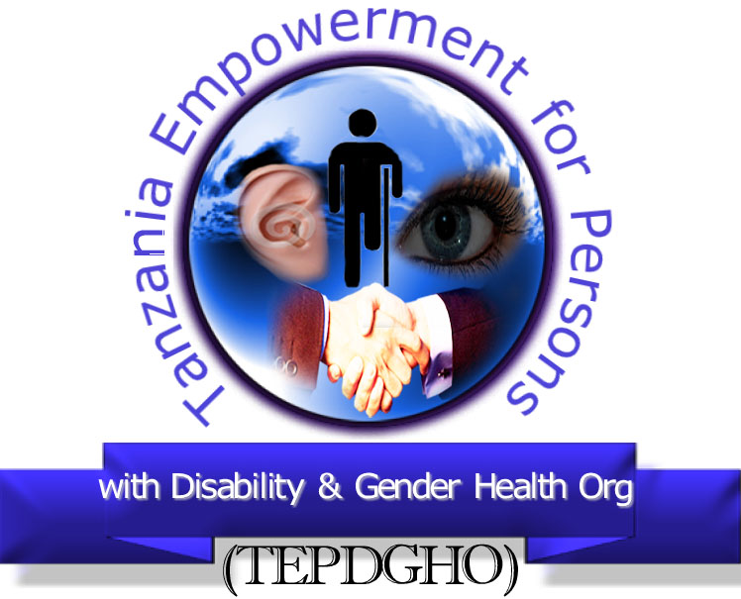

“THE RIGHT OF PERSONS WITH DISABILITIES TO THE HIGHEST ATTAINABLE STANDARD OF HEALTH IN TANZANIA”

Submitted by:

Tanzania Empowerment for Persons with disability and Gender Health Organization.
P.O.BOX.24,
MAZOMBE-IRINGA
TANZANIA(AFRICA)
Mobile Contacts; +255 763057166
Email; tepdgho@gmail.com or tngajilo@yahoo.co
Website:
Facebook page: https://web.facebook.com/TEPDGHO

MARCH 2018

LIST OF ACRONYM USED

DMO – District Medical Officers
IMR – Infant Mortality Rate
LGA – Local Government Authority
M&E – Monitoring and Evaluation
MOHSW – Ministry of Health and Social Welfare
PDO - Project Development Goal
PFM – Public Financial Management
PHC – Primary Health Care
PMORALG - Prime Minister’s office, Regional Administration and Local Government
PWDs – Persons with Disabilities
RHMTs - Regional Health Management Teams
UNCRPD – United Nations Convention on the Rights of Persons with Disabilities
U5MR - Under-five mortality rate
URT – United Republic of Tanzania

EXECUTIVE SUMMARY
Background:From a legal point of view, the Government of Tanzania has shown great commitments towards ensuring access to healthcare for persons with disabilities. Yet, the great challenge remains on making its health programmes more inclusive by mainstreaming the needs of PWDs and engaging them fully in planning, implementation and reporting outcomes of its health programmes.

Analysis of findings: The Ministry of Health and Local Government have no specific statistics on PWDs affected by the World Bank funded Basic Health Services project because the primary health care services were designed for the entire population of Tanzania without specific requirements for PWDs.
The main harms that PWDs suffer include, but are not limited to affordability of medical costs, inadequate medicines or medical equipments in district hospitals, poor maternal health services, and communication barriers.

This harm happened because Persons with Disability were neither consulted nor involved at all in the entire project. Thus, their concerns were not foreseen by implementers and they have exerted zero influence in several projects.
To minimize the said harms, the Bank should have fully involved PWDs in the initial processes of the project i.e. project design, planning/budgeting, launching, implementation, monitoring and reporting.

This would go together with conducting a needs assessment survey of PWDs and see how to incorporate them in the project. Had persons with Disability being fully involved in the process, specific instructions could be provided to ensure that a certain percentage of funds are set aside to promote access to health services by PWDs. Lack of that provision therefore, gave way to the implementing Ministry to disburse the entire fund to support other project actions.

According to the Ministry of Health, currently, there is no official plan in place to mitigate the impact.
Despite challenges discussed in this study, respondents have pointed out some positive project practices and outcomes found in their district hospitals such as improvement of immunization and maternal health services.
The recommendation is made to the Bank that, full participation of PWDs in the project would be a crucial step to identification and mainstreaming of their needs in the project process.

PART ONE

1.0 Introduction:

1.1 Explanation of general problem
The Alma-Ata Declaration of 1978 proclaimed Primary Health Care as the means for achieving Health for All. The Declaration has influenced the reorganization of the health systems in developing countries such as Tanzania where national policies are based on effective, cost-efficient primary health care strategies that entails universal health coverage, patient-centered approaches and demand-driven health policies. (Ref: Phci web).
Tanzania implements its primary health care through its existing network of multi-sectoral Primary Health Care (PHC) Committees at national, regional, district, ward and village levels. In 1990, the first National Health Policy was developed but did not provide any specific guidelines for persons with disabilities. A new policy was adopted in 2007 with primary health care as its cornerstone. The new National Health Policy has tried to address disability barriers to access healthcare services in the country. Among other things, it provided guidelines on cost sharing, rehabilitation services, immunizations of children below 5 years old and maternity services to PWDs.

In 2009, Tanzania ratified the UNCRPD. Article 25 urges States Parties to “recognize that persons with disabilities have the right to the enjoyment of the highest attainable standard of health without discrimination on the basis of disability. States Parties shall take all appropriate measures to ensure access for persons with disabilities to health services that are gender-sensitive, including healthrelated rehabilitation.” (Ref: UN web). Even the Tanzania Disability Act of 2010 provides similar provisions.

1.2 Statement of the problem
From a policy and legal point of view, the Government of the United Republic of Tanzania through the Ministry of Health has shown great commitments towards ensuring access to healthcare by persons with Disabilities. The government has recognized and included the specific needs of PWDs in policies and legal frameworks. Yet, the great challenge remains on making its health programmes more inclusive by mainstreaming the needs of PWDs. There is no full involvement of PWDs in planning, implementation and reporting outcomes of its health programmes.

PART TWO

2.0 Description

2.1Study overview
The recipient of the World Bank fund was the Ministry of Health and Social Welfare of Tanzania. Nevertheless, the funds are further channeled to the Prime Minister’s Office Regional Administration and Local Government –PMORALG for implementation. The project embraces all regions and districts of Tanzania and is intended to benefit the general population of Tanzania who access public health facilities.
The Basic Health Services Project has benefited the general population including PWDs, other programs has provided no specific instructions to ensure that funds are used to promote access to health services for PWDs. Lack of that provision, paved the way for the Ministry to leave out PWDs in the design of the project. In addition to that, the programs did not involve PWDs neither in preparatory nor implementation stage. This exclusion has caused harms to PWDs.

2.2 Objectives of the study
TEPDGHO conducted an impact assessment survey on the “the right of persons with disabilities to the highest attainable standard of health” to determine the positive and negative impact of the programs to PWDs.
The specific objective of this study was to determine how much the project has mainstreamed or left aside the medical requirements of Persons with Disabilities and establish whether the project was inclusive. The study also sought to find out how PWDs were involved in all essential steps of preparing and implementing the project and to what extent the project had benefitted or caused harm to PWDs of Tanzania.

2.3Study Population and sample size
This survey was realized in five district hospitals from 1st to 30th February 2018 in Tanzania namely: Tumbi and Kisarawe, coast region, Kilwa, Lindi region; Kilosa, Morogoro region and Korogwe district hospital, Tanga region.
According to the 2012’s Tanzania’s population census, the study area has the total population of 1,042,764 (Men account for 513,729 and Females 529,035). Since the total number of PWDs in the study area is unknown, the percentage of the sample derived cannot be well-established.
Table 1: The study population
No. | District | M | F | Total
1. | Kilosa District council | 218,378 | 219,797 | 438,175
2. | Kisarawe District council | 50,631 | 50,967 | 101,598
3. | Kilwa District council | 91,661 | 99,083 | 190,744
4. | Korogwe District council | 118,544 | 123,494 | 242,038
5. | Kibaha District council | 34,515 | 35,694 | 70,209
 | Total | 513,729 | 529,035 | 1,042,764

2.4Study Methodology
2.4.1 Research Design
The study used descriptive case study based on the cross-sectional survey that collected data at one point in time from a sample selected to represent a larger population. This approach involved the use of quantitative and qualitative methods for collection and analysis of data.

2.4.2 Data Collection Methods
The primary data was collected using structured questionnaires with both closed and open-ended questions. The questionnaire was simple yet with key research questions. The team prepared two types of questionnaires; one specifically designed for individual beneficiaries/respondents and the second for implementers (Medical officers and Ministry officials) who needed time to provide accurate information.

Physical Observations: The research team made their own purposeful observation and documented useful information for reporting. The observation helped the team learn the hospital’s surrounding environment, accessibility of infrastructures, types of beds, and so on and took some photos. Researchers also collected some information through ordinary conversation with respondents.
In-depth Interviews: This technique involved the oral discussion and face to face interaction between interviewers and respondents. This method was mainly used to get information from project implementers (hospitals and the Ministry of Health and social welfare) and other knowledgeable and key players of this project. The methodology worked well as it allowed researchers acquire more clarifications on issues.

Literature Review: Relevant information on primary health care was extracted from secondary data. Literature review was done from various books and on line information. These documents helped to relate the theories and practices implemented in the study area.

2.5Sampling techniques and procedure
Selection of hospitals was based on random sampling. Selection of respondents regarded the following important criteria:
- Equal participation of different groups of PWDs: This would capture the diverse challenges each group of PWDs faces. Distribution of respondents was as follows: Blind persons – 18, Persons with Albinism – 16, Physical disability – 16, Mental Disability – 11, Deaf – 10, and 4 Deaf blinds that makes the total of 75 respondents.
Figure 2: Distribution of respondents by Disabilities
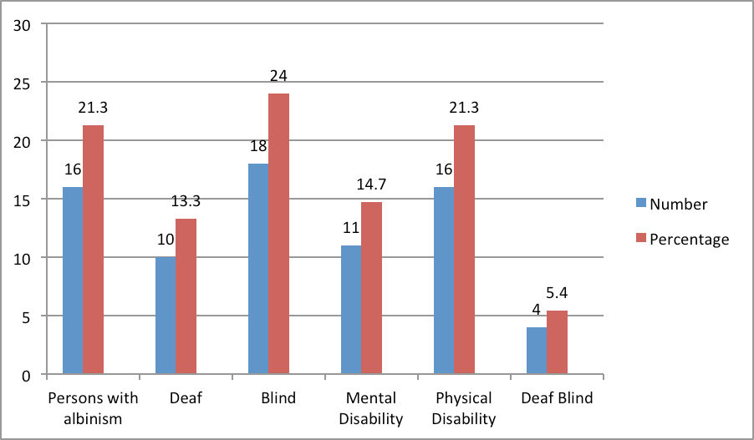

- Equal gender balance: Gender balance was considered in selection of respondents to avoid bias and ensure both sexes gets equal coverage. The study contacted about 39 (52%) males and 36 (48%) females.

Figure 3: Distribution of respondents by Sex
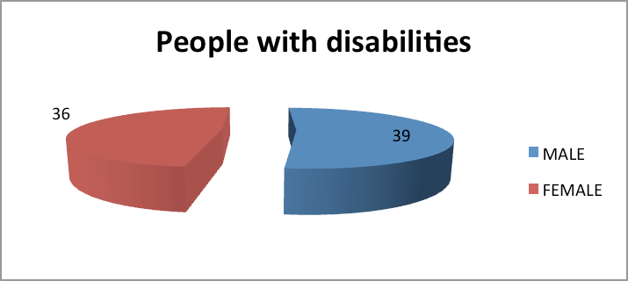
- Geographical coverage:Data collection made a good attempt to cover as much as possible the views from different locations of the study area. This included persons living in urban and sub urban areas.
- Scope of the study: The study was limited to district hospitals only. The study interviewed 75 people with disabilities, 2 officers in charge of the project from the Ministry of Health and Social Welfare, and 25 implementers of the project who included; District medical officers (DMOs), hospital secretaries, hospital social welfare officers, District social welfare officers and others from local authorities to enable collection of different opinions.

2.6Data analysis
Data was processed and analyzed using excel programme. Qualitative analysis was used for responses from open-ended questions of the questionnaires and interview schedules.

2.7Limitations of the study
The study however encountered the following major challenges;
Difficulties in acquiring reliable data on Disability in visited hospitals and from the Ministry of Health and social welfare.
Government bureaucracies in getting pertinent data have prevented researchers to accomplish the assignment in time.

PART THREE

3.0 Lack of safeguards for PWDs

3.1 Number of PWDs affected
According to the Ministry of Health and Social Welfare, the primary health project targeted the entire population of Tanzania. There were no special services or interventions for special groups like PWDs who account for over 4 million (about 10% of the entire population). Therefore, the ministry has currently no specific statistics on disabled persons who lacked or benefited from the project. Therefore, statistics from this report are purely based on the field data, literature and data from the MoHSW.

3.2 Groups more at risk
As far as financial cost is concerned, all persons with disabilities are affected to differing degrees depending on financial status of an individual or availability of financial support for the user.
Similarly, lack of rehabilitation services in visited hospitals indiscriminately affects all forms of disabilities too. The degree of impact may differ depending on different type and needs of each disabled group.

There is a special case for those with severe physical disabilities and wheel chair users. They are subjected to more risks when it comes to the issue of inaccessible infrastructure. The hardship may range from lack of ramps, presence of steep ramps to rough pavements that hinder their movements around hospital surroundings freely and independently. Other risks include inaccessible and unclean hospital toilets, non-adjustable hospital beds, lack of elevators and so on.
Lack of sign language assistance in hospitals affects Deaf patients in many ways. Medical staffs are not trained to communicate better with this particular group.

3.3 Harm they suffered
Responses from respondents reveal about five major challenges PWDs face in accessing primary health care services in their hospitals. These are: medical costs, inadequate medicines, inadequate maternal Health services, communication barriers and inaccessible infrastructures, as indicated by percentage in the following chart below.

Figure 4: A graph that presents a list of challenges and their percentages

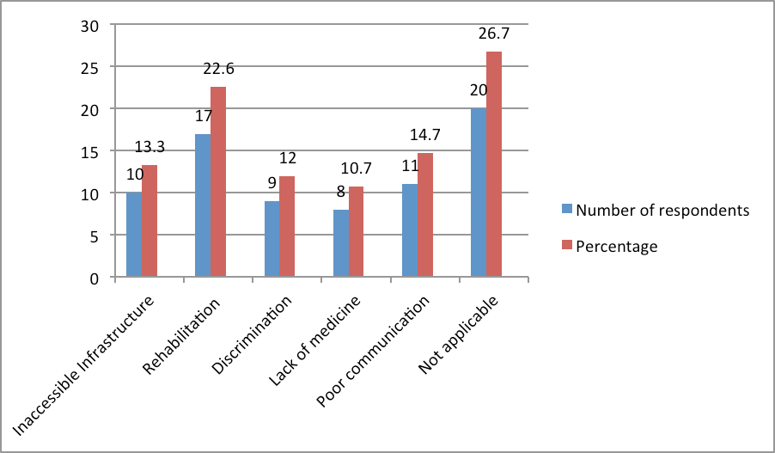

3.4The Harm caused by the Project
3.4.1. Affordability: According to respondents, the issue of affordability to medical services poses a greater challenge to persons with Disabilities. About 94 percent of PWDs could not afford the cost of medical services.
Figure 5: Affordability of medical care by persons with disabilities
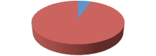
4
"
71
"
Number'of'responses'
Number"of"those"who"afford"to"
pay"
Number"of"those"who"cannot"
afford"to"pay"

The directives issued by the National Health policy of 2007 from the Ministry of Health and Social welfare and that of the Local Government Ministry of July 2012 on free medication to PWDs, automatically applies to all Public health providers regardless the source of funding. So the Tanzania Basic Health services project operations are subjected to such policy directives.
The provisions entitled free medication to all Persons with Disabilities regardless of their financial status. Despite the exemption provided for PWDs, still some pay for services in some hospitals due to the fact that there is no uniform awareness on such provisions across the country. In this case, there are two scenarios found:
First, as was found in Kilosa district hospital whereby along with other vulnerable groups, the exemption targets the poor PWDs with proven documentation from relevant authorities that they cannot pay for medical services. Usually, the seeker of exemption must obtain a letter of proof from both the local authority and social welfare officer before acquiring the exemption.

Second, involved Kilwa, Korogwe, Tumbi and Kisarawe district hospitals where medical officials were not aware of the exemption for PWDs and its requirements, hence they have never offered free medication. Such situation put PWDs in a dire situation because majority of them are either unemployed or low income earners.

The exemption is basically, the evolution of the health financing reforms in Tanzania towards promotion of universal and equal access to health care and pooling of financial risks is largely shaped by the history, culture and political ideology. The Arusha Declaration in 1967 marked the start of a series of health sector reforms with the intention of increasing universal access to social services to the poor and those living in marginalized rural areas. Followed by the Government banning private-for-profit medical practice in 1977 and took on the task of providing health services free of charge.

However, by the early 1990s, the strain of providing free health care for all became evident in the face of rising health care costs and a struggling economy. Early 1990s the government adopted health sector reforms that changed the financing system from free services to mixed financing mechanisms including cost sharing policies. Cost sharing in the form of user fees was introduced in four phases:
Phase I from July 1993 to June 1994 to referral and some services in regional hospital;
Phase II from July 1994 to December 1994 to regional hospital;
Phase III from January 1995 onwards to district hospital
Phase IV introduced to health centre and Dispensary after completion of introduction to all district hospital.
Exemption and waiver were integral part of the cost sharing policy introduced in 1994. (Ref: wikipedia)Financing involves three aspects, namely revenue collection, or a mixture of financing mechanisms such as general tax revenue, health insurance and external support.

There are four health insurance schemes which are publicly owned, namely National Health Insurance Fund (NHIF), Social Health Insurance Benefit (SHIB) established as a benefit under the National Social Security Fund (NSSF) and the Community Health Fund (CHF) and Tiba Kwa Kadi (TIKA). Recent statistics shows that there were about 7 private firms as indicated in the Tanzania Insurance Regulatory authority (TIRA) which were providing health insurance per se, while a few of other general insurance firms combine health insurance benefit under life insurance.
(MOH, 2010)
3.4.2. Inadequacy of Medicine: According to the MoHSW, the inadequacy of medicines and medical equipment are one of the chronic challenge that are is still facing District health facilities in Tanzania for many years before the onset of the project. Although the Ministry could not quantify the issue, officials had admitted that before the Tanzania Basic Health Services project, the situation was worse.
According to narrative evidence from medical officials, the inadequacy was always noted in sophiscated equipment such as x-ray, CT scan, ultra sound, and the like notwithstanding the fact that, there have been sporadic shortages of some medicines due to stock shortages or untimely deliveries to health centers by Government’s Medical Store Department.
In this particular project, there were some improvements noted in availability of tracer medicines as the table below indicate that inadequacy of all types of tracer medicines in two years was below
23% except for “two tracer medicines”
Figure 6: shows the two years trend data on unavailability of tracer medicines in district hospitals;
No. | Year | Type of Medicine | Shortage
1. | 2011/2012 | One tracer | 4% - 9%
2. | 2012/2013 | One tracer | 22%
3. | 2011/2012 | Two tracer | 49%
4. | 2012/2013 | Two tracer | 42%
5. | 2011/2012 | 3-5 tracer | 18%
6. | 2012/2013 | 3-5 tracer | 15%
7. | 2011/2012 | More than 5 tracer | 21%
8. | 2012/2013 | More than 5 tracer | 9%
9. | 2011/2012 | All tracer | 8%
10. | 2012/2013 | All tracer | 3%
Source: CCHP
That’s why only 48 percent of respondents have raised concern over inadequacy of medicines in their respective hospitals. The percentage is not high but the inadequacy rather affect PWDs who access medical exemptions too as they are compelled to buy medicines in private pharmacies which usually not recognize exemption cards for PWDs thus makes the idea of exemption worthless to them.
The shortage of essential medicine, medical equipment and medical personnel are issues that compel patients to seek alternative sources of treatments such as private health facilities, mission hospitals, private pharmacies, herbal clinics, and so forth and adversely lessening access to Public hospitals’ services.

The major reason for the long-standing inadequacy was the small budget quota that each hospital receives. That situation leaves a very little option forHospitals to purchase sufficient amount of Medical supplies, medicines, vaccines and contraceptives commodities. According to medical officers in visited hospitals, this amount of funds limits hospitals to purchasing only basic medical items, low-cost equipment, medicines and other health amenities.

That is why the project targeted to address the problem by 25% in 2011, by 17% in 2012 and by 10% in 2013 whose achievement statistical results have not yet released by the Ministry to date.
For instance in almost all visited district hospitals were facing the long-time challenge of delayed supply of medicines and medical equipments from Medical Stores Department (MSD) that enforce patients to seek alternative sources of medicine.

3.4.3. Challenges on Maternal Health Services: According to interviewed medical staff and respondents, Women with and without disabilities in the project areas have similarly benefitted from maternal health services in the visited hospitals. However, there are several challenges that may specifically affect women with Disabilities or create much more disabilities as follows:-
- Though vary from one hospital to another, the quality of maternal services at district level may be questionable. Emergency obstetrical care services for instance, are crucial for handling complicated deliveries that can cause death or Disabilities, yet most of the visited hospitals have demonstrated modest capacity to deal with it due to the poor facilities.

- The referral system in district hospitals encounter serious obstacles including small number of ambulances and unreliable communication systems especially in rural areas. This affects pregnant mothers with disabilities particularly those living in remote areas of Tanzania who need referrals to regional hospitals.

- Shortages of medical personnel are yet another limiting factor. The ratio of doctors to patient in Tanzania is 1:25,000 and the ratio of nurses to patient is 1:23,000, while the ratio in the United States, for instance, is 1:300 only. In 2010, about 51% of deliveries were assisted by skilled personnel, while it was 41% in 1999. Potentially, the current figure national-wide will be greater than 51 per cent. (Ref.DHS 2010).

- About 66 percent of women with disabilities in this study have reported different forms of verbal abuses or discriminatory practices when attending maternal services. Obstetrical section was mentioned as being notorious for these evil and unfair practices.In Tanzania, it is common for expectant mothers to suffer this kind of abuse in public hospitals thus, it is not the concern of women with disabilities alone.

- Delivery beds found in district hospitals are not disability friendly owing to the fact that they have no provision for adjustment. They are high for pregnant women with physical disabilities to climb on or off without an assistance.

- A good and balanced nutrition during the pre- and postnatal periods is extremely important for the good outcome of pregnancy as well as infant feeding. Due to little financial ability to afford the balanced diet, poor women with disabilities and their babies stand a high risk of contracting diseases or disabilities resulting from undernourishment. This can affect efforts to reducing more disabilities among children/infants.

- Maternal health clinics lack sign language interpretation for deaf women. Without sign language interpretation, Deaf women are subjected to a number of risks as they cannot follow important counseling, sexual and reproductive health education when attending regular clinic services.
According to the narrative evidence from medical staff, these challenges pose serious limitations on provision of better maternal services. The poor referral system and provision of poor maternal services in some hospitals; were even worse in the period before the project, that is why the project was planned to intervene in this respect and identified it as one of the priority area. Poor diet for expectant mothers has been the result of prevailed poverty among majority of Tanzanian populations. So it existed and it will stay more as long as poverty exists in the country.

Lack of sign language interpretations, non-adjustable delivery beds, discriminative practices and verbal abuses, existed before and during the project simply because Disability awareness among medical staff was low before and even during the project.

3.4.4 Communication barriers: Findings suggest that, medical staffs are incapable of communicating with deaf people both through lip reading or sign language. The existing communication hurdle prevents deaf patients from receiving doctors’ prescriptions properly or attending regular trainings organized by the hospital on maternal, family planning and regular clinics, to mention a few. As a result, the Deaf stand a fatal risk of wrong prescriptions (from doctors) or incorrect administration of dosage resulting from a misunderstanding between the two.
The component number three of the Tanzania Basic Health project targeted capacity building initiatives including provision of training to medical staffs. It could work well if some of such funds were directed to training on sign language for medical staff because the study has received considerable complaints from Deaf patients who experienced communication difficulties when accessing health service.

There is an example of a Comprehensive Community Based Rehabilitation - CCBRT hospital which have introduced sign language training programme to its medical staff. The hospital have hired a deaf staff who help translate for deaf patients and spare extra hours to train sign language to staff. Although this is not a Government hospital, yet it provides an example worth to be imitated.

3.5 What the Bank could do differently
The Bank must insist on involving PWDs in the initial stages of the project i.e. project design and planning. This would go together with conducting a needs assessment survey to identify the needs of PWDs in a particular project and see how to incorporate them in the project. If Persons with Disabilities were included in the World Bank Safeguard policies, the Bank would be responsible for ensuring that persons with disabilities were not harmed by but were able to fully benefit from the program. That was not the case in this project because their needs and rights were not adequately addressed.
The Bank must ensure that, the implementing agency is urged to engage PWDs in all project processes, i.e project design, planning/budgeting, launching, implementation, monitoring, evaluation and reporting. Full involvement of PWDs in the project would guarantee favorable outcomes for them.

3.6 Was the harm foreseen by Bank or Government?
The Tanzania Basic Health Project has invested in child immunization as an early intervention strategy geared to preventing some forms of disabilities. This is the only area of intervention that touched disability directly in this project. But the fact that there was no involvement of PWDs or their needs in project processes signifies that the harm was not foreseen by implementing ministries.

3.7 How was the project influenced by PWDs?
Article three of the UNCRPD, on general principles, calls for “Full and effective participation and inclusion in society” for PWDs. “Persons with Disabilities in Tanzania are among the beneficiaries of primary health care services; thus, they have the right to be involved in all project development.
But 82 percent of PWDs were not aware of the project itself and its funder because they were not involved at all. The poor participation of PWDs in the project is a clear indication that PWDs are left behind in crucial projects that touch their lives like this one. It implies that, someone is planning for them contrary to the theme for International Disability day of 2004 that stated “Nothing about us without us.” The statement means PWDs should have a say in their lives, they should be involved in whatever initiative that touches their life or interests.

But according to the survey observation, even some key medical staff at district hospitals were not involved in initial preparations of this project. No wonder some staff were totally ignorant of the basic details of this project. Some were not even aware that the fund for implementing basic health care comes from the World Bank.

3.8 Plans created to mitigate such harm and if Implemented properly
The objective of the World Bank's safeguard policies is to prevent and mitigate undue harm to people and their environment in the development process. These policies provide guidelines for bank and borrower countries in the identification, preparation, and implementation of programs and projects. Safeguard policies have often provided a platform for the participation of stakeholders in project design, and have been an important instrument for building ownership among local populations.

Apparently, Disability was not considered in the World Bank safeguards. This suggests that, there were no intended plans to mitigate any harm to PWDs. The Implementation Status and Results Report of 22 June 2014 of the project does not mention Disability and thus it is a clear indication that PWDs were forgotten in the project design and planning .

Conversely, the issue of costs to PWDs was already foreseen by the government that is why directives were provided in 2012 by PMORALG to Regional Administrative Secretaries (RAS) to ensure free medication is issued by all public hospitals. On other aspects of the project, there are no plans recorded so far.

PART FOUR

4.0 Lessons
This part discusses crucial lessons learned through the study. It highlights some positive elements observed by the study or reported by respondents. When asked to mention at least two best practices they have seen in their respective hospitals for the past two years, here are their comments:-

4.1 Improved child Immunization:
According to 2010 Demographic and Health Survey (DHS) in Tanzania, 66 per cent of children at 12 months of age were fully immunized during the surveywith the BCG coverage of 95.5%, Diphtheria tetanus toxoid and pertussis (DTP3) coverage of 88%; Polio (Pol3) coverage of 84.9% and Measles coverage of 84.5%. The proportion of children vaccinated against measles increased from 80 per cent in 2005 to 85 per cent in 2010. But the vaccination coverage in Tanzania presented to be more than 90% for each of the above vaccines according to World Health Organization in 2012. (Ref.DHS, 2010)

According to medical officers in the visited hospitals, the Tanzania Basic Health project has contributed significantly towards improvements of vaccination. About 46 percent of respondents were quite satisfied with free child immunization of less than five years of age. It was further argued that, various vaccinations have significantly helped reduce the infant, under-five mortality rates and disabilities among children in Tanzania. Malaria, Pneumonia, Measles, were mentioned as leading factors to infant mortality while polio contributes to disabilities among children.

The 2010 maternal mortality rate per 100,000 births for United Republic of Tanzania was 790.
Tanzania has reduced the infant mortality rate (IMR) of 101 to 38 per 1000 live births from 1990 to 2012 respectively.Also, it has reduced substantially the under-five mortality rate (U5MR) of 166 to 54 per 1000 live births from 1990 to 2012 respectively. The most significant contribution to the reduction of under-five mortality have been due to improved control measures of malaria, Acute Respiratory Infections, diarrhea; improved personal hygiene, environmental sanitation; and preventive, promotive as well as curative health services. (Ref.DHS, 2010)
According to them, there is a good drive towards preventing disabilities caused by polio. Tanzania has reaped pockets of achievement on TT and polio vaccines recently. This is evident by the significant reduction in neonatal tetanus deaths and polio cases in the country. In this regard, there is a need to scale up immunization efforts and sustain polio eradication initiatives to prevent new polio outbreak.

More efforts should also be directed to combat the Vitamin A deficiency in Tanzania since it is the leading cause of preventable blindness in children. According to them, Vitamin A supplementation twice a year can work best to prevent such deficiency.
Iodine deficiency during pregnancy was said to have great impact on physical and mental development of the fetus and is related to lower mental and physical development thus can cause disabilities. In Tanzania the prevalence of goiter among school children is still high in the visited districts. Most effective strategy such as salt iodization should be employed for the control of iodine deficiency.

4.2 Improved maternity services:
Despite the said challenges (in 3.4.3 a –f), the Basic Health project has generally devoted much effort to improve maternal health services. Intermediate Result indicator4 of the project point out that, about 57.5% (Total of 5,439,414) of pregnant women have received antenatal care under the basic health project out of the targeted number of 9, 457, 060.

The outcome of this intervention has been witnessed on improvements of periodic clinic checks for expectant mothers, Pre- and post delivery clinic. In some hospitals, maternity services were delivered to the satisfaction of clients both with and without disabilities. The obstetrical unit of some hospitals also worked well with some experienced and caring mid wives and staff.

Two years ago, maternal health services at district level were poorer than they are today. Hospitals had few maternal beds that saw some pregnant mothers sleep on the floor in some hospitals. But now, interviewed respondents have noted sufficient number of hospital beds in most district hospitals.

4.3 Others
- Majority of those who secured medical exemptions were able to access free medications in districts hospitals.
- Other respondents said the social welfare officers in hospitals helped facilitate for the administration of disability issues in hospitals.
PART FIVE

5.0 Recomendations

5.1 Recommendation for the donors
There is a need to increase awareness of PWDs by donors to sponsor projects.
Participation of PWDs in the Project: The donors should ensure the full involvement of PWDs in planning, implementation, monitoring and reporting outcomes of its health programmes. This would go together with conducting a needs assessment survey to identify the special needs for Persons with Disabilities and ensure they are able to benefit from and are not harmed by the project.

The donor should ensure that, PWDs are given priority in this and other upcoming projects. That is, for every fund disbursed by the donor should be attached with an obligation to the recipient country “To consider PWDs as one of primary beneficiaries or should at least set a quota (percent) of Persons with Disabilities to benefit.” This could be done in a similar way used to enforce gender issues by development partners .
Monitoring Projects: The donors should form a monitoring team of its own and initiate a system of monitoring its funds directly. This helps get fresh feedback from the field and get preinformation to use to countercheck with implementing partner’s reports.

5.2Recommendations to the government
5.2.1 Infrastructures:Article 48 (1) of the Tanzania Persons with Disability Act, number 9 of 2010 states that “All persons with Disabilities shall be entitled to a barrier-free and disability friendly environment to enable them have access to public premises and facilities for public use, roads and communications and other social amenities to assist and promote their mobility”

Government should provide guidelines and insist in improving hospital infrastructures to allow easy accessibility to Persons with Disabilities. Civil engineers who win tenders for construction of health facilities should be given clear directives on meeting accessibility needs to all persons with disabilities.
Although accessibility was not project’s priority area, yet the study tries to emphasize a point to planners and implementers that, physical accessibility is a cross cutting and a very crucial determinant factor for PWDs to enjoy health services and realizing the goal of health care for all.

Even if hospitals were full of medicines, equipments and Doctors, but PWDs fail to access Health services due to poor infrastructure; such services would be rendered incomplete to PWDs. So the project had to be in conformity to article 9: 1 of the UNCRPD of which Tanzania has ratified since 2009.

5.2.2 Sign language trainings: Government is advised to initiate a programme of sign language trainings to district medical staff to facilitate communications with Deaf persons. This can be made possible by hiring an interpreter in each district hospital to interpret for Deaf patients. The same interpreter will be used to train hospital staff.

5.2.3 Availability of Medicines: Government is urged to increase supply of medicines to make the exemption work better to PWDs. Lack of medicines compel PWDs to buy medicines in pharmacies that make the issue of exemption futile. Data from the study showed that 94% of PWDs in the study area are not able to afford health services including purchasing of assistive devices.

5.2.4 Health Insurance to PWDs: The present medical exemption limits PWDs to public hospitals which, according to them, have poor services. So even if they get free services, still it is of poor quality. They wished the card should have allowed them access better health care services in private hospitals or pharmacies. Or else they should be entitled to health insurance schemes that offer them wider options.

5.2.5 Two Ministries, one project: There should be one ministry designing policy and implementing it. Currently, health policy is designed by the Ministry of Health but implementation of primary health care services is done by the PMORALG. That is why it sometimes creates conflicting directives in the implementation process.

5.2.6 Government supervision: Government should closely supervise and make follow-up visits on donor funded projects to avoid complacency and misuse of funds or redirecting funds to unplanned activities.

CONCLUSION
Improving healthcare services in general is a good thing because it benefits all the people. Even PWDs are not attending hospitals for rehabilitations services alone but are also subjected to all sorts of illness like Malaria, diarrhea and so on just the same way as other folks without disabilities.

But PWDs as special group have some special needs that call for special intervention and services. It is imperative for the health care funding to start considering mainstreaming the rehabilitation component in each district hospital to make certain that PWDs medical needs are fully met. But full involvement of PWDs in World Bank projects will be a crucial step to realizing their rights to medication and participation.

REFERENCES
MoHSW; Tanzania National Health Policy, 2007

The National Bureau of statistics (NBS), Demographic and Health Survey (DHS), 2010; Dar es salaam, Tanzania

MOHSW, 2010; Tanzania Mainland National Health Accounts 2009/10, http://www.phci.ac.tz/OurHistory.htmlhttp://www.un.org/disabilities/default.asp?id=259http://en.wikipedia.org/wiki/Healthcare_in_Tanzania

