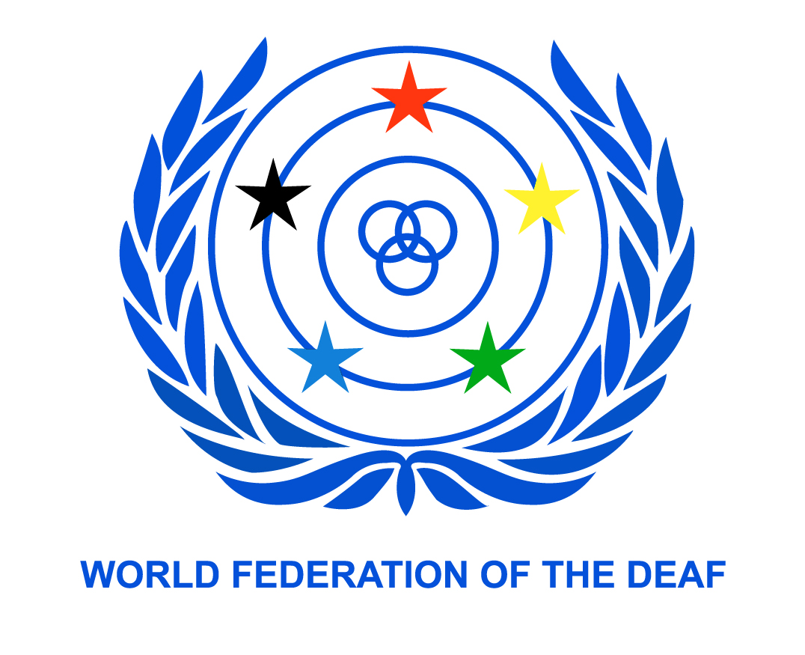

Legal Seat – Helsinki, Finland

WORLD FEDERATION OF THE DEAF
An International Non-Governmental Organisation in official liaison with ECOSOC, UNESCO, ILO,
WHO and the Council of Europe. WFD was established in Rome in 1951.
PO Box 65, 00401 Helsinki, FINLAND
www.wfdeaf.org

30 June 2016

Office of the United Nations High Commissioner for Human Rights (OHCHR)
Palais des Nations
CH-1211 Geneva 10, Switzerland
registry@ohchr.org

Study on Article 5 of the CRPD - Equality and non discrimination

Dear Sir/Madam

The World Federation of the Deaf (WFD) presents its compliments to the Office of the UN High Commissioner for Human Rights (OHCHR) and is pleased to be invited to make this submission toward a study on Article 5 of the CRPD on Equality and non-discrimination.

Background
Human Rights Council Resolution 31/6 requested the OHCHR to prepare a study on Article 5 of the Convention on the Rights of Persons with Disabilities (CRPD).
This submission summarises key points to assist OHCHR on equality and non-discrimination as it relates to deaf people and makes recommendations for the OHCHR consideration.

Key points
The complexities of indirect discrimination for deaf persons
A 2009 WFD Report Deaf People and Human Rights compiled outcomes of a survey exploring the lives of deaf people in 93 countries, most of which are developing countries. The report concludes “relatively few countries deny deaf people access to education, government services or equal citizenship on the basis of deafness alone. But lack of recognition of sign language, lack of bilingual education, limited availability of sign language interpreting services and widespread lack of awareness and knowledge about the situation of deaf people deprive most deaf people of access to large sections of society. Thus they are not able to truly enjoy even basic human rights.”
Accommodations/ reasonable accommodations
The CRPD outlaws all forms of discrimination, including direct, indirect, and systemic or any other forms of discrimination. The denial of reasonable accommodation, unless it imposes a disproportionate burden, is also a form of discrimination. Discrimination must be outlawed in all areas of life.
Further, protection from discrimination based on disability in the access of these rights is immediately applicable (as opposed to being progressively realised) and this would include the denial of reasonable accommodation as a form of discrimination.
Many deaf persons globally are denied access to information or communication in sign language or a qualified sign language interpreter across all spheres of life – e.g. in education, employment and in accessing health services or legal processes.
This may be because duty bearers (including government, instrumentalities, businesses and service providers) do not know sign language, there are no qualified sign language interpreters, because a duty bearer does not know how to arrange for a qualified sign language interpreter, or because the cost of sign language interpreters is imposed on the deaf individual and that cost is too high meaning the accommodation is not provided.
The non-provision of sign language or qualified sign language interpreters constitutes a violation of the right to reasonable accommodation (including the higher standard of the right to ‘accommodations’ under Art 14- Access to Justice).
The impact of non-provision of this accommodation is firstly a violation of the rights contained in Art 21 (freedom of expression - freedom to give and receive communication in a manner of one’s choosing, including in sign languages) and a violation of the rights in Art 30(4) (respect for and recognition of deaf identity and culture).
Denial of accommodations also means deaf persons may face a denial of all of the rights in CRPD to which it applies (e.g. non provision of sign language in an educational setting would compromise or negate the right to education in Art 24).
Affirmative actions for combating structural discrimination
Deaf persons globally face significant barriers to accessing education and employment. WFD considers it vitally important for Governments to provide for bilingual education of deaf children for their effective cognitive, academic, social and cultural development and to enable them to reach their fullest potential.
Laws and policies providing for this form of education will ensure equality and non-discrimination in educational outcomes for deaf persons.
In the workplace, provision of reasonable accommodation may be expensive for small businesses and denied on that basis, narrowing employment options for deaf persons. Forms of Government subsidies to employers to subsidise or offset some of these costs should be strongly encouraged, e.g. to provide for qualified sign interpreters and captioning in the open workforce. Schemes to provide basic introductory sign language training for work colleagues are also effective in raising awareness and promoting communication between deaf persons and their colleagues.
More broadly Government promotion of, and support for, community classes (run by the Deaf Community) to educate families and the wider public in sign languages increases the number of persons in the community who can communicate this way, and increases the pool of potential work colleagues or service providers with these communication skills.
Laws, policies and strategies for combating discrimination
Formal equality and laws against discrimination
Many countries do not provide for formal legal equality for deaf citizens, particularly in the areas of legal capacity (marriage, inheritance, property ownership, management of financial affairs etc.). Many countries also deny deaf persons the right to hold a drivers licence.
It is imperative that all countries have laws that afford formal legal equality to all deaf persons in all areas of life. Additionally, countries must provide for laws that prohibit direct and indirect discrimination in all areas of life.
This requires a comprehensive review and reform of all laws for discriminatory effects in line with the requirements of CRPD Article 4.

Sign language
WFD takes the position that it is vitally important for States Parties to recognise sign language as a national language and a language of the Deaf Community. This can be done through constitutional, legislative or policy recognition. This serves the purpose of ‘recognising and promoting’ sign languages, consistent with Art 21(e).
Legal recognition also provides a basis for, and paves the way for, a stronger recognition of the need to provide for education and training in sign languages and the establishment of accredited interpreter courses in sign languages. These are foundational steps that are needed to provide for equality and non-discrimination in practice, across all areas of life for deaf persons.
It is also important to have laws, programs and dedicated budget for the provision of sign language services in all areas of life covered by the CRPD- inter alia in schools and educational settings, medical settings, legal settings and broader community and cultural settings open to the public. New Zealand is a good example of a country which has dedicated budget for the Government funded provision of sign language in the community.
Deaf women and deaf girls
Anecdotally, deaf women and deaf girls face double discrimination - on the basis of gender and of disability. WFD has previously made a submission calling on the UN and other stakeholders to increase the evidence base (including disaggregated data) on deaf women and deaf girls and their human rights situation to make this more visible and to promote policy action toward addressing it.
Monitoring and collecting disaggregated data on discrimination
It is rare for any country to collect statistics on the degree and prevalence of discrimination against deaf persons. Many deaf individuals face discrimination every day through living societies that are predicated on being able to hear and which view the inability to hear as negative and deficient, rather than an equally valid state of being.
Discrimination in the provision of information/communications/services could be measured by e.g. the number of complaints brought to a human rights institution or similar institution, or to the courts, disaggregated by disability/impairment type, though this would be a significant underestimation of actual discrimination as many do not take formal action when discriminated against. Additionally, the lack of avenues in many countries to submit complaints in sign language is a barrier to submission of complaints. This leads to further gross under-estimation of the actual prevalence of discrimination against deaf people.
What are the key recommendations the OHCHR should make in relation to Art 5 CRPD as it relates to deaf people?
- States must have laws and policies which formally recognise and effectively promote the use of sign languages.
- All States must actively consult deaf associations on new policies, programs and laws affecting them, in line with CRPD Article 4(3).
- Protection from denial of reasonable accommodation needs to be specifically prescribed in relevant anti-discrimination legislation.
- Protection from discrimination must cover discrimination by individuals, enterprises and other private organisations against deaf persons and organisations.
- A broad definition of the concept of reasonable accommodation and an explanation as to how the disproportionate burden clause will be applied should be included in the legislation. The test should include the impact on the person with disability in the achievement of his/her rights in the CRPD.
- The right to qualified sign language interpreters is part of the right to reasonable accommodation in achieving equality and non-discrimination. The cost of providing qualified sign language interpreters must be supported by the State and by duty bearers not by the deaf individual(s).
- It is critically important that States have in place laws and policies to ensure that deaf children are supported to achieve their right to accessible education, and that any of deaf children have the right to learn in a sign language environment.
- Guidelines on universal accessibility must go beyond addressing mere physical access, to addressing how captioning and sign language will be provided - including in Parliament, courts, institutions open to the public, and at public meetings and events.
- States should legislate or have policies around the provision of captioning and sign interpretation on television and emerging media, such as internet streaming services.
- Positive laws are required regulating provision of access for greater strength and compulsion of obligation, not relying on general ‘non discrimination’ laws, e.g. a positive requirement of provision of captioning on all DVDs released into the market would yield better results than simply requiring non discrimination and then relying on complaints to address the issue.
- Laws, policies and practices should allow for deaf persons to submit complaints to National Human Rights Institutions and other anti-discrimination bodies in sign languages, to improve accessibility of the complaints mechanism.
- Laws should allow for NGOs/DPOs (including deaf associations) or disability discrimination commissioners to act on behalf of persons with disabilities that claim to have been victims of disability-based discrimination to achieve systematic change. This is more efficient than individual complaints to achieve long term sustainable and systematic change.
- Mechanisms must be set up to monitor and review the effectiveness of laws designed to promote access and remove discrimination. These mechanisms should have the power to make recommendations for positive change.

Contact details:
Ms Elena Down
Human Rights Officer
World Federation of the Deaf
elena.down@wfd.fi, info@wfd.fi

Authorised by:

Colin Allen
President

About the World Federation of the Deaf
The World Federation of the Deaf (WFD) is an international non-governmental organisation representing and promoting approximately 70 million deaf people's human rights worldwide. The WFD is a federation of deaf organisations from 132 nations; its mission is to promote the human rights of deaf people and full, quality and equal access to all spheres of life, including self-determination, sign language, education, employment and community life. WFD has a consultative status in the United Nations and is a member of International Disability Alliance (IDA). (www.wfdeaf.org) Email: info@wfdeaf.org

Hilde Haualand and Colin Allen (2009), Deaf People and Human Rights, World Federation of the Deaf.
Ibid, p 7.
See, e.g. World Federation of the Deaf Submission for the OHCHR study on the right to education of persons with disabilities (18 September 2013); WFD & EUD Submission to the Day of General Discussion on the right to education for persons with disabilities (20 March 2015).
See, e.g. International Disability Alliance (2013) Submission to the CEDAW Committee’s General Discussion on Access to Justice, 54th session .
This is so common that WFD has developed a position paper on this right (See: WFD (2009) Statement of Deaf people’s right to drive a car or other vehicles) and regularly assists deaf associations in lobbying for law reform on this point.
See WFD (2013) Deaf Women and girls not able to enjoy basic Human Rights –A submission by the WFD on the half day of general discussion on women and girls with disabilities, Geneva, 17 April 2013.
As required by CRPD Art 21(e).
See WFD & EUD (2015) Submission to the Day of General Discussion on the right to education for persons with disabilities

