Persons with disabilities
and the right to education

Written by the Office of the High Commissioner
for Human Rights of the United Nations

An easy to read version

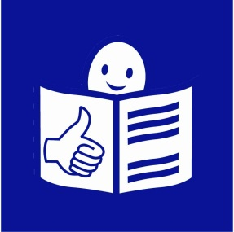

Disclaimer:

This is an easy-to-read version of the thematic study on the right
of persons with disabilities to education (A/HRC/25/29) written by
the Office of the United Nations High Commissioner for Human Rights.

This does not mean that the Office of the United Nations High Commissioner for Human Rights agrees to everything written in this document.

This easy-to-read version was prepared by Inclusion Europe
following the European standards for making information easy read
and understand www.easy-to-read.eu.

© European Easy-to-Read Logo: Inclusion Europe

What is this report about?

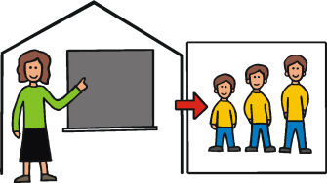
This report is about the right
of persons with disabilities to education.
Persons with disabilities have the same right
to go to school and learn new things
just like anyone else.
This means that:
- Children with disabilities have the right
to learn in the same schools
as children without disabilities.

- Adults with disabilities have the right
to learn new things all their life.

In this report, you will read about:

- The right to education.

- What important documents say
about the right to education.

- What the United Nations Convention
on the Rights of Persons with Disabilities says
about the right to education.

- How to make sure persons with disabilities
can use their right to education like anyone else.

- What governments should do to make sure
that all people can use their right to education.

The right to education

Everyone has the right to education.
Countries agreed to make sure that
all people can use this right.

All people should have the same chances
to go to school and learn the skills they need for life.

Persons with disabilities should go to the same schools
as persons without disabilities.
This is called inclusive education.

Inclusive education is about persons with disabilities
and persons without disabilities learning together
in the same class.
But all over the world, persons with disabilities
still have problems going to regular schools.

- Some persons with disabilities
do not go to school at all.

- Some go to special schools
for persons with disabilities.
In special schools, persons with disabilities
do not learn the same things as
persons without disabilities learn in regular schools.

- Sometimes, regular schools accept
persons with disabilities.
But they expect the person with a disability to fit in
and keep up with other students.
These schools do little effort to make sure that
all students have the same chances to learn.
Inclusive education is the only way to make sure that
all people have the same rights and chances to learn.

Schools should be for everyone.
Schools must change the way they teach
so that everyone can take part.

Inclusive education will make things better for everyone:
- People will change the way they think
about disability for the better.

- They will learn to respect each other.


- Persons with disabilities get better education.
They will learn things that all other students learn.
They will get the same learning certificate
as other students without disabilities.
This means they will find it easier to get a job.

What is written in important documents?

Countries agreed on many important documents
about rights.
In these documents, countries promised to make sure
that all people have the same rights and chances.

For example, the ‘Universal Declaration of Human Rights’
says what rights people have.
This document says that
everyone has the right to education.

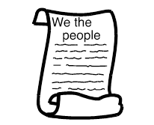
Another important document is called
the ‘International Covenant on Economic,
Social and Cultural Rights’.

It says many things about education.
For example, it says that:

- All children should go to primary schools.
Going to primary schools should be for free.
- Everyone should have a chance to
go to a high school or a university.

- Schools should be accessible for all.
- Schools should give students good education
and prepare them for life.

- Schools should adapt to the needs of their students.

There are many other important documents which
talk about the right to education.

In all these documents, countries promised to make sure
that all people have the same right to education.

The Committee on the Rights of the Child
is a group of people who check how countries make sure
that children can use their rights.

The Committee says that children with disabilities should
have the same rights and chances as other children,
also in education.

What is written in the United Nations Convention
on the Rights of Persons with Disabilities?

The ‘United Nations Convention on the Rights of Persons
with Disabilities’ is an agreement among countries.

In the Convention, countries agreed
to make sure that all persons with disabilities
can use their rights.
The countries now have to do what the Convention says.

This is what the Convention says
about the right to education:

Persons with disabilities have the right
to inclusive education.

Persons with disabilities have the right to education
just like anyone else.
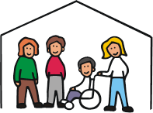
This means they have the right to learn
in the same schools as anyone else.
Primary schools, high schools, colleges and universities
must accept persons with disabilities.

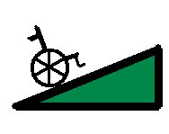
Schools must be accessible.

This means that:

- School buildings must be accessible
for everyone to get in.


- Books should be easy to read and understand
for all, also for blind people or
persons with intellectual disabilities.

- Persons with disabilities should have the same
chances to take part in the class as anyone else.
- Persons with disabilities should have a chance
to learn the same things as persons without disabilities.

Persons with disabilities have the right
to reasonable accommodation.
Reasonable accommodation means
that schools make changes
to make sure persons with disabilities can learn there.

For example, they make text books
easy to read and understand.

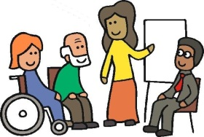
Persons with disabilities must have a chance
to learn the skills they need to take part in education.

For example, persons who are deaf
must have a chance to learn sign language.

Teachers must get training on disability.
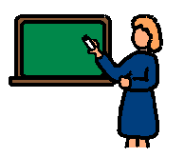
Schools should hire people who know how to support
persons with disabilities.
Teachers and other people working in schools
must get training on the needs of persons with disabilities.
This training will help them to make sure that
all students take part in classes,
including persons with disabilities.
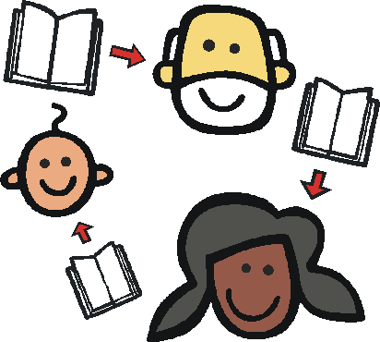
Persons with disabilities have the right to learn
all their life.

Persons with disabilities should have the same chances
to learn and take part in training as any other adult.
What needs to happen?

We need laws about inclusive education.

Regular schools must stop rejecting
persons with disabilities.

Every country should have a law about inclusive education.
The law should say that schools must accept
persons with disabilities.

We need to making sure persons with disabilities
get good education.
Inclusive education must be of a good quality.
It must give everyone a chance to learn the skills
they need for life.

Inclusive education must be free of charge for all children.

Schools must be accessible.

Schools must be accessible so that
everyone can take part.
For example:

- School buildings must be wheelchair accessible.
- Important information must be easy to read
and understand.

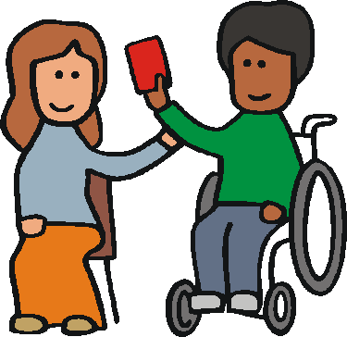
Persons with disabilities must get the support they need
to take part in the class.
For example, persons who are deaf
need sign language interpretation.
This support should be for free.
Each country should have a law
about making schools accessible.
Governments should give money
to make schools accessible.

Schools must make changes.
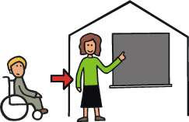
Many schools are still not accessible.
Persons with disabilities can ask them
to make some changes
to make sure they can learn there.

For example:

- A person in a wheelchair can ask for a ramp.
- A person who is blind can ask for textbooks in Braille.

Schools cannot refuse to make these changes.
This is called reasonable accommodation.

Persons with disabilities must get support.

Persons with disabilities have the right
to get the support they need to take part in school.
Everyone is different.
This means that every person needs different support.
For example, some people might need an assistant
to help them in a class.
Others might need specific learning aids.
Countries have to make sure that
everyone gets the support he or she needs.
They have to make sure that schools have enough money
to support persons with disabilities.
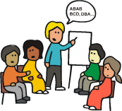
Schools, parents, professionals and students
should work together
to help persons who need support.

All people must have equal chances to learn.

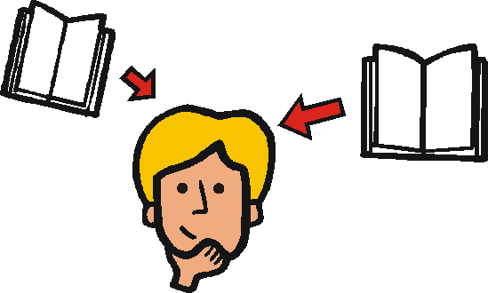
Inclusive schools allow everyone to learn
and do their best, including persons with disabilities.

Regular schools must change so that
persons with and without disability can learn together
in the class.
Teachers need training.

Teachers need training to understand
how to support persons with disabilities.
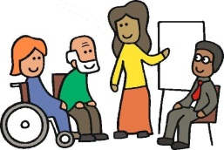
They should get support to teach all students,
including the ones with disabilities.

Persons with disabilities must have a change
to learn all their life.

Adults with disabilities should have the right to learn
new things all their life.
Training courses for adults must be accessible
to persons with disabilities.

What should governments do?

Governments are responsible for making
inclusive education happen in their countries.

This is what governments should do:
- Make a law about inclusive education.

- Come up with a plan on making schools inclusive.

- Work together with organisations of persons
with disabilities, parents, teachers and schools.

- Turn special schools into support centres
for inclusive education.

- Check regularly how the plan on inclusive education
is working out in practice.

- Make sure persons with disabilities can get help
if they have problems using their rights.

Governments should work together and help each other
to make inclusive education happen.
For example:
- The government of Norway helped Georgia
to make schools inclusive.
- The government of Japan gave money to Moldova
to train teachers on disability.

Important things to remember:

- Persons with disabilities have the right to learn
in the same schools as anyone else.

Schools have to change so that
persons with disabilities and
persons without disabilities can learn together.

Persons with disabilities must get the support they need
to take part.

- Many people think that persons with disabilities
cannot do well in regular schools.
This is not true.

We need to change the way people think
about disability for the better.

- Countries need to change the way schools are run
to make sure everyone can get good education.

They have to make sure that
everyone can go to a regular school.

Regular schools have to change the way they work
to make sure everyone is included.

- Countries have to make laws about inclusive education.

These laws should stop regular schools from rejecting
persons with disabilities.

The laws should make sure that persons with disabilities
can get reasonable accommodation.
This means that schools must make changes
so that a person with a disability can learn there.
Governments have to help schools
become inclusive.
- Countries should work together to make sure that
persons with disabilities all over the world can learn
in the same schools as anyone else.

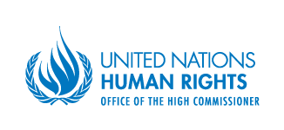
Who wrote this report?

The ‘Office of the High Commissioner
for Human Rights’ wrote this report.
In short we call it OHCHR.
The OHCHR helps countries to make sure that
all persons can use their rights.
Rights are things that should happen to everyone.
For example, everyone has a right to education.

The OHCHR is part of the United Nations.

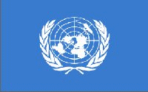
The United Nations is a group of countries
that work together to make the world a better place.
Almost all the countries in the world
are part of the United Nations.

To write this report, the OHCHR talked to different persons.
For example, they asked persons from:

- Governments
- United Nations
- Government offices which work on rights
- Organisations which work on rights
- Organisations of persons with disabilities

The OHCHR asked about how persons with disabilities
use their right to education.
You can find the replies from governments
and organisations on the website of the OHCHR.

