

A report on the right of persons
with disabilities to work

Written by the Office of the High Commissioner
for Human Rights of the United Nations

An easy to read version



Disclaimer:

This is an easy-to-read version of the thematic study
on the work and employment of persons with disabilities (A/HRC/22/25)
published by the Office of the United Nations High Commissioner
for Human Rights.

This does not mean that Office of the United Nations High Commissioner
for Human Rights agrees to everything written in this document.

This easy-to-read version of the text was prepared by Inclusion Europe www.inclusion-europe.org following the European standards for making information easy to read and understand www.easy-to-read.eu.

© European Easy-to-Read Logo: Inclusion Europe.

Who wrote this report  The United Nations is a group of states  that works to make the world a better place.  Almost all the states in the world  are part of the United Nations.  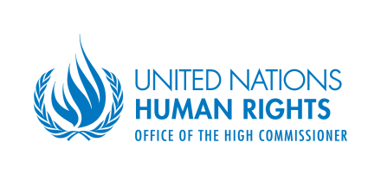  The United Nations has an office which works on rights.  It is called the Office of the High Commissioner  for Human Rights.  In short we call it ‘OHCHR’.  The OHCHR works to make sure that  all persons have the same rights.  Rights are things that should happen equally for everyone.  For example, persons with disabilities have the right to work  just like anyone else.  But persons with disabilities often find it hard to get a job  or to keep it.  The OHCHR wants to make sure that persons with disabilities  can use their right to work.  The OHCHR did a research to find out  why is it hard for persons with disabilities to find work.  In this report, you can read what the OHCHR found out. | 

What is in this report  This report is about the right of persons with disabilities  to work.  Work is important.  - When you work, you get paid.  This means you have money to pay for food, clothes, housing and other things you need.  - At work, you can learn new skills or  get better at things you already know.  - When you work, you take part in the community.  You help to make the life of the community better.  The United Nations says that everyone has the right to work.  This also means that:  - Everyone has the right to choose how and where  they want to work.  - Everyone has the right to be treated well at work.  - Everyone has the right to get help from the state  when they cannot work.  There are many laws and agreements between states  about the right to work. |  | 
For persons with disabilities, finding a job is not easy.
Many persons with disabilities are jobless.

In this report, you will read about:

- Why is it hard for persons with disabilities to find work

- What the United Nations says about the right
of persons with disabilities to work.

In this part you will read about:

- The right to have a regular job
- Stopping discrimination
- Accessible workplaces
- Reasonable accommodation
- Having more companies hire persons
with disabilities
- Fair working conditions
- Work training
- Self-employment
- Protecting persons with disabilities
from abuse at work

- What else needs to happen

- Why is it hard for persons with disabilities  to find work  Persons with disabilities are more likely to be without a job  than persons without disabilities.  Also, persons with disabilities usually get worse jobs  than persons without disabilities.  This means, for example, that:  - Persons with disabilities usually get jobs  which pay less money.  - Persons with disabilities are more likely to get a job  for a short time only.  - Persons with disabilities are less likely to get a promotion  than persons without disabilities.  Promotion is when your boss gives you a better job  because you are doing well.  There are many reasons why persons with disabilities  find it hard to get a job.  - Some people do not want to hire persons with disabilities.  They think that persons with disabilities cannot do  the same work as persons without disabilities.  - Persons with disabilities often have fewer chances  to learn the skills they need to get a good job.  - Some state gives little support to persons with disabilities.  - Some companies simply do think of hiring  persons with disabilities. | 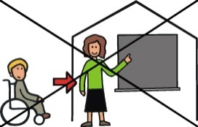  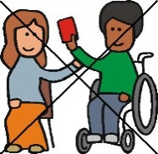    
- What the United Nations says about the right
of persons with disabilities to work

The United Nations wrote a document about
the rights of persons with disabilities.
The document is called the Convention on the rights
of persons with disabilities.

The Convention says what the states need to do so that persons with disabilities can use all their rights.
Many states in the world agreed to do
what the Convention says.

The Convention is made up of parts called articles.
Each article is about 1 right.

Article 27 is about the right of persons with disabilities to work.
The article says that persons with disabilities
have the right to work just like anyone else.

- They have the right to choose what job they want to do.

- They have the right to have a real job
and work alongside persons without disabilities.

- The places where persons with disabilities work
should be accessible.
This means they have to be easy for everyone
to get around.

The Convention also says what should happen in every country
so that persons with disabilities can work.

The states that agreed to the Convention  now have to do what the Convention says.  This means they have to make sure that  persons with disabilities have the same chances to work  as others.  Every state should have a law about that.  The right to have a regular job  The Convention says that persons with disabilities  have the right to work just like anyone else.  This means that persons with disabilities have the right to work  alongside persons without disabilities in regular workplaces.  But persons with disabilities rarely have regular jobs.  Very often, they work in special jobs  for persons with disabilities.  For example, many persons with disabilities  work in ‘sheltered workshops’.  Sheltered workshops are places where all workers  are persons with disabilities.  It is better when persons with disabilities work in regular jobs  than in ‘sheltered workshops’.  Sometimes, persons with disabilities have to work  in ‘sheltered workshops’ because there is no other choice  for them.  This is against the Convention.  The OHCHR says that ‘sheltered workshops’ can help  persons with disabilities to prepare for real jobs  in regular workplaces.  But the state should make sure that all persons with disabilities  can work in regular workplaces. | 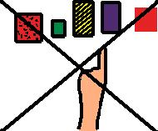
Persons with disabilities can get support  to work in a regular workplace.  This is called ‘supported employment’.  ‘Supported employment’ is when:  - Someone helps you to find the right job for you.  - Someone shows you how to do your job.  - Someone gives you support at work.  ‘Supported employment’ in regular workplaces is good  because it helps persons with disabilities to find real jobs.  The state should talk to employers about the right  of persons with disabilities to work.  For example in Peru or Serbia, the state tries to  show employers that persons with disabilities  are good workers.  Stopping discrimination  Discrimination is when persons with disabilities are treated unfairly because of their disability.  There are many kinds of discrimination.  For example:  - A company wants to hire a new person.  They have to choose between a person with disability  and a person without disability.  The person with disability is better for the job  but the company hires the person without disability.  This is discrimination. | 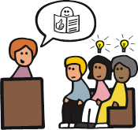

- Sometimes, the employer makes it harder for persons with disabilities to get a job.  This is also discrimination.  - Sometimes, persons with disabilities get paid less  than persons without disabilities for doing the same work.  This is also discrimination.  The Convention says that the state must protect persons  with disabilities from discrimination.  It also says that workers with disabilities should be treated  in the same way as workers without disabilities.  This means that persons with disabilities should have  the same rights at work as persons without disabilities.  Sometimes, persons with disabilities are treated unfairly  for other things than disability.  This is called ‘multiple discrimination’.  For example, women with disabilities can be treated unfairly  because they are women and because they have a disability.  The Convention says that the state must protect  persons with disabilities from ‘multiple discrimination’.  Accessible workplaces  Many persons with disabilities cannot work because  the workplaces are not accessible.  For example, the company building or public transport  is not accessible. |  | 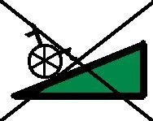  
The OHCHR found out that many states try to
make workplaces accessible for persons with disabilities.

Some states work to make buildings more accessible.
In Andorra or Egypt, the government works to
make the public transport accessible.

In Paraguay, deaf persons can get a sign language interpreter
for a job interview.

In Germany and Mexico, the law says that
certain workplaces must be accessible.

The state should talk to employers about making workplaces accessible.

Reasonable accommodation

‘Reasonable accommodation’ means making changes
to the job or workplace so that persons with disabilities
can do their work.

For example, a blind person gets a special computer
which reads all the text out loud.
Persons with intellectual disabilities get information
that is easy to read.

These changes must be fair to the employer.
This means they have to be easy to make and
they cannot cost too much money.

If the changes are fair, the employer cannot say ‘no’.
It is the right of persons with disabilities
to have these changes done.
Every state should have a law about this.
The OHCHR found out that in many states,
persons with disabilities cannot get
‘reasonable accommodation’.

Only few states have laws about ‘reasonable accommodation’.
Often, people do not understand well
what ‘reasonable accommodation’ is about.

Some employers are afraid of having to make
big or expensive changes.
That is why they do not hire persons with disabilities.

In reality, changes that workers with disabilities need are often very cheap.

The state must make sure that employers know about
their duty to make changes for persons with disabilities.
The state must help employers understand
what ‘reasonable accommodation’ means.

Having more companies hire persons with disabilities

The state can do a lot to make sure that
more companies hire persons with disabilities.

One way of having more companies hire
persons with disabilities is called ‘positive measures’.
This means that the state gives more help to companies
which hire persons with disabilities.

Here are some examples of positive measures:

 | - The state can make a rule that every company  has to have some workers with disabilities.  - The state can help companies to pay the wages  of workers with disabilities.  - Companies which hire persons with disabilities  pay less tax.  The OHCRH found out that some states find it hard  to make ‘positive measures’ work well.  For example, some people might complain that  persons with disabilities get jobs  only because they have a disability.  It is important that ‘positive measures’ help employers understand that persons with disabilities are good workers.  ‘Positive measures’ must help all persons with disabilities,  including women with disabilities,  persons with intellectual disabilities and  persons with mental health problems.  Fair working conditions  At work, persons with disabilities have the right  to be treated in the same way as their colleagues.  This means:  - Getting the same pay as persons without disabilities  if they do the same work.  - Getting the same benefits as others. | 
 | - Working in a safe and healthy place.  - Be treated well and with respect.  The employers must protect persons with disabilities  from bad treatment such as harassment.  Harassment is when someone treats you badly.  For example, harassment is when people call you bad names.  The employer must make sure harassment does not happen.  All states should have a law about good working conditions.  This law should say that persons with disabilities have the right  to the same working conditions as anyone else.  Work training  Training is important for persons to find and keep work.  Persons with disabilities have the right to get training and  learn new skills just like their colleagues.  But persons with disabilities rarely have the same chances  to take part in work training as persons without disabilities.  Every state should have a law to protect the right  of persons with disabilities to learn new skills.  Work training is also important for persons who got a disability  because of an accident or illness. |   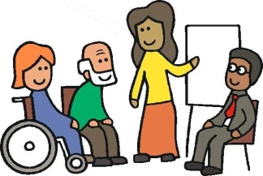  
 | The state should help workers who got a disability  to get back to work.  There should be laws which protect the jobs  of persons who got a disability.  The OHCHR found that that many states have work training  especially for persons with disabilities.  Such training is only for persons with disabilities.  In these trainings, persons with disabilities rarely learn  the skills they need to get a real job.  That it is why it is important that persons with disabilities  can take part in regular work trainings  together with persons without disabilities.  This means that regular work trainings must be accessible  for all persons with disabilities.  The state must make sure that all persons with disabilities  can learn new skills in regular work training,  including persons with intellectual disabilities and mental health problems.  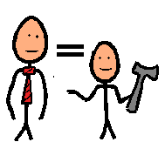  Self-employment  Finding a paid job is hard for persons with disabilities.  That is why many persons with disabilities are self-employed.  Self-employment means that you are your own boss.  You run your own business.  For example, you make cakes and you sell them. | 

The Convention says that the state should help  persons with disabilities to start their own business,  for example by giving them money.  Some states encourage persons with disabilities to get together and start a business in a group.  There are many programmes that help persons with disabilities  with self-employment.  Still, many persons with disabilities cannot get help  to start their own business.  For example, banks will not lend them the money they need  to start the business.  This is discrimination.  The state should make sure that persons with disabilities  have the same chances to borrow money and  start a business as anyone else.  Protecting persons with disabilities from abuse at work  People cannot be forced to work against their will.  People cannot be forced to do things which can harm them  or their health.  For example, people cannot be forced to work too hard or  too long without a time to rest or eat.  The state must protect persons with disabilities  from being forced to work against their will. | 

 | - What else needs to happen  Some other things written in the Convention need to happen  so that persons with disabilities can have the same chances  to work as other people:  - The state should help people understand that  persons with disabilities have the right to work  and that they can do a lot.  - The state should make sure that places, services and information is accessible.  - Persons with disabilities must be treated fairly by the law.  The law must respect the right of persons with disabilities  to make their own decisions.  - Persons with disabilities must get the same rights  and respect as anyone else.  - The state should make it easier for persons  with disabilities to get around independently.  - Persons with disabilities must have the chance to learn new things together with persons without disabilities.  - The state should help persons with disabilities  to stay in a good shape and live independently.  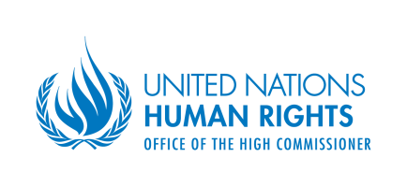  The OHCHR says that some other things can help  to make sure that persons with disabilities can work: | 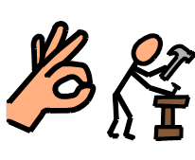    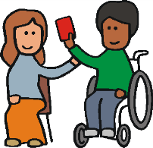
 | - Persons with disabilities must be able to  take part in unions.  Unions are groups of workers that got together  to protect their rights at work.  - Persons with disabilities must get help  from the state when they lose their job.  - The state should keep track of how many  persons with disabilities work.  - States should work together on helping persons  with disabilities with jobs.  Having a say  Persons with disabilities must be able to join unions  and protect their rights at work.  Organisations of persons with disabilities should work together with the unions and the government on the rights  of workers with disabilities.  In some countries, the state works together with companies, persons with disabilities and organisations to make sure that more persons with disabilities have jobs.  Getting help from the state  The state helps persons with disabilities with money.  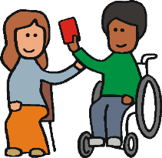  This money is called benefits.  Benefits help persons with disabilities to pay or their living. |           
 | In many countries, persons with disabilities lose the right to some benefits when they start working.  In some countries, they cannot get those benefits back again  when they lose their job.  Many persons with disabilities are afraid to end up  without a job and without the benefits.  That is why they never start working.  The states must change the way they give benefits  so that persons with disabilities are not afraid to work.  States should have information  The states should regularly check information on  how many persons with disabilities work.  This will help them to see if things are getting better or not.  Persons with disabilities must have a chance to complain  when they are treated unfairly.  The state must help them to get things right.  States should work together  The OHCHR found that it is good when states work together  on helping persons with disabilities to work.  The OHCHR thinks that the states should work together  on 2 things:  - Supporting persons with disabilities,  - Making sure that persons without disabilities can learn work skills in regular schools and trainings. | 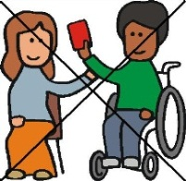  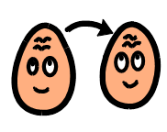
 | Summary  Here is the summary of the main things that  the OHCHR found out in its research:  - Finding work is hard for persons with disabilities because  many people think that persons with disabilities  cannot work well.  This needs to change!  - Many states try to help persons with disabilities  to find work.  In some countries, persons with disabilities  work in special workplaces only.  This is against the Convention.  The state should help persons with disabilities to work  in regular workplaces alongside  persons without disabilities.  The state should make sure companies hire persons  with disabilities and that workplaces are accessible.  - The state must make laws to protect the right  of persons with disabilities to work and  to stop discrimination.  These laws must make sure that persons with disabilities  can ask employers for the changes they need  to do their job.  - The state should help companies hire more  persons with disabilities. | 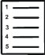
It is important that people understand the rights  of persons with disabilities to work.  Companies need to realise that  having workers with disabilities is good for their business.  The state should also help persons with disabilities  to start their own business.  - Persons with disabilities should get  the same work training as person without disabilities.  - The state should help persons with disabilities  to find work and keep it.  Persons with disabilities must be able to keep  the benefits they need to live independently.  - The states must keep track of  how many persons with disabilities work.  They should have information on persons  with every kind of disability.  The state must work together with organisations  of persons with disabilities on the right to work. |  | 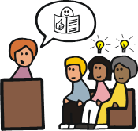  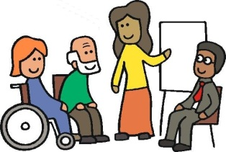  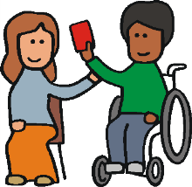

To write this report, the OHCHR talked to many states, organisations and persons to find out about the right of persons with disabilities to work.

Here is the list of states, organisations and persons that took part:

States:

Andorra
Armenia
Australia
Austria
Azerbaijan
Belgium
Bosnia and Herzegovina
Colombia
Cuba
Egypt
Estonia
Finland
France
Georgia
Germany
Ireland
Lebanon
Mauritius
Malta
Morocco
Mexico
New Zealand
Norway
Paraguay
Qatar
Republic of Congo
Russian Federation
Senegal
Serbia
Slovenia
Spain
Sri Lanka
Sweden
Tunisia

Organisations:

European Union Agency for Fundamental Rights
International Labour Organization

All-Russian Federation of the Deaf
Agence de Diffusion du Droit International Humanitaire en Afrique Centrale
Amis des Etrangers au Togo
Association rélwendé pour le dévéloppement, Burkina Faso
Comité Español de Representantes de Personas con Discapacidad, España
Confédération Nationale des Plateformes en Droits Humains, Madagascar
Disability Council International
DPI Germany (ISL e.V.)
German Association of Blind and Partially Sighted Academics
International Disability Alliance
NCBI, Ireland

Centre for Equal Opportunities and Opposition to Racism, Belgium
Commission Consultative des Droits de l’Homme, Luxembourg
Commission on Human Rights, Philippines
Commissioner for Fundamental Rights, Hungary
Equal Opportunities Commission, Hong Kong
Danish Institute for Human Rights
Human Rights Centre, Finland
Human Rights Commission, Maldives
Human Rights Commission, New Zealand
Institute of the Commissioner for Human Rights, Azerbaijan
National Commission for Human Rights, Honduras
National Commission for Human Rights, India
National Commission for Human Rights, Rwanda
National Human Rights Commission, Thailand
Ombudswoman, Croatia
Ombudsman, Portugal
Procuraduría para la Defensa de los Derechos Humanos, Nicaragua
South African Human Rights Commission

Persons:

Mr. Tom Butcher, Essl Foundation
Mr. Ryosuke Matsui, Hosei University, Tokyo
Mr. Trevor Smith, New Zealand

