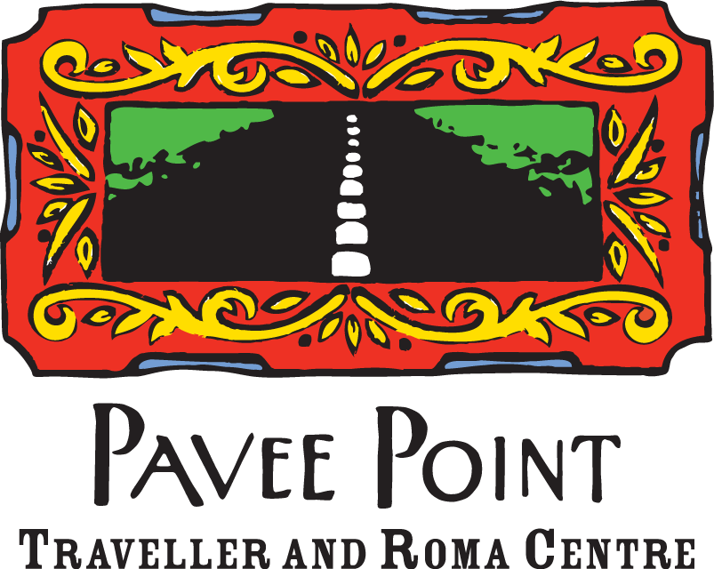

Contribution: Cultural dimension of the right to education

Pavee Point Traveller and Roma Centre (‘Pavee Point’), an Irish, non-governmental organisation, has been working to challenge racism and promote Traveller and Roma inclusion in Ireland since 1985. The organisation works from a community development perspective and promotes the realisation of human rights and equality for Travellers and Roma in Ireland. Irish Travellers are a minority ethnic group in Ireland who maintain a shared history, language, traditions and culture.

Our response to your questionnaire is framed by the entrenched education equality gap between the Traveller community and general population in Ireland:

• 57% of Traveller boys have only primary level education, compared to 13% of the rest of the population
• 13% of Traveller girls are educated to upper secondary or above compared with 69.1% of the general population
• One quarter of working age Travellers have no formal education
• 55% of Travellers overall leave school by the age of 15
• Travellers are over 50 times more likely to leave school without the Leaving Certificate
• Less than 1% of Travellers are in third level education.
• 167 Travellers hold a third level qualification

The education inequality gap between Travellers and the general population was further reinforced by cuts of 87% to Traveller education supports in 2011. These cuts dismantled supports such as the Visiting Teacher Service and Resource Teachers for Travellers in Ireland. In the following three years Traveller enrolment in secondary level dropped by 9%.

Please provide information on how, in your country, the issue of respect for cultural diversity and the cultural rights of each person is reflected in school curricula (legislative, institutional and policy framework and implementation)
Broadly, the Education Act, 1998 is the most comprehensive education legislation in Ireland and together with the Employment Equality Act, 1998 and the Equal Status Act, 2000 comprise the legislative framework in relation to education in Ireland. Within the Education Act the stated aim is for “the diversity of values, beliefs, languages and traditions in Irish society” to be respected (Education Act, 1998). However, in practice, the conditions of the Equal Status Act, 2000 can override this principle of inclusivity.

The Equal Status Act, 2000, Section 7, makes provision for protecting religious ethos and as such individual schools set their admissions policy in line with their ethos in the absence of national policy with sometimes discriminatory consequences including for Travellers and Roma and other minorities. Discriminatory enrolment policies also include a policy in some schools that a parent or sibling has to have attended the school which has repercussions also in terms of ethnicity and racism and the outcome of exclusion in the schooling system. This has resulted in Traveller children being excluded from schools of their choice.

The Department of Education and Skills in Ireland has developed policy documents to address integration in the Irish education system: Report and Recommendations for a Traveller Education Strategy 2006 and the Primary and Post Primary Intercultural Guidelines. The National Traveller and Roma Inclusion Strategy (NTRIS) (2017 – 2021) provides a comprehensive action plan in relation to accommodation, health, employment and education amongst other areas in Ireland. There are fourteen specific actions linked to Traveller education. While some actions are being progressed a robust Traveller Education Strategy/implementation plan with ringfenced resources remains to be developed for implementation of these actions in partnership with Traveller organisations.

Please provide information on how, in your country, the issue of respect for cultural diversity and the cultural rights of each person is taken into account in the organisation of the school system and schools (legislative, institutional and policy framework, and implementation);
There is evidence that schools in Ireland are limited in their responses to the issue of cultural diversity and the cultural rights of each individual in their organisation of the school system and schools. There is a very strong need for the cultural diversity and cultural rights of Travellers to be taken into account and a number of recommendations for how to do so are needed.

Other issues of concern are those regarding reduced timetables/school hours (dealt with by the Oireachtas Committee on Education and Skills in their Examination of the Current Use of Reduced Timetables ) and racist bullying which is currently being researched as part of the implementation of NTRIS (2017-2021).

For Roma students, there is a need to develop an English language infrastructure to support the English language needs of Roma and other minority ethnic students in mainstream schools whose first language is not English.

The recent ‘Seanad Public Consultation on Travellers Towards a More Equitable Ireland Post Recognition’ report recommends the urgent passage into legislation of the Traveller Culture and History in Education Bill 2018. This will, if passed, provide a statutory basis to ensure that Traveller history and culture are included and taught in the formal curriculum for early years, primary and secondary schools.

Other recommendations from the Seanad Public Consultation are the introduction of education policy and a range of documents considering:

• Insights into Traveller cultural understanding; and
• Ways in which schools need to fundamentally consider how formal school practice and a variety of cultural practices must be aligned.

Please clarify to what extent the measures described above relate to not only to the issue of languages in education (in this regard, please briefly explain the context and provide details on the State language policy), but also the arts, heritage, science, history values and religions, or world views and ways of life in all their diversity.
The Traveller Culture and History in Education Bill 2018 provides grounds for Traveller Culture and History to be obligatory in the mainstream educational curriculum. If passed this would ensure that all aspects of Traveller history and culture such as language, music, art and sport achievements and contributions to Irish society are included in the school curriculum.

Please specify the specific and particular difficulties encountered in ensuring an inclusive and quality education that allows cultural diversity and the cultural rights of each person to flourish at the same time

Initiatives such as modules produced by the Pavee Point education programme are far from adequate to meet the needs in contemporary Irish education. Add-on modules, however excellent, cannot be as effective as a coherent programme, informed throughout by human rights principles in promoting all forms of diversity and bias. If teacher education is to be effective in these areas, teacher education institutions need to be visibly informed by interculturalism and anti-racism, including explicit focus on Travellers. School inspections and other monitoring and accountability systems need to include assessment of the school’s interculturalism and anti-racism policies, curricula, and practice. Initial and ongoing professional education levels for all engaged in education delivery should be deeply informed by interculturalism and anti-racism principles and include mandatory modules that explicitly include Travellers and Roma.

Have specific mechanisms been established to consult and ensure the participation of stakeholders, in particular the populations concerned and parents, for a better understanding and effectiveness of the right to education, including its cultural dimension? What place is given in this context to the voice of children?

Such necessary mechanisms are not systematically in place but the NTRIS implementing frame could provide a basis for them.

What recommendations should be provided to States and other stakeholders on these issues?

The final recommendations to all states are:
1. Ongoing mandatory education of all education personnel, including policy makers, on anti- bias, interculturalism, structural discrimination and racism (sometimes unconscious, indirect, and a reflection of wider structural issues)
2. Direct engagement with Traveller organisations as equal and key partners in Traveller rights to ownership of and engagement with the education system at all levels, to be effective education partners and to maximise the benefits, societal and personal, they can achieve from that engagement. In order to achieve this ownership and engagement
3. Proactive focus on Traveller and Roma cultures and history in all aspects of the school curriculum.
4. Develop [English] language infrastructure to support the relevant [English] language needs of Roma students in mainstream schools where that is not their first language.

__________________________________________________________________________________________________________________________________________________________
46 Charles Street Great, Dublin 1, Ireland. Tel: 003531 8780255. E-Mail: info@pavee.ie Web: www.paveepoint.ie
Company registered in Ireland CRO: 105690 Charity No: CHY 11609

