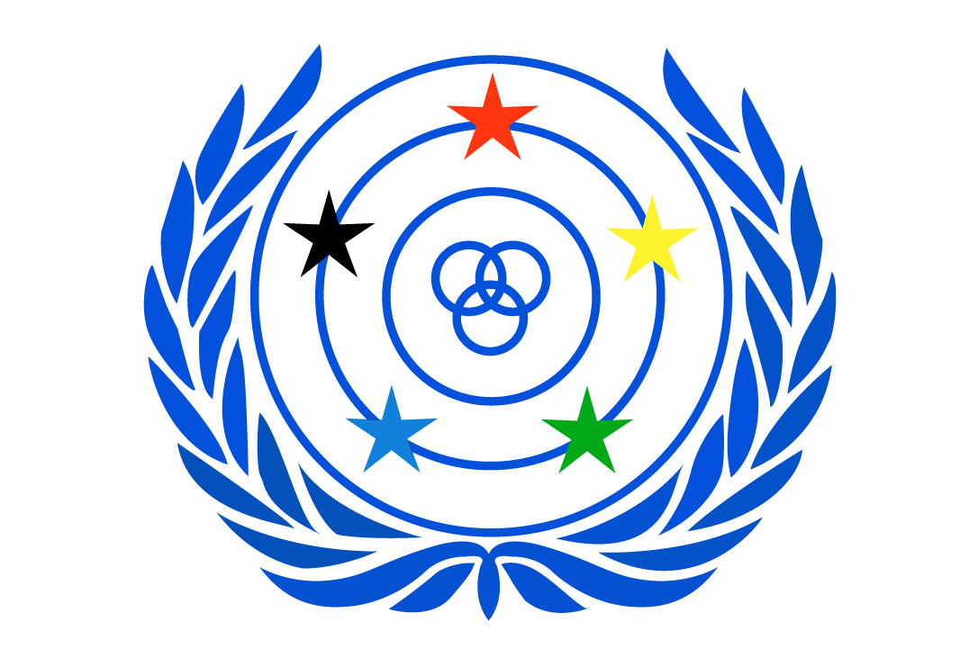

Legal Seat – Helsinki, Finland

WORLD FEDERATION OF THE DEAF
An International Non-Governmental Organisation in official liaison with ECOSOC, UNESCO, ILO,
WHO and the Council of Europe. WFD was established in Rome in 1951.
PO Box 65, 00401 Helsinki, FINLAND
www.wfdeaf.org

President

joseph j. murray
Email: info@wfd.fi

Inputs from the World Federation of the Deaf to the Human Rights Council’s report on “Cultural Dimension of the Rights to Education”.

The World Federation of the Deaf (WFD) welcomes the Resolution 8/4 of the Human Rights Council devoting the special Rapporteur on the rights of education, Ms. Koumbou Boly Barry, to the issue of the cultural dimension of the right to education.

The WFD is an international non-governmental organisation representing and promoting the human rights of approximately 70 million deaf people worldwide. The WFD is a federation of deaf organisations from 125 nations with the mission of promoting the human rights of deaf people and full, quality and equal access to all spheres of life, including self-determination, sign language, education, employment and community life. WFD has a consultative status in the United Nations and is a founding member of International Disability Alliance.

- Introduction

The WFD believes education is crucial for the growth and development of deaf children to be included as full citizen and actor of society. The main challenge faced by deaf children is accessing a quality and inclusive education in their natural language, sign language. Globally, deaf children face many barriers to education. Even where schools exist, many families in developing countries may not be able to afford to send a deaf child to school. Sometimes, there are no schools that accept a deaf child and/or may not have the means of transportation to bring their child to school or the necessary resources and skills to teach deaf children. Consequently, the education level attained by deaf children is often low and illiteracy is common.

Deaf people take pride in belonging to both the disability movement and in identifying as a linguistic and cultural minority movement. Deaf people and their use of sign languages are resources that contribute to the cognitive, creative and cultural dimensions of human diversity. Yet, the importance of the linguistic and cultural approach in the education of deaf people is often ignored in favour of normalcy in the mainstream system. Deaf learners are often outplaced in mainstream schools without any opportunities to access their natural language, sign language; and to develop their linguistic and cultural identity within the educational framework.

This paper will first start by highlighting the position of the World Federation of the Deaf regarding Inclusive Education for deaf children (II.) before bringing an overview of the position of the deaf community within the cultural and linguistic minority movement (III.). Then, this paper will highlight the necessity to have a tailored curriculum for deaf learners (IV.). Ultimately, some recommendations to governments to ensure the realisation of the cultural dimension of the rights to education will be provided (V.).

- Inclusive Education for deaf children

The provision of a quality bilingual education to deaf children from an early age is the first step to safeguard the cultural rights and inclusion of deaf people. The actual state of play is such that diversity is often not recognised or taken into account in the education of deaf children. Deaf children are often outplaced in mainstream school without opportunities to learn sign language and deaf culture.

Various barriers exist such as the lack of natural language inputs. Consequently, the education level attained by deaf children is often low and illiteracy is common. Other barriers to the effective education of deaf children include a lack of trained teachers – including deaf teachers as role models, a lack of teachers who are fluent in sign language and lack of learning environments and pedagogies, which are most conducive to deaf students’ effective learning. Most deaf children are born to hearing parents who do not yet have sign language skills, and there is a lack of comprehensive policies and programmes providing support for families of deaf children to learn sign language.

The Convention on the Rights of Persons with Disabilities (CRPD), in its Article 24, recognises the right of deaf persons, including deaf children, to access education in sign languages. As expressed in its Position Paper on Inclusive Education, the World Federation of the Deaf believes that education to deaf children is best achieved through bilingual education in the country’s national sign languages and national written language(s). Bilingual schools must follow the official national educational curriculum as well as teaching sign languages and deaf culture. Teachers must master sign language with native-level fluency and deaf children must be surrounded by their signing peers in inclusive settings.

The WFD does not believe the outplacement of deaf children in local schools with the provision of a sign language interpreter to be a viable solution. Indeed, through the medium of a sign language interpreter, deaf children are not receiving direct information from the teacher and are not able to communicate directly with other students. Children participate via the sign language interpreter and are at risk of missing out peer to peer interaction, not to mention information happening in their direct environment.

CRPD Committee’s General Comment N°6 on equality and non-discrimination, in point 65, recognises that the lack of proficiency in sign language skills of teachers of deaf children and the consequential inaccessibility of school environments effectively excludes deaf children and is considered discriminatory.

- Sign language and deaf culture as part of a unique minority

Deaf communities worldwide have long taken pride in being part of linguistic and cultural groups as well as the disability movement. No other disability or language/cultural group can claim similar intersectionality of rights. Deaf people have their own identity and culture, which manifest from different perspectives, such as personal experiences of being deaf, their use of sign language and one’s membership of a language community. However, deaf identity and culture are mainly tied to sign languages and the social connections built on the shared experience of using sign language. The membership of the deaf community is not usually defined by hearing loss but rather by identity with sign language. This highlights the fact that deaf people belong to a linguistic and cultural minority group.

Furthermore, the existence of such a culture is formally recognised by Art. 30 CRPD. This provision explicitly recognises deaf people’s right to their cultural and linguistic identity.

Deaf people differ from other linguistic minorities in one important way: they are usually unable to fully access the spoken languages of their surrounding environment because of their access to auditory input is not the same as people who are not deaf. Therefore, sign languages are not only culturally important, they are also the sole unconstrained means of language development and accessible communication for deaf people. The lack of access to their surrounding environment through sign languages and other accessibility measures impacts and disables deaf people, including in the sphere of education. The right to access as citizens in a larger dominant language culture, when societal barriers emerge, is the nexus that connects the Deaf Community with the disability movement.

However, what distinguishes the deaf community from the disability movement is the use of a specific language, sign language. Sign languages are fully-fledged languages with its own linguistic properties, including grammatical features, such as morphology, phonology and syntax. Sign languages are the mother tongue and the natural languages of deaf people. Sign languages are the means by which deaf people can realise all their other human rights, and be included both in deaf communities and in society. It is also the means by which deaf people can build their own identities and communities. Most of all, national sign languages are the only language for deaf children that can be accessed without barriers and can be used without additional help or support.

- Necessity of a tailored curriculum for deaf learners

Deaf children have a unique need for instruction in sign language, opportunities to study sign language and deaf culture, and opportunities to participate with their peers in congregated settings that allow for linguistic and cultural development. Due to shared ontologies and experiences, deaf children also have a need for instruction from deaf teachers who can advocate for their students and transmit social and cultural capital.

In addition to being the language through which deaf children access their education, education in sign language is also critical for the transmission and conservation of deaf culture. As most deaf children are born to families who do not yet know sign language, it is vital to provide early sign language linguistic support and learning to enable language acquisition. Deaf children must also be ensured the availability of a quality and inclusive education system in the national sign language and national written language. Teachers must master sign language with a native level; deaf children must be surrounded by their signing peers. Ultimately, the curriculum must maximise the full learning potential of deaf learners.
The maximisation of the full learning potential of deaf learners goes through the same curriculum that a hearing learner would receive, with the difference being their education is provided in the national sign language. In addition, deaf learners need to receive opportunities to develop and grow their cultural and linguistic identity. Fostering the cultural and linguistic identity of deaf learners is crucial to ensure the growth of their self-esteem to be actors of their full participation in society as citizens. Therefore, learning about deaf culture and deaf history must be provided to deaf learners in the inclusive bilingual schools.

- Recommendations

To fully implement Art. 24 and 30 CRPD to ensure that the cultural dimension of the rights to education of deaf learners is taken in account, governments must undergo several steps:

- Formally recognise national sign language(s) in law. This recommendation is in line with Art. 21 CRPD as well as fitting with the philosophy of the UN Resolution A/RES/72/161 recognising 23 September as the International Day of Sign Language.
- Developing a clear policy regarding inclusive education for deaf children. Educational policy should clearly state that national sign language medium education for deaf children with signing peers and teachers is part of an inclusive education system, in partnership with the National Association of the Deaf.
- Raising awareness of the importance of sign language as a crucial factor for the full inclusion and participation of deaf people in society.

- Ensuring the transition of educating deaf children in general education setting to educating deaf children in inclusive quality bilingual schools.

- Develop a deaf culture, history and sign language linguistics curriculum to be added to the national education curriculum for deaf learners that maximises their full learning potential and ensures the development of their linguistic and cultural, and their sense of belonging. Such policy should also address and solve the language deprivation of deaf children and approaches to language acquisition in their use of national sign languages.

For more information, please contact WFD Human Rights Officer, Mr. Alexandre Bloxs at alexandre.bloxs@wfdeaf.org.
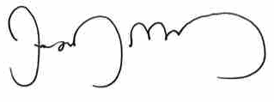
Joseph J. Murray
President

About the World Federation of the Deaf
The World Federation of the Deaf (WFD) is an international non-governmental organisation representing and promoting approximately 70 million deaf people's human rights worldwide. The WFD is a federation of deaf organisations from 125 nations; its mission is to promote the human rights of deaf people and full, quality and equal access to all spheres of life, including self-determination, sign language, education, employment and community life. WFD has a consultative status in the United Nations and is a founding member of International Disability Alliance (IDA). (www.wfdeaf.org) Email: info@wfd.fi

