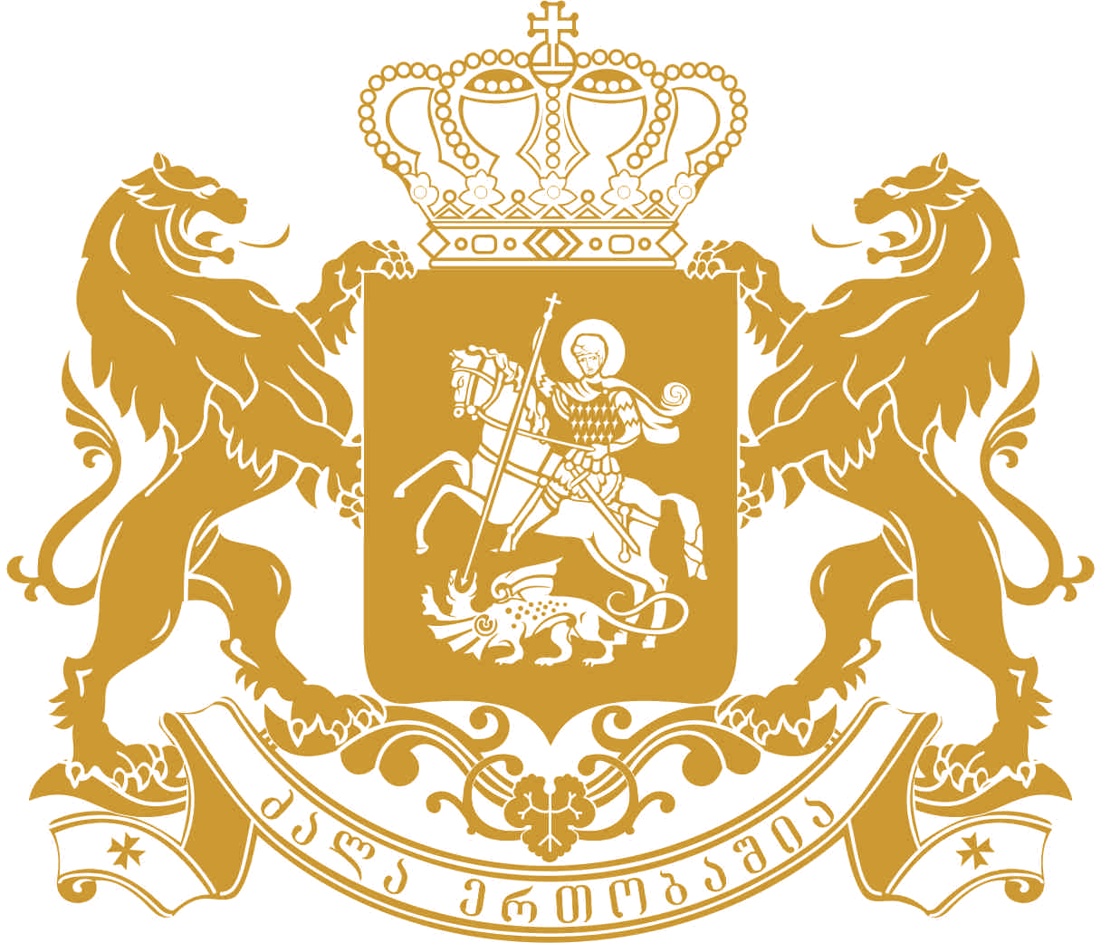
saqarTvelos saxalxo damcveli
Public Defender of Georgia
Written Contribution to the Office of the High Commissioner for Human Rights
In relation to the Human Rights Council Resolution 27/24
“Equal Participation in Political and Public Affairs”
National Human Rights Institution – Public Defender (Ombudsman) of Georgia

As a Public Defender of Georgia, I have the honor to submit to the Office of the High Commissioner for Human Rights present written contribution regarding the Human Rights Council Resolution 27/24 on Human Rights on equal participation in political and public affairs. The Office of Public Defender of Georgia, as a National Human Rights Institution and within a broad mandate provided to it by the Organic Law of Georgia on Public Defender is empowered to monitor and promote respect for the protection of all human rights and fundamental freedoms for all, including those of vulnerable individuals.
Present submission focuses on participation of women, ethnic minorities and persons with disabilities in political and public affairs in Georgia and underlines positive developments as well as challenges that are of particular concern to the Public Defender of Georgia.
- Observations with respect to participation of women in political and public affairs in Georgia
Key challenge for gender equality in Georgia is low rate of women’s involvement into political and public life of the country. According to the Global Gender Gap Report for 2014, Georgia holds 94th position among 142 countries in rating of women’s engagement in politics. For 2014 women’s share in the parliament of Georgia is 11%, 16% in the Cabinet of Ministers and 10% in local self-government bodies. The trend of women’s participation is particularly alarming in the regions where women of ethnic minority background reside.
Despite the fact that after the Parliamentary Elections of 2012 women’s representation in the legislative body has been increased by 5%, Georgia still remains in the list of the countries where women’s representation on a decision-making level is still low. As to the women’s representation in executive branch, from 2011 through 2012, their number did not exceed 16% (three women ministers); in 2013 number of women ministers made 21%, which again decreased to 16% in 2014; as of today, there are only 3 women ministers in the Cabinet.
Women’s participation in execution of local self-government has been decreasing during the last decade. As a result of the elections of 1998, women made 14% of local self-government bodies and only 10% after the elections of 2010. The index of women’s participation is particularly low in the self-government bodies of the municipalities settled by ethnic minorities. Out of 148 MPs elected in Akhalkalaki, Ninotsminda, Gardabani, Marneuli and Tsalka Sakrebulos, only 4 are women, which make only 2.7% of total deputation and legs behind the total index (10%).
Public Defender of Georgia welcomes measures taken in 2013 for facilitation of women’s political participation. In particular, on July 29, 2013 Paragraph 7¹ was added to Article 30 of the Organic Law of Georgian on Political Unions of Citizens, which provided for additional 30% on party funding in case 30% of every ten members would be opposite sex in the party list submitted. Nevertheless, gender statistics published by the election administration of Georgia in 2014 show that these changes are not incorporated in practice; in particular: there were only 2 women out of 14 in the list of Tbilisi mayoral elections of 2014; As per registered candidates for Mayors in the self-government bodies 8 are women and 65 - men. The distribution of election candidates in the party list also shows regrettable figures: there are only 427 women out of 1129 candidates. As to the gender composition of candidates registered by the party in the majority system of elections, there are only 846 women out of 5707 total candidates.
An important step towards gender mainstreaming was introduction of the position of the Advisor on Gender Equality issues at the institutional level. In particular, in 2013 the Assistant to the Prime Minister on the Issues of Human Rights and Gender Equality and the Advisor to the Minister of Regional Development and Infrastructure in Gender Issues were appointed. Despite such a positive development there still is need for further enhancement and facilitation of future of gender mainstreaming on the executive level.
In order to ensure participation of women in political and public affairs, Public Defender of Georgia makes following recommendations to the Georgian authorities:
- To support gender mainstreaming on executive government level, through appointing persons responsible for gender equality issues and establishing structural units;
- To support promotion of leader women on local self-government level to plan for the programs in support to women; to pay special attention to engagement of women from ethnic minorities and rural areas;
- To support enhancement/empowerment of the advisors on gender equality issues appointed on local self-government level; to establish their mandate and to inform community about their activity in the area of gender equality;
- Observations with respect to participation of ethnic minorities in political and public affairs in Georgia
One of the major indicators of national minority participation in political and public affairs is their representation in civil service and political positions, also the level of their engagement in decision-making process.
Currently, there are total of 8 MPs representing ethnic minorities in the Parliament of Georgia, marking a slight improvement compared with previous composition when there were 6 minority MPs during 2008-2012. However, it is still much lower compared to earlier Parliamentary composition: during 2004-2008 there were 12 MPs representing minorities, while during 1999-2004 – there were 16. Minority representatives are also represented as deputy chairs of parliamentary committees (Committee of Human Rights, Committee of Regional Politics and Self-Governance).
National minorities are represented at managing positions of local self-government in predominantly minority-populated regions of Kvemo Kartli and Samtskhe-Javakheti. However, national minorities are underrepresented in the capital city. Currently, there is not a single national minority member in Tbilisi City Council. Moreover, there are no representatives of national minorities in Tbilisi City Hall’s managing positions.
During 2012 Parliamentary Elections only a small number of ethnic minority representatives were among the political party lists. Traditionally, ethnic minorities were nominated as majoritarian candidates in minority-populated districts (Akhalkalaki, Ninotsminda and Marneuli). Unfortunately, national minorities were not included among the first ten of the party lists.
During 2013 Presidential elections out of 13 registered presidential candidates only 3 had conducted an active Presidential campaign in the regions populated by ethnic minorities (“Georgian Dream”, “United National Movement” and “Democratic Movement – United Georgia”). This demonstrates the lack of interest of political parties in problems of ethnic minorities.
On a positive side, Central Election Commission (CEC) implemented a number of important measures in order to facilitate the election processes for ethnic minority voters, namely:
- A working group on the issue of ethnic minorities was established;
- Functions of the working group were defined that included: development and monitoring of implementation of 2012 action plan, analysis of planned and implemented projects, organisation of round tables in Tbilisi and in the regions, development of a long-term action plan for 2013-2014;
- Election documentation was translated into the minority languages (Armenian and Azerbaijani);
- LEPL - Centre of Electoral Systems Development, Reforms and Trainings financed projects of non-governmental organisations aiming at supporting integration of national minorities and raising awareness on electoral procedures.
As a result, national minorities were better informed about the election process compared with previous years. Although challenges still remain: national minorities still do not have sufficient information about the political candidates or their programs and not many minorities were interested in information meetings organized by CEC.
In order to ensure participation of ethnic minorities in political and public affairs, Public Defender of Georgia makes following recommendations to the Georgian authorities:
- To include more representatives of ethnic minorities in the party lists and to pay more attention to integration issues in the political programs by the political parties;
- To work more actively in regions densely populated by national minorities to ensure increased level of political engagement and awareness of minorities;
- To facilitate increased involvement of national minority representatives in Tbilisi self government bodies.
- Observations with respect to participation of persons with disabilities in political and public affairs in Georgia
Public Defender is particularly concerned with the lack of adapted election environment - the infrastructure of the polling stations - which hinders the right of persons with disabilities to participate in election processes. Realization of this right is mainly possible by the portable ballot boxes.
Election legislation of Georgia contains number of provisions for facilitating the participation of persons with disabilities in elections – particularly, physical accessibility of polling stations and issues of adaptation of the election process. However, the provision, which provides for the physical accessibility of election administration buildings will be enacted only from 2016.
Public Defender of Georgia welcomes number of initiatives implemented by the Central Election Commission including broadcasting of political/election advertisements and TV shows related to elections (during election campaign) in sign language. During the local elections, blind voters had the opportunity to fill in the ballot paper with the help of the other person who would accompany him/her in the secret voting booth. Partially sighted voters were given the possibility to use a special magnifying device at the polling station - the lens. Special voting booths were produced during parliamentary and presidential elections for voters with physical disabilities and those using wheelchairs; as a result each district could change ordinary booth with a special one located in number of electoral precincts. Portable ramps were made in 13 polling stations during local elections. 88 disabled citizens utilized mobile groups and adapted transport service on the polling day.
One of the important components for the participation of persons with disabilities in political and public affairs is their inclusion in decision making processes by the central and local governments. In spite of the fact that there are no provisions in the legislation hindering such participation, in practice persons with disabilities have no possibility to enter administrative buildings and attend meetings due to the lack of accessible environment and relevant infrastructure.
In order to ensure participation of persons with disabilities in political and public affairs, Public Defender of Georgia makes following recommendations to the Georgian authorities:
- To make relevant amendments into the national legislation and harmonize it with standards set by the 2006 UN Convention on Rights of Persons with Disabilities;
- To adapt the environment where persons with disabilities have the possibility to make choices to be elected on relevant positions and participate in political and public affairs;
- To carry out measures towards strengthening persons with disabilities, since majority of them lack the possibility of self-realization and living life in dignity.
Hereby, the Office of Public Defender (Ombudsman) of Georgia avails itself of the opportunity to renew to the United Nations High Commissioner for Human Rights and the Human Rights Council assurances of its highest consideration and expresses his readiness to contribute to the work of international human rights system in the promotion and protection of rights of vulnerable persons.

Ucha Nanuashvili
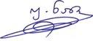
Public Defender of Georgia

http://www3.weforum.org/docs/GGGR14/GGGR_CompleteReport_2014.pdf

