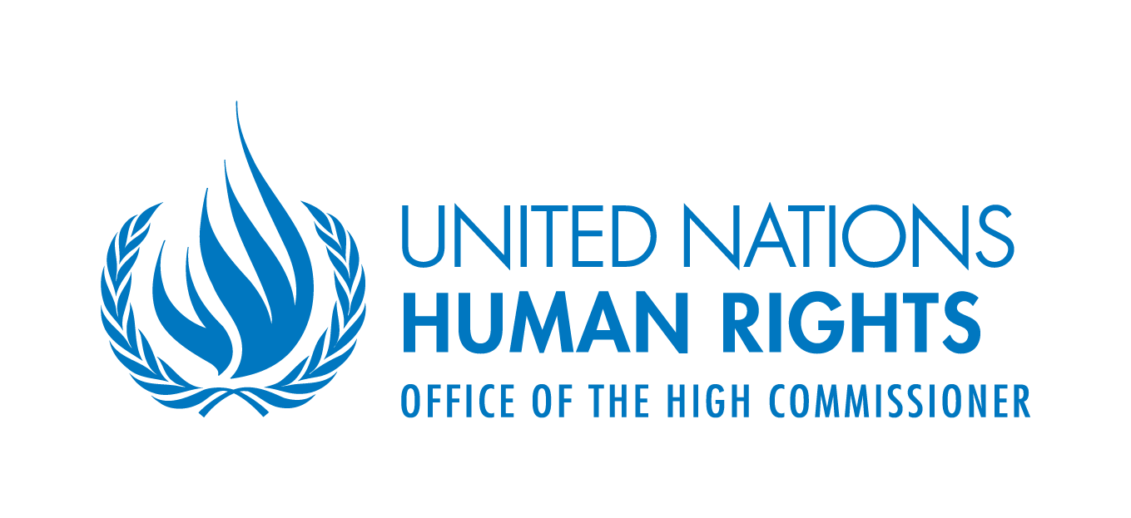 | 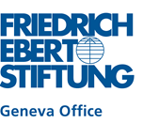

“Making the right impact?”
Expert workshop on evaluating Human Rights Impact Assessments (HRIAs) in trade and investment regimes

17-18 September 2014, Château de Bossey, Switzerland

List of Participants

- Mr. Roberto Bissio, Director, Social Watch, Uruguay
- Mr. Thomas Braunschweig, head, trade policy programme, Berne Declaration, Switzerland
- Mr. Biswajit Dhar, Professor, Centre for Economic Studies and Planning, Jawaharlal Nehru University, India
- Ms. Julia Dubslaff, coordinator of research, Facing Finance, Germany
- Ms. Marina Durano, Assistant Professor, University of the Philippines, Philippines,
- Mr. Eitan Felner, Independent Consultant, Israel
- Mr. James Harrison, Associate Professor, Warwick School of Law and Co-Director of the Centre for Human Rights in Practice, United Kingdom
- Mr. Robert Howse, Professor of International Law, New York University School of Law, United States
- Mr. Felix Kirchmeier, Senior Program Officer, Human Rights and Development, Geneva Office, Friedrich-Ebert-Stiftung, Switzerland
- Mr. Bernard Kuiten, Head of External Relations, Information and External Relations Division, WTO
- Mr. Lloyd Lipsett, international human rights lawyer (by video message)
- Mr. David Luke, Head, Africa Trade Policy Centre, United Nations Economic Commission for Africa, Ethiopia
- Ms. Susan Mathews, Human Rights Officer, Right to Development Section, OHCHR
- Ms. Claire Methven O’Brien, Special Adviser, Danish Institute for Human Rights, Denmark
- Ms. Jane Nalunga, Country Director, SEATINI, Uganda
- Naveed Nanjee, intern, Secretary to the Implementation Committee, Espoo Convention Secretariat and Protocol on SEA, Environment Division, UNECE
- Shyami Puvimanasinghe, Human Rights Officer, Right to Development Section, OHCHR
- Ms. Diana Rosert, Associate Legal Affairs Officer, International Investment Agreements Section, Division on Investment and Enterprise, UNCTAD
- Ms. Andrea Saldariaga, Lead, Investment & Human Rights Project, LSE, United Kingdom
- Mr. Olivier de Schutter, (by Skype), Former UN Special Rapporteur on the Right to Food and member of the Committee on Economic, Social and Cultural Rights, Belgium
- Ms. Andrea Shemberg, Lead, Investment & Human Rights Project, LSE, United Kingdom
- Ms. Aphrodite Smagadi, Environmental Affairs Officer, Secretary to the Implementation Committee, Espoo Convention Secretariat and Protocol on SEA, Environment Division, UNECE
- Ms. Yvonne Theemann, Program Officer, Trade and Development, Employment and Social Policy, Geneva office, Friedrich-Ebert-Stiftung, Switzerland
- Ms. Elisabeth Tuerk, Chief, International Investment Agreements Section, Division on Investment and Enterprise, UNCTAD
- Mr. Simon Walker, Chief, Civil, Political, Economic, Social and Cultural Rights Section, OHCHR
- Mr. Mark Wielga, Director, Nomogaia, United States
- Mr. Joe Zhang, Law Advisor, Investment and Sustainable Development Program,
International Institute for Sustainable Development, Switzerland

