Check against delivery

International Investment Agreements (IIA) Conference, UNCTAD World Investment Forum, 13-16 October 2014

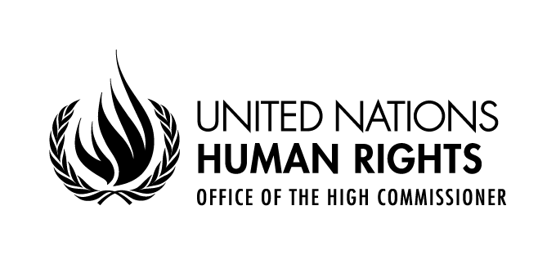

Statement by
Ms. Jane Connors
Director, Research and Right to Development Division
Office of the United Nations High Commissioner for Human Rights

Geneva, 16 October 2014
Palais des Nations, Salle XXVI

Thank you for providing the Office with an opportunity to bring human rights to your debate. International human rights law developed since the 1948 Universal Declaration of Human Rights, elaborates obligations which States are bound to respect. The core human rights treaties contain provisions on economic, social, civil, political and cultural rights, and in relation to particular persons, such as those who experience racial discrimination. Human rights law confers obligations on States, other actors, including private businesses and corporations also should respect human rights. This means that they should not infringe on the human rights of others and should address adverse human rights impacts with which they are involved.
We at OHCHR are privileged to support the mechanisms which encourage implementation of human rights obligations: the human rights treaty bodies, the Special Procedures of the Human Rights Council, such as the Working Group on the issue of human rights and transnational corporations and other business enterprises, which addresses human rights questions in relation to business operations and the Council’s Universal Periodic Review mechanism.
What is the link between human rights and investment treaties?
The impact of investment treaties can be positive: where investment results in economic growth, creates employment and new opportunities, and leads to concrete improvements in people’s lives. There are also examples of investment agreements that hamper the margin of manoeuvre of States to decide priorities in the social and economic sphere. For instance, in 2007, investors sued South Africa for 350 million US dollars in an investor-state dispute, because the Black Empowerment Act, to remedy past discriminatory practices, required investors to sell shares in their companies to “historically disadvantaged South Africans.” The case was settled in 2010 after the investors received new licenses that required them to sell fewer shares. Other investor-State arbitration cases have addressed issues relating to the implementation of the rights to water, health, and rights relating to environmental protection and corruption. These illustrate that commitments to investor protection can conflict with States’ international and national human rights obligations.
In addition, States sometimes fail adequately to protect individuals whose rights are adversely affected by an investment, and all too often they do not have access to justice and effective remedies for the damage caused.
Of particular concern is the ad hoc nature of international investment rules, which rarely reference international human rights law. Investment rules and mechanisms for resolving disputes are frequently applied in an opaque manner which precludes scrutiny.
The process of negotiating an agreement can also be a cause for concern. Lack of transparency in the conclusion of investment treaties and investment chapters in preferential trade agreements, together with their complexity and density, reduce opportunities for public participation, parliamentary oversight and diminish accountability.
So what can human rights bring to this area ?
First, human rights norms should provide the parameters to frame the social and ethical dimensions of investment. This means that they should be built on the principles of transparency, participation, accountability, reliance on human rights standards and provision of remedies.
Second, the corporate responsibility to respect human rights as stipulated in the United Nations Guiding Principles on Business and Human Rights requires business enterprises to undertake human rights due diligence to avoid adverse human rights impacts. The UN supported Principles for Responsible Contracts provide useful guidance on how to manage human rights risks in the context of State-investor contract negotiations.
Third, any reform of the International Investment Agreements (IIA) regime should include means to balance investor protection against the corporate responsibility to avoid adverse human rights impacts. Safeguards should be put in place so that Governments create adequate policy space so that they can meet their human rights obligations. Of equal importance is ensuring that that these concerns are taken into account in any dispute settlement that may arise. UNCTAD’s “Investment Policy Framework for Sustainable Development” (IPFSD) embodies this broader approach to investment policy, which is essential to meeting the sustainable development needs of the future. International human rights law binds States to implement key obligations, in particular the principles of participation, non-discrimination and accountability.
One way to build an evidence-base for integrating human rights in investment policymaking is to encourage the use of human rights impact assessments. The Guiding Principles on Human Rights Impact Assessments of Trade and Investment Agreements, developed by the former Special Rapporteur on the Right to Food in 2011, shows States how they can ensure that trade and investment agreements are consistent with States’ international human rights obligations.
In essence, working towards investment that brings significant development benefits, while respecting human rights and managing potential adverse impacts on people is essential. Putting this understanding at the core of any reform of the international investment regime would make investment more risk-averse and sustainable.

