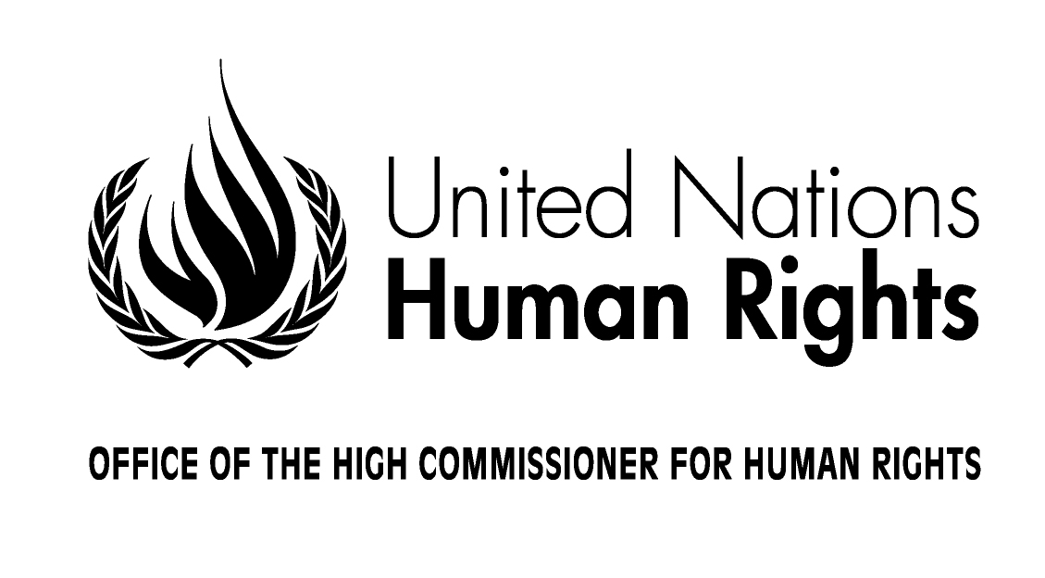
REGISTRATION FORM

Regional consultation on draft guidelines on the effective implementation
of the right to participate in public affairs
6-7 September 2017, Addis Ababa, Ethiopia

Mr. or Ms.

Last Name _______________________

First Name______________________

Official position_______________________________________________________________________

Country/Organisation/Institution__________________________________________________________

Passport number_______________________________Nationality______________________________

Phone _________________________________E-mail__________________________________________

Attends the meeting as: (please check only one box)

❐ Expert  Government Representative
❐ Representative of UN Agency, Fund or Programme
❐ Representative of Intergovernmental Organization
❐ Representative of Regional Organization
❐ Representative of International Non-Governmental organization
❐ Representative of National/Regional Non-Governmental organization
❐ Representative of National Human Rights Institution

Date ______________________________ Signature __________________________________

Note: Please return this form duly filled in to fmorvay@ohchr.org by 22 August 2017. For further information please contact Ms. Federica Morvay at fmorvay@ohchr.org

