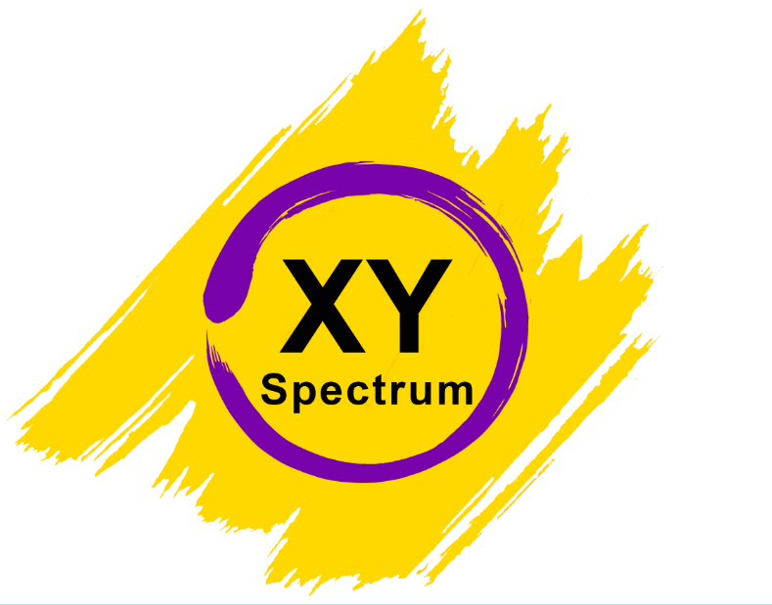
XY Spectrum
Organization for promotion and advancement of human rights and quality of life for intersex and trans persons
Mob: +381 60 613 06 69
E-mail: inter.xy.spectrum@gmail.com
Web site: www.xyspectrum.org

- Key areas in which people (in your country, region or worldwide) suffer socio-cultural and economic exclusion as a result of violence and discrimination on the basis of sexual orientation and/or gender identity; in particular,
- What knowledge, including data, exists in the State planning bases in relation to socio-cultural and economic exclusion based on sexual orientation and gender identity, including levels of poverty, homelessness, education, employment, health, political participation and any other relevant social indicator?
  - Data about cultural and economic exclusion based on sexual orientation and gender identity do not exist in state planning,
  - State institions are not transparent in term of whether there is any data they collect. From CSO’s prespective state is not aproachable and data are not publicly shared.
  - Gender identity is recognised as protective ground within anti-discrimination and hate ctime legislation, but state does not have official data collection system on the metter. ... POGLEDATI ZA MEDIJE
  - In terms of public poilicies in Serbia gender identity was recognized within National Anti-discrimination strategy and relevalnt Action Plan for period 2013-2018. However provisions from these documents related with gender identity remain mostly unforfield.
  - From 2012 public health insurance is covering 65% of surgeries (gender reaffirming surgeries) for trans people.
  - On all other levels their no available/transparent information.
- How are individuals, groups or communities differently affected, based on their sexual orientation and/or gender identity?
  - Apart from been protected from discrimination and hate crimes on paper, which lacks proper implementation and system of data collection, trans people are affected by economic and cultural exclusion in different areas: political, education and employment (especially trans women) and poverty as specific area.
- What are the main barriers in ensuring equal access to education, health care, employment and occupation, housing and other relevant sectors?
- The main barrier is related full recognition of trans identities through adopting Legal Gender recognition legislation in line with international human rights standards.
- Trans people face lack of proper implementation of provisions for protection from discrimination, also high level of stigma and prejudices and lack of state measures to overcome that.
- Root causes and structural factors responsible for marginalisation and socio-cultural and economic exclusion, such as laws, public policies, institutional practices, organizational behaviours, and prevailing ideologies, values and beliefs?
- In general public diversity of trans community is not recognised and presentation in media is still very sensationalist and creates negative perception.
- Combination of negative perceptions in Serbia’s society, lack of legal and policy framework related to trans rights and political will to adopt such measures and internalized fear of trans communities to become more visible and their empowerment to be included within areas in our society.
- State efforts to address socio-cultural and economic exclusion through legislation, policies, data gathering, and other means, for example:
- Destitution and poverty;
- No measures had been taken by the state.
- Current efforts by States to address bullying and exclusion of LGBT people from education, including in education curricula teacher training, measures to promote continuing education or reinsertion in education settings and vocational training;
  - State didn’t address bullying and exclusion of trans people.
- Homelessness among LGBT people, particularly youth, and inclusion in shelter programs;
  - State didn’t address homelessness of trans people and inclusion in shelter program. CSO which is working with trans community opened first drop in centre in Belgrade. State didn’t participate or support this initiative.
- Coverage by social security and benefits, as well as public and private health insurance (Taking into account survivor’s pensions for same-sex couples, insurance coverage for gender affirming care, social housing for LGBT youth and older persons etc.);
  - State health insurance is covering 65% of gender affirming surgeries for trans people and psychiatrist /psychologist evaluation, as well as endocrinologist treatment. Private health insurance does not gender affirming surgeries.
- Equal access to health (including through training and sensitisation of health care personnel), regardless of sexual orientation, gender identity or expression;
  - Health care personnel in state or private medical institution didn’t have any training on gender identity or expression.
  - Few representatives of CSO’s tried to contact Ministry of Health and to organize training for MD’s and health care personnel trough accredited programs.
- Complaints mechanisms available and accessible to LGBT people facing discrimination.
  - Commissioner for protection of equality and Ombudsman as independent bodies having complain mechanisms available and are accessible for trans people facing discrimination.
- Actions to ensure socio-cultural and economic inclusion based on sexual orientation and gender identity in measures undertaken to ensure implementation of the Sustainable Development Goals at the national and regional levels.
  - There is no information available on any actions taken by the state in relation of SDG’s on the matter.
- Actions taken to raise public awareness and sensitisation on issues of sexual orientation and gender identity, in order to promote the meaningful socio-cultural and economic inclusion of LGBT people.
  - State didn’t take any action to raise awareness and sensitisation on issues of sexual orientation and gender identity
- Services provided by civil society to excluded and marginalised LGBT people.
- Counselling and therapy is provided as well as legal aid is provided to trans people. Two organisations (Geten and Da se zna) are recording discrimination and violence of trans people.
- Organisation XY Spectrum organized several training for trans community to gain new knowledge in different fields and to be more independent financially and socially.

Kristian Ranđelović
Executive director of XY Spectrum
***
Board member of organisations:
OII EUROPE (Organisation Intersex International Europe)
ERA (Equal Rights Association for Western Balkans and Turkey)
THE ASTRAEA LESBIAN FOUNDATION FOR JUSTICE
TransMentors International

