The right to adequate housing and urbanization

Port-au-Prince, Haiti © UN-Habitat
Housing is not merely a commodity, it’s a human right.
“We reaffirm our commitment to the full and progressive realization of the right to adequate housing, as provided for in international instruments. In this context, we recognize an obligation by Governments to enable people to obtain shelter and to protect and improve dwellings and neighbourhoods. We commit ourselves to the goal of improving living and working conditions on an equitable and sustainable basis, so that everyone will have adequate shelter that is healthy, safe, secure, accessible and affordable and that includes basic services, facilities and amenities, and will enjoy freedom from discrimination in housing and legal security of tenure. We shall implement and promote this objective in a manner fully consistent with human rights standards.”
Habitat Agenda, Chapter III.A., Section 39

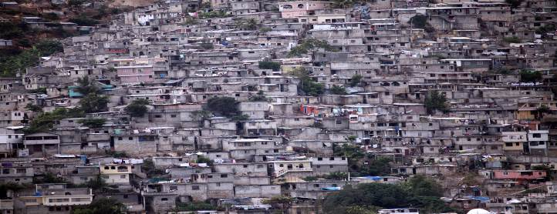
The shift towards a predominantly urban world makes the process of urbanization one of the most significant global trends of the 21st century. While this phenomenon has the potential to contribute positively to the lives of millions, in many places across the globe people find themselves living in unacceptable conditions in burgeoning urban centers. In many cases, the way in which housing is produced and consumed has shaped cities that are fragmented and gentrified, with increasing inequality among their inhabitants. The future sustainability of cities and urbanization processes will therefore strongly depend on effectively tackling current housing crises. The growing urgency to provide adequate housing to millions of people and communities, and the need to do so in ways which guarantee a sustainable future for cities, calls for a paradigm shift in housing policy and practice.

The human right to adequate housing means the right for all to a place to live in security, peace and dignity.
The right to adequate housing is recognized under international human rights law in the 1948 Universal Declaration of Human Rights, in the 1966 International Covenant on Economic, Social and Cultural Rights and in many other human rights treaties, international declarations and conference outcome documents, including the 1996 Habitat Agenda.
Adequate housing is more than four walls and a roof. “Adequacy” in housing has been defined by a number of elements which are as important as ensuring the basic supply and construction of housing units. For housing to be adequate it must, at a minimum, meet the following criteria:
Security of Tenure

All persons should possess a degree of security of tenure which guarantees legal protection against forced eviction, harassment and other threats, regardless of the type of tenure, including ownership, public and private rental accommodation, cooperative housing, lease-hold accommodation, emergency housing and informal settlements.

A home is a place to live in security, peace and dignity. Lack of security of tenure and adequate protection place people under the threat and fear of eviction, homelessness and destitution. This is a problem in developed and developing countries alike with grave consequences for all, especially children.

Affordability  Housing is not adequate if its cost threatens or compromises the occupants’ enjoyment of other human rights.  This happens when the costs of rent, mortgages and utilities are so high that people cannot afford food, medication, electricity, etc. Often the choice for a roof over their family’s head as opposed to homelessness is a priority even at the cost of resorting to food banks and charity for survival. | Habitability  Housing is not adequate if it does not guarantee physical safety or provide adequate space, as well as protection against the cold, damp, heat, rain, wind and other threats to health, and against structural hazards.  Living in unsafe structures, near polluted sites, in disaster-prone areas or overcrowded conditions is a challenge faced by many.
Availability of services, materials, facilities and infrastructure  Housing is not adequate if its occupants do not have safe drinking water, adequate sanitation, energy for cooking, heating, lighting, food storage or refuse disposal.  The right to adequate housing is intimately linked with the realization of other human rights, including the rights to water, sanitation and health. | Location  Housing is not adequate if it is cut off from employment opportunities, health care services, schools, childcare centers and other social facilities, or if located in polluted or dangerous areas.  Location has many implications for households, but also for the society and the development of cities. The right to adequate housing cannot be achieved without access to livelihood, education and basic services. That is why the production of housing units alone is insufficient to create housing sustainability.
Accessibility  Housing is not adequate if the specific needs of disadvantaged and marginalized groups are not taken into account.  Policies and programmes should prioritize the needs of the most vulnerable, for instance by removing the barriers in the built environment for persons with disabilities, and ensuring that ethnic minorities have full and sustainable access to housing. | Cultural adequacy  Housing is not adequate if it does not respect and take into account the expression of cultural identity.  Housing is an expression of the diversity of cultural practices and traditions. For instance, some indigenous communities’ way of life and housing can be quite different from non-indigenous communities. This is why housing that contradicts a community’s culture and needs should not be imposed.

Housing at the Centre


National and local authorities must ensure conditions in which everyone is able to progressively realize their right to adequate housing. Among other measures, States should ensure that a range of housing options are available to meet the various needs and financial capacities of all parts of the society, including people in situations of vulnerability. UN-Habitat’s new flagship initiative, ‘Housing at the Centre’, proposes not only to take into account the socio-developmental dimension of housing, but to position housing at the center of national and local urban agendas, at the center of the city, and at the center of the lives of people – thereby establishing the necessary preconditions for a holistic framework for housing development. This initiative is set within the context of the importance UN-Habitat places on urban legislation, urban planning and design, and urban economy/municipal finance.
Additional Resources from the UN Housing Rights Programme
The United Nations Human Settlements Programme (UN-Habitat) and the Office of the United Nations High Commissioner for Human Rights (OHCHR) collaborate under the auspices of the United Nations Housing Rights Programme (UNHRP). For additional information, see:
OHCHR’s webpage on human rights and urbanization
Fact Sheet 21: The Right to Adequate Housing
Right to Adequate Housing Toolkit
Housing and Slum Upgrading

