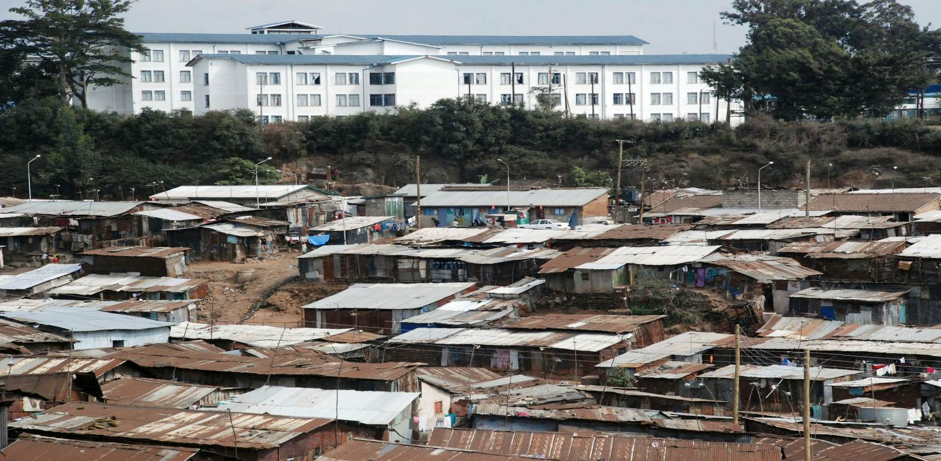
Urbanization is one of the most important global trends of the 21st Century, and is a phenomenon that has the potential to contribute positively to the lives of the majority of the world’s population. This is the vision captured in the 2030 Agenda for Sustainable Development, in which governments commit to ‘make cities and human settlements inclusive, safe, resilient and sustainable’ (Goal 11). They further commit to leave no-one behind, envisaging “a world of universal respect for equality and non-discrimination”, including gender equality, and reaffirm the responsibilities of all States to “respect, protect and promote human rights, without discrimination or distinction of any kind”. Yet, in many places the trend towards rapid urbanization has gone hand in hand with the creation of more slums, more people in inadequate living conditions and lacking secure tenure of their housing and land, and greater disparities, inequalities and discrimination.
Human Rights and Urbanization
Urbanization processes have too often narrowly focused on growth, on markets, and on private investment. At the same time relatively little attention has been paid to equality and wealth distribution, or to environmental and social sustainability, and virtually none to civil, economic, political, cultural and social rights.
Today more than half of the world’s population lives in urban areas, and by 2030 this is expected to rise to 60 percent. In the same period 90 percent of the world’s population growth will take place in cities, particularly in Africa and Asia.
As a result millions of people have been left in unacceptable living conditions in burgeoning urban centers wherein poverty, forced evictions and displacement, violence and insecurity are common. Inadequate regulation, poor governance, lack of inclusive urban planning, and considering housing, water, education, justice or land as mere commodities, amongst other factors, have exacerbated this situation.

Urbanization can only be a force for positive transformation if it respects and promotes human rights
The Habitat III conference in October 2016 offers a unique opportunity to chart a new course, by establishing a New Urban Agenda for urbanization that is sustainable, socially inclusive, that promotes equality and combats discrimination in all its forms; and which empowers individuals and communities to make cities places of equal opportunity for all, where people can live in security, peace and dignity. Sustainable and fair urbanization models can be achieved only if guided by human rights principles and with the aim of achieving the realization of the human rights of all inhabitants. Urban processes can support the implementation of State obligations towards human rights by ensuring:

- The free, active and meaningful participation of all inhabitants, in particular the most marginalized. Urban and spatial development should be done with and for all of a city’s inhabitants, with the priority being to protect and improve the living conditions of the most vulnerable.
- That duty-bearers are accountable for respecting, protecting and promoting the human rights of all inhabitants. Moving from a technocratic to a rights-based model, decisions and processes in cities - such as those affecting the right to adequate housing and the right to an adequate standard of living - need to be transparent, subject to public scrutiny, and must include free and fair dispute and complaint mechanisms.
- That the root causes of discrimination, inequalities and violence are addressed - not only on the basis of gender and geography, but also on the basis of race, culture, religion, age, disability and social and economic status. Too often the voices of the poor, people living in slums and informal settlements, women, children, minorities, indigenous peoples, migrants, persons with disabilities, refugees, older persons and others, are not heard in urban development processes, resulting in development that further marginalizes and discriminates against those most in need.
- That all urban development activities embrace strategies for the political, social and economic empowerment of people. In practice this requires upholding fundamental rights and freedoms, in particular freedom of speech and assembly, the right to information, consultation and participation in decision-making processes, and the right to vote, among others.

Human rights are key to advancing and developing an urbanization that is sustainable and socially inclusive, that promotes equality, combats discrimination in all its forms and empowers individuals and communities. A human rights approach is vital to make cities work for people as places of equal opportunity for all, where people can live in security, peace and dignity.

Upholding human rights in cities is an obligation of both national and local authorities
The international human rights obligations of a State extend to all levels of government and to all those who exercise governmental authority. For instance, urbanization challenges are deeply linked with the challenge of ensuring adequate housing for all. Effective national housing strategies grounded on human rights require reviews of laws and regulations, strategic planning that draws on local innovation and know-how, the mobilization of adequate financial resources and all stakeholders’ inputs, and local level implementation. In such processes it is essential to:
- Clearly articulate the responsibilities of national and local governments, to ensure the realization of human rights in accordance with international human rights law;
- Ensure that these responsibilities are met with adequate financial and other resources for their effective implementation;
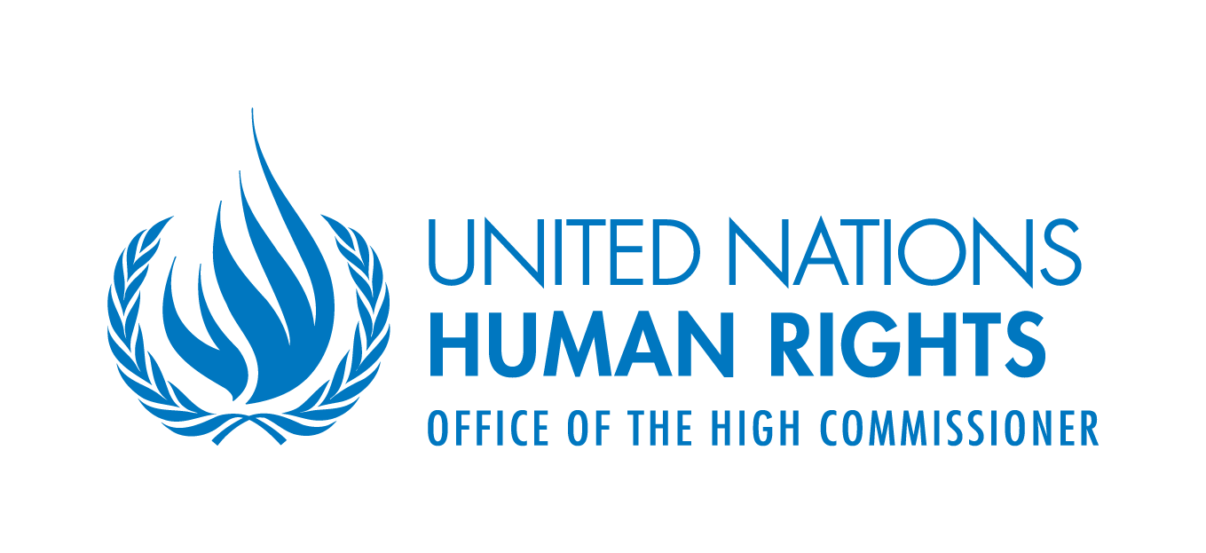
- Establish clear indicators and benchmarks for accountability, which assess progress towards the realization of human rights in cities.
For more information on human rights and urbanization, please visit:
http://www.ohchr.org/EN/Issues/Urbanization/Pages/UrbanizationHRIndex.aspx

