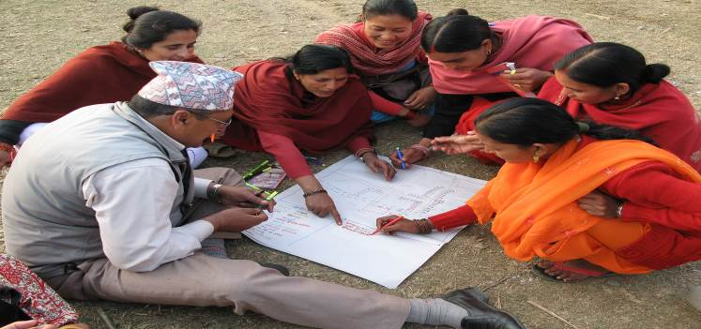
CONSULTATION AND PARTICIPATION IN URBAN PROCESSES
Participatory Planning in Nepal © UN-Habitat

Meaningful consultation and participation are the building blocks for transformative and sustainable urbanization

Any development processes that aim to combat discrimination and inequalities must embrace strategies for the political, social and economic empowerment of people, especially those in situations of vulnerability. Lack of participation in decision-making is a defining feature and cause of poverty, rather than just its consequence. Development policies and urbanization processes are more likely to be transformative, sustainable, inclusive and equitable if they are the result of a participatory process. This has also been recognized in the 2030 Agenda for Sustainable Development, in which governments made a commitment to leave no-one behind, envisaging “a world of universal respect for equality and non-discrimination”, and under Goal 16, to “ensure responsive, inclusive, participatory and representative decision-making at all levels”.

Consultation and participation in decision-making are human rights

International human rights treaties generally refer to these rights as participatory rights, and they have been enshrined in the Universal Declaration of Human Rights, the International Covenant on Civil and Political Rights, and many conventions and declarations since.

As such, the rights-holders, individuals, groups, communities, neighbourhood association - and especially those in situations of vulnerability - need to be included in every stage of the decision making process. States, as the primary duty-bearers of human rights, has to ensure a voice for people in both institutions and decision-making processes that affect them. It shifts the decision-making process from a charitable or benevolent one conducted solely by the State, to a process in which there is above all accountability for government obligations to realize human rights.

As human rights are interrelated and interdependent, participatory rights also depend on the full enjoyment of a number of human rights and fundamental freedoms. These include the freedom of expression, the freedoms of assembly, association, and of movement; and the right to seek, receive and impart information. Participation should also be based on the principles of inclusion, non-discrimination, equality, transparency and accountability.

Ways to promote participation

States have both positive and negative obligations to ensure the full realization of participatory rights, and this is especially important to bring about fair and transformative urbanization processes. States should not only respect participatory rights in this context, but should also take effective measures to facilitate and reduce obstacles to the enjoyment of these rights. Therefore, in order to promote civic engagement in urbanization processes:

- All inhabitants should be entitled to free, active and meaningful participation – particularly individuals and groups in situations of vulnerability.
- Wide consultation and participation should take place involving all inhabitants – not only the richest and the most powerful – at all stages of the decision-making process.
- Barriers to participation should be addressed, including factors such as illiteracy, language barriers, and poverty.
- Consultation and participation should be institutionalized in both law and in practice.
- Decision-making processes need to be transparent, with information provided in a timely, accessible and understandable manner, and authorities should be held accountable for ensuring civic participation, and for allowing their decisions to be subject to public scrutiny.
- People should have access to appropriate fora through which to express their views, in addition to having access to legal ways in which to express their views and opinions (such as the right to vote).
- Free and fair dispute and complaint mechanisms both formal and informal, should be made available to all.

Localizing Human Rights

The idea of Human Rights City is one example of localizing human rights principles at local level. It is a global initiative aimed at decentralizing and localizing human rights. The idea is based on the recognition of cities as key players in the promotion and protection of human rights, and refers in general to a city whose local government and population are morally and legally governed by human rights principles (A/HRC/30/49, p.11).

The role of civil society is crucial. Civil society plays a central role in boosting local action in the field of human rights. Specifically, it can help in monitoring progress and provide independent information and assessment of local government performance. Therefore, the role of civil society in terms of implementation of human rights in housing should be emphasized.

Realizing human rights through collaboration between district authorities, civil society and local organizations


The example of the Bang Bua communities in Bangkok, Thailand (for details see UN-Habitat and UNESCAP, Housing the Poor in Asian Cities, Quick guides for Policy Makers n°6; Community-based organizations, 2008
For more information on human rights and urbanization, please visit:
http://www.ohchr.org/EN/Issues/Urbanization/Pages/UrbanizationHRIndex.aspx

