Check against delivery
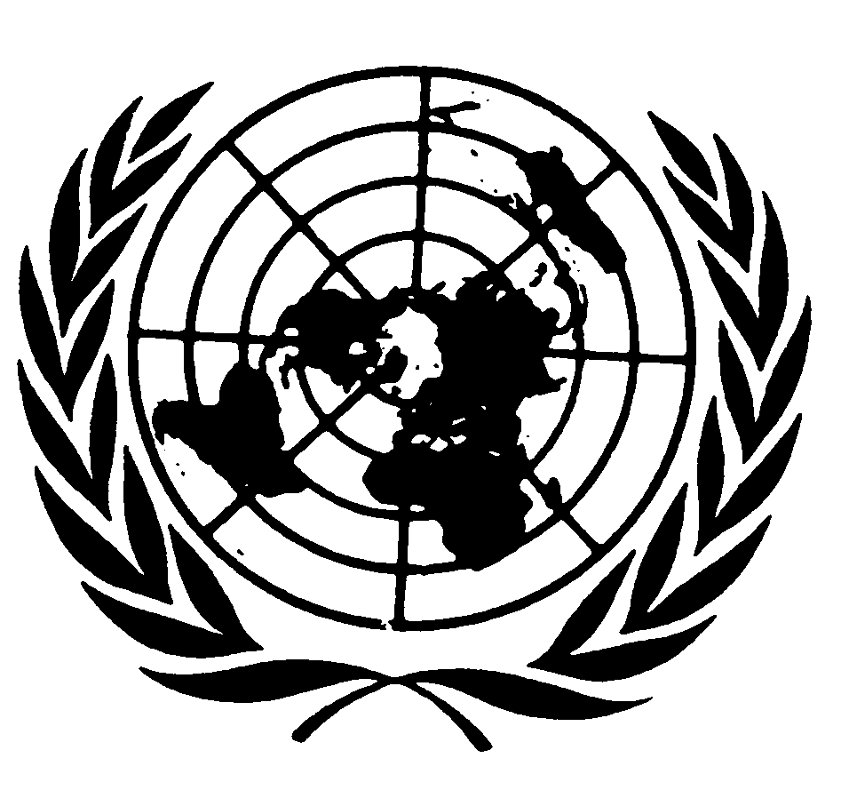

Statement by Ms. Rashida Manjoo,
Special Rapporteur on Violence against women, its causes and consequences

Commission on the Status of Women
Fifty-sixth session
27 February to 9 March 2012

29 February, 2012
New York



Chairperson,
Excellencies,
Distinguished Delegates, Colleagues and Friends,

It is an honour for me to contribute to the discussions of the Commission on the Status of Women (CSW) on this year’s priority theme, “the empowerment of rural women and their role in poverty eradication”, which is an issue of utmost importance when aiming to tackle and eliminate the structural causes of violence against women. Through my work and the work of my predecessors, this mandate has continuously highlighted the need for States to support the social, cultural, economic and political empowerment of women.

This year, the World Development Report by the World Bank focuses on Gender Equality and Development, and reflects, inter alia, the unequal access of women to economic opportunities. Today, women are more likely than men to work as unpaid family labourers or in the informal sector; women farmers tend to farm smaller plots and to focus on less profitable crops; and women entrepreneurs operate in smaller firms and in less profitable sectors. As a result, women everywhere tend to earn less than men.

The current economic and financial crisis poses additional challenges to the economic empowerment of women. Women’s concentration in export sectors such as manufacturing and high-value agriculture, the drop in remittances from migrant workers and the tightened conditions for microfinance lending to women farmers and entrepreneurs, also tend to adversely affect women’s incomes and livelihoods. As more people are driven to poverty in developing countries, the achievement of the MDGs, which aim to reduce poverty, hunger, infant and maternal mortality, and illiteracy, become seriously jeopardized. These worrisome signs are likely to result in serious setbacks to the realization of gender equality and the elimination of violence against women.

In the case of rural women, these risks are particularly high given the multiple forms of discrimination and inequality they face. Rural women often live in female-headed households, in chronic poverty, are subject to spiralling levels of violence, as well as impacted by a disproportionately high prevalence of HIV. Women agricultural producers already suffer the most negative effects of trade liberalization and changes in agricultural markets. Although they make up the majority of agricultural workers in many of the developing countries, due to lack of access to resources, secure tenure, credit, equipment, training and market know-how, poor rural women are further marginalized by trade liberalization that favours large-scale export cash crop production.

The ability of rural women to protect themselves from violence requires the realization of their socio-economic rights, particularly those regarding land, property and inheritance. Inequality and sex-based discrimination with regard to land ownership and its effective control, is the single most critical contributor to violations of the economic, social and cultural rights of women among the agrarian economies of most developing countries. It is crucial to understand that property is a livelihood sustaining asset that not only generates income, but also security for rural women. Owning land gives rural women economic rights and opportunities to avoid situations where they are vulnerable to violence. It also increases their bargaining power within the family and society at large.

Throughout my country missions, I have witnessed the limited access of rural women to productive resources such as land, and support services such as credit facilities. This is sometimes coupled by women’s lack of knowledge and/or understanding of the legal complexities that affect land matters, including how to register land, take ownership of land, and how to contest land rights. Efforts to implement affirmative action in allocating titled land to women can be limited by onerous requirements, including developing the land within short timelines and persistent discriminatory practices related to inheritance issues. Women’s access to credit also remains limited due to requirements by commercial banks of collaterals against loans - which rural women are usually unable to provide, due to not owning any land or property.

Furthermore, in many countries a woman’s access to property hinges on her relationship to a man. When she separates from her husband or when he dies, she risks losing her home, land, household goods and other property. Failure to ensure equal property rights upon separation or divorce discourages women from leaving violent marriages, as women may be forced to choose between violence at home and destitution in the street. Women’s difficulty in claiming their rights to property and land is often linked with other sex-discriminatory laws including male-biased marriage and divorce laws, inheritance laws, and biases within land dispute bodies which are usually made up of men and which exclude women from the decision-making process.

It is my hope that the Commission’s discussion during this session will allow for a better understanding of the legal and institutional obstacles that limit the access of rural women to their social and economic rights, particularly to land and property. The ultimate goal is not only to ensure that women’s participation in the rural economy fosters their own development, but also, that their increased financial contribution to their families and their communities, translates into greater power and influence in decision-making within the private sphere.

I would like now to take this opportunity to brief the Commission about the work that my mandate has carried out in the past year.

2011 Thematic Report

In 2011, I prepared a thematic report on multiple and intersecting forms of discrimination and violence against women. This report analyses the forms, causes and consequences of the multiple forms of discrimination suffered by women; highlights how these multiple and intersecting forms of discrimination have contributed to and exacerbated violence against women; and argues, that the intersections between gender-based discrimination and other forms of discrimination, and the consequences thereof, are too often overlooked.

My report questions the prevalent human rights discourse regarding violence, which regards real violence as public violence perpetrated by or at the behest of the state, and which often carries with it the elements of spectacle. This discourse has led to the marginalization and invisibility of violence perpetrated against women. I highlight how the more everyday ordinary violence that takes place within ostensibly private spaces, thought to be beyond the control and regulation of the State, does not receive enough attention.

Violence against women results from a complex interplay of individual, family, community and social factors – and, even though all women are at risk for violence in every society in the world, not all women are equally vulnerable to acts and structures of violence. I argue that a one-size-fits-all programmatic approach is insufficient for combating gender-based violence. Combating violence against women requires multiple approaches for its elimination. In adopting multiple approaches, preventing and combating violence must become localized, but also take into account differences within their community populations. In addition, multiple approaches require adequate human and material resources in order to assess and monitor how polices, laws and institutions impact violence and discrimination, including in the areas of redress and compensation to victims.

The report proposes a holistic approach which requires amongst others: 1) treating rights as universal, interdependent and indivisible; 2) situating violence on a continuum that spans interpersonal and structural violence; 3) accounting for both individual and structural discrimination, including structural and institutional inequalities; and 4) analyzing social and/or economic hierarchies among women, and, between women and men, i.e. both intra-gender and inter-gender.

Treating rights as universal, interdependent and indivisible

Everyone is entitled to have their human rights respected, protected and fulfilled regardless of their geographic location or social position, and this includes the right of women to be free from violence. Yet, understanding rights as universal should not preclude us from taking into consideration the specificities of violence against women and engaging at a local level to adequately recognize the diverse experiences of oppression faced by women. Human rights are also interdependent and indivisible. We should move beyond the erroneous focus that privileges civil and political rights and recognize how the denial of social, economic, and cultural rights restricts women from meaningfully exercising civil and political life.

Situating violence on a continuum that spans interpersonal and structural violence

A holistic approach to dealing with violence against women requires an understanding that such violence is situated along a continuum, both in terms of time and space. Some categorization of the different manifestations of violence against women might be useful in terms of the provision of services for victims, such as clinical, psychosocial or legal services. Yet, a holistic perspective sees all forms of abuse qualitatively impacting the economic, social, cultural and political well-being of women, of their communities and of the State. We must acknowledge that violence against women is not the root problem, but that violence occurs because other forms of discrimination are allowed to flourish.

Accounting for both individual and structural discrimination, including structural and institutional inequalities

The holistic approach also requires us to recognize the existence of structural and institutional inequalities related to discrimination. Whether based on race, ethnicity, national origin, ability, socio-economic class, sexual orientation, gender identity, religion, culture, tradition or other realities, discrimination often intensifies acts of violence against women. The acknowledgement of structural aspects and factors of discrimination is necessary for achieving non-discrimination and equality. Efforts to end all forms of violence against women must consider not only how individual lives are affected by the immediate impact of abuse, but how structures of discrimination and inequality perpetuate and exacerbate a victim’s experience. Interventions that seek to only ameliorate the abuse, and which do not factor in women’s realities, are not challenging the fundamental gender inequalities and discrimination that contribute to the abuse in the first place.

Analysing social and/or economic hierarchies among women, and, between women and men, i.e. both intra-gender and inter-gender

Adopting a holistic model with regards to gender-based violence requires an understanding of the ways in which inter- and intra-gender differences exist and the ways in which institutional and structural inequalities exacerbate violence through multiple and intersecting forms of discrimination. Discrimination affects women in different ways depending on how they are positioned within the social, economic and cultural hierarchies that prohibit or further compromise certain women’s ability to enjoy universal human rights. This approach also reveals critical aspects of intra-gender discrimination and inequality, which up until now have been invisible in efforts that treat all women homogenously in the responses to violence.

2012 Thematic Report

This year, my thematic report to the Human Rights Council will address the issue of gender-motivated killings of women – also known as femicide and/or feminicide. In the exercise of my mandate, I have observed that gender-motivated killings of women have taken disturbing proportions in the last few years. I, along with my predecessors have expressed particular concern at the extremely violent murders of women and girls, including in the context of country visits. I have also noted a worrisome failure of States to effectively comply with their due diligence obligations to prevent, investigate, punish and provide reparation for all acts of violence against women.

Report to the General Assembly

In October 2011, I presented my first written report to the General Assembly, which is an overview of the mandate’s work and main findings, and the challenges it continues to identify.

The report describes how the mandate has analysed violence against women in four main spheres: in the family; in the community; violence that is perpetrated or condoned by the State; and violence that occurs in the transnational sphere. It then analyses States’ obligations, under international human rights law, to prevent and respond to all acts of violence against women. States’ due diligence responsibility comprises an obligation to: 1) prevent acts of violence against women, 2) investigate and punish all acts of violence against women, 3) protect women against acts of violence, and 4) provide remedies including reparation to victims of violence against women.

I argue that States’ efforts to comply with their due diligence obligation must address the structural causes that lead to violence against women. In doing so, States should consider the multiple forms of violence suffered by women and the different types of discrimination they encounter, in order to adopt multifaceted strategies to effectively prevent and combat this violence. I conclude the report by presenting my proposal of a holistic approach to understanding and addressing discrimination and violence against women.

Country Visits

Concerning country visits, I will be submitting to the 20th session of the Human Rights Council in June 2012 the reports on my official visits to Jordan, Somalia and Italy. I would like to take this opportunity to thank the Governments of these countries for their full cooperation and look forward to a fruitful and continued dialogue on the implementation of my recommendations.

I have recently received a positive reply to conduct a visit to Papua New Guinea and the Solomon Islands in March this year. I also hope that my request to visit Croatia and Bosnia Herzegovina in the second semester of 2012 will be favourably considered. Earlier requests for country visits to the Governments of Uzbekistan, Turkmenistan, Zimbabwe, Nepal and Bangladesh, have to date remained unanswered. It is my hope that the Governments of these countries will soon engage with my mandate in order to advance the promotion and protection of women’s human rights.

Regional Consultations with Civil Society

In June 2011, I participated in consultations held in Brussels with European civil society organizations, including representatives of European observatories on violence against women.

Through these regional consultations, this mandate has kept abreast of regional and domestic trends pertaining to violence against women and has established direct contact with women’s rights organisations, academics and victims in different parts of the world. Such consultations also offer an opportunity to inform civil society on the work of special procedures and my mandate in particular, with a view to promoting and facilitating cooperation, including in relation to the communications procedure and country visits.

I continue valuing the exchanges during these consultations and hope that civil society organisations in all regions remain engaged and are supported in such important endeavours.

Conclusion

Ensuring the human rights of women remains a collective endeavour that requires joint action for effective implementation. The primary responsibility rests with States, in line with their obligations to protect, respect and fulfil all human rights for all, without discrimination. However, non-states actors and local activists can work together to promote a holistic response to identifying, preventing, and ultimately ending, all forms of violence against women. The UN and regional human rights treaties, declarations and mechanisms provide the institutional framework to facilitate such cooperation.

I remain fully committed to cooperate closely with the UN System and to assist States in their endeavours to make this a reality.

I thank you for your attention.

World Bank, World Development Report. Gender Equality and Development, Washington D.C., 2012, p. xxi
A/HRC/11/6. Political economy of women's human rights, report of the Special Rapporteur on violence against women, its causes and consequences, Yakin Ertürk, para. 26
A/HRC/11/6, para. 49
A/HRC/11, para. 49
A/HRC/11/6. para. 48
A/HRC/17/26/ Add.4. Mission to Zambia. Report of the Special Rapporteur on violence against women, its causes and consequences, Rashida Manjoo, para. 14
A/HRC/11/6. op. cit., para. 49
A/HRC/11/6. op. cit., para. 50
A/HRC/17/26
A/66/215

