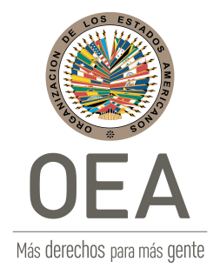
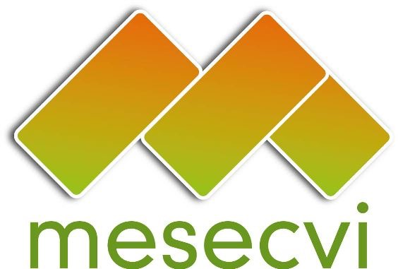
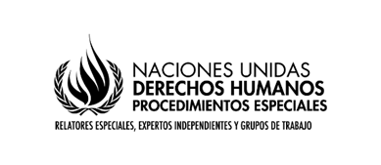

Experts from the OAS and the UN express their concern about the situation of the National Curriculum of Education and the alleged cases of corruption that would seek impunity in crimes against girls and adolescents in Peru

Washington DC (August 31st, 2018) - The President of the Committee of Experts of the Follow-up Mechanism of the Belém do Pará Convention (MESECVI), Sylvia Mesa; the United Nations Special Rapporteur on violence against women, its causes and consequences, Dubravka Šimonović; and the Chair of the United Nations Working Group on the issue of discrimination against women in law and in practice, Ivana Radačić, express their profound concern about the possible elimination of a gender focus from the National Education Curriculum, as well as the alleged cases of corruption that would seek impunity for crimes related to violence against girls and adolescents in Peru.

We have been informed that the implementation of the National Curriculum for Education, a document that seeks, inter alia, to educate with a gender focus from the initial levels of education, is in the process of being challenged and remains partially on hold since the First Civil Chamber of the Superior Court of Justice of Lima accepted a claim against it by a civil society group. This decision has been appealed and the case is now pending decision before the Supreme Court. On the other hand, the experts from the Inter-American system have also been informed that corruption cases allegedly involve representatives of the Peruvian judicial system seeking impunity including with regards to cases of crimes related to violence against girls and adolescents.

These issues merit greatest consideration, given that the partial or total elimination of the curricular guide would constitute a step backwards in the international obligations of the State in terms of eliminating violence against women and promoting human rights education and gender equality. In addition, if cases of corruption in the judicial system are confirmed, the vulnerability and risks faced by girls and women when accessing justice will be evident.

Sylvia Mesa, President of the Committee of Experts of the MESECVI, states that through the Third Hemispheric Report on the Implementation of the Belém do Pará Convention, "the Committee has indicated that the education system requires a set of rules to ensure that women and girls receive an education free of violence, gender stereotypes and without discrimination.” Therefore, educational entities must promote their safety by training teachers and students on gender equality and human rights. The Expert reminds us that Article 6 of the Belém do Pará Convention establishes that States Party must ensure that all women and girls are valued and educated free of stereotyped patterns of behavior and social and cultural practices based in concepts of inferiority or subordination.

Dubravka Šimonović, United Nations Special Rapporteur on violence against women, its causes and consequences, calls for “the full implementation of article 10 of the Convention on the Elimination of All Forms of Discrimination against Women (CEDAW), in order to eliminate the causes of gender-based violence and discrimination against women, and the CEDAW General Recommendation No. 36, which recognizes a transformative and empowering role of education in promoting human rights, gender equality and women’s empowerment.”

Ivana Radačić, Chair of the Working Group on the issue of discrimination against women in law and in practice, emphasized that “the Working Group encourages the authorities to contribute to strengthening the rights of women and girls in public policies, including educational policies, such as the curriculum. This will reaffirm the commitment of the State to promote a truly democratic and egalitarian society. The Working Group urges the authorities to reject any discriminatory measure and to prevent rollbacks in the struggle for women’s rights to equality.”

The State has to guarantee a non-sexist education free from gender stereotypes, as well as guaranteeing that all girls and adolescents are educated equally and without discrimination. In addition, the State must act with due diligence to investigate and punish all types of violence against women, ensure the reparation of victims and promote education and training of personnel in the administration of justice, police and other officials responsible for the implementation of the law, as well as all personnel involved in the implementation of policies for the prevention, punishment and elimination of violence against women.

In light of the above, the experts urge Peruvian authorities to take all necessary measures to ensure effective access of women and girls to justice and education, as established by international obligations and standards, especially those emanating from the Belém do Pará Convention and the CEDAW Convention, both international instruments subscribed and ratified by the Peruvian State. In particular, the State is urged to ensure that the application of the School Curriculum is implemented in accordance with current national regulations, laws and international standards. Consequently, we trust that the Supreme Court will rule in favor of maintaining the gender focus in public education policies.

Similarly, this group of experts urges the State to act with due diligence to investigate and punish all crimes that violate the right of all women and girls to live free from violence, strengthen access to justice and investigations to reduce the high degree of impunity and strengthen efforts to raise awareness and train all civil servants in the judicial system on integrating a gender perspective. The experts remain available to State’s authorities for any technical support they may require.

