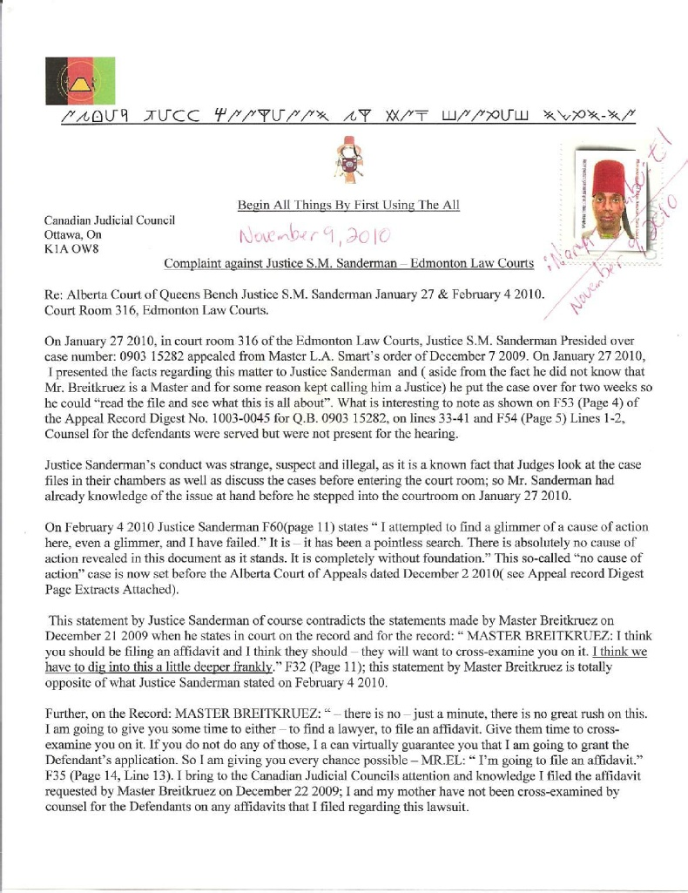
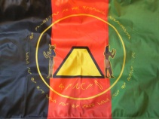 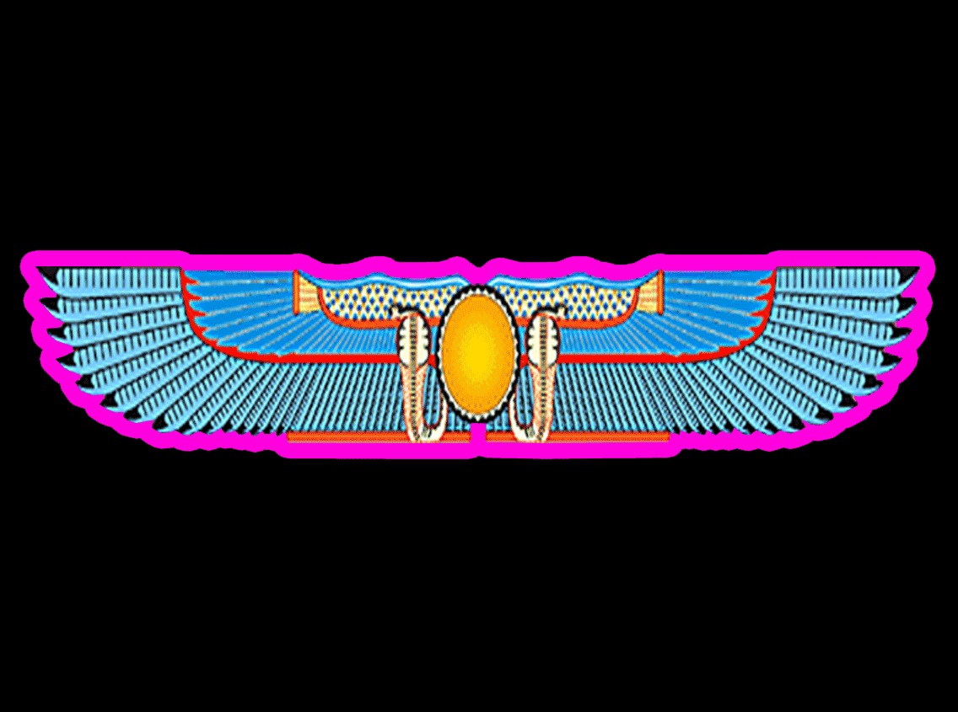 Begin All Things By First Using The All
:At-sik-hata :Nation of :Yamassee-Moors Submission to:
Women’s and girl’ sexual and reproductive health and rights in situations of crisis.

75 Year 4th Month 7th day Yamassic Calendar
[August 29, 2020 of the Gregorian Calendar]

Questionnaire

Concept/Definition of crisis
Definition

crisis (n.)
early 15c., crise, crisis, "decisive point in the progress of a disease," also "vitally important or decisive state of things, point at which change must come, for better or worse," from Latinized form of Greek krisis "turning point in a disease, that change which indicates recovery or death" (used as such by Hippocrates and Galen), literally "judgment, result of a trial, selection," from krinein "to separate, decide, judge," from PIE root *krei- "to sieve," thus "discriminate, distinguish." - https://www.etymonline.com/search?q=crisis .

Racial and Ethnic Categories and Definitions for NIH Diversity Programs

and for Other Reporting Purposes

https://www.nhlbi.nih.gov/grants-and-training/funding-opportunities-and-contacts/all-funding-opportunity-announcements/racial

Definitions for Racial and Ethnic Categories
The Revisions to OMB Directive 15 defines each racial and ethnic category as follows:
- American Indian or Alaska Native. A person having origins in any of the original peoples of North and South America (including Central America), and who maintains tribal affiliation or community attachment.
- Asian. A person having origins in any of the original peoples of the Far East, Southeast Asia, or the Indian subcontinent including, for example, Cambodia, China, India, Japan, Korea, Malaysia, Pakistan, the Philippine Islands, Thailand, and Vietnam.
- Black or African American. A person having origins in any of the black racial groups of Africa. Terms such as "Haitian" or "Negro" can be used in addition to "Black or African American."
- Hispanic or Latino. A person of Cuban, Mexican, Puerto Rican, South or Central American, or other Spanish culture or origin, regardless of race. The term, "Spanish origin," can be used in addition to "Hispanic or Latino."
- Native Hawaiian or Other Pacific Islander. A person having origins in any of the original peoples of Hawaii, Guam, Samoa, or other Pacific Islands.
- White. A person having origins in any of the original peoples of Europe, the Middle East, or North Africa.
The categories and definitions provide a common language to promote uniformity and comparability of data on race and ethnicity. Moreover, federal agencies have a continuing commitment to monitor the operation of its review and award processes to detect, and deal appropriately with, any instances of real or apparent inequities. All analyses conducted on race and ethnicity report aggregate statistical findings and do not identify individuals.
NIH collects racial and ethnic data on appointment forms, and using other formats (certification letters, training tables, etc.). See, e.g., Section G. 110, Application Process, Related Resources, Information Collection, https://grants.nih.gov/grants/collection-of-personal-demographic-data.htm. Declining to provide racial and ethnic information does not affect consideration of an application; however, NIH programs designed to enhance the participation of individuals who have been determined to be underrepresented in health-related sciences on a national basis (see data at http://www.nsf.gov/statistics/showpub.cfm?TopID=2&SubID=27, and the report Women, Minorities, and Persons with Disabilities in Science and Engineering) require such information.

https://grants.nih.gov/grants/guide/notice-files/not-od-15-089.html

NOTE: There are NO “Black Racial Groups of Africa.

Legal and Policy Framework by the United States of America and Canada:

United States Domestic Code(Title 18 USC sec 1091 – Genocide)/Provincial and Federal Legislation( Canada Code on Genocide), UNDRIP, Adrip, UN Charter, UN Convention on Economic, Social & Cultural Rights. Canada Charter of Rights and Freedoms, Congressional Record Page A3220.

Situations that would fit the concept of crisis example: subpar health care, genocide, violations of human rights( i.e. refusal to honor Indigenous Culture) .

Situations excluded: Black having no standing at law. Black is considered civilitus mortuus – dead in the eyes of the law. This applies to African-Americans/African-Canadians, etc.

Priorities are determined by Who has Standing at law and who has a high caste position.

No lessons learned. The same conduct against Indigenous Women still continues despite similar situations occurring. The United States of America & Canada have signed treaties with Indigenous Peoples and have not honored them and continue to dishonor those signed treaties.

The Main Challenges

a) WOMAN: There is no Definition of Woman(singular) in Black’s Law Dictionary( 1st Edition) and Bouvier’s Law Dictionary( 1856).

b) WOMEN: All the females of the human species. All such females who have arrived at the age of puberty. Black’s Law Dictionary( 1st Edition).

c) girl(n.), c.1300, gyrle”child, young person”(of either sex but most frequently of females), of unknown origin. One Guess[OED] leans toward an undrecorded Old English *gyrele, from Proto- Germaninc *gurwilon-, diminutive of *gurwjox(apparently also represented by Los German gaere “boy, girl,” Norwegian dialectial gorre, Swedish dialectal gurre “small child,” though the exact relationship, if any, between all these is obscure), from PIE * ghwrgh-, also found in Greek parthenous “virgin.” But this involves some objectionable philology. Liberman(2008) writes: Girl does not go back to any old English or Old Germanic form. It is part of a large group of ermanic words whose rose begins with a g or k and ends inr. The final consonant in girl is a diminutive suffix. The g-r words denote young animals, children, and all kinds of creatures considered immature, worthless, or past their prime.

d) There is no definition of girl in Black’s Law Dictionary 1st Edition.

e) There is no definition of girl in Bouvier’s Law Dictionary 1856.

f) CHILDREN. Offspring; progeny. Legitimate offspring; children born in wedlock. Black’s Law Dictionary( 1st Edition).

g) CHILD. This word has two meaning in law: (1) In the law of the domestic relations, and as to descent and distribution, ti is used strictly as the correlative of ‘parent,” and means a son or daughter considered as in relataion with the father or mother. (2) In the law of negligence, and in laws for the protection of children etc., it is used as the opposite of “adult” and means the young of the human species,( generally under the age of puberty,) without any reference to parentage and without distinction of sex. Black’s Law Dictionary( 1st Edition).

h) There is no Definition for BLACK in Black’s Law Dictionary 1 st Edition. i) There is no definition for BLACK in Bouvier’s Law Dictionary(1856)

The Problem that People of African Descent(MISNOMER: African-Americans) have and are refusing to acknowledge and admit is that BLACK HAS NO STANDING AT LAW. This is critically important as it relates to “Black” Women and “Black” girls and Indigenous Women and girls(So Tom Joyner interviews President Barack Obama on his ‘Tom Joyner Morning Show’ and greets him by saying “It’s our first ‘’BLACK’ president of the United States”...President Obama replies ‘Tom I don’t look at myself as the first ‘BLACK’ president because the word ‘BLACK’ has no standing at law. (https://www.facebook.com/PastAndPresentKingsandQueens/posts/167460326711167 https://www.google.ca/search?q=black+has+no+standing+a%20t+law&cad=h #1 OUT OF 55,900,00 on Google Search ; ). The United States OMB FORM SF-181 Form(https://www.opm.gov/forms/pdf_fill/sf181.pdf ) specifically states that Black/African-American “is a person belonging to any of the “Black Racial Groups of Africa”. There are NO “Black Racial Groups” of Africa and can be proven by anyone who is from Africa as they refer to themselves from a: Tribe, Clan or a Village; Furthermore, People from Africa will tell you they do NOT call/refer to themselves as “Black” in their language. The United States OMB FORM SF-181 Form(https://www.opm.gov/forms/pdf_fill/sf181.pdf ) states that “White” is” any person belonging to the Original Peoples of: Europe, the Middle East and North Africa”. This would mean that Black/African-American women and girls should be calling themselves White and NOT “Black”. As per the United Nations Council Resolution 29/22 “Convinced that the family, as the fundamental group of society and the natural environment for the growth and well-being of all its members and particularly children, should be afforded the necessary protection and assistance so that it can fully assume its responsibilities within the community, Reaffirming that the family is the natural and fundamental group unit of society and is entitled to protection by society and the State”. Those women and girls of “Black” and “African-American”( Afro-Caribbean, Afro-Latino, etc) Racial category(Designation) have no domestic nor International rights and protections. Those of “Black” and “African-American”( Afro-Caribbean, Afro-Latino, etc) Racial category(Designation) who have changed their Race and Ethnicity in compliance with Domestic and International Standards and claim their Indigenous Standing / Indigenous Heritage still face: Genocide, Apartheid, Discrimination, Forced Assimilation and Obstruction of their right for Self-Determination. The United Nations and the United Nations Human Rights Council has an obligation to promote “Solutions” as specified in Chapter IX Article 55 (b) of the United Nations Charter.( see: http://www.ohchr.org/Documents/Issues/Democracy/Forum2016/NationOfYamasseeMoors.pdf ) . The fact that Black/ African-American has no standing at law and therefore is not recognized in Law, reveals the truth that Black/ African-Americans are not entitled to Human Rights, Indigenous Rights or any other kind of rights. See Dred Scott Decision( Scott v. Sanford 1857 – NOTE: this case has never been overturned by the U.S. Supreme Court. https://supreme.justia.com/cases/federal/us/60/393/ ; The infamous, oft-quoted conclusion of the Supreme Court’s decision, written by Chief Justice Roger B. Taney, was that current or former slaves and their descendants had “no rights which the white man was bound to respect.” – This legal decision has become a ‘private’ global policy -).

Those in the legal community will point to 14th Amendment being the “solution” to this problem when in fact it is a placebo. The Reality of “Black” has NO STANDING at law is a Legal and International fact, deliberately covered by those in the Legal community. Those who are visually identified as “Black” are automatically discriminated against and their rights are violated. Women, children and adolescents of Indigenous and African Descent will be at the mercy and are at the mercy of the United States Corporation and they are not guaranteed protections under the law, under the United Nations Charter and under religion. See: Civilly dead; dead in the view of the law. The Condition of one who has lost his civil rights and capacities and is accounted dead in law. http://blacks.worldfreemansociety.org/1/C/c-0208.jpg ). Compounding this problem is when “Black” and “African-American”( Afro-Caribbean, Afro-Latino, etc), change their commercial status in accord with International Standards of Race and Ethnicity and claim their Indigenous Standing / Indigenous Heritage(http://nces.ed.gov/ipeds/Section/definitions ), they still face violations of their Indigenous and Human rights. http://www.ohchr.org/Documents/Issues/Democracy/Forum2016/NationOfYamasseeMoors.pdf . This is particularly important as “BLACK” has no standing at law meaning “BLACK” women and girls have no standing at law, they are not human and are not entitled to human rights.

The Actual and potential contribution of the Universal Periodic Review in tackling this issue is to tell “Black” women, “Black” girls and Indigenous Women and Indigenous girls that they are White and American Indian : White: A person having origins in any of the original peoples of Europe, the Middle East, or North Africa.” American Indian or Alaska Native – A person having origins in any of the peoples of North and South American(including Central America who maintains cultural identification through tribal affiliation or community attachment. - https://nces.ed.gov/ipeds/Section/definitions . Closing: the Original woman on the planet is from Africa( Ethiopia) this is an anthropological fact. “Black” women and girls are living in a commercial world where the definitions are not the same. Commercially “Black” women and girls are White and American Indian. The UNOCHR has an Obligation to tell “Black” women and girls that they are commercially White; failure to do so means the UNOCHR is not keeping in accord with the UN Charter see: Chapter IX Article 55(b). UNOCHR must promote the SF-181 as a viable solution for women and girls. - https://www.ohchr.org/Documents/Issues/Women/WRGS/Report/civilsociety/15.pdf

Challenges and good Practices

By: Sa Auset Tauwieret©TM [MISNOMER/CQT: Nicole Nicholas©TM]

During my pregnancy on Treaty 6 Territory corporately known as EDMONTON ALBERTA CANADA, I experienced GENOCIDE at the hands of 2 OB/GYN’s and attempted fratricide by Dr. Erin Bader OB/GYN on my White Indigenous daughter Sambinaa Ninti Baa Re®©TM D.B.A. Empress Khassiani Eil®©TM of Carib/Garafuna/ Panamanian/Aniyunwia descent who is a member of :At-sik-hata :Nation of Yamassee Moors.

Challenges and Good Practices:

At the beginning of my pregnancy I was referred to a Dr. Agnes Lee OB/GYN. Dr. Agnes Lee OB/GYN gave me a requisition form for an ultrasound. Dr. Agnes Lee OB/GYN was instructed to mark my race and ethnicity on the form was Native American/White. She did not mark White. I added White to the form when I presented the form at INSIGHT WEST END. The attendee who conducted the test at INSIGHT WEST END then changed my race simply to Black. That is GENOCIDE committed by the attendee because there is no such thing as a black racial group of Africa (see: https://nces.ed.gov/ipeds/report-your-data/race-ethnicity-definitions ). I faxed Dr. Agnes Lee OB/GYN the evidence of the genocide committed by INSIGHT WEST END. When I came to her office for my next prenatal appointment, she did not bring up the fax even though I had the confirmation that she received it. When I brought up the subject of the Genocide committed by INSIGHT WEST END she only admitted to receiving the fax and then said that I “was not a good fit/did not mesh well enough” to be her patient.
It was a challenge and not good practice for my doctor to condone altering my medical record and to not stand for me as her principle in this breach of contract by INSIGHT WEST END.

I followed up with INSIGHT WEST END on my own and was given remedy by the supervisor who took swift and immediate action to change my race and ethnicity to Native American/White as it was reported on the requisition (see: https://en.calameo.com/read/0050956393cac8621824c ).

I was then referred to Dr. Erin Bader OB/GYN. She did not offer any good practice during routine office visits in that she would stand with her back against the wall to be as far away from me sitting on the exam table as possible. Dr. Erin Bader OB/GYN often did not wipe away the gel from sonograms or even tell me she was finished and that I could pull my pants up/dress down; she simply walked out of the room and would leave the door to the room wide open and people passing by could see me half undressed! This diminished my dignity as a principle and a mother to be leaving me feeling vulnerable and my body violated.

It is published on the internet for all to see the similar lack of concern or care this Dr. Erin Bader OB/GYN inflicts on the public that I experienced. Unfortunately, other’s have had to experience the death of their child while being her principle.

Dr. Erin Bader
https://www.ratemds.com/doctor-ratings/3204069/Dr-Erin-Bader-Edmonton-AB.html

Dr. Lee
https://www.ratemds.com/doctor-ratings/42316/Dr-Agnes-Lee-Edmonton-AB.html

Experiences of Crisis:
I went to Dr. Erin Bader OB/GYN’s office multiple times without an appointment in a timely manner with crisis complaints of bleeding during the 18^{th-} 21st weeks of my pregnancy. On one occasion I brought the maxi pad to show the amount of blood I was passing as well as a clot that I passed in a sealed plastic sandwich bag. Dr. Erin Bader OB/GYN was aghast and petrified at what I thought was thorough necessary knowledge for her to determine the best course of action for a healthy pregnancy and delivery. Instead she told me upon seeing it for a flash of a second “I don’t need to see that!” This limited her ability to use her professional knowledge to assess my condition.

During the 23rd week of my pregnancy I was called to the Canada Border Services Agency for an admissions hearing. I was found ineligible and was given an Exclusion Order to leave Canada. I was traumatized by the CBSA officer Christopher Ward when he told me that the Exclusion Order was for me and that I would have to deliver my baby and leave my daughter in Canada 2 weeks later with my husband (see audio of CBSA hearing: https://soundcloud.com/user-937807397/fraud-immigration-hearing ). I left the CBSA office and went straight to Dr. Erin Bader OB/GYN’s office asking to see her so that she could intervene in this matter. I was certain she would be willing to help me regardless of her poor bedside manner given the extremities of what I was now facing. During prenatal check ups she continuously stated that I was a high risk pregnancy. I needed her to convey this to the CBSA authorities. The secretary made a note and said that Dr. Erin Bader OB/GYN would call me. Dr. Erin Bader OB/GYN called within 2 hours to tell me that she was not going to help me and that I was “fit for travel” if I had to leave Canada before giving birth- as if I was taking a vacation and not losing my life and livelihood by leaving my husband to be destitute in another country during my pregnancy! She was committed to not getting involved in my migratory status in anyway. She eluded support of CBSA’s decision even after I informed her of my Indigenous rights under the Treaty of Ghent to cross and re-cross the U.S./Canada border as I see fit. She was not concerned with my physical or mental well being with regards to the genocide and apartheid CBSA was attempting to commit on my family.

Exactly one week later from the time and day of the CBSA hearing I gave birth at 24 weeks and 5 days gestation. I had been diagnosed and treated the day before while in the hospital with a urinary tract infection. I had conveyed symptoms of UTI to Dr. Erin Bader OB/GYN frequently during prenatal checkups with Dr. Erin Bader OB/GYN, but she did not care to thoroughly investigate my complaints with any lab tests. The untreated urinary tract infection caused premature rupture of membranes, my water broke, and I delivered an extremely premature daughter who weighed 1.6 lbs. She required hospital stay in the NICU for 101 days.

Dr. Erin Bader OB/GYN delivered her and upon her exit from my body Dr. Erin Bader OB/GYN obviously felt guilty for her lack of professionalism and incompetent care because she apologized over and over saying “I don’t know what I was thinking. I’m sorry, I’m sorry.” I have this audio recorded but have not published it.

Dr. Erin Bader OB/GYN came to my hospital room for a post natal check up the following day. I took the measure of informing her again that I was White and Indigenous and that she was guilty of genocide. This conversation was recorded but unpublished. Dr. Erin Bader OB/GYN immediately drafted a hand written letter to whom it may concern stating that my breastmilk was essential to my daughter’s survival. The intent of her writing this letter was to do what I asked her to do a week prior to support me keeping my family together. The letter was a strong support measure that could be presented to CBSA so I would not be removed from Canada while my daughter was in the NICU at Royal Alexandra Hospital and/or essentially indefinitely as long as my daughter was breastfeeding.

The night my water broke I was writing to Ralph Goodale the Minister of Public Health and Safety about the genocide of Christopher Ward of CBSA, his fraudulent hearing and exclusion order (see: https://en.calameo.com/read/00509563933b5953d290d ). His response condoned the genocide of CBSA and further genocide of my family by stating I had no rights to status in Canada because I’d given birth to a child with Canadian status and he also tried to make me doubt the identity/character of my husband which is apartheid (see: https://en.calameo.com/read/005095639e5465538c9ed )

I filed a complaint with CBSA for their acts of genocide (see: https://en.calameo.com/read/005095639313b6abb1435 ) and received a response from a Nina Patel the A/Regional Director General of CBSA Prairie Region, who condoned the genocide actions of Christopher Ward of CBSA and also tried to make me doubt the identity/character of my husband which is apartheid (see: https://en.calameo.com/read/005095639675d213f63e0 ).
Preparedness, Recovery and Resilience:

Once a Carbonite [MISNOMER: Black/African American] self identifies as White/American Indian ALL assumptions to treat that individual as a black person with no standing at law or human rights must END. The SF-181 contract must be honored in all medical fields and in all commercial contracts on the planet. This calls for immediate and swift acceptance of the fact that Carbonites ARE WHITE and need to be treated with the highest level of care and concern in every facet of life across the planet.

- Background Information on Important Public Apologies
- HJR194 US Congress Apology to African Americans for Slavery (4 pgs.) https://www.govinfo.gov/content/pkg/BILLS-110hres194eh/pdf/BILLS-110hres194eh.pdf

U.S. Senate Apology to African Americans for Slavery: https://www.congress.gov/111/bills/sconres26/BILLS-111sconres26es.pdf

US Congress Apology to Native Americans and American Indians –
(Sec. 8113) States that the United States, acting through Congress: (1) recognizes that there have been years of official depredations, ill-conceived policies, and the breaking of covenants by the federal government regarding Indian tribes; (2) apologizes on behalf of the people of the United States to all Native Peoples for the many instances of violence, maltreatment, and neglect inflicted upon them by U.S. citizens; (3) urges the President to acknowledge such wrongs; and (4) commends state governments that have begun reconciliation efforts and encourages all state governments to work toward reconciling their relationships with Indian tribes within their boundaries. States that nothing in this section authorizes or supports any claim, or serves as a settlement of a claim, against the United States.
https://www.congress.gov/bill/111th-congress/house-bill/3326

- Motu Proprio of Pope Francis I July 11, 2013 https://w2.vatican.va/content/francesco/en/motu_proprio/documents/papa-francesco-motu-proprio_20130711_organi-giudiziari.html

- Pope Francis Apologizes to Indigenous Peoples for ‘Grave Sins’ of Colonialism (2 pgs.) https://newsmaven.io/indiancountrytoday/archive/pope-francis-apologizes-to-indigenous-peoples-for-grave-sins-of-colonialism-tlGAXDXgwkCkvmn10DjT3Q/

- Apologies and Motivation
Active Lien on the Whitehouse, The Vatican and the Pentagon see: http://naturalcredit.tripod.com and http://kemit19.googlepages.com/knowledgetothevatican - knowledge given to Pope Benedict XVI on the existence of Atlan, Amexem, Turtle Island , Land of the Frogs and the Non-Existence of the United States of America, Canada and Mexico.
- Apologies and the Law
Active Lien on the Whitehouse, The Vatican and the Pentagon see: http://naturalcredit.tripod.com and http://kemit19.googlepages.com/knowledgetothevatican - knowledge given to Pope Benedict XVI on the existence of Atlan, Amexem, Turtle Island , Land of the Frogs and the Non-Existence of the United States of America, Canada and Mexico.
Apologies and AccountabilityCommercial Liability
Active Lien on the Whitehouse, The Vatican and the Pentagon see: http://naturalcredit.tripod.com and http://kemit19.googlepages.com/knowledgetothevatican - knowledge given to Pope Benedict XVI on the existence of Atlan, Amexem, Turtle Island , Land of the Frogs and the Non-Existence of the United States of America, Canada and Mexico.
- Apologies and Responsibility
Yes, Yes, Yes, Yes –
- HJR194 US Congress Apology to African Americans for Slavery (4 pgs.) https://www.govinfo.gov/content/pkg/BILLS-110hres194eh/pdf/BILLS-110hres194eh.pdf

U.S. Senate Apology to African Americans for Slavery: https://www.congress.gov/111/bills/sconres26/BILLS-111sconres26es.pdf

US Congress Apology to Native Americans and American Indians –
(Sec. 8113) States that the United States, acting through Congress: (1) recognizes that there have been years of official depredations, ill-conceived policies, and the breaking of covenants by the federal government regarding Indian tribes; (2) apologizes on behalf of the people of the United States to all Native Peoples for the many instances of violence, maltreatment, and neglect inflicted upon them by U.S. citizens; (3) urges the President to acknowledge such wrongs; and (4) commends state governments that have begun reconciliation efforts and encourages all state governments to work toward reconciling their relationships with Indian tribes within their boundaries. States that nothing in this section authorizes or supports any claim, or serves as a settlement of a claim, against the United States.
https://www.congress.gov/bill/111th-congress/house-bill/3326

- Motu Proprio of Pope Francis I July 11, 2013 https://w2.vatican.va/content/francesco/en/motu_proprio/documents/papa-francesco-motu-proprio_20130711_organi-giudiziari.html

- Pope Francis Apologizes to Indigenous Peoples for ‘Grave Sins’ of Colonialism (2 pgs.) https://newsmaven.io/indiancountrytoday/archive/pope-francis-apologizes-to-indigenous-peoples-for-grave-sins-of-colonialism-tlGAXDXgwkCkvmn10DjT3Q/

Apologies and Truth
In the United States no truth recovery, historical acknowledgement, No.
- Apologies and Reparations
Yes, in the United States - US Congress Apology to Native Americans and American Indians –
(Sec. 8113) States that the United States, acting through Congress: (1) recognizes that there have been years of official depredations, ill-conceived policies, and the breaking of covenants by the federal government regarding Indian tribes; (2) apologizes on behalf of the people of the United States to all Native Peoples for the many instances of violence, maltreatment, and neglect inflicted upon them by U.S. citizens; (3) urges the President to acknowledge such wrongs; and (4) commends state governments that have begun reconciliation efforts and encourages all state governments to work toward reconciling their relationships with Indian tribes within their boundaries. States that nothing in this section authorizes or supports any claim, or serves as a settlement of a claim, against the United States.
https://www.congress.gov/bill/111th-congress/house-bill/3326 .
; No in Canada - On Wednesday June 11, 2008, the Prime Minister of Canada, the Right Honourable Stephen Harper, made a Statement of Apology to former students of Indian Residential Schools, on behalf of the Government of Canada. https://www.aadnc-aandc.gc.ca/eng/1100100015644/1100100015649 .

- Apologies and Timing
- HJR194 US Congress Apology to African Americans for Slavery (4 pgs.) https://www.govinfo.gov/content/pkg/BILLS-110hres194eh/pdf/BILLS-110hres194eh.pdf

U.S. Senate Apology to African Americans for Slavery: https://www.congress.gov/111/bills/sconres26/BILLS-111sconres26es.pdf

US Congress Apology to Native Americans and American Indians –
(Sec. 8113) States that the United States, acting through Congress: (1) recognizes that there have been years of official depredations, ill-conceived policies, and the breaking of covenants by the federal government regarding Indian tribes; (2) apologizes on behalf of the people of the United States to all Native Peoples for the many instances of violence, maltreatment, and neglect inflicted upon them by U.S. citizens; (3) urges the President to acknowledge such wrongs; and (4) commends state governments that have begun reconciliation efforts and encourages all state governments to work toward reconciling their relationships with Indian tribes within their boundaries. States that nothing in this section authorizes or supports any claim, or serves as a settlement of a claim, against the United States.
https://www.congress.gov/bill/111th-congress/house-bill/3326

- Motu Proprio of Pope Francis I July 11, 2013 https://w2.vatican.va/content/francesco/en/motu_proprio/documents/papa-francesco-motu-proprio_20130711_organi-giudiziari.html

- Pope Francis Apologizes to Indigenous Peoples for ‘Grave Sins’ of Colonialism (2 pgs.) https://newsmaven.io/indiancountrytoday/archive/pope-francis-apologizes-to-indigenous-peoples-for-grave-sins-of-colonialism-tlGAXDXgwkCkvmn10DjT3Q/

Yes, in the United States - US Congress Apology to Native Americans and American Indians –
(Sec. 8113) States that the United States, acting through Congress: (1) recognizes that there have been years of official depredations, ill-conceived policies, and the breaking of covenants by the federal government regarding Indian tribes; (2) apologizes on behalf of the people of the United States to all Native Peoples for the many instances of violence, maltreatment, and neglect inflicted upon them by U.S. citizens; (3) urges the President to acknowledge such wrongs; and (4) commends state governments that have begun reconciliation efforts and encourages all state governments to work toward reconciling their relationships with Indian tribes within their boundaries. States that nothing in this section authorizes or supports any claim, or serves as a settlement of a claim, against the United States.
https://www.congress.gov/bill/111th-congress/house-bill/3326 .
; No in Canada - On Wednesday June 11, 2008, the Prime Minister of Canada, the Right Honourable Stephen Harper, made a Statement of Apology to former students of Indian Residential Schools, on behalf of the Government of Canada. https://www.aadnc-aandc.gc.ca/eng/1100100015644/1100100015649 .

- Apologies, Preparation and Choreography
Government, Grassroots pressure and Indigenous Peoples effort for more than 20 years.
- Apologies and the Involvement of Victims
- Unknown. No role the church played domestically except by leave/authority of THE VATICAN/ THE CATHOLIC CHURCH. . Motu Proprio of Pope Francis I July 11, 2013 https://w2.vatican.va/content/francesco/en/motu_proprio/documents/papa-francesco-motu-proprio_20130711_organi-giudiziari.html

- Pope Francis Apologizes to Indigenous Peoples for ‘Grave Sins’ of Colonialism (2 pgs.) https://newsmaven.io/indiancountrytoday/archive/pope-francis-apologizes-to-indigenous-peoples-for-grave-sins-of-colonialism-tlGAXDXgwkCkvmn10DjT3Q/
Victims accepted apology actions of the government and the Church/THE VATICAN.
- Apologies, Leadership and the Management of Organisation or Constituency
Government representing the United States, Canada & THE VATICAN et. Al. Press release. Public pressure to accept( eg. Canada , United States, New Zeland, Australia Apology to Indigenous people the world over for rejecting the UNDRIP – UN Declaration on the Rights of Indigenous Peoples.
- Apologies and Audience
The apologies addressed Indigenous Peoples and peoples of African Descent( who are in fact Indigenous being the original peoples on the Planet, but have not asserted their Autochthonousness).
- Apologies and Legitimacy
Active Lien on the Whitehouse, The Vatican and the Pentagon see: http://naturalcredit.tripod.com and http://kemit19.googlepages.com/knowledgetothevatican - knowledge given to Pope Benedict XVI on the existence of Atlan, Amexem, Turtle Island , Land of the Frogs and the Non-Existence of the United States of America, Canada and Mexico.
- Apologies, Reconciliation and Follow-through
On the books publicly , but the actions have stayed the same prior to the apology. The apologies are in conflict with Civil Law.
- Apologies and Gender
No.
- Apologies and Non-recurrence
Subtle effect.
- apologies and local context

Challenges

This to the fraud and genocide that was done in whole by the Cumberland County Vital Statistics office inside of Cape Fear Valley Medical Center in Fayetteville, NC, US. This falls under the questionnaire’s section: “Challenges and good practices
- Please highlight any challenges faced in the provision of SRH services and good practices in ensuring women’s and girls’ SRHR in situations of crisis, including, for example, measures concerning timely access to the following types of services and aspects of care:
- Other pertinent information that may affect the availability accessibility, affordability, acceptability and quality of SRH services and information.”

Facts of Complaint
- My son was born March 28th, 2020 at the Cape Fear Valley Medical Center
- A signature was not obtained by me prior to submission of the verification of facts sent to the Raleigh office of Vital Statistics, the Register of Deeds office, and Cumberland County Public Health office. According to the NC GS Article 4 § 130A-101. Birth registration:
(a) A certificate of birth for each live birth, regardless of the gestation period, which occurs in this State shall be filed with the local registrar of the county in which the birth occurs within 10 days after the birth and shall be registered by the registrar if it has been completed and filed in accordance with this Article and the rules.
(b) When a birth occurs in a hospital or other medical facility, the person in charge of the facility shall obtain the personal data, prepare the certificate, secure the signatures required by the certificate and file it with the local registrar within 10 days after the birth. The physician or other person in attendance shall provide the medical information required by the certificate.
- I was told that the data collected for the Verification of Facts was from the Cape Fear Valley Medical Center health record. The race on the Verification of Facts does not match the race documented in the health record at Cape Fear Valley Medical Center.( https://soundcloud.com/astarte-amani-fewashi-care-of-grace-kelson/tina-rodgers-nc-vital https://soundcloud.com/astarte-amani-fewashi-care-of-grace-kelson/vof-ready-for-pick-up-ashla https://soundcloud.com/astarte-amani-fewashi-care-of-grace-kelson/in-person-picked-up ) .
- Since the first visit to Cape Fear Valley Medical Center on 08/31/2019, my race has been documented as White and American Indian.
- On January 9th, 2020, I received confirmation of the faxed copy of my SF181 packet and Certificate of Achievement from UN recognized :Chief and Plenipotentiary of :Turtle Island, Atlan, Amexem, Muu-lan, Hexian :Chief:Nanya-Shaabu:Eil:®©TM :At-sik-hata :Nation of :Yamassee-Moors to the Cape Fear Valley Medical Center Medical Records Division. (https://www.calameo.com/read/0059016383f82f1242bcf) .
- The screenshot of my demographics under the profile page in MyChart dated “Mar 31” reads, “American Indian or Alaskan Native, White”. This was obtained from the Cape Fear Valley Medical Center’s MyChart medical record system on March 31, 2020, prior to the submission of the Verification of Facts by the local Vital Statistics office (https://www.calameo.com/read/00590163824d54d27b530) .
- On 4/17/2020 I was advised that a signature on the Verification of Facts was required to obtain a copy of the Verification of Facts (https://soundcloud.com/astarte-amani-fewashi-care-of-grace-kelson/in-person-cape-fear-valley) and “mother refused to sign, 4/17/20 (initials)” was placed at bottom of the Verification of Facts ( https://www.calameo.com/read/00590163824d54d27b530) .
- On June 5th, 2020, I picked up a copy of the Verification of Facts, in which I was listed as: “Black or African American”. At this time the clerk advised me, “This is what was in the chart”. (https://soundcloud.com/astarte-amani-fewashi-care-of-grace-kelson/in-person-picked-up) .

Evidence of complaint

Publishing: https://www.calameo.com/read/00590163824d54d27b530 .
Audios:
Recordings Regarding Claim against Cumberland County Vital Statistics

Registration with Princess L&D 3/7/20
I question what race is listed in Cape Fear Valley's health system @3:47 answer was given @4:57 (White & American Indian)
https://soundcloud.com/astarte-amani-fewashi-care-of-grace-kelson/registration-with-princess-l-d .

Incoming Call: Vital Statistics @Cape Fear Valley with Sherri Sphinx 4/10/20.m4a
@3:00-"copy not available to you" (verification of facts)
https://soundcloud.com/astarte-amani-fewashi-care-of-grace-kelson/incoming-call-vital-statistics .

Callback: Sherri with Cape Fear Valley Vital Statistics ''able to pick up VOF''4/10/20
"@00:15-"able to print out.....have to sign for it"
https://soundcloud.com/astarte-amani-fewashi-care-of-grace-kelson/callback-sherri-with-cape-fear .

In Person: Cape Fear Valley Vital Statistics with Ashla 4/17/20
@3:35- "have to sign it(verification of facts) in order to get a copy
@4:20- "we're not a releasing agency"
@5:09- "not a releasable document
https://soundcloud.com/astarte-amani-fewashi-care-of-grace-kelson/in-person-cape-fear-valley .

Phone Call: Register of Deeds with Lauren 4/27/20
@1:57- "it’s (birth certificate) here"
https://soundcloud.com/astarte-amani-fewashi-care-of-grace-kelson/phone-call-register-of-deeds .

Vital Statistics Raleigh office-hung up on me
https://soundcloud.com/astarte-amani-fewashi-care-of-grace-kelson/vital-statistics-raleigh .

Health Department with Latoya 1 of 2 4/27/20@02:25"Cape Fear, before they sent that certificate off they're supposed to verify that information with the mother"
@06:50 "ok so I do have it"
@10:10 question of race by me
@10:35"doesn't give a race" (for baby)
@11:07 " yes, it has the mother's race as being black/African American
@11:13 "now it wouldn't show anything for the baby" (regarding race)
@11:35 "got a lot of unknown, I never seen one like this one"
https://soundcloud.com/astarte-amani-fewashi-care-of-grace-kelson/health-department-with-latoya .

Health department Latoya 2of2 4/27/20
@01:33 "What the hospital has you listed as"
@01:47 "came out of your record from Cape Fear" (information for verification of facts)
https://soundcloud.com/astarte-amani-fewashi-care-of-grace-kelson/health-department-latoya-2of2 .

Phone Call: Tina Rodgers NC Vital Statistics 6/2/20.
@00:48 "in the hospital system" (when asked where mother's demographic information is obtained)
@01:05 "yes" (to if the office is subject to NC General Statutes - Chapter 130A Article 4)
@03:08 "They should have sent you the verification of facts and a certified letter"
@04:04"No you don't, No, I wouldn't sign that"
@05:54 "you are to get a copy, but you are not to sign it, because you didn't sign it when the birth occurred"
@06:26 "you can't sign that paper"
https://soundcloud.com/astarte-amani-fewashi-care-of-grace-kelson/tina-rodgers-nc-vital .

Phone Call: Verification Of Facts ready for pick up. (Ashla)6/5/2020
@00:49 Question of where information obtained from
@00:59 "correct"
https://soundcloud.com/astarte-amani-fewashi-care-of-grace-kelson/vof-ready-for-pick-up-ashla

In Person: Picked up Verification of Facets from Cape Fear Valley Vital Statistics 6/5/20.m4a
@10:32-"This is what was in the chart"
https://soundcloud.com/astarte-amani-fewashi-care-of-grace-kelson/in-person-picked-up .

Resources Regarding the effects of being labeled as “black/African American”:

The Black-White disparity in pregnancy-related mortality from 5 conditions: differences in prevalence and case-fatality rates
https://pubmed.ncbi.nlm.nih.gov/17194867/.

CDC- Pregnancy Mortality Surveillance System
https://www.cdc.gov/reproductivehealth/maternal-mortality/pregnancy-mortality-surveillance-system.htm?CDC_AA_refVal=https%3A%2F%2Fwww.cdc.gov%2Freproductivehealth%2Fmaternalinfanthealth%2Fpregnancy-mortality-surveillance-system.html.

Black Mothers Keep Dying After Giving Birth. Shalon Irving's Story Explains Why
https://www.npr.org/2017/12/07/568948782/black-mothers-keep-dying-after-giving-birth-shalon-irvings-story-explains-why.

- My son was born March 28th, 2020 at the Cape Fear Valley Medical Center
- The Newborn Metabolic Screening was performed on March 30, 2020
- I, his mother, marked “White” on the Newborn Screening form on March 30, 2020 (https://www.calameo.com/read/005901638e8961fadda92). This form was not yet filled out, just a patient label attached with his blood sample.
- I spoke with the clerk outside of the labor and delivery unit, Angel. She changed Anuyi (ALMIGHTY)’s race from other to “White and “American Indian” in his medical record via the electronic health record on March 30, 2020. (https://soundcloud.com/astarte-amani-fewashi-care-of-grace-kelson/change-anuyi-race-and-link-to#t=20:00)
- On March 31st, I checked the “MyChart” application to confirm the correct listing of his race and ethnicity. The demographics read correct, “White and “American Indian”. (https://www.calameo.com/read/005901638e8961fadda92).
- On April 6th, a blood draw was performed at Cape Fear Valley Lab Services on Anuyi and during registration his race was listed as “White and “American Indian”. Both facilities uses the same electronic health record system. (https://soundcloud.com/astarte-amani-fewashi-care-of-grace-kelson/cfv-lab-race-check-854-answer#t=08:54)
- On April 9, 2020 a report was ready for the Newborn Metabolic Screening. This report listed Anuyi (ALMIGHTY/BABY BOY GRACE KELSON) as “Black, Unknown, and White”. His race was never discussed prior to submission of his bloodwork for the Newborn Metabolic Screening. (https://www.calameo.com/read/005901638e8961fadda92)

Black newborn babies in the United States are more likely to survive childbirth if they are cared for by Black doctors, but three
times more likely to die when looked after by White doctors, a study has found.
The mortality rate of Black newborns shrunk by between 39% and 58% when Black physicians took charge of the birth,
according to the research, which laid bare how shocking racial disparities in human health can affect even the first hours of a person's life. - https://www.cnn.com/2020/08/18/health/black-babies-mortality-rate-doctors-study-wellness-scli-intl/index.html

Civil Law. In the modern Western world, it is one of the two major legal systems; the other is common law. Taken from Roman law, it is used in continental Europe, their former colonies, Isle of Man, Latin America, Scotland, state of Louisiana in the US federation, and in Canada’s Quebec province. In this system, the law is a highly structured and rigid code of rules observed to the letter. An expert judge decides cases without the help of jury and without any reference to precedent. In this system, every defendant in a criminal trial is presumed guilty until proven innocent. Under common law, practiced in most English-speaking countries, a person is presumed innocent until proven guilty. 2. As Private law that contrasts to administrative law, criminal law, ecclesiastical law, and military law, and deals with relationships among individuals. -- https://thelawdictionary.org/civil-law/ .
So based on the definitions above and as they relate to the “ ‘harmonisation’ with ordinary justice system”, the current courts systems in the developed world cannot and will not achieve this. The intention of ‘harmonising’ the Indigenous justice systems( which are in line with nature) with the current court systems( which are in fact Judex NOT lex) cannot and will not happen, this is totally impossible as the present system regards a party as artificial and a corporation which is a non-physical entity and guilty(Civil law) first and must prove innocence; yet the courts continually commit genocide, fraud and Racketeering by telling the public they are innocent first until proven guilty. Natural law, Indigenous law, Common law are physical/spiritual/material are in direct conflict and controversy with these corporations, statutes, rules & codes( artificial and corporate rules not based nor applied on fact, science, evidence or reason) because it is in the interest of Jurisprudence(judge/jurist) to rule in favor of the community. It has been established that the community is make up of artificial entities, corporations etc., this proves that the public is viewed as dead, chatterl property of the state and therefore has no rights; the public is given the illusion that they have rights. Indigenous Peoples deal with ancestors, souls, spirits, nature for correcting wrongs and damage; this current civil court system does not deal with equity, fairness nor what is “right” the civil court system by its own admission is a discriminatory system.

Hotep, Kar Pa Rawuh $il Ra$unaat-na
Peace, With The Soul of :Our :Ancestors, Now.

UCC 1-308 All Indigenous Rights Reserved. UNDRIP.
Constitution of the :At-sik-hata :Nation of :Yamassee-Moors
:maku:nubu-~yunaat:Sagr^{®©TM}
:Chief:Nanya-Shaabu:Eil:®©TM 53 34 00 N. Lat; 113 31 00 W. Long
:At-sik-hata :Nation of :Yamassee-Moors – http://sites.google.com/site/atsikhatanationy

Amiskwaciwâskahikan, Turtle Island / :Atlan, Muu-Lan – http://sites.google.com/site/authenticexport/atsikhata-1
[GD STN MAIN , EDMONTON, AB T5J 2G8]
Phone: 1-587-712-0639 Email: truenative9@yahoo.com , kemit19@gmail.com, atsikhataym@gmail.com , www.twitter.com/kham19 , www.facebook.com/Nanya.Shaabu.Eil ,
UN ICERD REPORT: http://tbinternet.ohchr.org/Treaties/CERD/Shared%20Documents/USA/INT_CERD_NGO_USA_17721_E.pdf

