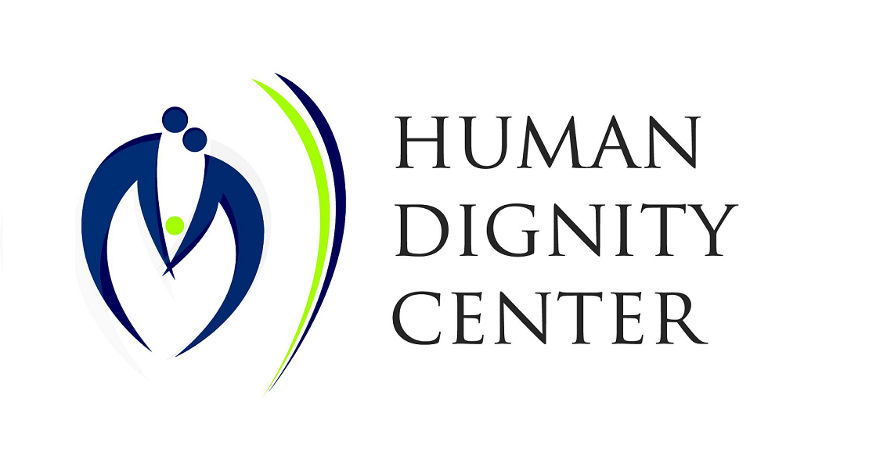
Women’s and girls’ sexual and reproductive health and rights in situations of crisis
Submitted by Human Dignity Center, Hungary

Definition of crisis

The legal definition of crisis or crisis situation in the Hungarian legislative system is unclear when it comes to SRHR. It involves physical and mental “tremble”.

Our work with women in crisis is based on Kaplan's crisis theory: the individual (or the system) arrives at a turning point (crisis) where the problem cannot be solved with the already known mechanisms and a new solution is needed. This approach is succesful in real life situations when crisis intervention is necessary.
All women who are considering abortion are in crisis. They find themselves in a situation where the already known mechanisms do not solve the current problems of their lives. Whether these problems come from the outer world (environmental, financial crisis or a pandemic) or from their inner world (relationship with the father of the child or her own parents, etc) the problems seem too large to be solved in a short period of time with the already available solutions. Some of them also realize that their situation in life cannot be put on the scale with the life of another human being, that is, their developing baby. In these crisis situations they need proper support from their families and friends, or the state, if necessary.

Institutional mechanisms

The Hungarian family support system has a wide range of solutions. To begin with, when a couple becomes a family, that is, when a man and a woman are in a situation of becoming parents, they might already face a crisis. For women or families who conceived a baby, there is already a strong support system: from the beginning of pregnany they can receive financial aid, counselling by the Family Protection Services (Családvédelmi Szolgálat), mother's or family shelters, visiting nurses, protected shelters and “halfway houses” that help violence-victims to become full members of the society again. On local level the municipalities also provide financial help, shelters of housing, depending on the need and availability.

When (or if) the child is born, they are also protected be the child welfare system. After birth special, local mother and child health nurses visit families to help and support new mothers and their families. These local nurses have responsibilities for the children's health and well-being until the age of 6, when school nurses take over this role.
Hungary provides counselling for women in crisis pregnancy on national level. This kind of support is essential for women who are most of the time left alone with a situation that they cannot face alone: they receive mental support and tailored solutions for their own lives. The special nurses who counsel them give information on SRHR services, mothers' shelters, adoptions, financial aid and all the local and national support they can use to solve the crisis. This system was introduced after the fall of the Communist regime in Hungary. However, the “culture of abortion” that was introduced to the country by the Communists, is still visible in the present. It is high time to change the old-fashioned Marxist attitude that considers the fetus a “burden” or an enemy against whom women and girls must “protect” themselves.

Challenges

Representetives from all worldviews expect non-biased and scientifically accurate information about sexual and reproductive health matters and services. However, in the current Hungarian healthcare system pregnant women are not provided with full information on what is happening in their bodies. At the moment of declaring the existence of a pregnancy, the doctor is required to detect the pulsing / heartbeat of the baby. This information is not shared with the woman automatically, therefore she is not given the proper information about reality. This is a huge challenge that needs to be addressed.
Couples experiencing difficulties conceiving naturally have less possibility to reach existing restorative treatment approaches (for example NaProTechnology or FEMM Health protocols), as these are not available and supported at the same level as artificial reproductive technologies (for example insemination or in vitro fertilization).
Women who suffer from post-partum depression or PTSD after an abortion are not given state-financed support to heal the mental scars. Professional counselling for them is difficult to find countrywide.
Women need publicly available information on doctors who do or do not perform abortions to be able to choose the right assistance for delivering their babies. There is no hospital in Hungary where women giving birth could openly and free of charge choose a doctor who does not perfom abortions. These women have no choice in the current system.

Good practices on the field of prevention and counselling

Hungary is on the way to strengthen prevention of teen pregnancies among youth: hopefully in the near future proper family life education is going to take place in schools with trained educators. Currently health visitors, school nurses or social workers are invited to the schools to fulfill this educational task. It is much needed to reduce the number of teen-pregnancies that can lead to further individual crisis.
Women in crisis pregnancy are provided counselling by special nurses (Family Protection Services) free of charge. This state-financed service with a specially developed methodology is provided by nurses who completed an accredited training to give mental support to women and couples.

Supporting states in their efforts to address a crisis

Women who choose to deliver their babies as teens and drop out from school due to their maternal obligations have difficulties later when they wish to enter (or re-enter) the labour market. The possibilities of home office or any work to be done from home as well as part-time jobs need further development in Hungary. Such steps would help women overcome the crisis caused by not finishing their schools and be more independent from outer circumstances. Developing part-time working conditions and home-office is necessary not only during the Covid-19 pandemic, but afterwards as well.

We are all members of the human family from our conception until we die. This shall be respected by all states, all laws and all communities. There should be no discrimination regarding age (developmental stage) or location (inside or outside the mother's womb) when human rights, especially the right to life are in question.

Submitted by:

Edit Frivaldszky
Human Dignity Center
Hungary

