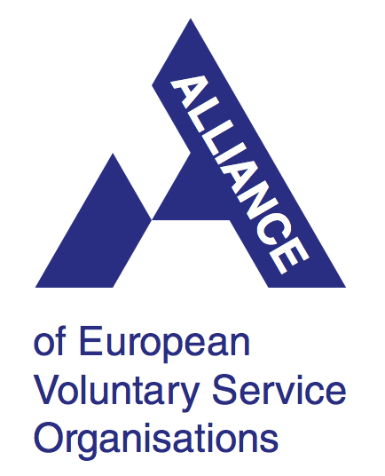
How human rights and youth come together in the International Voluntary Service (IVS)
ALLIANCE input to the OHCHR study
on youth and human rights

The Alliance of European Voluntary Service Organisations is part of an international movement, the IVS movement. As Alliance we currently have 50 members (independent national organisations) from 28 countries, working in the field of International Voluntary Service and organizing in particular so called International Workcamps, a non-formal and informal learning tool to address several difficulties society and especially youth are facing. Many of our members also run Medium and Long Term Voluntary Service projects (M/LTV) such as the European Voluntary Service, Weltwärts in Germany and other national and international programmes. Every year, our member organisations make it possible for 13000 young people to live an international volunteering experience with peers from all over the world, for the benefit of over 1200 local communities hosting the groups of volunteers.

International group Workcamps are a unique space for young people (the volunteers) to learn how to practice and guarantee their own rights in a multicultural, diverse, informal, value-driven and safe environment. The informal and non-formal learning dimension of Workcamps manifests itself in all aspects of everyday life (voluntary work with the local community, co-living with the other volunteers, joint free time activities, individual travel to the remote workcamp location), making this experience a life-changing one for thousands of young people every year. Effects of such experiences go well beyond the Workcamp timeframe, bringing a real impact in the competences and life perspectives of young people.
The 2015 research "Changing Perspectives" on the impact of Workcamps, implemented in 385 IVS projects and with 2373 volunteers from 60 countries worldwide, shows important learning results for both volunteers and local communities taking part in IVS, as explained further on.

The Alliance Network and its members are guided by the following principles:
- Full and effective participation especially of young people
- Interculturality, diversity and gender equality
- Social inclusion and accessibility
- Promotion of peace and mutual understanding
- Promotion of sustainable development
- Promotion of freedom of movement as a key element to ensure youth participation
- Acknowledgement of lifelong learning through non-formal education and informal learning
- Promotion of solidarity by cooperation and networking

With these principles we are highlighting several challenges faced by young people. Through our campaigns and common actions we are placing particular focus on the following aspects:

Interculturality, diversity and gender equality, sustainable development
Apart from Voluntary Service and particularly Workcamps as a tool to address and raise awareness about the added value of diversity and the importance of gender equality as a basic human rights value, we are running a common action called #1Table4All. Core of the action is that volunteers in Workcamps all around the world organise a community dinner, sharing a meal with various local stakeholders such as project partners, co-workers, neighbours etc. The action aims not least to trigger social inclusion and exchange as it provides a casual meeting place for a range of people with different backgrounds, needs and abilities. On top of that, it encourages active reflection and discussion on gender equality and sustainability, seeking to do away with gender roles and negative environmental impacts related to kitchen work and food. In 2017, around 72 camps from 15 organisations in various countries joined 1Table4All – at least 720 volunteers plus a number of local participants.
Volunteers interviewed in the framework of the Changing Perspectives study, before and after the Workcamp, reported an increased awareness and openness to cultural diversity; another relevant learning result is that young people participating in IVS gain significantly higher confidence in group dynamics and lower levels of conflict avoidance, thus testifying a common capacity to accept and transform potential conflicts into growth opportunities.

Freedom of movement
Together with other global and regional IVS networks such as CCIVS, SCI, SEEYN or NVDA we are aiming to raise awareness and call for action through the Freedom of Movement Campaign. As stated in the White Paper for international Voluntary Service 2011-2021, we strive for "a society which allows freedom of movement in which all members without distinction are empowered to exercise active citizenship.” Unfortunately, not all (young) people are able to exercise active citizenship because visa regulations are very often too restrictive. Freedom of movement still needs to be acknowledged as a universal right by several countries in the world.
In this context, Volunteering provides young people with increased self-confidence to overcome obstacles and take initiative. They gain autonomy, particularly in travelling alone (+ 6.3% according to research results), and increased confidence in individual and group capacity for problem-solving, they are much more self-aware and understand what kind of rights they have.

Full and effective participation especially of young people
Additionally, the Alliance organisations have always been striving to give everyone and anyone regardless of their origin, gender, religion or beliefs, socioeconomic background, physical condition, etc. the opportunity to participate in a Workcamp and through this actively take part in society. The Access For All Working Group of Alliance Network works every year to promote inclusion practices through IVS and support more organisations, camp leaders and local hosts to involve diverse profiles of volunteers in Workcamps and open up this opportunity to all young people without discrimination nor obstacles.
Last but not least, the many examples from the Changing Perspectives study show how valuable volunteering is for young people. Social engagement is highly stimulated during the Workcamp experience, which becomes a laboratory for active participation: 61% of interviewed volunteers have actively contributed to the organisation of a public event or a social movement after participating in a Workcamp, against 35% of positive answers before the Workcamp experience.
Our actions inspire and encourage people to engage in shaping, implementing and monitoring a truly sustainable development agenda for the future, one that is characterized by human rights, environmental responsibility, inclusive development, fair and democratic governance, freedom of movement, peace, well-being, and the fight against inequalities.

