 | United Nations | A/HRC/25/63
 | General Assembly |  | Distr.: General  7 February 2014  Original: English

Human Rights Council
Twenty-fifth session
Agenda item 4
Human rights situations that require the Council’s attention
Report of the commission of inquiry on
human rights in the Democratic People’s Republic of Korea*
Summary
The present report contains the main findings and recommendations of the commission of inquiry on human rights in the Democratic People’s Republic of Korea. **
Contents
Paragraphs Page
I. Introduction 1–2 3
II. Mandate and methodology 3–23 3
A. Non-cooperation by the Democratic People’s Republic of Korea 9–11 4
B. Methods of work 12–20 4
C. Legal framework and standard of proof for reported violations 21–22 6
D. Archiving and record-keeping of testimony 23 6
III. Principal findings of the commission 24–73 6
A. Violations of the freedoms of thought, expression and religion 26–31 7
B. Discrimination 32–37 8
C. Violations of the freedom of movement and residence 38–45 9
D. Violations of the right to food and related aspects of the right to life 46–55 10
E. Arbitrary detention, torture, executions and prison camps 56–63 11
F. Abductions and enforced disappearances from other countries 64–73 13
IV. Crimes against humanity 74–79 14
V. Conclusions and recommendations 80–94 15
Annexes
I. Correspondence with the Supreme Leader of the Democratic People’s Republic of Korea
and First Secretary of the Workers’ Party of Korea, Kim Jong-un 22
II. Correspondence with China 26
I. Introduction
- In its resolution 22/13, adopted on 21 March 2013, the Human Rights Council established the commission of inquiry on human rights in the Democratic People’s Republic of Korea. In resolution 22/13, the Council mandated the commission to investigate the systematic, widespread and grave violations of human rights in the State, with a view to ensuring full accountability, in particular, for violations that may amount to crimes against humanity.
- On 7 May 2013, the President of the Human Rights Council announced the appointment of Michael Kirby (Australia) and Sonja Biserko (Serbia), who joined the Special Rapporteur on the situation of human rights in the Democratic People’s Republic of Korea, Marzuki Darusman (Indonesia) to serve as the members of the commission of inquiry. Mr. Kirby was designated to serve as Chair. The commission implemented the mandate entrusted by the States Members of the Human Rights Council, bearing in mind the decision of the Council to transmit the reports of the commission to all relevant bodies of the United Nations and to the Secretary-General for appropriate action.
II. Mandate and methodology
- The mandate of the commission of inquiry is described in paragraph 5 of Human Rights Council resolution 22/13, in which the Council made specific reference to paragraph 31 of the 2013 report of the Special Rapporteur on the situation of human rights in the Democratic People’s Republic of Korea. Reading the two paragraphs together, the commission determined that it had been mandated to investigate the systematic, widespread and grave violations of human rights in the Democratic People’s Republic of Korea including, in particular, the following nine specific substantive areas:
- Violations of the right to food
- The full range of violations associated with prison camps
- Torture and inhuman treatment
- Arbitrary arrest and detention
- Discrimination, in particular in the systemic denial and violation of basic human rights and fundamental freedoms
- Violations of the freedom of expression
- Violations of the right to life
- Violations of the freedom of movement
- Enforced disappearances, including in the form of abductions of nationals of other States
- The above list is not exhaustive. Where appropriate, the commission also investigated violations intrinsically linked to one of the nine areas.
- The mandate further indicates that the inquiry should pursue three interlinked objectives:
(a) Further investigating and documenting human rights violations;
(b) Collecting and documenting victim and perpetrator accounts;
(c) Ensuring accountability.
- The commission paid specific attention to gender-based violations, particularly violence against women, and the impact of violations on particular groups, including women and children.
- Paragraph 5 of Council resolution 22/13 does not limit the temporal scope for the commission’s inquiry to a particular period within the existence of the Democratic People’s Republic of Korea.
- With regard to its geographic scope, the commission interpreted its mandate to include violations committed on the territory of the Democratic People’s Republic of Korea, as well as those violations that involve extraterritorial action originating from the State, such as abductions from other countries. The commission also considered violations that causally enable, or are the immediate consequence of, violations in the Democratic People’s Republic of Korea, and made findings regarding the extent to which other States carry relevant responsibility.
A. Non-cooperation by the Democratic People’s Republic of Korea
- In its resolution 22/13, the Human Rights Council urged the Government of the Democratic People’s Republic of Korea to cooperate fully with the commission’s investigation, to permit the commission’s members unrestricted access to visit the country and to provide them with all information necessary to enable them to fulfil their mandate. Immediately after the adoption of resolution 22/13, the Democratic People’s Republic of Korea publicly stated that it would “totally reject and disregard” it. In a letter dated 10 May 2013, it informed the President of the Human Rights Council that it “totally and categorically rejects the commission of inquiry”. Regrettably, this stance has remained unchanged, despite numerous attempts at engagement by the commission.
- The Democratic People’s Republic of Korea did not respond to the commission’s repeated requests for access to the country and to information on the human rights situation (see sect. III below).
- The Commission shared its detailed findings (A/HRC/25/CRP.1) with the Government of the Democratic People’s Republic of Korea, and invited its comments and factual corrections. A summary of the most serious concerns, in particular the principal findings on crimes against humanity, was also included in a letter addressed to the Supreme Leader of the Democratic People’s Republic of Korea, Kim Jong-un (see annex I). In the letter, the commission drew attention to the principle of command and superior responsibility under international criminal law. It urged the Supreme Leader to prevent and suppress crimes against humanity, and to ensure that perpetrators are prosecuted and brought to justice.
B. Methods of work
- Owing to its lack of access to the Democratic People’s Republic of Korea, the commission obtained first-hand testimony through public hearings that were transparent, observed due process and protected victims and witnesses. More than 80 witnesses and experts testified publicly and provided information of great specificity, detail and relevance, in ways that often required a significant degree of courage.
- Public hearings were conducted in Seoul (20 to 24 August 2013), Tokyo (29 and 30 August 2013), London (23 October 2013) and Washington, D.C. (30 and 31 October 2013). The commission invited the authorities of the Democratic People’s Republic of Korea to make representations at the public hearings, but received no reply.
- The commission and its secretariat conducted more than 240 confidential interviews with victims and other witnesses.
- In July 2013, the commission made a call for written submissions to all States Members of the United Nations and relevant stakeholders. At the finalization of the present report, 80 such submissions had been received.
- The commission conducted official visits to the Republic of Korea, Japan, Thailand, the United Kingdom of Great Britain and Northern Ireland and the United States of America.
- The commission sought access to China in order to conduct inquiries and to consult with officials of the Government and local experts. A working meeting was held in July 2013, at which that request was made. The commission requested access to parts of China bordering the Democratic People’s Republic of Korea. On 7 November 2013, the commission transmitted a further request for an invitation to visit China. On 20 November 2013, the Permanent Mission of China in Geneva informed the secretariat that, given the State’s position on country-specific mandates, especially on the Korean peninsula, it would not be possible to extend an invitation to the commission. In a follow-up letter dated 16 December 2013, the commission requested information on the status of citizens of the Democratic People’s Republic of Korea and their children in China, forced repatriations to and related cooperation with the Democratic People’s Republic of Korea, trafficking in persons and other issues relevant to the mandate of the commission (see annex II).
- The commission engaged with a number of United Nations entities and other humanitarian actors. It regrets that other such entities and actors were not in a position to provide relevant information. The commission expresses its gratitude to the Office of the United Nations High Commissioner for Human Rights (OHCHR) for its support. The commission benefited from the invaluable support of a number of non-governmental organizations that thoroughly document human rights violations in the Democratic People’s Republic of Korea, despite the inadequate financial resources available to them.
- The most significant investigative challenge faced by the commission, aside from the inability to have access to the Democratic People’s Republic of Korea, was the fear of reprisals by witnesses. Most of the potential witnesses residing outside the State were afraid to testify, even on a confidential basis, because they feared for the safety of family members and assumed that their conduct was still being clandestinely monitored by the authorities.
- The commission paid particular attention to the protection of victims and witnesses. It recalls that primary responsibility for protecting victims, witnesses and other persons cooperating with the commission rests with their States of residence and nationality. The commission therefore urges Member States to provide additional protection measures where necessary.
C. Legal framework and standard of proof for reported violations
- In assessing the situation of human rights in the Democratic People’s Republic of Korea, the commission relied chiefly on the binding legal obligations that the country voluntarily assumed as a State party to the International Covenant on Civil and Political Rights, the International Covenant on Economic, Social and Cultural Rights, the Convention on the Rights of the Child and the Convention on the Elimination of All Forms of Discrimination against Women. Where appropriate, the commission also considered relevant obligations of other States, including the prohibition of refoulement under international refugee law and international human rights law. Matters relating to crimes against humanity were assessed on the basis of definitions set out by customary international criminal law and in the Rome Statute of the International Criminal Court.
- The commission bases its findings on a “reasonable grounds” standard of proof. It concluded that there are reasonable grounds establishing that an incident or pattern of conduct had occurred whenever it was satisfied that it had obtained a reliable body of information, consistent with other material, based on which a reasonable and ordinarily prudent person would have reason to believe that such an incident or pattern of conduct had occurred.
D. Archiving and record-keeping of testimony
- All information gathered by the commission, including information pertaining to individual perpetrators, has been stored in a confidential electronic database. The commission has authorized OHCHR, acting as the residual secretariat of the commission, to provide access to the existing materials contained in the database to competent authorities that carry out credible investigations for purposes of ensuring accountability for crimes and other violations committed, establishing the truth about violations committed or implementing United Nations-mandated targeted sanctions against particular individuals or institutions. Access must only be granted to the extent that witnesses or other providers of information have given their informed consent and any protection and operational concerns are duly addressed.
III. Principal findings of the commission
- The commission finds that systematic, widespread and gross human rights violations have been and are being committed by the Democratic People’s Republic of Korea. In many instances, the violations found entailed crimes against humanity based on State policies. The main perpetrators are officials of the State Security Department, the Ministry of People’s Security, the Korean People’s Army, the Office of the Public Prosecutor, the judiciary and the Workers’ Party of Korea, who are acting under the effective control of the central organs of the Workers’ Party of Korea, the National Defence Commission and the Supreme Leader of the Democratic People’s Republic of Korea.
- The commission emphasizes that the current human rights situation in the Democratic People’s Republic of Korea has been shaped by the historical experiences of the Korean people. Confucian social structures and the experience of the Japanese colonial occupation have to some degree informed the political structures and attitudes prevailing in the country today. The division imposed on the Korean peninsula, the massive destruction caused by the Korean War and the impact of the Cold War have engendered an isolationist mindset and an aversion to outside powers that are used to justify internal repression. The particular nature and the overall scale of human rights violations in the State can be more easily understood through an appreciation of the nature of its political system, which is based on a single party led by a single Supreme Leader, an elaborate guiding ideology and a centrally planned economy.
A. Violations of the freedoms of thought, expression and religion
- Throughout the history of the Democratic People’s Republic of Korea, among the most striking features of the State has been its claim to an absolute monopoly over information and total control of organized social life. The commission finds that there is an almost complete denial of the right to freedom of thought, conscience and religion, as well as of the rights to freedom of opinion, expression, information and association.
- The State operates an all-encompassing indoctrination machine that takes root from childhood to propagate an official personality cult and to manufacture absolute obedience to the Supreme Leader (Suryong), effectively to the exclusion of any thought independent of official ideology and State propaganda. Propaganda is further used by the Democratic People’s Republic of Korea to incite nationalistic hatred towards official enemies of the State, including Japan, the United States of America and the Republic of Korea, and their nationals.
- Virtually all social activities undertaken by citizens of all ages are controlled by the Workers’ Party of Korea. Through the associations that are run and overseen by the Party, and to which citizens are obliged to be members, the State is able to monitor its citizens and to dictate their daily activities. State surveillance permeates the private lives of all citizens to ensure that virtually no expression critical of the political system or of its leadership goes undetected. Citizens are punished for any “anti-State” activities or expressions of dissent. They are rewarded for reporting on fellow citizens suspected of committing such “crimes”.
- Citizens are denied the right to have access to information from independent sources; State-controlled media are the only permitted source of information in the Democratic People’s Republic of Korea. Access to television and radio broadcasts, as well as to the Internet, is severely restricted, and all media content is heavily censored and must adhere to directives issued by the Workers’ Party of Korea. Telephone calls are monitored and mostly confined to domestic connections for citizens. Citizens are punished for watching and listening to foreign broadcasts, including foreign films and soap operas.
- Strengthening market forces and advancements in information technology have allowed greater access to information from outside the country as information and media from the Republic of Korea and China increasingly enter the country. The State’s monopoly on information is therefore being challenged by the increasing flow of outside information into the country and the ensuing curiosity of the people for “truths” other than those provided by State propaganda. Authorities seek to preserve their monopoly on information by carrying out regular crackdowns and enforcing harsh punishments.
- The State considers the spread of Christianity a particularly serious threat, since it challenges ideologically the official personality cult and provides a platform for social and political organization and interaction outside the realm of the State. Apart from the few organized State-controlled churches, Christians are prohibited from practising their religion and are persecuted. People caught practising Christianity are subject to severe punishments in violation of the right to freedom of religion and the prohibition of religious discrimination.
B. Discrimination
- The Democratic People’s Republic of Korea presents itself as a State where equality, non-discrimination and equal rights in all sectors have been fully achieved and implemented. In reality, it is a rigidly stratified society with entrenched patterns of discrimination, although these are being modified to some extent by the transformative socioeconomic changes introduced by market forces and technological developments. State-sponsored discrimination in the Democratic People’s Republic of Korea is pervasive, but is also shifting. Discrimination is rooted in the songbun system, which classifies people on the basis of State-assigned social class and birth, and also includes consideration of political opinions and religion. Songbun intersects with gender-based discrimination, which is equally pervasive. Discrimination is also practised on the basis of disability, although there are signs that the State may have begun to address this particular issue.
- The songbun system used to be the most important factor in determining where individuals were allowed to live; what sort of accommodation they had; what occupations they were assigned to; whether they were effectively able to attend school, in particular university; how much food they received; and even whom they might marry. This traditional discrimination under the songbun system was recently complicated by increasing marketization in the Democratic People’s Republic of Korea and by the influence of money, including foreign currency, on people’s ability to have greater access their economic, social and cultural rights. At the same time, significant segments of the population who have neither the resources nor favourable songbun find themselves increasingly marginalized and subject to further patterns of discrimination, given that basic public services have collapsed or now effectively require payment.
- Early reforms aimed at ensuring formal legal equality have not resulted in gender equality. Discrimination against women remains pervasive in all aspects of society. Indeed, it might even be increasing, as the male-dominated State preys on both economically advancing women and marginalized women. Many women, survival-driven during the famine of the 1990s, began operating private markets. The State imposed, however, many restrictions on female-dominated markets. Gender discrimination also takes the form of women being targeted to pay bribes or fines. There is recent evidence that women are beginning to object and to resist such impositions.
- The economic advances of women have not been matched by advances in the social and political spheres. Entrenched traditional patriarchal attitudes and violence against women persist in the Democratic People’s Republic of Korea. The State has imposed blatantly discriminatory restrictions on women in an attempt to maintain the gender stereotype of the pure and innocent Korean woman. Sexual and gender-based violence against women is prevalent throughout all areas of society. Victims are not afforded protection from the State, support services or recourse to justice. In the political sphere, women make up just 5 per cent of the top political cadre and 10 per cent of central government employees.
- Discrimination against women also intersects with a number of other human rights violations, placing women in a position of vulnerability. Violations of the rights to food and to freedom of movement have resulted in women and girls becoming vulnerable to trafficking and increased engagement in transactional sex and prostitution. The complete denial of the freedoms of expression and association has been a large contributing factor to the generally unequal status of women vis-à-vis men. These limitations have, inter alia, prevented women from collectively advocating for their rights as women have done elsewhere in the world.
- While discrimination exists to some extent in all societies, the Democratic People’s Republic of Korea has practised a form of official discrimination that has had a very significant impact on individual enjoyment of human rights. Given the exceptional extent of State control, this official discrimination influences most aspects of people’s lives. Discrimination remains a major means for the leadership to maintain control against perceived threats, both internal and external.
C. Violations of the freedom of movement and residence
- The systems of indoctrination and discrimination on the basis of social class are reinforced and safeguarded by a policy of isolating citizens from contact with each other and with the outside world, violating all aspects of the right to freedom of movement.
- In the Democratic People’s Republic of Korea, the State imposes on citizens where they must live and work, violating their freedom of choice. Moreover, the forced assignment to a State-designated place of residence and employment is heavily driven by discrimination based on songbun. This has created a socioeconomically and physically segregated society, where people considered politically loyal to the leadership can live and work in favourable locations, whereas families of persons who are considered politically suspect are relegated to marginalized areas. The special status of Pyongyang, reserved only for those most loyal to the State, exemplifies this system of segregation.
- Citizens are not even allowed to leave their province temporarily or to travel within the country without official authorization. This policy is driven by the desire to maintain disparate living conditions, to limit the flow of information and to maximize State control, at the expense of social and familial ties.
- In an attempt to keep Pyongyang’s “pure” and untainted image, the State systematically banishes entire families from the capital city if one family member commits what is deemed to be a serious crime or political wrong. For the same reason, the large number of street children migrating clandestinely to Pyongyang and other cities – principally in search of food – are subject to arrest and forcible transfer back to their home provinces, experiencing neglect and forced institutionalization on their return.
- The State imposes a virtually absolute ban on ordinary citizens travelling abroad, thereby violating their human right to leave the country. Despite the enforcement of this ban through strict border controls, nationals still take the risk of fleeing, mainly to China. When they are apprehended or forcibly repatriated, officials from the Democratic People’s Republic of Korea systematically subject them to persecution, torture, prolonged arbitrary detention and, in some cases, sexual violence, including during invasive body searches. Repatriated women who are pregnant are regularly subjected to forced abortions, and babies born to repatriated women are often killed. These practices are driven by racist attitudes towards interracial children of Koreans, and the intent to punish further women who have left the country and their assumed contact with Chinese men. Persons found to have been in contact with officials or nationals from the Republic of Korea or with Christian churches may be forcibly “disappeared” into political prison camps, imprisoned in ordinary prisons or even summarily executed.
- Despite the gross human rights violations awaiting repatriated persons, China pursues a rigorous policy of forcibly repatriating citizens of the Democratic People’s Republic of Korea who cross the border illegally. China does so in pursuance of its view that these persons are economic (and illegal) migrants. However, many such nationals of the Democratic People’s Republic of Korea should be recognized as refugees fleeing persecution or refugees sur place. They are thereby entitled to international protection. In forcibly returning nationals of the Democratic People’s Republic of Korea, China also violates its obligation to respect the principle of non-refoulement under international refugee and human rights law. In some cases, Chinese officials also appear to provide information on those apprehended to their counterparts in the Democratic People’s Republic of Korea.
- Discrimination against women and their vulnerable status in the Democratic People’s Republic of Korea, as well as the prospect of refoulement, make women extremely vulnerable to trafficking in persons. Many women are trafficked by force or deception from the Democratic People’s Republic of Korea into or within China for the purposes of exploitation in forced marriage or concubinage, or prostitution under coercive circumstances. An estimated 20,000 children born to women from the Democratic People’s Republic of Korea are currently in China. These children are deprived of their rights to birth registration, nationality, education and health care because their birth cannot be registered without exposing the mother to the risk of refoulement by China.
- The Democratic People’s Republic of Korea has repeatedly breached its obligations to respect the rights of its nationals who have special ties to, or claims in relation to, another country, in this case the Republic of Korea, to return there or otherwise to enjoy a facility to meet long separated families. The severe impediments put in place by the Democratic People’s Republic of Korea to prevent contact and communication with family members in the Republic of Korea are a breach of the State’s obligations under international human rights law. The restrictions are arbitrary, cruel and inhuman. This is particularly the case when previously agreed temporary reunions of separated families are cancelled for wholly unpersuasive reasons, especially given the advanced age of the persons concerned.
D. Violations of the right to food and related aspects of the right to life
- The rights to food, freedom from hunger and to life in the context of the Democratic People’s Republic of Korea cannot be reduced to a narrow discussion of food shortages and access to a commodity. The State has used food as a means of control over the population. It has prioritized those whom the authorities believe to be crucial in maintaining the regime over those deemed expendable.
- Confiscation and dispossession of food from those in need, and the provision of food to other groups, follows this logic. The State has practised discrimination with regard to access to and distribution of food based on the songbun system. In addition, it privileges certain parts of the country, such as Pyongyang, over others. The State has also failed to take into account the needs of the most vulnerable. The commission is particularly concerned about ongoing chronic malnutrition in children and its long-term effects.
- The State was aware of the deteriorating food situation in the country well before the first appeal for international aid in 1995. State-controlled production and distribution of food had not been able to provide the population with adequate food since the end of the 1980s. The lack of transparency, accountability and democratic institutions, as well as restrictions on freedom of expression, information and association, prevented the adoption of optimal economic solutions over those in accordance with Party directives. The State has evaded structural reforms to the economy and agriculture for fear of losing its control over the population.
- During the period of famine, ideological indoctrination was used in order to maintain the regime, at the cost of seriously aggravating hunger and starvation. The concealment of information prevented the population from finding alternatives to the collapsing public distribution system. It also delayed international assistance that, provided earlier, could have saved many lives. Despite the State’s inability to provide its people with adequate food, it maintained laws and controls effectively criminalizing people’s use of key coping mechanisms, particularly moving within or outside the country in search of food and trading or working in informal markets.
- Even during the worst period of mass starvation, the State impeded the delivery of food aid by imposing conditions that were not based on humanitarian considerations. International humanitarian agencies were subject to restrictions contravening humanitarian principles. Aid organizations were prevented from properly assessing humanitarian needs and monitoring the distribution of aid. The State denied humanitarian access to some of the most affected regions and groups, including homeless children.
- The State has consistently failed in its obligation to use the maximum of its available resources to feed those who are hungry. Military spending – predominantly on hardware and the development of weapons systems and the nuclear programme – has always been prioritized, even during periods of mass starvation. Nevertheless, the State still failed to feed the ordinary soldiers of its disproportionately large army. Large amounts of State resources, including parallel funds directly controlled by the Supreme Leader, have been spent on luxury goods and the advancement of his personality cult instead of providing food to the starving general population.
- The State has also used deliberate starvation as a means of control and punishment in detention facilities. This has resulted in the deaths of many political and ordinary prisoners.
- The commission found evidence of systematic, widespread and grave violations of the right to food in the Democratic People’s Republic of Korea. While acknowledging the impact of factors beyond State control over the food situation, the commission finds that decisions, actions and omissions by the State and its leadership caused the death of at least hundreds of thousands of people and inflicted permanent physical and psychological injuries on those who survived.
- In the highly centralized system of the Democratic People’s Republic of Korea, decisions relating to food, including its production and distribution, State budget allocation, decisions relating to humanitarian assistance and the use of international aid, are ultimately made by a small group of officials, who are not accountable to those affected by their decisions.
- While conditions have changed since the 1990s, hunger and malnutrition continue to be widespread. Deaths from starvation continue to be reported. The commission is concerned that structural issues, including laws and policies that violate the right to adequate food and freedom from hunger, remain in place, which could lead to the recurrence of mass starvation.
E. Arbitrary detention, torture, executions and prison camps
- The police and security forces of the Democratic People’s Republic of Korea systematically employ violence and punishments that amount to gross human rights violations in order to create a climate of fear that pre-empts any challenge to the current system of government and to the ideology underpinning it. The institutions and officials involved are not held accountable. Impunity reigns.
- Gross human rights violations in the Democratic People’s Republic of Korea involving detention, executions and disappearances are characterized by a high degree of centralized coordination between different parts of the extensive security apparatus. The State Security Department, the Ministry of People’s Security and the Korean People’s Army Military Security Command regularly subject persons accused of political crimes to arbitrary arrest and subsequent incommunicado detention for prolonged periods of time. Their families are not informed of their fate or whereabouts. Persons accused of political crimes therefore become victims of enforced disappearance. Making the suspect disappear is a deliberate feature of the system that serves to instil fear in the population.
- The use of torture is an established feature of the interrogation process in the Democratic People’s Republic of Korea, especially in cases involving political crimes. Starvation and other inhumane conditions of detention are deliberately imposed on suspects to increase the pressure on them to confess and to incriminate other persons.
- Persons who are found to have engaged in major political crimes are “disappeared”, without trial or judicial order, to political prison camps (kwanliso). There, they are incarcerated and held incommunicado. Their families are not even informed of their fate if they die. In the past, it was common that the authorities sent entire families to political prison camps for political crimes committed by close relatives (including forebears, to the third generation) on the basis of the principle of guilt by association. Such cases still occur, but appear to be less frequent now than in past decades.
- In the political prison camps of the Democratic People’s Republic of Korea, the inmate population has been gradually eliminated through deliberate starvation, forced labour, executions, torture, rape and the denial of reproductive rights enforced through punishment, forced abortion and infanticide. The commission estimates that hundreds of thousands of political prisoners have perished in these camps over the past five decades. The unspeakable atrocities that are being committed against inmates of the kwanliso political prison camps resemble the horrors of camps that totalitarian States established during the twentieth century.
- Although the authorities in the Democratic People’s Republic of Korea deny the existence of the camps, this claim was shown to be false by the testimonies of former guards, inmates and neighbours. Satellite imagery proves that the camp system continues to be in operation. While the number of political prison camps and inmates has decreased owing to deaths and some releases, it is estimated that between 80,000 and 120,000 political prisoners are currently detained in four large political prison camps.
- Gross violations are also being committed in the ordinary prison system, which consists of ordinary prison camps (kyohwaso) and various types of short-term forced labour detention facilities. The vast majority of inmates are victims of arbitrary detention, since they are imprisoned without trial or on the basis of a trial that fails to respect the due process and fair trial guarantees set out in international law. Furthermore, many ordinary prisoners are, in fact, political prisoners, who are detained without a substantive reason compatible with international law. Prisoners in the ordinary prison system are systematically subjected to deliberate starvation and illegal forced labour. Torture, rape and other arbitrary cruelties at the hands of guards and fellow prisoners are widespread and committed with impunity.
- As a matter of State policy, the authorities carry out executions, with or without trial, publicly or secretly, in response to political and other crimes that are often not among the most serious crimes. The policy of regularly carrying out public executions serves to instil fear in the general population. Public executions were most common in the 1990s. However, they continue to be carried out today. In late 2013, there appeared to be a spike in the number of politically motivated public executions.
F. Abductions and enforced disappearances from other countries
- Since 1950, the Democratic People’s Republic of Korea has engaged in the systematic abduction, denial of repatriation and subsequent enforced disappearance of persons from other countries on a large scale and as a matter of State policy. Well over 200,000 persons, including children, who were brought from other countries to the Democratic People’s Republic of Korea may have become victims of enforced disappearance, as defined in the Declaration on the Protection of All Persons from Enforced Disappearance. More information would have to emerge from the Democratic People’s Republic of Korea to provide a more precise estimate of the number of victims.
- For a nation State that seeks to live alongside others, the above-mentioned actions, in defiance of the sovereignty of other States and the rights of foreign nationals guaranteed under international law, are exceptional.
- The vast majority of abductions and enforced disappearances are linked to the Korean War and the organized movement of ethnic Koreans from Japan that started in 1959. However, hundreds of nationals of the Republic of Korea, Japan and other States were also abducted and disappeared between the 1960s and 1980s. In more recent years, the Democratic People’s Republic of Korea abducted a number of its own nationals and nationals of the Republic of Korea from China.
- The Democratic People’s Republic of Korea used its land, naval and intelligence forces to conduct abductions and arrests. Operations were approved at the level of the Supreme Leader. The vast majority of victims were forcibly disappeared to gain labour and other skills for the State. Some victims were used to further espionage and terrorist activities. Women abducted from Europe, the Middle East and Asia were subjected to forced marriages with men from other countries to prevent liaisons on their part with ethnic Korean women that could result in interracial children. Some of the abducted women have also been subject to sexual exploitation.
- A number of the forcibly disappeared travelled to the Democratic People’s Republic of Korea voluntarily. Others were abducted through physical force or fraudulent persuasion. Subsequently, they were all denied the right to leave the country. They have also been subject to severe deprivation of their liberty and freedom of movement within the Democratic People’s Republic of Korea, denied the right to recognition as a person before the law, and the right not to be subjected to torture and other cruel, inhuman or degrading treatment. All of the forcibly disappeared have been placed under strict surveillance. They have been denied education and employment opportunities.
- Ethnic Koreans from the Republic of Korea and Japan, forcibly disappeared by the Democratic People’s Republic of Korea, have been discriminated against for their origins and background. They were categorized as “hostile” and forced to work in mines and farms in remote marginalized areas of the country. Many of them were likely to have been the first victims of the famine in the 1990s because of their lower social status.
- Non-Korean abductees were not able to integrate into social and economic life in the Democratic People’s Republic of Korea as they were detained in tightly controlled compounds. They were denied the right to work, to leave their place of residence or to move freely in society, and they were unable to choose educational opportunities for themselves and their children.
- Family members abroad and foreign States wishing to exercise their right to provide diplomatic protection have been consistently denied information necessary to establish the fate and whereabouts of the victims. Family members of the disappeared have been subjected to torture and other cruel, inhuman or degrading treatment. They have been denied the right to effective remedies for human rights violations, including the right to the truth. Parents and disappeared children have been denied the right to family life.
- Despite admitting to the abduction of 13 Japanese nationals by agents of the State, the Democratic People’s Republic of Korea has never adequately disavowed the practice of international abductions. Since the 1990s, its agents have abducted a number of persons from Chinese territory, including nationals of China, the Republic of Korea and, in at least one case, a former Japanese national.
- The commission finds that almost all of the foregoing victims remain disappeared. Human rights violations continue against them and their families. The shock and pain caused by such actions is indescribable.
IV. Crimes against humanity
- In accordance with Human Rights Council resolution 22/13, the commission carried out its inquiry with a view to ensuring full accountability, in particular where these violations may amount to crimes against humanity. The commission is neither a judicial body nor a prosecutor. It cannot make final determinations of individual criminal responsibility. It can, however, determine whether its findings constitute reasonable grounds establishing that crimes against humanity have been committed so as to merit a criminal investigation by a competent national or international organ of justice.
- According to that standard, the commission finds that the body of testimony and other information it received establishes that crimes against humanity have been committed in the Democratic People’s Republic of Korea, pursuant to policies established at the highest level of the State.
- These crimes against humanity entail extermination, murder, enslavement, torture, imprisonment, rape, forced abortions and other sexual violence, persecution on political, religious, racial and gender grounds, the forcible transfer of populations, the enforced disappearance of persons and the inhumane act of knowingly causing prolonged starvation. The commission further finds that crimes against humanity are ongoing in the Democratic People’s Republic of Korea because the policies, institutions and patterns of impunity that lie at their heart remain in place.
- Persons detained in political and other prison camps, those who try to flee the State, Christians and others considered to introduce subversive influences are the primary targets of a systematic and widespread attack against all populations that are considered to pose a threat to the political system and leadership of the Democratic People’s Republic of Korea. This attack is embedded in the larger patterns of politically motivated human rights violations experienced by the general population, including the discriminatory system of classification of persons based on songbun.
- In addition, the commission finds that crimes against humanity have been committed against starving populations, particularly during the 1990s. These crimes arose from decisions and policies violating the right to food, which were applied for the purposes of sustaining the present political system, in full awareness that such decisions would exacerbate starvation and related deaths of much of the population.
- Lastly, the commission finds that crimes against humanity are being committed against persons from other countries who were systematically abducted or denied repatriation, in order to gain labour and other skills for the Democratic People’s Republic of Korea.
V. Conclusions and recommendations
- Systematic, widespread and gross human rights violations have been and are being committed by the Democratic People’s Republic of Korea, its institutions and officials. In many instances, the violations of human rights found by the commission constitute crimes against humanity. These are not mere excesses of the State; they are essential components of a political system that has moved far from the ideals on which it claims to be founded. The gravity, scale and nature of these violations reveal a State that does not have any parallel in the contemporary world. Political scientists of the twentieth century characterized this type of political organization as a totalitarian State: a State that does not content itself with ensuring the authoritarian rule of a small group of people, but seeks to dominate every aspect of its citizens’ lives and terrorizes them from within.
- The Democratic People’s Republic of Korea displays many attributes of a totalitarian State: the rule of a single party, led by a single person, is based on an elaborate guiding ideology that its current Supreme Leader refers to as “Kimilsungism-Kimjongilism”. The State seeks to ensure that its citizens internalize this guiding ideology by indoctrinating citizens from childhood, suppressing all political and religious expression that questions the official ideology, and tightly controlling citizens’ physical movement and their means of communication with each other and with those in other countries. Discrimination on the basis of gender and songbun is used to maintain a rigid social structure that is less likely to produce challenges to the political system.
- The State’s monopolization of access to food has been used as an important means to enforce political loyalty. The distribution of food has prioritized those who are useful to the survival of the current political system at the expense of those deemed to be expendable. Citizens’ complete dependence on the State led to one of the worst cases of famine in recent history. The authorities have only recently come to tolerate the fact that markets can no longer be fully suppressed. Instead of fully embracing reforms to realize the right to food, however, the Democratic People’s Republic of Korea maintains a system of inefficient economic production and discriminatory resource allocation that inevitably produces more unnecessary starvation among its citizens.
- The key to the political system is the vast political and security apparatus that strategically uses surveillance, coercion, fear and punishment to preclude the expression of any dissent. Public executions and enforced disappearance to political prison camps serve as the ultimate means to terrorize the population into submission. The State’s violence has been externalized through State-sponsored abductions and enforced disappearances of people from other nations. These international enforced disappearances are unique in their intensity, scale and nature.
- Today, the Democratic People’s Republic of Korea finds itself surrounded by a world that is changing rapidly in political, economic and technological terms. These changes offer opportunities for incremental social change within the State. In response, the authorities engage in gross human rights violations so as to crack down on “subversive” influences from abroad. These influences are symbolized by films and soap operas from the Republic of Korea and other countries, short-wave radio broadcasts and foreign mobile telephones. For the same reason, the State systematically uses violence and punishment to deter its citizens from exercising their human right to leave the country. Persons who are forcibly repatriated from China are commonly subjected to torture, arbitrary detention, summary execution, forced abortion and other forms of sexual violence.
- A number of long-standing and ongoing patterns of systematic and widespread violations, which were documented by the commission, meet the high threshold required for proof of crimes against humanity in international law. The perpetrators enjoy impunity. The Democratic People’s Republic of Korea is unwilling to implement its international obligation to prosecute and bring the perpetrators to justice, because those perpetrators act in accordance with State policy.
- The fact that the Democratic People’s Republic of Korea, as a State Member of the United Nations, has for decades pursued policies involving crimes that shock the conscience of humanity raises questions about the inadequacy of the response of the international community. The international community must accept its responsibility to protect the people of the Democratic People’s Republic of Korea from crimes against humanity, because the Government of the Democratic People’s Republic of Korea has manifestly failed to do so. In particular, this responsibility must be accepted in the light of the role played by the international community (and by the great powers in particular) in the division of the Korean peninsula and because of the unresolved legacy of the Korean War. These unfortunate legacies help not only to explain the intractability of the human rights situation but also why an effective response is now imperative.
- The United Nations must ensure that those most responsible for the crimes against humanity committed in the Democratic People’s Republic of Korea are held accountable. Options to achieve this end include a Security Council referral of the situation to the International Criminal Court or the establishment of an ad hoc tribunal by the United Nations. Urgent accountability measures should be combined with a reinforced human rights dialogue, the promotion of incremental change through more people-to-people contact and an inter-Korean agenda for reconciliation.
- On the basis of its findings and conclusions, the Commission makes the recommendations below.
- The commission of inquiry recommends that the Democratic People’s Republic of Korea:
- Undertake profound political and institutional reforms without delay to introduce genuine checks and balances upon the powers of the Supreme Leader and the Workers’ Party of Korea; such changes should include an independent and impartial judiciary, a multiparty political system and elected people’s assemblies at the local and central levels that emerge from genuinely free and fair elections; reform the security sector by vetting the entire officers’ corps for involvement in human rights violations and by limiting the functions of the Korean People’s Army to defending the nation against external threats; and dismantle the State Security Department and place the Ministry of Public Security under transparent democratic oversight. An independent constitutional and institutional reform commission, consisting of respected members of society in the Democratic People’s Republic of Korea, should be constituted to guide this process and should be assisted by appropriate international experts;
- Acknowledge the existence of human rights violations, including the political prison camps described by the commission in the present report; provide international humanitarian organizations and human rights monitors with immediate access to the camps and their surviving victims; dismantle all political prison camps and release all political prisoners; and clarify with full detail the fate of any disappeared persons who cannot be readily traced;
- Reform the Criminal Code and Code of Criminal Procedure to abolish vaguely worded “anti-State” and “anti-People” crimes and to fully enshrine the right to a fair trial and due process guarantees articulated in the International Covenant on Civil and Political Rights; enforce existing provisions in the Criminal Code and the Code of Criminal Procedure that prohibit and criminalize the use of torture and other inhuman means of interrogation that are illegal under international law; reform the ordinary prison system so as to ensure humane conditions of detention for all inmates deprived of liberty; end reprisals against persons on the basis of guilt by association; and abolish immediately the practice of forcibly resettling the families of convicted criminals;
(d) Declare and implement an immediate moratorium on the imposition and execution of the death penalty, followed without undue delay by the abolition of the death penalty both in law and in practice;
(e) Allow the establishment of independent newspapers and other media; allow citizens to freely access the Internet, social media, international communications, foreign broadcasts and publications, including the popular culture of other countries; and abolish compulsory participation in mass organizations and indoctrination sessions;
(f) Introduce education to ensure respect for human rights and fundamental freedoms; and abolish any propaganda or educational activities that espouse national, racial or political hatred or war propaganda;
(g) Allow Christians and other religious believers to exercise their religion independently and publicly, without fear of punishment, reprisal or surveillance;
(h) End discrimination against citizens on the basis of their perceived political loyalty or the sociopolitical background of their families, including in matters of access to education and employment; dismantle the neighbourhood watch (inminban), the secret resident registration file system, and all surveillance of persons and their communications that serve purposes of political oppression and/or are not subject to effective judicial and democratic control; and publicly acknowledge the extent of surveillance practices carried out in the past and provide citizens with access to their resident registration file;
(i) Take immediate measures to ensure gender equality in practice, such as by providing equal access for women in public life and employment; eradicate discriminatory laws, regulations and practices affecting women; take measures to address all forms of violence against women, including domestic violence, sexual and gender-based violence by State agents and/or within State institutions; and respond immediately and effectively to trafficking in women, and address the structural causes that make women vulnerable to such violations;
(j) Ensure that citizens can enjoy the right to food and other economic and social rights without discrimination; pay particular attention to the needs of women and vulnerable groups, such as street children, the elderly and persons with disabilities; promote agricultural, economic and financial policies based on democratic participation, good governance and non-discrimination; and legalize and support free market activities, internal and external trade and other independent economic conduct that provide citizens with a livelihood;
(k) In the light of the past expenditures by the leadership, the military and security apparatus, realign priorities and dedicate the resources made available to ensure, as necessary, freedom from hunger and other essential minimum standards for citizens, including those citizens serving in the armed forces;
(l) Where necessary to ensure the right to food, seek international humanitarian assistance without delay; provide international humanitarian organizations with free and unimpeded access to all populations in need, including for the purposes of effective monitoring; and hold accountable State officials who illegally divert humanitarian aid for improper purposes;
(m) Abolish the de facto prohibition on foreign travel imposed on ordinary citizens; decriminalize illegal border crossings and introduce border controls that conform to international standards; renounce orders to shoot and kill at the border; cease to regard citizens repatriated from China as political criminals or to subject them to imprisonment, execution, torture, arbitrary detention, deliberate starvation, illegal cavity searches, forced abortions and other sexual violence; and abolish the State’s compulsory designation of places of residence and employment, as well as the requirement to obtain a permit for domestic travel outside a person’s designated province;
(n) Provide the families and nations of origin of all persons who have been abducted, or otherwise forcibly disappeared, with full information on their fate and whereabouts, if they have survived; allow those who remain alive, and their descendants, to return immediately to their countries of origin; and, in close cooperation with their families and nations of origin, identify and repatriate the physical remains of those who have died;
(o) Allow separated families to unite, including by allowing citizens to travel or emigrate where they choose; and immediately provide such persons with facilities for unmonitored communications by way of mail, telephone, email and any other means of communication;
(p) Prosecute and bring to justice those persons most responsible for alleged crimes against humanity; appoint a special prosecutor to supervise this process; ensure that victims and their families are provided with adequate, prompt and effective reparation and remedies, including by knowing the truth about the violations that have been suffered; launch a people-driven process to establish the truth about the violations; provide adults and children with comprehensive education on national and international law and practice on human rights and democratic governance; and seek international advice and support for transitional justice measures;
(q) Take immediate steps to end all other human rights violations and to address the human rights concerns raised by the commission in the present report, as well as in successive resolutions of the General Assembly and the Human Rights Council, in the procedures of universal periodic review and in the reports of special procedures mandate holders and the treaty bodies;
(r) Ratify without delay the International Convention for the Protection of All Persons from Enforced Disappearance, the Convention on the Rights of Persons with Disabilities, the Rome Statute of the International Criminal Court and the fundamental conventions of the International Labour Organization;
(s) Accept immediately a field-based presence and technical assistance from the Office of the United Nations High Commissioner for Human Rights and other relevant United Nations entities to help to implement the above-mentioned recommendations.
- The commission of inquiry recommends that China and other States:
(a) Respect the principle of non-refoulement and, accordingly, abstain from forcibly repatriating any persons to the Democratic People’s Republic of Korea, unless the treatment there, as verified by international human rights monitors, markedly improves; extend asylum and other means of durable protection to persons fleeing the Democratic People’s Republic of Korea who need international protection; ensure that such persons are fully integrated and duly protected from discrimination; stop providing information on activities and contacts of persons from the Democratic People’s Republic of Korea living in China to the State Security Department and other security agencies in the Democratic People’s Republic of Korea; and allow persons from the Democratic People’s Republic of Korea free access to diplomatic and consular representations of any State that may be willing to extend nationality or other forms of protection to them;
(b) Provide the Office of the United Nations High Commissioner for Refugees, and relevant humanitarian organizations, full and unimpeded access to all persons from the Democratic People’s Republic of Korea seeking such contact;
(c) Request technical assistance from the United Nations to help to meet the obligations imposed under international refugee law, and ensure the effective protection of persons from trafficking;
(d) Adopt a victim-centric and human rights-based approach to trafficking in persons, including by providing victims with the right to stay in the country and access to legal protection and basic services, such as medical treatment, education and employment opportunities equivalent to those afforded to their own citizens;
(e) Regularize the status of women and men from the Democratic People’s Republic of Korea who marry or have a child with a Chinese citizen; and ensure that all such children may realize their rights to birth registration and Chinese nationality where applicable, and have access to education and health care without discrimination;
(f) Take immediate measures to prevent agents of the Democratic People’s Republic of Korea from carrying out further abductions from Chinese territory; prosecute and adequately punish apprehended perpetrators of abduction and demand the extradition of those giving such orders so that they may be tried in accordance with law. China should raise with the Supreme Leader of the Democratic People’s Republic of Korea and other high-level authorities the issues of abductions, the infanticide of children entitled to Chinese nationality, forced abortions imposed on repatriated women and other human rights violations that target persons repatriated from China.
- The commission of inquiry recommends that the Korean people foster inter-Korean dialogue in a phased approach leading to an agenda for reconciliation. Inter-Korean dialogue could be furthered through such initiatives as friendly sporting events; academic and business interactions; scholarships and apprenticeships for young people from the Democratic People’s Republic of Korea; student exchanges; exchanges between civil society organizations, including national Red Cross Societies; contacts between professional organizations and women’s groups; and the development of “sister city” relationships and, eventually, the re-establishment of transport and communication links.
- The commission of inquiry recommends that States and civil society organizations foster opportunities for people-to-people dialogue and contact in such areas as culture, science, sports, good governance and economic development that provide citizens of the Democratic People’s Republic of Korea with opportunities to exchange information and be exposed to experiences outside their home country. The Democratic People’s Republic of Korea and other States should remove applicable obstacles to people-to-people contact, including measures that criminalize travel and contact to the extent that these are not in accordance with relevant obligations under international human rights law.
93. The commission also recommends that States, foundations and engaged business enterprises provide more support for the work of civil society organizations to improve the situation of human rights in the Democratic People’s Republic of Korea, including efforts to document human rights violations and to broadcast accessible information into each country. Eventually, and once conditions are deemed to be appropriate, such foundations and enterprises should join forces with the Governments concerned to coordinate efforts to adopt a coherent plan for the development of the country, creation of livelihoods for the population and the advancement of the situation of human rights.
94. With regard to the international community and the United Nations, the commission makes the following recommendations:
(a) The Security Council should refer the situation in the Democratic People’s Republic of Korea to the International Criminal Court for action in accordance with that court’s jurisdiction. The Security Council should also adopt targeted sanctions against those who appear to be most responsible for crimes against humanity. In the light of the dire social and economic situation of the general population, the commission does not support sanctions imposed by the Security Council or introduced bilaterally that are targeted against the population or the economy as a whole;
(b) The General Assembly and the Human Rights Council should extend the country-specific human rights monitoring and reporting mechanisms on the Democratic People’s Republic of Korea that predate the establishment of the commission; these include the periodic reports of the Secretary-General and the United Nations High Commissioner for Human Rights, as well as the mandate of the Special Rapporteur on the situation of human rights in the Democratic People’s Republic of Korea. Such mechanisms should be mandated to focus on ensuring accountability, in particular for crimes against humanity, and should report on the implementation of the commission’s recommendations;
(c) The United Nations High Commissioner for Human Rights, with full support from the Human Rights Council and the General Assembly, should establish a structure to help to ensure accountability for human rights violations in the Democratic People’s Republic of Korea, in particular where such violations amount to crimes against humanity. The structure should build on the collection of evidence and documentation work of the commission, and further expand its database. It should be field-based, supported by adequate personnel deployed to the region so as to enjoy sustained access to victims and witnesses. In addition to informing the work of human rights reporting mechanisms and serving as a secure archive for information provided by relevant stakeholders, the work of such a structure should facilitate United Nations efforts to prosecute, or otherwise render accountable, those most responsible for crimes against humanity;
(d) The High Commissioner should continue the engagement of OHCHR with the Democratic People’s Republic of Korea, offering technical assistance and enhancing advocacy initiatives. The High Commissioner should facilitate the implementation of a strategy led by the Special Rapporteur and involving all concerned human rights mechanisms of the United Nations system to address, coherently and without delay, the special issue of international abductions and enforced disappearances and related matters described in the present report. Member States should afford full cooperation to ensure the implementation of such a strategy;
(e) The High Commissioner should periodically report to the Human Rights Council and other appropriate United Nations organs on the implementation of the recommendations contained in the present report;
(f) The Human Rights Council should ensure that the conclusions and recommendations of the commission do not pass from the active attention of the international community. Where so much suffering has occurred, and is still occurring, action is the shared responsibility of the entire international community;
(g) The United Nations Secretariat and agencies should urgently adopt and implement a common “Rights up Front” strategy to ensure that all engagement with the Democratic People’s Republic of Korea effectively takes into account, and addresses, human rights concerns, including those collected in the present report. The United Nations should immediately apply this strategy to help to prevent the recurrence or continuation of crimes against humanity in the Democratic People’s Republic of Korea. The strategy should contemplate the possibility of the Secretary-General referring the situation to the Security Council;
(h) States that have historically friendly ties with the Democratic People’s Republic of Korea, major donors and potential donors, as well as those States already engaged with the Democratic People’s Republic of Korea in the framework of the six-party talks, should form a human rights contact group to raise concerns about the situation of human rights in the Democratic People’s Republic of Korea and to provide support for initiatives to improve it;
(i) States should not use the provision of food and other essential humanitarian assistance to impose economic or political pressure on the Democratic People’s Republic of Korea. Humanitarian assistance should be provided in accordance with humanitarian and human rights principles, including the principle of non-discrimination. Aid should only be curbed to the extent that unimpeded international humanitarian access and related monitoring is not adequately guaranteed. Bilateral and multilateral providers of assistance should coordinate their efforts to ensure that adequate conditions of humanitarian access and related monitoring are provided by the Democratic People’s Republic of Korea;
(j) Without prejudice to all the obligations under international law that the Democratic People’s Republic of Korea must immediately implement, the United Nations and the States that were parties to the Korean War should take steps to convene a high-level political conference. Participants in that conference should consider and, if agreed, ratify a final peaceful settlement of the war that commits all parties to the principles of the Charter of the United Nations, including respect for human rights and fundamental freedoms. States of the region should intensify their cooperation and consider following such examples as the Helsinki Process.
Annex I
[English only]
Correspondence with the Supreme Leader of the Democratic People’s Republic of Korea and First Secretary of the Workers’ Party of Korea, Kim Jong-un
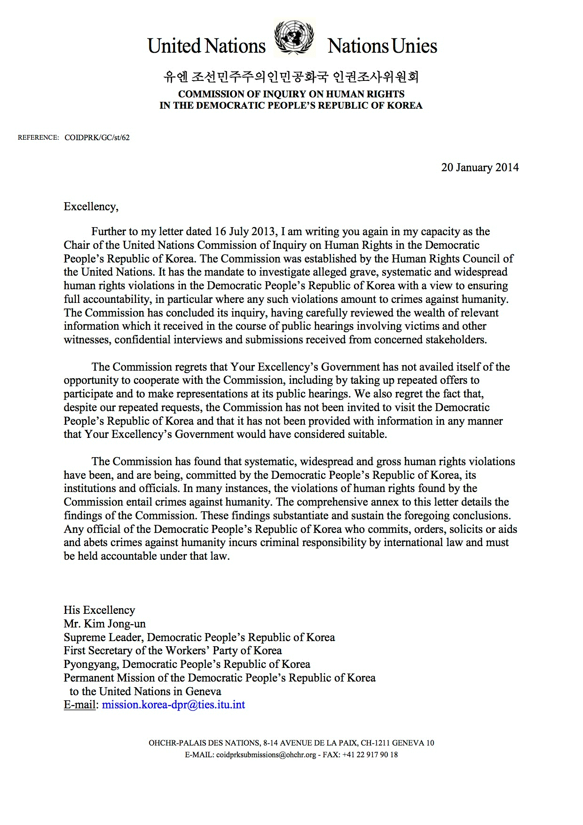
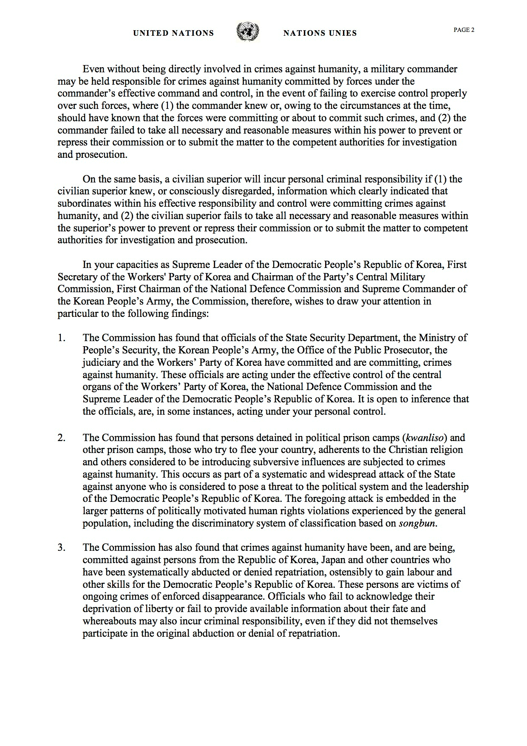
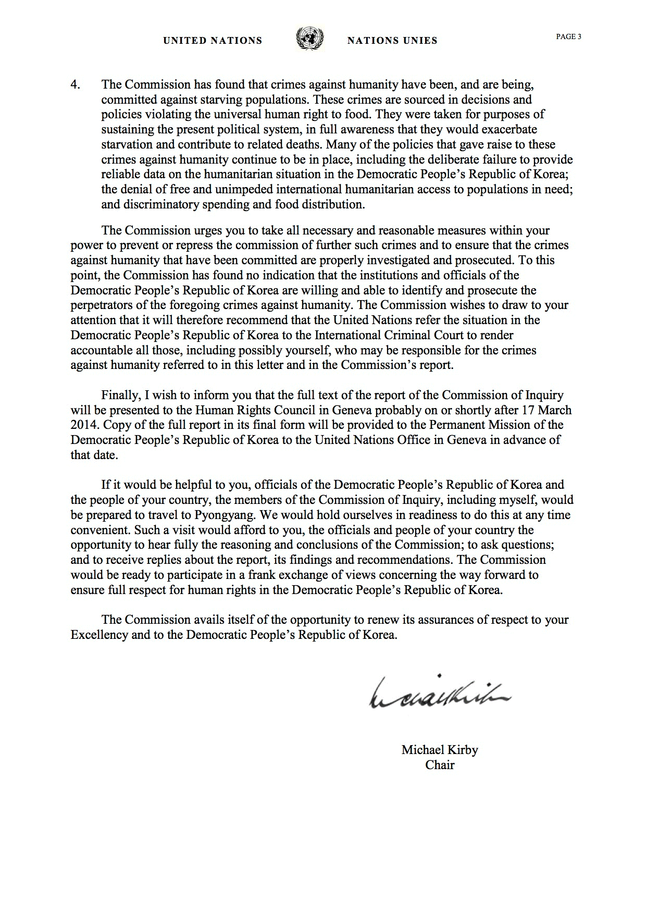
Annex II
[English only]
Correspondence with China
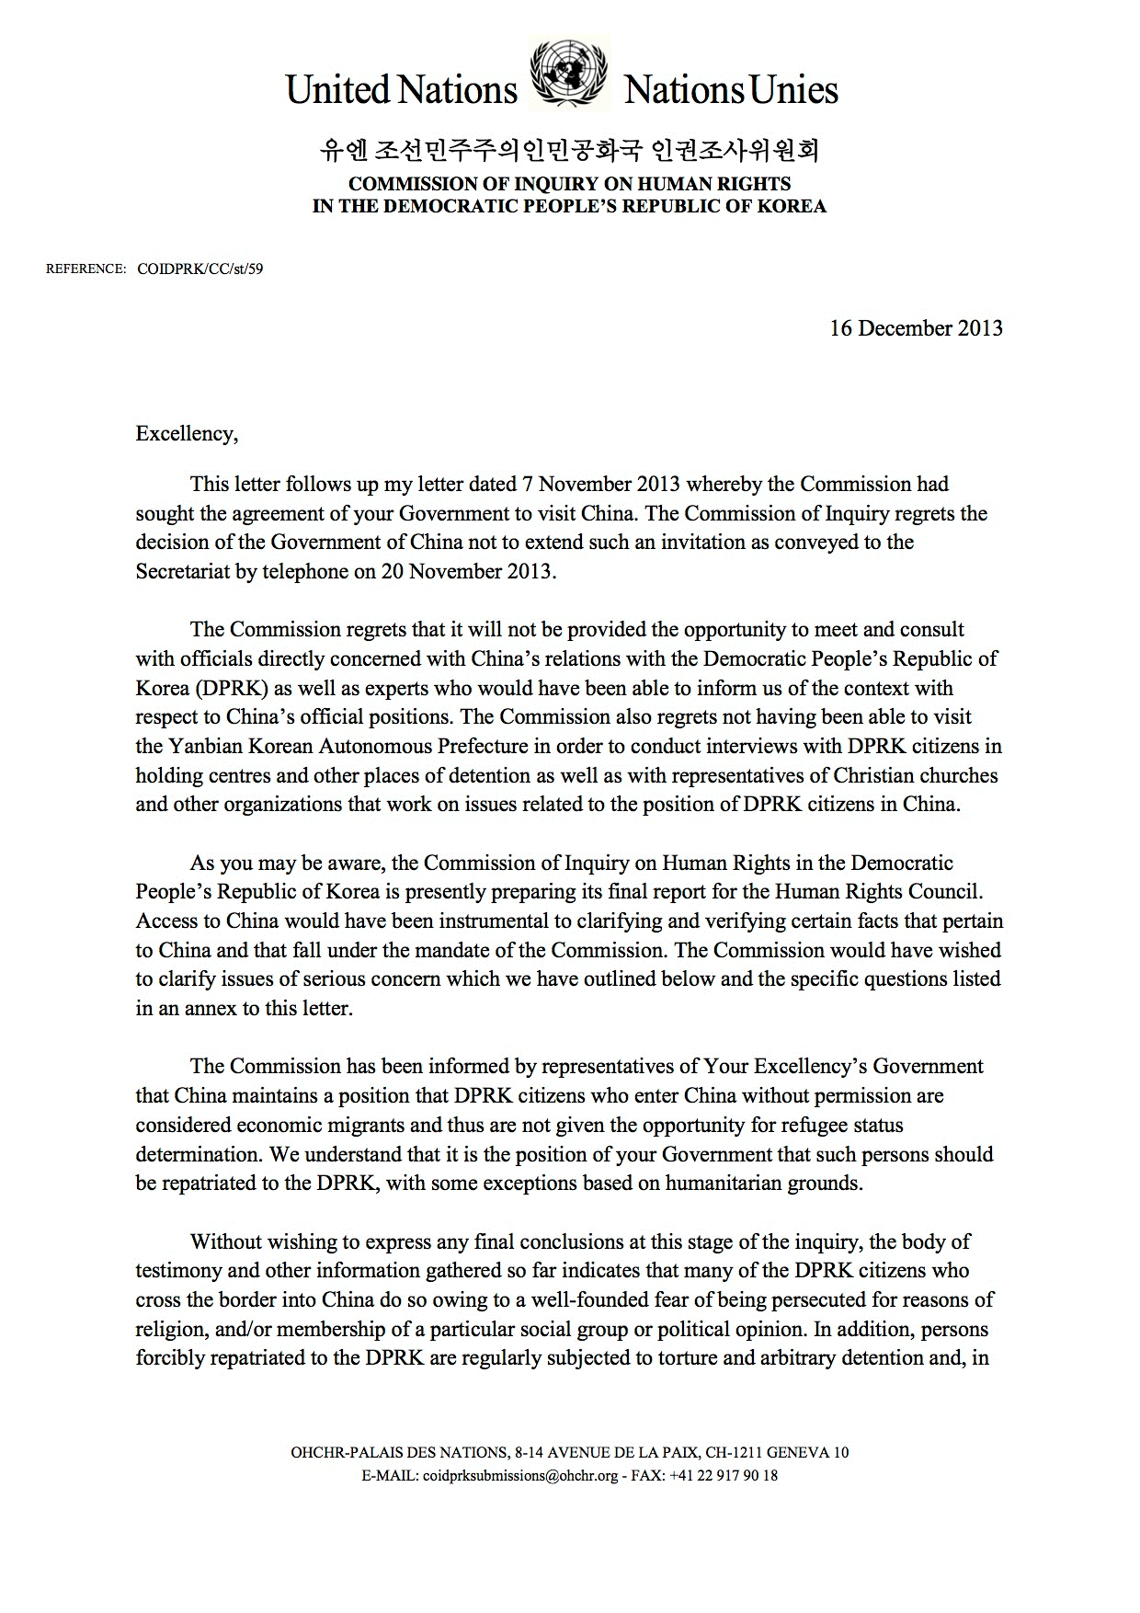
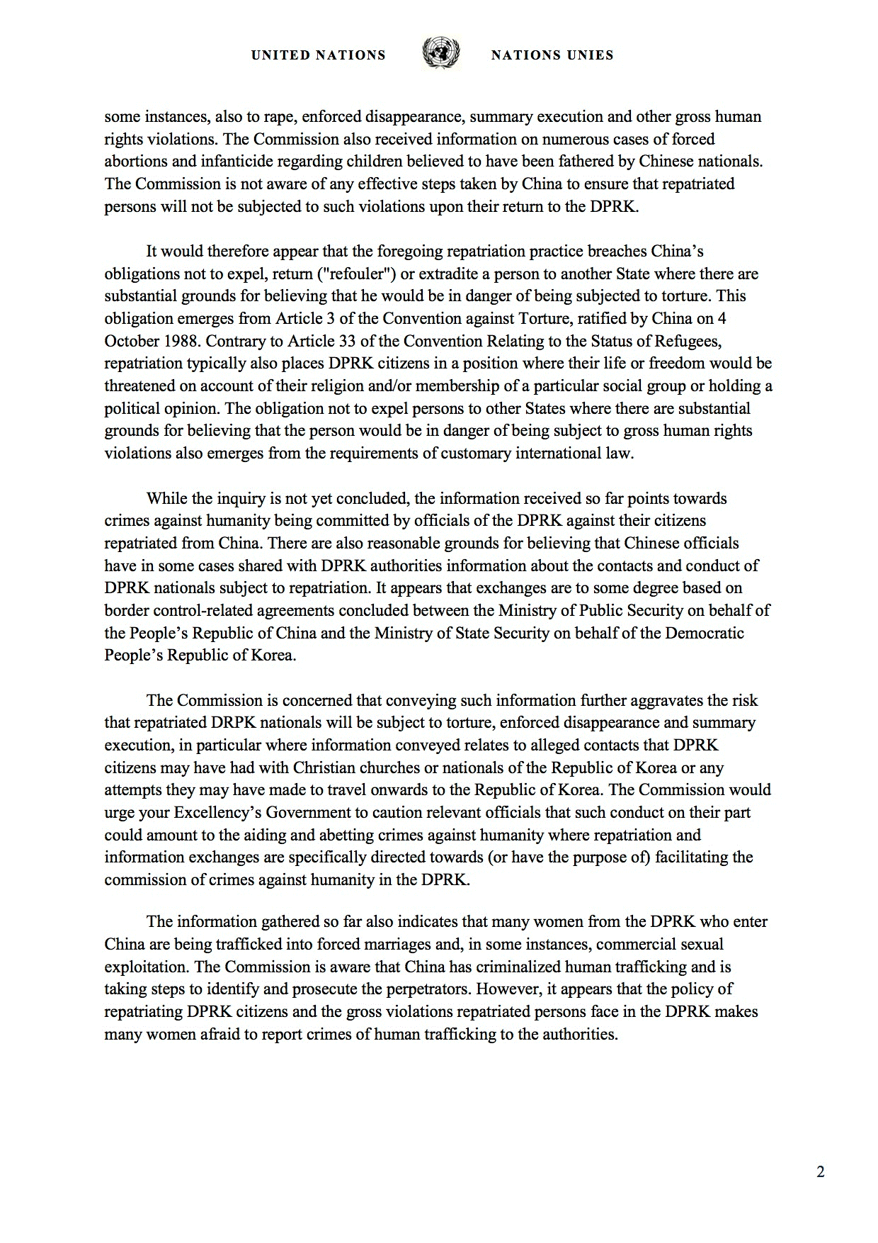
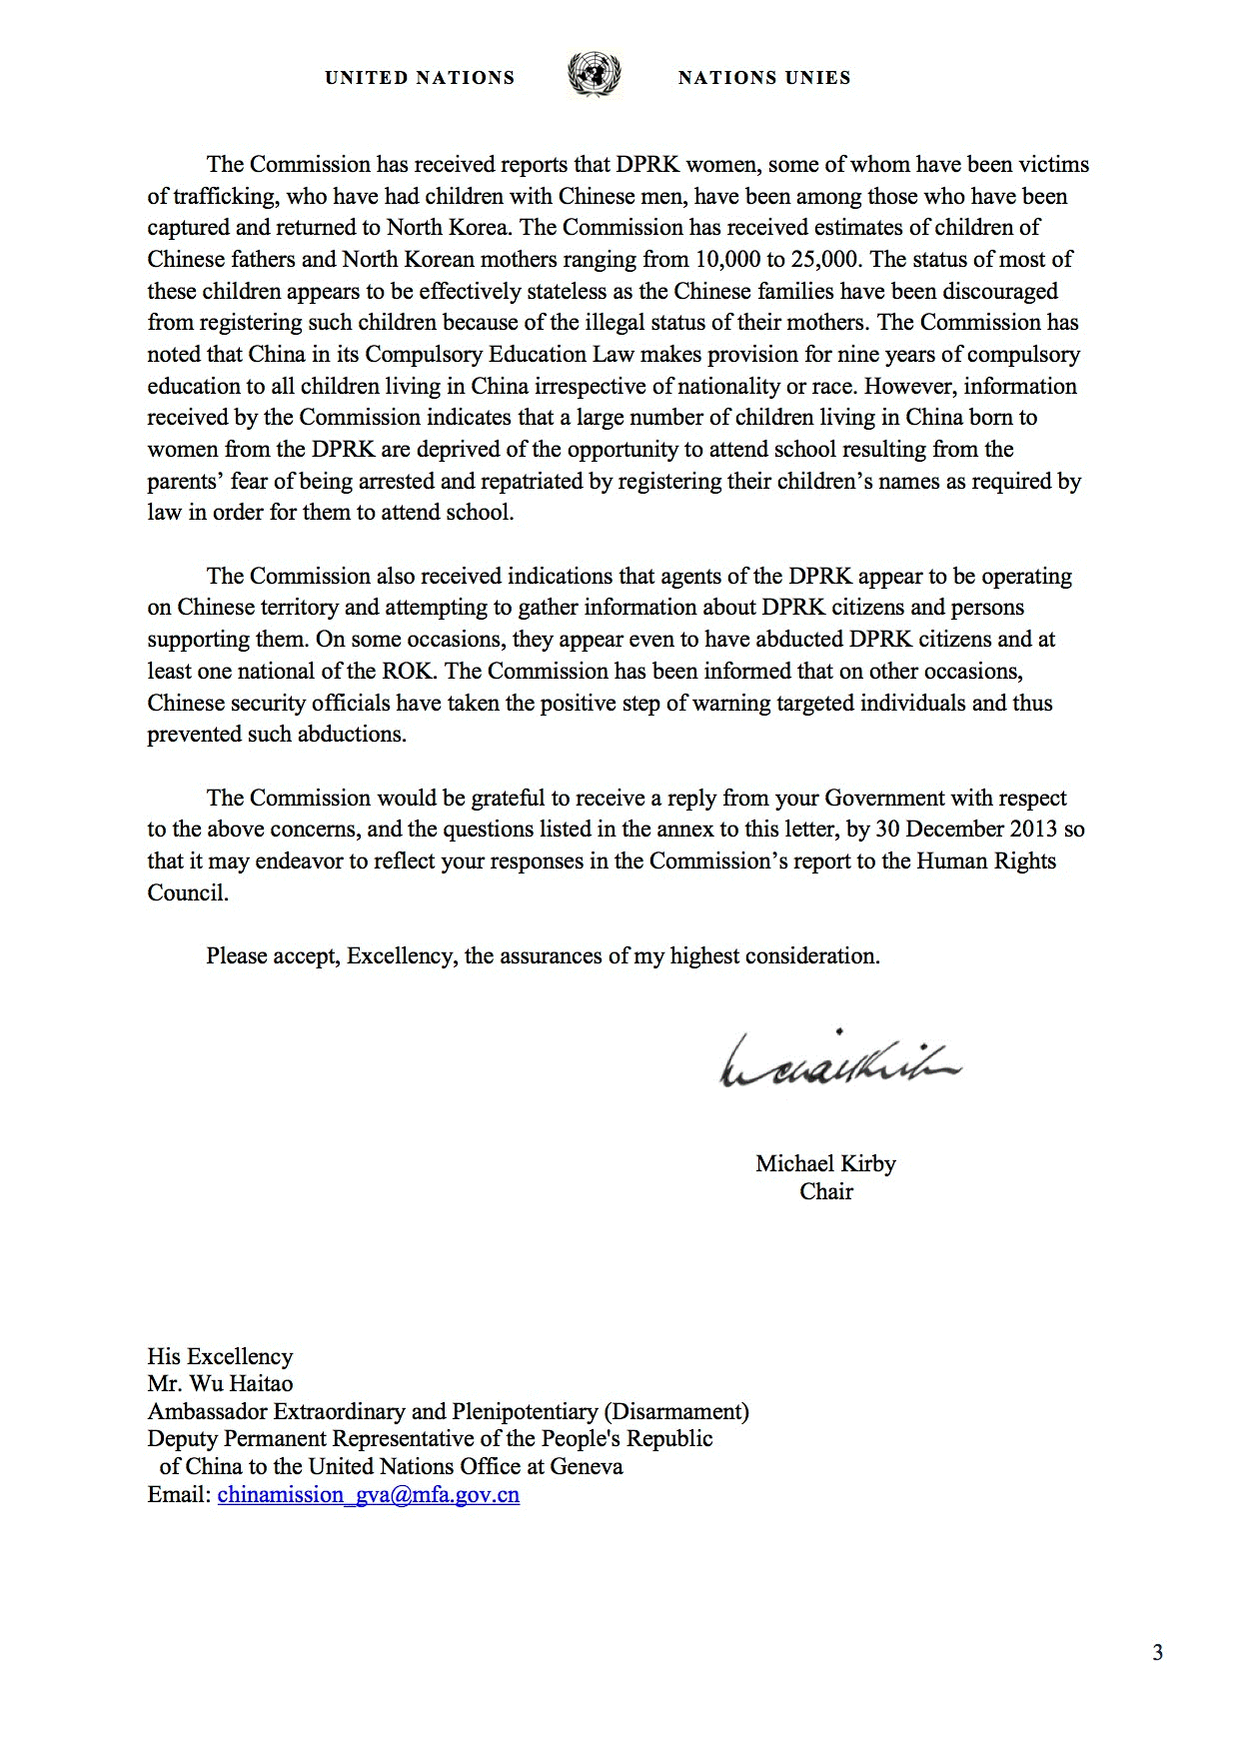
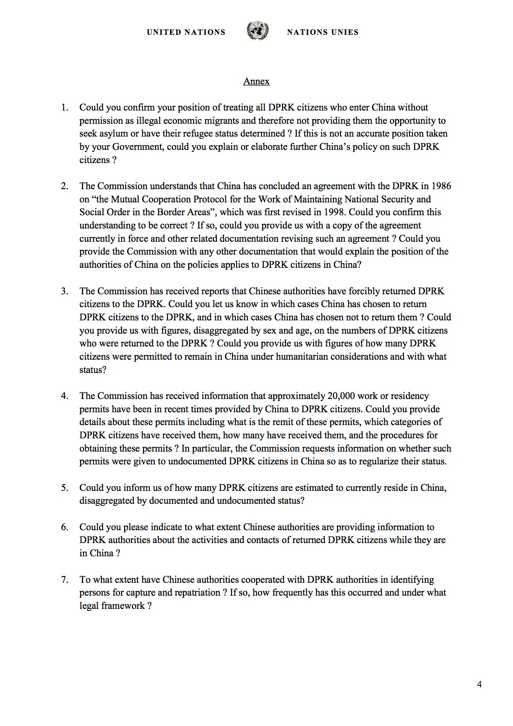
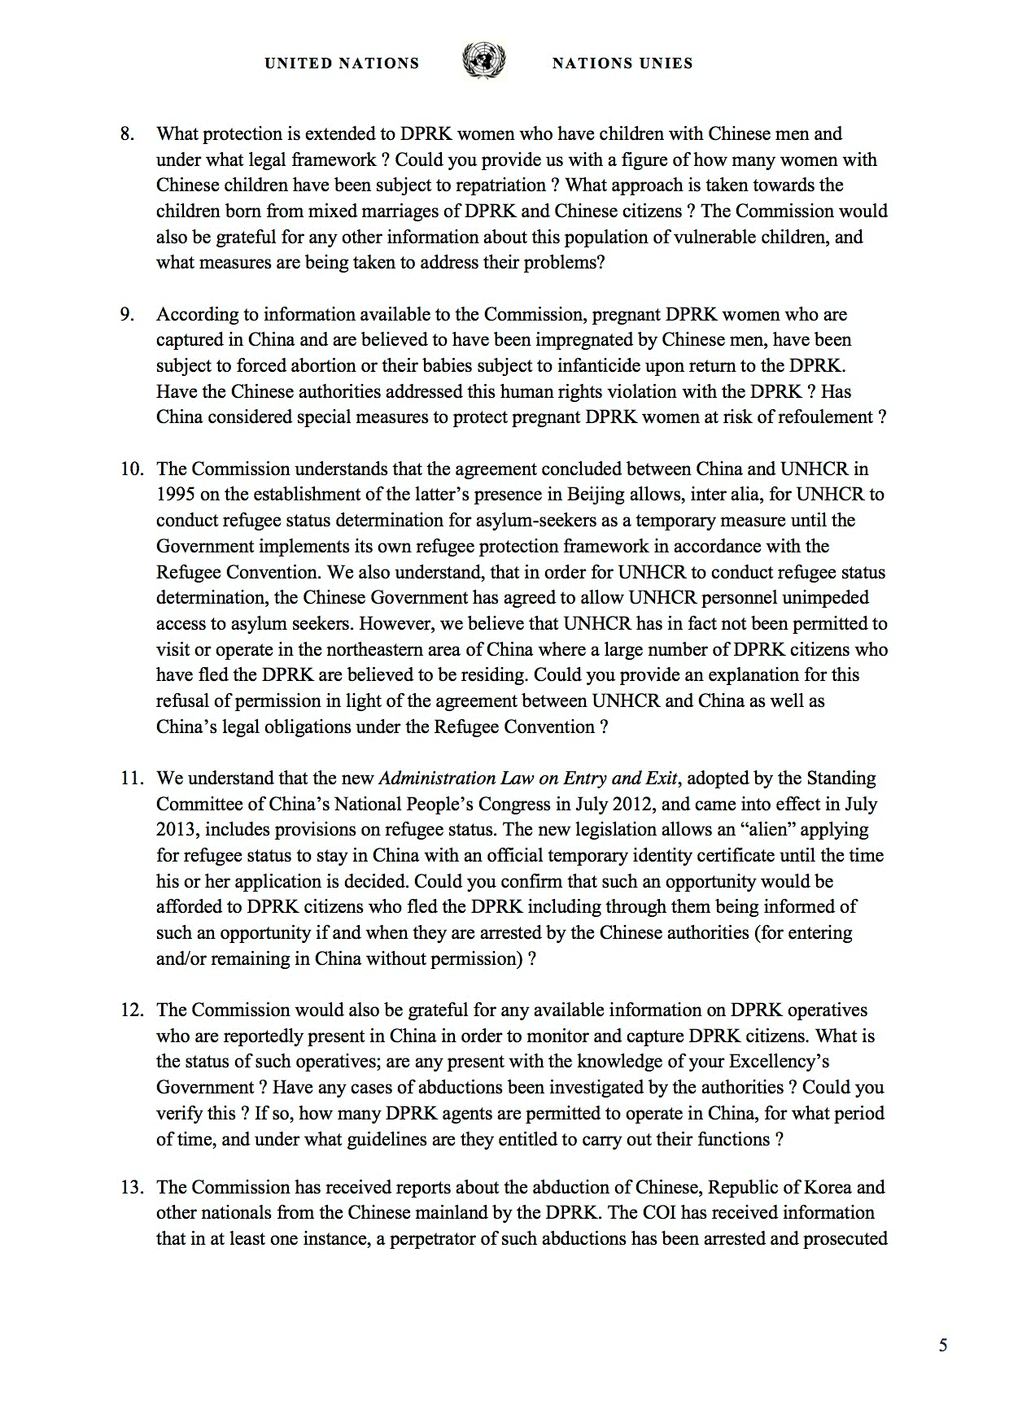
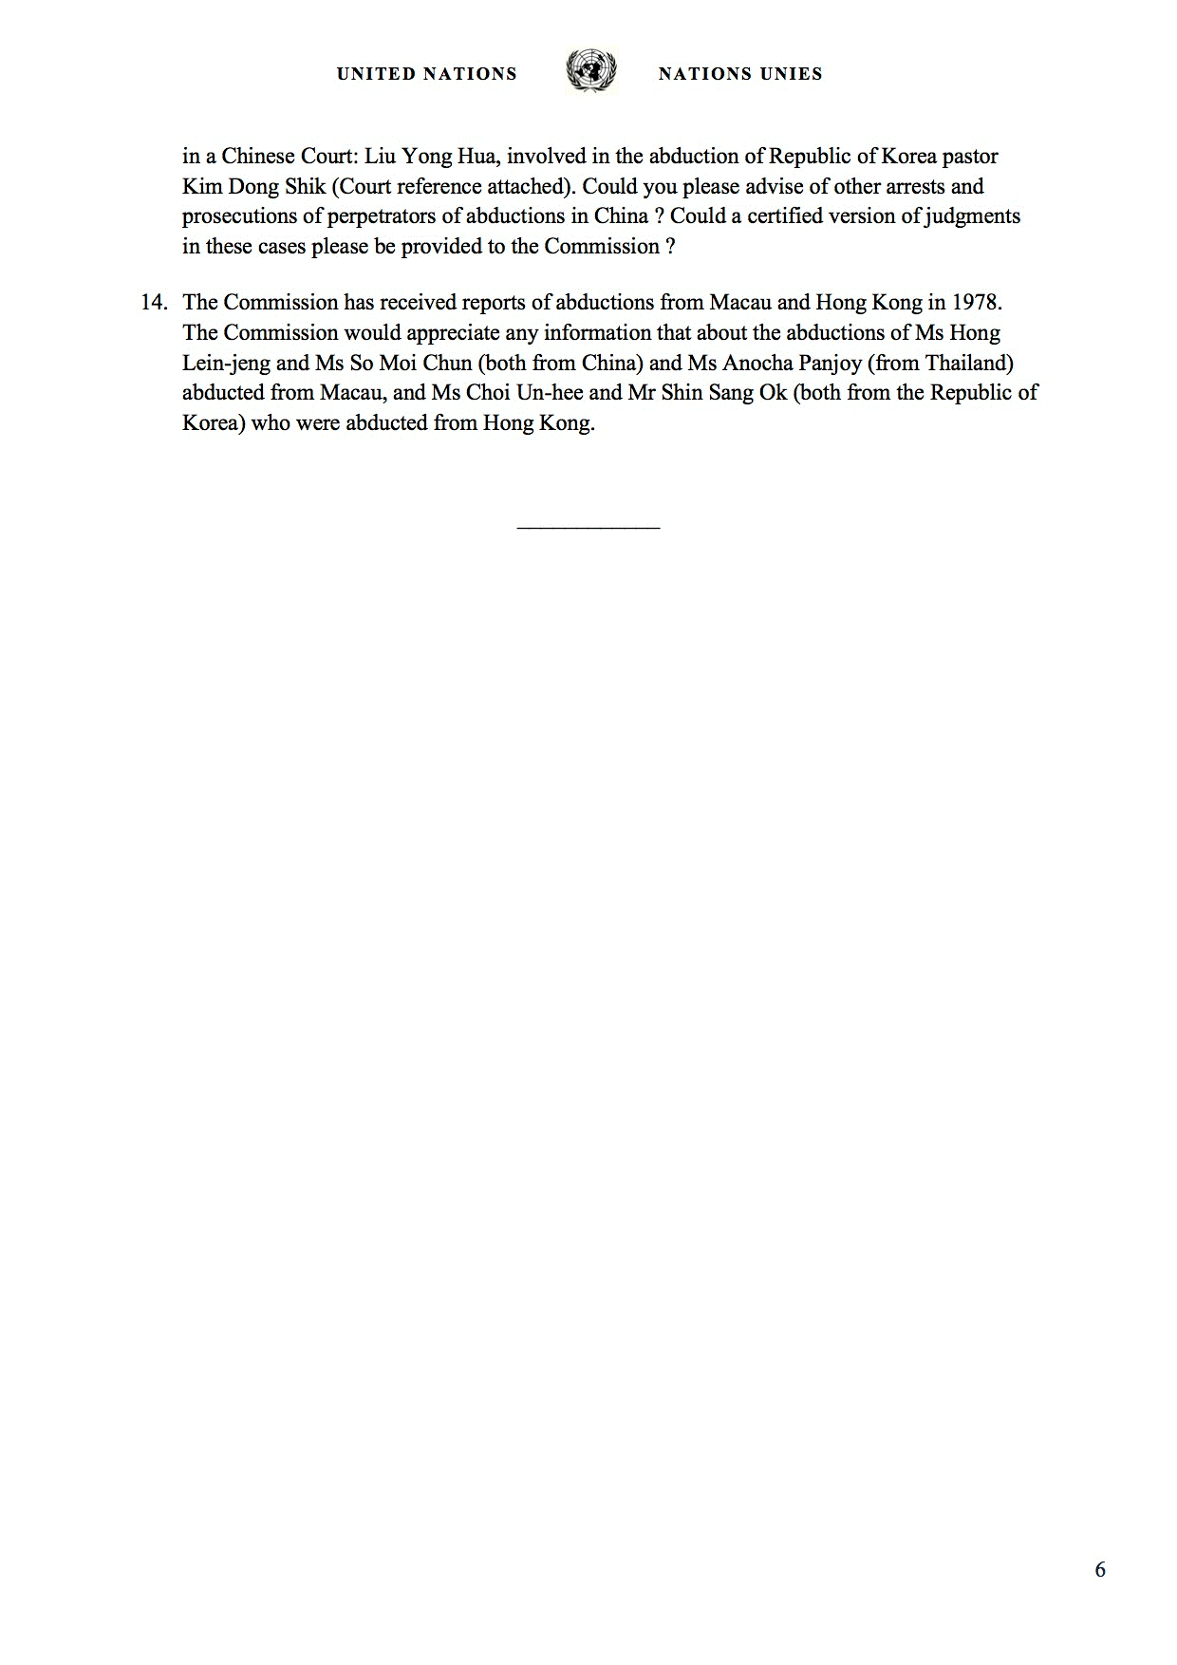
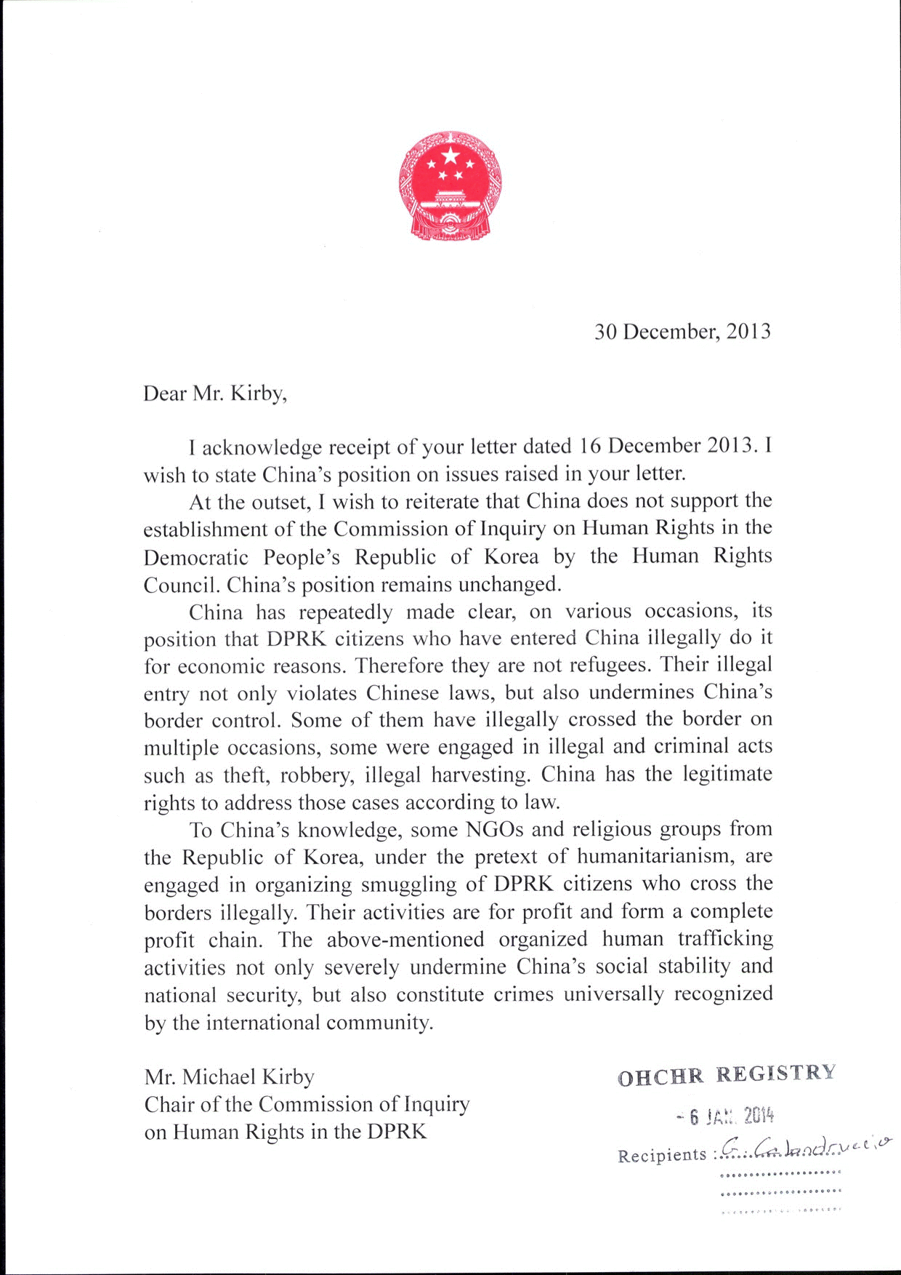
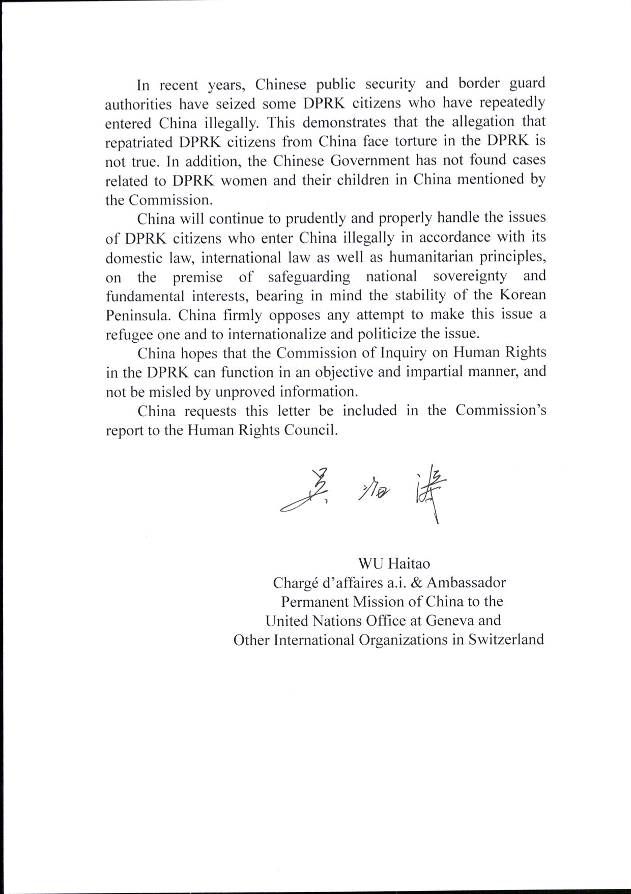
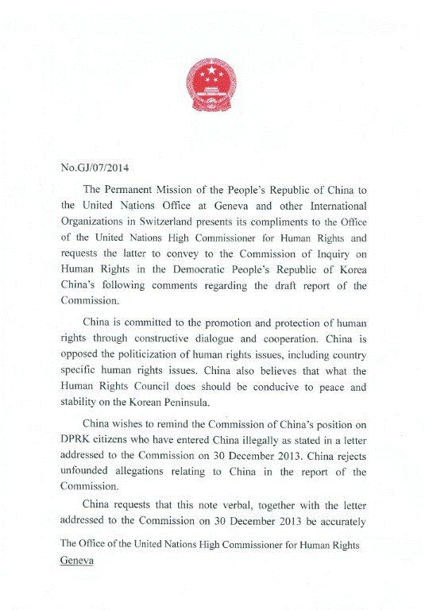
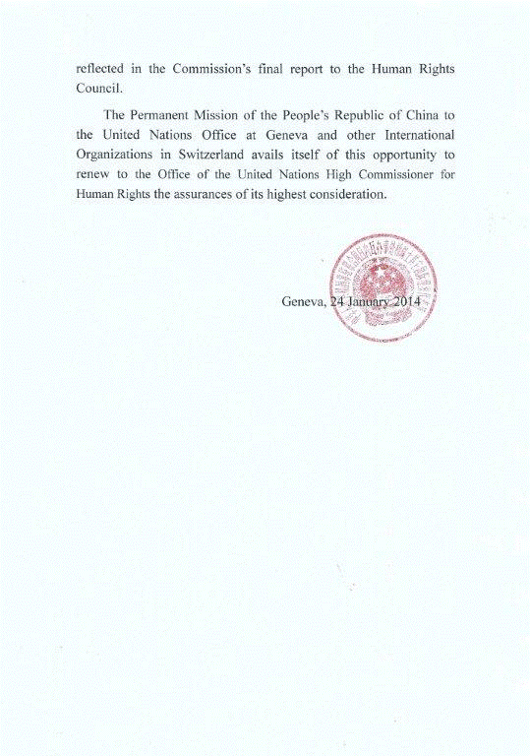

* * The annexes to the present report are circulated as received, in the language of submission only.
* ** For detailed findings of the commission of inquiry, see document A/HRC/25/CRP.1.
*
? For further information on the interpretation of the mandate and the Commission’s methods of work, see A/HRC/25/CRP.1, sect. II.
? A/HRC/22/57.
? Video recordings and transcripts from all the public hearings are available on the website of the commission of inquiry at www.ohchr.org/EN/HRBodies/HRC/CoIDPRK.
? See also A/HRC/25/CRP.1, sect. IV.
? See ibid., sect. III.
? See also A/HRC/25/CRP.1, sect. V.

