 | United Nations | A/HRC/26/25/Add.1
 | General Assembly |  | Distr.: General  28 April 2014  Original: English
Human Rights Council
Twenty-sixth session
Agenda item 3
Promotion and protection of all human rights, civil,
political, economic, social and cultural rights,
including the right to development
Report of the Working Group on the issue of human rights and transnational corporations and other business enterprises
Addendum
Uptake of the Guiding Principles on Business and Human Rights: findings from a 2013 questionnaire for corporations*
Summary
This report summarizes the findings from a 2013 questionnaire for corporations on the Guiding Principles on Business and Human Rights. The objectives of the questionnaire were threefold: (1) to understand progress on the dissemination of the Guiding Principles among the business community; (2) to highlight implementation motivations and challenges among business enterprises; and (3) to understand the support that businesses enterprises need to implement their corporate responsibility to respect human rights.
The questionnaire revealed the following key findings:
(a) The majority of the sampled businesses are aware of the Guiding Principles;
(b) Priorities are focused on in-house awareness and integration, improving complaints/grievance mechanisms, building accountability in the business, and (for large companies in particular) mapping risks;
(c) Half of the sampled businesses have a public statement of human rights, yet more transparency is required;
(d) Corporate responsibility/sustainability departments tend to lead on human rights;
(e) Half of the sampled businesses stated that they are actively engaged in the human rights agenda, including by working on their own policies and practices;
(f) Moving from policy to practice on human rights and addressing human rights in business relationships are the main challenges for half of the sampled businesses;
(g) When asked about “eco-system support”, the most common responses were: the need for training and educational opportunities, effective government enforcement of local laws and multi-stakeholder initiatives. Other responses, though less common, included public benchmarking and legal requirements to conduct human rights due diligence.

Annex
[English only]
Uptake of the Guiding Principles on Business and Human Rights: findings from a 2013 questionnaire for corporations
Contents
Paragraphs Page
I. Introduction 1–7 4
II. A note on supporting evidence 8 4
III. Brief overview of the Guiding Principles on Business and Human Rights 9–11 5
IV. Methodology 12–18 6
V. Potential future methodologies 19–22 7
VI. Survey structure 23–24 7
VII. Survey sample 25–30 8
VIII. Key findings 31–48 11
IX. Conclusions 49–56 16
I. Introduction
    - This report summarizes the findings from a 2013 questionnaire for corporations on the Guiding Principles on Business and Human Rights. The questionnaire was carried out for the Working Group by the International Chamber of Commerce (ICC), the International Organisation of Employers (IOE), the Global Business Initiative on Business and Human Rights (GBI) and the University of Denver.
    - The objectives of the questionnaire were threefold: (1) to understand progress on the dissemination of the Guiding Principles among the business community; (2) to highlight implementation motivations and challenges among business enterprises; and (3) to understand the support that businesses enterprises need to implement their corporate responsibility to respect human rights.
    - The aim of this report, which follows on from a pilot survey in 2012, is to gather solid data to support the United Nations and other organizations as they work to disseminate and implement the Guiding Principles. This questionnaire is not an in-depth inquiry or assessment of how companies are progressing with detailed implementation of the Guiding Principles. Instead, it aims to understand how business enterprises are approaching the Guiding Principles and shed light on the motivations, challenges, gaps and opportunities for businesses in implementing the Guiding Principles.
    - One hundred and fifty-three business representatives from 39 countries responded to the questionnaire. This is an increase of 23.5 per cent from the 117 businesses that responded to the 2012 pilot survey. Europe was the region with the highest percentage of overall respondents, at 45.7 per cent. It also provided the most diverse regional sample with perspectives shared from 18 company representatives.
    - The Working Group is using the results and findings from the questionnaire in its wider efforts to map the dissemination and implementation of the Guiding Principles. The questionnaire helps the Working Group to track business awareness of and progress in implementing the Guiding Principles. It also helps it to identify the common obstacles to the fulfilment of “the corporate responsibility to respect human rights” (the second pillar of the Guiding Principles).
    - This questionnaire complements a parallel questionnaire focused on government action regarding “the State duty to protect human rights” (the first pillar of the Guiding Principles).
    - The Working Group welcomes feedback to help it advance the business and human rights agenda within the framework of the Guiding Principles. Please send any feedback to: wg-business@ohchr.org.
II. A note on supporting evidence
    - While the questionnaire did not require supporting or verifiable evidence or data, respondents were given the opportunity to upload or provide links to any internal or external company documents on human rights from their organizations. Information was uploaded by 32 of the 153 companies that participated in the questionnaire. The types of information provided included examples of codes of conduct; supplier codes of conduct; human rights policies/statements; sustainability principles and policies; sustainability/annual reports; a human rights risk assessment; human rights due diligence programmes; human rights management documentation; and human rights event reports.
III. Brief overview of the Guiding Principles on Business and Human Rights
    - The Human Rights Council endorsed the Guiding Principles on Business and Human Rights in June 2011. The Guiding Principles elaborate on the three pillars of the United Nations “Protect, Respect and Remedy” Framework, which the former Special Representative of the Secretary-General proposed to the Human Rights Council in 2008. The three pillars of the Framework are:
(a) The State duty to protect against human rights abuses by third parties, including business enterprises, through appropriate policies, regulation, and adjudication;
(b) The corporate responsibility to respect human rights, that is, to act with due diligence to avoid infringing the rights of others and address adverse impacts with which they are involved; and
(c) The need for greater access for victims to effective remedy, both judicial and non-judicial.
    - The endorsement of the Guiding Principles established a common global platform for action. The Guiding Principles apply to all States and to all business enterprises, both transnational and others, regardless of their size, sector, location, ownership and structure. While they are universally applicable, the Guiding Principles recognize that there is no one-size-fits-all approach to how business enterprises meet their corporate responsibility to respect human rights. Specifically the Guiding Principles set out that businesses should have in place:
(a) A policy commitment to meet their responsibility to respect human rights;
(b) A human rights due-diligence process to identify, prevent, mitigate and account for how they address their impacts on human rights; and
(c) Processes to enable the remediation of any adverse human rights impacts they cause or to which they contribute.
    - The Guiding Principles stipulate that, in order to conduct effective due diligence, businesses should conduct meaningful engagement with affected stakeholders, implement the results of their impact assessments and take appropriate action, including assigning responsibility for addressing any impacts to the appropriate level and function within the business enterprise. Furthermore, businesses should track the effectiveness of their human rights response using qualitative and quantitative indicators and feedback from stakeholders, and report publicly on how they address their human rights impacts.
IV. Methodology
    - This report summarizes the findings from the second corporate questionnaire on the Guiding Principles, which was carried out in 2013, following a pilot survey in 2012. The Working Group aims to undertake a corporate questionnaire every year.
    - The project team analyzed the questions and results from the 2012 questionnaire with a view to improving the design of the 2013 questionnaire, which consequently has different questions and amended answer choices and formats. Year-on-year comparative data cannot therefore be included in the present report, except for the respondent rate. A total of 165 organizations completed the questionnaire. However, 12 of these were deemed ineligible for inclusion as they were business associations and/or NGOs and were therefore not included in the analysis. In total 153 companies responded to the survey, the baseline figure for the analysis.
    - The involvement of GBI, ICC and IOE, three prominent business associations and membership bodies, enabled access to their extensive corporate networks. However, their involvement is not without limitations. Some answers to the questionnaire may be affected by the fact that they are a part of these convening organizations. Where this may be the case, it has been indicated in the text. Furthermore, there is no third-party validation of the information given by respondents to establish the accuracy of fact-based answers to some of the questions.
    - The questionnaire was administered from 29 October 2013 to 31 January 2014 using a custom online tool and the team employed a snowball sampling methodological approach. Snowball sampling relies on the networks that exist between members of a target population. The process starts with an initial “seeding” of the survey, which then gathers size and pace at it disperses through networks. As a sampling methodology, it differs considerably from approaches which involve taking a random sample from a known population, as often used in public opinion surveys.
    - The chief disadvantage of snowball sampling is that it is not as representative of the wider population (in this case global businesses) as a random sampling strategy. It also limits the extent to which the results can be generalized. Furthermore, there is sampling bias due to the reliance on e-mails being forwarded on through networks. For example, people may be more likely to forward the e-mail to contacts they know well, who may share similar traits and characteristics with them, which means the end sample may only represent a subgroup of the wider population.
    - The drawbacks of this method could be minimized by using a range of different “seeds” to start the snowballing process in order to reach a more diverse group of individuals. For the questionnaire, GBI, ICC and IOE leveraged their multiple networks to disperse the survey and, in turn, these networks further circulated the information and the survey link via e-mail to their own networks.
    - In interpreting the results of the study, it is important to note that this is not a representative study offering a snapshot of global business. However, the 153 respondents who participated do constitute a valid sample, obtained in an appropriate manner, and they are able to offer a useful perspective on business and human rights issues. Even so, it is anticipated that respondents were previously familiar with or interested in the business and human rights agenda since they self-selected to complete the survey. In this context generalizations are not possible, yet there are a sufficient number of respondents to provide useful insights about a subset of businesses that are familiar with, or interested in, business and human rights.
V. Potential future methodologies
    - Looking ahead to future questionnaires, it is worth considering alternative methodologies. It may be possible to achieve a more representative sample by limiting the population of businesses surveyed. For example, partner organizations may have priority countries, defined by both the size of the national economy and the extent to which human rights are seen as an issue in the country. They may also have priority audiences in terms of company size and sector.
    - More research could be carried out to define a range of company roles/job titles whose incumbents are likely to possess the necessary knowledge to answer on the topics in the survey. The partner organizations (GBI, ICC and IEO) would aim to identify “priority audiences” as opposed to the business world in general. Regarding the methods available to represent the priority audience:
(a) If large businesses are particularly important for an organization, it is a fairly simple exercise to obtain company contact details from the Financial Times Stock Exchange (FTSE) 250, Fortune 500, etc., contact these companies to explain the nature of the research, and ask to be directed to a suitable individual;
(b) In several countries, it is possible to purchase a pre-constructed list of business individuals fitting the target profile (for example, with a suitable job title), with information on sector, business size, etc. also included. From these lists, a sample frame can be constructed that matches the profile of the target audience, and individuals can be selected at random to be approached to take part in the survey.
    - Both approaches are more resource-intensive than snowball sampling, in that they would rely on more than just an initial “seeding” for the survey to reach the target respondents. Selected companies may need to be contacted by telephone as well as e-mail, and respondents given the opportunity to complete the survey in this manner.
    - The effort to represent a more clearly defined target population may also require setting certain quotas (e.g. X per cent of respondents from companies in Y sector) against which progress needs to be monitored. For this reason, specialist third-party research firms may need to be engaged to design and implement such a survey.
VI. Survey structure
    - The 2013 questionnaire included a variety of question types such as multiple choice, yes/no answers, rating of a list of options, and open text boxes requiring more detailed explanations. Participating company representatives were also able to upload or provide links to any internal or external company documents on human rights to share with the Working Group.
    - The questions were grouped into three main sections as follows:
- Section 1: Gathering information on the demographics of respondents, including country location of their company headquarters, location of operations of the respondent, industry sector and size and how the respondent had heard about the questionnaire.
- Section 2: Questions such as whether participants had previously heard of the Guiding Principles (to establish their level of awareness), when they had first heard about the Guiding Principles, and in what contexts they had most frequently heard about the corporate responsibility to respect human rights.
- Section 3: Participants were asked to select their human rights priorities over the following 12 months, to state whether they had a public human rights policy in place, and to identify the department(s) leading the implementation of their human rights policy. Also requested were examples of engagement in activities related to respect for human rights; primary motivators for addressing human rights within their company; challenges in implementing respect for human rights in practice; and productive ecosystem support for taking forward the corporate responsibility to respect human rights.
VII. Survey sample
1. By region and headquarters
    - There were 153 respondents from businesses to the 2013 questionnaire, representing an increase of 23.5 per cent from the 117 who responded to the 2012 questionnaire. At a global level, there were respondents from 39 countries, with Europe the region with the highest percentage of overall respondents (at 45.7 per cent) and the most diverse regional sample, with perspectives shared from 18 company representatives.
Figure 1
Respondent companies (percentage by region)
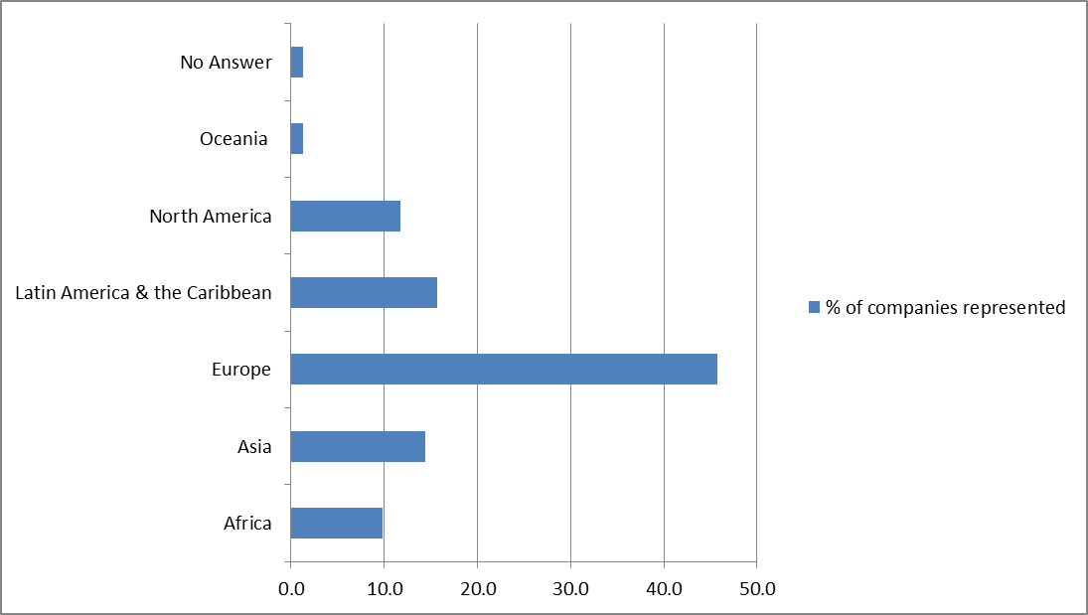
    - Respondents from companies headquartered in the United States of America (9.8 per cent), followed closely by Germany (8.4 per cent), accounted for the highest percentage of respondents by headquarters country of the total of 153 (see Figure 1). Respondents from companies headquartered in Colombia and Kenya (6.5 per cent) were the next largest group, leading the response from the emerging markets. Other countries with notable response rates were companies headquartered in France (5.8 per cent) and Switzerland (4.5 per cent) from developed countries, and Brazil (3.9 per cent) and Indonesia (3.9 per cent) from developing countries. Almost half of the respondent companies (49 per cent) operate in up to 10 different countries. Just under three quarters of the respondent companies (73.85 per cent) operate in 50 countries or fewer. Approximately 4.5 per cent of the 153 companies operate in 150 or more countries.
Figure 2
Questionnaire respondents (by company headquarters country)
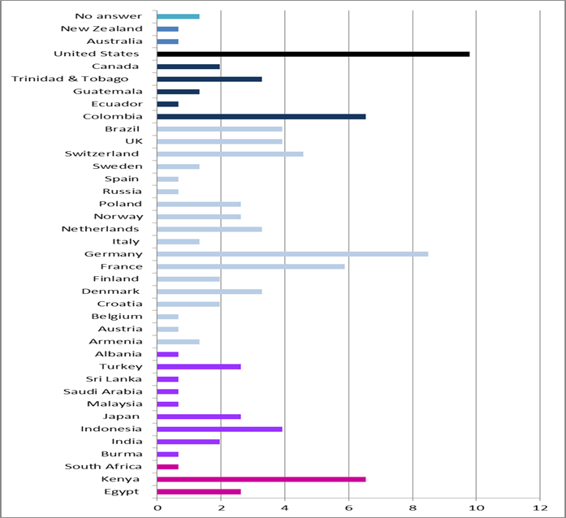
    - The largest number of individual respondents were based in Colombia (9.8 per cent), followed by Germany and the United States (7.19 per cent), although their companies were not based in these countries. While generalizations are not possible, these patterns of participation in the survey may indicate a relatively higher level of discourse on business and human rights in these countries for a variety of factors, such as a proactive civil society or business association engagement on the issues.
2. By sector
    - All listed sectors were represented in the 153 company sample, with the largest percentage of respondents drawn from the manufacturing (22.2 per cent), extractive industries (11.76 per cent) and infrastructure and utilities (11.11 per cent) sectors (see Figure 3). This may reflect the fact that these sectors are closely involved with the business and human rights agenda owing to greater awareness in these industries of their potential or actual negative human rights impacts in comparison with other industries.
Figure 3
Sample (by company’s industry sector)
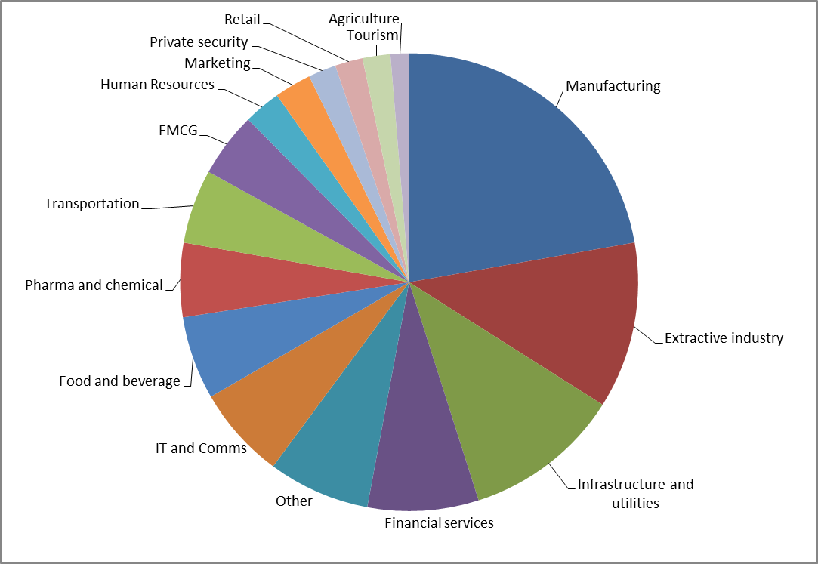
3. By company size
    - All company sizes were represented in the survey, evenly split between respondents from companies with fewer than 5,000 employees and with more than 5,000. Specifically, 20.9 per cent of respondents were from companies with over 100,000 employees, while at the lower end 13.7 per cent of respondents were from companies that had fewer than 50 employees. The definition of small, medium and large company size was defined prior to the survey as: small = fewer than 1,000; medium = 1,000−30,000; and large = larger than 30,000.
Figure 4
Sample (by respondent’s size of business)
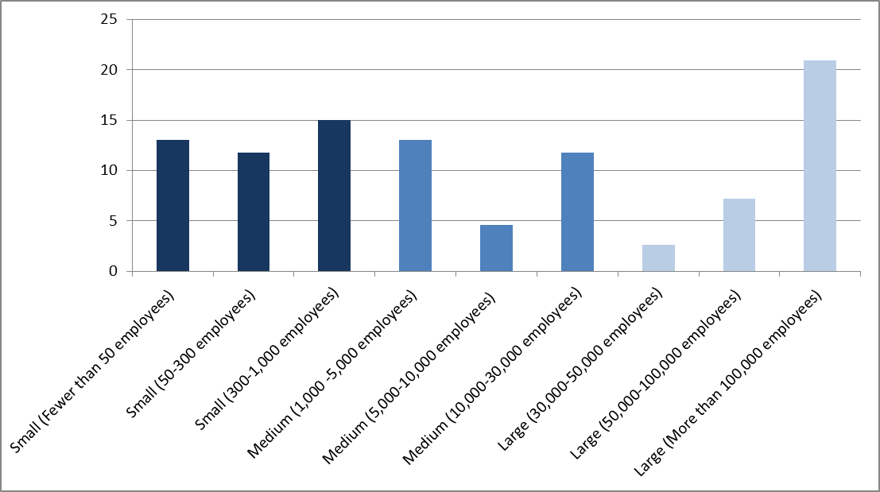
4. By source
    - Nearly two in five (37.25 per cent) of respondents had heard about the survey directly from sources other than the collaborating partners (ICC, IOE, GBI and the University of Denver). This suggests that the networks of the collaborating partners played an active role in disseminating the call for participation.
VIII. Key findings
1. The majority of the sampled businesses are aware
of the Guiding Principles
    - Awareness of the Guiding Principles and the corporate responsibility to respect human rights is high among this sample group, with three quarters of the 153 respondents having heard of the Guiding Principles. There is clearly a need for further awareness-raising, with approximately a quarter of respondents stating that they had previously been unaware of the Guiding Principles. However, given the limitations of this study, these findings cannot be extrapolated to indicate that they are representative of the entire global business community.
    - Of the 75 per cent of the respondents who had heard of the Guiding Principles, more than half reported that they had heard of them at the time when they were being developed in 2010 or earlier. Notably, just over 20 per cent had heard of the Guiding Principles for the first time in 2012 or 2013, indicating that continued awareness-building activities on the Guiding Principles may be yielding incremental results.
    - When asked about the main mechanisms through which they had heard about the Guiding Principles, the majority of respondents selected: associations or networks; interaction with civil society and participation in events (See Figure 5). In addition to the collaborating partners, those commonly cited by respondents were: United Nations Global Compact, the International Council on Mining and Metals (ICMM), IPIECA (the global oil and gas industry association for environmental and social issues), the Global Reporting Initiative (GRI), the Global e-Sustainability Initiative (GeSI) and the National Business Association of Colombia (ANDI). However it should be noted that, in an example of the limitations of the survey, the databases of an organization such as GBI will be skewed in favour of those companies that have attended GBI-organized events. It is perhaps therefore unsurprising that these mechanisms have scored highly. Nevertheless, it raises the question as to how the Working Group can seek to leverage on and stimulate membership bodies and business associations to further engage their networks on the theme of business and human rights in the future. Additionally, the findings indicate that there is a continued need for engagement with business associations and networks, as well as civil society, to build awareness on business and human rights, through events and other mechanisms.
    - The results point to further scope for cross referencing the Guiding Principles in other relevant standards. For example, 39.87 per cent of respondents noted that they had heard about the Guiding Principles when reviewing other standards, such as the GRI Guidelines, Organisation for Economic Co-operation and Development (OECD) Guidelines and ISO 26000 of the International Organization for Standardization.
    - It is valuable to note that some respondents stated that they were aware of the Guiding Principles because of being asked for information related to them in “requests for proposals”, and in the process of tendering for work, as well as from socially responsible investors.
Figure 5
Context where respondents most frequently hear about the corporate responsibility to respect human rights (percentage, by size of business)
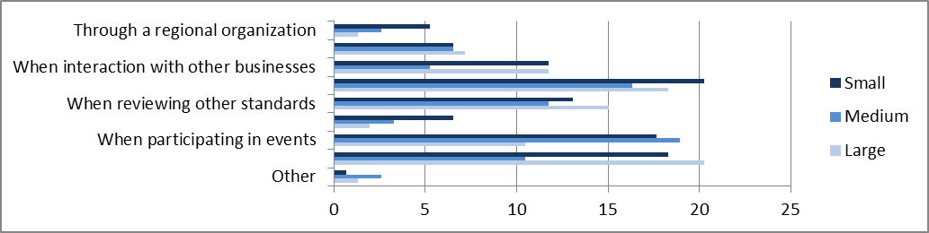
2. Priorities are focused on in-house awareness-raising and integration, improving complaints/grievance mechanisms, building accountability in the business, and (for large companies in particular) mapping risks
    - Survey respondents’ top priorities were to build in-house awareness on human rights and improve complaints/grievance mechanisms. Mapping the company’s high-risk operations was also identified as a priority. However, the focus on this differed according to company size with, perhaps unsurprisingly, larger companies identifying this as a priority (see Figure 6).
Figure 6
Ranking human rights priorities (percentage, by size of business)
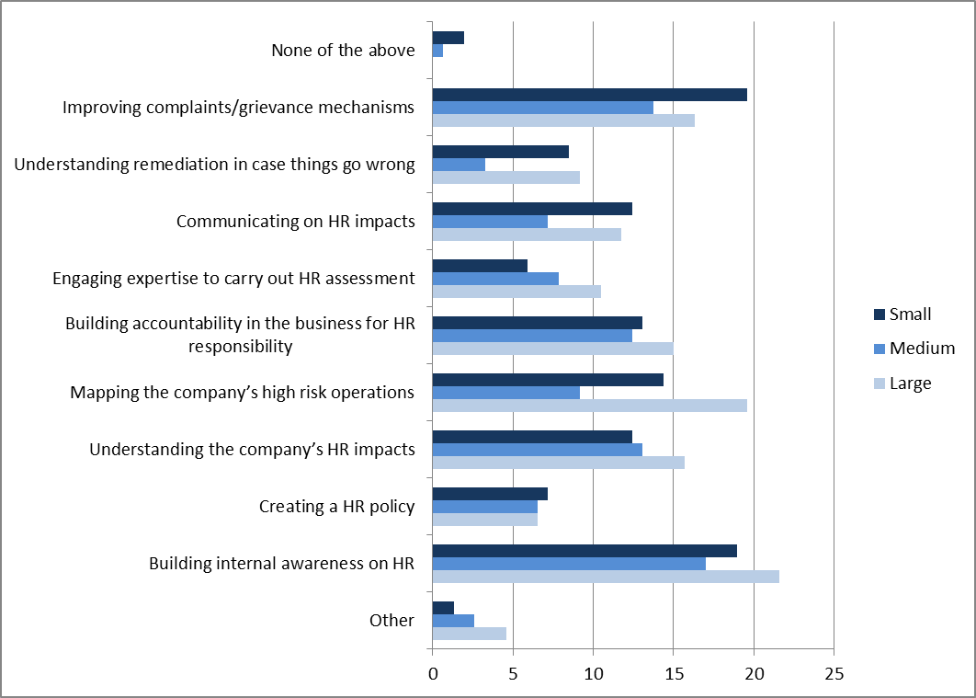
3. Half of the sampled businesses have a public statement of human rights, yet more transparency is required
    - While nearly three in five companies (57.52 per cent) have a public policy statement on human rights, just over two in five respondent companies have yet to create one. This indicates that there is progress still to be made in encouraging companies to establish a policy commitment. Moreover, of those that do not have a public policy statement, 15 per cent of surveyed companies have an internal policy statement that is not public. Guiding Principle 16 states that: “As the basis for embedding their responsibility to respect human rights, business enterprises should express their commitment to meet this responsibility through a statement of policy that: (a) is approved at the most senior level of the business enterprise; (b) is informed by relevant internal and/or external expertise; (c) stipulates the enterprise’s human rights expectations of personnel, business partners and other parties directly linked to its operations, products or services; (d) is publicly available and communicated internally and externally to all personnel, business partners and other relevant parties; (e) is reflected in operational policies and procedures necessary to embed it throughout the business enterprise.”
4. Corporate responsibility/sustainability departments tend
to be leading on human rights
    - When asked which department (or departments) leads on the implementation of their company’s human rights policy (with the option to select “all that apply”), approximately three quarters of the 88 respondents replied “the corporate responsibility/sustainability department”. However, many of the respondents also indicated that multiple departments lead on implementation and half of those who answered indicated that Human Resources are involved. This may be due to the connection between the respect for human rights and labour rights, suggesting a growing awareness of human rights as a cross-cutting issue.
    - Notably, “investor relations” was the department least recognized by respondents as leading the implementation of the company’s human rights policy. This suggests a lack of involvement and engagement on the part of investors with regard to human rights, which is contrary to much thinking among the business and human rights/sustainability community. However, this could be explained by ambiguity in the question. For example, even if investors do not lead on the agenda, it does not mean that they do not take relevant action on a regular basis.
5. Half of the sampled businesses stated that they are actively engaged in the human rights agenda, including by working
on their own policies and practices
    - More than half of the 153 respondents reported that their company has engaged in activities related to respect for human rights. Examples cited by respondents include: supporting human rights advocacy campaigns; endorsing principles such as the United Nations Global Compact; speaking at third-party events and writing in third-party publications on business and human rights; creating in-house guides on human rights for employees; installing human rights whistleblower systems; undertaking human rights impact assessments, employee capacity building/training on the Guiding Principles, human rights compliance assessments and verification on labour rights; and conducting stakeholder dialogues. However a quarter of respondents said that they have not engaged in a human rights activity and one seventh said that they did not know of any such engagement.
6. Moving from policy to practice on human rights and addressing human rights in business relationships are the main challenges
for half of the sampled businesses
    - Respondents were asked to note their companies’ three primary motivations for addressing human rights. At an aggregate level, these were: “a commitment to human rights in our code of conduct”; “human rights are part of effective risk management”; and “it is the right thing to do”. Overall, these results are consistent with the generally recognized business case for respecting human rights. As a caveat, it is nevertheless worth noting that a limitation of any questionnaire is that people will select what they perceive is the anticipated “right” answer (see Figure 7).
    - In general, these results were the same regardless of the company’s size, with the exception of smaller businesses, which placed a lower emphasis on human rights risk management as a motivation and on motivation stemming from a commitment to human rights in their codes of conduct.
Figure 7
Ranking human rights motivators (percentage, by size of business)
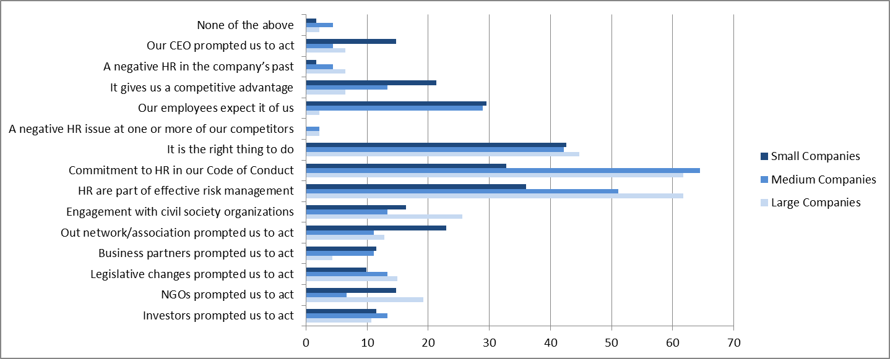

    - It is interesting to note that few respondents chose the following three options: “a negative human rights issue at one or more of our competitors”; “a negative human rights issue in the company’s past”; or “investors prompted us to act”. The last of these perhaps indicates a lack of engagement by many investors on the theme of human rights. It could also be a result of allowing respondents to choose only their top three answers to this question. Moreover, the response may depend on who is responding to the survey. Since respondents are unlikely to be board level executives, their perception of the company’s motivations may differ from that of the chief executive officer (CEO), who may be more motivated by investor opinion.
    - Nearly half of the 153 respondents said that moving from a policy commitment on human rights to putting this policy into practice was the biggest challenge, closely followed by managing challenges in business relationships (see Figure 8). Nevertheless, for a third of the sampled businesses, there remain challenges in understanding human rights impacts and galvanizing internal commitment and undertaking capacity-building. In addition, a quarter of those sampled cite a lack of resources. With this in mind, it can be inferred that capacity-building support is required to guide companies in the process of understanding their human rights impacts, provide them with training, and shape the internal messaging to get resources allocated to address human rights risks. It should be noted that multiple respondents stated that they had experienced challenges when considering human rights impacts over which they had limited control but were able to exert influence.
Figure 8
Identifying business challenges (percentage)
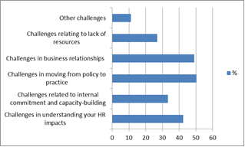
7. When asked about “eco-system support”, the most common responses were the need for training and educational opportunities, effective government enforcement of local law and multi-stakeholder initiatives. Other responses, although less common, included public benchmarking and legal requirements to conduct human rights due diligence
    - Companies were asked to select the top three areas of support that would be the most productive over the coming years in enabling companies to take forward the corporate responsibility to respect human rights. More than one in two of the respondents identified training and educational opportunities as a top priority for support (see Figure 8). Effective government enforcement of local law received the second highest number of respondents (45.75 per cent), followed by multi-stakeholder initiatives (39.22 per cent). This indicates the critical role of the rule of law in enforcing corporate respect for human rights, as well as the recognition that civil society and other multi-stakeholder initiatives play a role in ensuring that corporations understand and implement their human rights responsibilities. These findings were consistent among different sized companies.
Figure 9
Ranking ecosystem support (percentage, by size of business)
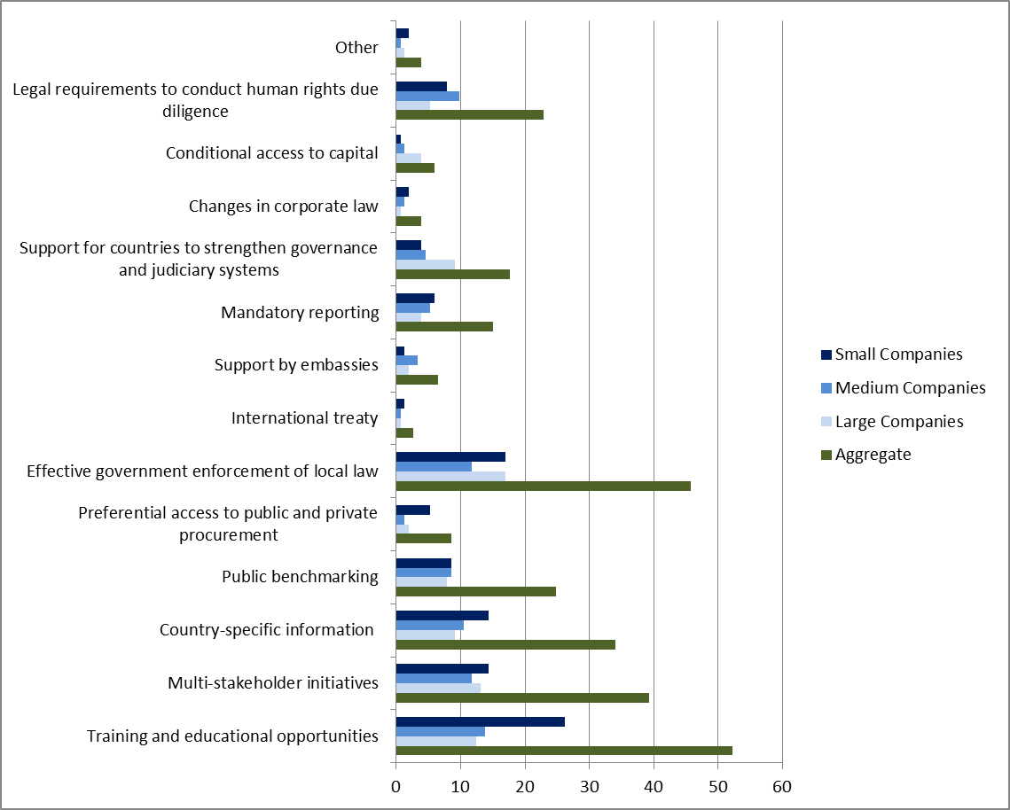
    - A third of the 153 respondents identified the need for greater availability of country-specific information on human rights risks to enable companies to carry out their corporate responsibility to respect human rights. Approximately a quarter of respondents recognized the value of public benchmarking on human rights performance. Just over a fifth acknowledged that legal requirements to conduct human rights due diligence may ensure that companies take forward the corporate responsibility to respect human rights.
    - Notably, a small number of respondents identified mandatory reporting requirements for companies in high-risk countries. This is an interesting finding given discussions about mandatory corporate human rights reporting, notably since the US State Department set requirements for some types of United States company operating in Myanmar after the lifting of economic sanctions.
    - In addition, respondents indicated very low support for “an international treaty on the responsibilities of companies in conflict areas”, with only 4 of the 153 companies selecting this option.
IX. Conclusions
    - This 2013 questionnaire has provided useful insights for the Working Group. In particular, the diversity of participants – in terms of geography, industry sector and size of businesses – indicates the global nature of engagement on human rights by business.
    - To summarize, for the majority of the 153 sampled businesses, both internal and external factors act as motivators to address human rights, which confirms existing assumptions. There is clear recognition by businesses of their responsibility to respect human rights from a risk management perspective but also because it is the right thing to do. One in two respondents questioned were aware of the Guiding Principles, have a public statement of human rights, and have actively engaged in human rights activity. Yet, while some companies have moved from policy to practice on human rights, doing so remains a major challenge.
    - Despite these useful insights, the small scale of the questionnaire and the fact that it was not randomized has limited the extent to which the results can be extrapolated and generalizations can be made at a global level. The results have therefore underscored the potential value of conducting a larger scale, randomized survey in the future in order to gather a solid baseline of credible and complete data to support the United Nations and other organizations as they continue their work to disseminate and implement the Guiding Principles.
    - Looking ahead, future questionnaires/surveys could take a two-tier approach to gather answers not only from company representatives with an interest in human rights at the management level, but also from CEOs and board level respondents, whose perceptions may differ and add additional value. This could be complemented by an institutional investor survey, given the critical role that this can play in driving corporate behaviour. While the questionnaire featured feedback from respondents from 39 countries, there was a skewed response in favour of European headquartered businesses. Consequently, a regional approach to the survey and/or its dissemination may be of value in achieving a more geographically balanced response in the future. In addition, a more detailed focus on the challenges facing businesses in the implementation of their responsibility to respect human rights may help lead to solutions.
    - The results from this questionnaire will help the Working Group and other business and human rights players to disseminate the Guiding Principles and ensure that corporations meet their responsibility to respect human rights. There is indicative demand for supporting businesses in the provision of business and human rights training and education, in particular for small businesses. Support is also required in the process of building in-house awareness of the business case for human rights, the need to communicate company progress transparently and develop grievance mechanisms. In addition, there may be demand to create learning materials to document good practice on internal and external communications and human rights reporting. Specific training and support could be tailored to the unique needs of smaller businesses, with an emphasis on the creation of human rights codes of conduct. Moreover, further emphasis could be placed on tools to disseminate the Guiding Principles in order to support companies in mapping their human rights risks at a geographical and sector level and in better understanding their indirect human rights impacts.
    - The questionnaire demonstrates the clear business interest and the ability of business associations and networks to stimulate interest in the topic of business and human rights. Approaches that leverage business associations and networks to raise support and continue awareness-raising activities to help ensure that corporations meet their responsibility to respect human rights are of integral strategic value to the Working Group.
    - The Working Group wishes to thank the companies that completed the questionnaire and the organizations that supported it, namely the Global Business Initiative on Human Rights, the International Chamber of Commerce, the International Organisation of Employers and the Corporations and Human Rights Database Project at the University of Denver.
    - All feedback is strongly encouraged and welcome. Please provide any comments that you have on this questionnaire to the Working Group, using the following e-mail address: wg-business@ohchr.org.

* * The summary of the present report is being circulated in all official languages. The report itself, contained in the annex to the summary, is being circulated in the language of submission only.
? Results from the 2012 questionnaire for business enterprises can be found at: http://www.ohchr.org/ Documents/Issues/Business/ForumSession1/Report_UNWGBusinessSurvey_Dec2012.pdf.
? See report of the Special Representative of the Secretary-General on the issue of human rights and transnational corporations and other business enterprises – Guiding Principles on Business and Human Rights: Implementing the United Nations “Protect, Respect and Remedy” Framework (A/HRC/17/31), available from: http://www.ohchr.org/documents/issues/business/A.HRC.17.31.pdf.
? Interest in the questionnaire was shown by non-business constituents. In the future, it may be useful to signpost them from the corporate questionnaire to the parallel surveys being undertaken for other stakeholders by the Working Group.

