 | United Nations | A/HRC/27/49
 | General Assembly |  | Distr.: General  4 August 2014  Original: English

Human Rights Council
Twenty–seventh session
Agenda item 3
Promotion and protection of all human rights, civil,
political, economic, social and cultural rights,
including the right to development
Report of the Working Group on Enforced or Involuntary Disappearances*
Summary
The Working Group on Enforced or Involuntary Disappearances was the first United Nations human rights thematic mechanism to be established with a universal mandate by resolution 20 (XXXVI) of 29 February 1980 of the Commission on Human Rights. The mandate was most recently extended by the Human Rights Council by its resolution 16/16 of 24 March 2011 and decision 25/116 of 27 March 2014.
The mandate of the Working Group is to assist families of disappeared persons to ascertain the fate and whereabouts of their disappeared relatives; and to monitor State’s compliance with their obligations deriving from the Declaration on the Protection of All Persons from Enforced Disappearance and to provide States with assistance in the implementation of those norms.
Since its inception, the Working Group has transmitted a total of 54,405 cases to 104 Governments. The number of cases under active consideration stands at 43,250 in a total of 88 States. The Working Group has been able to clarify 254 cases over the past five years.
The present report reflects the activities of and communications and cases examined by the Working Group on Enforced or Involuntary Disappearances covering the period 10 November 2012 to 16 May 2014.
Contents
Paragraphs Page
I. Introduction 1–8 3
II. Activities of the Working Group on Enforced or Involuntary Disappearances:
10 November 2012 to 16 May 2014 9–35 4
A. Activities 9–17 4
B. Meetings 18–19 5
C. Communications 20–25 5
D. Country visits 26–30 6
E. Follow–up reports and other procedures 31–32 6
F. Press releases and statements 33–54 7
G. Methods of work 55 9
III. Decisions on individual cases taken by the Working Group and communications
transmitted to the States concerned during the reporting period 10
IV. Observations 56–109 15
V. Conclusions and recommendations 110–123 23
Annexes
I. Country visit requests and invitations extended 26
II. Statistical summary: cases of enforced or involuntary disappearance reported to the Working
Group between 1980 and 2014, and general allegations transmitted 28
III. Graphs showing the number of cases of enforced disappearances per year and per country
according to the cases transmitted by the Working Group during the period
1980–16 May 2014 (only for countries with more than 100 cases transmitted) 33
I. Introduction
- The Working Group on Enforced or Involuntary Disappearances was the first United Nations human rights thematic mechanism to be established with a universal mandate. The original mandate derives from Commission on Human Rights resolution 20 (XXXVI) of 29 February 1980. The mandate was most recently extended by the Human Rights Council in its resolution 16/16 of 24 March 2011 and decision 25/116.
- The primary task of the Working Group is to assist families in determining the fate or whereabouts of their family members who are reportedly disappeared. In that humanitarian capacity, the Working Group serves as a channel of communication between family members of victims of enforced disappearance and other sources reporting cases of disappearances, and the Governments concerned.
- Following the adoption by the General Assembly of its resolution 47/133 and of the Declaration on the Protection of All Persons from Enforced Disappearance (hereinafter “the Declaration”), the Working Group was entrusted to monitor the progress of States in fulfilling their obligations derived from the Declaration. The Human Rights Council, in its resolution 7/12, encouraged the Working Group to provide assistance in the implementation by States of the Declaration and of existing international rules.
- The present report reflects the activities of and communications and cases examined by the Working Group covering the period from 10 November 2012 to 16 May 2014. A summary of the decisions on individual cases taken by the Working Group and communications transmitted to the States concerned during the reporting period is presented in a table (see sect. III).
- Since its inception, the Working Group has transmitted a total of 54,405 cases to Governments. The number of cases under active consideration that have not yet been clarified, closed or discontinued stands at 43,250 in a total of 88 States. The Working Group has been able to clarify 254 cases over the past five years.
- The Working Group is concerned that many communications from Governments are not still translated in time, thus delaying their consideration by the Working Group and limiting its humanitarian mandate.
- Information on the website of the Working Group remains inadequate. The majority of the content is in English only. The Working Group once again calls on the Office of the United Nations High Commissioner for Human Rights to provide adequate resources to bring it up to date and render it more accessible.
- The Working Group is grateful for the voluntary contributions provided by donor States, notably Argentina and France. It notes, however, that, despite the efforts made, almost 600 cases reporting allegations of enforced disappearances still need to be reviewed. The Working Group considers reducing the backlog of cases as one of its priorities. Given that the Working Group continues to regularly receive a high number of newly reported cases and taking into account all its other activities, it is essential that additional and sustained support be provided by the United Nations under its regular budget to fulfil the mandate.
II. Activities of the Working Group on Enforced or Involuntary Disappearances: 10 November 2012 to 16 May 2014
A. Activities
- During the period under review, the Working Group held five sessions: the ninety-ninth session, from 11 to 15 March 2013; the 100th session, from 15 to 19 July 2013; the 101st session, from 4 to 13 November 2013; the 102nd session, from 3 to 7 February 2014; and the 103rd session, from 7 to 16 May 2014. The 100th session was held in New York and the other sessions were held in Geneva.
- Further to its comments in its last annual report (A/HRC/22/45 and Corr.1, para. 5) the Working Group has adopted the practice of producing post-sessional documents to allow the translation of information on and timely reporting on its activities. It commenced the practice at its ninety-eighth session.
- Post-sessional documents were adopted and published after the ninety-ninth (A/HRC/WGEID/99/1); 100th (A/HRC/WGEID/100/1); 101st (A/HRC/WGEID/101/1); 102nd (A/HRC/WGEID/102/1); and 103rd (A/HRC/WGEID/103/1) sessions. Those post-sessional documents should be considered complements to the present annual report.
- The post of Chairperson-Rapporteur of the Working Group was held by Olivier de Frouville until 30 September 2013. As from 1 October 2013, the Chairperson-Rapporteur of the Working Group is Ariel Dulitzky. Osman El-Hajjé was elected Vice-Chairperson during the ninety-ninth session of the Working Group. Jeremy Sarkin completed his appointment as a member of the Working Group on 31 May 2014. A new member, Houria Es Slami, was appointed in May 2014 to replace Mr. Sarkin. The other member of the Working Group is Jasminka Dzumhur.
- On 5 March 2013, the Chairperson-Rapporteur presented the annual report of the Working Group for 2012 to the Human Rights Council at its twenty-second session, and participated in the interactive dialogue with Member States.
- On 24 October 2013, the Chairperson-Rapporteur of the Working Group addressed the General Assembly at its sixty-eighth session and participated in the interactive dialogue with Member States. That was the second consecutive time that the Chairperson-Rapporteur of the Working Group addressed the General Assembly, which was highly valued and appreciated.
- On 15 July 2013, the Working Group held a commemorative event marking its 100th session, which provided an opportunity to reflect on the achievements made during the first 100 sessions and the challenges that may lie ahead in countering the crime of enforced disappearance.
- On 8 November 2013, an expert consultation on enforced disappearance and economic, social and cultural rights was held. During the half-day thematic discussion, experts from various regions of the world exchanged views on the indivisibility of human rights and the relationship between enforced disappearance and economic, social and cultural rights. The Working Group is currently preparing a study on the linkages between enforced disappearance and economic, social and cultural rights.
- During the reporting period, all the members of the Working Group carried out a number of activities connected to enforced disappearance, which included their participation in conferences, consultations, seminars, training events, workshops and lectures, organized by Governments and/or civil society organizations.
B. Meetings
- During the period under review, representatives of the Governments of Algeria (100th), Angola (102nd), Bahrain (ninety-ninth), Colombia (ninety-ninth), Cyprus (101st), Ecuador (101st), Japan (ninety-ninth, 100th, 101st, 102nd and 103rd), Morocco (102nd), the Republic of Korea (101st), the Sudan (ninety-ninth), Sri Lanka (ninety-ninth), and Togo (102nd) attended the sessions of the Working Group. A number of informal meetings were also held with representatives from various States. The Working Group expresses its appreciation to those Governments for the meetings and emphasizes the importance of cooperation and dialogue.
- The Working Group also met with the Committee on Enforced Disappearances, representatives of international governmental organizations, relatives and associations of relatives of disappeared persons, and non-governmental organizations.
C. Communications
- During the reporting period, the Working Group transmitted 418 new cases of enforced disappearance to 42 States.
- The Working Group transmitted 93 of the above-mentioned cases under the urgent action procedure to Bahrain, Bangladesh, Cambodia, China, the Dominican Republic, Egypt, India, Indonesia, Iraq, Kenya, Mexico, Nepal, Pakistan, Peru, Saudi Arabia, Senegal, the Syrian Arab Republic, Tajikistan, Thailand, the United Arab Emirates and Yemen.
- The Working Group clarified 47 cases, in Bahrain (4), Chile (5), China (2), Colombia (1), Egypt (1), Mexico (1), Morocco (1), Namibia (1), Pakistan (3), Saudi Arabia (1), Sri Lanka (6), Switzerland (1), the Syrian Arab Republic (2), Tajikistan (1), the United Arab Emirates (16) and Uzbekistan (1). Of the 47 cases, 16 were clarified on the basis of information provided by Governments, and 31 on the basis of information provided by sources.
- The Working Group transmitted 25 prompt intervention communications addressing allegations of harassment of and/or threats to human rights defenders and relatives of disappeared persons in Algeria, Angola, Bangladesh, Colombia, El Salvador, Guatemala, Kenya, Mexico, Nepal, Pakistan, Sri Lanka and Thailand.
- It transmitted 35 urgent appeals concerning persons who had been arrested, detained, abducted or otherwise deprived of their liberty or who had been forcibly disappeared or were at risk of disappearance in Algeria, Bahrain, Bangladesh, China, Egypt, Gambia, Iraq, Kazakhstan, the Lao People’s Democratic Republic, Mexico, Norway, the Russian Federation, the Sudan, the Syrian Arab Republic, Ukraine and the United Arab Emirates.
- The Working Group transmitted 14 general allegations, to the Governments of Algeria, Bosnia and Herzegovina, the Central African Republic, Colombia, Guatemala, India, Indonesia, Libya, Mexico, Morocco, Spain, Sri Lanka and Uruguay.
D. Country visits
- At the invitation of the Government, the Working Group, represented by Ariel Dulitzky and Jasminka Dzumhur, visited Spain from 23 to 30 September 2013. The report on the visit to Spain is contained in an addendum to the present report (A/HRC/27/45/Add.1). The Working Group thanks the Government for the cooperation extended to it, before and during its visit to the country.
- At the invitation of the Governments of Croatia, Montenegro and Serbia, the Working Group visited the Western Balkans in June 2014. The Working Group thanks the States that have extended invitations to the Working Group to visit their countries. The Governments of Algeria and Peru invited the Working Group to undertake a visit in 2014.
- During the reporting period, the Working Group requested visits to Bangladesh, China, Kenya, Peru, the Philippines, Turkey and the United Arab Emirates.
- The Working Group has requested a visit to the following countries, without having yet received a positive response: Bangladesh, Belarus, Burundi, China, Egypt, India, Indonesia, Kenya, Nepal, Nicaragua, the Philippines, the Russian Federation, South Sudan, Sri Lanka, the Sudan, the Syrian Arab Republic, Thailand, Turkey, the United Arab Emirates, Uzbekistan and Zimbabwe. The Working Group invites all States that have received a request for a visit by the Working Group to respond favourably to it, in accordance with Human Rights Council resolution 21/4.
- The Working Group recalls the fact that the Islamic Republic of Iran agreed to a visit by the Working Group in 2004, which was delayed at the request of the Government. The Working Group calls upon the Government to set the dates for the visit.
E. Follow–up reports and other procedures
- The Working Group prepared follow-up reports on the implementation of recommendations made following its visits to Argentina and Bosnia and Herzegovina. The follow-up reports are contained in an addendum to the present report (A/HRC/27/45/Add.3).
Referral of claims of crimes against humanity to other bodies
- As highlighted in its methods of work (A/HRC/WGEID/102/2, para. 48) and its general comment on enforced disappearance as a crime against humanity (A/HRC/13/31 and Corr.1, para. 39), when there are claims of practices of enforced disappearances which may amount to crimes against humanity, the Working Group evaluates those claims and, if appropriate, may refer them to the competent authorities, be they international, regional or domestic. In the light of the seriousness of the situation in relation to enforced disappearances in the Syrian Arab Republic (A/HRC/WGEID/102/1, paras. 156 and 157), and in the Democratic People’s Republic of Korea (A/HRC/WGEID/103/1, paras. 67 and 68), the Working Group wrote to the President of the Human Rights Council, the President of the General Assembly, the President of the Security Council and the Secretary-General to request the adoption of any appropriate action that they may deem appropriate. In particular, the Working Group requested the President of the Security Council to bring the matters to the attention of the Council for any appropriate action, including a possible referral to the International Criminal Court. The Working Group informed the respective Governments of that step in letters dated 5 March 2014 and 12 June 2014, respectively.
F. Press releases and statements
- On 8 November 2012, the Working Group, jointly with the Committee on Enforced Disappearances, issued a statement on the occasion of the second meeting between the two bodies held on 1 November 2012.
- On 18 December 2012, the Working Group issued a press statement on the occasion of the twentieth anniversary of the Declaration, noting that enforced disappearances continued to occur in several countries across the globe, notably in situations of conflict or internal unrest or as a tool to fight terrorism or organized crime.
- On 8 May 2013, the Working Group issued a press release, urging all Governments to ratify the Optional Protocol to the International Covenant on Economic, Social and Cultural Rights.
- On 10 June 2013, the Working Group issued a press release welcoming the recognition of the importance of equality in a key United Nations report on the post-2015 development agenda.
- On 19 July 2013, the Working Group issued a press release on the occasion of its 100th session, calling for new strategies to fight the crime of enforced disappearance.
- On 29 August 2013, the Working Group, jointly with the Committee on Enforced Disappearances, issued a press release on the occasion of the third International Day of the Victims of Enforced Disappearances.
- On 24 October 2013, a press release was issued on the occasion of the address to the General Assembly of its Chairperson-Rapporteur and the Chairperson of the Committee on Enforced Disappearances.
- On 13 November 2013, the Working Group issued a press release regarding the launch of its study on the causes and effects of enforced disappearance on the economic, social and cultural rights of the victims, families and human rights defenders.
- On 15 November 2013, the Working Group, jointly with the Committee on Enforced Disappearances, issued a statement on the occasion of the third meeting between the two bodies, held on 7 November 2013.
- On 22 November 2013, the Working Group issued a press release on the occasion of the International Day to End Impunity.
- During the reporting period, the Working Group also issued press releases — most of them jointly with other mandate holders — concerning the Central African Republic, China, the Democratic People’s Republic of Korea, Guatemala, Iraq, the Lao People’s Democratic Republic, Spain, the Syrian Arab Republic, Thailand and Uruguay.
- On 28 February 2013, the Working Group issued a press release concerning allegations of serious human rights violations, including enforced disappearances, in the context of an extensive labour camp system for political prisoners in the Democratic People’s Republic of Korea.
- On 18 April 2013 and 15 May 2013, the Working Group issued two press releases concerning the trial for genocide and crimes against humanity of José Efraín Ríos Montt and José Mauricio Rodríguez Sánchez in Guatemala.
- On 25 June 2013, the Working Group issued a press release regarding the rulings of the Supreme Court of Justice of Uruguay that led to the closure of at least two cases in which serious allegations of torture, enforced disappearances and killings committed during the dictatorship in the 1970s and 1980s were being investigated.
- On 5 August 2013, the Working Group issued a press release concerning the situation of human rights in the Central African Republic.
- On 30 September 2013, the Working Group issued a press release at the end of its official visit to Spain.
- On 16 October 2013, the Working Group issued a press release concerning alleged reprisals against activists linked to the universal periodic review of China.
- On 9 December 2013, the Working Group issued a press release urging the Government of Iraq to establish the fate and whereabouts of the seven residents of Camp Ashraf, allegedly abducted in September 2013.
- On 16 December 2013, the Working Group issued a press release urging the Government of the Lao People’s Democratic Republic to increase its efforts to investigate the enforced disappearance on 15 December 2012 of Sombath Somphone.
- On 11 March 2014, the Working Group issued a press release calling on the Government of Thailand to establish the truth and hold criminally responsible the perpetrators of the disappearance of human rights defender Somchai Neelaphaijit, 10 years after his disappearance.
- On 18 March 2014, the Working Group issued a press release expressing dismay at the death of Shunli Cao, a prominent human rights lawyer in China, who had tirelessly campaigned since 2008 for transparency and greater participation of civil society in the second universal periodic review of China.
- On 20 March 2014, the Working Group issued a press release calling for action by the highest United Nations bodies to tackle enforced disappearances as crimes against humanity in the Syrian Arab Republic.
G. Methods of work
- During its 102nd session, on 7 February 2014, the Working Group adopted the revised methods of work (A/HRC/WGEID/102/2), which, taking into account the evolving nature and new dimensions of the crime of enforced disappearance, render the Working Group more efficient and enable it to respond more swiftly to urgent matters, including transmitting information received on outstanding cases and other communications more promptly.

III. Decisions on individual cases taken by the Working Group and communications transmitted to the States concerned during the reporting period
Countries | Number of outstanding cases at the beginning of the period under review | Cases transmitted to the Government during the reporting period |  | Cases clarified during the period under review by |  | Number of cases of possible clarification by Government (6–month rule) | Number of outstanding cases at the end of the period under review | Communications sent during the period under review |  |  | Communications received during the period under review
Countries |  | Urgent actions | Standard cases | Government | Sources |  |  | Prompt intervention letter | Urgent appeal | General allegation | Response to prompt intervention letter | Response to urgent appeal | Response to general allegation
Afghanistan | 3 | - | - | - | - | - | 3 | - | - | - | - | - | -
Albania | 1 | - | - | - | - | - | 1 | - | - | - | - | - | -
Algeria | 3,005 | - | 41 | - | - | - | 3,047 | 3 | 1 | 1 | 2 |  | 1
Angola | 0 | - | 2 | - | - | - | 2 | 2 | - | - | 2 | - | -
Argentina | 3,271 | - | - | - | - | 1 | 3,271 | - | - | - | - | - | -
Bahrain | 1 | 6 | - | 1 | 3 | 1 | 3 | - | 2 | - | - | 2* | -
Bangladesh | 11 | 2 | 2 | - | - | - | 15 | 1 | 3 | - | - | - | -
Belarus | 3 | - | - | - | - | - | 3 | - | - | - | - | - | -
Bhutan | 5 | - | - | - | - | - | 5 | - | - | - | - | - | -
Bolivia (Plurinational State of) | 28 | - | - | - | - | - | 28 | - | - | - | - | - | -
Bosnia and Herzegovina | 0 | - | - | - | - | - | 0 | - | - | 1 | - | - | 4
Brazil | 13 | - | - | - | - | - | 13 | - | - | - | - | - | -
Burundi | 52 | - | - | - | - | - | 52 | - | - | - | - | - | -
Cambodia | 0 | 1 | - | - | - | - | 1 | - | - | - | - | - | -
Cameroon | 14 | - | - | - | - | - | 14 | - | - | - | - | - | -
Central African Republic | 3 | - | - | - | - | - | 3 | - | - | 1 | - | - | -
Chad | 23 | - | - | - | - | - | 23 | - | - | - | - | - | -
Chile | 801 | - | - | 5 | - | 15 | 796 | - | - | - | - | - | -
China | 30 | 7 | 2 | - | 2 | - | 37 | - | 8 | - | - | 10* | 1
Colombia | 969 | - | 3 | 1 | - | - | 971 | 3 | - | 1 | 2 | - | 2
Congo | 88 | - | - | - | - | - | 88 | - | - | - | - | - | -
Democratic People’s Republic of Korea | 20 | - | 27 | - | - | - | 47 | - | - | - | - | - | -
Democratic Republic of the Congo | 44 | - | 1 | - | - | - | 45 | - | - | - | - | - | -
Dominican Republic | 1 | 1 | - | - | - | - | 2 | - | - | - | - | - | -
Ecuador | 4 | - | 1 | - | - | - | 5 | - | - | - | - | - | -
Egypt | 41 | 3 | 9 | - | 1 | - | 52 | - | 1 | - | - | 1 | -
El Salvador | 2,271 | - | 6 | - | - | - | 2,277 | 2 | - | - | 1 | - | -
Equatorial Guinea | 8 | - | - | - | - | - | 8 | - | - | - | - | - | -
Eritrea | 54 | - | - | - | - | - | 54 | - | - | - | - | - | -
Ethiopia | 112 | - | - | - | - | - | 112 | - | - | - | - | - | -
France | 1 | - | - | - | - | - | 1 | - | - | - | - | - | -
Gambia | 1 | - | 2 | - | - | - | 3 | - | 1 | - | - | - | -
Georgia | 1 | - | - | - | - | - | 1 | - | - | - | - | - | -
Greece | 1 | - | - | - | - | - | 1 | - | - | - | - | - | -
Guatemala | 2,899 | - | - | - | - | - | 2,899 | 2 | - | 1 | - | - | 1
Guinea | 21 | - | 16 | - | - | - | 37 | - | - | - | - | - | -
Haiti | 38 | - | - | - | - | - | 38 | - | - | - | - | - | -
Honduras | 129 | - | - | - | - | - | 129 | - | - | - | - | - | -
India | 353 | 1 | - | - | - | - | 354 | - | - | 1 | - | 1 | -
Indonesia | 162 | 1 | - | - | - | - | 163 | - | - | 1 | - | - | -
Iran (Islamic Republic of Iran) | 518 | - | - | - | - | - | 518 | - | - | - | - | 1 | -
Iraq | 16,401 | 7 | - | - | - | - | 16,408 | - | 1 | - | - | - | -
Israel | 2 | - | - | - | - | - | 2 | - | - | - | - | - | -
Jordan | 2 | - | - | - | - | - | 2 | - | - | - | - | 1 | -
Kazakhstan | 0 | - | - | - | - | - | 0 | - | 1 | - | - | 1* | -
Kenya | 40 | 1 | 19 | - | - | - | 60 | 2 | - | - | - | - | -
Kuwait | 1 | - | - | - | - | - | 1 | - | - | - | - | - | -
Lao People’s Democratic Republic | 1 | - | 1 | - | - | - | 2 | - | 1 | - | - | 3 | -
Lebanon | 313 | - | - | - | - | - | 313 | - | - | - | - | - | -
Libya | 9 | - | 1 | - | - | - | 10 | - | - | 1 | - | - | -
Mauritania | 3 | - | 1 | - | - | - | 4 | - | - | - | - | - | -
Mexico | 327 | 1 | 32 | - | 1 | - | 359 | 3 | 1 | 2 | 4 | - | -
Morocco | 53 | - | 8 |  | 1 | - | 60 | - | - | 1 | - | - | 1
Mozambique | 2 | - | - | - | - | - | 2 | - | - | - | - | - | -
Myanmar | 1 | - | 1 | - | - | - | 2 | - | - | - | - | - | -
Namibia | 3 | - | - | - | 1 | - | 2 | - | - | - | - | - | -
Nepal | 458 | 1 | - | - | - | - | 459 | 1 | - | - | - | - | -
Norway | 0 | - | - | - | - | - | 0 | - | 1 | - | - | 1* | -
Nicaragua | 103 | - | - | - | - | - | 103 | - | - | - | - | - | -
Pakistan | 99 | 24 | 31 | - | 3 | - | 151 | 1 | - | - | - | - | -
Peru | 2371 | 1 | - | - | - | - | 2370 | - | - | - | - | - | -
Philippines | 621 | - | 4 | - | - | - | 625 | - | - | - | - | - | -
Russian Federation | 471 | - | - | - | - | - | 471 | - | 3 | - | 1 | 1* | -
Rwanda | 21 | - | - | - | - | - | 21 | - | - | - | - | - | -
Saudi Arabia | 4 | 1 | 2 | - | 1 | - | 6 | - | - | - | - | - | -
Senegal | 0 | 1 | - | - | - | - | 1 | - | - | - | - | - | -
Seychelles | 3 | - | - | - | - | - | 3 | - | - | - | - | - | -
Somalia | 1 | - | - | - | - | - | 1 | - | - | - | - | - | -
South Africa | 0 | - | 1 | - | - | - | 1 | - | - | - | - | - | -
South Sudan | 1 | - | - | - | - | - | 1 | - | - | - | - | - | -
Spain | 3 | - | 3 | - | - | - | 6 | - | - | 1 | - | - | -
Sri Lanka | 5676 | - | 63 | 6 | - | 8 | 5731 | 4 | - | 1 | 2 | - | 2
Sudan | 173 | - | - | - | - | - | 173 | - | 2 | - | - | 2 | -
Switzerland | 1 | - | - | 1 | - | - | 0 | - | - | - | - | - | -
Syrian Arab Republic | 72 | 13 | 19 | - | 2 | - | 102 | - | 5 | - | - | 4 | -
Tajikistan | 4 | 1 | - | 1 | - | 1 | 4 | - | - | - | - | - | -
Thailand | 71 | 2 | 9 | - | - | - | 81 | 1 | - | - | - | - | -
Timor-Leste | 428 | - | - | - | - | - | 428 | - | - | - | - | - | -
Togo | 10 | - | - | - | - | - | 10 | - | - | - | - | - | -
Tunisia | 2 | - | - | - | - | - | 2 | - | - | - | - | - | -
Turkey | 60 | - | 2 | - | - | 1 | 62 | - | - | - | - | - | -
Turkmenistan | 1 | - | - | - | - | - | 1 | - | - | - | - | - | -
Uganda | 15 | - | - | - | - | - | 15 | - | - | - | - | - | -
Ukraine | 4 | - | - | - | - | - | 4 | - | 2 | - | - | 1* | -
United Arab Emirates | 5 | 12 | 11 | - | 16 | - | 12 | - | 2 | - | - | 2 | -
Uruguay | 19 | - | - | - | - | - | 19 | - | - | 1 | - | - | 1
Uzbekistan | 8 | - | - | 1 | - | - | 7 | - | - | - | - | - | -
Venezuela (Bolivarian Republic of) | 10 | - | 2 | - | - | - | 12 | - | - | - | - | - | -
Viet Nam | 1 | - | - | - | - | - | 1 | - | - | - | - | - | -
Yemen | 2 | 6 | 2 | - | - | - | 10 | - | - | - | - | - | -
Zimbabwe | 4 | - | - | - | - | - | 4 | - | - | - | - | - | -
State of Palestine | 3 | - | 1 | - | - | - | 4 | - | - | - | - | - | -

IV. Observations
- In addition to the observations formulated in its post-sessional documents (see para. 11 above), the Working Group makes the following country-specific observations based on the cooperation received and on significant developments regarding its mandate during the whole reporting period.
Algeria
- The Working Group expresses its appreciation to the Government for the invitation extended to it to undertake a visit to the country during the second semester of 2014 and looks forward to the confirmation of dates for the visit, based on the three options provided by the Working Group in its note verbale dated 13 May 2014.
- The Working Group notes with concern that it has transmitted three prompt intervention letters during the reporting period concerning the alleged excessive use of force and arrest of relatives of victims of enforced disappearances participating in peaceful protests (see A/HRC/WGEID/100/1, para. 9, and A/HRC/WGEID/101/1, paras. 9–10). While thanking the Government for its responses to two of the communications, the Working Group recalls article 13, paragraph 3, of the Declaration, which provides that steps shall be taken to ensure that all involved in the investigation of an enforced disappearance, including the complainant, counsel, witnesses and those conducting the investigation, are protected against ill-treatment, intimidation or reprisal. It would also like to recall Human Rights Council resolution 21/4, in which the Council urged States to take steps to provide adequate protection to, among others, human rights defenders acting against enforced disappearances and families of disappeared persons against any intimidation, persecution, reprisals or ill-treatment
- The Working Group thanks the Government for the reply to the general allegation sent on 30 December 2013, concerning the discovery of a mass grave near Ras El-Ma, Azzaba in the Wilaya of Skikda (A/HRC/WGEID/102/1, para. 30). The Working Group encourages the Government to continue the investigations, identify the remains and keep the relatives and the Working Group informed of the results. In that respect, the Working Group recalls article 13, paragraph 4, of the Declaration which provides that the findings of investigation into cases of enforced disappearances shall be made available upon request to all persons concerned, unless doing so would jeopardize an ongoing criminal investigation.
Bahrain
- The Working Group is concerned that, during the reporting period, it transmitted to the Government six cases under its urgent action procedure (A/HRC/WGEID/102/1, paras. 33–35, and A/HRC/WGEID/103/1, paras. 36–37) and two urgent appeals (A/HRC/WGEID/101/1, para. 20, and A/HRC/WGEID/102/1, para. 38). While the Working Group appreciates that the Government has replied to most communications and notes that four cases have been clarified, it is concerned at what seems to be a recent pattern of short-term disappearances. The Working Group recalls articles 7 (“no circumstances whatsoever … may be invoked to justify enforced disappearances”) and 10 (“accurate information on the detention of such persons and their place or places of detention, including transfers, shall be made promptly available to their family members, their counsel or to any other persons having a legitimate interest in the information”) of the Declaration.
Bangladesh
- The Working Group regrets that no reply has been received to three urgent appeals and one prompt intervention letter transmitted during the reporting period (A/HRC/WGEID/99/1, para. 17; A/HRC/WGEID/100/1, paras. 16–17; and A/HRC/WGEID/103/1, para. 42). It also regrets that no information has been received from the Government in connection with a general allegation transmitted on 4 May 2011, concerning the alleged frequent use of enforced disappearance as a tool by law enforcement agencies, paramilitary and armed forces to detain and even extrajudicially execute individuals (see A/HRC/22/45, para. 33). The Working Group is concerned about the reported harassment against and detention of Adilur Rahman Khan, the Secretary of Odhikar, a human rights non-governmental organization which reports on cases of enforced disappearances and works with the families of disappeared persons (A/HRC/WGEID/103/1, para. 42).
- On 12 March 2013, the Working Group requested an invitation to undertake a visit to the country. The Working Group hopes that a positive reply can be received soon.
Belarus
- The Working Group regrets that, during the reporting period, the Government of Belarus reported that it will no longer be able to take part in the consideration of three specific cases. The Working Group hopes that the Government will resume its cooperation with the mechanism and recalls in that respect Human Rights Council resolution 21/4,in which the Council urged States to cooperate with the Working Group to help it to carry out its mandate effectively.
- On 30 June 2011, the Working Group requested an invitation to undertake a visit to the country. Despite a reminder sent in 2013, no response yet has been received from the Government. The Working Group hopes that a positive reply will be received soon.
Bosnia and Herzegovina
- The Working Group thanks the Government for its substantive responses to the general allegations transmitted on 15 May 2009 and 4 May 2011. Concerning the response to the general allegation dated 4 May 2011 (A/HRC/WGEID/99/1, paras. 25–26), regarding the Government’s alleged failure to clarify the fate and whereabouts of the victims of the Korićanske Stijene massacre, the Working Group reiterates its request to be informed of the results of the pending criminal proceedings of those accused of committing the crime of enforced disappearance.
- With respect to the general allegation sent on 1 April 2014 (A/HRC/WGEID/103/1, para. 43), concerning the effect of the decision of the Constitutional Court in 2013 to order the quashing of the verdicts in the cases of 10 individuals convicted of war crimes against civilians and genocide as a result of an automatic application of a European Court of Human Rights decision, the Working Group reiterates that enforced disappearance is a continuous crime and thus can be punished on the basis of an ex post legislation without violating the principle of non-retroactivity, for as long as the fate or the whereabouts of the disappeared person has not been clarified (A/HRC/16/48/Add.1, para. 57; see also the Working Group’s general comment on enforced disappearance as a continuous crime, A/HRC/16/48, para. 39).
- The follow-up report on the implementation of the recommendations made by the Working Group after its visit to Bosnia and Herzegovina in 2010 (A/HRC/16/48/Add.1) can be found in document A/HRC/27/49/Add.3. The Working Group thanks the Government of Bosnia and Herzegovina for its cooperation throughout the process.
Central African Republic
- The Working Group is deeply concerned at the situation in the Central African Republic, as reflected by a general allegation transmitted and a press release issued, respectively, on 16 July and 5 August 2013 (A/HRC/WGEID/100/1, para. 21, and A/HRC/WGEID/101/1, para. 23), highlighting the numerous human rights violations occurring in the country, including enforced disappearances. Although the Working Group has not received many allegations of enforced disappearance under its different procedures, it is concerned that the situation has continued to deteriorate towards a total breakdown of law and order, which may facilitate the occurrence of multiple human rights violations, including enforced disappearances.
China
- The Working Group thanks the Government for the high number of replies transmitted to the Working Group. Nonetheless, the Working Group is concerned that during the reporting period it has transmitted seven cases under its urgent action procedure (A/HRC/WGEID/99/1, paras. 29–30, and A/HRC/WGEID/103/1, para. 46), eight urgent appeals (A/HRC/WGEID/99/1, para. 31; A/HRC/WGEID/100/1, paras. 23–24; A/HRC/WGEID/101/1, paras. 26–28; and A/HRC/WGEID/102/1, para. 43) and has issued two press releases in relation to the crackdown against human rights defenders prior to the presentation to the Human Rights Council made during its universal periodic review and the death of Shunli Cao (see paras. 49 and 53 above). The Working Group is also concerned about the case of human rights lawyer Zhisheng Gao who has been repeatedly disappeared since 2006, and is now reportedly being held incommunicado since 12 January 2013. The Working Group recalls articles 2 (“no State shall practise, permit or tolerate enforced disappearances”), 7 (“No circumstances whatsoever … may be invoked to justify enforced disappearances”) and 10 (“accurate information on the detention of such persons and their place or places of detention, including transfers, shall be made promptly available to their family members, their counsel or to any other persons having a legitimate interest in the information”) of the Declaration.
- On 19 February 2013, the Working Group requested an invitation to undertake a visit to the country. The Working Group hopes that a positive reply can be received soon.
Colombia
- The Working Group thanks the Government for the substantive replies dated 4 April and 9 April 2014 to the general allegation transmitted by the Working Group after its 101st session concerning, inter alia, the alarming figures of enforced disappearances, the worrying number of human rights defenders victim to that practice in recent years and shortcomings regarding the search of the disappeared, the protection of the relatives and accountability for that crime (A/HRC/WGEID/101/1, paras. 33–41). In that respect, the Working Group, while recognizing the measures adopted to address those issues, encourages the Government to strengthen the measures adopted, intensify the dialogue with the families, speed up the process for the identification of remains and strengthen its efforts to combat impunity.
Democratic People’s Republic of Korea
- The Working Group is particularly concerned about the extent and scale of enforced disappearance in the Democratic People’s Republic of Korea, as also highlighted by the work of the commission of inquiry on human rights in the Democratic People’s Republic of Korea (A/HRC/25/63, paras. 75–76), which has revealed the nature of crime against humanity of enforced disappearances that have been committed and are ongoing in the country. Consequently, the Working Group has decided to call for action by the highest United Nations bodies to tackle the issue and, in particular, has requested the Security Council to consider referring the matter to the International Criminal Court (see para. 32 above).
- The Working Group regrets that no reply has been received to the general allegation dated 3 October 2012 concerning reports of serious human rights violations, including enforced disappearances, in the context of an extensive labour camp system for political prisoners. In that respect, and in relation to the nature of the replies received from the Government concerning the cases outstanding before it, the Working Group recalls Human Rights Council resolution 21/4, which urges States to cooperate with the Working Group to help it to carry out its mandate effectively.
Egypt
- The Working Group is concerned that during the reporting period, it transmitted three cases under the urgent action procedure (A/HRC/WGEID/103/1, paras. 72–75). The Working Group is concerned that the situation continues to deteriorate in Egypt, which may facilitate the occurrence of multiple human rights violations, including enforced disappearance, and recognizes the need for the Government to adopt measures to secure truth, justice and reconciliation.
- On 30 June 2011, the Working Group requested an invitation to undertake a visit to the country. No response yet has been received from the Government in spite of reminders sent. The Working Group hopes that a positive reply will be received soon.
Guatemala
- The Working Group thanks the Government for the substantive reply dated 12 March 2014 to the general allegation transmitted after its 101st session concerning, inter alia, the risk of jeopardizing the progress on the investigation of cases of enforced disappearances owing to the Government’s stance that it is not possible to investigate enforced disappearances committed during the armed conflict, given that the crime of enforced disappearance was not punishable by law at the time and because such cases would be subject to a statute of limitations (A/HRC/WGEID/101/1, paras. 55–64). In that respect, the Working Group recalls article 13, paragraph 6 (“an investigation … should be able to be conducted for as long as the fate of the victim of enforced disappearance remains unclarified”); article 17, paragraph 1 (“acts constituting enforced disappearance shall be considered a continuing offence as long as perpetrators continue to conceal the fate and the whereabouts of persons who have disappeared and these facts remain unclarified”); and article 18, paragraph 1 (“persons who have or are alleged to have committed [acts of enforced disappearance] shall not benefit from any special amnesty law or similar measures that might have the effect of exempting them from any criminal proceedings or sanction”) of the Declaration.
- The Working Group also reiterates that the establishment of truth and justice are fundamental elements both for reparation for the victims and to ensure the non-recurrence of the heinous crimes that characterized the civil war, including enforced disappearances. In that respect, it expresses concern about the developments in the trial for genocide and crimes against humanity of the former head of State, José Efraín Ríos Montt, and the uncertainty caused regarding the right to truth and justice of victims. It is also concerned about possible acts of intimidation and interference in the work of the judiciary in that case.
Indonesia
- The Working Group regrets that no reply has been received to the general allegation dated 19 December 2013 concerning the lack of implementation of the Parliament’s recommendations to the President and the Government in relation to the issue of enforced disappearances between 1997 and 1998 (A/HRC/WGEID/101/1, paras. 71–74). The Working Group urges the Government to adopt measures to ensure the rights to truth, justice and reparations for victims of enforced disappearances.
- On 12 December 2006, the Working Group requested an invitation to undertake a visit to the country. No positive response yet has been received from the Government in spite of reminders sent. The Working Group hopes that a positive reply will be received soon.
Iraq
- While thanking the Government for the information it submitted on 3 January 2014 regarding the case of seven residents of Camp Ashraf (A/HRC/WGEID/101/1, para. 76), including six women, allegedly abducted in September 2013 after an attack in which 52 persons were killed, the Working Group reiterates that the information is not sufficient to clarify the cases and urges the Government of Iraq to continue its investigations, establish the fate and whereabouts of the individuals concerned, ensure that the perpetrators are held accountable and publish the results of relevant investigations.
Islamic Republic of Iran
- The Working Group reiterates its hope that a final date will be agreed in the near future for the visit which was agreed to in 2004 and recalls Human Rights Council resolution 21/4, which urges States to cooperate with the Working Group to help it to carry out its mandate effectively and, in that framework, to give serious consideration to responding favourably to its requests for visits to their countries.
Lao People’s Democratic Republic
- While thanking the Government for its replies to the communications concerning Sombath Somphone, the Working Group reiterates its deep concern about his safety and integrity and encourages the Government to continue its investigations into the case and keep the Working Group informed thereof.
Libya
- The Working Group regrets that its planned visit in 2013 did not transpire because of the security situation in the country. The Working Group hopes to be able to visit the country in not too distant future.
Kenya
- The Working Group is concerned at the lack of replies from the Government to its communications. It recalls Human Rights Council resolution 21/4, in which the Council urges States to cooperate with the Working Group to help it to carry out its mandate effectively. During the reporting period, the Working Group transmitted to the Government one case under its urgent action procedure and two prompt intervention letters in which it expressed deep concern about the alleged killing of a human rights lawyer and the harassment and intimidation of families of victims of enforced disappearance (A/HRC/WGEID/99/1, para. 68, and A/HRC/WGEID/101/1, paras. 80–81).
- On 19 February 2013, the Working Group requested an invitation to undertake a visit to the country. The Working Group hopes that a positive reply will be received soon.
Morocco
- The Working Group thanks the Government for the reply dated 20 February 2014 to the general allegation transmitted by the Working Group after its 101st session concerning the discovery of the remains of eight persons who had seemingly been buried in a mass grave in Fadret Leguiaa (A/HRC/WGEID/101/1, paras. 96–103). In that respect, the Working Group emphasizes that the families of victims have a right to the truth as delineated in the general comment of the Working Group on the right to the truth in relation to enforced disappearance (A/HRC/16/48, para. 39), as well as the importance of a full and independent investigation into the allegations of enforced disappearances. It also recalls article 13, paragraph 4, of the Declaration, which provides that the findings of investigation on cases of enforced disappearances shall be made available upon request to all persons concerned, unless doing so would jeopardize an ongoing criminal investigation.
Nepal
- The Working Group continues to monitor the situation in Nepal concerning the establishment of a truth commission and a commission on enforced disappearance and it recalls that amnesties should not be granted for mass violations of human rights. The Working Group had already expressed its concern on the issue in the follow-up report to the recommendations made in the report of its visit to Nepal in 2004 (A/HRC/19/58/Add.4) and a letter sent to the Government of Nepal on 21 March 2013.
- On 12 May 2006, the Working Group requested an invitation to undertake a follow-up visit to the country. No positive response yet has been received from the Government in spite of reminders sent. The Working Group hopes that a positive reply will be received soon.
Pakistan
- The Working Group is concerned that, during the reporting period, it transmitted to the Government 24 cases under its urgent action procedure. It reiterates that, as provided in article 7 of the Declaration, no circumstances whatsoever may be invoked to justify enforced disappearances.
Philippines
- The Working Group welcomes the enactment of the Anti-Enforced or Involuntary Disappearance Act in December of 2012, which makes the Philippines the first country in Asia to criminalize enforced and involuntary disappearances. At the same time, the Working Group encourages the Government to ensure effective implementation of the Act by taking all necessary measures, including, but not limited to, legal, policy and institutional reforms.
- On 3 April 2008, the Working Group requested an invitation to undertake a visit to the country. No response yet has been received from the Government in spite of reminders sent. The Working Group hopes that a positive reply will be received soon.
Russian Federation
- The Working Group is concerned that it transmitted three urgent appeals during the reporting period (A/HRC/WGEID/101/1, para. 127; A/HRC/WGEID/102/1, para. 104; and A/HRC/WGEID/103/1, para. 131) and reminds the Government of its obligations to prevent and eradicate enforced disappearance and that, as provided in article 7 of the Declaration, no circumstances whatsoever may be invoked to justify enforced disappearances.
- On 2 November 2006, the Working Group requested an invitation to undertake a visit to the country. No positive response has been received yet in spite of reminders. The Working Group hopes that a positive reply will be received soon.
Sri Lanka
- The Working Group notes with concern that it has transmitted four prompt intervention letters during the reporting period concerning the alleged intimidation of and reprisals against human rights defenders who work on the issue of enforced disappearances (A/HRC/WGEID/99/1, para. 123; A/HRC/WGEID/100/1, para. 94; A/HRC/WGEID/103/1, paras. 154–155). While thanking the Government for its responses to two of those communications, the Working Group recalls article 13 of the Declaration which provides that steps shall be taken to ensure that all involved in the investigation, including the complainant, counsel, witnesses and those conducting the investigation, are protected against ill-treatment, intimidation or reprisal.
- The Working Group appreciates the replies on a high number of cases from the Government of Sri Lanka and hopes that a visit will contribute to the clarification of many of the outstanding cases.
- The Working Group thanks the Government for its response to the general allegation sent on the process and methodology of the Presidential Commission on Enforced Disappearances and hopes that the challenges identified are addressed in a way that secures the right to truth and justice.
- The Working Group notes resolution 25/1 of the Human Rights Council of 26 March 2014, which calls for advice and technical assistance by the Office of the United Nations High Commissioner for Human Rights and special procedures mandate holders, urges the Government to cooperate and offers any assistance necessary in that regard.
- On 16 October 2006, the Working Group requested an invitation to undertake a visit to the country. No positive response yet has been received from the Government in spite of reminders sent. The Working Group hopes that a positive reply will be received soon.
Syrian Arab Republic
- The Working Group is particularly concerned about the extent and scale of enforced disappearance in the Syrian Arab Republic, as also highlighted by the work of the independent international commission of inquiry on the Syrian Arab Republic, which has revealed the nature of crime against humanity of enforced disappearances in the country. Consequently, the Working Group has decided to call for action by the highest United Nations bodies to tackle that issue and in particular has requested the Security Council to consider referring the matter to the International Criminal Court (see para. 32 above).
- On 19 September 2011, the Working Group requested an invitation to undertake a visit to the country. No response yet has been received from the Government in spite of a reminder sent in 2013. The Working Group hopes that a positive reply can be received soon.
Thailand
- The Working Group reiterates its concern that, 10 years after the disappearance of Somchai Neelaphaijit, his fate and whereabouts remain unknown. It urges the Government of Thailand to continue the investigations into the case, establish the truth and hold criminally responsible the perpetrators of the disappearance.
- On 30 June 2011, the Working Group requested an invitation to undertake a visit to the country. No positive response yet has been received from the Government in spite of reminders sent. The Working Group hopes that a positive reply will be received soon.
Ukraine
- The Working Group is concerned about the deteriorating situation in Ukraine, which may facilitate the occurrence of enforced disappearances. It reiterates article 7 of the Declaration, which provides that no circumstances whatsoever may be invoked to justify enforced disappearances.
United Arab Emirates
- The Working Group is concerned that, during the reporting period, it transmitted to the Government 12 cases under its urgent action procedure and 2 urgent appeals (A/HRC/WGEID/100/1, paras. 121–128, A/HRC/WGEID/101/1, paras. 167–168; A/HRC/WGEID/102/1, para. 163; and A/HRC/WGEID/103/1, paras. 181–185, 189). While thanking the Government for replying to most communications and noting that 16 cases have been clarified during the reporting period, it is concerned at what seems to be a recent pattern of short-term disappearances.
- The Working Group recalls articles 2 (“no State shall practise, permit or tolerate enforced disappearances”), 7 (“no circumstances whatsoever ... may be invoked to justify enforced disappearances”) and 10 (“accurate information on the detention of such persons and their place or places of detention, including transfers, shall be made promptly available to their family members, their counsel or to any other persons having a legitimate interest in the information”) of the Declaration.
- On 13 September 2013, the Working Group requested an invitation to undertake a visit to the country. No response yet has been received from the Government. The Working Group hopes that a positive reply will be received soon.
Uruguay
- The Working Group thanks the Government for its response dated 25 July 2013 to the general allegation sent on 14 May 2013, concerning the closure, and potential closure, of certain judicial cases relating to enforced disappearance, as a consequence of rulings of the Supreme Court of Justice, which considered articles 2 and 3 of Law No. 18.831 (entitled “Punitive Powers of the State”) unconstitutional. The concerns expressed in the general allegation were reiterated in a press release in June 2013 (see para. 46 above).
- In that respect, the Working Group recalls that there shall not be special amnesties granted for enforced disappearances. It would also like to reiterate that the application of statutory limitations when the crime of enforced disappearance is still ongoing or when the practice of enforced disappearance constitutes a crime against humanity should be considered contrary to the Declaration. In its general comment No. 10 (2010) on the right to the truth in relation to enforced disappearance, the Working Group emphasized that the State has “the obligation to investigate until the fate and the whereabouts of the person have been clarified” (para. 5).
Yemen
- The Working Group notes with concern that it has transmitted six cases under its urgent action procedure during the reporting period (A/HRC/WGEID/100/1, para. 144; A/HRC/WGEID/101/1, para. 187; and A/HRC/WGEID/103/1, paras. 197–199). The Working Group reminds the Government that, under article 2 of the Declaration, no State shall practise, permit or tolerate enforced disappearances.
V. Conclusions and recommendations
- During the reporting period, the Working Group transmitted 418 newly reported cases of disappearance to 42 States. It used the urgent action procedure in 93 of those cases, which allegedly occurred within the three months preceding the receipt of the report by the Working Group.
- The number of cases transmitted during the reporting period under the urgent action procedure demonstrates that enforced disappearance is not a crime of the past but continues to be used across the world with the false and pernicious belief that it is a useful tool to preserve national security and combat terrorism or organized crime.
- During the reporting period, the Working Group was able to clarify 47 cases of enforced disappearance. More than 43,000 cases still remain unclarified, many dating back decades. Cases remain outstanding with the Working Group for a number of reasons, notably for the lack of sufficient efforts to establish the fate and whereabouts of the disappeared. States should urgently take into account the sufferings of the families and strengthen their efforts in searching for the disappeared persons. The Working Group emphasized in that respect the importance of expanding the use of forensic expertise and DNA testing.
- In spite of that large number of cases, underreporting remains a major problem, and is due to various reasons, including fear of reprisals, weak administration of justice, ineffectual reporting channels, institutionalized systems of impunity, poverty, illiteracy, language barriers, a practice of silence and restrictions on the work of civil society. More assistance should be provided to family members and members of civil society to enable them to report cases to the Working Group.
- The Working Group is grateful for the cooperation received from a number of States; such cooperation is indispensable for discovering the fate or whereabouts of disappeared persons around the globe. Nevertheless, the Working Group remains concerned that, of the 88 States with outstanding cases, some have never replied to the Working Group and some provide responses that do not contain relevant information. The Working Group urges all States to fulfil their obligations under the Declaration and the relevant resolutions of the General Assembly and the Human Rights Council.
- The Working Group is concerned that many communications from Governments are not translated in time, thus delaying their consideration by the Working Group and limiting its humanitarian mandate.
- The Working Group is particularly concerned about the extent and scale of enforced disappearances in certain countries; these include the Democratic People’s Republic of Korea and the Syrian Arab Republic. The Working Group welcomes the work of the independent international commission of inquiry on the Syrian Arab Republic and the commission of inquiry on human rights in the Democratic People’s Republic of Korea, which have revealed the nature of crime against humanity of enforced disappearances in those countries. In both cases, the Working Group has called for action by the highest United Nations bodies to tackle the issue of enforced disappearance and has requested the Security Council to consider referring those matters to the International Criminal Court.
- During the reporting period, the Working Group observed a pattern of short-term enforced disappearances being used in a number of countries, including Bahrain and the United Arab Emirates. The Working Group expresses its deep concern at the phenomenon. It stresses that there is no time limit, no matter how short, for an enforced disappearance to occur and that accurate information on the detention of any person deprived of liberty and their place of detention shall be made promptly available to their family members.
- The Working Group is also concerned about the deteriorating situation in the Central African Republic, South Sudan and Ukraine. It reiterates article 7 of the Declaration, which provides that no circumstances whatsoever, whether a threat of war, a state of war, internal political instability or any other public emergency, may be invoked to justify enforced disappearances.
- The Working Group continues to note a pattern of threats, intimidation and reprisals against victims of enforced disappearance, including family members, witnesses and human rights defenders working on such cases. It calls upon States to take specific measures to prevent such acts, protect those working on cases of enforced disappearances and punish the perpetrators, in accordance with article 13, paragraphs 1 and 3, of the Declaration. The Working Group supports the establishment of a United Nations-wide senior focal point to engage with all stakeholders, in particular Member States, to promote the prevention of, protection against and accountability for reprisals and intimidation related to cooperation with the United Nations, its representatives and mechanisms.
- Country visits are an integral part of the mandate fulfilled the Working Group. They allow the Working Group to highlight country practices in addressing enforced disappearance, to assist States in reducing obstacles to implement the Declaration, and to ensure direct contact with the family members of victims. There are, however, a number of States from which the Working Group has requested invitations to visit, which have not been forthcoming. Those States include Bangladesh, Belarus, Burundi, China, Egypt, India, Indonesia, Kenya, Nepal, Nicaragua, the Philippines, the Russian Federation, South Sudan, Sri Lanka, the Sudan, the Syrian Arab Republic, Thailand, Turkey, the United Arab Emirates, Uzbekistan, and Zimbabwe. There are others that have informally invited the Working Group to visit and/or confirmed invitations, but for which specific dates to visit have not been agreed, such as Algeria and the Islamic Republic of Iran. The Working Group therefore calls upon all States with pending requests for visits to respond favourably to them in the light of Human Rights Council resolution 21/4, and those that have agreed to visits to respond as soon as possible with specific dates.
- The Working Group once again calls upon States that have not signed and/or ratified the International Convention for the Protection of All Persons from Enforced Disappearance to do so as soon as possible and to accept the competence of the Committee on Enforced Disappearances to receive individual cases under article 31, and inter-State complaints under article 32 of the Convention.
- The Working Group carries out a wide range of activities and receives an increasing number of demands from various stakeholders. The resources that have been provided to the Working Group under the regular budget are unfortunately not sufficient for it to respond to all requests. That also prevents the Working Group from properly planning its activities. The Working Group continues to periodically receive newly reported cases of enforced disappearance from across the globe while dealing with a backlog standing at around 600 cases. The Working Group is grateful to the Governments of Argentina and France for their financial contributions, which allowed the Working Group to have enhanced support, but emphasizes the need to provide additional support to the mandate under the regular budget of the United Nations. At the same time, it calls on all States for greater assistance to allow it to accomplish its mandate.
- The Working Group concludes by emphasizing how the changing situation of enforced disappearance requires new strategies to counter that crime and urges States to strengthen measures to prevent and eradicate enforced disappearance and to secure the rights to truth, justice and reparations of victims.
Annexes
[English only]
Annex I
Country visit requests and invitations extended
Invitations extended to the WGEID
Country | Date

Algeria | tbd
Croatia | 15 June 2014
Ecuador | tbd
Iran (Islamic Republic of) | tbd
Kyrgyzstan | tbd
Libya | Postponed
Montenegro | 27 June 2014
Peru | Tbd
Serbia | 19 June 2014
Tajikistan | tbd

Visits requested by the WGEID
Country | Request sent | Last reminder sent
Bangladesh | 12 March 2013
Belarus | 30 June 2011 | 4 October 2013
Burundi | 27 May 2009 | 2 September 2013
China | 19 February 2013 | 2 September 2013
Egypt | 30 June 2011 | 18 September 2013
India | 16 August 2010 | 2 September 2013
Indonesia | 12 December 2006 | 2 September 2013
Kenya | 19 February 2013 | 2 September 2013
Nepal | 12 May 2006 | 2 September 2013
Nicaragua | 23 May 2006 | 2 September 2013
Philippines | 03 April 2013 | 18 September 2013
Russian Federation | 02 November 2006 | 2 September 2013
South Sudan | 29 August 2011 | 2 September 2013
Sri Lanka | 16 October 2006 | 11 October 2013
Sudan | 20 December 2005 | 2 September 2013
Syrian Arab Republic | 19 September 2011 | 2 September 2013
Thailand | 30 June 2011 | 2 September 2013
Turkey | 19 February 2013 | 2 September 2013
United Arab Emirates | 13 September 2013
Uzbekistan | 30 June 2011 | 2 September 2013
Zimbabwe | 20 July 2009 | 2 September 2013

Annex II
Statistical summary: cases of enforced or involuntary disappearance reported to the Working Group between 1980 and 2014, and general allegations transmitted
States/entities | Cases transmitted to the Government |  |  |  | Cases clarified by: |  | Status of person at date of clarification |  |  | Discontinued cases | Closed cases | General Allegation
States/entities | Outstanding cases |  | Total
States/entities | Cases | Female | Cases | Female | Government | Sources | At  liberty | In  detention | Dead | Discontinued cases | Closed cases | GA sent | Response
Afghanistan | 3 | - | 3 | - | - | - | - | - | - | - | - | - | -
Albania | 1 | - | 1 | - | - | - | - | - | - | - | - | - | -
Algeria [1] | 3047 | 20 | 3074 | 21 | 9 | 19 | 10 | 10 | 8 | - | - | Yes (2013) | Yes
Angola | 2 | - | 12 | 1 | 7 | - | - | - | 7 | 3 | - | - | -
Argentina | 3271 | 734 | 3449 | 773 | 124 | 52 | 30 | 5 | 141 | - | - | - | -
Bahrain | 3 | - | 11 | - | 1 | 7 | 2 | 6 | - | - | - | - | -
Bangladesh | 15 | 1 | 16 | 2 | 1 | - | 1 | - | - | - | - | Yes (2011) | No
Belarus | 3 | - | 3 | - | - | - | - | - | - | - | - | - | -
Bhutan | 5 | - | 5 | - | - | - | - | - | - | - | - | - | -
Bolivia (Plurinational State of) | 28 | 3 | 48 | 3 | 19 | 1 | 19 | - | 1 | - | - | - | -
Bosnia and Herzegovina | - | - | - | - | - | - | - | - | - | - | - | Yes (2009/2011/2014) | Yes
Brazil | 13 | - | 63 | 4 | 46 | 4 | 1 | - | 49 | - | - | - | -
Bulgaria | - | - | 3 | - | 3 | - | - | - | 3 | - | -
Burkina Faso | - | - |  | - | 3 | - | - | - | 3 | - | -
Burundi | 52 | - | 53 | - | - | 1 | 1 | - | - | - | - | - | -
Cambodia | 1 | - | 3 | - | - | - | - | - | - | 2 | -
Cameroon | 14 | - | 19 | - | 5 | - | 4 | 1 | - | - | - | - | -
Central African Republic | 3 | - | 3 | - | - | - | - | - | - | - | - | Yes (2013) | -
Chad | 23 | - | 34 | - | 3 | 8 | 9 | 1 | 1 | - | - | - | -
Chile | 796 | 64 | 908 | 65 | 88 | 23 | 2 | - | 109 | - | - | - | -
China | 37 | 8 | 128 | 19 | 77 | 14 | 54 | 35 | 2 | - | - | Yes (2010/2011) | Yes
Colombia | 971 | 96 | 1258 | 126 | 219 | 68 | 160 | 24 | 103 | - | - | Yes (2012/2013) | Yes
Congo | 88 | 3 | 114 | 3 | - | - | - | - | - | - | - | - | -
Czech Republic | - | - | - | - | - | - | - | - | - | - | - | Yes (2009) | Yes
Democratic People’s Republic of Korea | 47 | 9 | 47 | 9 | - | - | - | - | - | - | - | Yes (2012) | No
Democratic Republic of the Congo | 45 | 11 | 54 | 11 | 6 | 3 | 9 | - | - | - | - | - | -
Denmark | - | - | 1 | - | - | 1 | - | 1 | - | - | - | Yes (2009) | No
Dominican Republic | 2 | - | 5 | - | 2 | - | 2 | - | - | 1 | - | - | -
Ecuador | 5 | - | 27 | 2 | 18 | 4 | 12 | 4 | 6 | - | - | - | -
Egypt | 52 | - | 81 | - | 8 | 21 | 5 | 24 | - | - | - | Yes (2011) | Yes
El Salvador | 2277 | 296 | 2668 | 333 | 318 | 73 | 196 | 175 | 20 | - | - | - | -
Equatorial Guinea | 8 | - | 8 | - | - | - | - | - | - | - | - | - | -
Eritrea | 54 | 4 | 54 | 4 | - | - | - | - | - | - | - | Yes (2012) | No
Ethiopia | 112 | 1 | 119 | 2 | 3 | 4 | 2 | 5 | - | - | - | - | -
France | 1 | - | 1 | - | - | - | - | - | - | - | - | - | -
Gambia | 3 | - | 4 | - | - | 1 | - | - | - | - | - | - | -
Georgia | 1 | - | 1 | - | - | - | - | - | - | - | - | - | -
Greece | 1 | - | 3 | - | - | - | - | - | - | 2 | - | - | -
Guatemala | 2899 | 372 | 3155 | 390 | 177 | 79 | 187 | 6 | 63 | - | - | Yes (2011/2013) | Yes
Guinea | 37 | 2 | 44 | 2 | - | 7 | - | - | 7 | - | - | - | -
Haiti | 38 | 1 | 48 | 1 | 9 | 1 | 1 | 4 | 5 | - | - | - | -
Honduras | 129 | 21 | 209 | 34 | 37 | 43 | 54 | 8 | 18 | - | - | - | -
India | 354 | 11 | 434 | 13 | 68 | 12 | 51 | 7 | 22 | - | - | Yes (2009/2011/2013) | No
Indonesia | 163 | 3 | 166 | 3 | 3 | - | 3 | - | - | - | - | Yes (2011/2013) | No
Iran (Islamic Republic of) | 518 | 102 | 537 | 103 | 14 | 5 | 8 | 2 | 9 | - | - | - | -
Iraq | 16408 | 2300 | 16555 | 2317 | 117 | 30 | 122 | 16 | 9 | - | - | - | -
Ireland | - | - | - | - | - | - | - | - | - | - | - | Yes (2009) | No
Israel | 2 | - | 3 | - | - | 1 | - | - | - | - | - | - | -
Japan | - | - | 4 | 3 | - | - | - | - | - | - | - | - | -
Jordan | 2 | - | 2 | - | - | - | - | - | - | - | - | - | -
Kazakhstan | - | - | 2 | - | - | 2 | - | - | - | - | -
Kenya | 60 | - | 60 | - | - | - | - | - | - | - | - | Yes (2011) | No
Kuwait | 1 | - | 1 | - | - | - | - | - | - | - | - | - | -
Lao People’s Democratic Republic | 2 | 1 | 8 | 1 | - | 5 | - | 4 | 1 | 1 | - | - | -
Lebanon | 313 | 19 | 321 | 19 | 2 | 6 | 7 | 1 | - | - | - | - | -
Libya | 10 | 1 | 18 | 1 | - | 8 | 6 | 2 | - | - | - | Yes (2014) | No
Lithuania | - | - | - | - | - | - | - | - | - | - | - | Yes (2012) | Yes
Malaysia | - | - | 2 | - | - | 1 | - | 1 | - | 1 | -
Mauritania | 4 | - | 4 | - | - | - | - | - | - | - | - | - | -
Mexico | 359 | 33 | 538 | 43 | 134 | 29 | 77 | 18 | 68 | 16 | - | Yes (2013/2014) | No
Montenegro | - | - | 16 | 1 | 1 | - | - | 1 | - | 14 | 1
Morocco | 60 | 8 | 294 | 30 | 160 | 52 | 142 | 16 | 55 | 21 | - | Yes (2013) | Yes
Mozambique | 2 | - | 2 | - | - | - | - | - | - | - | - | - | -
Myanmar | 2 | 1 | 9 | 6 | 7 | - | 5 | 2 | - | - | - | - | -
Namibia | 2 | - | 3 | - | - | 1 | 1 | - | - | - | - | - | -
Nepal | 459 | 56 | 673 | 72 | 135 | 79 | 153 | 60 | 1 | - | - | - | -
Nicaragua | 103 | 2 | 234 | 4 | 112 | 19 | 45 | 11 | 75 | - | - | - | -
Nigeria | - | - | 6 | - | 6 | - | 6 | - | - | - | -
Pakistan | 151 | 2 | 206 | 2 | 42 | 12 | 34 | 14 | 6 | - | - | - | -
Paraguay | - | - | 23 | - | 20 | - | 19 | - | 1 | 3 | -
Peru [2] | 2370 | 236 | 3010 | 311 | 253 | 385 | 450 | 85 | 103 | - | - | - | -
Philippines | 625 | 74 | 786 | 94 | 126 | 35 | 108 | 19 | 29 | - | - | Yes (2009/2012) | No
Romania | - | - | 1 | - | 1 | - | 1 | - | - | - | -
Russian Federation | 471 | 25 | 483 | 27 | 2 | 10 | 12 | - | - | - | - | - | -
Rwanda | 21 | 2 | 24 | 2 | - | 2 | 1 | 1 | - | 1 | - | - | -
Saudi Arabia | 6 | - | 13 | - | 2 | 3 | 2 | 3 | - | 2 | - | - | -
Senegal | 1 | - | 1 | - | - | - | - | - | - | - | - | - | -
Serbia | - | - | 1 | - | 1 | - | 1 | - | - | - | - | - | -
Seychelles | 3 | - | 3 | - | - | - | - | - | - | - | - | - | -
Somalia | 1 | - | 1 | - | - | - | - | - | - | - | - | - | -
South Africa | 1 | 1 | 12 | 2 | 3 | 2 | 1 | 1 | 3 | 6 | -
South Sudan | 1 | - | 1 | - | - | - | - | - | - | - | - | - | -
Spain | 6 | - | 8 | - | 2 | - | - | - | 2 | - | - | Yes (2014) | No
Sri Lanka [3] | 5731 | 96 | 12536 | 165 | 6541 | 40 | 109 | 27 | 6 445 | - | - | Yes (2011/2014) | Yes
Sudan | 173 | 5 | 383 | 37 | 205 | 4 | 209 | - | - | - | - | - | -
Switzerland | 0 | - | 1 | - | 1 | - | - | 1 | - | - | - | - | -
Syrian Arab Republic | 102 | 10 | 153 | 12 | 15 | 36 | 27 | 18 | 6 | - | - | Yes (2) (2011) | Yes
Tajikistan | 4 | - | 10 | - | 4 | 2 | 1 | - | 5 | - | - | - | -
Thailand [4] | 81 | 8 | 89 | 8 | 2 | - | 1 | 1 | - | 2 | - | Yes | No
The former Yugoslav Republic of Macedonia | - | - | - | - | - | - | - | - | - | - | - | Yes (2009) | No
Timor-Leste | 428 | 28 | 504 | 36 | 58 | 18 | 51 | 23 | 2 | - | - | - | -
Togo | 10 | 2 | 11 | 2 | - | 1 | 1 | - | - | - | - | - | -
Tunisia | 2 | - | 19 | 1 | 12 | 5 | 1 | 16 | - | - | - | - | -
Turkey | 62 | 2 | 184 | 11 | 72 | 49 | 71 | 24 | 26 | 1 | - | - | -
Turkmenistan | 1 | - | 3 | - | 2 | - | - | 2 | - | - | - | - | -
Uganda | 15 | 2 | 22 | 4 | 2 | 5 | 2 | 5 | - | - | - | - | -
Ukraine | 4 | - | 6 | - | 2 | - | 1 | - | 1 | - | - | - | -
United Arab Emirates | 12 | - | 30 | - | 2 | 16 | 2 | 16 | - | - | - | - | -
United Kingdom of Great Britain and Northern Ireland | - | - | 1 | - | - | - | - | - | - | - | -
United Republic of Tanzania | - | - | 2 | - | 2 | - | 2 | - | - | - | -
United States of America | - | - | 1 | - | 1 | - | - | - | - | - | -
Uruguay | 19 | 2 | 31 | 7 | 11 | 1 | 5 | 4 | 3 | - | - | Yes (2013) | Yes
Uzbekistan | 7 | - | 20 | - | 12 | 1 | 2 | 11 | - | - | - | - | -
Venezuela (Bolivarian Republic of) | 12 | 2 | 16 | 3 | 4 | - | 1 | - | 3 | - | - | - | -
Viet Nam | 1 | - | 2 | - | 1 | - | - | - | - | - | - | - | -
Yemen | 10 | - | 168 | - | 135 | 9 | 66 | 5 | 73 | 14 | - | - | -
Zambia | - | - | 1 | 1 | - | 1 | - | 1 | - | - | -
Zimbabwe | 4 | 1 | 6 | 1 | 1 | 1 | 1 | - | 1 | - | - | Yes (2009) | No
State of Palestine | 4 | 1 | 4 | 1 | - | - | - | - | - | - | - | - | -

[1] The Working Group decided to reopen one case.
[2] The Working Group determined that two cases were duplicates and subsequently expunged them from its records.
[3] The Working Group determined that two cases were duplicates and subsequently expunged them from its records.
[4] The Working Group determined that one case was a duplicate and subsequently expunged it from its records.
Annex III
Graphs showing the number of cases of enforced disappearances per year and per country according
to the cases transmitted by the Working Group during the period 1980–16 May 2014 (only for countries
with more than 100 cases transmitted)

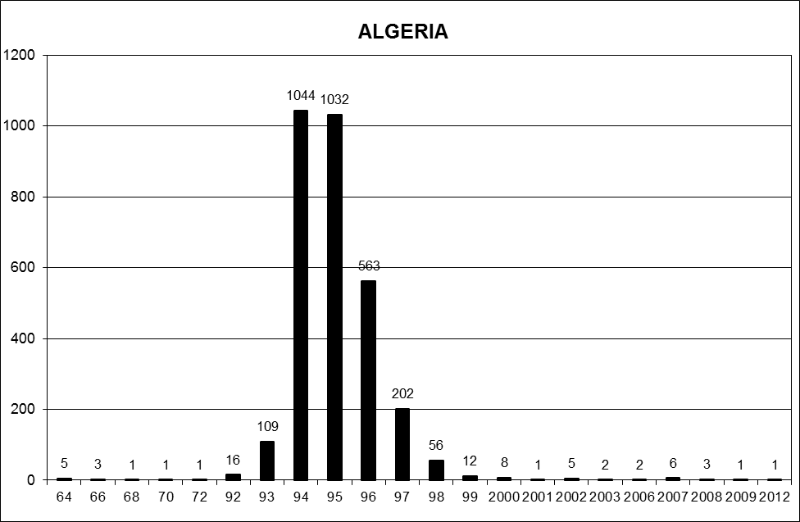

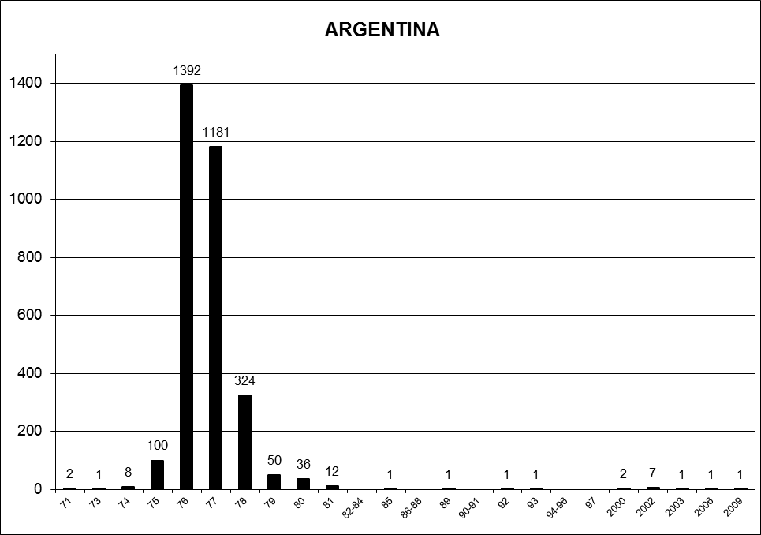

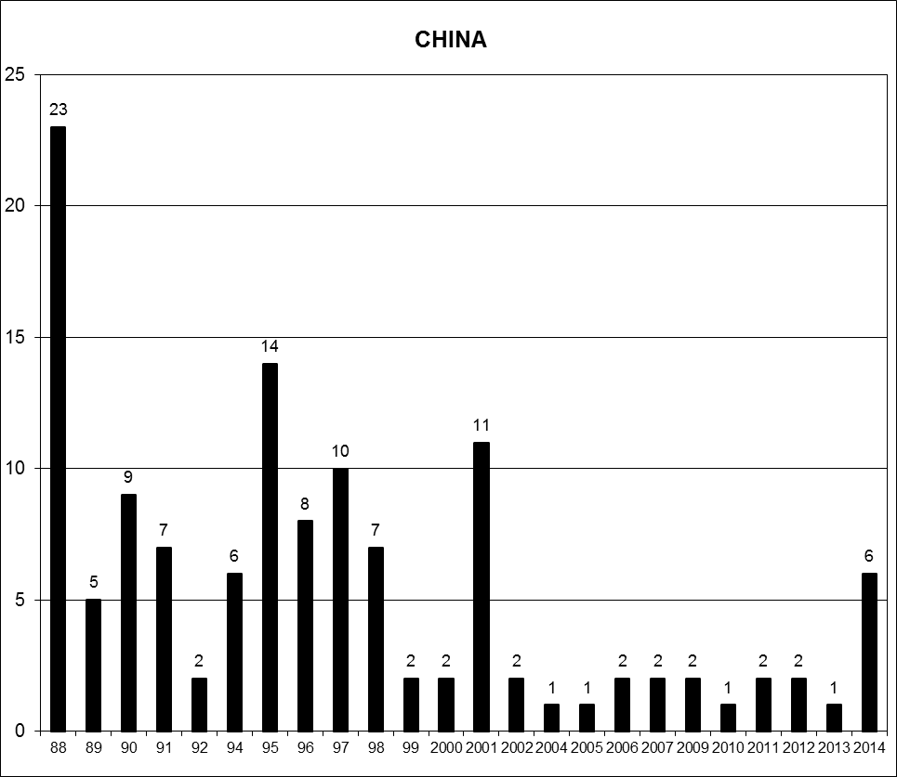

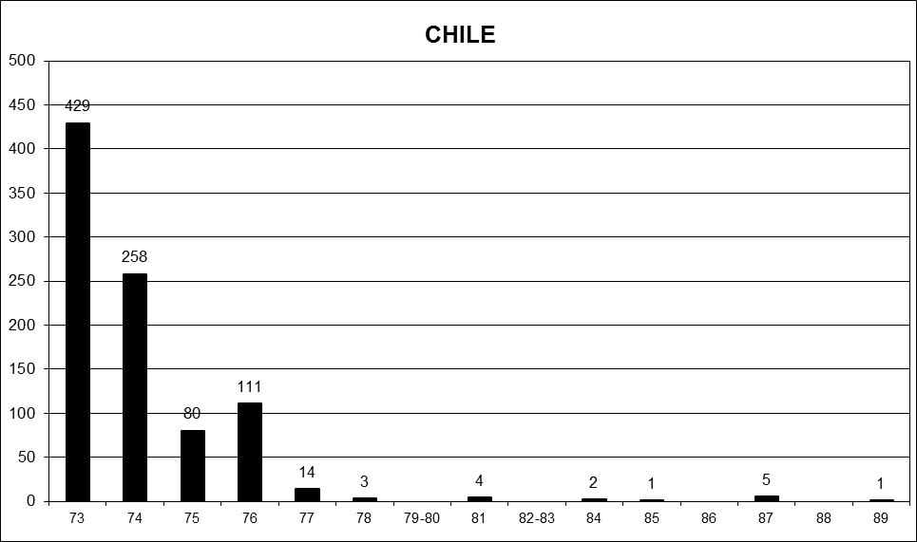

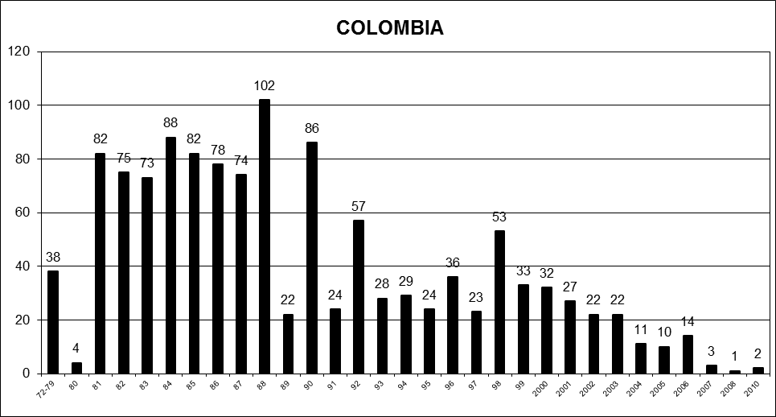

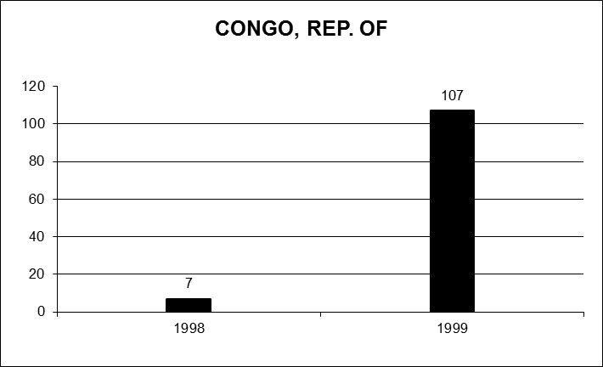

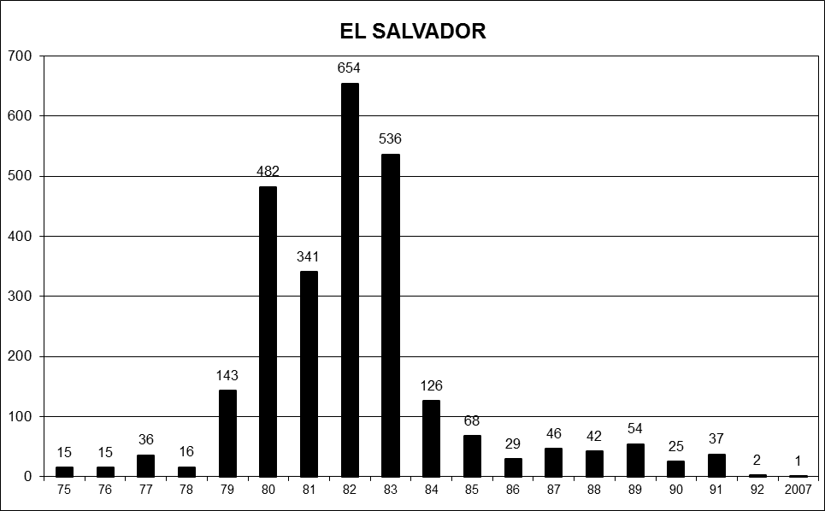

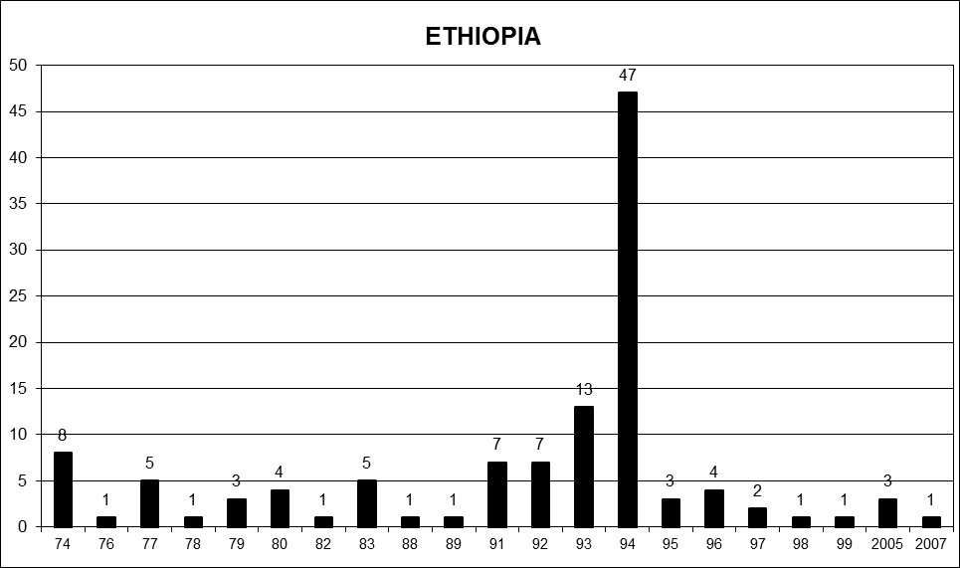

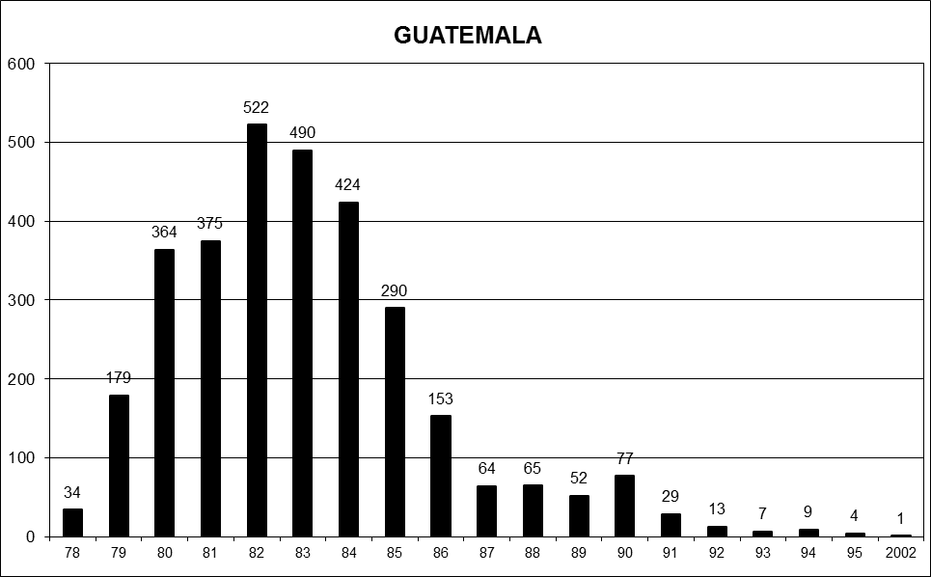

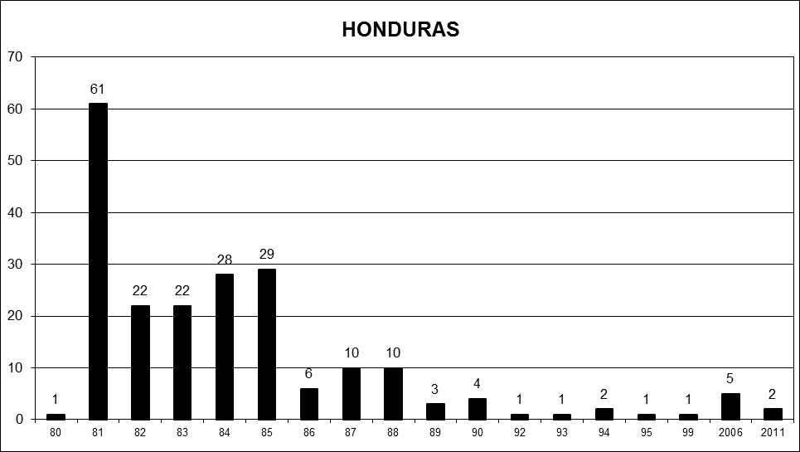

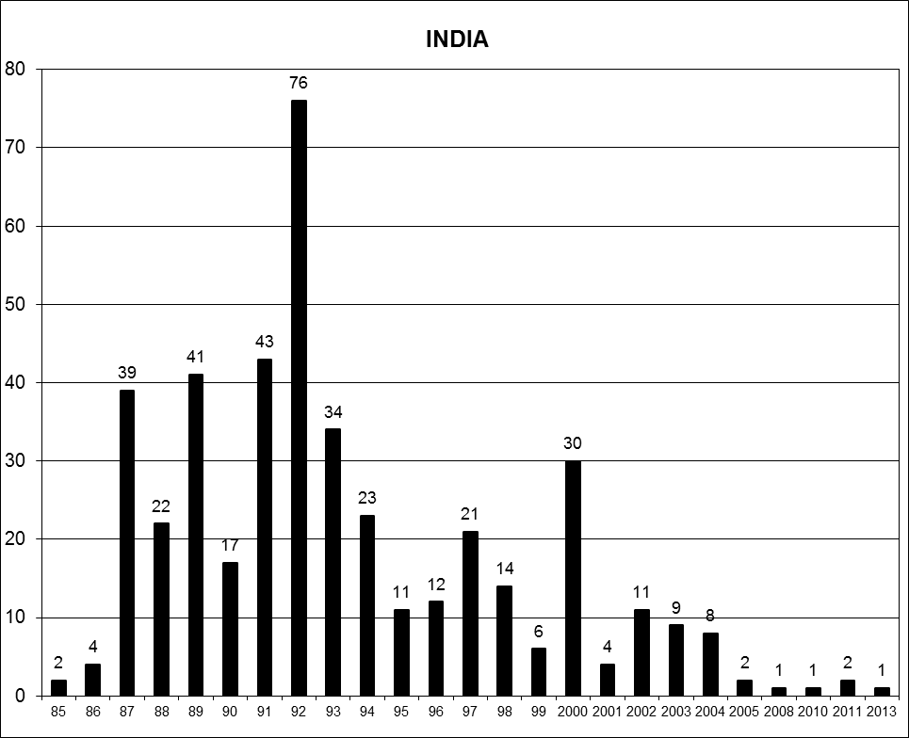

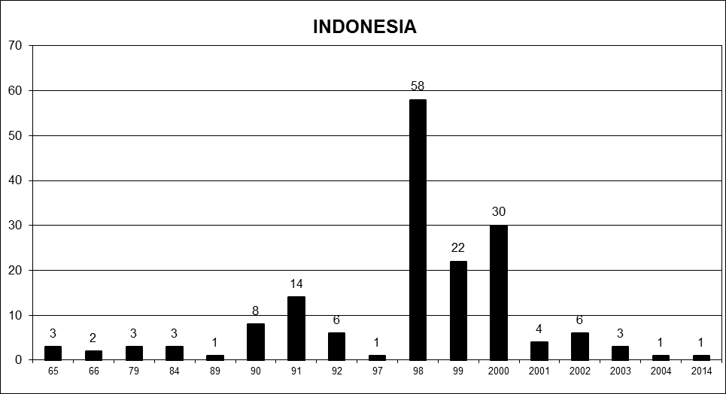

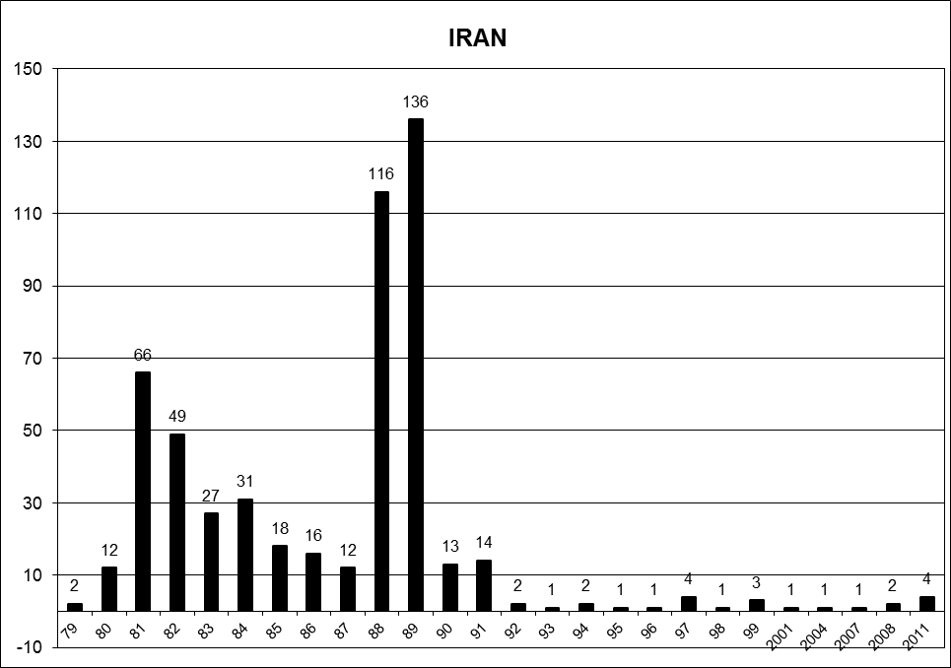

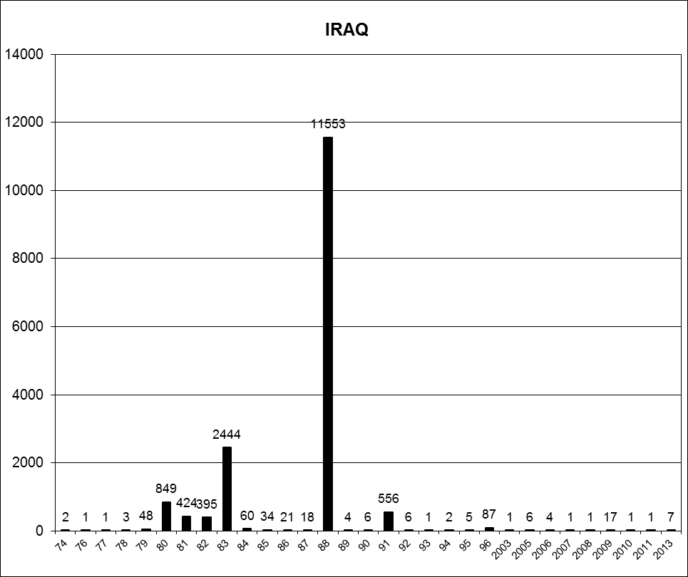

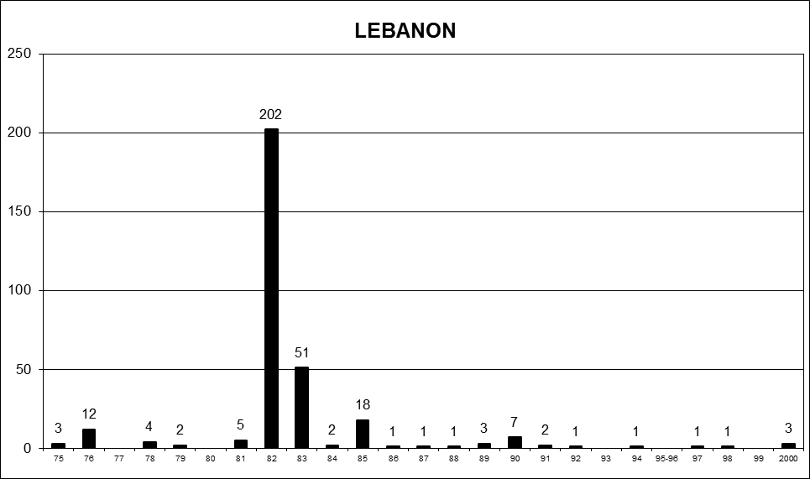

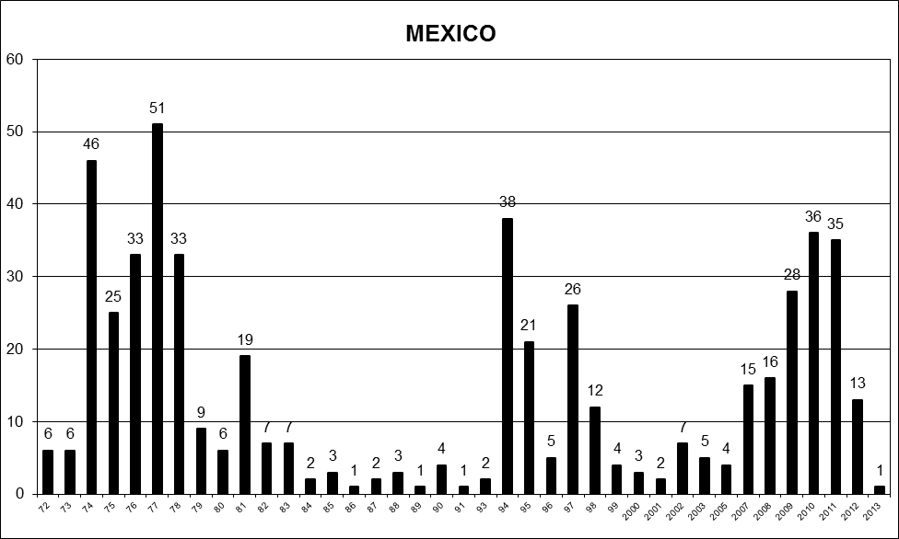

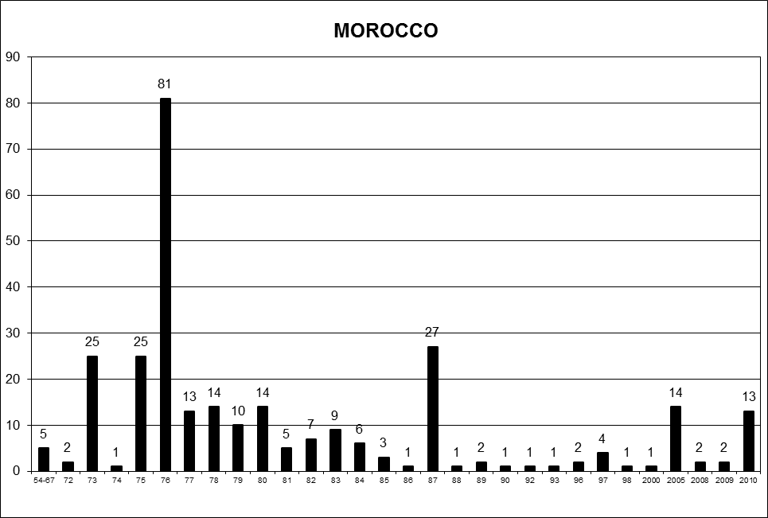

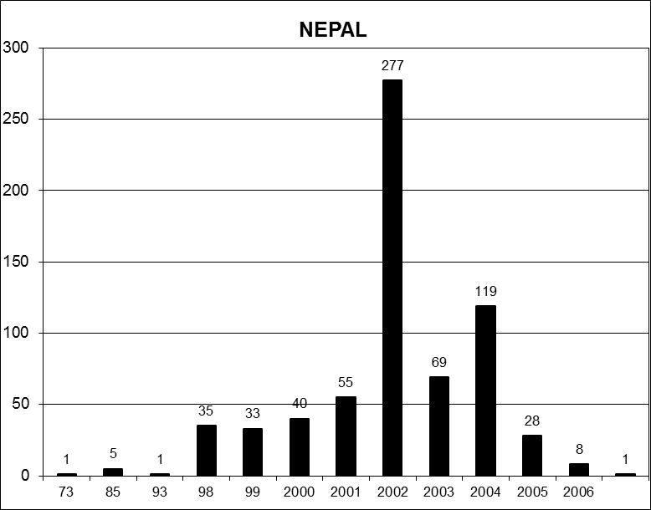

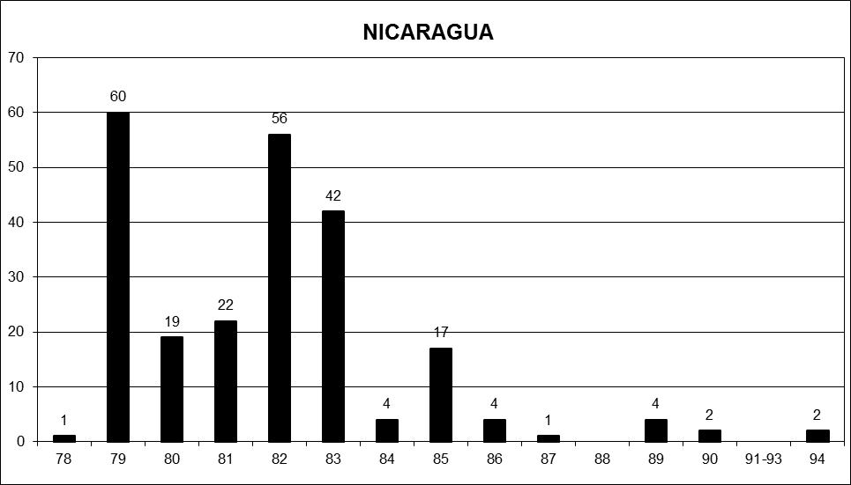

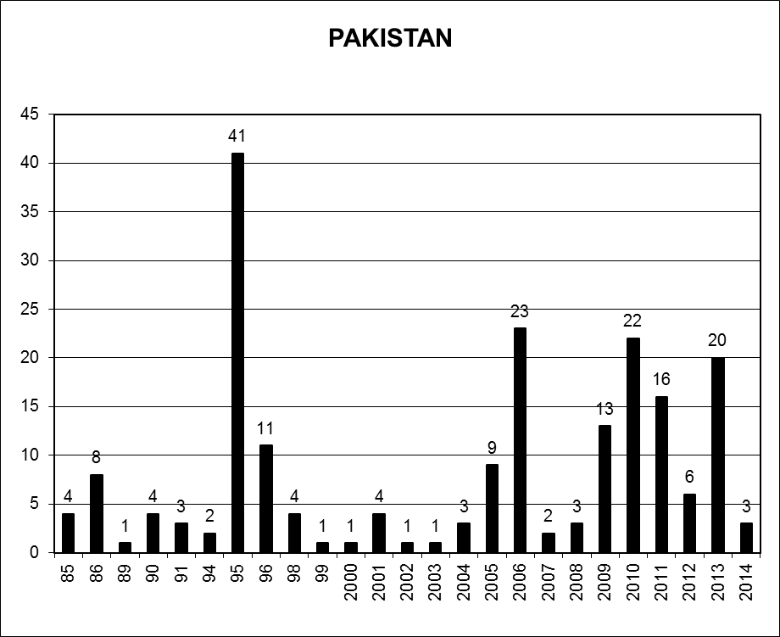

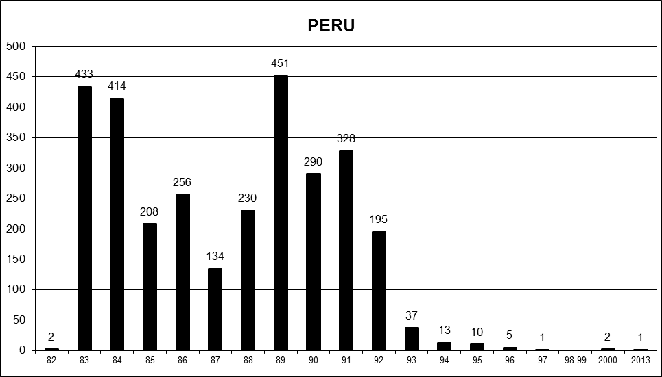

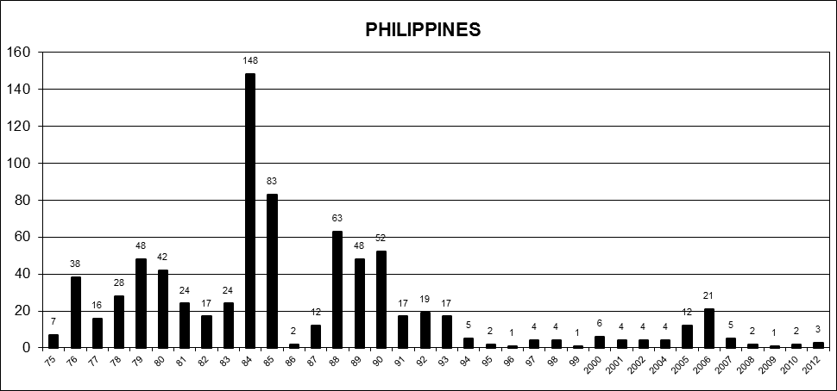

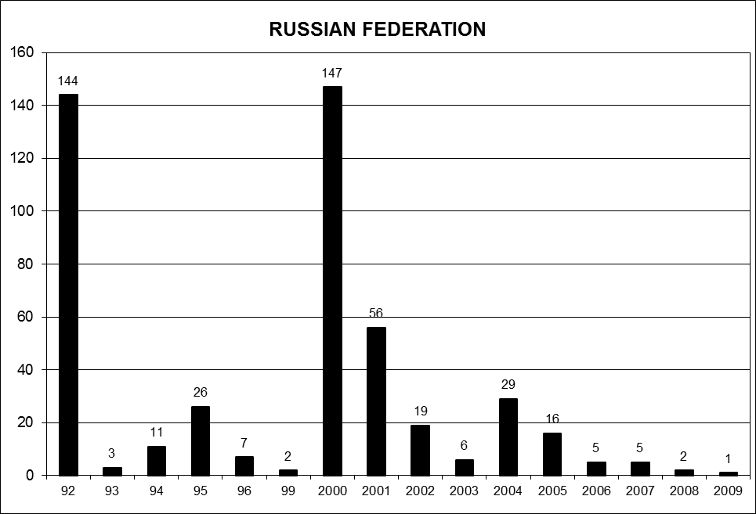

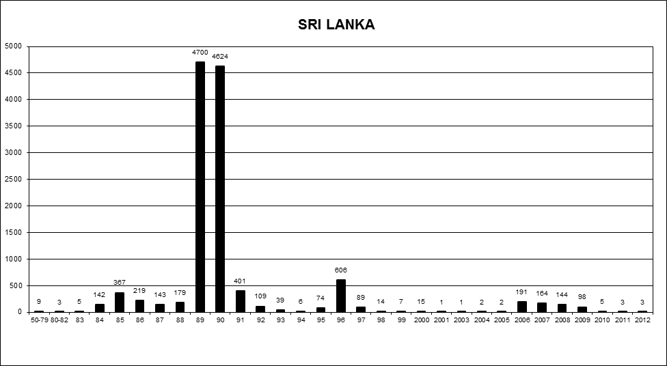

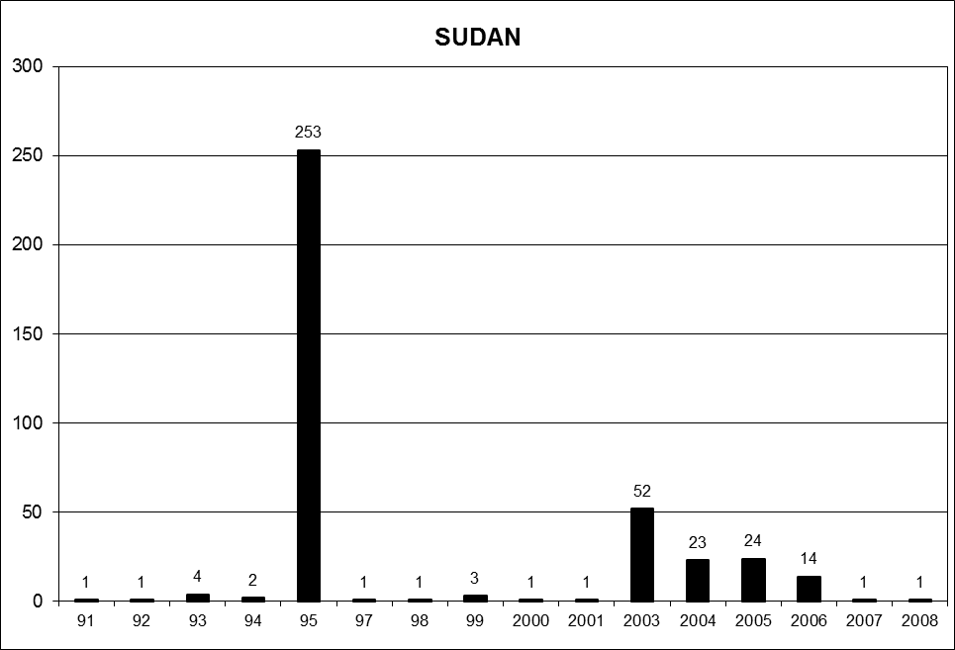

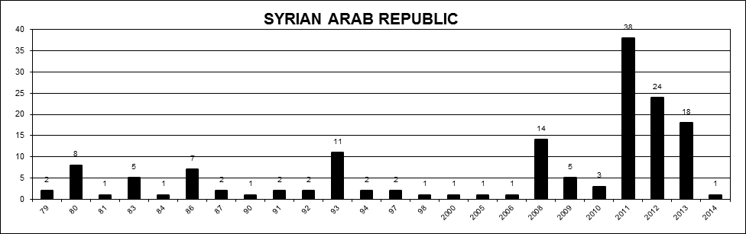

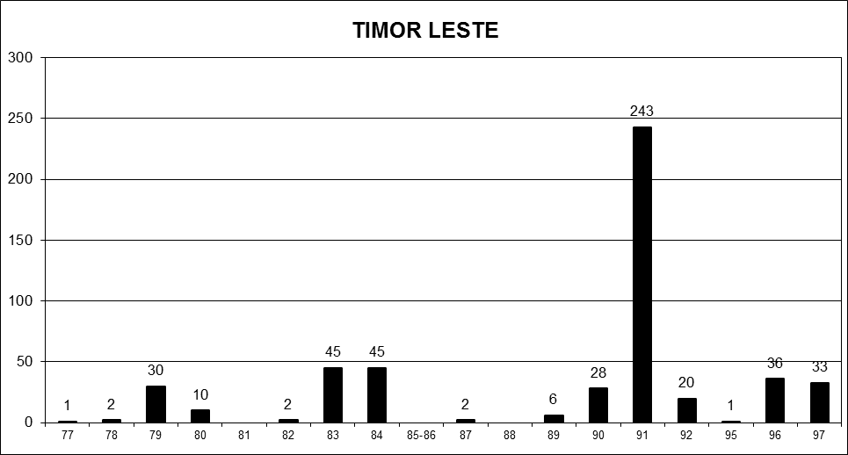

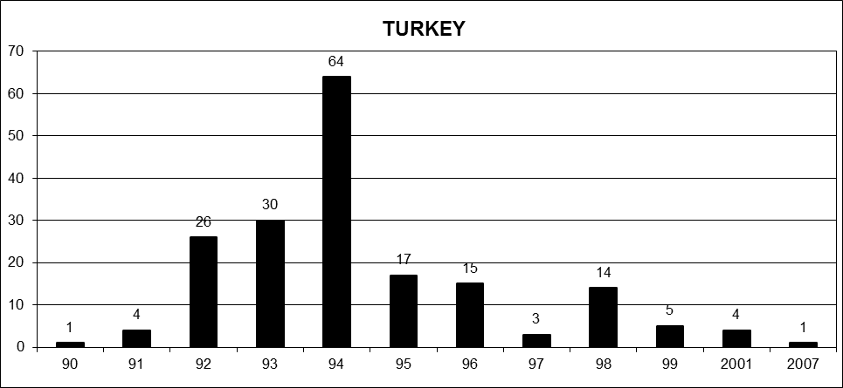

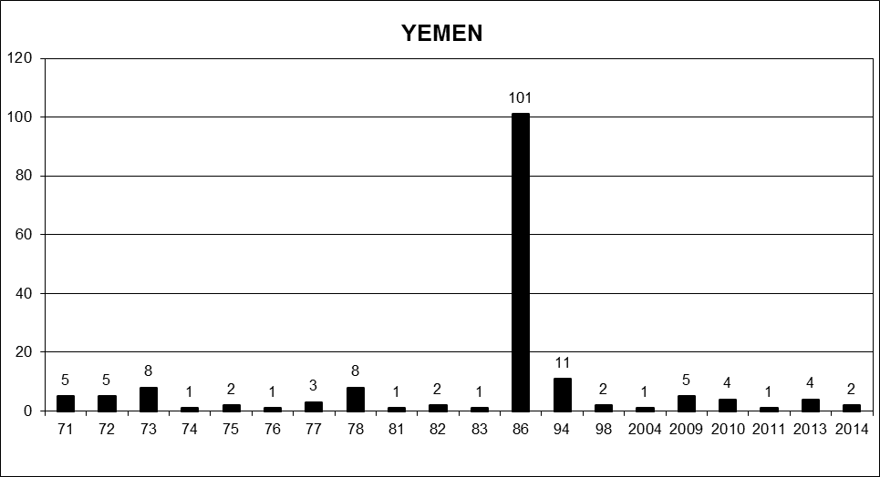

* * The annexes to the present report are circulated as received, in the language of submission only.
? As of 2014, the Working Group will report to the Human Rights Council at its September sessions.
? For more details please refer to: www.ohchr.org/EN/NewsEvents/Pages/DisplayNews.aspx?NewsID=13113&LangID=E.
? For more details please refer to: www.ohchr.org/EN/NewsEvents/Pages/DisplayNews.aspx?NewsID=13543&LangID=E.
? For more details please refer to: www.ohchr.org/EN/NewsEvents/Pages/DisplayNews.aspx?NewsID=14031&LangID=E.
? For more details please refer to: www.ohchr.org/EN/NewsEvents/Pages/DisplayNews.aspx?NewsID=14235&LangID=E.
? For more details please refer to: www.ohchr.org/EN/NewsEvents/Pages/DisplayNews.aspx?NewsID=14612&LangID=E.
? For more details, please refer to: www.ohchr.org/EN/NewsEvents/Pages/DisplayNews.aspx?NewsID=13082&LangID=E.
? For more information please refer to www.ohchr.org/EN/NewsEvents/Pages/DisplayNews.aspx?NewsID=13898&LangID=E.
? For more details please refer to: www.ohchr.org/EN/Issues/Disappearances/Pages/100thsessioneventNewYork.aspx.
? For more details please refer to: www.ohchr.org/EN/NewsEvents/Pages/DisplayNews.aspx?NewsID=14010&LangID=E.
? Please see annex I for country visit requests and invitations extended.
? See www.ohchr.org/EN/NewsEvents/Pages/DisplayNews.aspx?NewsID=12754&LangID=E.
? See www.ohchr.org/EN/NewsEvents/Pages/DisplayNews.aspx?NewsID=12896&LangID=E.
? See www.ohchr.org/EN/NewsEvents/Pages/DisplayNews.aspx?NewsID=13310&LangID=E.
? See www.ohchr.org/EN/NewsEvents/Pages/DisplayNews.aspx?NewsID=13433&LangID=E.
? See www.ohchr.org/EN/NewsEvents/Pages/DisplayNews.aspx?NewsID=13568&LangID=E.
? See www.ohchr.org/EN/NewsEvents/Pages/DisplayNews.aspx?NewsID=13668&LangID=E.
? See www.ohchr.org/EN/NewsEvents/Pages/DisplayNews.aspx?NewsID=13898&LangID=E.
? See www.ohchr.org/EN/NewsEvents/Pages/DisplayNews.aspx?NewsID=13982&LangID=E.
? See www.ohchr.org/EN/NewsEvents/Pages/DisplayNews.aspx?NewsID=14010&LangID=E.
? See www.ohchr.org/EN/NewsEvents/Pages/DisplayNews.aspx?NewsID=14018&LangID=E.
? See www.ohchr.org/EN/NewsEvents/Pages/DisplayNews.aspx?NewsID=13058&LangID=E.
? See www.ohchr.org/SP/NewsEvents/Pages/DisplayNews.aspx?NewsID=13249&LangID=S and www.ohchr.org/EN/NewsEvents/Pages/DisplayNews.aspx?NewsID=13330&LangID=E.
? See www.ohchr.org/SP/NewsEvents/Pages/DisplayNews.aspx?NewsID=13486&LangID=S.
? See www.ohchr.org/EN/NewsEvents/Pages/DisplayNews.aspx?NewsID=13607&LangID=E.
? See www.ohchr.org/EN/NewsEvents/Pages/DisplayNews.aspx?NewsID=13801&LangID=E.
? See www.ohchr.org/EN/NewsEvents/Pages/DisplayNews.aspx?NewsID=13860&LangID=E.
? See www.ohchr.org/EN/NewsEvents/Pages/DisplayNews.aspx?NewsID=14078&LangID=E.
? See www.ohchr.org/EN/NewsEvents/Pages/DisplayNews.aspx?NewsID=14103&LangID=E.
? See www.ohchr.org/EN/NewsEvents/Pages/DisplayNews.aspx?NewsID=14353&LangID=E.
? See www.ohchr.org/EN/NewsEvents/Pages/DisplayNews.aspx?NewsID=14394&LangID=E.
? See www.ohchr.org/EN/NewsEvents/Pages/DisplayNews.aspx?NewsID=14410&LangID=E.
? The asterisk in this column indicates that some of the replies received during the reporting period still need to be reviewed by the Working Group.
? The Working Group decided to reopen one case.
? The Working Group determined that two cases were duplicates and subsequently expunged them from its records.
? The Working Group determined that two cases were duplicates and subsequently expunged them from its records.
? The Working Group determined that one case was a duplicate and subsequently expunged it from its records.
? A press release followed, dated 27 February 2013.
? Please refer to para. 56 of the current document.
? Please refer to para. 80 of the current document.

