 | United Nations | A/HRC/28/41
 | General Assembly |  | Distr.: General  29 January 2015  Original: English
Human Rights Council
Twenty-eighth session
Agenda items 2 and 5
Annual report of the United Nations High Commissioner
for Human Rights and reports of the Office of the
High Commissioner and the Secretary-General
Human rights bodies and mechanisms
Report on the twenty-first annual meeting of special rapporteurs/representatives, independent experts and working groups of the special procedures of the Human Rights Council, including updated information on the special procedures
Note by the United Nations High Commissioner for Human Rights* **
Rapporteur: Mireille Fanon-Mendes-France
Summary
The present report, submitted pursuant to Commission on Human Rights resolution 2004/76, focuses on the special procedures system during the period from 1 January to 31 December 2014 and the main points raised at the twenty-first annual meeting of special procedures of the Human Rights Council, held in Geneva from 29 September to 3 October 2014.

Contents
Paragraphs Page
I. Introduction 1 – 2 3
II. Facts and figures 3 – 29 3
A. New mandates 3 3
B. Mandate holders 4 3
C. Country visits and standing invitations 5 – 6 4
D. Communications 7 – 9 4
E. Thematic reports and studies 10 – 13 4
F. Contributions to standard-setting and and the protection and
promotion of human rights 14 – 18 5
G. Media outreach and public awareness 19 6
H. Other activities 20 – 29 7
III. Activities of the Coordination Committee of Special Procedures 30 – 33 8
IV. Twenty-first annual meeting of special procedures 34 – 100 9
A. Methods of work 36 – 48 9
B. Engagement with stakeholders 49 – 50 11
C. Challenges confronting the system 51 – 59 11
D. Thematic issues 60 – 72 13
E. Interaction with representatives of the United Nations and other
stakeholders 73 – 100 15
Annexes
I. Statistics of current mandate holders (as at December 2014) 19
II. Country visits conducted in 2014 21
III. Standing invitations 27
IV. States not yet visited by any mandate holder 30
V. Communications 31
VI. Themes addressed in special procedures reports 34
VII. Joint statements 41
VIII. Mandate holders attending the twenty-first annual meeting 42
IX. Non-exhaustive list of follow-up activities undertaken by mandate holders in 2014 45
X. Statement by the Chairperson of the Coordination Committee 48
I. Introduction
1. In 2014, the special procedures continued to play a critical role in the promotion and protection of human rights. Mandate holders addressed all types of rights – civil, cultural, economic, political and social – as well as issues relating to specific groups. They reported to the Human Rights Council and the General Assembly, undertook country visits and acted on individual cases and concerns of a broader structural nature by means of communications to States and others. They also conducted thematic studies, convened expert consultations, contributed to the development of international human rights standards, engaged in advocacy, raised public awareness and provided advice and support for technical cooperation. The examples provided in the present report are indicative only and do not reflect all activities carried out by all mandate holders.
2. The present report provides facts and figures on the composition and outputs of the special procedures in 2014, including concrete examples of their contributions for the advancement of human rights. It describes the activities of the Coordination Committee of Special Procedures and the main points discussed by the special procedures at their twenty-first annual meeting. The annual meeting is rooted in the Vienna Declaration and Programme of Action, which underlined the importance of preserving and strengthening the system of special procedures and enabling it to harmonize and rationalize its work through periodic meetings.
II. Facts and figures
A. New mandates
3. During 2014, the Human Rights Council established two new thematic mandates: on the rights of persons with disabilities, and on the negative impact of unilateral coercive measures on the enjoyment of human rights. It also established a country mandate on capacity-building and technical cooperation with Côte d’Ivoire in the field of human rights. The special procedures system currently consists of 53 mandates, of which 39 are thematic and 14 concern countries.
B. Mandate holders
4. There are a total of 77 mandate holder positions, of which 31 were appointed in 2014. Mandate holders come from all United Nations geographic groups. At 31 December 2014, 23.68 per cent were from the African States, 19.74 per cent from Asian States, 11.84 per cent from Eastern European States, 19.74 per cent from Latin American and Caribbean States and 25 per cent from the Western Group (see annex I). A total of 38 per cent of mandate holders are female and 62 per cent are male.
C. Country visits and standing invitations
5. In 2014, special procedures conducted 80 country visits to 60 States and territories (see annex II). One Member State (Cameroon) and one non-Member observer State (State of Palestine) were added to the list of those that have extended a standing invitation to special procedures, reaching a total of 110 (see annex III).
6. Over the years, 167 States (or 86.5 per cent) have accepted requests for country visits, and 166 have been visited by at least one special procedures mandate holder. A total of 26 States (or 13.4 per cent) have never received or accepted any request for a visit by one or more mandate holders (see annex IV).
D. Communications
7. In 2014, the special procedures addressed a total of 553 communications to 116 States; 451 communications were sent jointly by more than one mandate holder. Communications covered at least 1,061 individuals, 179 of whom were women. A total of 237 replies were received (equivalent to 42.7 per cent of communications). A total of 135 communications were followed up by mandate holders (see annex V). Responses varied from acknowledgement of receipt to more substantive replies. Three communications reports were submitted to the Human Rights Council at its sessions.
8. Following opinions issued by the Working Group on Arbitrary Detention qualifying the detention of a complainant as arbitrary, in 2014 the Working Group received information on the release of 17 individuals and 230 military officers.
9. In 2014, the Working Group on Enforced or Involuntary Disappearances transmitted 259 new cases of enforced disappearances, of which 69 under the urgent action procedure. The Working Group clarified 47 cases.
E. Thematic reports and studies
10. In 2014, 135 reports were submitted to the Human Rights Council (including 64 country missions reports) and 36 to the General Assembly (see annex VI).
11. Some newly appointed mandate holders focused their first report on their methods of work and priorities; this was the case of the mandate holders on the sale of children, child prostitution and child pornography; the effects of foreign debt and other related international financial obligations of States on the full enjoyment of all human rights, particularly economic, social and cultural rights; adequate housing as a component of the right to an adequate standard of living, on the right to non-discrimination in this context; the situation of human rights defenders; the right to food; the enjoyment of all human rights by older persons; the rights of indigenous peoples; contemporary forms of slavery, including its causes and consequences; and the implications for human rights of the environmentally sound management and disposal of hazardous substances and wastes.
12. A number of outgoing mandate holders recapitulated the achievements of their mandate in their last report; this was the case of the mandate holders on the sale of children, child prostitution and child pornography; the rights of indigenous peoples; the effects of foreign debt and other related international financial obligations of States on the full enjoyment of all human rights, particularly economic, social and cultural rights; trafficking in persons, especially women and children; the right to food; the situation of human rights defenders; extreme poverty and human rights; and the human right to safe drinking water and sanitation. The final report submitted by the Special Rapporteur on the situation of human rights in Cambodia included reflections on the work of the mandate holder during the six years of the mandate. The Special Rapporteur on violence against women, its causes and consequences, addressed the developments witnessed within the United Nations with regard to the theme of violence against women.
13. Some mandate holders contributed to the debate on the post-2015 development agenda, such as the mandate holders on human rights and international solidarity; minority issues; the rights of indigenous peoples; the human rights of migrants; and the independence of judges and lawyers.
F. Contributions to standard-setting and the protection and promotion of human rights
14. In 2014, mandate holders continued to contribute to the progressive development of international human rights law by means of studies, consultations and the elaboration of guidelines in a variety of specific areas. For example, the Special Rapporteur on the human right to water and sanitation published a handbook for realizing the human right to safe drinking water and sanitation, aimed at providing all relevant actors with concrete guidance and tools on the meaning of this human right. The Special Rapporteur on trafficking in persons, especially women and children, issued a set of basic principles on the right to effective remedy for victims of trafficking in persons, intended to be a “living tool” for practitioners and law enforcement officials to use in their daily anti-trafficking work. Pursuant to Council resolution 20/16, the Working Group on Arbitrary Detention embarked on the preparation of draft basic principles and guidelines on remedies and procedures on the right of anyone deprived of his or her liberty to bring proceedings before court. The draft will be presented to the Council at its thirtieth session. The Independent Expert on human rights and international solidarity presented a draft declaration on the right of peoples and individuals to international solidarity to the Council for its input. The draft embodies the evolution of international solidarity into a concrete right to address the structural causes of poverty, inequality and other global challenges that impede human rights. A revised draft will be submitted to the Council and the General Assembly by 2016.
15. Several reports submitted to the Council and the General Assembly contained recommendations for the development of international law, such as the recommendation of the Special Rapporteur on the promotion and protection of human rights while countering terrorism that the Human Rights Committee develop and adopt a general comment on the right to online privacy. The Special Rapporteur on extreme poverty recommended the drafting of an optional protocol to the International Covenant on Economic, Social and Cultural Rights or adapting the methods of work of the Committee on Economic, Social and Cultural Rights to monitor the implementation of social protection floors. The Special Rapporteur on violence against women recommended the conclusion of a legally binding instrument to combat violence against women that addresses gaps in international human rights law. The Working Group on the use of mercenaries as a means of violating human rights and impeding the exercise of the right of peoples to self-determination recommended the drafting of an internationally binding instrument on private military and security companies. The Independent Expert on the promotion of an equitable and democratic international order is supporting the work of the open-ended intergovernmental working group on a draft United Nations declaration on the right to peace.
16. Mandate holders contributed to the human rights debate, bringing to the attention of the international community issues such as the use of drones in extraterritorial lethal counter-terrorism operations; the trend of remotely piloted aircraft or armed drones and emerging autonomous weapons systems; the use of mass digital surveillance for counter-terrorism purposes; the implementation of the right to social security through the universal adoption of social protection floors; and the use of private military and security companies.
17. The Special Rapporteur on torture and other cruel, inhuman or degrading treatment or punishment published a book containing essays from more than 30 international experts reflecting on and expanding interpretations of his report on abuses in health-care settings. The report of the Special Rapporteur has indeed led to widespread debate on such issues as palliative care, forced psychiatric treatment and gender assignment surgery for intersex persons.
18. Mandate holders witnessed positive developments in national legal and policy frameworks. For example, following the visit of the Special Rapporteur on trafficking in persons, especially women and children to Seychelles, a prohibition of trafficking in persons act was enacted. The law not only penalizes the crime of trafficking and makes provisions for the protection and rehabilitation of victims of trafficking, but also established a formalized interministerial committee to harmonize the State’s efforts to combat trafficking in persons and to oversee the implementation of a national strategy and plan of action on trafficking in persons based on the recommendations of the Special Rapporteur.
G. Media outreach and public awareness
19. During the period under review, 379 news releases and public statements were issued, individually or jointly, by mandate holders. In addition, a number of web stories were produced, as were three documentaries, on the visits of the Special Rapporteur on the human right to water and sanitation, to Brazil; the Special Rapporteur on trafficking in persons, especially women and children, to Italy; and the Special Rapporteur on the promotion of truth, justice, reparation and guarantees of non-recurrence, to Uruguay.
H. Other activities
20. Mandate holders continued to engage with numerous stakeholders and institutions and to conduct several activities aimed at advocating for better protection of human rights.
21. On 30 May 2014, the Special Rapporteur on the human rights of internally displaced persons held an Arria Formula meeting with the Security Council on the theme “Protection of internally displaced persons: challenges and role of the Security Council.” On 28 October, he also participated in an open debate of the Council on women, peace and security, with a focus on “displaced women and girls: leaders and survivors”. The Special Rapporteur on the rights of indigenous peoples attended the Forum on Indigenous peoples, held in New York in May, and the high-level plenary meeting of the General Assembly known as the World Conference on Indigenous Peoples, in September. Similarly, the Special Rapporteur on violence against women, its causes and consequences, attended the fifty-eighth session of the Commission on the Status of Women in March, while the Special Rapporteur on the enjoyment of all human rights by older persons addressed the Open-ended Working Group on the Human Rights of Older Persons at its fifth session, in July.
22. In 2014, 12 mandate holders participated in panel discussions held during the sessions of the Human Rights Council. As a result of two consecutive reports submitted by the Special Rapporteur in the field of cultural rights on the issue of historical and memorial narratives in divided societies, the Council decided to convene, at its twenty-seventh session, a panel discussion on the issue. The Special Rapporteur on the promotion of truth, justice, reparation and guarantees of non-recurrence participated in the ensuing discussion as a panellist, reflecting the linkages between the two mandates on this issue.
23. Following a recommendation of the Special Rapporteur on the promotion and protection of human rights and fundamental freedoms while countering terrorism, the Council convened a panel discussion during its twenty-seventh session on the use of remotely piloted aircraft or armed drones in counter-terrorism and military operations, with the participation of the Special Rapporteur and the Special Rapporteur on extrajudicial, summary or arbitrary executions.
24. Mandate holders continued to organize expert meetings on topics of relevance to their respective mandate. In November 2014, the Special Rapporteur on contemporary forms of racism, racial discrimination, xenophobia and related intolerance convened an expert meeting on the dilemmas and challenges faced in combating the use of racial profiling by law enforcement officers. The outcome of the meeting will inform his thematic report to be submitted to the Council at its twenty-ninth session.
25. Under the guidance of the Working Group on Business and Human Rights, the third annual Forum on Business and Human Rights was held in Geneva from 1 to 3 December 2014, and saw the participation of some 2,000 representatives of the private sector, Governments and civil society. The theme of the Forum was “Advancing business and human rights globally: alignment, adherence and accountability”. The report of the Forum will be presented to the Council at its twenty-ninth session.
26. On 25 and 26 November 2014, the Forum on Minority Issues held its seventh session under the leadership of the Special Rapporteur on minority issues. Some 570 participants attended the Forum, including representatives of Member States, non-governmental organizations and United Nations and regional intergovernmental bodies. The debate focused on the theme “Preventing and addressing violence and atrocity crimes targeted against minorities”. The recommendations of the Forum will be presented to the Council at its twenty-eighth session.
27. The substantive inputs of the Working Group of Experts on People of African Descent contributed greatly to the adoption on 18 November 2014 by the General Assembly of a programme of activities for the implementation of the International Decade for People of African Descent (2015-2024) with the theme “People of African descent: recognition, justice and development”. The programme includes the establishment of a forum for persons of African descent and the drafting of a United Nations declaration on the promotion and full respect of the human rights of people of African descent. The International Decade was officially launched at Headquarters on 10 December.
28. A number of mandate holders followed closely the debate over the post-2015 development agenda and draft documents on the sustainable development goals, advocating for a stand-alone goal on equality and women’s empowerment and the mainstreaming of a gender perspective into all other goals.
29. Mandate holders also continued to integrate a gender perspective and promote the human rights of women in their work.
III. Activities of the Coordination Committee of Special Procedures
30. In 2013 and 2014, the Coordination Committee of Special Procedures continued to assist coordination among mandate holders and to facilitate interaction and dialogue with a range a bodies and stakeholders. It prioritized engagement with the Council and the participation of mandate holders in the Council’s work. The Committee and its Chairperson met regularly with stakeholders, including the Secretary-General, the High Commisioner, the President of the Council, and representatives of Member States and civil society. The Committee advised on the appointment of new mandate holders, in particular the need for the voice of special procedures to be heard in this process and for expertise and skills to be main selection criteria, and engaged with the Consultative Group in this context. It also worked on other issues, including the coordination of joint activities and statements on country-specific and thematic issues; country-specific issues; the role of special procedures in mainstreaming human rights; the facilitation of dialogue and cooperation between States and special procedures; and reprisals against those who cooperate with the United Nations in the field of human rights, and attacks against mandate holders, in particular at the sessions of the Council and in relation to country visits. In addition, it continued to give guidance on issues relating to the independence of special procedures, working methods and the code of conduct, in accordance with the internal advisory procedure. The Committee maintained regular contact with civil society.
31. The Committee’s activities included, inter alia, delivering statements on behalf of all mandate holders at the special sessions of the Council, including during the sessions on the Central African Republic, the occupied Palestinian territories and Iraq.
32. The Committee also coordinated on behalf of all mandate holders the issuance of an open letter on 21 January 2014 on the situation in the Syrian Arab Republic; on 21 February, a joint statement on the situation in Ukraine; on 17 October, a letter on climate change; and, on 10 December, a statement on the occasion of Human Rights Day on climate change and human rights (see annex VII).
33. The Committee continued to nurture its partnership with regional mechanisms, including during a Wilton Park conference held in January 2014 on the theme “Addressing implementation gaps: improving cooperation between global and regional human rights mechanisms”. A group of mandate holders attended the fifty-fifth ordinary session of the African Commission on Human and Peoples’ Rights (28 April - 12 May 2014), in Luanda, including the Special Rapporteur on extrajudicial, summary or arbitrary executions, who officially addressed the Commission.
IV. Twenty-first annual meeting of special procedures
34. The twenty-first annual meeting focused on issues relating to the special procedures system. Mandate holders exchanged views with the United Nations High Commissioner for Human Rights, the Deputy Secretary-General, the Special Advisers of the Secretary-General on the Prevention of Genocide and the Responsibility to Protect, the Special Envoy of the Secretary-General on Climate Change and the President of the Human Rights Council, and representatives of United Nations entities, States, the Inter-American Commission on Human Rights, the International Coordinating Committee of National Human Rights Institutions and civil society organizations.
35. During the meeting, the participants (see annex VIII) elected by acclamation the Special Rapporteur on the human rights of migrants, François Crépeau, as Chairperson of the Coordination Committee for the 2014-2015 cycle. The Chairperson of the Working Group of Experts on People of African Descent, Mireille Fanon-Mendes-France, was elected Rapporteur of the annual meeting and member of the Coordination Committee. The Special Rapporteur on the situation of human rights in Myanmar, Yanghee Lee, the Independent Expert on the situation of human rights in the Central African Republic, Marie-Therese Keita Bocoum, and the Chairperson of the Working Group on the issue of human rights and transnational corporations and other business enterprises, Michael Addo, were endorsed as members of the Committee. The former Chairperson of the Coordination Committee and Special Rapporteur on the human rights of internally displaced persons, Chaloka Beyani, will remain an ex officio member for the coming year.
A. Methods of work
36. During the meeting, mandate holders discussed their methods of work and areas for improvement, including through enhanced coordination, strategic partnerships and the use of information technologies.
1. Country visits and strategies
37. Mandate holders welcomed the increasing number of Member States issuing standing invitations to special procedures. They noted, however, that in practice, they still faced difficulties in visiting the countries to which they had been invited. It was suggested that the attention of the President of the Council be drawn to instances where States deny access to requests for visits so that appropriate action could be considered. Mandate holders also regretted the practice of some States that deny access to certain mandate holders while inviting others to visit.
38. Participants also discussed specific issues affecting country-specific mandate holders, particularly when denied access to the State under consideration. They reiterated the need to be able to monitor and follow up the human rights situation as requested by the Council as its “eyes and ears”. The recommendation was also made that the Council use its influence to assist country-specific mandates to carry out their functions adequately.
39. Participants identified the need to improve coordination among mandate holders and to keep each other informed when planning visits to avoid numerous visits to a single country. It was also recommended that country-specific and thematic mandate holders be more closely coordinated when the latter intend to visit a State which is already the subject of a special procedures mandate.
2. Follow-up to activities
40. Mandate holders continued to discuss ways to improve follow-up to their recommendations, including those made after country visits. They shared their experiences of follow-up, in particular the initiatives that they had taken, including the publication of reports, such as in the case of the Special Rapporteur on torture, who published a compilation in September 2014. The compilation includes articles by senators and representatives, officials of the Ministry of the Interior and the Penitentiary System, members of the national human rights institution and the national preventive mechanism of Uruguay, the Parliamentary Commissary for the penitentiary system,\ and a variety of representatives leading non-governmental organizations. The publication is designed to be a tool to focus attention on the status of the implementation of the recommendations made by the mandate holder.
41. Other mandate holders disseminated questionnaires and convened workshops (see annex IX). One mandate holder pointed out that, one year after a country visit, he asked the State authorities whether they were interested in inviting him again; responses were often positive. These more focused follow-up visits proved to be a positive experience; for instance, in May 2014, the Special Rapporteur on freedom of religion or belief conducted a working visit to the Republic of Moldova, including the Transnistria region, to follow up on the recommendations he had made when visiting the country in 2012. He welcomed the adoption of Law 121/2012 on Ensuring Equality and the establishment in 2013 of the Council for Preventing and Eliminating Discrimination and Ensuring Equality. Moreover, the adoption of a law on alternative civilian service in February 2014 and amnesty for those who were previously condemned for conscientious objection to military service in Transnistria were also a positive example of the implementation of one of his recommendations. Other significant progress was the inclusion by the Ministry of Education of a subject on the Holocaust in history lessons in several grades.
42. Other mandate holders recalled the important role played by other stakeholders, in particular civil society, in following up on the work of special procedures. The Special Rapporteur on torture worked with civil society stakeholders to support their follow-up efforts and to provide a platform for the engagement of civil society with the Government to drive anti-torture work forward. Participants also requested that reports on country visit be also translated into the local languages of the States concerned.
43. Mandate holders also considered issues relating to alternative ways to follow up on country visits in the light of the limited budget resources.
3. Information technologies
44. Mandate holders reiterated the need to revisit the OHCHR webpages devoted to special procedures with a view to optimize this important information tool and to keep users informed about their activities, including those of the Coordination Committee.
45. Moreover, participants requested that the above-mentioned webpages be made more user-friendly and accessible to a broader audience, which could therefore engage in an interactive dialogue. One step suggested was the translation of the content of the webpages into all official languages of the United Nations. Mandate holders also enquired about electronic meeting platforms.
46. OHCHR informed the special procedures about steps taken to enhance and redesign its current website. The process is being put in place in a gradual manner and is expected to also include webpages devoted to special procedures mechanisms. In the meantime, the Secretariat will continue to update content relating to special procedures mandates and to create new pages for newly appointed mandate holders.
4. Media and outreach
47. Mandate holders discussed ways to increase efficiency when issuing media statements, including issues related to timing and coordination with all concerned. They also enquired about contacts with media units in other organizations on crossing-cutting issues such environment and health, and suggested a different approach to press releases, including by making them more targeted to resonate at the national and local levels.
48. The OHCHR media unit briefed participants about media established practices. It also reported on other successful communication tools, such as web stories and information notes.
B. Engagement with stakeholders
49. Participants considered how best to relate and share information within the United Nations system, including in the field, to ensure that all are well informed about their work and recommendations. In addition to and in keeping with the Human Rights Up Front initiative, launched by the Secretary-General in July 2013, discussions should continue on other ways to more fully integrate the findings of special procedures into the work of the United Nations system and its intergovernmental bodies, such as the Security Council.
50. Participants also considered cooperation with academic institutions, which could provide useful research, especially in the light of the resource constraints faced by the special procedures. Other useful ways for the special procedures to secure inputs included expert meetings, national and regional consultations and meetings with regional mechanisms.
C. Challenges confronting the system
51. Despite an expanding system and the major contributions of the special procedures to the protection and promotion of human rights, the system continued to face critical challenges, including underfunding, which was having an impact on their activities. Reprisals against those cooperating with the United Nations, its representatives and mechanisms in the field of human rights were a cause of great concern, as was the non-cooperation of certain States with mandate holders.
1. Financing the special procedures
52. OHCHR recalled that the special procedures received approximately 0.5 per cent of the United Nations regular budget. These resources were distributed evenly across mandates, but were still insufficient to support adequately all mandates and the needs of mandate holders. In the past, a number of mandates had been established by the Council without adequate regular budget resources and, in some cases, without any provision at all for staff support. Today, the standard minimum of 1.5 Professional and 0.5 General Service staff support for each individual mandate and three Professionals and one General Service staff for each working group to ensure effective support to the mandates concerned had not been met. Regular budget allocations provided for consultancies under existing mandates had also decreased. Moreover, in the absence of a resolution on the special procedures mechanism, there was no regular budget allocated to support the system as a whole, including the activities of the Coordination Committee, the organization of the annual induction session for newly appointed mandate holders, the annual meeting of mandate holders and all information and other tools and services provided by the Special Procedures Branch to the system.
53. The limited and/or lack of regular budget allocations was compensated by voluntary contributions received by OHCHR from Member States. A number of mandates also occasionally received earmarked contributions from Member States. Overall voluntary contributions were, however, insufficient to meet all needs of the special procedures.
54. Mandate holders reiterated their concerns with regard to the inadequate resouces put at their disposal under each mandate to fulfil their tasks adequately. They also discussed fundraising issues and the possibility of approaching private institutions and foundations in that regard. It was suggested that OHCHR be regularly informed of fundraising activities by the special procedures.
55. Participants reiterated the need for Member States, the General Assembly and United Nations budgetary bodies to allocate the corresponding budget when a mandate is established. The establishment of a new mandate must be accompanied by the timely provision of necessary resources through the regular budget, which must also provide existing mandates with a reasonable minimum level of resources to allow the activities of mandates to be conducted.
2. Reprisals
56. Mandate holders discussed the issue of intimidation and reprisals against persons cooperating with the United Nations and its representatives and mechanisms in the field of human rights. Several reported on cases of intimidation and reprisals against witnesses and other interlocutors willing to engage with them before, during and after country visits. One mandate holder gave a specific example from his own experience following a recent country visit. Civil society representatives had been harassed and intimidated, some put under de facto house arrest to prevent them from meeting with him; meeting places were barricaded, and activities were monitored. The mandate holder had had to suspend the fact-finding part of his mission. He provided insights into the reactions of the Government and United Nations field presences and proposed a discussion on reacting to a crisis situation and providing persons in need with protection, including when reprisals are committed after the visit. There was thus a need to develop a systematic approach to the issue and to protect sources, who were now even more vulnerable because of the new electronic ways by which they could be exposed.
57. Mandate holders agreed on the need to find ways to respond to acts of intimidation, harrassment and reprisal faced by individuals trying to contact them, including by identifying more effective and rapid mechanisms in situations where protection gaps exist and when dealing with States that deny or trivialize protection concerns. They expressed the need for a high-level mechanism to respond to States that engage in reprisals.
58. Mandate holders also referred to defamatory, ad hominem attacks by States and non-governmental organizations on mandate holders, and stressed that the Council should be more active in responding to such attacks.
59. Mandate holders reiterated their concerns during their exchange with the President of the Council, who noted that reprisals were a hindrance to the protection and promotion of human rights. He acknowledged the difficulties in addressing this issue and agreed on the need to continue to denounce cases of reprisal, to raise awareness and to protect actively those at risk. The mandate holders also raised the issues with the Deputy Secretary-General, with a focus on the response given by the Secretary-General to the increasing number of reprisals perpetrated against interlocutors of special procedures. The Coordination Committee also informed participants on how it had systematically raised the issue with the Secretary-General, the High Commissioner, the President of the Council, States and civil society.
D. Thematic issues
1. Women’s human rights and Human Rights Council resolution 26/11
60. Discussions focused on Council resolution 26/11 on protection of the family and the subsequent panel discussion, and were led by the Chairperson-Rapporteur of the Working Group on discrimination against women in law and in practice.
61. Mandate holders appreciated the emphasis on the structural problems of care responsibilities and the need to redistribute them between women and men, the family and the State. They also appreciated the fact that, in the panel discussion, there was general acceptance that families were diverse and as such, there should be no discrimination, and that violence in the family should be eliminated.
62. Resolution 26/11 made, however, no reference to women’s right to equality within the family, and participants in the panel discussion had erroneously equated the protection of the family with the protection of the rights of individual members of the family, which does not secure the right of women to equality in the family. Women and men had a well-established right to equality in all aspects of family life, as reflected in the Universal Declaration of Human Rights, the International Covenant on Civil and Political Rights, the International Covenant on Economic, Social and Cultural Rights and the Convention on the Elimination of All Forms of Discrimination against Women.
63. Furthermore, it could not be said that children had, like women, the right to equality in the family: under the Convention on the Rights of the Child, children were entitled to be free from abuse, have their voices heard and be respected, and this was not equivalent to women’s right to equality with men in all aspects of family life. What should be guaranteed was the equality of girls with boys in the family.
64. The Chairperson of the Coordination Committee made a statement on behalf of the mandate holders on this issue (see annex X).
2. Sustainable development goals
65. Several mandate holders pointed out that they wished to continue their own efforts to integrate human rights into the sustainable development goals, especially with regard to putting greater emphasis on accountability for human rights. Participants in the discussion acknowledged that, although the outcome document of the Open Working Group on Sustainable Development Goals put greater emphasis on human rights than the Millennium Development Goals, gaps and weaknesses remained and had to be addressed. Mandate holders agreed that much would depend on the way indicators to measure achievement of the targets under each goal were formulated. It was suggested that the mandate holders should endeavour to inform the discussion on indicators to make them human rights-sensitive.
66. Some mandate holders explained how the current formulation of sustainable development goals did not address all the human rights dimensions related to their individual mandates. For example, the right to adequate housing was not reflected to the same extent as were the rights to food, education, health or water and sanitation. It was also noted that long-term efforts and strong partnerships with other stakeholders were important in order to influence the process. It was agreed that mandate holders would continue to seek ways to monitor the negotiations and influence the formulation of the goals and indicators by mapping out crucial dates in the process and channels for input. The possibility of a joint statement focused on common issues, such as accountability, equality and non-discrimination, was also discussed.
3. Climate change
67. Mandate holders focused their attention to climate change in the light of several upcoming events on the issue within the framework of the United Nations in 2015, with a view to increasing their interaction with the United Nations entities working on that issue.
68. The Special Envoy of the Secretary-General on Climate Change urged mandate holders to speak out about the impact of climate change on human rights as they saw it in the course of their work, and to contribute to discussions.
69. The Special Envoy emphasized that this was a crucial time for the international community and its response to climate change in the lead-up to the conclusion of a new legally binding climate agreement in December 2015. Efforts of human rights advocates had to build upon the Cancun Agreements and the language therein identifying the relationship between human rights and climate change, and support the new language to be proposed at the twentieth session of the Conference of the Parties to the United Nations Framework Convention on Climate Change, in Lima, “that parties should, in all climate change-related actions, fully respect, protect and fulfil human rights”. In this regard, the Council, in its resolution 10/4, had influenced the Agreements by affirming that human rights obligations and commitments had the potential to inform and strengthen international and national policymaking in the area of climate change, promoting policy coherence, legitimacy and sustainable outcomes.
70. The Coordinator and Principal Legal Adviser of the United Nations Framework Convention on Climate Change updated participants on the status of negotiations on the climate change agreement, and explained the events and opportunities that human rights advocates, like other stakeholders, could use to express their views. Because of the Cancun Agreements, human rights were now part of the discourse and the best way to generate input was through States parties.
71. The Independent Expert on the issue of human rights obligations relating to the enjoyment of a safe, clean, healthy and sustainable environment referred to his mapping report, which reflected the work of all special procedures on climate change. He had initiated an open letter to States parties to the Framework Convention, in which he urged them to build upon the human rights language of the Cancun Agreements and to ensure the protection and promotion of and respect for human rights in the new legally binding instrument. The letter was underwritten by other mandate holders. The representative of the United Nations Environment Programme added that the environment community was increasingly interested in incorporating human rights and the work of the special procedures, and expressed support for the open letter. Other mandate holders shared their experience of work on climate change and their views on the process and opportunities to influence discussions. They supported the need to work individually and collectively to emphasize human rights in the discussions over the next 15 months.
72. In accordance with Council resolution 26/27, in which the Council called upon mandate holders to consider climate change in their work, the Council would convene a discussion thereon at its twenty-eighth session.
E. Interaction with representatives of the United Nations and other stakeholders
1. United Nations High Commissioner for Human Rights
73. The High Commissioner welcomed the opportunity, at such an early stage since his appointment, to engage in a candid discussion with all participants. He considered the annual meeting a platform not just for exchanging views but also for exploring ways of achieving greater synergies among mandates and impact for those who are unable to enjoy their human rights. While recalling that the independence of the mandates of the High Commissioner and the special procedures must be respected, he welcomed opportunities to collaborate. OHCHR was committed to providing holistic support for all human rights mechanisms to ensure that the entire system was resourced and supported to operate with maximum efficiency and effectiveness, despite the very real resource constraints faced by all.
74. Mandate holders raised a number of points, including budget constraints, the need for a stronger human rights perspective in United Nations country teams and for greater support from Resident Coordinators, attacks on mandate holders and increasing reprisals against those who cooperate with human rights mechanisms.
75. OHCHR was endeavouring to address funding shortfalls. Efforts would continue during the preparation of the 2016/17 regular budget submission to advocate for greater regular budget funding for the special procedures. On the sustainable development goals, the High Commissioner welcomed the contributions of special procedures. He also pointed out that, in its assessment of the outcome document, OHCHR had found that progress had been made in ensuring that the framework addressed the full range of rights and included a focus on inequalities, all key groups and some critical international reforms. With regard to reprisals, the High Commisioner intended to address the issue with the General Assembly at its sixty-ninth session.
2. Deputy Secretary-General
76. The Deputy Secretary-General provided an overview of the Human Rights Up Front initiative. Prevention through early warning was core to the initiative and, in this regard, special procedures had an important role to play, since conflicts often originate from human rights violations that special procedures monitor and report on. The initiative had been presented within the United Nations system to Members States, and was taking root in the field, including through a letter addressed to all Resident Coordinators.
77. The Deputy Secretary-General pointed out that information gathered by special procedures was extremely valuable, and invited mandate holders to find a more institutional way of sharing information with the Human Rights Up Front initiative. The Chairperson expressed the readiness of the special procedures to contribute to the initiative, and proposed that a consultation be organized between the Coordination Committee, OHCHR and the Deputy Secretary-General on submitting early warning information.
3. Special Advisers of the Secretary-General on the Prevention of Genocide and on the Responsibility to Protect
78. The Special Adviser of the Secretary-General on the Prevention of Genocide listed the different opportunities to enhance cooperation: (a) sharing information and analysis; (b) contributing to the preparation of country visits or conducting joint country visits; (c) contributing with comments to reports of special procedures; (d) participating in meetings on thematic issues that are relevant to all; (v) issuing joint public statements; and (e) holding meetings to enhance cooperation and share strategies on joint action.
79. The Special Adviser on the Responsibility to Protect briefed participants on the evolution of the concept of responsibility to protect and its relevance, and added two additional opportunities for cooperation with the special procedures, namely, through the first pillar of the responsibility of States to protect their own populations, through prevention and early action; and the second pillar of the responsibility of the international community to assist States. In the latter case, she stressed the role that special procedures could play in encouraging States to live up to their responsibilities and in capacity-building efforts to make States more resilient to atrocity crimes.
80. A number of mandate holders raised questions on, inter alia, the role and responsibility of non-State actors (such as business enterprises); the type of information that could be shared with the Special Advisers; how to broaden the approach to the prevention of crimes (beyond criminal justice to also include social justice); the need to address both justice and reconciliation issues; and to look into violence against women in non-conflict situations, which may exacerbate violence against women in conflict situations.
81. The mandate holders agreed to explore areas of cooperation with the Special Advisers, who reiterated their willingness to work with the special procedures.
4. President of the Human Rights Council
82. The President of the Council pointed out that 2014 had been a busy year, with 31 out of 53 mandates appointed. Two new thematic mandates had been created: on the rights of persons with disabilities, and on the negative impact of unilateral coercive measures on the enjoyment of human rights. The Council had also responded to emergency situations by establishing, for example, commissions of inquiry on the situation in the Occupied Palestinian Territory, including East Jerusalem, and in Eritrea. It had also accepted that a human rights team should be deployed to Iraq. At the most recent session of the Council, the issues of civil society space and the protection of human rights defenders and journalists, and violence against persons because of their sexual orientation had been taken up, and demanded ongoing attention.
83. The President encouraged mandate holders to be guided by the letter and spirit of the Code of Conduct. Cooperation between States and the special procedures should be constructive and open, with continuing dialogue. Although some States complained about the work of special procedures, it was important to preserve the credibility of the system and the independence of mandate holders.
84. The President reiterated the fact that the Council attached great importance to recommendations made in the thematic and country visit reports of special procedures, given that they gave States more information and helped in decision-making. Gabon, for example, had had a positive experience with the visit of the Special Rapporteur on trafficking in persons. The visit had resulted in a policy that was beneficial to the country.
85. The President had raised the issue of personal attacks on mandate holders with States during Council sessions, and had noted a decrease. He pointed out that attacks on those who cooperate with the mechanisms, including during country missions, had increased, and he was advocating for civil society, including as partners of Governments. With regard to the budget, the President informed participants that he had addressed the issue of the increasing number of mandates without commensurate resources during his discussions with senior officials of the United Nations Secretariat.
86. During the discussion, mandate holders advocated for their greater participation in sessions of the Council, including during the universal periodic review, special sessions and panel discussions. The issue of reporting on country visits outside of the annual interactive dialogue with the Council was raised.
5. Member States
87. In their meeting with representatives of Member States, mandate holders raised issues relating to, inter alia, the limited regular budget allocations to special procedures; State cooperation with special procedures, particularly for country visits; follow-up to and implementation of the recommendations of special procedures; reprisals against those who cooperate with the United Nations; the Human Rights Up Front initiative; compliance with the Code of Conduct; and cooperation with regional mechanisms.
88. Mandate holders also expressed concern at the increase in reprisals against individuals associated with country visits, and requested a more formal response from the Human Rights Council condemning such actions.
89. The representatives of a number of Member States took the floor to inform participants about their experience with the special procedures, including the steps taken to follow up on their recommendations following country visits. It was recalled that Member States ultimately decided on the opportunity of visits on the basis of their own needs. A number of States also referred to the importance of the timing of visits, which should be organized whenever a need is expressed at the national level. This would enable national actors to benefit in a timely manner from the expertise provided by the mandate holder and also facilitate follow-up activities.
90. Mandate holders referred to the importance of finalizing country reports shortly after their visit, and requested flexibility to permit rapid visits to countries when the human rights situation was deteriorating. The need for more follow-up visits was noted by mandate holders, who suggested looking at ways to institutionalize the practice.
6. Civil society and non-governmental organizations
91. In their meeting with representatives of civil society, mandate holders highlighted the need for integrated follow-up strategies at both the national and international levels. They recalled the important role that they played in developing the capacity of local organizations to disseminate and monitor the implementation of the recommendations made by special procedures. They also referred to the importance of protecting and strengthening the participation of civil society organizations in United Nations forums.
92. The civil society representatives expressed gratitude for the commitment of mandate holders to cases of reprisal and the protection of human rights defenders. They requested mandate holders to examine discrimination on the basis of sex, gender, caste and descent; the right to privacy; the impact of extractive industries on the rights of indigenous peoples; and the sustainable development goals. They also expressed the view that the Coordination Committee should play a role in the selection and appointment of new mandate holders.
93. Participants in the meeting acknowledged that civil society greatly contributed to the work undertaken by all mandate holders. It was agreed that dialogue and consultations with civil society organizations should continue on a regular basis.
7. Regional human rights mechanisms
94. The Chairperson highlighted the importance that the special procedures system had placed on cooperation with regional mechanisms over the years, particularly because such cooperation added value to the work of both systems.
95. Marison Blanchard, a member of the Inter-American Commission on Human Rights, provided an overview of the work of the inter-American system, with a particular focus on the Commission. The priority topics of the thematic special procedures of the Commission included racism in the judicial system; indigenous women’s rights, including disappearances of indigenous women; corporal punishment; the impact of organized violence on the rights of children; migrant children’s rights; the use of criminal law to prosecute human rights defenders; the rights of lesbian, gay, bisexual, transgender and intersex persons; and economic, social and cultural rights.
96. Ms. Blanchard gave examples of good cooperation between the Commission and the special procedures. The support of the special procedures of the Council had proven to be effective, particularly at times when efforts were being made to weaken the regional system. The Commission was willing to enhance cooperation.
97. Mandate holders sought further discussion on the petition procedure, country visits and joint statements. They also added other examples of ongoing or upcoming cooperation, and expressed openness to forging links with the Commission. A number of themes emerged for further exchanges between the two systems in relation to development of standards and common positions.
98. Mandate holders also discussed the status of implementation of the Addis Ababa road map agreed between the special procedures of the Human Rights Council and the African Commission on Human and Peoples’ Rights on 17 and 18 January 2012. The Chairperson of the joint working group on the implementation of the road map outlined the main activities carried out since June 2013. He highlighted the review of the road map conducted between the two systems on the margins of the fifty-fifth ordinary session of the Commission and some issues of common interest, such as the right to life, child marriage, and business and human rights. He encouraged mandate holders to pursue cooperation with all regional human rights mechanisms in a way that was respectful of the priorities and procedures of those mechanisms.
8. National human rights institutions
99. The mandate holders welcomed the Secretary of the International Coordinating Committee of National Human Rights Institutions, who pointed out that national human rights institutions constituted a bridge between the State and non-governmental organizations, and between international human rights and national protection systems. The Committee was committed to strengthening cooperation with the special procedures in respect of country visits and information-sharing on human rights situations. It intended to develop a compilation of good practices in collaboration with the special procedures.
100. The mandate holders recalled the important role played by national human rights institutions in promoting and protecting human rights. They thanked these institutions for their work in disseminating the findings of the special procedures and, in some instances, in following up on their recommendations. They agreed to continue working together, particularly in the context of country visits.
Annexes
[English only]
Annex I
Statistics of current mandate holders (as at December 2014)
 | Male | Female | Total | % Geographic distribution
African States | 12 | 6 | 18 | 23.68%
Asian States | 10 | 5 | 15 | 19.74%
EEG | 5 | 4 | 9 | 11.84%
GRULAC | 8 | 7 | 15 | 19.74%
WEOG | 12 | 7 | 19 | 25.00%
Total | 47 | 29 | 76 | 100%
Gender balance | 62% | 38% | 100%

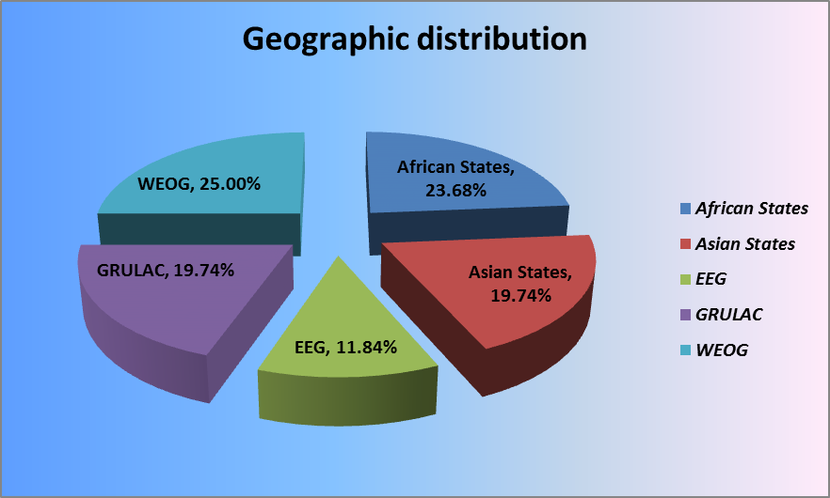
Regional distribution of mandate holders, including gender composition (as of December 2014)
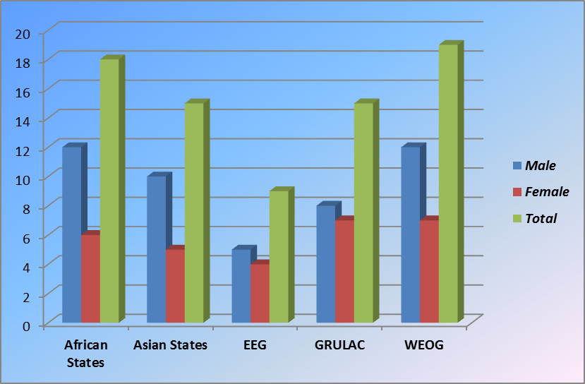

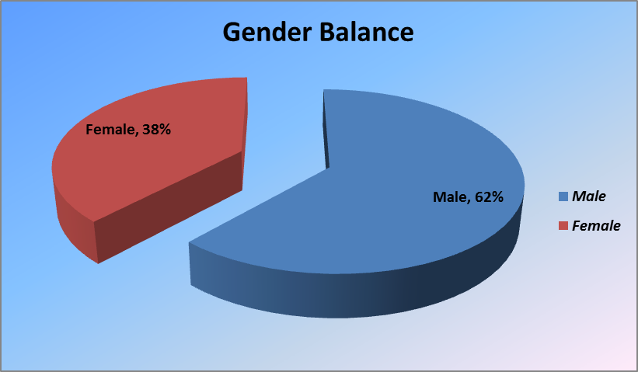

Annex II
Country visits conducted in 2014
REGION | STATE VISITED | MANDATE | DATE
African States | Rwanda | Special Rapporteur on the rights to freedom of peaceful assembly and of association | 20 – 27 January 2014
African States | Sudan | Independent Expert on the situation of human rights in the Sudan | 11 – 20 February 2014
African States | Côte d'Ivoire | Special Rapporteur on the situation of human rights in Côte d'Ivoire | 11 – 23 February 2014
African States | Seychelles | Special Rapporteur on trafficking in persons, especially women and children | 27 – 31 January 2014
African States | Mali | Independent Expert on the situation of human rights in Mali | 17 – 26 February 2014
African States | Nigeria | Independent Expert on minority issues | 17 – 28 February 2014
African States | Mauritania | Special Rapporteur on contemporary forms of slavery, including its causes and consequences | 24-27 February 2014
African States | Guinea-Bissau | Special Rapporteur on extreme poverty and human rights | 24 February – 1 March 2014
African States | Central African Republic | Independent Expert on the situation of human rights in the Central African Republic | 4 – 14 March 2014
African States | Central African Republic | Independent Expert on the situation of human rights in the Central African Republic | 10 – 18 April 2014
African States | Comoros | Working Group on the use of mercenaries as a means of violating human rights and impeding the exercise of the right of peoples to self-determination | 8 – 16 May 2014
African States | Tunisia | Special Rapporteur on torture and other cruel, inhuman or degrading treatment or punishment | 4 – 6 June 2014
African States | Côte d'Ivoire | Special Rapporteur on the situation of human rights in Côte d'Ivoire | 16 – 20 June 2014
African States | Sudan | Independent Expert on the situation of human rights in the Sudan | 15 – 24 June 2014
African States | Kenya | Special Rapporteur on the human right to safe drinking water and sanitation | 22 – 29 July 2014
African States | Côte d'Ivoire | Working Group on the use of mercenaries as a means of violating human rights and impeding the exercise of the right of peoples to self-determination | 7 – 10 October 2014
African States | Mali | Independent Expert on the situation of human rights in Mali | 8 – 17 October 2014
African States | Gambia | Special Rapporteur on torture and other cruel, inhuman or degrading treatment or punishment / Special Rapporteur on extrajudicial, summary or arbitrary executions | 3 – 7 November 2014
African States | Niger | Special Rapporteur on contemporary forms of slavery, including its causes and its consequences | 11 – 21 November 2014
African States | Botswana | Special Rapporteur in the field of cultural rights | 14 – 26 November 2014
African States | Burundi | Special Rapporteur on the situation of human rights defenders | 14 – 25 November 2014
African States | Tunisia | Special Rapporteur on the independence of judges and lawyers | 27 November – 5 December 2014
African States | Burundi | Special Rapporteur on the promotion of truth, justice, reparation and guarantees of non-recurrence | 8 – 16 December 2014
African States | Somalia | Independent Expert on the situation of human rights in Somalia | 6 – 13 December 2014
Asian States | Cambodia | Special Rapporteur on the situation of human rights in Cambodia | 12 – 17 January 2014
Asian States | Qatar | Special Rapporteur on the independence of judges and lawyers | 19 – 26 January 2014
Asian States | United Arab Emirates | Special Rapporteur on the independence of judges and lawyers | 28 January – 5 February 2014
Asian States | Tajikistan | Special Rapporteur on torture and other cruel, inhuman or degrading treatment or punishment | 10 – 12 February 2014
Asian States | Myanmar | Special Rapporteur on the situation of human rights in Myanmar | 14 – 19 February 2014
Asian States | Papua New Guinea | Special Rapporteur on extrajudicial, summary or arbitrary executions | 3 – 14 March 2014
Asian States | Jordan | Special Rapporteur on the right to safe drinking water and sanitation | 11 – 16 March 2014
Asian States | Kazakhstan | Special Rapporteur on contemporary forms of slavery, including its causes and consequences | 25 – 27 March 2014
Asian States | Kazakhstan | Special Rapporteur on the rights to freedom of religion and belief | 25 March – 5 April 2014
Asian States | Japan | Special Rapporteur on the situation of human rights in the Democratic People’s Republic of Korea | 8 – 10 April 2014
Asian States | Sri Lanka | Special Rapporteur on the human rights of migrants | 19 – 26 May 2014
Asian States | Bhutan | Special Rapporteur on the right to education | 26 May – 4 June 2014
Asian States | Cambodia | Special Rapporteur on the situation of human rights in Cambodia | 15 – 25 June 2014
Asian States | Myanmar | Special Rapporteur on the situation of human rights in Myanmar | 17 – 26 July 2014
Asian States | Viet Nam | Special Rapporteur on the freedom of religion of belief | 21 – 31 July 2014
Asian States | Oman | Special Rapporteur on the rights to freedom of peaceful assembly and of association | 7 – 13 September 2014
Asian States | OPT | Special Rapporteur on the situation of human rights in the Palestinian territories occupied since 1967 | 20 – 28 September 2014
Asian States | Republic of Korea | Special Rapporteur on contemporary forms of racism, racial discrimination, xenophobia and related intolerance | 29 September – 6 October 2014
Asian States | Afghanistan | Special Rapporteur on violence against women, its causes and consequences | 4 – 10 November 2014
Asian States | Republic of Korea | Special Rapporteur on the situation of human rights in the Democratic People’s Republic of Korea | 10 – 14 November 2014
Asian States | Malaysia | Special Rapporteur on the right of everyone to the enjoyment of the highest attainable standard of physical and mental health | 19 November – 2 December 2014
EEG | Lithuania | Special Rapporteur on the situation of human rights in Belarus | 2 – 5 February 2014
EEG | Ukraine | Special Rapporteur on minority issues | 7 – 13 April 2014
EEG | Azerbaijan | Special Rapporteur on the human rights of internally displaced persons | 18 – 24 May 2014
EEG | Croatia | Working Group on Enforced or Involuntary Disappearances | 15 – 18 June 2014
EEG | Serbia | Working Group on Enforced or Involuntary Disappearances | 19 – 23 June 2014

EEG | Kosovo | Working Group on Enforced or Involuntary Disappearances | 24 – 26 June 2014
EEG | Montenegro | Working Group on Enforced or Involuntary Disappearances | 27 – 30 June 2014
EEG | Azerbaijan | Working Group on the issue of human rights and transnational corporations and other business enterprises | 18 – 27 August 2014
EEG | Ukraine | Special Rapporteur on the human rights of internally displaced persons | 16 – 25 September 2014
EEG | Slovenia | Independent Expert on the enjoyment of all human rights by older persons | 17 – 21 November 2014
GRULAC | Honduras | Special Rapporteur on the sale of children, child prostitution and child pornography | 21 – 25 April 2014
GRULAC | Mexico | Special Rapporteur on torture and other cruel, inhuman or degrading treatment or punishment | 21 April – 2 May 2014
GRULAC | Haiti | Special Rapporteur on the human rights of internally displaced persons | 28 June – 5 July 2014
GRULAC | Honduras | Special Rapporteur on violence against women, its causes and consequences | 1 – 8 July 2014
GRULAC | Haiti | Independent Expert on the situation of human rights in Haiti | 15 – 22 July 2014
GRULAC | Chile | Working Group on discrimination against women in law and in practice | 1 – 9 September 2014
GRULAC | Peru | Working Group on discrimination against women in law and in practice | 11 – 19 September 2014
GRULAC | Paraguay | Special Rapporteur on the rights of indigenous peoples | 21 – 28 November 2014
WEOG | Spain | Special Rapporteur on the promotion of truth, justice, reparation and guarantees of non-recurrence | 21 January – 3 February 2014
WEOG | Switzerland | Special Rapporteur on the situation of human rights in Eritrea | 17 – 28 March 2014
WEOG | Germany | Special Rapporteur on the situation of human rights in Eritrea | 17 – 28 March 2014
WEOG | New Zealand | Working Group on Arbitrary Detention | 24 March – 7 April 2014
WEOG | United Kingdom | Special Rapporteur on violence against women, its causes and consequences | 31 March – 15 April 2014
WEOG | Sweden | Special Rapporteur on the situation of human rights in the Islamic Republic of Iran | 27 May – 6 June 2014
WEOG | Austria | Special Rapporteur on the situation of human rights in the Islamic Republic of Iran | 27 May – 6 June 2014
WEOG | Italy | Special Rapporteur on the situation of human rights in the Islamic Republic of Iran | 27 May – 6 June 2014
WEOG | Netherlands | Working Group of Experts on People of African Descent | 26 June – 4 July 2014
WEOG | Italy | Working Group on Arbitrary Detention | 7 – 9 July 2014
WEOG | Italy | Special Rapporteur on the situation of human rights in Eritrea | 22 – 26 September 2014
WEOG | France | Independent Expert on the issue of human rights obligations relating to the enjoyment of a safe, clean, healthy and sustainable environment | 20 – 24 October 2014
WEOG | Sweden | Working Group of Experts on People of African Descent | 1 – 5 December 2014
WEOG | Italy | Special Rapporteur on the human rights of migrants | 2 – 5 December 2014
WEOG | Malta | Special Rapporteur on the human rights of migrants | 6 – 10 December 2014
WEOG | Iceland | Independent Expert on the effects of foreign debt and other related international financial obligations of States on the full enjoyment of all human rights, particularly economic, social and cultural rights | 8 – 15 December 2014
WEOG | Spain | Working Group on discrimination against women in law and in practice | 9 – 19 December 2014
Statistics
Region | Number of visits | Percentage
African States | 24 | 30
Asian States | 21 | 26%
EEG | 10 | 13%
GRULAC | 8 | 10%
WEOG | 17 | 21%
Total | 80 | 100%

Africa: Botswana, Burundi, Central African Republic, Comoros, Côte d’Ivoire, Gambia, Guinea-Bissau, Kenya, Mali, Mauritania, Niger, Nigeria, Rwanda, Seychelles, Somalia, Sudan, Tunisia.
Asia: Afghanistan, Bhutan, Cambodia, Japan, Jordan, Kazakhstan, Malaysia, Myanmar, Oman, Papua New Guinea, Qatar, Republic of Korea, Sri Lanka, Tajikistan, United Arab Emirates, Viet Nam.
EEG: Azerbaijan, Croatia, Lithuania, Montenegro, Serbia, including Kosovo, Slovenia, Ukraine.
GRULAC: Chile, Haiti, Honduras, Mexico, Paraguay, Peru.
WEOG: Austria, Germany, France, Iceland, Italy, Malta, Netherlands, New Zealand, Spain, Sweden, Switzerland, United Kingdom of Great Britain and Northern Ireland.
One territory visited: Occupied Palestinian Territory.
Country visits by region (%)
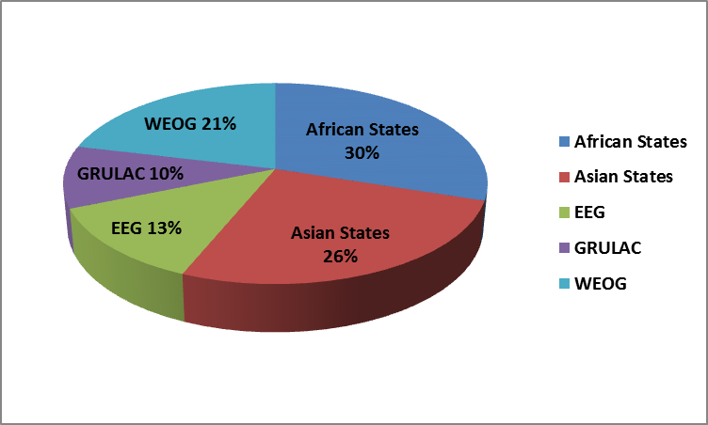
Annex III
Standing invitations
As at 31 December 2014, 109 Member States and 1 non-Member observer State had extended a standing invitation to thematic special procedures.
Member States and non-Member observer A – L | Date | Member States and non-Member observer M - Z | Date
Albania | 2 December 2009 | Luxembourg | March 2001
Andorra | 3 November 2010 | Madagascar | 26 August 2011
Argentina | 3 December 2002 | Maldives | 2 May 2006
Armenia | 1 May 2006 | Malta | March 2001
Australia | 7 August 2008 | Marshall Islands | 4 March 2011
Austria | March 2001 | Mexico | March 2001
Azerbaijan | 15 April 2013
Bahamas | 6 June 2013 | Monaco | 22 October 2008
Belgium | March 2001 | Mongolia | 9 April 2004
Benin | 31 October 2012 | Montenegro | 11 October 2005
Bolivia (Plurinational State of) | 10 February 2010 | Nauru | 30 May 2011
Bosnia and Herzegovina | 7 May 2010 | Netherlands | March 2001
Brazil | 10 December 2001 | New Zealand | 3 February 2004
Bulgaria | March 2001 | Nicaragua | 26 April 2006
Burundi | 6 June 2013 | Niger | 21 August 2012
Cameroon | 15 September 2014 | Nigeria | 25 October 2013
Canada | April 1999 | Norway | 26 March 1999
Cabo Verde | 26 April 2013 | Palau | 3 May 2011
Central African Republic | 3 September 2013
Chad | 1 June 2012 | Panama | 14 March 2011
Chile | 12 May 2009 | Papua New Guinea | 11 May 2011
Colombia | 17 March 2003 | Paraguay | 28 March 2003
Costa Rica | 2002 | Peru | 3 April 2002
Croatia | 13 March 2003 | Poland | March 2001
Cyprus | March 2001 | Portugal | March 2001
Czech Republic | September 2000 | Qatar | 1 June 2010
Denmark | March 2001 | Republic of Korea | 3 March 2008
Dominica | 9 December 2009 | Republic of Moldova | 2 June 2010
Ecuador | 9 January 2003 | Rwanda | 27 June 2011
El Salvador | 9 February 2010 | Samoa | 14 February 2011
Estonia | March 2001 | San Marino | 3 April 2003
Finland | March 2001 | Sao Tome and Principe | 2 February 2011
France | March 2001 | Serbia | 11 October 2005
Gabon | 29 October 2012 | Seychelles | 5 November 2012
Georgia | 30 March 2010 | Sierra Leone | 7 April 2003
Germany | March 2001 | Slovakia | March 2001
Ghana | 21 April 2006 | Slovenia | March 2001
Greece | March 2001 | Solomon islands | 6 May 2011
Guatemala | April 2001 | South Africa | 17 July 2003
Guinea-Bissau | 7 May 2010 | Spain | March 2001
Honduras | 12 May 2010 | Sweden | March 2001
Hungary | March 2001 | Switzerland | April 2002
Iceland | September 2000 | Thailand | 4 November 2011
India | 14 September 2011 | The former Yugoslav Republic of Macedonia | 13 October 2004
Iraq | 16 February 2010 | Tonga | 25 January 2013
Ireland | March 2001 | Turkey | March 2001
Islamic Republic of Iran | 24 July 2002 | Tunisia | 28 February 2011
Italy | March 2001 | Tuvalu | 26 April 2013
Japan | 1 March 2011 | Ukraine | 23 June 2006
Jordan | 20 April 2006 | United Kingdom of Great Britain and Northern Ireland | March 2001
Kazakhstan | 28 July 2009 | Uruguay | 18 March 2005
Kuwait | 13 September 2010 | Vanuatu | 12 May 2009
Latvia | March 2001 | Zambia | 16 July 2008
Lebanon | 17 March 2011 | State of Palestine | 30 July 2014
Libya | 15 March 2012
Liechtenstein | 21 January 2003
Lithuania | March 2001
Percentages on regional representation relating to standing invitations (as at December 2014)
United Nations Regional Groups of Member States | Number of standing invitations extended per region (total number of States within that region) | Percentage of standing invitations extended per regional group out of the total of 109 | Percentage of standing invitations extended compared to the total number of States within that region
African Group | 20 (out of 54 States) | 18 per cent | 37 per cent
Asia-Pacific Group | 22 (out of 53 States*) | 20 per cent | 41 per cent
Eastern European Group | 21 (out of 23 States) | 19 per cent | 91 per cent
Latin American and Caribbean Group (GRULAC) | 18 (out of 33 States) | 17 per cent | 55 per cent
Western European and Others Group (WEOG) | 28 (out of 30 States) | 26 per cent | 93 per cent
Total | 109 (of 193 States*) | 100 per cent
NB. The State of Palestine, accorded non-Member Observer status by General Assembly resolution 67/19 of 29 November 2012, extended a standing invitation to all special procedures on 4 July 2014.
Annex IV
States not yet visited by any mandate holder
Out of the 193 States Members of the United Nations, 167 States (86.5 per cent) have accepted requests for country visits and 166 have been visited by at least one of the special procedures mandate holders. A total of 26 States (13.4 per cent) have never received or accepted any request for a visit by one or more of the special procedures mandate holders.
States never visited, no requests sent (15 in total) | States never visited, despite requests sent (12 in total)
Andorra | Barbados
Antigua and Barbuda | Democratic People’s Republic of Korea
Brunei Darussalam | Djibouti
Dominica | Eritrea
Grenada | Guinea
Luxembourg | Lesotho
Micronesia | Libya*
Monaco | Nauru
Palau | Swaziland
Saint Kitts and Nevis | Vanuatu
Saint Lucia | Zimbabwe
Samoa
San Marino
Sao Tome e Principe
Tonga
Annex V
Communications
Statistics of communications sent by mandate holders
2014 Basic Figures
553 – Total number of communications sent
81% - Joint communications by two or more mandates
1061 – Individuals covered (17.19% expressly relate to women)
116 – Countries which received communications by 31 December 2014
42.7% - States replies to communications N.B. These statistics do not include data from the Working Group on Enforced or Involuntary Disappearances (WGEID) which uses different working methods.

Communications by type 2014

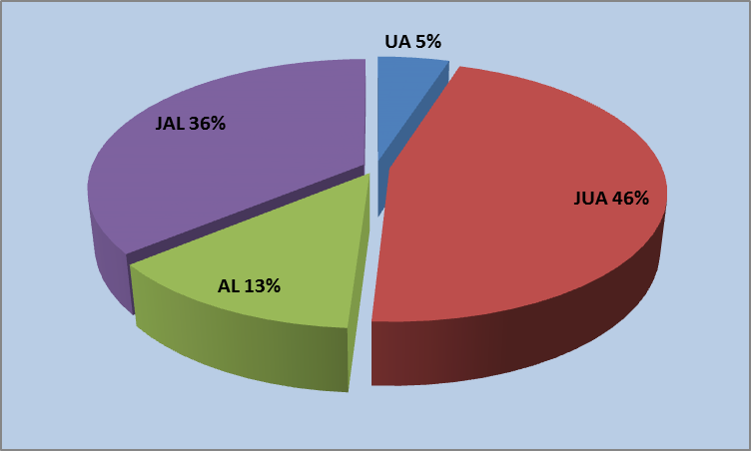
Communications by sex
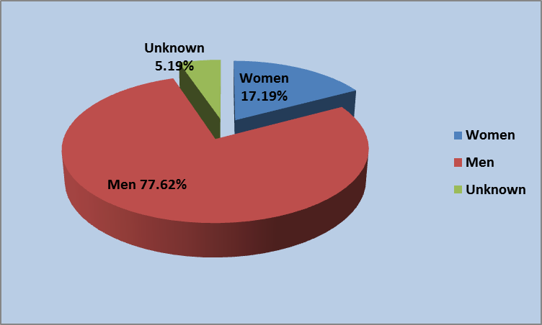
Communications and follow-up by type of communication in 2014 (by number)
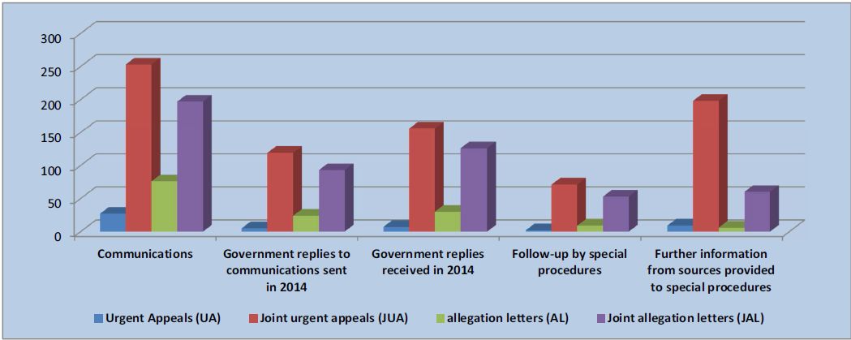
Communications and follow-up by region in 2014 (by number)
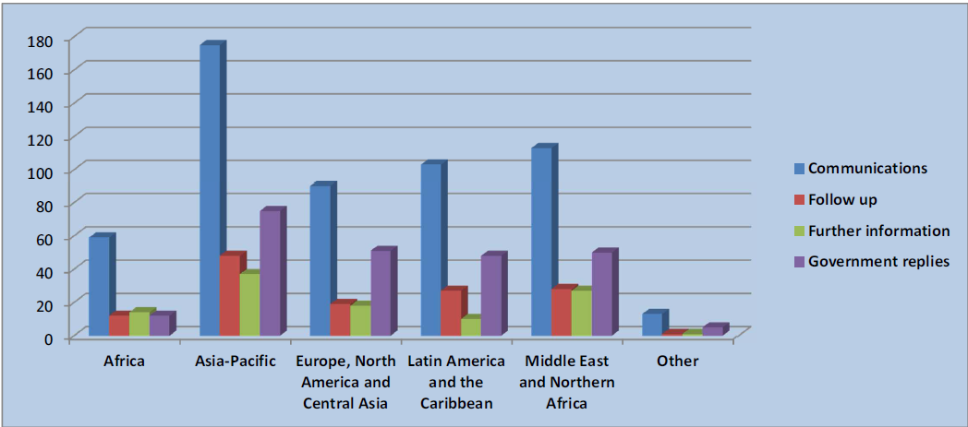
Annex VI
Themes addressed in special procedures reports
Mandate | Title
Special Rapporteur on the sale of children, child prostitution and child pornography  Ms Maud de Boer-Buquicchio | HRC, ‘Overview of six year tenure and main issues relating to the mandate’, A/HRC/25/48  (Ms Najat Maalla M’jid)  GA, ‘Vision and methods of work’, A/69/262
Special Rapporteur in the field of cultural rights  Ms Farida Shaheed | HRC, ‘Memorialization processes of the events of the past in post-conflict and divided societies, with a specific focus on memorials and museums of history/memory, A/HRC/25/49  GA, ‘The impact of advertising and marketing practices on the enjoyment of cultural rights’, A/69/286
Independent Expert on the effects of foreign debt and other related international financial obligations of States on the full enjoyment of human rights, particularly economic, social and cultural rights  Mr Pablo Bohoslavsky | HRC, ‘Overview on activities of the mandate 2008-2014’, A/HRC/25/50  (Mr Cephas Lumina)  HRC, ‘Draft commentary on the guiding principles on foreign debt and human rights’, A/HRC/25/51  (Mr Cephas Lumina)  HRC, ‘Impact of non-repatriation of funds of illicit origin on human rights’, A/HRC/25/52  (Mr Cephas Lumina)  GA, ‘Thematic priorities for 2014-2017’, A/69/273
Independent Expert on the issue of human rights obligations relating to the enjoyment of a safe, clean, healthy and sustainable environment  Mr John Knox | HRC, ‘Mapping report’, A/HRC/25/53
Special Rapporteur on adequate housing as a component of the right to an adequate standard of living, and on the right to non-discrimination in this context  Ms Leilani Farha | HRC, ‘Guiding principles to assist States and other relevant actors in addressing the current tenure insecurity crisis faced by the urban poor in an increasingly urbanized world’, A/HRC/25/54  (Ms Raquel Rolnik)  GA, ‘Outline of some priority themes and areas of interest for the new mandate holder’, A/69/274
Special Rapporteur on the situation of human rights defenders  Mr Michel Forst | HRC, ‘Elements of a safe and enabling environment for human rights defenders’, A/HRC/25/55  (Ms Margaret Sekaggya)  GA, ‘Vision and priorities of the Special Rapporteur’, A/69/259
Special Rapporteur on minority issues  Ms Rita Izsák | HRC, ‘Ensuring the inclusion of minority issues in post-2015 development agendas’, A/HRC/25/56  GA, ‘Preventing and addressing violence and atrocities against minorities’, A/69/266
Special Rapporteur on the right to food  Ms Hilal Elver | HRC, ‘The transformative potential of the right to food’, A/HRC/25/57  (Mr Olivier De Schutter)  GA, ‘Vision for the mandate and relevant thematic issues’, A/69/275
Special Rapporteur on freedom of religion or belief  Mr Heiner Bielefeldt | HRC, ‘Tackling manifestations of collective religious hatred’, A/HRC/25/58  GA, ‘Tackling religious intolerance and discrimination in the workplace’, A/69/261
Special Rapporteur on the promotion and protection of human rights and fundamental freedoms while countering terrorism  Mr Ben Emmerson | HRC, ‘The use of drones in extraterritorial lethal counter-terrorism operations, including in the context of asymmetrical armed conflict’, A/HRC/25/59  GA, ‘The use of mass digital surveillance for counter-terrorism purposes, and implications of bulk access technology for the right to privacy under article 17 of the International Covenant on Civil and Political Rights,’  A/69/397
Special Rapporteur on torture and other cruel, inhuman or degrading treatment or punishment  Mr Juan Méndez | HRC, ‘The use of torture-tainted information and the exclusionary rule’, A/HRC/25/60  GA, ‘The role of forensic science regarding the obligation of States to effectively investigate and prosecute allegations of torture’, A/69/387
Independent Expert on the situation of human rights in Mali  Mr Suliman Baldo | HRC, ‘Political and security situation and institutional reforms undertaken by Mali since the end of the severe crisis triggered in January 2012 and the return to constitutional order,’ A/HRC/25/72
Special Rapporteur on the situation of human rights in Myanmar  Ms Yanghee Lee | HRC, ‘Reflection on the extent of progress made during the course of the mandate holders six year tenure,’ A/HRC/25/64  (Tomás Ojea Quintana)  GA, ‘Preliminary key areas of focus and recommendations aimed at contributing to Myanmar’s efforts towards respecting, protecting and promoting human rights and achieving democratization, national reconciliation and development,’ A/69/398
Special Rapporteur on the situation of human rights in the Palestinian territories occupied since 1967  Mr Makarim Wibisono | HRC, ‘Final report of the Special Rapporteur,’ A/HRC/25/67  (Mr Richard Falk)  GA, ‘Next steps towards the fulfilment of the mandates,’ A/69/301 and A/69/301/Corr.1
Working Group on the issue of human rights and transnational corporations and other business enterprises | HRC, ‘Review of strategic objectives, activities and outcomes since creation of the Working Group in 2011 and an overview on the challenges ahead’, A/HRC/26/25  HRC, “Business Impacts and Non-judicial Access to Remedy: Emerging Global Experience”, A/HRC/26/25/Add.3  GA, ‘National action plans to implement the Guiding Principles on Business and Human Rights’, A/69/263
Special Rapporteur on the right to education  Mr Kishore Singh | HRC, ‘Assessment of students’ educational attainment and the implementation of the right to education’, A/HRC/26/27  GA, ‘Privatization in education’, A/69/402
Special Rapporteur on extreme poverty and human rights  Mr Philip Alston | HRC, ‘Taxation and human rights’, A/HRC/26/28 and A/HRC/26/28/Corr.1  (Ms Maria Magdalena Sepúlveda Carmona)  HRC, ‘Overview of the activities of the Special Rapporteur on extreme poverty and human rights during the term of her mandate 2008-2014’, A/HRC/26/28/Add.3  (Ms Maria Magdalena Sepúlveda Carmona)  GA, ‘Implementation of right to social security through the universal adoption of social protection floors’, A/69/297
Special Rapporteur on the rights to freedom of peaceful assembly and of association  Mr Maina Kiai | HRC, ‘Challenges faced by groups most at risk when exercising or seeking to exercise the rights to freedom of peaceful assembly and/or of association’, A/HRC/26/29  GA, ‘Exercise of the rights to freedom of peaceful assembly and of association in the context of multilateral institutions: the impact of State actions at the multilateral level on civil society’s ability to engage and participate in social, economic, political and other pursuits’, A/69/365
Special Rapporteur on the promotion and protection of the right to freedom of opinion and expression  Mr David Kaye | HRC, ‘Freedom of expression in elections’, A/HRC/26/30  (Mr Frank La Rue)  GA, ‘The right of the child to freedom of  expression’, A/69/335  (Mr. Frank La Rue)
Special Rapporteur on the right of everyone to the enjoyment of the highest attainable standard of physical and mental health  Mr Dainius Pūras | HRC, ‘Unhealthy foods and non-communicable diseases’, A/HRC/26/31  (Mr Anand Grover)  GA, ‘Effective and full implementation of the right to health framework’, A/69/299
Special Rapporteur on the independence of judges and lawyers  Ms Gabriela Knaul | HRC, ‘Judicial accountability’, A/HRC/26/32  GA, ‘Justice and the post-2015 development agenda’, A/69/294
Special Rapporteur on the human rights of internally displaced persons  Mr Chaloka Beyani | HRC: ‘The Kampala Convention: key provisions and the progress made in its adoption and implementation’, A/HRC/26/33  GA, ‘The challenges of finding durable solutions for IDPs in urban settings’, A/69/295
Independent Expert on human rights and international solidarity  Ms Virginia Dandan | HRC, ‘The process of constructing the draft declaration on the rights of peoples and individuals to international solidarity’, A/HRC/26/34  HRC, ‘Preliminary text of a draft declaration on the right of peoples and individuals to international solidarity’, A/HRC/26/34/Add.1  GA, ‘The contribution of intl. solidarity to the future SDGs, including an analysis of the proposed draft declaration on the right to international solidarity on three areas of concern relevant to the future goals: overcoming inequality, ending poverty and discrimination: building effective, accountable institutions and peaceful societies; international cooperation: strengthening implementation and revitalizing global partnerships’, A/69/366
Special Rapporteur on the human rights of migrants  Mr François Crépeau | HRC, ‘Labour exploitation’, A/HRC/26/35  GA, ‘Human rights of migrants in the post-2015 Agenda’, A/69/302
Special Rapporteur on extrajudicial, summary or arbitrary executions  Mr Christof Heyns | HRC, ‘Protection of the right to life during law enforcement’, A/HRC/26/36  GA, ‘Overview of the activities of the mandate’, A/69/265
Special Rapporteur on trafficking in persons, especially women and children  Ms Maria Grazia Giammarinaro | HRC, ‘Analysis of the first decade of the mandate’, A/HRC/26/37  (Ms Joy Ngozi Ezeilo)  Stocktaking exercise on the work of the mandate on its 10th anniversary, A/HRC/26/37/Add.2  (Ms Joy Ngozi Ezeilo)  GA, ‘Analysis of the major areas of focus and main achievements of the mandate since its inception’, A/69/269  (Ms Joy Ngozi-Ezeilo
Special Rapporteur on violence against women, its causes and consequences  Ms Rashida Manjoo | HRC, ‘Violence against women: twenty years of developments within the United Nations’, A/HRC/26/38  GA, ‘Violence against women as a barrier to the realization of women’s civil, political, economic, social, cultural and developmental rights, and the effective exercise of citizenship rights’, A/69/368
Working Group on the issue of discrimination against women in law and in practice | HRC, ‘Discrimination against women in economic and social life’, A/HRC/26/39
Special Rapporteur on contemporary forms of racism, racial discrimination, xenophobia and related intolerance  Mr Mutuma Ruteere | HRC, ‘Racism on the internet and social media’, A/HRC/26/49  HRC, ‘Combatting glorification of Nazism and other practices’, A/HRC/26/50  GA, ‘Racism in sports’, A/69/340  GA, ‘Glorification of Nazism: inadmissibility of certain practices that contribute to fuelling contemporary forms of racism, racial discrimination, xenophobia and related intolerance’, A/69/334
Special Rapporteur on the situation of human rights in the Democratic People’s Republic of Korea  Mr Marzuki Darusman | HRC, ‘Direction in fulfilling the mandate, building on the findings and recommendations of the commission of inquiry on human rights in the Democratic People’s Republic of Korea’, A/HRC/26/43
Independent Expert on the enjoyment of all human rights by older persons  Ms Rosa Kornfeld-Matte | HRC, ‘Preliminary considerations and views about the foundations and context of the mandate’, A/HRC/27/46
Working Group on arbitrary detention | HRC, A compilation of national, regional and international laws, regulations and practices on the right to challenge the lawfulness of detention before court’, A/HRC/27/47  HRC, ‘Military Justice. Over-incarceration. Protective custody’, A/HRC/27/48
Working Group on enforced or involuntary disappearances | HRC, ‘Activities, communications and cases of the mandate’, A/HRC/27/49
Working Group on the use of mercenaries as a means of violating human rights and impeding the exercise of the right of peoples to self-determination | HRC, ‘National laws and regulations on private military and security companies in Africa and in Asia’, A/HRC/27/50  GA, ‘The UN’s use of private military and security companies’, A/69/338
Independent Expert on the promotion of a democratic and equitable international order  Mr Alfred de Zayas | HRC, ‘Preliminary study of the adverse impacts of military spending on the realization of a democratic and equitable international order’, A/HRC/27/51  GA, ‘The right of self-determination’, A/69/272
Special Rapporteur on the rights of indigenous peoples  Ms Victoria Tauli Corpuz | HRC, ‘Preliminary reflections on the status of operationalization of international standards related to indigenous peoples’, A/HRC/27/52  GA, ‘Indigenous peoples’ economic, social and cultural rights in the post-2015 development framework’, A/69/267
Special Rapporteur on contemporary forms of slavery, including its causes and its consequences  Ms Urmila Bhoola | HRC, ‘Priorities of the mandate’, A/HRC/27/53
Special Rapporteur on the implications for human rights of the environmentally sound management and disposal of hazardous substances and wastes  Mr Baskut Tuncak | HRC, ‘Overview of the mandate’, A/HRC/27/54
Special Rapporteur on the human right to safe drinking water and sanitation  Ms Catarina de Albuquerque | HRC, ‘Common violations of the human rights to water and sanitation’, A/HRC/27/55  HRC, ‘Handbook for realizing the human right to safe drinking water and sanitation’,  A/HRC/27/55/Add.3  GA, ‘Participation in the realization of the human rights to water and sanitation’, A/69/213
Special Rapporteur on the promotion of truth, justice, reparation and guarantees of non-recurrence  Mr Pablo de Greiff | HRC, ‘Prosecution strategies in the aftermath of conflict and/or repression’, A/HRC/27/56  GA, ‘Reparation for victims in the aftermath of gross violations of human rights and serious violations of international humanitarian law’, A/69/518
Working Group of Experts on People of African Descent | HRC, ‘People of African descent: access to justice’, A/HRC/27/68
Special Rapporteur on the situation of human rights in Cambodia  Mr Surya Prasad | HRC, ‘Reflections on the work of the Special Rapporteur for the six years of his mandate,’ A/HRC/27/70  (Mr Surya Subedi)
Independent Expert on the situation of human rights in Somalia  Mr Bahame Nyanduga | HRC, ‘Analysis of the human rights situation and emerging issues in Somalia’, A/HRC/27/71
Special Rapporteur on the situation of human rights in Belarus  Mr Miklós Haraszti | GA, ‘State of freedom of association and the impact of the legal framework and legal practices on non-governmental organizations and human rights defenders in Belarus’, A/69/307
Annex VII
Joint statements
On 18 August 2013, the Coordination Committee issued a press release on the situation of human rights in Egypt.
On 2 October 2013, at the initiative of the Special Rapporteur on the rights of migrants, the Committee facilitated the issuance of an open letter and a press release on the High Level Dialogue on International Migration and Development on behalf of all mandate holders.
On 10 December 2013, the Coordination Committee initiated a declaration on behalf of all mandate holders focusing on cooperation with special procedures and related challenges.
On 20 January 2014, the Chairperson of the Coordination Committee participated in the Special Session of the Human Rights Council on the human rights situation in the Central African Republic and delivered a statement on behalf of the Coordination Committee.
On 21 January 2014, the Coordination Committee issued an open letter in advance of the Geneva II conference on the conflict on Syria.
On 21 February 2014, the Coordination Committee issued a statement on the situation on human rights in Ukraine.
On 23 July 2014, at the request of the Coordination Committee, the Special Rapporteur on the situation of human rights in the Occupied Palestinian Territories, including East Jerusalem, participated in the 21st special session of the Human Rights Council on the human rights situation in the Occupied Palestinian Territory, including East Jerusalem. He delivered a statement on his and the Coordination Committee's behalf.
On 1 September 2014, the Chairperson of the Coordination Committee participated in the 22nd special session of the Human Rights Council on the human rights situation in Iraq in light of abuses committed by the Islamic State in Iraq and the Levant and associated groups and delivered a statement on behalf of the Coordination Committee.
On 10 December 2014, on the occasion of Human Rights Day, special procedures mandate holders issued a joint statement on climate change and human rights.
Annex VIII
Mandate holders attending the twenty-first annual meeting
Thematic mandates
1. | Working Group of Experts on People of African Descent | Mireille Fanon-Mendes-France (France)
2. | Working Group on Arbitrary Detention | Mads Andenas (Norway)
3. | Special Rapporteur in the field of cultural rights | Farida Shaheed (Pakistan)
4. | Independent Expert on the promotion of a democratic and equitable international order | Alfred de Zayas (United States of America)
5. | Working Group on the issue of discrimination against women in law and in practice | Frances Raday (Israel/United Kingdom of Great Britain and Northern Ireland)
6. | Working Group on Enforced or Involuntary Disappearances | Jasminka Dzumhur (Bosnia and Herzegovina)
7. | Special Rapporteur on the right to education | Kishore Singh (India)
8. | Independent Expert on the issue of human rights obligations relating to the enjoyment of a safe, clean, healthy and sustainable environment | John Knox (United States of America)
9. | Special Rapporteur on the right to food | Hilal Elver (Turkey)
10. | Special Rapporteur on the promotion and protection of the right to freedom of opinion and expression | David Kaye (United States of America)
11. | Special Rapporteur on freedom of religion or belief | Heiner Bielefeldt (Germany)
12. | Special Rapporteur on the right of everyone to the enjoyment of the highest attainable standard of physical and mental health | Dainius Puras (Lithuania)
13. | Special Rapporteur on adequate housing as a component of the right to an adequate standard of living | Leilani Farha (Canada)
14. | Special Rapporteur on the situation of human rights defenders | Michel Forst (France)
15. | Special Rapporteur on the independence of judges and lawyers | Gabriela Knaul (Brazil)
16. | Special Rapporteur on the rights of indigenous peoples | Victoria Lucia Tauli-Corpuz (Philippines)
17. | Special Rapporteur on the human rights of internally displaced persons | Chaloka Beyani (Zambia)
18. | Working Group on the use of mercenaries as a means of violating human rights and impeding the exercise of the right of peoples to self-determination | Patricia Arias (Chile)
19. | Special Rapporteur on the human rights of migrants | François Crépeau (Canada/France)
20. | Special Rapporteur on minority issues | Rita Izsák (Hungary)
21. | Independent Expert on the enjoyment of all human rights by older persons | Rosa Kornfeld-Matte (Chile)
22. | Special Rapporteur on the sale of children, child prostitution and child pornography | Maud De Boer-Buquicchio (Netherlands)
23. | Special Rapporteur on contemporary forms of slavery, including its causes and its consequences. | Urmila Bhoola (South Africa)
24. | Independent Expert on human rights and international solidarity | Virginia Dandan (Philippines)
25. | Special Rapporteur on extrajudicial, summary or arbitrary executions | Christof Heyns (South Africa)
26. | Special Rapporteur on torture and other cruel, inhuman or degrading treatment or punishment | Juan Ernesto Mendez (Argentina)
27. | Special Rapporteur on the implications for human rights of the environmentally sound management and disposal of hazardous substances and wastes | Baskut Tuncak (Turkey)
28. | Special Rapporteur on trafficking in persons, especially women and children | Maria Grazia Giammarinaro (Italy)
29. | Working Group on the issue of human rights and transnational corporations and other business enterprises | Michael K. Addo (Ghana)
30. | Special Rapporteur on violence against women, its causes and consequences | Rashida Manjoo (South Africa)
31. | Independent Expert on the effects of foreign debt and other related international financial obligations of States on the full enjoyment of all human rights, particularly economic, social and cultural rights | Juan Bohoslavsky (Argentina)
32. | Special Rapporteur on the human right to safe drinking water and sanitation | Catarina de Albuquerque (Portugal)
Country-specific mandates
37. | Special Rapporteur on the situation of human rights in Cambodia | Surya Prasad Subedi (Nepal)
38. | Independent Expert on the situation of human rights in the Central African Republic | Marie-Therese Keita Bocoum (Côte d’Ivoire)
39. | Special Rapporteur on the situation of human rights in Eritrea | Sheila B. Keetharuth (Mauritius)
Annex IX
Non-exhaustive list of follow-up activities undertaken by mandate holders in 2014
A. Follow-up concerning communications
In 2014, 135 follow-up communications were sent, out of a total of 553 communications, constituting 24%. In addition, the following mandate holders issued observations on communications:
Special Rapporteur on torture and other cruel, inhuman or degrading treatment of punishment | Observations on communications transmitted to Governments and replies received (A/HRC/25/60/Add.2)
Special Rapporteur on the situation of human rights defenders | Observations on communications transmitted to Governments and replies received (A/HRC/25/55/Add.3)
Special Rapporteur on the right to freedom of assembly and of association | Observations on communications transmitted to Governments and replies received (A/HRC/26/29/Add.1)
Special Rapporteur on extrajudicial, summary or arbitrary executions | Observations on communications transmitted to Governments and replies received (A/HRC/26/36/add.2)
B. Follow-up country visits
Six mandate holders conducted in total eleven follow-up visits:
Working Group on Arbitrary Detention | Follow-up visit to Italy from 7 to 9 July 2014 (report will be presented to the Human Rights Council at its thirtieth session)

Special Rapporteur on the human rights of internally displaced persons | Follow-up visit to Kenya from 29 April to 7 May 2014 (no separate report will be presented to the Human Rights Council)  Follow-up working visit to Côte d’Ivoire from 16 to 20 June 2014 (no separate report will be presented to the Human Rights Council)  Follow-up visit to Serbia, including Kosovo,from 9 to 12 October 2013, of which the report was presented to the Council at its twenty-sixth session (A/HRC/26/33/Add.2)
Special Rapporteur on the human rights of migrants | Follow-up visit to Italy from 2 to 5 December 2014 (report will be presented to the Human Rights Council at its twenty-ninth session)  Follow-up visit to Malta from 6 to 10 December 2014 (report will be presented to the Human Rights Council at its twenty-ninth session)
Special Rapporteur on contemporary forms of racism, racial discrimination, xenophobia and related intolerance | Follow-up visit to Mauritania from 2 to 8 September 2013 (A/HRC/26/49/Add.1)
Special Rapporteur on the sale of children, child prostitution and child pornography | Follow-up visit to Honduras from 21 to 25 April 2014 (A/HRC/25/48/Add.1)
Special Rapporteur on contemporary forms of slavery, including its causes and consequences | Follow-up visit to Kazakhstan from 25 to 27 March 2014 (A/HRC/27/53/Add.2)  Follow-up visit to Mauritania from 24 to 27 February 2014 (A/HRC/27/53/Add.1)
Special Rapporteur on torture and other cruel, inhuman and degrading treatment or punishment | Follow-up visit to Tunisia from 4 to 6 June 2014 (report will be presented to the Human Rights Council at its twenty-eighth session)  Follow-up visit to Tajikistan from 10 to 13 February 2014 (report will be presented the Human Rights Council at its twenty-eighth session)  Follow-up visit to Uruguay from 2 to 6 December 2012 (A/HRC/22/53/Add.3)
C Follow-up consultations, workshops and other meetings
Three mandate holders took part in follow-up consultations, workshops and other meetings:
The Special Rapporteur on torture and other cruel, inhuman or degrading treatment or punishment | Round-table discussions with civil society and high-level Government representatives, held during follow-up visits by mandate holders to Tajikistan and Tunisia in February and June 2014 respectively.
The Special Rapporteur on freedom of religion or belief | - Interreligious round table, held in Cyprus, on 12 September 2013.  - Round table with religious communities and civil society organizations, held in the Republic of Moldova, during a working visit to the country, from 15 to 18 May 2014.
D. Follow-up reports
Three Special Rapporteurs and one Working Group presented reports in which they followed up on their recommendations made to States:
Working Group on enforced or involuntary disappearances | Follow-up report to their country missions to Argentina and Bosnia and Herzegovina (A/HRC/27/49/Add.2)
Special Rapporteur on the human rights of internally displaced persons | Follow-up report on Georgia (A/HRC/26/33/Add.1)  Follow-up report on Serbia, including Kosovo (A/HRC/26/33/Add.2)
Special Rapporteur on trafficking in persons, especially women and children | Report analyzing the achievements of the first decade of the mandate (A/HRC/26/37)  - Report analyzing the major areas of focus and main achievements of the mandate since its inception (A/69/33797)
Special Rapporteur on extreme poverty and human rights | - Addendum to report of the Special Rapporteur on extreme poverty and human rights, Magdalena Sepúlveda Carmona, Summary of activities of the Special Rapporteur on extreme poverty and human rights, 2008-2014 (A/HRC/26/28/Add.3)
E. Other follow-up activities
One mandate holder undertook other additional follow-up activities:
Special Rapporteur on torture and other cruel, inhuman and degrading treatment or punishment | Follow-up publication: Torture in Health-Care Settings: Reflections on the Special Rapporteur on Torture’s 2013 Thematic Report, February 2014, Washington D.C., released February 2014.  Follow-up publication: Next Steps Towards a Human Rights Penitentiary System in Uruguay: Reflections on the Implementation of the 2009 and 2013 Recommendations of the United Nations Special Rapporteur on Torture, released in September 2014.
Annex X
Statement by the Chairperson of the Coordination Committee
We, special procedures mandate holders, have taken note with interest of Human Rights Council resolution 26/11, adopted on 23 June 2014, on the “protection of the family”, and the panel discussion on 15 September 2014.
We note with appreciation the emphasis on the structural problems of care responsibilities and the need to redistribute them not only between women and men, as was established by CEDAW in 1980, but also between the family and the State. We are also reassured that in the panel discussion, there was general acceptance that families are diverse and in this context, there should be no discrimination; and that violence within the family should be eliminated. We trust that the Human Rights Council will incorporate these positive elements in all its future work, in accordance with international standards.
Yet we want to express our concern regarding the fact that the resolution made no reference to women’s right to equality within the family and the panel discussion erroneously equated the protection of the family with the protection of the rights of individual members of the family, in particular the rights of women to equality.
We recall that the right to equality between women and men in the family is guaranteed under the Universal Declaration of Human Rights, the International Covenants on Civil and Political Rights and Economic, Social and Cultural Rights, and the Convention on the Elimination of All Forms of Discrimination against Women.
We therefore call on the Human Rights Council to ensure that in all future resolutions, concept notes and reports on the issue of the family, the right to equality between women and men and between girls and boys within the family be explicitly included as a fundamental human right.

* * The annexes to the present report are circulated in the language of submission only.
* ** Late submission.
? A/CONF.157/24 (Part I), part II, para. 95.
? A/HRC/25/74, A/HRC/26/21 and A/HRC/27/72.
? A/HRC/26/38.
? A/HRC/27/55/Add.3.
? A/HRC/26/18, annex.
? A/HRC/26/34, annex.
? A/69/397, para. 64.
? A/69/297, paras. 61-62.
? A/69/368, para. 71.
? See A/68/389 and A/HRC/25/59.
? A/HRC/26/36.
? A/69/397.
? A/69/297.
? A/69/338.
? A/HRC/22/53.
? Available on the OHCHR website at www.ohchr.org/EN/HRBodies/SP/Pages/Welcomepage.aspx.
? A/68/296 and A/HRC/25/49.
? A/HRC/29/29.
? See A/HRC/28/77.
? See General Assembly resolution 69/16.
? Center for Human Rights and Humanitarian Law, Próximos Pasos Hacia una Política Penitenciaria de Derechos Humanos en Uruguay: Ensayos en seguimiento a las recomendaciones de 2009 y 2013 de la Relatoría de Naciones Unidas contra la tortura, Washington College of Law, September 2014.
? A/68/970.
? A/HRC/25/53.
? All references to Kosovo in the present report should be understood to be in full compliance with Security Council resolution 1244 (1999), without prejudice to the status of Kosov.
? All references to Kosovo in the present report should be understood to be in full compliance with Security Council resolution 1244 (1999), without prejudice to the status of Kosovo.
* * Kiribati, even though not a member of any regional group, has for statistical purposes been added to the Asia-Pacific Group.
* * All missions to Libya have been postponed for security reasons.
? All references to Kosovo in the present report should be understood to be in full compliance with Security Council resolution 1244 (1999), without prejudice to the status of Kosovo.

