 |  | A/HRC/31/39
 | Advance Unedited Version |  | Distr.: General  17 February 2016  Original: English
Human Rights Council
Thirty-first session
Agenda items 2 and 5
Annual report of the United Nations High Commissioner
for Human Rights and reports of the Office of the
High Commissioner and the Secretary-General
Human rights bodies and mechanisms
Report of the twenty-second annual meeting of special rapporteurs/representatives, independent experts and working groups of the special procedures of the Human Rights Council (Geneva, 8 to 12 June 2015), including updated information on the special procedures
Note by the United Nations High Commissioner for Human Rights* * ****
Rapporteur: Seong-Phil Hong
Summary
The present report is submitted pursuant to Commission on Human Rights resolution 2004/76 and covers the period from 1 January to 31 December 2015. In addition to elaborating on the main points discussed during the twenty-second annual meeting of the special procedures, the report also contains relevant information on the system of special procedures as a whole.

Contents
Page
I Introduction 3
II. Facts and figures 3
A. New mandates 3
B. Mandate holders 3
C. Country visits and standing invitations 3
D. Communications 4
D. Thematic reports and studies 4
F. Contributions to standard-setting and human rights protection and promotion 5
G. Media outreach and public awareness 5
H. Engagement with other parts of the United Nations system and regional mechanisms 6
I. Other activities 7
III. Activities of the Coordination Committee of the Special Procedures 7
IV. Acts of intimidation and reprisal 8
V. Twenty-second annual meeting of special procedures 9
A. Coordination Committee 9
B. Methods of work 10
C. Human Rights up Front 13
D. Thematic discussions 13
E. Consultations with stakeholders 14
Annexes
I. 2015 Factsheet on special procedures 17
II. Statistics on current mandate holders (as of December 2015) 18
III. Overview of standing invitations 19
IV. Overview of country visits conducted in 2015 23
V. Overview of states not yet visited by any mandate holder 32
VI. Statistics on communications sent in 2015 33
VII. Overview of themes addressed in special procedures reports 35
VIII. List of joint statements issued by special procedures 40
IX. Non-exhaustive list of follow-up activities undertaken by mandate holders in 2015 41
X. Table on external funding received by mandate holders in 2015 44
XI. List of special procedures mandate holders as of 31 December 2015 53
XII. List of special procedures mandate holders to be appointed in 2016 57
XIII. List of sponsors of HRC resolutions establishing special procedures mandates 58
I. Introduction
1. The present report provides an overview in numbers of the system of special procedures as well as concrete examples of activities undertaken by mandate holders in 2015 (Chapter II). It also provides information on the work of its Coordination Committee (Chapter III) as well as reflects the main points of the discussions held and conclusions reached at the twenty-second annual meeting of the special procedures (Chapter VI). In particular, this report provides information on steps taken to address main issues of concern for mandate holders, namely acts of intimidation and reprisal against those cooperating with the United Nations in the field of human rights, including special procedures (Chapter IV), and the issue of disclosure of external funds received by mandate holders (Chapter V). The examples provided in this report are indicative only and do not reflect the many activities carried out by all mandate holders in 2015.
II. Facts and figures
A. New mandates
2. The Human Rights Council established two new mandates in 2015; that of the Independent Expert on the enjoyment of human rights of persons with albinism (A/HRC/RES/28/6) and of the Special Rapporteur on the right to privacy (A/HRC/RES/28/16). The special procedures system currently consists of 55 mandates, of which 41 with a thematic and 14 a country specific focus (Annex XI).
B. Mandate holders
3. The special procedures system currently includes 79 mandate holder positions, of which 12 were appointed in 2015. By Decision 30/115, adopted during its 30th session, the Council decided to adjust the terms of mandate holders on an exceptional one-time basis in order to better spread out the appointment process over time, extending the term of all Working Group members by two regular sessions of the Council (A/HRC/DEC/30/115).
4. As at 31 December 2015, 24 per cent of mandate holders came from United Nations Member States belonging to the African Group, 16 per cent from the Asia-Pacific Group, 13 per cent from the Eastern European Group, 19 per cent from the Latin American and Caribbean Group and 28 per cent from the Western European and Others Group (Annex II). Currently, a total of 37 per cent of mandate holders are female and 63 per cent are male.
C. Country visits and standing invitations
5. In 2015, mandate holders conducted 76 country visits to 53 States and territories (Annex IV). Six Member States extended a standing invitation to special procedures in 2015, resulting in a total of 115 Member States and one Non-Member observer State having extended a standing invitation to the thematic special procedures (Annex III).
6. As at 31 December 2015, 167 Member States had been visited by at least one mandate holder. This means that 26 Member States have never been visited by any mandate holder, either because they have not yet received a request (14 Member States), they have not yet accepted any request (10 Member States) or they have accepted the request for a country visit but it has not yet taken place (2 Member States) (Annex V). Some country mandates continued to be refused access to the country they are mandated to report on.
7. An internal country visits database with the ability to generate external webpages was developed by the special procedures branch during 2015 in order to facilitate direct access to information on country visits, including requests sent, replies received, forthcoming visits and visits conducted. The current status of a country visit is displayed on the special procedures webpages in real time. This tool also allows for monitoring of the progress of a visit at all stages; from the official request to the member state to the presentation of the country visit report.
D. Communications
8. Mandate holders transmitted a total of 532 communications in 2015, to 123 States and 13 non-State actors. The overwhelming majority, 442 communications, were sent jointly by two or more mandate holders. Communications covered at least 846 individuals, 152 of whom were women. A total of 318 replies were received in 2015, of which 222 were related to communications sent in 2015 (reply rate of 42 per cent), varying from acknowledgements of receipt to substantive replies. A total of 137 communications were followed-up by mandate holders (Annex VI). Three communications reports were submitted to the Council in 2015 (A/HRC/28/85, A/HRC/29/50 and A/HRC/30/27).
9. In 2015, the Working Group on enforced or involuntary disappearances transmitted 603 new cases of enforced disappearance to States, of which 244 under its urgent action procedure. The Working Group was able to clarify 73 cases.
10. The Working Group on arbitrary detention issued 56 opinions in 2015. As a result of opinions qualifying the detention of a complainant as arbitrary, the Working Group received information on the release of nine individuals, of which two women.
11. The upgrading by the special procedures branch of the internal OHCHR database to store and process communications has been finalized. An online questionnaire for submission of cases has also been finalized after undergoing a process of consultations by OHCHR, civil society organizations and mandate holders. By March 2016, all stakeholders will be able to submit information through this new tool and are encouraged to do so as this new secure and user-friendly system will allow for communications to be tracked, thereby improving follow-up. Initially it will operate alongside the usual means for submitting information to special procedures. Furthermore, the work on the set up of a searchable database of the communications reports started in 2015.
E. Thematic reports and studies
12. In 2015, mandate holders submitted 134 reports to the Human Rights Council, including 53 country visit reports, and 38 reports to the General Assembly
13. The Special Rapporteurs on the rights of persons with disabilities and the Special Rapporteur on the negative impact of unilateral coercive measures on the enjoyment of human rights, whose mandates were established in 2014, presented their first reports to the Council detailing their vision of their mandates (A/HRC/28/58 and A/HRC/30/45).
14. Several newly appointed mandate holders focused their first reports on their vision of the mandate, namely the Special Rapporteur on the situation of human rights in Myanmar (A/HRC/28/72), the Special Rapporteur on the right of everyone to the enjoyment of the highest attainable standard of physical and mental health (A/HRC/29/33), the Special Rapporteur on human rights defenders (A/HRC/28/63), the Special Rapporteur on trafficking in persons, especially women and children (A/HRC/29/38) and the Special Rapporteur on the human rights to safe drinking water and sanitation (A/HRC/30/39/Add.1).
15. In her last report to the General Assembly, the outgoing Special Rapporteur on the independence of judges and lawyers provided an overview of the issues addressed during her term (A/GA/70/263).
16. Thematic reports presented in 2015 concerned a variety of issues, including the World Bank and human rights (A/70/274), the protection of sources and whistle blowers (A/70/361), the affordability of water and sanitation services (A/HRC/30/39), the rights to autonomy and care of older persons (A/HRC/30/43), the impact of intellectual property regimes on the enjoyment of the right to science and culture (A/HRC/28/57), human rights in the fight against the Islamic State in Iraq and the Levant (A/HRC/29/51), discrimination against women in cultural and family life (A/HRC/29/40), protecting children’s rights in the justice system (A/HRC/29/26), the exercise of the rights to freedom of peaceful assembly and of association in the context of natural resource exploitation (A/HRC/29/25), a study on foreign fighters (A/70/330) and the responsibilities of local and other subnational governments in relation to the right to adequate housing (A/HRC/28/62) (see list of themes in Annex VII).
17. Mandate holders also continued to contribute to the debate on the post-2015 development agenda. The Special Rapporteur on the human rights of internally displaced persons presented a report focusing on internally displaced persons in the context of the post-2015 development agenda (A/HRC/29/34). The Independent Expert on the effects of foreign debt and other related international financial obligations of States on the full enjoyment of all human rights, particularly economic, social and cultural rights presented his interim study on illicit financial flows, human rights and the post-2015 development agenda (A/HRC/28/60).
F. Contributions to standard-setting
18. The Working Group on arbitrary detention presented the United Nations Basic Principles and Guidelines on remedies and procedures on the right of anyone deprived of his or her liberty by arrest or detention to bring proceedings before court (A/HRC/30/37). These Principles and Guidelines are intended to provide States with guidance on fulfilling their obligation to avoid the arbitrary deprivation of liberty.
19. The Special Rapporteur on the issue of human rights obligations relating to the enjoyment of a safe, clean, healthy and sustainable environment presented a compendium of best practices related to the use of human rights obligations and commitments to inform, support and strengthen environmental policy making, especially in the area of environmental protection (A/HRC/28/61).
G. Media outreach and public awareness
20. During 2015, mandate holders issued 450 media products, of which 323 press releases, 53 media statements and 75 media advisories, either individually or jointly, by which they raised awareness and expressed concerns over a wide array of issues related to their mandates. In addition, the Coordination Committee issued eight press releases and public statements in relation to, inter alia, public and adhominem attacks against one mandate holder, terrorist attacks and human rights abuses and violations committed by the terrorist group Boko Haram, the migrant crisis, the fiftieth anniversary of the ICCPR and ICESCR on the occasion of the Human Rights Day and the situation of human rights in Burundi (Annex VIII).
H. Engagement with other parts of the United Nations system and regional mechanisms
21. Mandate holders have been actively engaging and organizing joint actions with the wider United Nations system and its agencies. For example, on 5 May 2015, the United Nations Environmental Programme Regional office for Europe and the Special Rapporteur on toxic wastes organized an event entitled “Linkages between human rights and hazardous substances”, in Geneva, Switzerland. On 12 June 2015, the Special Adviser of the Secretary-General on the Prevention of Genocide, the Special Adviser of the Secretary-General on the Responsibility to Protect and the Special Rapporteurs on minority issues and on freedom of religion or belief issued a joint press statement on the situation in Syria. In addition, the World Food Programme and United Nations African Union Mission in Darfur provided essential logistical and substantive support to the Special Rapporteur on violence against women, its causes and consequences, in relation to her visit to Sudan in May 2015. Furthermore, the Special Rapporteur on the human right to safe drinking water and sanitation was appointed as a member of the Strategic Advisory Group for the World Health Organization (WHO)/United Nations International Children’s Emergency Fund Joint Monitoring Programme on Water Supply and Sanitation and the United Nations-Water/WHO Global Analysis and Assessment of Sanitation and Drinking-water. (For full list see Annex I)
22. Mandate holders also strengthened their engagement with regional mechanisms and undertook several joint activities. For example, in February 2015, the Special Rapporteur on the human rights of internally displaced persons undertook a joint working visit to the Central African Republic with the United Nations Deputy Emergency Relief Coordinator and European Commission’s Humanitarian Aid and Civil Protection department Director of Operations. On 6 May 2015, the Special Rapporteur in the field of cultural rights contributed to the discussions of the legal affairs committee of the European Parliament on the evaluation of its 2001 copyright directive, raising the cultural rights perspective developed in her report (A/HRC/28/57). From 15 to 28 April 2015, the Special Rapporteur on violence against women, its causes and consequences, undertook a joint working visit to the Caribbean with the Inter-American Commission on Human Rights’ Rapporteur on the rights of women, which was concluded with the issuance of a joint press release. On 3 and 4 September 2015, the African Commission on Human and Peoples’ Rights Working Group on the Death Penalty and Extrajudicial, Summary or Arbitrary Killings in Africa and the Special Rapporteur on extrajudicial, summary or arbitrary executions convened a meeting in Geneva, Switzerland, regarding the Draft General Comment on Article 4 of the African Charter on Human and Peoples’ Rights (Right to Life). Special procedures continued to focus on the implementation of the Addis Ababa Roadmap; A stocktaking meeting took place in Banjul, the Gambia, on 3 November 2015 with the participation of special procedures from the United Nations and the African human rights systems.
I. Other activities
23. Mandate holders conducted several activities in the pursuit of their mandates and engaged with several stakeholders, including Governments, civil society and the private sector.
24. The fourth annual Forum on Business and Human Rights took place from 16 to 18 November 2015 under the guidance of the Working Group on Business and Human Rights. The Forum was the largest so far, with more than 2,400 registered participants from 130 countries representing the private sector, Governments and civil society. The number of participants showed the recognition of the Forum as the world’s foremost multi-stakeholder gathering for constructive dialogue and action on business and human rights. The report of the Forum will be presented to the thirty-second Council session.
25. The eighth session of the Forum on Minority Issues took place on 24 and 25 November 2015 under the guidance of the Special Rapporteur on minority issues. Over 500 participants from all regions participated to discuss key issues of global concern regarding the treatment of minorities by criminal justice systems, and to make specific recommendations to protect and promote their rights. The Forum produced a number of recommendations, which will be presented to the thirty-first Council session (A/HRC/31/72).
26. At least 17 mandate holders organized expert seminars and consultations in 2015. For example, on 2 April 2015, the Special Rapporteur on contemporary forms of slavery, including its causes and consequences, convened an expert meeting on the issue of eradicating contemporary forms of slavery from supply chains, contributing towards the Special Rapporteur’s annual report to the Council (A/HRC/30/35). On 5 May 2015, the Independent Expert on the promotion of a democratic and equitable international order convened an expert meeting on the adverse impact of free trade and investment agreements on the promotion of a democratic and equitable international order to inform his latest reports to the Council (A/HRC/30/44) and General Assembly (A/70/285). On 18 and 19 May 2015, the Special Rapporteur on trafficking in persons, especially women and children, convened an expert meeting on the Due Diligence Standard and its application to trafficking in persons, the outcome of which fed into the Rapporteur’s latest thematic report to the General Assembly (A/GA/70/260). In addition, the Special Rapporteurs on the rights to freedom of peaceful assembly and of association and on extrajudicial, summary or arbitrary executions convened a series of expert meetings and consultations with Member States in preparation of their set of practical recommendations on the proper management of assemblies to the thirty-first Council session (A/HRC/31/66). Furthermore, the Independent Expert on international solidarity convened four regional consultations in 2015 aimed at obtaining inputs on the proposed draft declaration on the right to international (A/HRC/26/34).
27. Follow-up on previous actions taken continued to be a priority for mandate holders. They have developed different ways of following-up on their communications, country visits, reports, consultations and other activities, including through the issuing of observations on communications reports, conducting follow-up visits to follow-up on their recommendations, the convening of round-table discussions and the issuing of follow-up reports and press releases (Annex IX).
III. Activities of the Coordination Committee of Special Procedures
28. The Coordination Committee continued to assist coordination among mandate holders and to facilitate interaction with a range of bodies and stakeholders. The Committee and its Chairperson met regularly with stakeholders, including the Secretary-General, the High Commissioner, the President of the Council, Member States and civil society. The Committee also engaged with the Consultative Group to ensure that the voice of special procedures is heard in the selection process. It also worked on the coordination of joint activities and statements on country-specific and thematic issues; mainstreaming human rights; the facilitation of dialogue and cooperation with States; reprisals against those who cooperate with the United Nations in the field of human rights, and adhomimen attacks against mandate holders. In addition, it continued to provide guidance on issues relating to the independence of special procedures, conflict of interest, the code of conduct and working methods, in accordance with the Internal Advisory Procedure.
29. In line with established practice, the Chairperson participated in the twenty-third and twenty-fourth Special Sessions of the Council “in light of the terrorist attacks and human rights abuses and violations committed by the terrorist group Boko Haram” and on “preventing further deterioration of the human rights situation in Burundi”.
30. In 2015, steps have been taken to consolidate the role of the Committee as the main body representing and acting on behalf of special procedures. For the first time, the Chairperson presented the annual report of special procedures to the Council (A/HRC/28/41). The format of this report has been revised to include facts and figures on special procedures and information on the impact of their work. It gives a comprehensive picture of what they have achieved in one year.
31. The Coordination Committee met in New York from 3 to 6 November 2015 with the objectives to enhance its outreach with United Nations counterparts and to address issues related to human rights mainstreaming with a focus on the Human Rights up Front initiative (HRuF). Meetings were organized with various high-level United Nations representatives, including the Secretary-General, the Deputy Secretary-General, the President of the General Assembly, the Chair of the Third Committee and various senior representatives of the Department for Peacekeeping Operations, Department for Political Affairs, Peace Building Support, United Nations Development Programme and United Nations Development Operations Coordination Office. Consultations with selected Resident Coordinators and a webinar using Huritalks gathering more than 60 United Nations participants from all regions were also organized. All interlocutors expressed willingness to further deepen their cooperation and engagement with special procedures. Concrete ways to develop structural channels of exchange of information and cooperation and a better integration of the work of special procedures into United Nations efforts to enhance human rights mainstreaming, including in the context of HRuF were explored.
32. For the first time, the Committee met in person in Geneva from 7 to 11 December 2015 to discuss issues related to the special procedures system as a whole, such as questions related to conflict of interest, reprisals or the status and visibility of the special procedures system within the United Nations system. The Committee also discussed its role and methods of work, including cooperation with member states, communications, disclosure of funds, etc.
33. The Committee also coordinated special procedures’ contribution to the OHCHR investigations on Sri Lanka and Libya (see A/HRC/RES/25/1 and A/HRC/RES/28/30), thereby demonstrating further their ability to contribute to the work of other parts of the United Nations system in the field of human rights.
IV. Acts of intimidation and reprisal
34. The issue of acts of intimidation and reprisal against those cooperating with the United Nations in the field of human rights, in particular with special procedures, has been taken very seriously by mandate holders. They have experienced different forms of reprisals against individuals and groups cooperating with them, such as harassment, including inside United Nations premises, threats against the life of individuals and their family, arbitrary arrest, (incommunicado) detention and prosecution on the basis of false allegations, physical attacks and killings. Even though most reports indicate that alleged perpetrators are affiliated to States, other actors, including private companies and organizations, can also be involved in these types of violations and must not be disregarded. The majority of cases concerned alleged acts of intimidation and reprisal for cooperation with mandate holders in relation to their country visits and communications procedure. These cases are also reflected in the report of the Secretary General on cooperation with the United Nations its representatives and mechanisms in the field of human rights (A/HRC/30/29). Mandate holders have also addressed cases of policies or legislation which could result in deterring cooperation with special procedures or intimidating those willing to do so. They have also received information about cases of intimidation and reprisals for cooperation with other parts of the United Nations in the field of human rights.
35. Mandate holders have used communications, public statements, press releases, official reports or meeting with various stakeholders to express their grave concern at all acts of intimidation and reprisal, not only at the fact that these acts have continued without consequence for the perpetrator but also that they have become increasingly severe in nature. The Coordination Committee raised this issue in particular with the President of the Human Rights Council, the High Commissioner and the Secretary-General. The issue of reprisals has also been repeatedly discussed during the annual meetings, which has resulted in the appointment of a special procedures focal point on reprisals among the Coordination Committee members (see below paras. 40-41).
V. Twenty-second annual meeting of special procedures
36. The twenty-second annual meeting of the special procedures was held in Geneva from 8 to 12 June 2015 (list of participants contained in Annex X) and focused on working methods aiming at enhancing coordination and developing common approaches by the special procedures to mandate transcending and cross-cutting issues. The meeting discussed a number of key issues in this regard, including the communications procedure, follow-up to recommendations, participation in and organization of consultations, seminars and working visits, responding to public and ad hominem attacks against mandate holders, strategies for the use of media, mandate holders’ participation in legal proceedings and support to special procedures, including resources.
37. Mandate holders agreed on a course of action to coordinate further country specific action and on responding to acts of intimidation and reprisals against those cooperating with the United Nations in the field of human rights, in particular special procedures. The meeting further exchanged views on special procedures’ contribution to the Human Rights up Front initiative as well as held thematic discussion on the Sustainable Development Goals, case based discrimination and special procedures’ response to crisis situations, prompted by the issue of migrants at sea. Mandate holders also held consultations with the United Nations High Commissioner for Human Rights, the President of the Human Rights Council, Member States and representatives of civil society, non-governmental organizations and National Human Rights Institutions.
A. Coordination Committee
1. Election of the Coordination Committee 2015 - 2016
38. The meeting elected Michael K. Addo, Chair of the Working Group on the issue of human rights and transnational corporations and other business enterprises, as Chairperson of the Coordination Committee for the 2015-2016 cycle and Seong-Phil Hong, Chair of the Working Group on Arbitrary Detention, as Rapporteur of the annual meeting and member of the Coordination Committee. Rita Izsák, Special Rapporteur on minority issues; Virginia Dandan, Independent Expert on human rights and international solidarity, and, Marzuki Darusman, Special Rapporteur on the situation of human rights in the Democratic People’s Republic of Korea, were endorsed as members of the Committee. The former Chairperson of the Coordination Committee and Special Rapporteur on the human rights of migrants, François Crépeau, will remain as ex officio member for one year.
2. Reflection and strategies for the Coordination Committee 2015 – 2016
39. Mandate holders reflected on the work done by the Committee and made suggestions on issues to be addressed in the coming year. They invited the Committee to continue paying attention to the issue of reprisals against those cooperating with special procedures, public and ad hominem attacks against mandate holders, persistent cases of non-cooperation by States, the Human Rights up Front initiative, country specific action coordination, disclosure of external funding and strengthening relationships with the Human Rights Council, the General Assembly and the Security Council. Mandate holders also identified as a priority to improve the knowledge of special procedures, in particular at grassroots level, and advised the Committee to engage more closely with OHCHR in this regard. Translation of special procedures’ work into relevant local languages was mentioned as an important way of improving this knowledge. Mandate holders further indicated that the transition phase between outgoing and incoming mandate holders should be better facilitated in order to avoid protection gaps.
B. Methods of work
1. Acts of intimidation and reprisals
40. Extreme concern was expressed by mandate holders for the safety and well-being of those individuals with whom they engage in the execution of their mandates in light of the number of reports of such acts of intimidation and reprisals, which must not only be seen as aimed at preventing or stopping anyone from cooperating with mandate holders but as aimed at attacking the special procedures mechanism as a whole. Even though initiatives have been developed in this regard, including the systematically raising of reported cases of reprisals by special procedures with the State concerned and by the President of the Human Rights Council with the Bureau and State concerned, the public voicing of concerns by the High Commissioner and the increased attention to the report of the Secretary-General on this issue, mandate holders urged for the United Nations focal point on reprisals to be appointed as soon as possible in order to develop a much needed United Nations system wide coordinated response.
41. Mandate holders also recognized their own responsibility in developing a coordinated response to any act of intimidation and reprisals. To this end, the meeting adopted standard operating procedures developed by the Coordination Committee outlining steps to be taken to enhance the special procedures’ response when faced with cases of intimidation and reprisals and established a focal point among the members of the Coordination Committee (François Crépeau for the 2015-2016 cycle). A section on reprisals will be systematically included in the annual report of special procedures. In addition, once established, special procedures will closely cooperate with the United Nations focal point on reprisals.
2. Public and adhominem attacks against mandate holders
42. A number of mandate holders have become the subject of public and ad hominem attacks for carrying out their work. While mandate holders appreciate frank dialogue on their work and accept criticism, including in the media, a threshold is reached when criticism is no longer directed at the work of the mandate holder but rather at the person. Several mandate holders shared their experiences with such, either isolated or sequenced, attacks. The Coordination Committee had addressed such incidents in consultation with the mandate holder concerned by contacting relevant States, issuing press releases and approaching the President of the Human Rights Council, the High Commissioner and the Secretary-General.
43. The meeting discussed ways of further ensuring a coherent response of special procedures, in particular the Coordination Committee, in such cases. Mandate holders stressed that responses to such attacks should be calibrated based on various factors including the author of such attacks, its type and consequences. Mandate holders agreed to continue to work on this issue and keep it on the Coordination Committees’ agenda.
3. Disclosure of external funding received by mandate holders outside OHCHR
44. The issue of transparency and disclosure of funding received by mandate holders was discussed. It was recalled that all funding received through OHCHR, be it from the regular budget or from voluntary contributions is publicly available on the OHCHR website and in OHCHR annual reports. Mandate holders discussed the continued lack of adequate resources provided to special procedures and the wider human rights pillar of the United Nations and reiterated their call on Member States to ensure that sufficient resources be allocated to the human rights pillar from the regular budget of the United Nations. Mandate holders stressed that such lack of adequate funding continued to trigger the need for extra-budgetary funding to support their work. The meeting agreed on the need for greater transparency of external funding received in support of their mandates, given that it might have an impact on the perception of their independence, and decided to rend disclosure of external funding received mandatory and make it publicly available through modalities to be specified further.
45. Following the decision taken by mandate holders during the twenty-second annual meeting of special procedures to rend disclosure of external funding received obligatory and make it publicly available, special procedures decided to include a table containing information on external funding received to each annual report of special procedures (Annex X).
46. 58 mandate holders provided information concerning external funding received in 2015, of which 25 indicated that they had received some type of external funding. 33 mandate holders did not receive any external funding. In nine of the cases where mandate holders replied in the positive, the external funding consisted solely of in-kind support usually received from their home institution in the form of administrative and research support, and the use of facilities. Ten mandate holders received external funding solely in the form of cash-support either earmarked for a specific event or for research and administrative assistance to the mandate. The cash-support was in almost all cases provided by the mandate holders’ home institution, a foundation or by a Government. Six mandate holders received a combination of in-kind and cash support in 2015.
4. Follow-up to special procedures recommendations
47. Mandate holders engaged with several senior staff from headquarters and field presences on the issue of follow-up to special procedures actions, in particular recommendations emanating from country visits. Several practical examples of follow-up to recommendations were given, emphasizing that such follow-up constitutes an important part of the work of OHCHR field offices and human rights advisors.
48. Mandate holders indicated in general their willingness to create such synergies with the international human rights mechanisms, including Treaty Bodies and Universal Periodic Review, whenever possible while emphasizing at the same time the need for safeguarding the specificities of special procedures, integrity of their recommendations as well as their independence, including vis-à-vis the United Nations. Mandate holders further requested that information on follow-up given to their reports, recommendations and other activities by other parts of OHCHR and the wider United Nations system be shared with them whenever available so that this could inform their subsequent actions.
49. In addition, mandate holders stressed that United Nations Country Teams, regional organizations, national human rights institutions and non-governmental organizations also constitute important partners and should be engaged and their capacities strengthened to follow-up to special procedures recommendations.
5. Country specific action coordination
50. Even though mandate holders had been increasingly seeking mutual coordination and collaboration concerning country specific action, in particular in case where a country mandate exists, a need for a more strategic approach was expressed. Hence the Coordination Committee developed guidelines on country-specific action coordination which was adopted by the meeting. In these guidelines, country visits were identified as a specific area of attention, especially in cases where Member States refuse to cooperate with the country mandate and instead express its willingness to engage with, and invite some thematic mandates, or where a State extends invitations to a number of thematic mandates while not responding to the requests sent by other mandates.
51. Mandate holders provided examples of challenges and achievements in this regard, including recently conducted joint visits, and agreed that they should consult with one another prior to accepting any invitation for a country visit in any of the above-mentioned cases. It was however noted that the refusal of States to cooperate with a country mandate does not per se preclude thematic mandates from accepting invitations for country visits, if this has been coordinated beforehand with the country mandate. In those cases thematic mandates could urge the country concerned to accept a joined visit and include as much as possible the work of the country mandate holder in the preparation, execution and follow-up to the visit.
6. Reflection on the communications procedure
52. The communications procedure is one of the key instruments at mandate holders’ disposal to intervene on a variety of issues, including on individual cases. The procedure has grown in an ad hoc manner over the years and mandate holders voiced the need for reflection on its effectiveness, efficiency, visibility and impact. Mandate holders decided to review the system with a focus on confidentiality and the criteria for prioritizing communications. The review should look at, inter alia, the issue of informed consent when direct contact with the victim is not possible or when the victim is underage and what confidentiality means vis-á-vis the sources which submit information, sometimes at great risk to them, as mandate holders feel that they owe the sources information on the status of their submission. In addition mandate holders decided to also look at the increased demands to consider issues related to compliance of legislation and policies with human rights standards, as well as at the low response rate of States and other, the role and responsibility of States and the Human Rights Council in improving reply rates, and how to improve the visibility of the communications procedure.
7. Participation in and organization of consultations, expert meetings and working visits
53. Mandate holders discussed the issue of participating in or organizing consultations, expert meetings and working visits in their official capacity as mandate holder. In accordance with the Manual of Operations of Special Procedures, mandate holders confirmed that OHCHR should always be informed in advance of mandate holders travels in relation to their participation in or organization of consultations, expert meetings or working visits. In addition, a formal notification should be send to the relevant permanent mission for their information. In case the mandate holder is initiating the activity him or herself, he or she should provide the name, date and venue of the event to the State concerned.
C. Human Rights up Front
54. Mandate holders discussed ways in which they could contribute to the Human Right up Front initiative (HRuF) with the participation of UN senior officials. They voiced their support for the initiative highlighting at the same time the need to ensure that the initiative is fully implemented within the United Nations and its agencies.
55. Mandate holders were informed of the ways their work was being taken up by OHCHR and other parts of the United Nations system, both at headquarters and field level, including in the context of HRuF. Special procedures’ reports, recommendations and actions inform country analysis on human rights risks and are an important source of information for United Nations Country Teams (UNCTs) to keep abreast of human rights developments. Information and analysis from special procedures also contribute to the identification of early warning signs of serious human rights violations.
56. Moreover, engagement with special procedures is considered as a means to enhance visibility on a situation, engage in dialogue with authorities on sensitive issues, or support UNCTs’ advocacy efforts at the country level. Similarly, information from special procedures has the potential to be reflected within broader analysis encompassing regional and international dynamics, and action by special procedures can be proposed as part of United Nations strategies to help prevent or respond to serious human rights violations. HRuF promotes more proactive and effective engagement with Member States so that early and preventive action by the United Nations is possible, and in this context special procedures are key partners in fostering constructive relations and engaging on human rights issues with States, at the country, regional and global level.
57. Mandate holders stressed the need to step up efforts to engage and coordinate with United Nations entities in the field, in particular Resident Coordinators, to ensure that they fully include human rights into their work. In this respect, HRuF needs to consistently be applied at the highest level of all United Nations entities.
D. Thematic discussions
58. With the participation of the OHCHR section working on the Sustainable Development Goals (SDGs), mandate holders discussed recent developments in this area focusing on ways of contributing to this process. Participants expressed concern over the lack of inclusion of particular human rights issues and groups such as women’s rights, people of African descent and indigenous peoples. In addition, a brainstorming session was convened by the Special Rapporteur on minority issues to discuss discrimination related issues.
59. Mandate holders also discussed how to respond to crisis situations, focusing on the Andaman Sea migrant crisis. The situation of Rohingyas seeking refuge in neighbouring countries was highlighted in the discussion. Participants recognized that while the country mandate holder should address the root causes of discrimination against this ethnic group and look at finding long-term solutions, other thematic mandate holders could join this effort in addressing relevant human rights issues related to the Rohingyas who are detained in countries where they intend to seek protection.
E. Consultations with stakeholders
1. United Nations High Commissioner for Human Rights
60. The High Commissioner reiterated his support to special procedures mentioning the critical role they play in promoting and protecting human rights. They had reinforced each other on several occasions in the past year and he was looking for more opportunities to engage with mandate holders during the coming years. The High Commissioner further stressed that he was aware of the need to safeguard the independence of special procedures and the dedicated support provided to them by OHCHR and stated that the re-organization will allow for OHCHR and special procedures to complement each other’s work and increase their impact.
61. Mandate holders extended their support to the High Commissioner’s efforts to position OHCHR as a dynamic office in the context of the change initiative and stressed that the independence and the visibility of special procedures as a whole should be upheld in this context. They mentioned in particular the need for continued dedicated support and centralized coordination, and expressed the wish to continue engaging with him on this matter and have the opportunity to provide their views, in particular in view of the impact it may have on the special procedures system. Mandate holders also raised issues related to the continued lack of funding for special procedures that was significantly impacting their work. Concerning allegations of sexual abuse and exploitation committed by international forces in countries in (post-)conflict situations, procedures in place to address and prevent future abuses were discussed, in particular the possible involvement of special procedures based on their monitoring functions and how to ensure that special procedures have access to relevant information.
2. President of the Human Rights Council
62. The President of the Human Rights Council, Mr. Joachim Rücker, stated that he has been engaging with the Coordination Committee on a regular basis, including on finding ways to increase special procedures impact and dialogue with the Council. This had resulted in the first time ever presentation of the annual report of special procedures at the Council in March 2015 by the Chair of the Coordination Committee. The President aimed at making the work of the Council more visible and audible as well as at contributing to drawing the attention of the wider public to the work of the special procedures including by mentioning special procedures in several public statements.
63. The President had identified three baskets of interrelated topics to focus on, namely the New York and Geneva relationship and the Council’s institutional position, effectiveness and efficiency. The President specifically expressed serious concern over reported cases of harassment and reprisals against anyone cooperating with the United Nations in the field of human rights indicating that he had adopted a due diligence approach in these cases by assessing all information brought to his attention, following-up on every reported case with States concerned and the Bureau, and providing all information to the Secretary-General for inclusion in his annual report on this issue.
64. Mandate holders mentioned that the possibility of participating in the Universal Periodic Review and other meetings organized under the auspices of the Council could be further explored. In terms of effectiveness, mandate holders referred to the responsibility of States to cooperate with them, in particular by accepting country visits and by providing information on the implementation of recommendations urging for the establishment of an annual progress reporting system.
3. Member States
65. Member States expressed appreciation for the work of special procedures, describing them as an essential mechanism able to identify good practices as well as bring human rights violations to the attention of the international community. Appreciation was also expressed for the improved availability of information on special procedures via the introduction of the enhanced annual report of special procedures as well as for the announced publication of external funding received by mandate holders. Several Member States reiterated their concern over acts of intimidation and reprisals against those cooperating with mandate holders becoming more common.
66. Several States shared their experiences receiving mandate holders in their country. One State stressed that the real success of a country visit depends on the openness of the State and its level of engagement. A number of States urged their peers to cooperate with special procedures and issue a standing invitation. At the same time several States supported the rationalization of country visits and increased coordination among mandate holders taking into account the need for universal coverage and avoiding duplication, adding that some countries are overanalysed and others not at all. States agreed that follow-up is an essential element to ensuring implementation and mandate holders need to maintain a constant dialogue with States, non-governmental organizations, national human rights institutions, lawyers, researchers and academics to ensure that balanced information is received.
67. Mandate holders expressed appreciation for the additional time allotted for the interactive dialogue during the presentations of their reports to the Human Rights Council. Concerning country visits, mandate holders urged States that had extended a standing invitation to abide by their commitment and respond positively to requests for visits, to raise more awareness in country of mandate holders’ visits, in particular outside of capital, and to keep mandate holders abreast of follow-up action taken to implement their recommendations. Mandate holders stressed that they do not conduct country visits only in search of human rights violations but also to identify and report on good practices and positive examples.
4. Civil society, Non-Governmental Organizations and National Human Rights Institutions
68. The exchange of views with representatives of civil society, non-governmental organizations (NGOs) and national human rights institutions (NHRIs) focused on the communications procedure. The representatives agreed that this procedure is key in addressing human rights violations, allowing mandate holders not only to address broader violations but also to raise individual cases. It is therefore extremely important to raise awareness of this system, in particular at grassroots level.
69. The continued failure of a number of States to provide substantive responses to communications remained of great concern and the representatives urged that data be made public as to the level of compliance of States with this procedure. Participants further stressed the need for a publicly accessible database containing all communications. In addition, they requested easier access to the communications report of special procedures by improving OHCHR webpages, including their translation into all official United Nations languages, as well as by organizing its contents by States.
70. Mandate holders thanked all civil society organizations, NGOs and NHRIs in helping to disseminate their work and urged them to continue to raise awareness on special procedures. Mandate holders further encouraged civil society, NGOs and NHRIs to provide them with constructive criticism on their work to help them improve. As to the communications procedure, mandate holders were positive about publicizing statistics on responsiveness of States to communications. Recognizing that in some cases questions contained in communications had been too general, mandate holders indicated that they were trying to make questions more specific and so facilitate more substantive responses.

Annexes
[English only]
Annex I
2015 factsheet on special procedures
 | Mandates and mandate holders |  |  | Communications
55  2  78  8  11  37%  63% | mandates – 41 thematic and 14 country mandates  new mandates established: Expert on the enjoyment of human rights of persons with albinism and Special Rapporteur on the right to privacy.  active mandate holders  mandate holders finished their term in office and new mandate holders were appointed  of mandate holders are female  of mandate holders are male |  | 532  64%  846  318  137  3 | communications sent to 123 states and 13 non-state actors  of United Nations Member States received one or more communications from special procedures  individual cases covered, of which 152 women  replies received, of which 222 to communications sent in 2015  communications followed-up by mandate holders  communications reports submitted, one to each Human Rights Council session
 | Country visits |  |  | Forums, consultations and expert meetings
76  115  6  167  26 | country visits to 53 States and territories  standing invitations extended by member states and 1 by a non-Member Observer state  standing invitations issued in 2015  United Nations Member States have been visited at least once  member states not yet visited |  | 2  17 | forums organized – 4th annual forum on Business and Human Rights and 8th annual forum on Minority Issues.  experts meetings and consultations organized by mandate holders, including in cooperation with other parts of the United Nations system as well as with regional mechanisms.
 | Thematic and country visit reports |  |  | Media outreach and public awareness
134  38 | reports submitted to the Human Rights Council, of which 53 country visit reports  reports submitted to the General Assembly |  | 450  8 | media products released – 323 press releases, 53 media statements and 75 media advisories.  press releases and public statements issued by the Coordination Committee of special procedures.
Engagement with other parts of the UN system and regional mechanisms
Special procedures mandate holders engaged and/or undertook joint activities with the Special Envoy of the Secretary-General on Disability and Accessibility, Special Adviser of the Secretary-General on the Prevention of Genocide, Special Adviser of the Secretary-General on the Responsibility to Protect, Inter-Agency Standing Committee, United Nations Country Teams, OHCHR, Treaty Bodies, OCHA, UNHCR, UNWRA, WFP, UN Women, UNDP, UNEP, UNAMID, UNHABITAT, UNICEF, WHO, ILO, IOM, UNCTAD, United Nations Peace Building Support Office, the United Nations Department of Political Affairs, United Nations Office for Disarmament Affairs and several of the regional mechanisms.

Annex II
Statistics on current mandate holders (as of 31 December 2015)
United Nations Regional Groups of Member States | Male | Female | Total | Geographic distribution
African Group | 13 | 6 | 19 | 24%
Asian-Pacific Group | 9 | 4 | 13 | 16%
Eastern European Group (EEG) | 6 | 4 | 10 | 13%
Latin American and Caribbean Group (GRULAC) | 10 | 5 | 15 | 19%
Western European and Others Group (WEOG) | 12 | 10 | 22 | 28%
Total | 50 | 29 | 79 | 100%
Gender balance | 63% | 37% | 100%

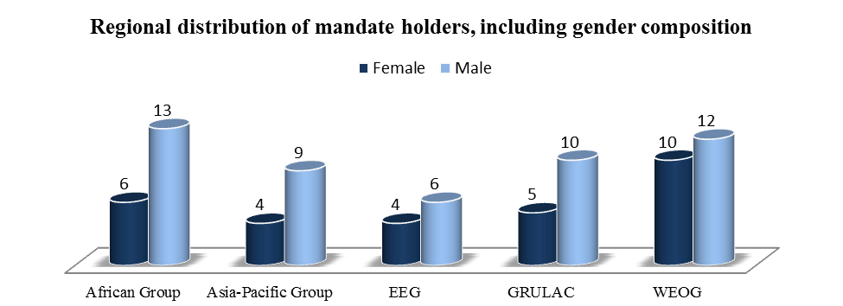
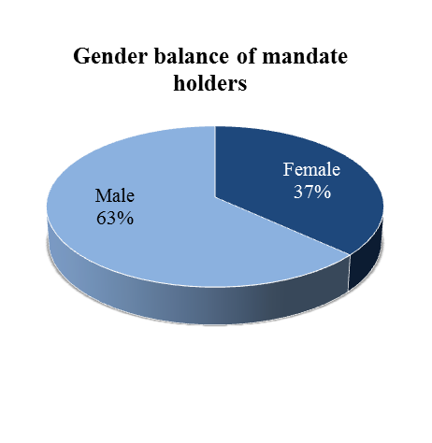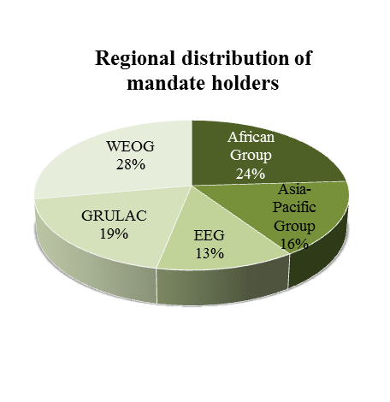
Annex III
Standing Invitations
A standing invitation is an open invitation extended by a Government to all thematic special procedures. By extending a standing invitation States announce that they will always accept requests for visits from all special procedures. As at 31 December 2015, out of the 193 United Nations Member States, the following 115 Member States (60%) as well as one non-Member Observer State had extended a standing invitation to the thematic special procedures.

Countries | Date | Countries | Date
Albania | 2 December 2009 | Libya | 15 March 2012
Andorra | 3 November 2010 | Liechtenstein | 21 January 2003
Argentina | 3 December 2002 | Lithuania | March 2001
Armenia | 1 May 2006 | Luxembourg | March 2001
Australia | 7 August 2008 | Madagascar | 26 August 2011
Austria | March 2001 | Malawi | 7 September 2015
Azerbaijan | 15 April 2013 | Maldives | 2 May 2006
Bahamas | 6 June 2013 | Malta | March 2001
Belgium | March 2001 | Marshall Islands | 4 March 2011
Benin | 31 October 2012 | Mexico | March 2001
Bolivia | 10 February 2010 | Monaco | 22 October 2008
Bosnia and Herzegovina | 7 May 2010 | Mongolia | 9 April 2004
Brazil | 10 December 2001 | Montenegro | 11 October 2005
Bulgaria | March 2001 | Nauru | 30 May 2011
Burundi | 6 June 2013 | Netherlands | March 2001
Cameroon | 15 September 2014 | New Zealand | 3 February 2004
Canada | April 1999 | Nicaragua | 26 April 2006
Cape Verde | 26 April 2013 | Niger | 21 August 2012
Central African Republic | 3 September 2013 | Nigeria | 25 October 2013
Chad | 1 June 2012 | Norway | 26 March 1999
Chile | 12 May 2009 | Occupied Palestinian Territory (non-Member Observer State) | 30 July 2014
Colombia | 17 March 2003 | Palau | 3 May 2011
Costa Rica | 2002 | Panama | 14 March 2011
Croatia | 13 March 2003 | Papua New Guinea | 11 May 2011
Cyprus | March 2001 | Paraguay | 28 March 2003
Czech Republic | September 2000 | Peru | 3 April 2002
Denmark | March 2001 | Poland | March 2001
Dominica | 9 December 2009 | Portugal | March 2001
Ecuador | 9 January 2003 | Qatar | 1 June 2010
El Salvador | 9 February 2010 | Republic of Korea | 3 March 2008
Estonia | March 2001 | Republic of Moldova | 2 June 2010
Fiji | 17 March 2015 | Romania | March 2001
Finland | March 2001 | Rwanda | 27 June 2011
France | March 2001 | Samoa | 14 February 2011
Gabon | 29 October 2012 | San Marino | 3 April 2003
Georgia | 30 March 2010 | Sao Tome and Principe | 2 February 2011
Germany | March 2001 | Serbia | 11 October 2005
Ghana | 21 April 2006 | Seychelles | 5 November 2012
Greece | March 2001 | Sierra Leone | 7 April 2003
Guatemala | April 2001 | Slovakia | March 2001
Guinea-Bissau | 7 May 2010 | Slovenia | March 2001
Honduras | 12 May 2010 | Solomon Islands | 6 May 2011
Hungary | March 2001 | South Africa | 17 July 2003
Iceland | September 2000 | Spain | March 2001
India | 14 September 2011 | Sri Lanka | 17 December 2015
Iran (Islamic Republic of) | 24 July 2002 | Sweden | March 2001
Iraq | 16 February 2010 | Switzerland | 1 April 2002
Ireland | March 2001 | Thailand | 4 November 2011
Italy | March 2001 | The former Yugoslav Republic of Macedonia | 13 October 2004
Japan | 1 March 2011 | Tonga | 25 January 2013
Jordan | 20 April 2006 | Tunisia | 28 February 2011
Kazakhstan | 28 July 2009 | Turkey | March 2001
Kenya | 22 January 2015 | Tuvalu | 26 April 2013
Kuwait | 13 September 2010 | Ukraine | 23 June 2006
Latvia | March 2001 | United Kingdom of Great Britain and Northern Ireland | March 2001
Lebanon | 17 March 2011 | Uruguay | 18 March 2005
Lesotho | 21 January 2015 | Vanuatu | 12 May 2009
Liberia | 25 September 2015 | Zambia | 16 July 2008

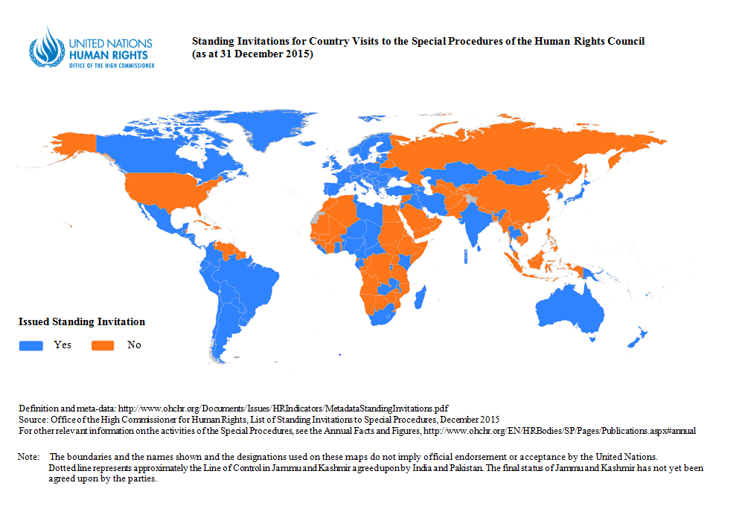
Statistics on standing invitations

United Nations Regional Groups of Member States | Number of standing invitations extended by states within their regional group | Percentage of standing invitations extended within regional groups | Percentage of standing invitations extended by regional groups
African Group | 24 out of 54 states | 44 % | 21 %
Asia-Pacific Group | 24 out of 53 states | 45 % | 21 %
EEG | 21 out of 23 states | 91 % | 18 %
GRULAC | 18 out of 33 states | 55 % | 16 %
WEOG | 28 out of 30 states | 93% | 24 %
Total | 115 out of 193 United Nations Member States |  | 100%

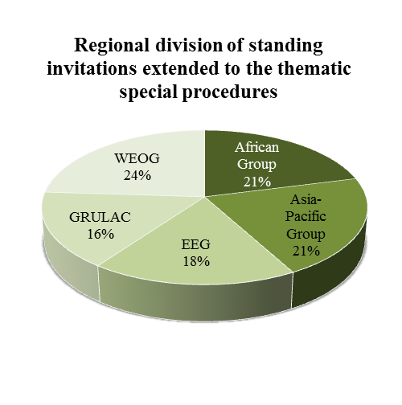
Standing invitations extended in 2015
Fiji | 17 March
Kenya | 22 January
Lesotho | 21 January
Liberia | 25 September
Malawi | 7 September
Sri Lanka | 17 December

NB. The State of Palestine, accorded non-Member Observer status on 29 November 2012 by General Assembly resolution 67/19 (A/RES/67/19), extended a standing invitation to the special procedures on 4 July 2014.
Annex IV
Country visits conducted by special procedures mandate holders in 2015
Country visits conducted in 2015 (by country)
States visited | Mandate |  | Dates
Algeria | Special Rapporteur on the right to education |  | 27 January to 3 February
Armenia | Special Rapporteur on the sale of children, child prostitution and child pornography |  | 12 to 18 May
Austria | Independent Expert on the enjoyment of all human rights by older persons |  | 22 to 30 January
Bangladesh | Special Rapporteur on freedom of religion or belief |  | 31 August to 9 September
Belgium | Special Rapporteur on contemporary forms of slavery, including its causes and its consequences |  | 19 to 26 February
Belgium | Special Rapporteur on the human rights situation in Eritrea |  | 9 to 11 March
Belgium | Working Group on the use of mercenaries as a means of violating human rights and impeding the exercise of the right of peoples to self-determination |  | 12 to 16 October
Botswana | Special Rapporteur on the human right to safe drinking water and sanitation |  | 9 to 17 November
Brazil | Special Rapporteur on torture and other cruel, inhuman or degrading treatment or punishment |  | 3 to 14 August
Brazil | Special Rapporteur on minority issues |  | 14 to 24 September
Brazil | Working Group on the issue of human rights and transnational corporations and other business enterprises |  | 7 to 16 December
Cabo Verde | Special Rapporteur on adequate housing as a component of the right to an adequate standard of living, and on the right to non-discrimination in this context |  | 19 to 26 January
Cambodia | Special Rapporteur on the situation of human rights in Cambodia |  | 17 to 25 January
Cambodia | Special Rapporteur on the situation of human rights in Cambodia |  | 16 to 24 September
Central African Republic | Independent Expert on the situation of human rights in Central African Republic |  | 3 to 14 February
Central African Republic | Independent Expert on the situation of human rights in Central African Republic |  | 14 to 23 June
Chile | Special Rapporteur on extreme poverty and human rights |  | 16 to 24 March
Chile | Special Rapporteur on the rights to freedom of peaceful assembly and of association |  | 21 to 30 September
China | Independent Expert on the effects of foreign debt and other related international financial obligations of States on the full enjoyment of all human rights, particularly economic, social and cultural rights |  | 29 June to 6 July
Côte d'Ivoire | Independent Expert on capacity-building and technical cooperation with Côte d’Ivoire in the field of human rights |  | 12 to 21 January
Côte d'Ivoire | Independent Expert on capacity-building and technical cooperation with Côte d’Ivoire in the field of human rights |  | 21 to 29 May
Côte d'Ivoire | Independent Expert on capacity-building and technical cooperation with Côte d’Ivoire in the field of human rights |  | 2 to 12 November
Fiji | Special Rapporteur on the right to education |  | 4 to 15 December
Finland | Special Rapporteur on the human rights situation in Eritrea |  | 2 to 5 October
Georgia | Special Rapporteur on torture and other cruel, inhuman or degrading treatment or punishment |  | 12 to 19 March
Germany | Special Rapporteur on the implications for human rights of the environmentally sound management and disposal of hazardous substances and wastes |  | 30 November to 7 December
Greece | Special Rapporteur on contemporary forms of racism, racial discrimination, xenophobia and related intolerance |  | 4 to 7 May
Greece | Independent Expert on the effects of foreign debt and other related international financial obligations of States on the full enjoyment of all human rights, particularly economic, social and cultural rights |  | 30 November to 7 December
Guinea-Bissau | Special Rapporteur on the independence of judges and lawyers |  | 10 to 16 October
Haiti | Independent Expert on the situation of human rights in Haiti |  | 23 February to 3 March
Haiti | Independent Expert on the situation of human rights in Haiti |  | 6 to 15 September
Honduras | Special Rapporteur on the rights of indigenous peoples |  | 2 to 10 November
Honduras | Special Rapporteur on the human rights of internally displaced persons |  | 23 to 27 November
Iraq | Special Rapporteur on the human rights of internally displaced persons |  | 8 to 15 May
Italy | Working Group of Experts on People of African Descent |  | 1 to 5 June
Japan | Special Rapporteur on the situation of human rights in the Democratic People’s Republic of Korea |  | 19 to 23 January
Japan | Special Rapporteur on the sale of children, child prostitution and child pornography |  | 19 to 26 October
Kazakhstan | Special Rapporteur on the rights to freedom of peaceful assembly and of association |  | 19 to 27 January
Kazakhstan | Special Rapporteur on the implications for human rights of the environmentally sound management and disposal of hazardous substances and wastes |  | 26 March to 8 April
Lebanon | Special Rapporteur on freedom of religion or belief |  | 23 March to 2 April
Malaysia | Special Rapporteur on trafficking in persons, especially women and children |  | 23 to 28 February
Mali | Independent Expert on the situation of human rights in Mali |  | 1 to 10 March
Mali | Independent Expert on the situation of human rights in Mali |  | 10 to 19 October
Malta | Working Group on Arbitrary Detention |  | 23 to 25 June
Mauritius | Independent Expert on the enjoyment of all human rights by older persons |  | 14 to 24 April
Morocco | Special Rapporteur on the right to food |  | 5 to 12 October
Myanmar | Special Rapporteur on the situation of human rights in Myanmar |  | 7 to 16 January
Myanmar | Special Rapporteur on the situation of human rights in Myanmar |  | 3 to 7 August
Netherlands | Special Rapporteur on the human rights situation in Eritrea |  | 28 September to 1 October
Paraguay | Special Rapporteur on the right of everyone to the enjoyment of the highest attainable standard of physical and mental health |  | 23 September to 6 October
Paraguay | Special Rapporteur on the rights of persons with disabilities |  | 19 to 27 November
Peru | Working Group on Enforced or Involuntary Disappearances |  | 1 to 10 June
Philippines | Special Rapporteur on the right to food |  | 20 to 27 February
Philippines | Special Rapporteur on the human rights of internally displaced persons |  | 21 to 30 July
Portugal | Special Rapporteur on the independence of judges and lawyers |  | 27 January to 3 February
Republic of Korea | Special Rapporteur on the situation of human rights in the Democratic People’s Republic of Korea |  | 6 to 10 September
Republic of Korea | Special Rapporteur on the implications for human rights of the environmentally sound management and disposal of hazardous substances and wastes |  | 12 to 23 October
Republic of Korea | Special Rapporteur on the situation of human rights in the Democratic People’s Republic of Korea |  | 23 to 27 November
Republic of Moldova | Special Rapporteur on the rights of persons with disabilities |  | 10 to 17 September
Romania | Special Rapporteur on extreme poverty and human rights |  | 2 to 11 November
Senegal | Working Group on discrimination against women in law and in practice |  | 7 to 17 April
Serbia and Kosovo* | Special Rapporteur on adequate housing as a component of the right to an adequate standard of living, and on the right to non-discrimination in this context |  | 18 to 27 May
Somalia | Independent Expert on the situation of human rights in Somalia |  | 22 to 29 May
South Africa | Special Rapporteur on violence against women, its causes and consequences |  | 4 to 11 December
Sri Lanka | Working Group on Enforced or Involuntary Disappearances |  | 9 to 18 November
Sudan | Special Rapporteur on violence against women, its causes and consequences |  | 13 to 24 May
Sudan | Independent Expert on the situation of human rights in the Sudan |  | 13 to 23 May
Sudan | Special Rapporteur on the negative impact of the unilateral coercive measures on the enjoyment of human rights |  | 23 to 30 November
Sweden | Special Rapporteur on the rights of indigenous peoples |  | 25 to 27 August
Syrian Arab Republic | Special Rapporteur on the human rights of internally displaced persons |  | 16 to 19 May
Tajikistan | Special Rapporteur on the human right to safe drinking water and sanitation |  | 4 to 12 August
Tunisia | Working Group on the use of mercenaries as a means of violating human rights and impeding the exercise of the right of peoples to self-determination |  | 1 to 8 July
Ukraine | Special Rapporteur on extrajudicial, summary or arbitrary executions |  | 9 to 18 September
United Kingdom | Special Rapporteur on the promotion of truth, justice, reparation and guarantees of non-recurrence |  | 9 to 18 November
 | Special Rapporteur on the human rights situation in Eritrea |  | 6 to 10 October
United States of America | Working Group on the issue of discrimination against women in law and in practice |  | 30 November to 11 December

*Any reference to Kosovo, whether to the territory, institutions or population, is to be understood in full compliance with the United Nations Security Council resolution 1244 (1999) and without prejudice to the status of Kosovo.

Country visits conducted in 2015 (by mandate)
Thematic mandates

Mandate |  | State(s) visited | Dates | Report
Working Group of Experts on People of African descent |  | Italy | 1 to 5 June | 33rd HRC session (September 2016)
Working Group on arbitrary detention |  | Malta | 23 to 25 June | 33rd HRC session (September 2016)
Working Group on the issue of discrimination against women in law and in practice |  | Senegal | 7 to 17 April | 32nd HRC session (June 2016)
 |  | United States of America | 30 November to 11 December | 32nd HRC session (June 2016)
Special Rapporteur on the rights of persons with disabilities |  | Republic of Moldova | 10 to 17 September | A/HRC/31/62/Add.2
 |  | Paraguay | 19 to 27 November | 34th HRC session (March 2017)
Working Group on enforced or involuntary disappearances |  | Peru | 1 to 10 June | 33st HRC session (September 2016)
Working Group on enforced or involuntary disappearances |  | Sri Lanka | 9 to 18 November | 33st HRC session (September 2016)
Special Rapporteur on the right to education |  | Algeria | 27 January to 3 February | A/HRC/29/30/Add.2
Special Rapporteur on the right to education |  | Fiji | 4 to 15 December | 32nd HRC session (June 2016)
Special Rapporteur on extreme poverty and human rights |  | Chile | 16 to 24 March | 32nd HRC session (June 2016)
Special Rapporteur on extreme poverty and human rights |  | Romania | 2 to 11 November | 32nd HRC session (June 2016)
Special Rapporteur on the right to food |  | Philippines | 20 to 27 February | A/HRC/31/51/Add.1
Special Rapporteur on the right to food |  | Morocco | 5 to 12 October | A/HRC/31/51/Add.2
Special Rapporteur on the rights to freedom of peaceful assembly and of association |  | Kazakhstan | 19 to 27 January | A/HRC/29/25/Add.2
 |  | Chile | 21 to 30 September | 32nd HRC session (June 2016)
Special Rapporteur on freedom of religion or belief |  | Lebanon | 23 March to 2 April | A/HRC/31/18/Add.1
Special Rapporteur on freedom of religion or belief |  | Bangladesh | 31 August to 9 September | A/HRC/31/18/Add.2
Special Rapporteur on the right of everyone to the enjoyment of the highest attainable standard of physical and mental health |  | Paraguay | 23 September to 6 October | 32nd HRC session (June 2016)
Special Rapporteur on adequate housing as a component of the right to an adequate standard of living, and on the right to non-discrimination in this context |  | Cabo Verde | 19 to 26 January | A/HRC/31/54/Add.1
 |  | Serbia and Kosovo* | 18 to 26 May | A/HRC/31/54/Add.2
Special Rapporteur on the independence of judges and lawyers |  | Portugal | 27 January to 3 February | A/HRC/29/26/Add.4
Special Rapporteur on the independence of judges and lawyers |  | Guinea-Bissau | 10 to 16 October | 32st HRC session (June 2016)
Special Rapporteur on the rights of indigenous peoples |  | Honduras | 2 to 10 November | 33rd HRC session (September 2016)
Special Rapporteur on the rights of indigenous peoples |  | Sweden | 25 to 27 August | 33rd HRC session (September 2016)
Special Rapporteur on the human rights of internally displaced persons |  | Iraq | 8 to 15 May | 32nd HRC session (June 2016)
 |  | Syrian Arab Rep. | 16 to 19 May | 32nd HRC session (June 2016)
 |  | Philippines | 21 to 30 July | 32nd HRC session (June 2016)
 |  | Honduras | 23 to 27 November | 32nd HRC session (June 2016)
Working Group on the use of mercenaries as a means of violating human rights and impeding the exercise of the right of peoples to self-determination |  | Tunisia | 1 to 8 July | 33rd HRC session (September 2016)
 |  | Belgium | 12 to 16 October | 33rd HRC session (September 2016)
Special Rapporteur on minority issues |  | Brazil | 14 to 24 September | A/HRC/31/56/Add.
Independent Expert on the enjoyment of all human rights by older persons |  | Austria | 22 to 30 January | A/HRC/30/43/Add.2
 |  | Mauritius | 14 to 24 April | A/HRC/30/43/Add.3
Special Rapporteur on contemporary forms of racism, racial discrimination, xenophobia and related intolerance |  | Greece | 4 to 7 May | 32nd HRC session (June 2016)
Special Rapporteur on the sale of children, child prostitution and child pornography |  | Armenia | 12 to 18 May | A/HRC/31/58/Add.2
 |  | Japan | 19 to 26 October | A/HRC/31/58/Add.1
Special Rapporteur on contemporary forms of slavery, including its causes and its consequences |  | Belgium | 19 to 26 February | A/HRC/30/35/Add.2
Special Rapporteur on extrajudicial, summary or arbitrary executions |  | Ukraine | 9 to 18 September | 32nd HRC session (June 2016)
Special Rapporteur on torture and other cruel, inhuman or degrading treatment or punishment |  | Georgia | 12 to 19 March | A/HRC/31/57/Add.3
 |  | Brazil | 3 to 14 August | A/HRC/31/57/Add.4
Special Rapporteur on the implications for human rights of the environmentally sound management and disposal of hazardous substances and wastes |  | Kazakhstan | 26 March to 8 April | A/HRC/30/40/Add.1
 |  | Republic of Korea | 12 to 23 October | 33rd HRC session (September 2016)
 |  | Germany | 30 November to 7 December | 33rd HRC session (September 2016)
Special Rapporteur on trafficking in persons, especially women and children |  | Malaysia | 23 to 28 February | A/HRC/29/38/Add.1
Working Group on the issue of human rights and transnational corporations and other business enterprises |  | Brazil | 7 to 16 December | 32nd HRC session (June 2016)
Special Rapporteur on the promotion of truth, justice, reparation and guarantees of non-recurrence |  | United Kingdom | 9 to 18 November | 33rd HRC session (September 2016)
Special Rapporteur on the negative impact of the unilateral coercive measures on the enjoyment of human rights |  | Sudan | 23 to 30 November | 33rd HRC session (September 2016)
Special Rapporteur on violence against women, its causes and consequences |  | Sudan | 13 to 24 May | 32nd HRC session (June 2016)
 |  | South Africa | 4 to 11 December | 32nd HRC session (June 2016)
Independent Expert on the effects of foreign debt and other related international financial obligations of States on the full enjoyment of all human rights, particularly economic, social and cultural rights |  | China | 29 June to 6 July | A/HRC/31/60/Add.1
 |  | Greece | 30 November to 7 December | A/HRC/31/60/Add.2 (provisional)
Special Rapporteur on the human right to safe drinking water and sanitation |  | Tajikistan | 4 to 12 August | 33rd HRC session (September 2016)
 |  | Botswana | 9 to 17 November | 33rd HRC session (September 2016)

*Any reference to Kosovo, whether to the territory, institutions or population, is to be understood in full compliance with the United Nations Security Council resolution 1244 (1999) and without prejudice to the status of Kosovo.
Country-specific mandates

Mandate |  | State(s) visited | Dates | Report
Special Rapporteur on the situation of human rights in Cambodia |  | Cambodia | 17 to 25 January | A/HRC/30/58
 |  | Cambodia | 16 to 24 September. | 33rd HRC session (September 2016)
Independent Expert on the situation of human rights in Central African Republic |  | Central African Republic | 3 to 14 February | A/HRC/30/59
 |  | Central African Republic | 14 to 23 June | A/HRC/30/59
Independent Expert on capacity-building and technical cooperation with Côte d’Ivoire in the field of human rights |  | Côte d'Ivoire | 12 to 21 January | A/HRC/28/84
 |  | Côte d'Ivoire | 21 to 29 May | A/HRC/29/49
 |  | Côte d'Ivoire | 2 to 12 November | A/HRC/31/78
Special Rapporteur on the situation of human rights in the Democratic People’s Republic of Korea |  | Japan | 19 to 23 January | A/HRC/28/71
 |  | Republic of Korea | 6 to 10 September | A/HRC/31/70
 |  | Republic of Korea | 23 to 27 November | A/HRC/31/70
Special Rapporteur on the human rights situation in Eritrea |  | Belgium | 9 to 11 March | A/HRC/29/41
Special Rapporteur on the human rights situation in Eritrea |  | Finland  Netherlands | 2 to 5 October  28 September to 1 October | Oral report on the visits to Finland, Netherlands and United Kingdom to be presented at HRC 32st session (June 2016)
 |  | United Kingdom | 6 to 10 October
Independent Expert on the situation of human rights in Haiti |  | Haiti | 23 February to 3 March | A/HRC/28/82
Independent Expert on the situation of human rights in Haiti |  | Haiti | 6 to 15 September | A/HRC/31/77
Independent Expert on the situation of human rights in Mali |  | Mali | 1 to 10 March | A/HRC/31/76
Independent Expert on the situation of human rights in Mali |  | Mali | 10 to 19 October | A/HRC/31/76
Special Rapporteur on the situation of human rights in Myanmar |  | Myanmar | 7 to 16 January | A/HRC/28/72
 |  | Myanmar | 3 to 7 August | A/HRC/31/71
Independent Expert on the situation of human rights in Somalia |  | Somalia | 22 to 29 May | A/HRC/30/57
Independent Expert on the situation of human rights in the Sudan |  | Sudan | 13 to 23 May | A/HRC/30/60

Statistics on country visits conducted in 2015
United Nations Regional Groups of Member States | Number of country visits conducted* | Number of countries visited**
African Group | 20 | 14
Asia-Pacific Group | 22 | 15
EEG | 6 | 6
GRULAC | 12 | 6
WEOG | 16 | 12
Total | 76 | 53

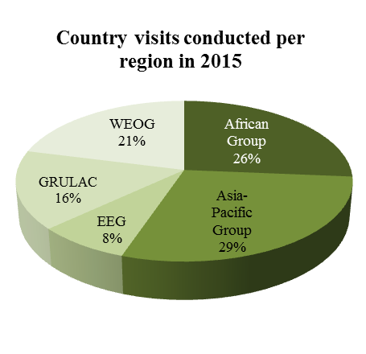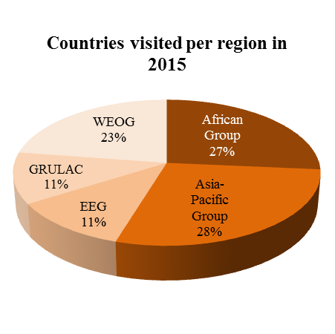
*Distribution of visits by region out of the total number of visits | **Distribution of countries visited by region

Annex V
Overview of states not yet visited by any mandate holder
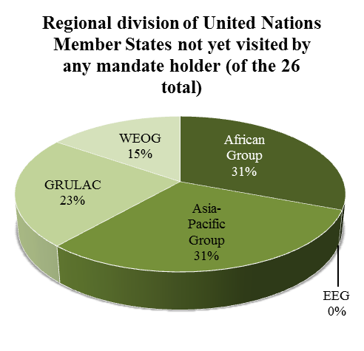
As at 31 December 2015, out of the 193 United Nations Member States, 167 States (87%) have been visited by at least one special procedures mandate holder. A total of 26 States (13%) have either never received (7%) or not yet accepted (6%) any request for a visit by one or more of the special procedures mandate holders.

States never visited, no request sent  (14 in total) | States never visited, request sent  (12 in total)
Andorra  Antigua and Barbuda  Brunei Darussalam  Dominica  Grenada  Micronesia  Monaco  Palau  Saint Kitts and Nevis  Saint Lucia  Samoa  San Marino  Sao Tome e Principe  Tonga | Barbados  Democratic People’s Republic of Korea  Djibouti  Eritrea  Guinea  Lesotho  Libya  Luxembourg  Nauru  Swaziland  Vanuatu  Zimbabwe

Annex VI
Statistics on communications over the year 2015
2015 Basic Figures |  |  | 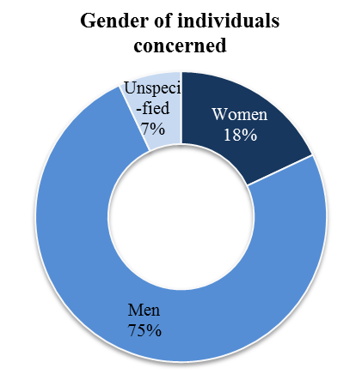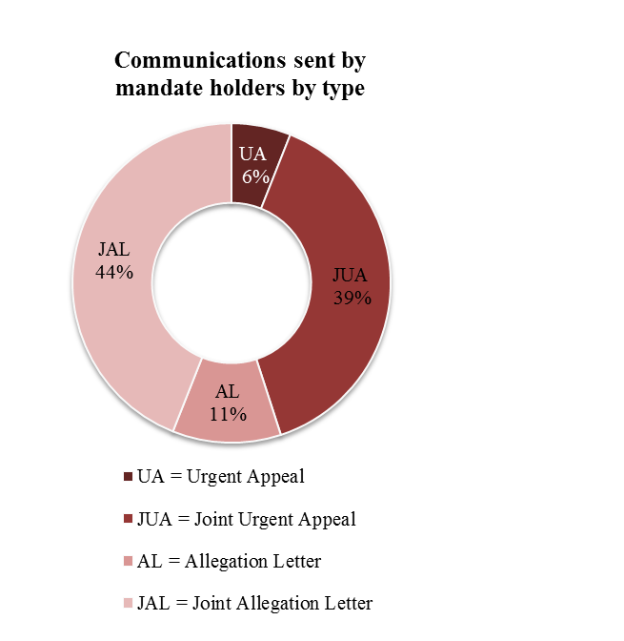
3 | Communications report submitted to the Human Rights Council
13 | Communications sent to Non-State actors
78 | Communications related to legislation
123 | Countries received at least one communication
137 | Communications followed up by mandate holders
222 | Replies received to communications sent in 2015
318 | Replies received in 2015
442 | Joint communications by two or more mandate holders
532 | Communications sent
846 | Individuals covered, of which 152 communications expressly relate to women.

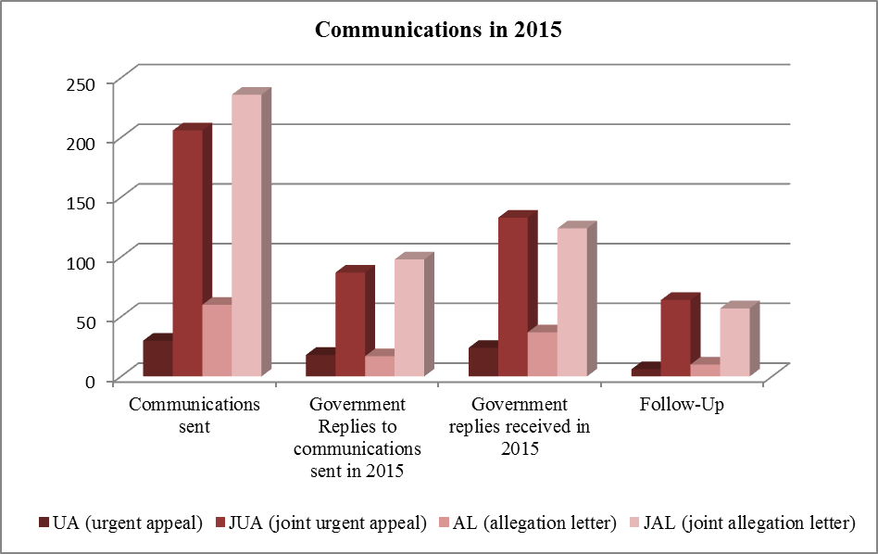

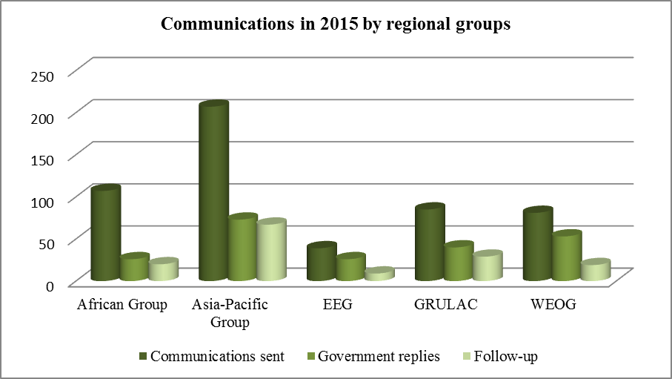

Annex VII
Themes addressed in special procedures reports to the 28th, 29th and 30th sessions of the Human Rights Council and 70th session of the General Assembly
Thematic mandates
Mandate |  | Title and/or theme of the report (document symbol)
Working Group of Experts on People of African Descent |  | Report of its fifteenth and sixteenth sessions focusing mainly on the theme of “Development and people of African descent” (A/HRC/30/56).  Report of the Working Group of Experts on People of African Descent (A/70/309).
Independent Expert on the enjoyment of human rights by persons with albinism |  | The mandate of the Independent Expert on the enjoyment of human rights by persons with albinism was established by the Human Rights Council at its twenty-eighth session. The mandate holder will submit their first report to the thirty-first Human Rights Council session (A/HRC/31/63) and to the seventy-first General Assembly.
Working Group on Arbitrary Detention |  | Drug policies and arbitrary detention and Remedies for arbitrary detention. (A/HRC/30/36).  United Nations Basic Principles and Guidelines on remedies and procedures on the right of anyone deprived of their liberty to bring proceedings before a court - Report of the Working Group on Arbitrary Detention (A/HRC/30/37)
Working Group on the issue of human rights and transnational corporations and other business enterprises |  | How the Guiding Principles on Business and Human Rights need to be further embedded throughout United Nations programmes and processes in order to improve policy coherence for inclusive and sustainable development (A/HRC/29/28).  Measuring the implementation of the Guiding Principles on Business and Human Rights (A/70/216).
Special Rapporteur in the field of cultural rights |  | Copyright policy and the right to science and culture (A/HRC/28/57)  Patent policy and the right to science and culture (A/70/279)
Special Rapporteur on the rights of persons with disabilities |  | Vision of the mandate, working methods and a work plan for the first three years of the mandate (A/HRC/28/58)  The right of persons with disabilities to social protection (A/70/297)
Working Group on Enforced or Involuntary Disappearances |  | Activities of and communications and cases examined by the Working Group on Enforced or Involuntary Disappearances covering the period 17 May 2014 to 15 May 2015, including country-specific observations (A/HRC/30/38).  Study on enforced or involuntary disappearances and economic, social and cultural rights (A/HRC/30/38/Add.5).
Special Rapporteur on the right to education |  | Protecting the right to education against commercialization (A/HRC/29/30).  Public Private Partnerships and the right to education (A/70/342).
Special Rapporteur on the issue of human rights obligations relating to the enjoyment of a safe, clean, healthy and sustainable environment |  | Compilation of good practices in the use of human rights obligations relating to the environment (A/HRC/28/61).
Special Rapporteur on extrajudicial, summary or arbitrary executions |  | Use of information and communications technologies to secure the right to life (A/HRC/29/37).  Role of forensics investigations in protecting the right to life / The application of the death penalty to foreign nationals (A/70/304)
Special Rapporteur on the right to food |  | Access to justice and the right to food: the way forward (A/HRC/28/65).  Climate change and the right to food (A/70/287).
Independent Expert on the effects of foreign debt and other related international financial obligations of States on the full enjoyment of all human rights, particularly economic, social and cultural rights |  | Report on financial complicity: lending to States engaged in gross human rights violations (A/HRC/28/59)  Illicit financial flows, human rights and the post-2015 development agenda (A/HRC/28/60 and A/HRC/28/60/Corr.1)  Activities during 2014/2015 and sovereign debt restructuring (A/70/275).
Special Rapporteur on the promotion and protection of the right to freedom of opinion and expression |  | The use of encryption and anonymity to exercise the rights to freedom of opinion and expression in the digital age (A/HRC/29/32).  Protection of sources and whistleblowers (A/70/361).
Special Rapporteur on the rights to freedom of peaceful assembly and of association |  | The rights to freedom of peaceful assembly and of association in the context of natural resource exploitation projects (A/HRC/29/25).  Comparative study of enabling environments for businesses and associations (A/70/266).
Special Rapporteur on the right of everyone to the enjoyment of the highest attainable standard of physical and mental health |  | Work of the mandate, focusing on the right to health framework and the development of the contours and content of the right to health, and priorities of the Special Rapporteur (A/HRC/29/33).  Right to health in early childhood - right to survival and development (A/70/213).
Special Rapporteur on adequate housing as a component of the right to an adequate standard of living, and on the right to non-discrimination in this context |  | Responsibilities of local and other subnational governments in relation to the right to adequate housing (A/HRC/28/62).  Centrality of the right to adequate housing for the development and implementation of the New Urban Agenda to be adopted at Habitat III in October 2016 (A/70/270).
Special Rapporteur on the situation of human rights defenders |  | Outline of strategic workplan (A/HRC/28/63).  Global trends in risks and threats facing human rights defenders (A/70/217).
Special Rapporteur on the independence of judges and lawyers |  | Protection of children’s rights in the justice system (A/HRC/29/26).  Review and assessment of the main issues addressed over six years of mandate (A/70/263).
Special Rapporteur on the rights of indigenous peoples |  | Study on the situation of indigenous women globally (A/HRC/30/41).  The impact of international investment and free trade on the human rights of indigenous peoples (A/70/301).
Special Rapporteur on the human rights of internally displaced persons |  | Human rights of internally displaced persons in the context of the Post-2015 development agenda (A/HRC/29/34).  Governance structures for internal displacement (A/70/334).
Independent Expert on the promotion of a democratic and equitable international order |  | The adverse impacts of free trade and investment agreements on a democratic and equitable international order (A/HRC/30/44).  The impact of investor-State-dispute-settlement on a democratic and equitable international order (A/70/285).
Independent Expert on human rights and international solidarity |  | Conceptualization in human rights terms of international solidarity in the context of the proposed draft declaration (A/HRC/29/35).  Preventive solidarity and international cooperation (A/70/316).
Working Group on the use of mercenaries as a means of violating human rights and impeding the exercise of the right of peoples to self-determination |  | National legislation on private military and security companies in Central America and the Caribbean, South America, and Europe (A/HRC/30/34).  Foreign fighters (A/70/330).
Special Rapporteur on the human rights of migrants |  | Banking on mobility over a generation: follow-up to the regional study on the management of the external borders of the European Union and its impact on the human rights of migrants (A/HRC/29/36).  The impact of recruitment practices on the human rights of migrants, particularly low-wage workers, during labour migration (A/70/310).
Special Rapporteur on minority issues |  | Hate speech and incitement to hatred against minorities in the media (A/HRC/28/64).  Comprehensive study of the Special Rapporteur on minority issues on the human rights situation of Roma worldwide, with a particular focus on the phenomenon of anti-Gypsyism (A/HRC/29/24).  Minorities in the criminal justice system (A/70/212).
Independent Expert on the enjoyment of all human rights by older persons |  | Autonomy and care of older persons (A/HRC/30/43).
Special Rapporteur on extreme poverty and human rights |  | Extreme inequality and human rights (A/HRC/29/31).  The World Bank’s approach to human rights (A/70/274).
Special Rapporteur on the right to privacy |  | The mandate of the Special Rapporteur on the right to privacy was established by the Human Rights Council at the twenty-eighth session. The mandate holder will submit his first report to the thirty-first Human Rights Council session (A/HRC/31/64) and to the seventy-first General Assembly.
Special Rapporteur on contemporary forms of racism, racial discrimination, xenophobia and related intolerance |  | Racial and ethnic profiling (A/HRC/29/46).  Combating glorification of Nazism and other practices that contribute to fuelling contemporary forms of racism, racial discrimination, xenophobia and related intolerance (A/HRC/29/47).  Report of the Special Rapporteur on the glorification of Nazism: inadmissibility of certain practices that contribute to fuelling contemporary forms of racism, racial discrimination, xenophobia and related intolerance (A/70/321).  Collection and use of disaggregated data with a view to effectively combating racism, racial discrimination, xenophobia and related intolerance (A/70/335).
Special Rapporteur on freedom of religion or belief |  | Preventing violence committed in the name of religion (A/HRC/28/66).  Rights of the child and his or her parents in the area of freedom of religion or belief (A/70/286)
Special Rapporteur on the sale of children, child prostitution and child pornography |  | Information and communication technologies and the sale and sexual exploitation of children (A/HRC/28/56).  Thematic report on the establishment of comprehensive, rights-based and child-centred care, recovery and reintegration programmes (A/70/222).
Special Rapporteur on contemporary forms of slavery, including its causes and consequences |  | Eradicating contemporary forms of slavery from supply chains (A/HRC/30/35).
Special Rapporteur on the promotion and protection of human rights while countering terrorism |  | Human rights challenges posed by the fight against the Islamic State in Iraq and the Levant (A/HRC/29/51).  Report of the Special Rapporteur on the promotion and protection of human rights and fundamental freedoms while countering terrorism (A/70/371).
Special Rapporteur on torture and other cruel, inhuman or degrading treatment or punishment |  | The international legal framework and standards protecting children deprived of their liberty from being subjected to torture or other ill-treatment and from experiencing developmentally harmful and torturous conditions of confinement (A/HRC/28/68).  Extraterritoriality - The extraterritorial application of the prohibition of torture and other ill -treatment and attendant obligations under international law (A/70/303).
Special Rapporteur on trafficking in persons, especially women and children |  | Agenda setting of the work of the Special Rapporteur (A/HRC/29/38).  Due diligence and trafficking in persons (A/70/260).
Special Rapporteur on the promotion of truth, justice, reparation and guarantees of non-recurrence |  | Guarantees of non-recurrence (A/HRC/30/42).  Security sector reform, including vetting of security institutions (A/70/438).
Special Rapporteur on the negative impact of unilateral coercive measures on the enjoyment of human rights |  | Views on the foundations and context of the mandate (A/HRC/30/45).  Preliminary review of human rights adversely affected by unilateral coercive measures (A/70/345).
Special Rapporteur on violence against women, its causes and consequences |  | Closing the gap in international human rights law: lessons from three regional human rights systems on legal standards and practices regarding violence against women (A/HRC/29/27 and A/HRC/29/27/Add.4).  Closing the gap in international human rights law: lessons from three regional human rights systems on legal standards and practices regarding violence against women (A/70/209).
Special Rapporteur on the implications for human rights of the environmentally sound management and disposal of hazardous substances and wastes |  | Scope and content of the right to information throughout the life cycle of hazardous substances and wastes (A/HRC/30/40).
Special Rapporteur on the human right to safe drinking water and sanitation |  | Affordability of water and sanitation services (A/HRC/30/39).  Different levels and types of services and the human rights to water and sanitation (A/70/203).
Working Group on the issue of discrimination against women in law and in practice |  | Eliminating discrimination against women in cultural and family life, with a focus on the family as a cultural space (A/HRC/29/40).
Country mandates
Mandate |  | Title and/or theme of the report (document symbol)
Special Rapporteur on the situation of human rights in Belarus |  | Outline of development in human rights in the country since the previous report (A/HRC/29/43).  The situation of freedom of expression in Belarus (A/70/313)
Special Rapporteur on the situation of human rights in Cambodia |  | Overview of progress made over the past year within the tenure of the former Special Rapporteur (A/HRC/30/58).
Independent Expert on the situation of human rights in Central African Republic |  | Overview of and major developments in the situation of human rights in the country (A/HRC/30/59).
Independent expert on capacity-building and technical cooperation with Côte d’Ivoire in the field of human rights |  | Report of the Expert’s first visit to the country, from 12 to 21 January 2015 (A/HRC/29/49).
Special Rapporteur on the situation of human rights in the Democratic People’s Republic of Korea |  | Development of a multitrack strategy aimed at addressing the issue of international abductions, enforced disappearances and related matters (A/HRC/28/71).  Report of the Special Rapporteur on the situation of human rights in the Democratic People's Republic of Korea to the General Assembly providing an assessment of the latest developments on a number of thematic areas that were pointed out by the commission of inquiry on human rights in the Democratic People’s Republic of Korea as requiring particular attention (A/70/362).
Special Rapporteur on the situation of human rights in Eritrea |  | Overview of activities undertaken by the Special Rapporteur and an update on the situation of human rights, focusing on the issue of forced evictions and demolition of houses in different parts of Eritrea (A/HRC/29/41).
Independent Expert on the situation of human rights in Haiti |  | Review of the efforts made thus far to address the five human rights areas identified in the Expert’s previous report as warranting urgent action, namely: (a) illiteracy, (b) prolonged pre-trial detention, (c) elections, (d) redress for large-scale human rights violations perpetrated in the past and (e) resettlement of the people displaced by the 2010 earthquake. (A/HRC/28/82).
Special Rapporteur on the situation of human rights in the Islamic Republic of Iran |  | Concerns and emerging developments in the State’s human rights situation (A/HRC/28/70).  Report of the Special Rapporteur on the situation of human rights in the Islamic Republic of Iran (A/70/411).
Independent Expert on the situation of human rights in Mali |  | Account of the Expert’s third visit to Mali, from 7 to 17 October 2014 (A/HRC/28/83).
Special Rapporteur on the situation of human rights in Myanmar |  | Outline of key areas of focus and recommendations aimed at contributing to the efforts of Myanmar towards respecting, protecting and promoting human rights and achieving democratization, national reconciliation and development (A/HRC/28/72).  Report of the Special Rapporteur on the situation of human rights in Myanmar (A/70/412).
Special Rapporteur on the situation of human rights in the Palestinian territories occupied since 1967 |  | Concerns pertaining to the situation of human rights in the Occupied Palestinian Territory. Report primarily based on interviews and briefings, as well as written submissions received, in connection with the mission of the Special Rapporteur to the region in September 2014 (A/HRC/28/78).  Concerns pertaining to the situation of human rights in the Occupied Palestinian Territory. Report primarily based on interviews and briefings, as well as written submissions received, in connection with the mission of the Special Rapporteur to the region in June 2015 (A/70/392).
Independent Expert on the situation of human rights in Somalia |  | Review of the human rights situation in Somalia based on information obtained from consultations with various interlocutors during the two country visits (A/HRC/30/57).
Independent Expert on the situation of human rights in the Sudan |  | Overview of the situation of human rights situation in the Sudan and some of the human rights challenges in the country following the Expert’s first visit to the country (A/HRC/30/60).
Special Rapporteur on the situation of human rights in the Syrian Arab Republic |  | The mandate holder will take up his functions once the mandate of the commission of inquiry has ended.

Annex VIII
Joint statements issued by special procedures in 2015
Statement by Michael K. Addo, Chairperson of the Coordination Committee of Special Procedures at the Twenty-fourth Special Session of the Human Rights Council on preventing further deterioration of the human rights situation in Burundi, 17 December 2015.
“As the Covenants turn 50, it is time to turn norms into action”, Human Rights day statement, 9 December 2015.
Migrant crisis: “High time for Europe to reclaim a leading role in human rights” – UN experts, 9 October 2015.
Joint statement by UN Special Procedures on the occasion of World Environment Day, 5 June 2015.
“A central role for a civil society is the only way to guarantee inclusive post-2015 development goals”, 18 May 2015.
Statement of the Coordination Committee of Special Procedures at the Twenty-Third Special Session of the Human Rights Council on terrorist attacks and human rights abuses and violations committed by the terrorist group Boko Haram, 1 April 2015.
Statement by the Coordination Committee of Special Procedures on the repeated hate speech and incitement to violence directed against the Special Rapporteur on Myanmar, 20 March 2015.
François Crépeau, the Chairperson of the Coordination Committee, presents the annual report of special procedures to the Council, 18 March 2015.

Annex IX
Non-exhaustive list of follow-up activities undertaken by mandate holders in 2015

A. Follow-up on communications
In 2015, 137 follow-up communications were sent, out of a total of 532 communications, constituting 26 % (see Annex VI). In addition, the following mandate holders issued observations on communications:
Special Rapporteur on the situation of human rights defenders | - Observations on communications transmitted to Governments and replies received (A/HRC/28/63/Add.1)
Special Rapporteur on the right to freedom of assembly and of association | - Observations on communications transmitted to Governments and replies received (A/HRC/29/25/Add.3)
Special Rapporteur on extrajudicial, summary or arbitrary executions | - Observations on communications transmitted to Governments and replies received (A/HRC/29/37/Add.5)
Special Rapporteur on torture and other cruel, inhuman or degrading treatment of punishment | - Observations on communications transmitted to Governments and replies received (A/HRC/28/68/Add.1)
Working Group on enforced or involuntary disappearances | - Observations on communications included in the post-sessional documents and annual reports of the Working Group (A/HRC/30/38, A/HRC/WGEID/104/1, A/HRC/WGEID/105/1 and A/HRC/WGEID/106/1)
Special Rapporteur on the situation of human rights in the Palestinian territories occupied since 1967 | - References to communications sent and replies received included in the SR’s reports presented in 2015 to the Human Rights Council and the General Assembly (A/HRC/28/78 and A/70/392).
B. Follow-up country visits
Four mandate holders conducted in total five follow-up visits:
Working Group on arbitrary detention | - Follow-up visit to Malta from 23 to 25 June 2015 (report to be presented at the 33rd HRC session in September 2016).
Independent Expert on foreign debt and other related international financial obligations of States on the full enjoyment of all human rights, particularly economic, social and cultural rights | - Follow-up visit to Greece, 30 November to 8 December 2015 (report to be presented at the 31st HRC session in March 2016 (provisional)).
Special Rapporteur on the human rights of internally displaced persons | - Follow-up working visit to Kenya, 2 to 7 September 2015;  - Follow-up working visit to South Sudan, 13 to 16 September 2015.
Special Rapporteur on torture and other cruel, inhuman or degrading treatment or punishment | - Follow-up visit to Ghana, 3 to 7 November 2015 (report to be presented at the 31st HRC session in March 2016 (A/HRC/31/57/Add.2)).
C. Follow-up reports
Two Working Groups and one Special Rapporteur presented reports in which they followed-up on their recommendations made to States:
Working Group on arbitrary detention | - Report of the follow-up visit to Germany (A/HRC/30/36/Add.1)  - Report of the follow-up visit to Italy (A/HRC/30/36/Add.3)
Working Group on enforced or involuntary disappearances | - Follow-up reports on the implementation of recommendations made following the SR’s visits to Mexico and Timor-Leste (A/HRC/30/38/Add.4)
Special Rapporteur on the human rights of migrants | - Report of the follow-up visit to Italy (A/HRC/29/36/Add.2)
Special Rapporteur on extrajudicial, summary or arbitrary executions | - Follow-up report on the recommendations made in relation to the visit of the SR to Turkey (A/HRC/29/37/Add.4)  - Follow-up report on the recommendations made in relation to the visit of the SR to India (A/HRC/29/37/Add.3)
Special Rapporteur on torture and other cruel, inhuman or degrading treatment or punishment | - Follow- up report on visits to the Republic of Tajikistan and Tunisia (A/HRC/28/68/Add.2)
D. Follow-up public statements and press releases
One mandate holder issued two follow-up public statements:
Special Rapporteur on extreme poverty and human rights, Special Rapporteur on the human rights of migrants, Special Rapporteur on adequate housing as a component of the right to an adequate standard of living | - Press release issued on 28 January 2015, in follow-up to the announcement by the Dutch Government early January 2015 to provide funding to help municipalities that offer emergency shelters for homeless migrants, following the transmission of a communication to the Netherlands on 12 December 2014 the issue (A/HRC/29/50, case no. NLD 1/2014).  - Press release issued on 16 April 2015 in follow-up to the above-mentioned press release as well as to a joint letter sent to the Committee of Ministers of the Council of Europe on 12 February 2015 concerning its issuance of a recommendation that failed to explicitly state that Member States have a responsibility to prevent homelessness of persons with an irregular migration status (A/HRC/30/27, case no. OTH 2/2015).
Special Rapporteur on the promotion of truth, justice, reparation and guarantees of non-recurrence | - Public statement issued on 27 August 2015 on the on-going trial for genocide in Guatemala, jointly with the United Nations Special Adviser on the Prevention of Genocide, Adama Dieng, in follow-up to a communication sent on 22 December 2014 (see A/HRC/29/50, case no. GTM 8/2014).  - Public statement issued on 27 March 2015 regarding the denial of extradition of Spanish nationals to Argentina accused of torture during the Franco regime in follow-up to the SR’s visit to Spain carried-out in January 2014 (A/HRC/27/56/Add.1).
E. Follow-up consultations, workshops and other meetings
Five mandate holders took part in follow-up consultations, workshops and other meetings:
Special Rapporteur on extreme poverty and human rights | - Meetings held by the SR in March 2015 in Washington, United States of America, with representatives of the World Bank, relevant Government officials and civil society in follow-up to the SR’s issuing of a public letter on the World Bank's draft environmental and social safeguards in December 2014.  - Consultations held by the SR with several Governments and civil society organizations in September and October 2015 in follow-up to his report to the 70th General Assembly to engage in discussions on the World Bank's position on human rights (A/70/274).
Independent Expert on the promotion of a democratic and equitable international order | - Second expert group meeting convened by the IE in follow-up to his 2015 reports to the HRC and GA (A/HRC/30/44 and A/70/285) to discuss a strategy to follow-up on the recommendations contained therein, 13 October 2015, Geneva, Switzerland.
Special Rapporteur on minority issues | - Follow-up workshop titled "The situation of Roma in the Americas", in follow-up to the SR’s report on the human rights situation of Roma worldwide (A/HRC/29/24), 25 September 2015, Brazil, (report to be presented at the 31st HRC session in March 2016).
The Special Rapporteur on freedom of religion or belief | - Third Inter-Religious Round Table for Human Rights in follow-up to the SR’s visit to Cyprus in 2012 (A/HRC/22/51/Add.1), 6 October 2015, Nicosia, Cyprus (report to be included in the annual report of the mandate to be presented at the 31st HRC session in March 2016 and at the 71st GA session in October 2016, see also S/2016/11).
Special Rapporteur on the promotion of truth, justice, reparation and guarantees of non-recurrence | - High-Level Policy Dialogue on “guarantees of non-recurrence - from aspiration to policy: Challenges & lessons in preventing mass violations”, organized in cooperation with the Ministry for Foreign Affairs of Sweden, held on 14 and 15 October 2015 in Stockholm, Sweden, to follow-up on and advocate for the approach presented in the SR’s report on guarantees of non-recurrence to the 30th HRC session in September 2015 (A/HRC/30/42).
F. Other follow-up activities
One Working Group and 12 Special Rapporteurs/Independent Experts undertook other additional follow-up activities:
Working Group on discrimination against women in law and in practice | - Communication transmitted to China on 28 April 2015 in follow-up to the recommendations made by the Working Group in its report of its official visit to the country in December 2013 (A/HRC/26/39/Add.2 and A/HRC/29/51, case. no. CHN 3/2015).
Special Rapporteur on extreme poverty and human rights | - Communication transmitted to Moldova on 28 May 2015 in follow-up to the recommendation made by the former SR after their visit to the country in September 2013 to ensure the adequate placement of Roma community mediators (A/HRC/30/27, case no. MDA 3/2015).
Special Rapporteur on the right to freedom of opinion and expression | - Communication transmitted to Montenegro on 10 December 2015 in follow-up to the SR’s conclusions and recommendations included in the report of his visit to the country in 2013 during which he received reports concerning alleged acts of intimidation and violence against journalists and media outlets (A/HRC/26/30/Add.1, case no. MNE 2/2015).
Special Rapporteur on the situation of human rights in the Islamic Republic of Iran | - Questionnaire sent to the Iranian authorities in follow-up to a first expert level dialogue held on 15 and 16 September 2015 by the SR on the issue of drug-trafficking, addiction and death penalty in Iran with the Permanent Representative of Iran in Geneva and an Iranian delegation consisting of members of the Judiciary, the High Council for Human Rights in Iran, the Ministry of Foreign Affairs and Chief of the Anti-Narcotics forces.
Special Rapporteur on the promotion of truth, justice, reparation and guarantees of non-recurrence | - Update presented at the 30th HRC session in September 2015 on the situation in Burundi in follow-up to the visit of the SR to the country in December 2014 (see A/HRC/30/42/Add.1 and A/HRC/30/CRP.1).  - Oral update included in the SR’s presentation to the 30th HRC session in September 2015 in follow-up to the SR’s visit to Tunisia carried out in November 2012 (A/HRC/24/42/Add.1).  - Set of general recommendations for truth commissions and archives, annexed to the RS’s report to the 30th HRC session in September 2015 (A/HRC/30/42, Annex) in follow-up to an expert meeting on “Archives in the Context of the Right to Know”, jointly organised with the ICRC and Swisspeace, September 2014, Geneva, Switzerland, following-up to the SR’s recommendations calling for the development of international standards on archiving, presented in his report on truth commissions (A/HRC/24/42, para 106).
Annex X
Table on external funding received by mandate holders in 2015
Thematic mandates
Mandate (mandate holder) | Earmarked funding by donors received through OHCHR | External funding received through other sources
Working Group of Experts on People of African Descent | No
Mr. Ahmed Reid | No | Information not provided
Mr. Michal Balcerzak | No | No
Mr. Ricardo III Sunga | No | Received cash support of Philippine peso 7000/ month for 10 months from home institution of University of the Philippines for two research assistants in 2015 -2016.
Ms. Mireille Fanon- Mendes-France | No | Received per diem of USD 700 from AFRICITE, UCLG Africa,  Johannesburg, for general use by the mandate.  Received per diem of USD 1000 from UNISA University of Pretoria South Africa for general use by the mandate.
Mr. Sabelo Gumedze | No | No
Independent Expert on the enjoyment of human rights by persons with albinism (Ms. Ikponwosa Ero) | No | Received in kind support from home institution for office space and admin assistance on a continuous basis.
Working Group on arbitrary detention | Earmarked contribution to the Working Group of USD 112,233 from Govt. of France
Mr. Sètondji Roland Jean-Baptiste Adjovi |  | Received in kind support from home institution for research assistants on a continuous basis.
Mr. Seong-Phil Hong |  | Received in kind support from home institution for office and admin space and research assistant, on a continuous basis.
Mr. Vladimir Tochilovsky |  | No
Ms. Leigh Toomey |  | No
Mr. José Guevara |  | No
Working Group on transnational corporations and other business enterprises | Earmarked contribution to the Working Group of USD 67,231 from Govt. of Norway.
Mr. Michael K. Addo |  | Received in kind support from home institution, University of Exeter, office and admin space and research assistant, multi-year basis.  Received one time, USD 281,000 in cash, from Govt. of Netherlands for a particular event.
Mr. Pavel Sulyandziga |  | Information not provided
Mr. Dante Pesce |  | Information not provided
Ms. Margaret Jungk |  | Received cash support (3 months’ salary devoted to mandate work) from home institution, Danish Institute for Human Rights, and also in kind for office space and 30 hours of editing work each year on a continuous basis.
Mr. Puvan Selvanathan |  | Information not provided
Forum on business and human rights | Earmarked contribution of USD 16,667 from the Govt. of Russia for the Forum | NA
Independent Expert in the field of cultural rights (Ms. Karima Bennoune) | No | No
Special Rapporteur on the rights of persons with disabilities (Ms. Catalina Devandas Aguilar) | Earmarked contribution to the mandate of USD 218,579 by the Govt. of Finland | Received in kind support from Federal Ministry for Economic Cooperation and Development/GIZ to organize an expert meeting on Social Protection and Persons with Disabilities to inform the preparation of a thematic report.  Received USD 165,000 from an anonymous donor as two year grant for use by the mandate.  Received in kind support from National University of Ireland, Galway, two research interns for 6 weeks.  Received in kind support from Open Society Foundation for a research assistant for 6 months.
Working Group on enforced or involuntary disappearances | Earmarked contribution to the mandate of USD 56,117 by the Govt. of France  Earmarked contribution to the mandate of USD 25,000 by the Govt. of Japan
Mr. Bernard Duhaime |  | Information not provided
Ms. Houria Es Slami |  | Information not provided
Mr. Ariel Dulitzky |  | Information not provided
Mr. Henrikas Mickevicius |  | Information not provided
Mr. Tae-Ung Baik |  | Information not provided
Special Rapporteur on the right to education (Mr. Kishore Singh) | No | No
Independent Expert on the issue of human rights obligations relating to the enjoyment of a safe, clean, healthy and sustainable environment  (Mr. John Knox) | No | Received in kind support from home institution for office space/admin support, research assistants and developmet of a website on good practices, on a continuous basis.  Received in kind support from the United Nations Environmental Programme for particular events/processes on a multi-year basis.  Received in kind support from the United Nations Institute for Training and Research earmarked for particular events/processes on a one off basis.
Special Rapporteur on extrajudicial, summary or arbitrary executions (Mr. Christof Heyns) | Earmarked contribution to the mandate of USD 66,845 by the Govt. of Belgium | Received both cash support of ZAR 6 million and in kind support from home institution, University of Pretoria and its Centre for Human Rights for general use by mandate holder, recruitment of research assistant, organize events and for office space and admin support on a continuous basis.
Special Rapporteur on the right to food (Ms. Hilal Elver) | No | No
Independent Expert on foreign debt and other related international financial obligations of States on the full enjoyment of human rights, particularly economic, social and cultural rights (Mr. Juan Bohoslavsky) | No | No
Special Rapporteur on the promotion and protection of the right to freedom of opinion and expression (Mr. David Kaye) | Earmarked contribution to the mandate of USD 22,124 by the Govt. of Austria for expert meeting on protection of sources | Information not provided
Special Rapporteur on the rights to freedom of peaceful assembly and of association (Mr. Maina Kiai) | No | Received in kind admin and office space from ‘InformAction’.  Received multi-year funding of NOK 1,787,667 from Govt. of Norway, which was used to hire research assistants as well as for specific events and general use by the mandate.  Received multi-year cash support of USD 38,776 from World Movement for Democracy to hire research assistant, and general use by the mandate.  Received multi-year cash support of US$ 17,400 from Community of Democracies, which was used for particular events and to hire research assistant.
Special Rapporteur on the right of everyone to the enjoyment of the highest attainable standard of physical and mental health (Mr. Dainius Pūras) | No | Received multi-year funding 2015-2017, of USD 200,000, from Open Society Foundation, to organize events and recruit research assistant.
Special Rapporteur on adequate housing as a component of the right to an adequate standard of living, and on the right to non-discrimination in this context (Ms. Leilani Farha) | Earmarked contribution to the mandate of USD 26,511 by the Govt. of Germany | Received in kind admin support from a non-governmental organization.  Received cash support of 70.000 EUR from the Government of Germany, which was used to hire a research assistant and organize and host an expert consultation.  Received one-time in kind support from the ‘Rosa Luxemburg Foundation’ who hosted an event in NYC.  Received in kind support from the University of Toronto providing student research assistant.
Special Rapporteur on the situation of human rights defenders (Mr. Michel Forst) | No | Received in kind support from home institution in the form of office space/admin support on a continuous basis.  Received a one-time contribution of EUR 800.000 from the Government of Norway for general use by the mandate holder.  Received a one-time contribution of EUR 300.000 from the European Union earmarked for particular events/ processes.
Special Rapporteur on the independence of judges and lawyers (Ms. Mónica Pinto) | No | No
Special Rapporteur on the situation of human rights and fundamental freedoms of indigenous peoples (Ms. Victoria Lucia Tauli-Corpuz) | No | Received a one off amount of 10.000 USD from UNWomen for research assistants.
Special Rapporteur on the human rights of internally displaced persons (Mr. Chaloka Beyani) | No | For the period 2015/2016, received one off amounts of £36,945 as a travel grant, £50,310 as a buyout grant and £31,480 for the provision of research assistants from the London School of Economics.
Independent expert on the promotion of a democratic and equitable international order (Mr. Alfred de Zayas) | No | No
Independent Expert on human rights and international solidarity (Ms. Virginia Dandan) | No | No
Working Group on the use of mercenaries as a means of violating human rights and impeding the exercise of the right of peoples to self-determination | Earmarked contribution from the Govt. of Russia of USD 50,000
Mr. Anton Katz |  | No
Mr. Saeed Mokbil |  | Information not provided
Ms. Patricia Arias |  | No
Ms. Elzbieta Karska |  | Information not provided
Mr. Gabor Rona |  | No
Special Rapporteur on the human rights of migrants (Mr. François Crépeau) | Received one off cash support of USD 23,906 from Govt. of Switzerland, to hire a research assistant. | Received cash grant of USD 2,000 from home institution, Oppenheimer Chair in Public International law, for general use by the mandate holder.
Special Rapporteur on minority issues (Ms. Rita Izsák) | Earmarked contribution from the Govt. of Hungary of USD 21,164.  Earmarked contribution from the Govt. of Russia of USD 50,000 | No
Forum on Minority Issues | Earmarked contribution to the Forum of USD 55,310 by the Govt. of Austria.  Earmarked contribution from the Govt. of Russia of USD 16,667 | NA
Independent Expert on the enjoyment of all human rights by older persons (Ms. Rosa Kornfeld-Matte) | Earmarked contribution to the mandate of USD 12,000 by individual donor | Information not provided
Special Rapporteur on extreme poverty and human rights (Mr. Philip Alston) | Earmarked support to the mandate of USD 66,298 by the Govt. of Finland | Received in kind support equivalent of USD 5,000, from home institution, New York University School of Law, for office space, admin support and research assistant.
Special Rapporteur on the right to privacy (Mr. Joseph Cannataci) | No | Received in kind support from home institution, University of Malta and University of Groningen, for office and admin space and research assistant, multi-year basis.  Received one-time in kind support from Govt. of Brazil and Information & technology Society (ITS) Brazil, for a specific event.  Received one time in kind support from Privacy & Identity Lab – Utrecht, to attend an event.
Special Rapporteur on contemporary forms of racism, racial discrimination, xenophobia and related intolerance (Mr. Mutuma Ruteere) | Earmarked contribution from the Govt. of Russia of USD 50,000. | No
Special Rapporteur on freedom of religion or belief (Mr. Heiner Bielefeldt) | Earmarked contribution to the mandate of USD 33,670 by the Govt. of France.  Earmarked contribution to the mandate of USD 53,022 by the Govt. of Germany.  Earmarked contribution from the Govt. of Russia of US$ 50,000 | No
Special Rapporteur on the sale of children, child prostitution and child pornography (Ms. Maud De Boer-Buquicchio) | Earmarked contribution to the mandate of USD 10,989 by the Govt. of Monaco  Earmarked contribution to the mandate of USD 50,000 by the Govt. of Netherlands | No
Special Rapporteur on contemporary forms of slavery, including its causes and consequences (Ms. Urmila Bhoola) | No | No
Special Rapporteur on the promotion and protection of human rights and fundamental freedoms while countering terrorism (Mr. Ben Emmerson) | Earmarked contribution from the Govt. of Russia of USD 50,000. | Information not provided
Special Rapporteur on torture and other cruel, inhuman or degrading treatment or punishment (Mr. Juan Ernesto Méndez) | No | Received in kind support from home institution, American University Washington College of Law, of office space for use by officers for Asst. Director of Anti-Torture Initiative project and for DC-based OHCHR Staff.  Received cash support of USD 51,380 from Govt. of Switzerland that supports follow-up country visits and associated costs, expert consultations and publications. Also funds salary for P3 post in Washington DC where the mandate holder is currently based.  Received two year funding of USD 200,000 from Open Society Foundations, which was used to hire research assistants, organize events, and support salaries for staff of the Anti-Torture Initiative (i.e. Asst. Project Director and Research Assistants (Dean’s Fellows)  Received support from the Govt. of Denmark for a renewable annual P2 JPO post.  Received one time cash support of USD 15,000 from Ford Foundation that supported convening of expert consultation on the topic of gender and torture.  Received USD 75,000 from Ford Foundation that was used to hire research assistant and support drafting of thematic report on gender and torture, including support for consultant, student research assistants, travel for and development of follow-up activities and events, and publication
Special Rapporteur on trafficking in persons, especially women and children (Ms. Maria Grazia Giammarinaro) | Earmarked contribution to the mandate of USD 53,022 by the Govt. of Germany  Earmarked contribution to the mandate of USD 60,601 by the Govt. of Switzerland | No
Special Rapporteur on the promotion of truth, justice, reparation & guarantees on non-recurrence (Mr. Pablo De Greiff) | Earmarked contribution to the mandate of USD 15,000 by the Govt. of Argentina  Earmarked contribution to the mandate of USD 16,928 by the Govt. of Germany | Received multi-year grant from October 2013 to October 2015 (and extended for 3 month until December 2015), from Govt. of Switzerland of CHF 100,000 for general use by the mandate as well as to the Geneva Academy of International Law, which covered costs associated with hosting and supporting a research assistant for the mandate.  Received one time contribution from the Govt. of Sweden of CHF 220,000 for use in 2015 for general use by the Mandate as well as to cover the costs of the research assistant at the Geneva Academy, and the remainder were earmarked for the meeting in Stockholm on Guarantees of Non-recurrence.
Special Rapporteur on the negative impact of the unilateral coercive measures on the enjoyment of human rights (Mr. Idriss Jazairy) | Earmarked contribution from the Govt. of Russia of USD 50,000. | No
Special Rapporteur on violence against women, its causes and consequences (Ms. Dubravka Šimonović) | No | No
Special Rapporteur on the human rights obligations related to environmentally sound management and disposal of hazardous substances and wastes (Mr. Baskut Tuncak) | No | No
Special Rapporteur on the human right to safe drinking water and sanitation (Mr. Léo Heller) | Earmarked contribution to the mandate of USD 26,511 by the Govt. of Germany | Received EUR 69,000 for 2015 only from the Govt. of Germany that was used to hire research assistant and organize particular events.
Working Group on the issue of discrimination against women in law and in practice | No
Ms. Kamala Chandrakirana | No | Information not provided
Ms. Emna Aouij | No | Information not provided
Ms. Alda Facio | No | No
Ms. Frances Raday | No | No
Ms. Eleonora Zielinska | No | Information not provided
Country mandates
Mandate (mandate holder) | Earmarked funding by donors received through OHCHR | External funding received through other sources
Special Rapporteur on the situation of human rights in Belarus (Mr. Miklós Haraszti) | No | No
Special Rapporteur on the situation of human rights in Cambodia (Ms. Rhona Smith) | No | Received in-kind support from home institution, Northumbria University, UK, as paid time off to undertake mandated activity like going on country visit and present report to HRC, Geneva in September 2015.
Independent Expert on the situation of human rights in Central African Republic (Ms. Marie-Therese Keita Bocoum) | No | Information not provided
Independent Expert on capacity-building and technical cooperation with Côte d’Ivoire in the field of human rights (Mr. Mohammed Ayat) | No | Information not provided
Special Rapporteur on the situation of human rights in Eritrea (Ms. Sheila B. Keetharuth) | No | No
Special Rapporteur on the situation of human rights in the Democratic People’s Republic of Korea (Mr. Marzuki Darusman) | No | No
Independent Expert on the situation of human rights in Haiti (Mr. Gustavo Gallón) | No | No
Special Rapporteur on the situation of human rights in the Islamic Republic of Iran (Mr. Ahmed Shaheed) | No | Received multi-year in-kind support for the period 2011-2015 from the City University of New York for research assistant and website design. Research and technical staff for website/social media pages is drawn from university staff and student body.
Independent Expert on the situation of human rights in Mali (Mr. Suliman Baldo) | No | Information not provided
Special Rapporteur on the situation of human rights in Myanmar (Ms. Yanghee Lee) | No | Received one off cash support from home institution, Sungkyunkwan University, of KRW 50 million for research assistant and a particular event.
Special Rapporteur on the situation of human rights in the Palestinian territories occupied since 1967 (Mr. Makarim Wibisino) | No | No
Independent Expert on the situation of human rights in Somalia (Mr. Bahame Nyanduga) | No | No
Independent Expert on the situation on human rights in the Sudan (Mr. Aristide Nononsi) | No | No

NB.1. Details on earmarking of the 2015 contribution from the Government of the Russian Federation was received only on 8 February 2016, while the funds were actually received in December 2015. The funds will therefore be used only in 2016.
NB.2. The Government of Switzerland made an earmarked contribution of USD 125.000 to support the implementation of HRC resolution 25/38 on the promotion and protection of human rights in the context of peaceful protests.

Annex XI
List of special procedures mandate holders as of 31 December 2015
* Mandate holders attending the twenty-second annual meeting
Thematic mandates (41)
Working Group of experts on people of African descent | Ms. Mireille Fanon-Mendes-France (France)*  Mr. Ahmed Reid (Jamaica)  Mr. Ricardo III Sunga (Philippines )  Ms. Michal Balcerzak (Poland)  Mr. Sabelo Gumedze (South Africa) | africandescent@ohchr.org
Working Group on arbitrary detention | Mr. Seong-Phil Hong (Republic of Korea)*  Mr. Sètondji Roland Jean-Baptiste Adjovi (Benin)  Ms. Leigh Toomey (Australia)  Mr. José Guevara (Mexico)  Mr. Vladimir Tochilovsky (Ukraine) | wgad@ohchr.org
Independent Expert on the enjoyment of human rights of persons with albinism | Ms. Ikponwosa Ero (Nigeria) | albinism@ohchr.org
Special Rapporteur in the field  of cultural rights | Ms. Karina Bennoune (United States of America) | srculturalrights@ohchr.org
Independent expert on the promotion of a democratic and equitable international order | Mr. Alfred de Zayas (United States of America)* | ie-internationalorder@ohchr.org
Working Group on the issue of discrimination against women in law and in practice | Ms. Emna Aouij (Tunisia)*  Ms. Kamala Chandrakirana (Indonesia)  Ms. Frances Raday (Israel/United Kingdom)  Ms. Eleonora Zielinska (Poland)  Ms. Alda Facio (Costa Rica) | Wgdiscriminationwomen @ohchr.org
Special Rapporteur on the rights of persons with disabilities | Ms. Catalina Devandas  Aguilar (Costa Rica )* | sr.disability@ohchr.org
Working Group on enforced or involuntary disappearances | Mr. Hendrikas Mickevicius (Lithuania)  Mr. Bernard Duhaime (Canada)  Mr. Ariel Dulitzky (Argentina/United States of America)  Mr. Tae-Ung Baik (Republic of Korea)  Ms. Houria Es Slami (Morocco) | wgeid@ohchr.org
Special Rapporteur on the right to education | Mr. Kishore Singh (India)* | sreducation@ohchr.org
Special Rapporteur on the issue of human rights obligations relating to the enjoyment of a safe, clean, healthy and sustainable environment | Mr. John Knox (United States of America)* | ieenvironment@ohchr.org
Special Rapporteur on extreme poverty and human rights | Mr. Philip Alston (Australia)* | srextremepoverty@ohchr.org
Special Rapporteur on the right to food | Ms. Hilal Elver (Turkey)* | srfood@ohchr.org
Special Rapporteur on the promotion and protection of the right to freedom of opinion and expression | Mr. David Kaye (United States of America)* | freedex@ohchr.org
Special Rapporteur on the rights to freedom of peaceful assembly and of association | Mr. Maina Kiai (Kenya)* | freeassembly@ohchr.org
Special Rapporteur on freedom of religion or belief | Mr. Heiner Bielefeldt (Germany) | freedomofreligion@ohchr.org
Special Rapporteur on the right of everyone to the enjoyment of the highest attainable standard of physical and mental health | Mr. Dainius Pūras (Lithuania)* | srhealth@ohchr.org
Special Rapporteur on adequate housing as a component of the right to an adequate standard of living | Ms. Leilani Farha (Canada)* | srhousing@ohchr.org
Special Rapporteur on the situation of human rights defenders | Mr. Michel Forst (France)* | defenders@ohchr.org
Special Rapporteur on the independence of judges and lawyers | Ms. Mónica Pinto (Argentina) | srindependencejl@ohchr.org
Special Rapporteur on the rights of indigenous peoples | Ms. Victoria Lucia Tauli-Corpuz (Philippines)* | indigenous@ohchr.org
Special Rapporteur on the  human rights of internally displaced persons | Mr. Chaloka Beyani (Zambia)* | idp@ohchr.org
Working Group on the use of mercenaries as a means of violating human rights and impeding the exercise of the  right of peoples to self-determination | Ms. Elzbieta Karska (Poland)*  Mr. Saeed Mokbil (Yemen)  Ms. Patricia Arias (Chile)  Mr. Anton Farrel Katz (South Africa)  Mr. Gabor Rona (United States of America/Hungary) | mercenaries@ohchr.org
Special Rapporteur on the  human rights of migrants | Mr. François Crépeau (Canada)* | migrants@ohchr.org
Special Rapporteur on minority issues | Ms. Rita Izsák (Hungary)* | minorityissues@ohchr.org
Independent Expert on the enjoyment of all human rights  by older persons | Ms. Rosa Kornfeld-Matte (Chile)* | olderpersons@ohchr.org
Special Rapporteur on the right to privacy | Mr. Joseph Cannataci (Malta) | sprivacy@ohchr.org
Special Rapporteur on contemporary forms of racism, racial discrimination, xenophobia and related intolerance | Mr. Mutuma Ruteere (Kenya) | racism@ohchr.org
Special Rapporteur on the sale  of children, child prostitution and child pornography | Ms. Maud De Boer-Buquicchio  (The Netherlands)* | srsaleofchildren@ohchr.org
Special Rapporteur on contemporary forms of slavery, including its causes and its consequences | Ms. Urmila Bhoola (South Africa)* | srslavery@ohchr.org
Independent Expert on human rights and international solidarity | Ms. Virginia Dandan (Philippines)* | iesolidarity@ohchr.org
Special Rapporteur on extrajudicial, summary or arbitrary executions | Mr. Christof Heyns (South Africa) * | eje@ohchr.org
Special Rapporteur on the promotion and protection of human rights and  fundamental freedoms while countering terrorism | Mr. Ben Emmerson (United Kingdom) | srct@ohchr.org
Special Rapporteur on torture and other cruel, inhuman or degrading treatment or punishment | Mr. Juan Ernesto Méndez (Argentina)* | sr-torture@ohchr.org
Special Rapporteur on the implications for human rights of the environmentally sound management and disposal of hazardous substances and wastes | Mr. Baskut Tuncak (Turkey) * | srtoxicwaste@ohchr.org
Special Rapporteur on trafficking in persons, especially women and children | Ms. Maria Grazia Giammarinaro (Italy)* | srtrafficking@ohchr.org
Working Group on the issue of human rights and transnational corporations and other business enterprises | Mr. Michael K. Addo (Ghana)*  Ms. Margaret Jungk (United States of America)  Mr. Pavel Sulyandziga (Russian Federation)  Mr. Dante Pesce (Chile) | wg-business@ohchr.org
Special Rapporteur on the promotion of truth, justice, reparation & guarantees of non-recurrence | Mr. Pablo de Greiff (Colombia) | srtruth@ohchr.org
Special Rapporteur on the negative impact of unilateral coercive measures on the enjoyment of human rights | Mr. Idriss Jazairy (Algeria)* | ucm@ohchr.org
Special Rapporteur on violence against women, its causes and consequences | Ms. Dubravka Šimonovic (Croatia) | vaw@ohchr.org
Independent Expert on the effects of foreign debt and other related international financial obligations of States on the full enjoyment of all human rights, particularly economic, social and cultural rights | Mr. Juan Bohoslavsky (Argentina)* | ieforeigndebt@ohchr.org
Special Rapporteur on the human right to safe drinking water and sanitation | Mr. Léo Heller (Brazil)* | srwatsan@ohchr.org
Country-specific mandates (14)
Special Rapporteur on the situation of human rights in Belarus | Mr. Miklós Haraszti (Hungary)* | sr-belarus@ohchr.org
Special Rapporteur on the situation of human rights in Cambodia | Ms. Rhona Smith (United Kingdom)* | srcambodia@ohchr.org
Independent Expert on the situation of human rights in Central African Republic | Ms. Marie-Thérèse Keita Bocoum (Côte d’Ivoire)* | ie-car@ohchr.org
Independent Expert on the enhancement of capacity building and technical cooperation with Côte d’Ivoire in the field of human rights | Mr. Mohammed Ayat (Morocco)* | eicotedivoire@ohchr.org
Special Rapporteur on the situation of human rights in the Democratic People’s Republic of Korea | Mr. Marzuki Darusman (Indonesia)* | hr-dprk@ohchr.org
Special Rapporteur on the situation of human rights in Eritrea | Ms. Sheila B. Keetharuth (Mauritius)* | sr-eritrea@ohchr.org
Independent Expert on the situation of human rights in Haiti | Mr. Gustavo Gallón (Colombia) | ie-haiti@ohchr.org
Special Rapporteur on the situation of human rights in the Islamic Republic of Iran | Mr. Ahmed Shaheed (Maldives)* | sr-iran@ohchr.org
Independent Expert on the situation of human rights in  Mali | Mr. Suliman Baldo (Sudan)* | ie-mali@ohchr.org
Special Rapporteur on the situation of human rights in Myanmar | Ms. Yanghee Lee (Republic of Korea)* | sr-myanmar@ohchr.org
Special Rapporteur on the situation of human rights in the Palestinian territories  occupied since 1967 | Mr. Makarim Wibisono (Indonesia) | sropt@ohchr.org
Independent Expert on the situation of human rights in Somalia | Mr. Bahame Tom Mukirya Nyanduga (Tanzania)* | ie-somalia@ohchr.org
Independent Expert on the situation of human rights in the Sudan | Mr. Aristide Nononsi (Benin)* | iesudan@ohchr.org
Special Rapporteur on the situation of human rights in the Syrian Arab  Republic | Mr. Pablo Sérgio Pinheiro (Brazil) - will start once the mandate of the commission of inquiry ends | srsyria@ohchr.org
* The following former mandate holders, who have since finished their terms in office, attended the twenty-second annual meeting: Ms. Farida Shaheed (Pakistan), former Special Rapporteur in the field of cultural rights, Ms. Jasminka Dzumhur (Bosnia and Herzegovina), former member of the Working Group on enforced or involuntary disappearances, Ms. Gabriela Knaul (Brazil), former Special Rapporteur on the independence of judges and lawyers, Ms. Rashida Manjoo (South Africa), former Special Rapporteur on violence against women, its causes and consequences.

Annex XII
List of special procedures mandate holders to be appointed in 2016

31st session of the Human Rights Council (29 February - 24 March 2016)

- Working Group on the issue of human rights and transnational corporations and other business enterprises, member from Asia-Pacific States [HRC res. 26/22]
- Special Rapporteur on the situation of human rights in the Palestinian territories occupied since 1967 [CHR res. 1993/2 and HRC res. 5/1]

32nd session of the Human Rights Council (13 June 2016 - 1 July 2016 tbc)

- Special Rapporteur on extrajudicial, summary or arbitrary executions [HRC res. 26/12]
- Special Rapporteur on freedom of religion or belief [HRC res. 22/20]
- Special Rapporteur on the right to education [HRC res. 26/17]
- Special Rapporteur on the situation of human rights in the Democratic People’s Republic of Korea [HRC res. 28/22]

33rd session of the Human Rights Council (13 - 30 September 2016 tbc)

- Special Rapporteur on the human rights of internally displaced persons [HRC res. 23/8]
- Special Rapporteur on torture and other cruel, inhuman or degrading treatment or punishment [HRC res. 25/13]
- Working Group on Arbitrary Detention, member from Eastern European States [HRC res. 24/7]

Annex XIII

List of sponsors of HRC resolutions establishing special procedures mandates

Thematic mandates (41)

Single regional sponsors
Regional Group | Country | Mandate
African Group | African Group. | Working Group of Experts on people of African Descent
African Group | African Group. | Independent Expert on the enjoyment of human rights of persons with albinism
African Group | African Group. | Special Rapporteur on contemporary forms of racism, racial discrimination, xenophobia and related intolerance
African Group | African Group. | Special Rapporteur on the implications for human rights of the environmentally sound management and disposal of hazardous substances and wastes
Asia-Pacific Group | Iran on behalf of the Non-Aligned Movement. | Special Rapporteur on unilateral coercive measures
GRULAC | Cuba | Special Rapporteur in the field of cultural rights
GRULAC | Cuba. | Independent Expert on the promotion of a democratic and equitable international order
GRULAC | Mexico, Colombia. | Working Group on the issue of discrimination against women in law and practice
GRULAC | Cuba. | Special Rapporteur on the right to food
GRULAC | Cuba. | Independent Expert on the effects of foreign debt and other related international financial obligations of States on the full enjoyment of all human rights, particularly economic, social and cultural rights
GRULAC | Brazil. | Special Rapporteur on the right of everyone to the enjoyment of the highest attainable standard of physical and mental health
GRULAC | Mexico, Guatemala. | Special Rapporteur on the rights of indigenous peoples
GRULAC | Cuba | Working Group on the use of mercenaries as a means of violating human rights and impeding the exercise of the right of peoples to self-determination
GRULAC | Mexico. | Special Rapporteur on the human rights of migrants
GRULAC | Argentina, Brazil. | Independent Expert on the enjoyment of all human rights by older persons
GRULAC | Cuba. | Independent Expert on human rights and international solidarity
GRULAC | Mexico. | Special Rapporteur on the protection and promotion of human rights and fundamental freedoms while countering terrorism
WEOG | Germany, Finland. | Special Rapporteur on adequate housing as a component of the right to an adequate standard of living
WEOG | France. | Working Group on Arbitrary Detention
WEOG | Portugal. | Special Rapporteur on the right to education
WEOG | Sweden. | Special Rapporteur on extrajudicial, summary or arbitrary executions
WEOG | United States of America. | Special Rapporteur on the promotion and protection of the right to freedom of opinion and expression
WEOG | Norway. | Special Rapporteur on the situation of human rights defenders
WEOG | Austria. | Special Rapporteur on the human rights of internally displaced persons
WEOG | Austria. | Special Rapporteur on minority issues
WEOG | United Kingdom. | Special Rapporteur on contemporary forms of slavery, including its causes and consequences
WEOG | Denmark. | Special Rapporteur on torture and other cruel, inhuman or degrading treatment or punishment
WEOG | Canada. | Special Rapporteur on violence against women, its causes and consequences
WEOG | Spain, Germany. | Special Rapporteur on the human right to safe drinking water and sanitation
Cross regional sponsors
Regional Group | Country | Mandate
African Group, Asia-Pacific Group, GRULAC, EEG, WEOG | Maldives, Costa Rica, Slovenia, Switzerland, Morocco. | Special Rapporteur on the issue of Human Rights obligations relating to the enjoyment of a safe, clean, healthy and sustainable environment
African Group, Asia-Pacific Group, EEG, GRULAC, WEOG | United States of America, Czech Republic, Indonesia, Lithuania, Maldives, Mexico, Nigeria. | Special Rapporteur on the rights to freedom of peaceful assembly and association
African Group, Asia-Pacific Group, EEG, GRULAC, WEOG | France, Albania, Romania, Belgium, Peru, Chile, Philippines, Senegal, Morocco. | Special Rapporteur on extreme poverty and human rights
African Group, Asia-Pacific Group, GRULAC, EEG, WEOG | Hungary, Australia, Botswana, Maldives, Mexico, Thailand. | Special Rapporteur on the independence of judges and lawyers
African Group, Asia-Pacific Group, GRULAC, WEOG | France, Argentina, Japan, Morocco | Working Group on Enforced or Involuntary Disappearances
African Group, GRULAC, EEG, WEOG | Norway, Russian Federation, Ghana, Argentina and cross-regional group. | Working Group on the issue of human rights and transnational corporations and other business enterprises
African Group, GRULAC, WEOG, | Argentina, Switzerland, Morocco. | Special Rapporteur on the promotion of truth, justice, reparation and guarantees of non-recurrence
Asia-Pacific Group, WEOG | Germany, Philippines. | Special Rapporteur on trafficking in persons, especially women and children
EEG, WEOG | European Union. | Special Rapporteur on freedom of religion or belief
GRULAC, EEG, WEOG, | European Union, GRULAC. | Special Rapporteur on the sale of children, child prostitution and child pornography
GRULAC, WEOG | New Zealand, Mexico. | Special Rapporteur on the human rights of persons with disabilities
GRULAC, WEOG | Brazil, Germany, Austria, Liechtenstein, Mexico, Norway, Switzerland. | Special Rapporteur on the right to privacy in the digital age

Country mandates (14)

Single regional sponsors
Regional Groups | Country | Mandate
African Group | Djibouti, Somalia, Nigeria. | Special Rapporteur on the situation of human rights in Eritrea
African Group | African Group. | Independent Expert on the situation of human rights in Mali
African Group | African Group. | Independent Expert on the situation of Human Rights in Sudan
African Group | African Group | Independent Expert on the situation of human rights in Central African Republic
African Group | African Group | Independent Expert on the enhancement of capacity building and technical cooperation with Côte d’Ivoire in the field of human rights
Asia-Pacific Group | Japan. | Special Rapporteur on the situation of Human Rights in Cambodia
GRULAC | Haiti and group of friends. | Independent Expert on the situation of human rights in Haiti
WEOG | Sweden. | Special Rapporteur on the situation of Human Rights in the Islamic Republic of Iran
Cross regional sponsors
Regional Groups | Country | Mandate
African Group, Asia-Pacific Group, GRULAC, EEG, WEOG | Cross regional group. | Independent Expert on the situation of Human Rights in Somalia
African Group, Asia-Pacific Group, GRULAC, WEOG | Cross regional group (WEOG and Organisation of Islamic Cooperation). | Special Rapporteur on the situation of human rights in the Syrian Arab Republic
African Group, Asia-Pacific Group, GRULAC | Organisation of Islamic Cooperation, Arab Group. | Special Rapporteur on the situation of Human Rights in the Palestinian territories occupied since 1967
EEG, WEOG | European Union. | Special Rapporteur on the situation of Human Rights in Myanmar
EEG, WEOG | European Union | Special Rapporteur on the situation of Human Rights in Belarus
EEG, WEOG | European Union | Special Rapporteur on the situation of human rights in the Democratic People's Republic of Korea

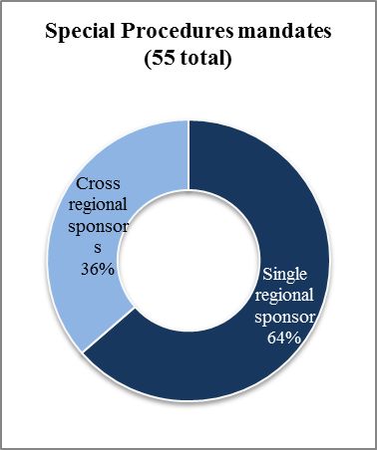

Statistics
on sponsors of
HRC resolutions
establishing
special procedures
mandates

(all mandates)

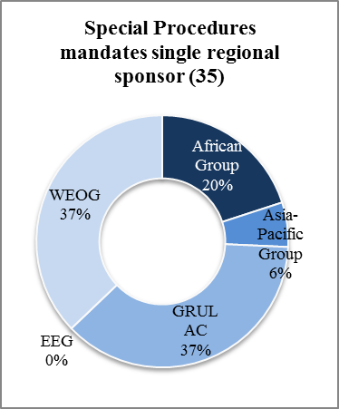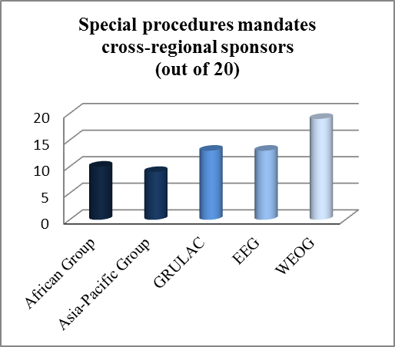

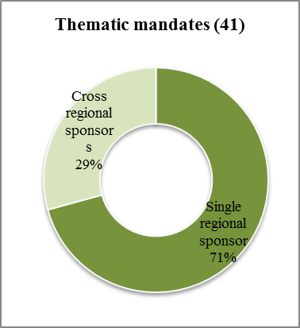

Statistics
on sponsors of
HRC resolutions
establishing
special procedures
mandates

(thematic mandates)

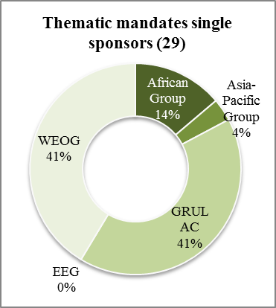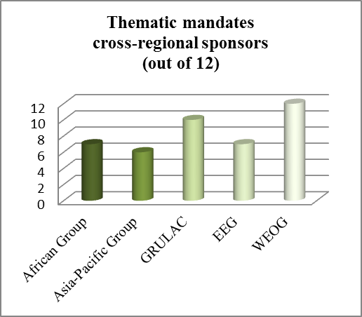

Statistics
on sponsors of
HRC resolutions
establishing
special procedures
mandates

(country mandates)

* * The annexes to the present report are circulated in the language of submission only.
** ** The present report was submitted after the deadline in order to reflect the most recent developments
See http://spinternet.ohchr.org/_Layouts/SpecialProceduresInternet/Forthcomingcountryvisits.aspx , http://spinternet.ohchr.org/_Layouts/SpecialProceduresInternet/ViewCountryVisits.aspx?Lang=en and http://spinternet.ohchr.org/_Layouts/SpecialProceduresInternet/StandingInvitations.aspx .
OHCHR press statement of 12 June 2015, “Statement by the Special Adviser of the Secretary-General on the Prevention of Genocide, the Special Adviser of the Secretary-General on the Responsibility to Protect, the Special Rapporteur on Minority Issues and the Special Rapporteur on Freedom of Religion or Belief, on the situation in Syria”.
OHCHR press release of 28 April 2015, “Violence against Women – Joint Press Release by UN and IACHR Rapporteurs”.
For statistical purposes the annexes make use of the United Nations Regional Groups of Member States incorporating Israel, Turkey and the United States of America under WEOG and Kiribati under the Asia-Pacific Group, for an overview of the regional division please see http://www.un.org/Depts/DGACM/RegionalGroups.shtml
The above doesn’t take into consideration the resignation by male member of the WG on business and human rights from the Asian States on 15 December 2015, as his replacement has not yet been appointed.
The Special Rapporteur participated in a three-day conference organized by the Sami Parliamentary Council on issues related to Sami indigenous peoples of Norway, Finland and Sweden and hosted in Hemavan, Sweden, which is considered an official visit to the traditional region of the Sami people.
Ibid.
These statistics do not include data from the Working Group on Enforced or Involuntary Disappearances.
See A/HRC/28/85, A/HRC/29/50 and A/HRC/30/27.
The Government of Switzerland made an earmarked contribution of USD 125,000 to support implementation of the HRC resolution 25/38 on “the promotion and protection of human rights in the context of peaceful protests”.

