y | United Nations | A/HRC/31/68
 | General Assembly |  | Distr.: General  11 February 2016  Original: English

Human Rights Council
Thirty-first session
Agenda item 4
Human rights situations that require the Council’s attention
Report of the Independent International Commission of Inquiry on the Syrian Arab Republic*
Summary
As the war is poised to enter its sixth year, its horrors are pervasive and ever-present. The lives of Syrian men, women and children have been ravaged as they suffer the destruction of their country and the devastation of the Syrian mosaic. As the conflict has intensified, civilians remain the primary victims, and are often the object of deliberate attacks by the warring parties.
Flagrant violations of human rights and international humanitarian law continue unabated, aggravated by blatant impunity. Relevant Security Council resolutions remain largely unheeded and unimplemented. Crimes against humanity continue to be committed by government forces and by Islamic State in Iraq and Al-Sham (ISIS). War crimes by the belligerents are rampant.
The call for peace is imperative. Momentum must be sustained to ensure an all-inclusive, Syrian-led process to end the armed conflict and transition towards peace. Accountability is an essential part of this process.
Ensuring humanitarian access and respect for human rights and fundamental freedoms remains paramount. Local and international actors, with their underlying constituencies, bear a shared responsibility to bring this process to fruition, while countering the spread of terrorism and extreme violence in the region.
Contents
Page
I. Introduction 3
A. Challenges 3
B. Methodology 3
II. Political context 3
III. Dynamics of the conflict 5
IV. Destruction of a country 7
A. Destruction of cities, towns and villages 7
B. Attacks on medical care 10
C. Attacks on education 11
D. Attacks on public spaces 12
E. Cuts to electricity and water 12
F. Destruction of cultural heritage 13
V. Devastation of a nation 14
A. Tearing of the social fabric 14
B. Fracturing of communities 15
C. Devastation of basic conditions of life 17
D. Dismantling of the economy 18
VI. Clandestine marketplaces 19
VII. Conclusions and recommendations 20
A. Conclusions 20
B. Recommendations 21
Annexes
I. Correspondence with the Government of the Syrian Arab Republic 24
II. Damage assessment of Omar Ibn al-Khattab mosque, Jisr al-Shugur (Idlib) 26
III. Damage assessment of Husseiniya (Hasakah) 27
IV. Damage assessment of Al-Eis field hospital (Aleppo) 28
V. Damage assessment of Palmyra ruins (Homs) 29
VI. Security Council resolutions on the Syrian Arab Republic 30
VII. Map of the Syrian Arab Republic 31
I. Introduction
1. In the present report, submitted pursuant to Human Rights Council resolution 22/24, the Independent International Commission of Inquiry on the Syrian Arab Republic presents its findings based on investigations conducted from 10 July 2015 to 10 January 2016. The present report should be read in conjunction with previous reports of the Commission (see S-17/2/Add.1, A/HRC/19/69, A/HRC/21/50, A/HRC/22/59, A/HRC/23/58, A/HRC/24/46, A/HRC/25/65, A/HRC/27/60 and A/HRC/30/48).
A. Challenges
2. The Commission’s investigations remain curtailed by the denial of access to the Syrian Arab Republic (see annex I).
B. Methodology
3. The methodology employed by the Commission was based on standard practices of commissions of inquiry and human rights investigations. The Commission relied primarily on first-hand accounts.
4. The information contained herein is based on 415 interviews conducted in the region and from Geneva.
5. Photographs, video recordings, imagery provided by UNOSAT and medical records were collected and analysed. Reports from Governments and non-governmental sources, academic analyses and United Nations reports formed part of the investigation.
6. The standard of proof is met when the Commission has reasonable grounds to believe that incidents occurred as described.
II. Political context
7. Recent months have presented rare opportunities for reaching a political solution to the Syrian crisis, most notably through the latest Vienna talks. Increased regional and international involvement in the internal Syrian dynamic has created opportunities but also underscored serious challenges to the achievement of a lasting political solution.
8. The first series of the Vienna talks, attended by the Ministers for Foreign Affairs of 17 States, was held on 30 October. In the declaration adopted at the end of the talks, the participants notably called for “inclusive, non-sectarian governance followed by […] elections”, and stressed that the ensuing political process should be “Syrian-led and Syrian-owned”. They also called for, in conjunction with the political process, a ceasefire sponsored and monitored by the United Nations. While borrowing some of its elements from the Geneva communiqué of June 2012, the Vienna declaration generated much-needed political momentum among the parties.
9. Talks resumed in Vienna on 14 November with the same participants now under the International Syria Support Group, with the inclusion of the League of Arab States. In its statement, the Support Group expanded on the Vienna declaration, presenting a specific timeline for political transition and elections within 18 months. Formal negotiations between the Government and the opposition were set for 1 January 2016. The Support Group welcomed the efforts, together with the Special Envoy of the Secretary-General for Syria, Staffan de Mistura, to “bring together the broadest possible spectrum of the opposition, chosen by Syrians, who will decide their negotiating representatives”.
10. On 9 December 2015, a meeting for the opposition was held in Riyadh with the aim of reaching an agreement on negotiating principles with the Government of the Syrian Arab Republic. In their final statement, the participants stressed the willingness of the opposition to engage in intra-Syrian negotiations, but insisted on a series of confidence-building measures by the Government as a sign of good faith before negotiations could be held. They also called for the departure of the Syrian President before the start of any transitional phase. A 34-member high negotiations committee was subsequently created. It includes a representation from the National Coalition of Syrian Revolutionary and Opposition Forces, the National Coordination Committee for Democratic Change and armed groups.
11. In parallel to the Riyadh conference, a meeting representing the Syrian Democratic Forces (SDF) – a force dominated by the Kurdish People’s Protection Units (YPG), and including their allies among Arab and Assyrian armed groups – and other opposition groups was held in Derik, in the north-east of the Syrian Arab Republic. A political entity, the Democratic Syrian Assembly, was subsequently created to represent the group.
12. The unanimous adoption by the Security Council of resolution 2254 (2015) on 18 December was the successful culmination of both rounds of the Vienna talks. The resolution reflected the agreement among the permanent members of the Council on the conditions for a political solution, as expressed in the Vienna declaration and the statement made by the International Syria Support Group. In resolution 2254 (2015), the Council also called for a series of confidence-building measures by the parties, including unimpeded access to humanitarian aid and the release of detainees. Important differences remain among the parties, however, with regard to the fate of President Assad during and after a transitional period. The Secretary-General had warned that negotiations should not become hostage to this issue alone.
13. While a relative regional and international consensus underpinned the latest diplomatic push, certain issues must be settled for negotiations in Geneva to achieve some success. Specifically, a number of Syrian groups and independents, including those under the Democratic Syrian Assembly, who do not currently come under the umbrella of the high negotiations committee, have requested to participate in direct talks with the Government of the Syrian Arab Republic. The members of the high negotiating committee have also demanded that the Government take a number of confidence-building measures, in accordance with Security Council resolution 2254 (2015), before any negotiations can be held. Despite existing challenges, the efforts made by the Special Envoy have been instrumental in bringing the parties together and generating the consensus necessary for the latest political impetus. His good offices remain crucial for pushing the Geneva negotiations process forward and for keeping the momentum among the parties in the coming months. At the time of writing, intra-Syrian peace talks were scheduled to open on 29 January 2016.
III. Dynamics of the conflict
14. In March 2016, the Syrian Arab Republic will enter the sixth year of a conflict that has caused untold suffering to its population.
15. The intensity of fighting has fluctuated among different regions according to the actors involved and the strategic value of the objectives at stake. In recent months, the most intense hostilities have set government forces and their allies against the rebels in Latakia, Idlib and Aleppo governorates, and Islamic State in Iraq and Al-Sham (ISIS) against YPG forces and their allies in Hasakah and Ar Raqqah. The situation in southern governorates has remained broadly unchanged despite incessant confrontations.
16. Most parties to the conflict continue to employ siege warfare on neighbourhoods and localities (albeit to different degrees) in combination with continuous bombardment. Whenever the tactical circumstances have allowed, the sieges have been imposed in an attempt to force opponents and their supporting communities to surrender or to extract political concessions.
17. The conflict has devolved into a multisided proxy war steered from abroad by an intricate network of alliances. States, entities and individuals outside the Syrian Arab Republic have supported all sides, profoundly shaping their operational capabilities and performance. Paradoxically, the international and regional stakeholders that are ostensibly pushing for a peaceful solution to the war are the same that continue to feed the military escalation.
18. In this regard, the direct and active military intervention of external State actors has escalated. The international coalition, led by the United States of America and involving a number of Western and Arab countries, continues its air operations against ISIS. It has provided air support to military ground operations conducted in north-eastern governorates by SDF, facilitating its progress farther south into areas held by ISIS. The coalition’s airstrikes have also continued to target the terrorist group’s financial and operational resources in Dayr az-Zawr.
19. The Russian Federation has intensified its involvement through the deployment of an air force group in Latakia, reportedly pursuant to a request from the Government of the Syrian Arab Republic. Since beginning its air strikes on 30 September 2015, the Russian forces have provided – in coordination with the Government of the Syrian Arab Republic – close air support to ground operations conducted by the State forces and their supporting militia, enabling their expansion in large areas. Besides the Al-Qaida affiliate Jabhat al-Nusra and some of its tactical allies, the air strikes have also targeted the anti-government armed groups battling pro-government forces initially in the north-west of the Syrian Arab Republic before extending its strikes to all other restive governorates. Russian sorties also attacked ISIS command centres, logistical assets and training camps in Ar Raqqah, Homs and Dayr az-Zawr.
20. Simultaneously, spillover effects, including border insecurity and the outflow of refugees, have spread beyond neighbouring countries, affecting other regions of the world and confirming the risk of the internationalization of the conflict. The sectarian schism sustained by extremist actors on different sides has also contributed to the recent escalation between regional powers.
21. Government forces and their allies have recently regained the operational initiative on a number of fronts, reversing the conflict trajectory to their advantage. Bolstered by the Russian airstrikes and foreign militia reinforcements, they have made substantial advances during large offensive operations in the countryside of Latakia and Aleppo governorates, securing the defensive perimeters around some of their strategic positions and lines of communications.
22. The Government has also made important gains in the governorates of Homs and Damascus countryside through local ceasefire agreements reached after months of besiegement and bombardment.
23. Severely constrained by a shortage of manpower, government regular ground forces have relied on a growing number of foreign militia groups in their recent attacks, implying an increasing fragmentation of the government forces and the decentralization of Syrian State authority.
24. Anti-government armed groups have failed to sustain the offensive momentum that allowed them to make significant gains in the first months of 2015. Apart from the minor advance in northern Hamah, they have been pushed back into a defensive posture in most of the other contested areas, subsequently losing several strategic positions.
25. The capacity of the rebels to confront multiple opponents simultaneously on different front lines has decreased in recent months, partly owing to the intensified airstrikes against their command centres, logistical networks and lines of communications. Disagreements among certain groups with regard to the political process have also affected their operational cohesion.
26. Jabhat al-Nusra was one of the parties most engaged in opposing the most recent attacks by State forces. The terrorist group has continued to control large parts of Idlib while maintaining an influential presence throughout rebel-held areas in Dar’a, Damascus countryside and Homs.
27. In spite of divergences over political and governance matters, Jabhat al-Nusra and anti-government armed groups have continued to coordinate most of their military operations when facing the other belligerents. The group has been particularly targeted by the increased aerial bombardments in Idlib and Latakia; reports indicated significant human and material losses.
28. ISIS remains in control of large swathes of the Syrian eastern and north-eastern governorates, while maintaining smaller pockets in other areas, including around Damascus. Recently, the terrorist group has come under mounting military pressure from different belligerents, including, in particular, SDF in Hasakah and Ar Raqqah, and pro-government forces in Homs and Aleppo. In reaction to its recent losses in eastern Aleppo and in Al-Hawl near the Iraqi border, the group has escalated its military pressure on government-held areas in Dayr al-Zawr and eastern Homs countryside.
29. The coalition led by the United States and the Russian air strikes have diminished the financial and operational capabilities of ISIS, but failed to eradicate its ability to attack sensitive areas, such as the Hamah-Aleppo supply line or in the country’s central corridor in eastern Homs. As its ability to conduct symmetric operations has been hampered, ISIS has gradually reverted to its preferred tactics, including the extensive use of explosive devices and the conduct of operations in enemy territory, often by means of sleeper cells.
30. YPG and allied Arab and Assyrian armed groups have made significant gains in their military operations targeting ISIS in the northern governorates. Recently integrated into SDF, they have launched new attacks in Hasakah, Aleppo and Ar Raqqah, pushing farther south into territory held by ISIS and inflicting significant damage to their lines of communications. Benefitting from the air strikes made by the international coalition led by the United States, they have increasingly threatened key towns held by ISIS, including Al-Shaddadeh (Hasakah) and Manbij (Aleppo).
31. YPG has also confronted other opponents whenever its control over what they consider its territory has been challenged. It has fought Jabhat al-Nusra and the anti-government armed groups in Aleppo northern countryside, and intermittently clashed with pro-government National Defence Forces, in particular since it reinforced its control over additional areas in Hasakah.
32. Growing in complexity, the Syrian conflict has involved an increasing number of belligerents on a multitude of interconnected front lines. While no party seems able to achieve “victory”, all appear to have sufficient capacity to sustain operations for the foreseeable future, perpetuating death and destruction along the way.
IV. Destruction of a country
A. Destruction of cities, towns and villages
33. Destruction of the structures of civilian life – houses, businesses, schools, parks, markets and hospitals among them – continues apace as the conflict storms towards its sixth year. The proliferation of warring parties and front lines has challenged the ability of civilians to survive even further.
34. Aerial bombardments continued to pummel civilian-inhabited areas controlled by anti-government armed groups, Jabhat al-Nusra and ISIS, resulting in hundreds of casualties. Civilians remaining in localities that have suffered attacks for several years are often unable to leave owing to personal circumstances, including poverty, chronic ill health or disability and unwillingness to abandon the family’s personal property. In besieged areas, civilians are prevented from leaving.
35. Areas not under government control suffered from ground shelling by pro-government forces. Many missile and rocket attacks were launched on areas containing no discernible military targets. Where they resulted in casualties, the majority – if not all – were civilians, including a large number of children.
36. In Aleppo city, the neighbourhoods of Al-Firdous, Al-Kalasa, Al-Huluk, Al-Sukkari and Al-Saliheen experienced aerial bombardments throughout the period under review. Numerous attacks with heavy civilian casualties were documented from October to December.
37. In the south and east of Aleppo governorate, aerial bombardments by pro-government forces presaged a movement of Syrian ground forces into the area. The air strikes prompted the mass displacements of tens of thousands of men, women and children. Some of the internally displaced moved to the Azaz region of Aleppo governorate, where there are intense clashes along multiple front lines. Others fled towards Idlib and into makeshift camps along the border with Turkey. This influx has strained camps, which have scarcely been able to provide for the needs of existing internally displaced persons, and where the infrastructure to support civilian life is inadequate.
38. North of Aleppo city, fighting has continued along multiple unstable front lines, pitting a collection of anti-government armed groups battling ISIS pushing from the east, government forces coming from the south, and more recently SDF from the west. For civilians who have remained in the area, aerial bombardments by pro-government forces have added a further layer of suffering. On 12 December, a rocket attack in Atarib killed 20 civilians. One week later, a plane attacked a civilian convoy, killing civilians. In November and December, Azaz suffered multiple strikes that resulted in scores of civilian casualties. Many of buildings destroyed or damaged during the attacks contained no military objectives.
39. In November and December, Syrian ground forces – heavily supported by Syrian and Russian aerial bombardments – sought to retake parts of western Homs lost to ISIS a few months earlier. Pro-government forces struck Huwwarin and Qaryatayn on 2 November. While accounts suggested there was a nearby ISIS checkpoint or security station, the projectile struck a bread storage facility, killing more than 20 civilians. On 8 and 9 November, pro-government forces launched aerial assaults on Al-Sawwanah al-Sharquiyah, killing several civilians, including two children. No deaths of fighters were documented.
40. Government forces also launched aerial attacks on localities under the control of anti-government armed groups in Homs. In the early evening of 26 September, a missile fired by a government plane struck a playground in the Al-Waar neighbourhood of Homs city, killing 20 children and injuring 50 others. Before a ceasefire was reached on 8 December, the Government had not permitted medical supplies into Al-Waar for three years, which limited the treatment of those who had survived the initial explosion.
41. On 15 October, an attack on Al-Ghantu village killed 47 civilians, including 12 children, all from one family that had sought shelter together during the air strike. On the same day, pro-government forces struck the nearby town of Teir Maalah, hitting a bakery. Some 12 civilians were killed, as well as a local commander of the Free Syrian Army. Pro-government radio, reporting on the date of the attacks, referred to Russian and Syrian strikes on both localities. While an assessment of the proportionality of the attack cannot be made on the basis of the information available, the Commission has grave concerns about the large number of civilian deaths.
42. In Idlib governorate, areas under the control of anti-government armed groups and Jabhat al-Nusra were targeted by pro-government forces. In some attacks, no military target was recorded or there was a disproportionate number of civilian casualties. Two attacks on Jisr al-Shugur – on 1 October on Omar Ibn Al-Khattab mosque (see annex II) and on 12 October on a market – resulted in significant civilian casualties. On 2 and 29 November, pro-government forces struck a bus station in Maarat al-Numan and a vegetable market in Ariha. While there are anti-government armed groups operating on the outskirts of Ariha, there was no information to suggest the presence of targets of sufficient importance to justify the resulting civilian casualties.
43. Government forces in Rif Damascus continued to bombard areas inhabited by civilians. In December 2015, in western Ghutah, government forces escalated their military operations between Darayya and Moadamiyah in order to cut all lines of communications between them. Ground forces shelled Darayya from positions nearby, killing civilians who were in their homes or on the street.
44. The heaviest recorded strikes launched from ground and air were on Duma and on villages to its south. Between August 2015 and January 2016, more than a dozen separate strikes resulted in mass civilian casualties. Bombardments by government forces struck hospitals, markets and several mosques.
45. Multiple attacks were launched on the Al-Masakin neighbourhood of Duma. These included attacks on two markets, on 12 and 16 August, and an attack on 10 November that led to the collapse of a building that killed civilians, including a 12-year-old girl. On 30 October, a projectile launched from a ground position hit a market, killing more than 60 people.
46. In the southern governorate of Dar’a, lethal aerial attacks were launched, notably the dropping of barrel bombs from government helicopters, including on 19 November on Sheikh Miskine, and 1 December on Tsil. Continuing bombardments caused civilians to flee to the countryside, where their existence is precarious.
47. Government ground forces in Izra shelled Sheikh Miskine throughout November and December. Approximately 20 civilians were killed in one such shelling on 20 November. On 10 December, another attack caused further civilian casualties. In neither case were military targets targeted.
48. In areas controlled by ISIS, pro-government forces and the coalition led by the United States are conducting air strikes. Without access to the territory to allow examination of fragments of the weaponry used, identifying the party from which the strikes originated is extremely challenging. In Al Mayadin (Dayr az-Zawr), a market was hit in September 2015, causing civilian casualties. No ISIS fighters were present in the market.
49. YPG forces reportedly destroyed some houses in villages in southern Hasakah. In Husseiniya village, where there had been intense clashes with ISIS, satellite imagery showed the razing of houses (see annex III).
50. Anti-government armed groups, using conventional weapons as well as improvised rockets, continued to shell civilian-inhabited areas under the control or perceived to support the Government. The indiscriminate means of the attacks consistently result in civilian casualties and destroy the infrastructure necessary for civilian life.
51. In late August, Jaysh al-Fatah fired hundreds of shells into the besieged Fu’ah and Kafraya from nearby locations. Approximately 18 civilians were killed, including two young children.
52. Nubul and Zahra (Aleppo) also continued to be shelled by anti-government armed groups based in nearby villages. Similarly, government-held neighbourhoods of Damascus city, such as Jaramana, continue to come under regular attack from armed groups. Shelling killed three civilians and destroyed businesses on 19 November.
53. Anti-government armed groups and Jabhat al-Nusra shelled and fired rockets from positions in and around Salma (Latakia) into Latakia city, causing civilian casualties. On 17 August, multiple shells were fired towards the Al-Walid mosque, killing six civilians. On 10 November, multiple rockets hit the university and two hospitals; approximately 35 civilians were killed.
54. Anti-government armed groups, when operating in areas alongside Jabhat al-Nusra, have used improvised explosive devices to bomb civilian areas. On 2 September, an explosion in Al-Hammam square, Latakia city, killed 10 civilians. Two weeks later, car bombs exploded at Fu’ah access points during a heavy mortar attack.
55. ISIS continues to spread terror through its use of suicide bombs and other improvised explosive devices. This means of attack is often employed as the group is pushed out of areas, or by sleeper cells in enemy territory.
56. Following the retreat of ISIS from Tall al-Abyad region (Ar Raqqah) in June, a substantial number of improvised explosive devices reportedly were found throughout towns and villages. One civilian was killed when a device planted in the ground exploded as he returned to tend his crops. Similar accounts were received from southern Hasakah after ISIS had been routed.
57. On 22 November, an ISIS suicide bomber self-detonated on a main street in Tall al-Abyad, killing five civilians, including three children. Multiple coordinated ISIS bombings in Al-Zahra (Homs) on 28 November, and in Tel Tamer (Hasakah) on 10 December, killed scores of people.
B. Attacks on medical care
58. The targeting of hospitals, medical personnel and transport, and the denial of access to medical care remain an ingrained feature of the Syrian conflict. Interviewees from across the country emphasized the long-standing paucity of medical care available to the sick and wounded, resulting in an increase in deaths and permanent disabilities.
59. That civilians have little or no access to medical care is largely the result of the deliberate destruction of health-care infrastructure by warring parties. In areas under bombardment, only minor injuries were treated locally. For governorates with access to neighbouring countries, there is a continuous flow of medical transport rushing injured civilians over the border.
60. Government forces targeted hospitals and medical clinics in areas not under their control. Of the 33 hospitals open in Aleppo city in 2010, fewer than 10 are still functioning. Attacks on health-care infrastructure resulted in little or no medical help being available for serious injuries. A survivor of a rocket attack on Kafr Hamra neighbourhood, Aleppo city, on 29 October described a young relative dying while en route to Turkey to receive treatment.
61. Medical staff and patients have been killed during attacks. On 19 November, a clinic in Duma was struck by a missile, killing a doctor. Pro-government planes over Azaz attacked a children’s hospital on 18 December, killing seven people, including two children. On 25 December, pro-government planes also struck hospitals in Azaz and Al-Eis (Aleppo) (see annex IV), resulting in their closure.
62. ISIS has directed multiple bombings of medical centres in areas recently seized by YPG, including on 10 December the triple bombing of a clinic in Tel Tamer (Hasakah) that killed more than 50 civilians.
63. Government ground and air forces destroyed essential medical equipment and supplies during its attacks on hospitals and clinics in Zabadani in July and Al-Latamneh (Hamah) in October, destroying generators and medical equipment.
64. Where health-care infrastructure is destroyed in besieged areas, the negative consequences are amplified. Cut off from food, potable water and medical supplies, the health condition of the population is critical. On 19 November, in Darayya, under siege for several years, a government bombardment destroyed a field hospital, wiping out one of the only sources of basic medical care available.
65. Medical facilities, transport and personnel are protected under international humanitarian law; their safety and functionality should therefore be ensured by all parties to a conflict. The documented attacks have been against functioning hospitals and yielded no military advantage greater than the collateral damage to civilians and civilian objects. No warnings were given before the attacks.
66. In such assaults, the warring parties deny entire communities medical treatment. Large numbers of health-care workers have died, suffered injuries or fled, depriving communities of skills needed more than ever.
67. In spite of the threat to their lives, Syrian doctors, nurses, paramedics and support staff continue to toil in unimaginable conditions in an effort to stitch together a health-care system that belligerents appear intent on destroying. Their work, under fire, has saved countless civilian lives.
68. Their courage and commitment stands in stark contrast to the lack of action forthcoming from the international community and its institutions. In its resolution 2139 (2014), the Security Council demanded that all parties respect the principle of medical neutrality, and recalled that medical and humanitarian personnel, facilities and transport must be respected and protected. To date, there has been no effective implementation of that resolution nor any follow-up with regard to the continuing attacks on medical care.
C. Attacks on education
69. More than 3 million children inside the Syrian Arab Republic have ceased to attend classes on a regular basis. One reason is the continued, deliberate and indiscriminate attacks on schools by the warring parties. These attacks, many of which have killed teachers and students, have destroyed and damaged schools. Even where schools still operate, parents opt to keep children at home, fearing for their safety.
70. Government air forces twice bombarded a girls’ school in Duma on 13 December. The second attack struck the school during first-aid and evacuation efforts; 19 civilians were killed, including the school director and 15 students. There were no military objectives in the vicinity.
71. Anti-government armed groups, shelling localities from nearby ground positions, have struck schools. On 10 November, fighters in the area of Salma (Latakia) fired rockets striking Tishreen University, Latakia city, killing one student.
72. On 22 December, ISIS fired rockets into the government-controlled Al-Jourah neighbourhood of Dayr az-Zawr city. Several struck the yard of a girls’ school, killing approximately 20 students. In areas under its control in Homs and Dayr az-Zawr, the terrorist group has closed schools for months at a time, stating that they will re-open once a new curriculum has been promulgated. In Ar Raqqah and northern Aleppo, schools operate with a curriculum dictated by the group’s religious interpretations; girls are permitted to attend until they are 10 years old.
73. There are continued reports of warring parties using schools for military purposes, including as depots, headquarters and barracks. Such use prevents students from attending and makes schools vulnerable to attack.
74. Declining access to education is a consequence of the conflict as a whole and the displacement it has caused. Children are less likely to attend schools in areas where there have been sustained clashes and bombardment. Schools in these areas, if functioning, regularly suspend their operations. In besieged areas, malnutrition and weakness from lack of food have led to chronic absenteeism. Displaced children, particularly those inside the Syrian Arab Republic, are even less likely to attend school. The war has also killed and displaced teachers, without whom the education system cannot operate meaningfully.
75. Many of the millions out of school may never complete their education. The consequences of this loss are immense, affecting not only the future prospects of Syrian children but also those of the country and the region.
D. Attacks on public spaces
76. Areas where civilians gather have been targeted for aerial bombardment, shelling and suicide bombings. During the period under review, hundreds of men, women and children were killed while shopping in open-air markets, waiting for taxis at roundabouts or crossing public squares.
77. Government forces continue to strike markets, bakeries and venues offering humanitarian assistance. On 30 June, 12 and 16 August, 30 October and 13 December, residents of Duma were killed while shopping in vegetable and meat markets. On 12 August, government planes struck three separate markets. Four days later, a crowded Sunday market was struck, killing 100 people. There appears to be no military justification for these attacks. The strike on Sad al-Looz market in Al-Shaar neighbourhood, Aleppo city, killed more than 25 civilians shopping for Eid.
78. Air strikes have hit bakeries, as in Qaryatayn (Homs) on 2 November and in Al-Huluk neighbourhood (Aleppo city) on 2 December. In the latter attack, five civilians were killed, including a child. In November, a projectile fired from a pro-government plane attacked a truck depot in Azaz (Aleppo), destroying vehicles distributing humanitarian supplies.
79. ISIS has targeted civilians with suicide bombings in enemy-controlled territory. Its fighters carried out car and suicide bombings in streets full of civilians and near hospitals in Ar Raqqah, Hasakah and Homs.
80. Such attacks serve to terrify civilians, removing even the possibility of an assurance of safety. Attacks, which dominate news headlines when they take place in Europe, are tragically commonplace in the Syrian Arab Republic.
E. Cuts to electricity and water
81. Millions of Syrian residents have little or no access to electricity and running water. In some instances, notably in besieged areas, electricity and water have been deliberately cut, intensifying the suffering of the civilian population within. In other areas, incidental destruction and damage to electrical grids and water pumping stations from clashes or bombardments have caused cuts.
82. Continuing hostilities have undermined efforts to repair, maintain and upgrade electricity production and water pumping and treatment facilities. This is particularly the case where water and electrical networks for a locality have fallen under the control of an opposing party. In some instances, the economic crisis brought about by the conflict has relegated repairs and maintenance to low-priority concerns.
83. While some people have access to generators and fuel, and/or live in areas with wells, many do not. Lack of electricity forces civilians to stay in unheated homes, schools and hospitals. The United Nations Children’s Fund denounced the fact that dwindling supplies of potable water risked exposing children to water-borne diseases. Drinking, cooking with and bathing in untreated water may cause bacterial infections.
84. Alongside the rising health concerns, electricity and water shortages have rendered hospitals and clinics unable to function, further limiting access to medical care.
F. Destruction of cultural heritage
85. During the period under review, the lives of two leading scholars of Syrian antiquity as well as irreplaceable objects of cultural heritage were lost because of intentional targeting and indiscriminate attacks.
86. When ISIS captured Tadmur (Homs) in May 2015, the group also gained control of the ancient city of Palmyra. The systematic razing of millennia-old structures and objects began shortly thereafter.
87. Shortly after capturing Palmyra, the terrorist group barred employees from the Palmyra museum, destroying invaluable artefacts inside. Khaled Asaad, a highly-regarded archaeologist and head of antiquities in Palmyra, was detained. On 18 August, after Mr. Asaad’s refusal to disclose the location of valuable artefacts, ISIS publicly executed him. His death is a loss not only to his family but also to the cultural heritage of the Syrian Arab Republic.
88. In July, the terrorist group destroyed Assad al-Lat, the Lion Statue, a symbol of the city. ISIS also forced residents to watch fighters destroying funerary busts in a public square in Tadmur. On 24 August, it destroyed the Temple of Baalshamin, built in 1 A.D. A week later, it detonated explosives around the Temple of Baal. In early September, the group destroyed seven funerary towers, including the Tower of Elahbel, built in 103 A.D. On 5 October, the Arch of Triumph, one of most recognizable sites of Palmyra, was destroyed. The loss of this cultural heritage has been confirmed by satellite imagery (see annex V).
89. On 21 August, ISIS desecrated then destroyed the Mar Elian monastery in Al Qaryatayn (Homs). A video released by the group showed the destruction of the monastery and the exhumation of the remains of Saint Elian, martyred in 3 A.D.
90. The destruction by ISIS is driven partly by its wish to create a territory in which only its forms of cultural expression exist. It is also an attempt to project the group’s dominance, its ability to annihilate other forms of identity and to impose its world view on populations under its control. In destroying these sites, and publishing photographs in its English-language magazine, ISIS emphasizes that it acts without fear of accountability.
91. Those trying to protect Syrian cultural heritage have been killed and injured during indiscriminate attacks. In August, the Assistant Director of Laboratories at the Directorate General of Antiquities and Museums, Qasem Abdullah Yehiya, was killed in a rocket attack on the national museum and the Damascus citadel; five other employees were injured. On 24 December, the United Nations Educational, Scientific and Cultural Organization (UNESCO) reported that clashes had caused severe damage to the 2nd-century Roman theatre and parts of the Ayyubid citadel in Bosra al-Sham (Dar’a).
92. Deliberate attacks on properties of great cultural importance, such as those perpetrated by ISIS, stand as clear violations of international customary humanitarian law and are a war crime.
93. While most multilateral instruments concerning the protection of cultural heritage – such as the Convention for the Protection of Cultural Property in the Event of Armed Conflict (Hague Convention) – refer to the State as their primary subjects, the significance of cultural heritage to all humanity has led to non-legally binding statements on the obligations of the international community. Part VI of the Declaration concerning the Intentional Destruction of Cultural Heritage, adopted at the thirty-second session of the General Conference, states that States should “take all appropriate measures to prevent, avoid, stop and suppress acts of intentional destruction of cultural heritage, wherever such heritage is located.” The cultural heritage of the Syrian Arab Republic continues to be erased, publicly and with impunity.
V. Devastation of a nation
A. Tearing of the social fabric
94. Syrian society, in all its diversity, has demonstrated remarkable resilience as it endures the brutal toll exacted by years of armed conflict. Syrians increasingly live in starkly different realities. The belligerents currently in control of an area determine not only the laws under which civilian life operates but also the frequency, scale and means of attack by opposing parties.
95. Communities countrywide have been fragmented, separated from one another by checkpoints, front lines or ongoing clashes. When displaced by violence or the fear of violence, religious and ethnic communities have tended to cluster together. In seeking safety, their flight has aligned the geographic divisions with differences in real or perceived political loyalties. There is a danger of such geographic divisions becoming entrenched.
96. In some cases, warring parties have separated residents and communities. In mid-August, government forces raided the homes of families of armed groups in areas around Zabadani, including Bloudan and Bqine, to check residents’ registration cards. Individuals determined to be originally from Zabadani were forcibly displaced to Madaya. Government forces tightened their siege around Madaya in September.
97. Reports emerged alleging the forced displacement of Arab and Turkmen communities in the villages in southern Hasakah and Tall al-Abyad (Ar Raqqah) once control had been gained in these areas by YPG forces, in June 2015. Some interviewees described having fled in advance of clashes between ISIS and YPG owing in part to fear of coalition air strikes. Others stated they were told to leave for their own security. The Commission notes the indiscriminate presence of mines, improvised explosive devices and booby traps left by ISIS in civilian areas, including in their houses and vehicles, as part of its withdrawal strategy. In many towns and villages in Tall al-Abyad and in southern Hasakah, residents have returned. Civilian deaths due to undiscovered explosive devices, as well as the detonation of car and motorcycle bombs in civilian areas, continue nonetheless to be documented. Such a threat to the security of civilian residents may justify ordering their temporary displacement, but only for the time needed for YPG to take steps to safeguard their security. Investigations are continuing.
98. Ethnic differences between the predominantly Kurdish YPG and the largely Arab residents of the areas captured from ISIS underpin distrust in the motivations of YPG. It is essential that residents from towns (such as Suluk) who have not yet been allowed to return to their homes be given detailed information about the reasons for their displacement, and a timeline for return.
99. Kidnapping, hostage-taking and prisoner swaps committed by various parties to the conflict contribute further to the division of families. Some civilians have been separated from their families for years, including a majority of the approximately 60 women and children who were kidnapped by Jabhat al-Nusra and anti-government armed groups in September 2013 as they left Nubul and Zahra (Aleppo). Only some of these abductees have been released in prisoner swaps with government forces.
100. Several other prisoners continue to be exchanged between government forces and anti-government armed groups, while others are released in exchange for the bodies of dead government soldiers. In Nawa (Dar’a), civilian women and family members of armed groups originally from the rebel-held locality of Busra al-Harir (Dar’a) were detained by government forces and subsequently released as part of a swap. Armed groups and Jabhat al-Nusra have sometimes executed detainees after determining that the Government had no interest in negotiating their release.
101. Cultural disincentives, including social stigma, alienation and feelings of guilt and shame, inhibit victims of sexual violence from speaking out. Some female victims have been rejected or killed by their own families. Throughout the conflict, reports of the rape of male and female detainees in government detention facilities have been documented. Women’s greater freedom of movement through checkpoints has increased their vulnerability to sexual and physical assault by warring parties and by individual criminal elements. Trauma of this type, which often remains unspoken, can be an obstacle to the healing of the survivor, the family and the wider community.
102. In areas controlled by ISIS, Syrian women and girls continue to live under almost unbearable restrictions, their access to education, work and freedom of movement severely curtailed or completely denied. Rigidly defined gender forces, harshly enforced, have removed women and girls from public life, limiting their ability to contribute to their community beyond the accepted roles of wife and mother.
103. In areas not controlled by ISIS, gender roles have shifted. Owing to the absence of men from the familial home because of their involvement in fighting, or of having been killed or disappeared, women are increasingly the head of their households. That so many men are no longer with their families has had a detrimental impact on the women and, particularly, the children left behind. This is especially the case in the context of enforced disappearance, a violation perpetrated by government forces, where the severe mental anguish endured by the relatives is a human rights violation. Nonetheless, while born out of tragedy, the renewed agency of women as a result of the war may, if sustained, underpin the recovery of a post-conflict Syrian Arab Republic.
B. Fracturing of communities
104. Civilians have been deliberately killed in attacks where the belligerents have conflated a community’s ethnic and/or religious backgrounds and its perceived political loyalties. In some cases, there has been intentional targeting of various ethnic, religious and professional communities, as well as sexual minorities. The backing of external actors, including foreign fighters on all sides, has exacerbated ethno-sectarian tensions on the ground.
105. Following an air strike on a vegetable market in Duma on 30 October in which at least 50 civilians were killed, Jaysh al-Islam used metal cages to parade men and women belonging to the Alawite sect through the streets of their stronghold in eastern Ghutah (Rif Damascus). In an attempt to deter further aerial attacks and to send a clear message to the Government, the captured civilians and government soldiers were used as human shields.
106. In September, fighters from Jabhat al-Nusra and anti-government armed groups executed seven men in Rastan city (Homs) on accusations of homosexuality. An unauthorized court, functioning on behalf of all armed groups from the area, ordered the executions.
107. In September, Jabhat al-Nusra and some anti-government armed groups overtook the Abu Duhur airbase (Idlib) from the Syrian air force. Upon capture, the terrorist group and its affiliates executed more than 70 government soldiers who had been detained and rendered hors de combat. A video of the executions that surfaced in November shows a cleric affiliated with Jabhat al-Nusra warning Sunni soldiers to defect or to face a similar fate.
108. In October, the remains of 22 men belonging to the minority Murshidi Muslim sect were discovered in the Al-Ghab valley of Hamah, an area against which Jabhat al-Nusra and anti-government armed groups had launched a coordinated attack in August. All victims bore signs of severe torture, and many were found with their hands bound and teeth pulled. It is unclear whether the dead were civilians or captured fighters, and the extent to which their religious background motivated the attack.
109. ISIS continues to attack basic individual liberties of those residing in the areas they control by ruthlessly imposing strict interpretations on matters of faith and practice. While their regulations are rigidly imposed on all those who live in their “caliphate”, regardless of belief, they fall most heavily on those not adhering to Sunnism, and on secularists. As “people of the Book”, Christians are allowed to live with the group’s conception of its so-called “Islamic State”, but under stringent conditions, including the payment of a jiyza tax, the removal of crosses, and the destruction of statues and shrines.
110. When Christian communities seek the protection of opposing forces, as did Assyrian Christians living in villages along the Khabur River (Hasakah) from YPG in February 2015, ISIS attacked, turning the area into a front line. During the assault, the terrorist group kidnapped between 220 and 250 Assyrian civilians, including women and children. In early October, it released a video showing the execution of three male captives. In November, 37 elderly civilians were released; in January, an additional 16, including eight children, were reportedly released. At least 60 Assyrians kidnapped in Hasakah are still held by ISIS.
111. ISIS has further targeted the Assyrian Christian community of Al Qaryatayn. In May 2015, Father Jacques Mourad and two others were kidnapped and taken to Ar Raqqah. All were urged to convert to Islam or face death. When ISIS seized Al Qaryatayn in August, it kidnapped 200 Assyrian Christians. The group was forced to live under a subjugated legal and social status. Father Mourad was later transferred to Qaryatayn. While he and some others have since escaped, the remaining Assyrian Christian community are prevented from traveling outside territory by ISIS.
112. In several public statements, ISIS declared that it did not recognize the right of the Yazidi religious minority to exist inside its “caliphate”. Thousands of Yazidi women and girls were captured from Sinjar (Iraq) by ISIS in August 2014 and brought to the Syrian Arab Republic, where they are held in sexual slavery, bought and sold like chattel, and subjected to extreme sexual and physical violence. ISIS also forcibly recruits captured Yazidi boys, some as young as seven years of age.
113. ISIS continues to target sexual minorities for execution. In August, the terrorist group released a video showing two men being thrown from a building in Tadmur as punishment for allegedly committing homosexual acts.
114. The Asayish, a civil policing force operating in the Syrian Kurdish regions, has arbitrarily arrested Kurdish political activists. In December, Asayish personnel raided the premises of a non-governmental organization in Afrin (Aleppo), arresting 22 staff members and confiscating files and laptop computers. Detainees were questioned about the nature of their professional engagements. The arbitrary arrest of journalists and political opponents was documented in Hasakah in November. Detentions lasted between one and 48 hours, with no evidence of torture or ill-treatment. Nevertheless, the arrests served as intimidation, which infringes upon the rights to the freedom of expression and of assembly.
115. The intentional targeting of specific communities is most visible when directed against minorities. The Government’s attacks on communities perceived to support armed groups – owing to their geographic location and/or religious background – and its reliance on Alawite and Shia forces, both within its own ranks and in allied forces, have also stoked sectarian tensions.
116. In the Syrian Arab Republic before the conflict, discriminatory policies were already in place. Kurds, for example, were stripped of Syrian citizenship in the 1960s and forbidden from, inter alia, officially using the Kurdish language. Members of the minority Alawite sect held a disproportionate number of positions in the political and military establishment. Protesters, and later the armed groups and their supporters, believed that the Government was intent on maintaining political, economic and military power within this small community. This view has been further entrenched by the Government’s reliance on Hizbullah and Iraqi Shia forces.
117. Sunnis, the largest religious community within the Syrian population, account for the majority of civilian casualties and detainees. The Government, through its unlawful attacks and acts of enforced disappearance, has targeted communities believed to support armed groups or be insufficiently loyal to the Government. This has disproportionately affected the Sunni majority, in particular those from restive areas. Such targeting, while more opaque than that practised by armed groups and terrorist organizations, is, however, clearly understood by its victims.
C. Devastation of basic conditions of life
118. Belligerents in Rif Damascus, Idlib and Dayr az-Zawr continue to employ sieges. The primary victims of this brutal tactic are the nearly 400,000 vulnerable civilians trapped inside densely populated districts where food, water, medicine and electricity are scarce. Owing to the marked escalation in hostilities countrywide, an additional 4.5 million Syrian men, women and children are confined to areas where humanitarian actors do not have regular access.
119. With no procedures in place for safe medical evacuation, nearly 5 million civilians endure an unremitting deterioration of basic living conditions. Weakened resilience, severe psychological trauma, acute malnutrition and, in numerous instances, preventable deaths characterize the besieged and hard-to-reach communities in the Syrian Arab Republic.
120. In the Rif Damascus mountain town of Madaya, government forces have used starvation as a weapon of war. Government forces alongside Hizbullah encircled Madaya in June 2015 as part of a military offensive against the neighbouring town of Zabadani. Government forces tightened their siege around Madaya in September. After imposing a complete blockade on goods, the situation for civilians in Madaya, Zabadani, Bqine and other areas around Damascus became increasingly desperate.
121. Government forces also restricted the movement of civilians out of Madaya. Civilians were prevented access to the Madaya valley, where agricultural land could be used to cultivate crops. Instead, areas surrounding Madaya were littered with anti-personnel landmines, some of which killed residents who risked searching for food.
122. In March 2015, anti-government armed groups strengthened their siege around Fu’ah and Kafraya, and both towns have been without electricity or water since. While the Government has occasionally dropped aid to these areas, grave shortages of food, water and medicine persist.
123. In September, a truce was reached between the Government and anti-government armed groups concerning access to Zabadani and Madaya, and Fu’ah and Kafraya. In October, a team comprising staff from the United Nations, the International Committee of the Red Cross (ICRC) and the Syrian Arab Red Crescent delivered a shipment of food and health items to Madaya, Fu’ah and Kafraya. Supplies in Madaya were exhausted within 20 days. By December, residents were eating grass, leaves and cats.
124. Shortages of food, water and medicine in Madaya have led to moderate or acute malnutrition and deaths in vulnerable groups, including children and the elderly. A local veterinarian and anaesthetic technician perform surgeries on parturient mothers. With no electricity or fuel, residents burn garbage for cooking.
125. Amid international outrage, additional convoys organized by the United Nations, ICRC and the Syrian Arab Red Crescent were granted access to deliver humanitarian assistance to Madaya and Bqine, and Fu’ah and Kafraya, on 11, 14 and 18 January.
126. Government forces continue to besiege eastern Ghutah and parts of southern Damascus countryside. In Duma, soldiers at checkpoints have impeded the delivery of life-saving humanitarian aid. Residents rely on an elaborate network of tunnels to smuggle in food and medicine, while soldiers demand bribes to grant entry of the most basic commodities. Government forces cut the city’s access to water two and a half years ago, while inhabitants continue to incinerate plastic in order to generate electricity. Largely inadequate medical care caused by years of siege had fatal consequences for those wounded in intense aerial bombardments in August and September 2015. No individuals were allowed to evacuate to hospital in government-held areas.
127. ISIS encircled the government-held neighbourhoods of Dayr az-Zawr city in June 2014. As ISIS continues to deny all commercial and humanitarian access to the city, the primary source of aid and supplies is through the main airport, which remains under government control. More than 200,000 residents living in the densely populated districts of Dayr az-Zawr city face increasing hardship, as the Government has been unable to provide enough aid to sustain all residents. In January, the Government of the Russian Federation announced that its air force had dropped 50 tons of relief by air into the city.
128. In addition to the siege imposed by ISIS, government forces have prevented residents in Dayr az-Zawr city from travelling outside areas under government control. In September, government forces began requiring residents to submit applications to leave, which would be granted only if they contained a medical imperative. Residents often pay bribes to officials to facilitate their exit. Once they enter areas controlled by ISIS, they are forcibly subjected to istitaba (“repentance-seeking”) lessons. Women traveling alone face insurmountable challenges, given that ISIS forbids women from travelling without a close male relative.
129. The use of starvation as a method of warfare is prohibited, as is denying civilians safe passage from besieged areas. The rights to adequate food, to health and to to life, as well as the special duty of care owed to the well-being of children, continue to be breached countrywide. Such acts violate core human rights and humanitarian law obligations.
D. Dismantling of the economy
130. Since 2011, countrywide insecurity, the imposition of sieges, economic sanctions and warfare have seriously impaired the ability of Syrian civilians to earn a living. The protracted nature of the war has produced a devastating wave of unemployment, with many – especially those internally displaced – struggling to survive in dire conditions of poverty.
131. Years of hostilities have given rise to a host of parallel economies rooted in opportunism, comprising acts of violence, extortion and an abject denial of fundamental human rights. Throughout besieged areas, a surge in the price of basic commodities and restrictions on freedoms of movement, which prevent the access of residents to their places of work, have a devastating impact on confined populations.
132. In Darayya, under continuous government siege for the past three years, an economy previously based on agriculture and furniture manufacturing has been all but depleted. In Tadmur, the town abutting the ruins of Palmyra, tourism and the sale of handicrafts used to serve as key income-generating activities. The war and the fall of Palmyra to ISIS in May 2015 resulted in the collapse of the city’s economy. The subsequent destruction by ISIS of World Heritage sites reduces the region’s economic prospects. According to accounts by some residents, young men had joined ISIS primarily to generate income.
133. In other areas held by ISIS, such as Ar Raqqah, militants have forced women to relinquish their jobs, which has had a severe economic impact on them and their families. Female doctors, nurses, teachers and civil servants have described how they had been forced to stop working in order to observe the rigid directives issues by ISIS.
134. Damage to industrial and economic infrastructure varies widely among areas under the control of the Government and those controlled by anti-government armed groups or terrorist groups. As conflict enveloped Aleppo city, the former national industrial and financial centre suffered immensely. Few, if any, of its former textile and food-processing plants still function. Government-held areas countrywide tend to benefit from relative security, consequently the economic situation in them has been less affected overall. Many businesses and factories in areas held by the opposition have been destroyed, owing in large part to intensive and indiscriminate aerial bombardments by pro-government forces.
135. While some industrial infrastructure, including factories in Damascus, remains intact and operational, the Damascene economy has deteriorated owing to inflation and the depreciation of the local currency. Although goods, including basic necessities, medicines and clothes are available for purchase, prices have risen to such an extent that they have become inaccessible to the vast majority of the city’s inhabitants. Countless other cities, towns and villages countrywide have suffered a similar collapse in their local economies.
VI. Clandestine marketplaces
136. As influence over an area dictates who controls the natural resources there, the warring parties – as well as local communities and opportunistic individuals – have profited from the instability caused by the ongoing conflict.
137. Agreements over control of resources have strengthened the dominance of ISIS in Dayr az-Zawr. Through deals with local communities on the management of production of oil and gas, ISIS has built trust, entrenching its power and authority. The terrorist group developed crude oil operations in Dayr az-Zawr when it seized oil fields in 2014. While production is not at pre-war levels and the oil fields and distribution centres held by ISIS have been adversely affected by the air strikes conducted by the international coalition and pro-government forces, ISIS still benefits from sales to local clients that refine the oil and sell it across front lines and borders. Major oil fields under the control of ISIS include Al-Omar and Tanak.
138. Throughout the conflict, World Heritage and archaeological sites have been looted by individuals, some of whom are affiliated to warring factions. ISIS has systematically engaged in theft and trafficking in cultural property, and has specialists in its ranks to identify and evaluate such property.
139. In the month preceding the takeover of Tadmur by ISIS, government forces transferred hundreds of ancient artefacts to safe locations. Despite these efforts, the illicit excavation of invaluable cultural property continued. Artefacts have been smuggled out and sold on the black market. ISIS further levies a tax on smugglers who transport items through the territory it holds.
140. Theft, pillage, and misappropriation of and acts of vandalism directed against property of great importance to cultural heritage are prohibited under customary international humanitarian law, as well as under the Syrian antiquities law of 26 October 1963. In its resolution 2199 (2015), the Security Council condemned the destruction of cultural heritage in Iraq and the Syrian Arab Republic, whether incidental or deliberate. It noted the illegal trade in antiquities and determined that all Member States should take appropriate steps to prevent the trade in Iraqi and Syrian cultural property, including by prohibiting cross-border trade in such items.
141. ISIS has set up markets where fighters and civilian supporters buy Yazidi women and girls, some as young as nine years of age. Female Yazidis are treated like chattel and held in sexual slavery. The presence of de facto slave markets has been documented in cities in Ar Raqqah, Dayr az-Zawr and Aleppo. Smaller markets, as well as a considerable amount of sales to individuals, are organized throughout territory controlled by ISIS. Although forbidden by ISIS and punishable by death, some “owners” earn tens of thousands of dollars by selling women and girls back to their families.
142. Anti-government armed groups, Jabhat al-Nusra and ISIS hold hostages for ransom as a way of generating revenue. Some anti-government armed groups levy taxes in areas they control.
143. In government-held areas, a market has developed in the context of arbitrary arrests, detentions and disappearances. Government officials demand bribes from families seeking information about their relatives, and for their release. Officials are also taking bribes to authorize civilian departure from Government-held areas of Dayr az-Zawr city besieged by ISIS.
VII. Conclusions and recommendations
A. Conclusions
144. The horrors of the war are pervasive and ever-present: the lives of the population are ravaged by the destruction of the country and the devastation of the nation.
145. Since 2011, the situation has degenerated into an extremely complicated conflict, characterized by a proliferation of armed actors, the multiplication of front lines and the absence of any timely remedial action by the international community. The fractured Syrian State is on the brink of collapse.
146. Indiscriminate and disproportionate attacks on the civilian population must be brought to an end. Government forces, anti-government armed groups and terrorist organizations employ sieges and consequent starvation, denial of humanitarian access and other forms of deprivation as instruments of war to force surrender or to extract political concessions. Civilians, who bear the brunt, serve as little more than pawns. Their suffering has been compounded by an absence of civilian protection.
147. Opportunists and criminal elements exploit the plight of others for their own ends. Their conduct includes price gouging and the demanding of bribes. Terrorist organizations fund themselves in part through systematic illegal trade in oil and antiquities and through hostage-taking. Given the opportunity, some anti-government armed groups also participate in the clandestine marketplace.
148. The humanitarian space is shrinking daily. Flagrant violations of human rights and international humanitarian law continue unabated, aggravated by blatant impunity. The stipulations of relevant Security Council resolutions (see annex VI) remain largely unheeded and unimplemented. Crimes against humanity continue to be committed by government forces and by ISIS. War crimes are rampant.
149. The call for peace is imperative. The stepping stones enunciated by the Vienna statements advancing the Geneva communiqué of 2012 and endorsed by the Security Council in its resolution 2254 (2015), generate a momentum that must be sustained to ensure an all-inclusive, Syrian-led process to end the armed conflict and the transition towards peace. Accountability is an essential part of this process. The possibility of instituting national ceasefires, complemented by local ceasefires, deserves to be explored.
150. Ensuring humanitarian access and respect for human rights and fundamental freedoms is paramount. Local and international actors, with their underlying constituencies, bear a shared responsibility to bring this process to fruition while countering the spread of terrorism and extreme violence in the region.
151. Humanitarian spaces must be supported and sustained. These include the work of humanitarian institutions, facilities and personnel, but also the comfort and care that Syrian civilians, including volunteer organizations such as the White Helmets, provide to their own communities.
152. Syrian women play an indispensable role in the protection of their families and communities, often invisible to the outside world, yet laudable in the sense of humanity and the comfort that they offer selflessly to others. As powerful voices advocating for the resolution of the conflict, women should be able to participate fully in current and future political negotiations.
B. Recommendations
153. Since its inception on 22 August 2011, the Commission of Inquiry has submitted 11 reports to the Human Rights Council pursuant to the six mandates it received. The Commission concluded each report with targeted recommendations addressed to a variety of actors, including all parties to the armed conflict, Member States concerned, the international community as a whole and influential political mechanisms, including the Security Council, the General Assembly and the Human Rights Council.
154. As its reports have remained current to the reporting cycle during which they were written, the Commission began a practice of reiterating the recommendations made in its previous reports as a means to draw continued attention to a large number of recommendations made at an earlier time in the armed conflict that remain both salient and unimplemented. Once again, the Commission reiterates the recommendations made in its previous reports addressed to all parties to the conflict.
155. The Commission recommends that all parties comply effectively and comprehensively with human rights and international humanitarian law, and in particular:
(a) Distinguish military from civilian objectives, refraining from all indiscriminate and disproportionate attacks;
(b) End all sieges and related starvation and acts of deprivation, and guarantee unhindered access to humanitarian aid, including food, water and medical care;
(c) Prohibit and prevent torture and other cruel, inhuman or degrading treatment, including sexual violence;
(d) Ban effectively the recruitment and use of children in hostilities;
(e) Protect humanitarian workers and facilities, including medical personnel, hospitals and transport;
(f) Assist and protect the full range of displaced persons, with due regard to sex and age;
(g) Uphold the tapestry of religious and ethnically diverse communities, and guarantee the space for a variety of human rights defenders, lawyers, journalists, academics and civil society;
(h) Prohibit and prevent the use of illegal weapons;
(i) Refrain from attacking cultural sites, assist in the safeguarding of these sites, and prohibit the trade and trafficking of cultural objects;
(j) Cooperate effectively against the terrorist organizations listed by the Security Council in its resolutions.
156. The Commission recommends that the Government of the Syrian Arab Republic:
(a) Abide fully by human rights and international humanitarian law, as well as Security Council resolutions, with a clear order thereof to all officials and forces accordingly;
(b) Cease indiscriminate and disproportionate attacks on areas inhabited by civilians;
(c) Ensure that besieged and hard-to-reach communities have access to humanitarian aid, with cross-border and cross-line facilitation, in compliance with the stipulations of Security Council resolutions;
(d) Allow the Commission access to the country.
157. The Commission recommends that anti-government armed groups repudiate extreme elements and apply effective leverage for compliance with international law.
158. The Commission recommends that States with influence over the warring parties, in particular the permanent members of the Security Council, work in concert to apply pressure to the parties to end the violence and to support all-inclusive negotiations for a sustainable political transition process in the country.
159. The Commission recommends that all members of the international community:
(a) Curb the proliferation and supply of weapons to warring parties, and address the sources thereof;
(b) Sustain and expand funding and other support for humanitarian operations;
(c) Protect the human rights of all persons, including migrants, internally displaced persons, asylum seekers and refugees, and comply with their obligations under international human rights treaties, the Convention relating to the Status of Refugees and the Protocol thereto, and other relevant instruments;
(d) Ensure protection space for asylum seekers and refugees, and abide by the principle of non-refoulement, with effective international solidarity and shared responsibility;
(e) Create more legal avenues to safety for persons needing protection, inter alia, by expanding resettlement programmes and humanitarian admissions, and providing for flexible visa policies, family reunification and academic and sponsorship schemes;
(f) Underline the need for accountability with regard to major violations and support effective and accessible processes in this regard;
(g) Ensure that confidence-building measures envisaged through the political process account for the needs and concerns of beleaguered communities throughout the Syrian Arab Republic, including the release of political prisoners and arbitrarily detained civilians, the tracking of missing and victims of enforced disappearance, and future monitoring of places of detention.
160. The Commission recommends that the Human Rights Council support its recommendations, including by transmitting the present report to the Secretary-General for the attention of the Security Council in order that appropriate action may be taken, and through a formal reporting process to the General Assembly and to the Security Council.
161. The Commission recommends that the Security Council:
(a) Support its recommendations;
(b) Include regular briefings by the Commission as part of the formal agenda of the Security Council;
(c) Include implementation mechanisms in future Security Council resolutions to monitor implementation of Council demands;
(d) Take appropriate action by referring the situation to justice, possibly to the International Criminal Court or an ad hoc tribunal, bearing in mind that, in the context of the Syrian Arab Republic, only the Security Council is competent to refer the situation;
(e) Ensure an immediate commitment by the relevant actors and stakeholders to a comprehensive peace process that responds inclusively to the aspirations of the Syrian population.

Annex I
Correspondence with the Government of the Syrian Arab Republic
Annex II
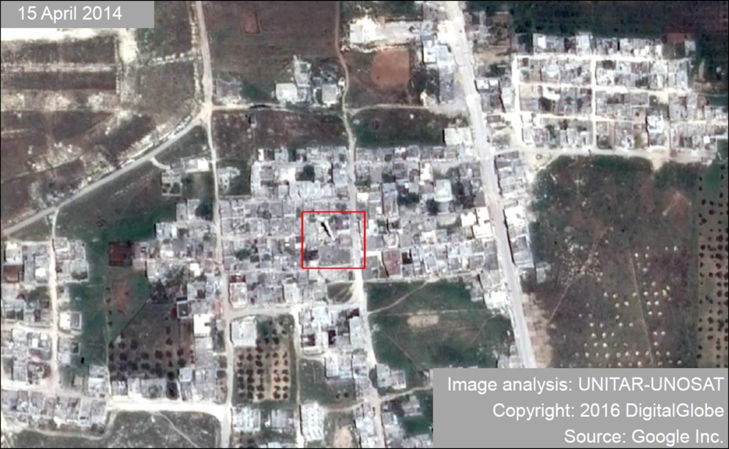
Damage assessment of Omar Ibn al-Khattab mosque, Jisr al-Shugur (Idlib)
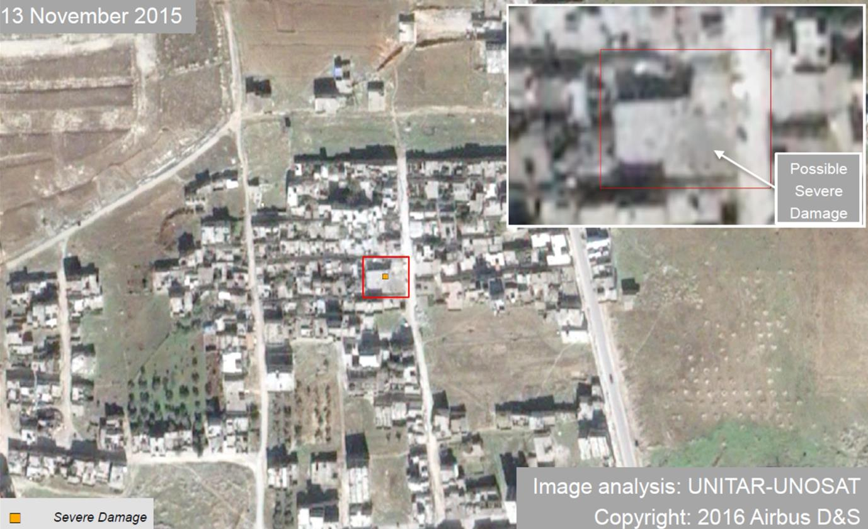
UNOSAT analysed imagery acquired on 13 November 2015 and 15 April 2014 to detect possible damage to the Omar Ibn al-Khattab mosque in Jisr al-Shugur, Idlib. Using satellite imagery based change detection analysis, UNOSAT identified possible severe damage to the main mosque building and probable damage to the mosque minaret.
Annex III
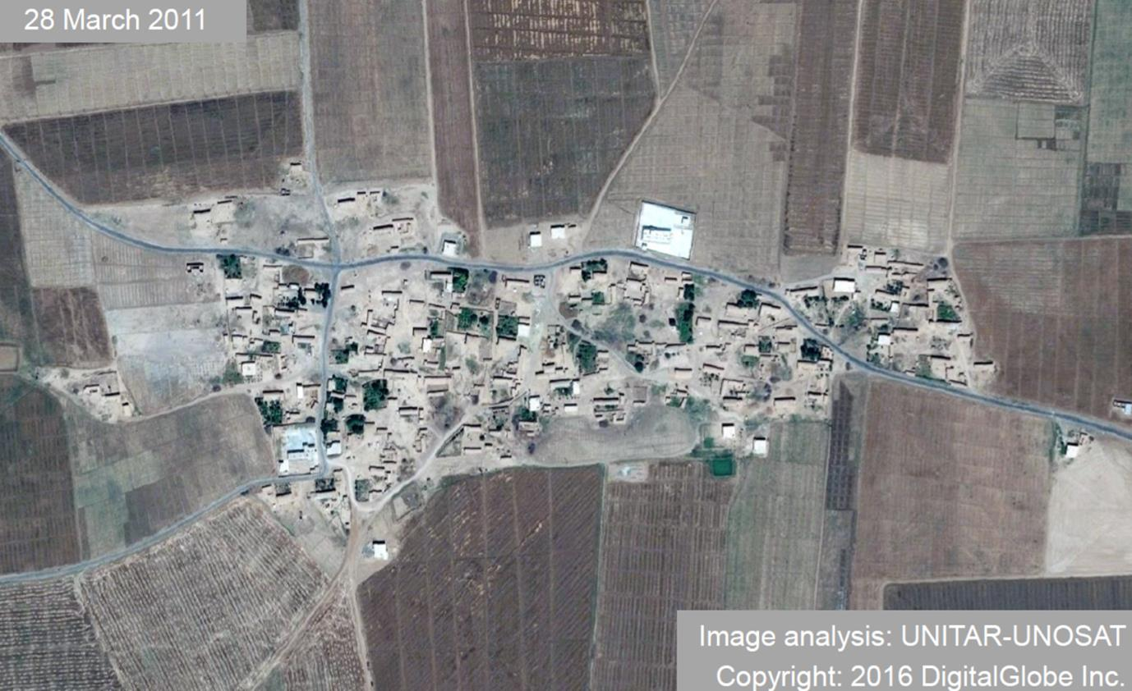
Damage assessment of Husseiniya (Hasakah)
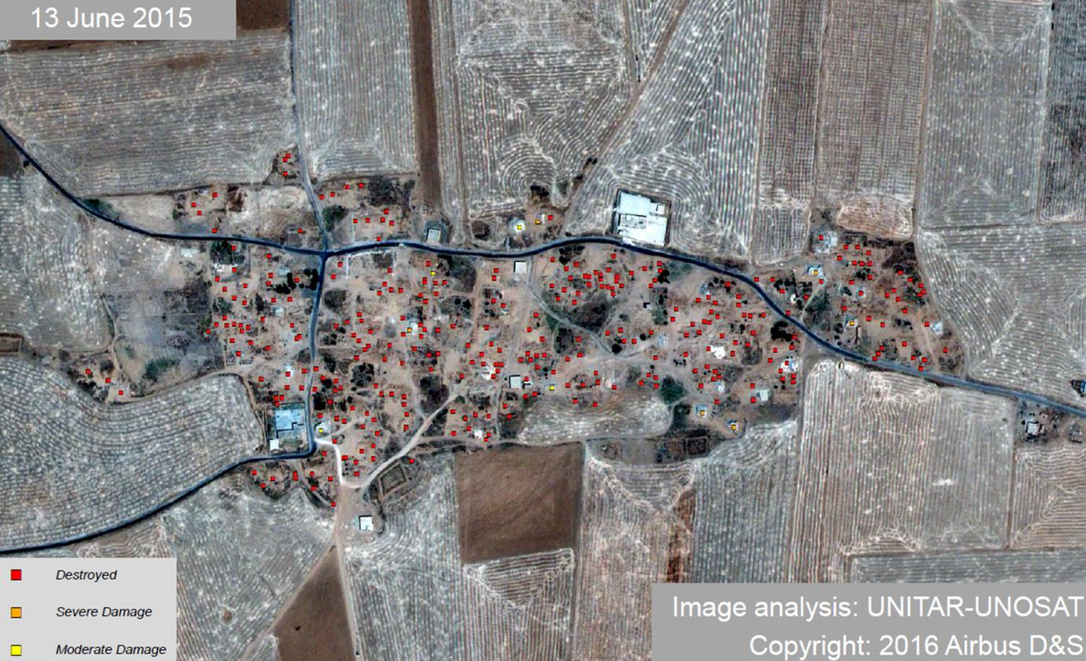

UNOSAT analysed imagery acquired on 28 March 2011 and 13 June 2015 to detect changes in Al Husseiniyah village in Tel Hamis countryside, Hasakah. UNOSAT identified that a majority of the previously visible buildings had been destroyed or razed. A total of 319 buildings were destroyed or razed.
Annex IV
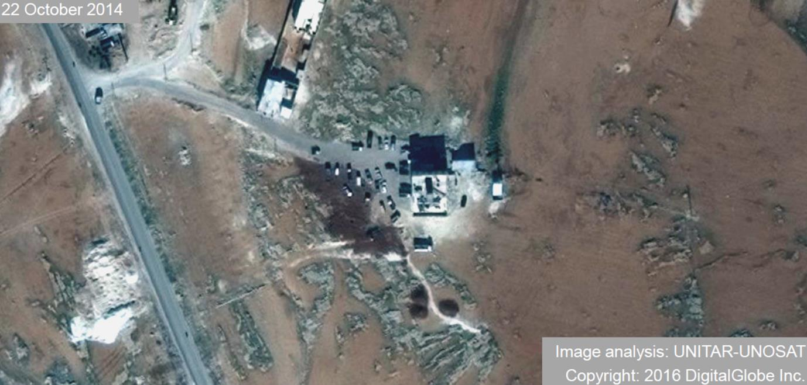
Damage assessment of Al-Eis field hospital (Aleppo)
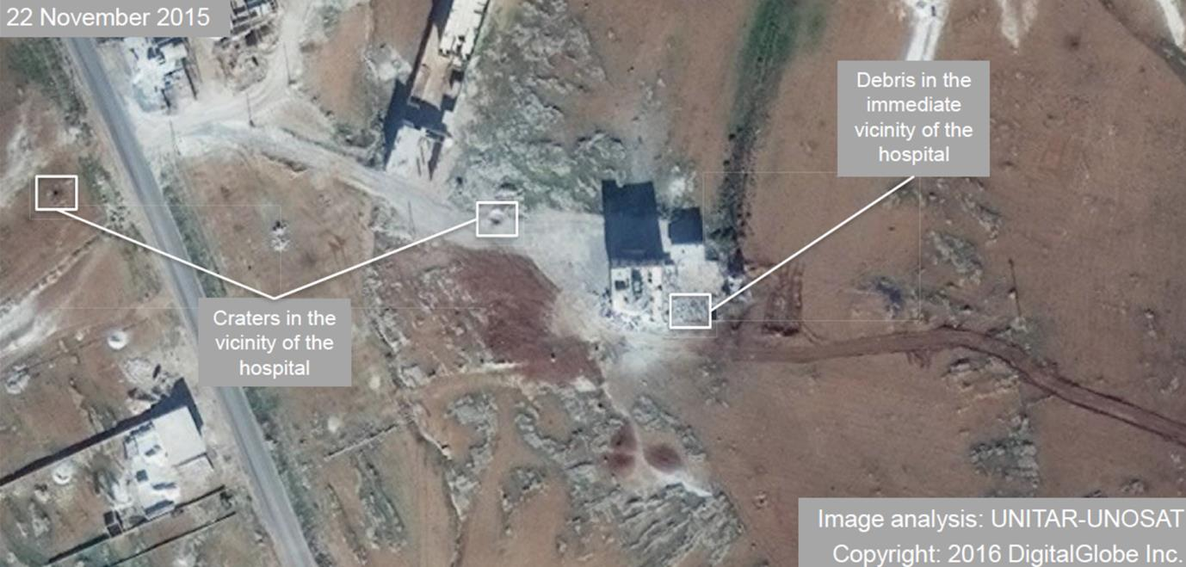
UNOSAT analysed imagery acquired on 22 November2015 and 22 October 2014 to detect changes at the Makeshift Hospital in Jabal al-Eis,Syria. Using satellite imagery based change detection analysis, UNOSAT assess the building as being moderately damaged.

Annex V
Damage assessment of Palmyra ruins (Homs)
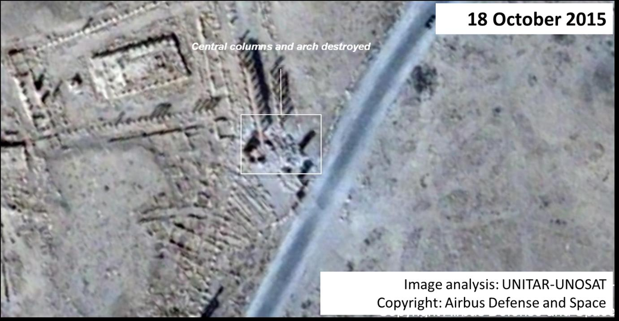
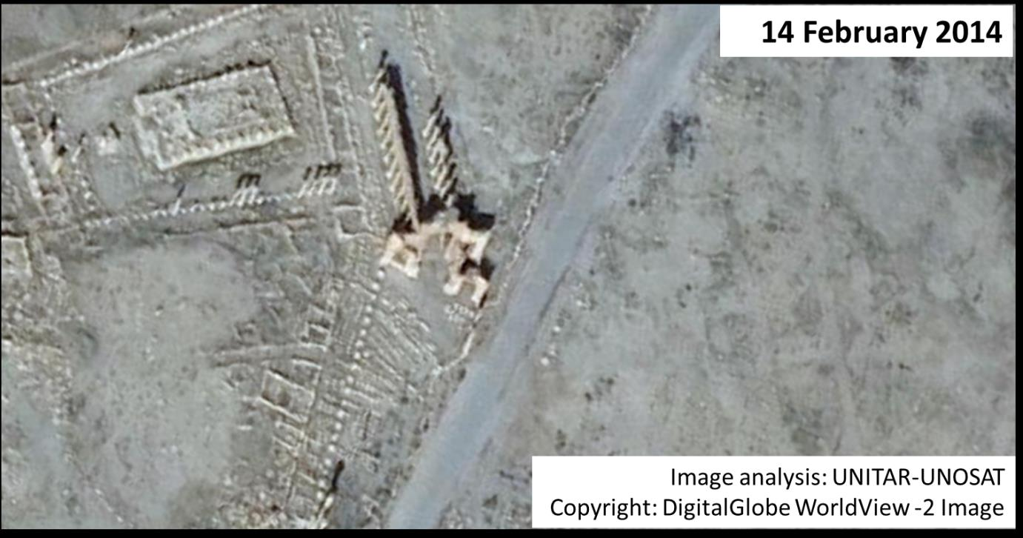
Annex VI
Security Council resolutions on the Syrian Arab Republic
Resolution | Date of adoption | Theme
2042 (2012) | 14 April 2012 | Authorizes an advanced team to monitor ceasefire implementation in the Syrian Arab Republic
2043 (2012) | 21 April 2012 | Establishes the United Nations Supervision Mission in the Syrian Arab Republic (UNSMIS)
2059 (2012) | 20 July 2012 | Renews the mandate of the United Nations Supervision Mission in the Syrian Arab Republic (UNSMIS) for 30 days
2118 (2013) | 27 September 2013 | Establishes the framework for the elimination of Syrian chemical weapons
2139 (2014) | 22 February 2014 | Urges access to humanitarian aid and calls parties to facilitate delivery of aid and lifting of sieges in populated areas
2165 (2014) | 14 July 2014 | Authorizes, for 180 days, cross-border relief delivery and the expeditious deployment of a monitoring mechanism to ensure compliance
2170 (2014) | 15 August 2014 | Condemns widespread human rights violations by extremist groups in Iraq and the Syrian Arab Republic
2178 (2014) | 24 September 2014 | Condemns violent extremism and underlines the role of states in preventing travel and funding to terrorist fighters
2199 (2015) | 12 February 2015 | Condemns trade with groups associated with Al-Qaida
2209 (2015) | 6 March 2015 | Condemns use of chemical weapons (chlorine) in the Syrian Arab Republic
2235 (2015) | 7 August 2015 | Establishes a mechanism to identify perpetrators using chemical weapons in the Syrian Arab Republic
2249 (2015) | 20 November 2015 | Condemns ISIS terrorist attacks and requires member states to take all necessary measures to prevent terrorist acts on ISIS-controlled territory
2253 (2015) | 17 December 2015 | Expands sanctions framework to include Islamic State in Iraq and Levant, including suppressing financing to this group
2254 (2015) | 18 December 2015 | Endorses a road map for peace in the Syrian Arab Republic
2258 (2015) | 22 December 2015 | Renews authorization for passage of humanitarian aid until January 2017

Annex VII
Map of the Syrian Arab Republic
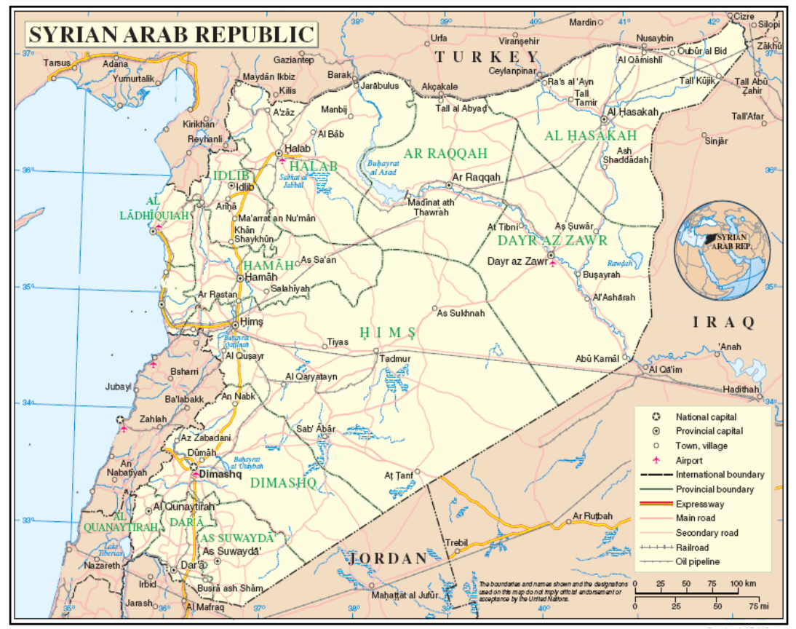
_________________

* * The annexes to the present report are circulated as received.
The commissioners are Paulo Sérgio Pinheiro (Chairperson), Karen Koning AbuZayd, Vitit Muntarbhorn and Carla Del Ponte.
The States represented included the United States of America, the Russian Federation, China, France, Turkey, Iran (Islamic Republic of), Saudi Arabia, the United Kingdom of Great Britain and Northern Ireland, Germany, Iraq, Italy, Egypt, Jordan, Lebanon, Oman, Qatar, the United Arab Emirates. The talks were also attended by representatives of the European Union and the United Nations.
The proliferation of warring parties has also challenged the identification of those responsible for particular attacks. “Pro-government forces” denotes Syrian and Russian forces conducting aerial attacks. “Government forces” denotes attacks launched by the Government of the Syrian Arab Republic alone. The “coalition led by the United States” refers to a group of 11 States currently launching air strikes on areas of the Syrian Arab Republic controlled by ISIS.
UNICEF, “Millions of children in Syria at high risk of disease amid water scarcity and summer heat”, news note, 10 July 2015.

