**Check against delivery**

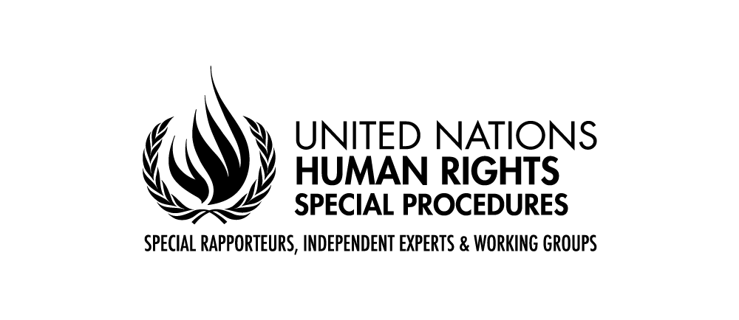

**STATEMENT BY MS. ANAÏS MARIN**

**SPECIAL RAPPORTEUR ON THE SITUATION OF HUMAN RIGHTS IN BELARUS**

**Agenda item 4: Human rights situations that require the Council’s attention**

**56th session of the Human Rights Council**

**3 July 2024**

**Geneva**

Mr. President, Excellencies, Distinguished Delegates, Ladies and Gentlemen,

This is my last address to the Council in my capacity as Special Rapporteur on human rights in Belarus. In addition to the usual annual overview of developments, the report I am presenting today draws your attention to freedom of association.

Over the reporting period, the situation with *every single human right* continued to deteriorate. The concerns and recommendations stemming from the negative trends that I alerted you about in previous years remain topical, whether regarding the administration of justice, the misuse of security laws to restrict human rights, or the fact that this pushes people to flee their own country.

Mr President,

I am sorry to say that I have no improvement to report.

The authorities ignored my requests for a visit. They did not use the opportunity to share input or comments on the report. Legislative changes meant to further restrict the enjoyment of human rights were adopted that also illustrate an attempt at legalizing *post hoc* the persecution of anyone trying to exert these rights. The first part of the report lists these provisions, stressing their incompatibility with Belarus’ international obligations.

The general trend I observe is a further tightening of the screws against any real or perceived opposition to the acting government, and the systematic persecution of anyone who dares expressing dissenting views about its policies. Belarus entered a new electoral cycle, sending no signal that the next presidential election will be held differently than before. Hence, I believe that the Council was right to renew my mandate. Excellencies, the situation of human rights in Belarus will continue to require your attention.

Let me share my concerns about three of the most worrying recent trends.

Firstly, I received multiple reports of cruel and ill treatment in detention, especially of persons deprived of liberty on political motives. According to human rights defenders, there are now 1409 political prisoners in Belarus. New searches, arbitrary detentions and seizure of property occur on a daily basis, increasingly targeting relativesof those in prison or in exile. Those behind bars suffer from discrimination, restrictions on communication with their families and lawyers, disciplinary sanctions solitary confinement and incommunicado detentions – in some cases for such long periods that they could amount to enforced disappearances. Additional prison terms are regularly handed out, for alleged “malicious disobedience” to the penitentiary administration.

Denial of adequate and timely medical care is reportedly systematic and deliberate against political prisoners. This is particularly concerning since it apparently led to several deaths in prison. While calling for the release and rehabilitation of all those arbitrarily detained, I encourage the President of Belarus to act on his yesterday’s promise and immediately pardon ill persons imprisoned because of their involvement in the 2020 events.

Secondly, dissidents compelled to exile continue to face harassment, being labelled as traitors or extremists, and prosecuted *in* *absentia* for alleged crimes, in what appears to me rather as a revengeon the part of the government. These exilees have no fair trial guarantees.

Since September 2023, allBelarusians living abroad have seen several of their human rights impacted by the fact that consulates stopped issuing passports and powers of attorney. In the long run, those who for any reason cannot return to Belarus are at risk of statelessness.

Thirdly, I deplore the continuous impunity for past human rights violations, although some of those committed since 2020 may amount to crimes against humanity, according to reports submitted in the frame of the accountability mechanism established by this Council in 2021.

In fact, recent legislative changes illustrate an effort at preventively exonerating from accountability some categories of State officials previously identified as perpetrators of human rights violations: the security forces, which have recently been granted the right to fire indiscriminately at protesters; and the President, who received lifelong immunity.

This should prompt the international community to support all efforts to enable or establish courts with universal jurisdiction to adjudicate the gravest violations committed in the country, such as crimes of torture and deportation. As we all know, it is not only our moral duty, this is the only guarantee of non-reoccurrence.

Distinguished delegates,

Turning to freedom of association, I remind that without free associations, all other human rights are limited, and civic space is not free from control of the State itself. My report shows that the Government of Belarus embarked in a systematic purge of all the associations it sees as disloyal.

The first targeted were human rights defense groups, NGOs and online communities including Telegram chats; in 2022, cultural associations, independent trade unions and bar associations. In 2023, the legislation on political parties was amended, leading to the disappearance of 11 out of 15 parties, with only 4 allowed to field candidates in last February parliamentary elections. In 2024, religious associations became the next in line.

In all these cases, drastic measures were taken to suppress independent associations. The authorities ordered re-registration campaigns, restricted access to funding and retaliated against anyone making donations to independent organizations. These associations were liquidated through, or without judicial proceedings, or forced to self-dissolve. Altogether, over 1500 associations disappeared in recent years, that is almost half the number that existed prior to the 2020 events. This was achieved also by designating them as “extremist formations”, and subsequently prosecuting their leaders and members, pushing them to relocate abroad. The report details the extent of the damage incurred for civil society.

Ladies and gentlemen,

As you see, repression in Belarus has reached such a scale and intensity that it should not be considered a safe country for anyone who ever showed disagreement with the government or its policies. I therefore reiterate my call to refrain from extraditions and expulsions to Belarus. Please consider with extreme caution any request for international cooperation with the police, judiciary or tax administration of Belarus. From what I know, the authorities even misled Interpol into issuing red notices in order to capture dissidents abroad. Supporting this misuse could turn your governments into accomplices of very serious human rights violations.

On the other hand, I commend amendments to domestic regulations introduced by some States to prevent the pushback of exiled Belarusians whose passports have expired, and to issue IDs and travel documents to their children born abroad. I call on all other host countries to follow suit and generalise the issuance of permanent residence permits and “foreigners’ passports” to Belarusians compelled to remain abroad. Concerns for their safety are absolutely founded.

I deeply regret that the Government of Belarus chose not to cooperate with my mandate and mostly ignored its recommendations so far. I am calling on the authorities to review their position and establish an effective working relation with my successor, as this Council repeatedly requested in its resolutions since 2012.

Meanwhile, I encourage all stakeholders to continue supporting civil society in Belarus and abroad; to never stop protecting Belarusians’ human rights, by all possible means at their disposal, at the UN and beyond; and to help them promote their independence, culture and language. This is essential for their survival as a nation.

Thank you.