 | 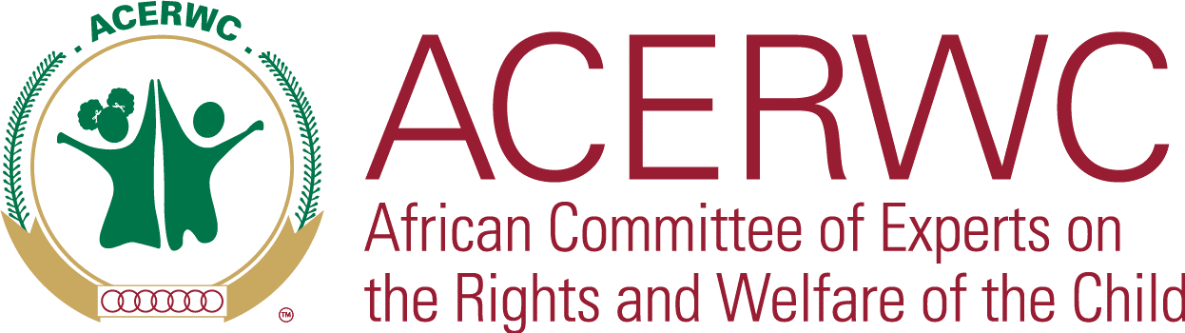

Joint statement of the United Nations Committee on the Rights of the Child and the African Committee of Experts on the Rights and Welfare of the Child on 16th June 2024 - Day of the African Child
On this 16th day of June 2024, as the United Nations Committee on the Rights of the Child and the African Committee of Experts on the Rights and Welfare of the Child, we come together to express our solidarity in the commemoration of the Day of the African Child. We underscore our deep concern about the violation of the rights of children as the world faces an escalation of multiple economic and social challenges enforced by different factors such as poverty, climate change and armed conflicts that consequently impact children’s access to quality, accessible and adaptable education. Particularly, we cannot turn a blind eye to the escalation of armed conflicts that are occurring worldwide. At a global level, children caught in armed conflict reached “extreme levels” last year, with a shocking 21% increase in violations.Within Africa, an estimated 183 million of these children to be living in conflict zones.
We are thus concerned by the increased conflicts raging across the world swallowing children into their cruel cores. Children continue to find themselves caught up in the cruel crossfires of conflict where there is great disregard for their safety and wellbeing. These ongoing conflicts are characterised by grave violations against children including killing and maiming, abduction, physical and sexual violence, attacks on schools and hospitals, forced recruitment into armed groups/forces and denial of humanitarian assistance. Other pertinent violations with an African lens include child marriages, harmful traditional practices and child labour. We are concerned that despite the disproportionate impact on children, children are often overlooked in disaster management and responses by States.
These conflicts disrupt the education of children, as schools are destroyed or repurposed by armed forces, directly underming our collective goal of ensuring quality education, as reiterated in this year’s theme of the Day of the African Child “Education for All Children in Africa: The time is now”. We reiterate the ACERWC’s Agenda for Children (Agenda 2024), specifically aspirations 6 and 9, which highlight the importance of education and the need to protect children from armed conflict. The destruction and militarization of educational spaces not only obstructs daily learning but also poses a threat to the development of children, affecting their cognitive, emotional, and social growth during the most crucial phase of their development.
In Africa, armed conflict is coupled with other crises including the devastating effects of climate change and natural disasters which result in increased displacement and/or starvation due to drought and famine and various health crises. These include the COVID-19 pandemic, Ebola, malaria and poverty. Poverty continues to prevent families and the States from providing children with their basic needs; and other socio-economic needs such as adequate housing, a high standard of healthcare and access to quality education. We stress the negative impact of these existing crises, further exacerbated by armed conflict which breaks down the rule of law that upholds the rights of children as well as the institutions needed to implement these rights. We note that these breakdowns in society set back development and progress. We deplore the unfathomable destruction of infrastructure in Khartoum, Sudan. Such destruction impedes development, causing children living in areas affected by armed conflict to be left behind, contrary to Goal 2 of the UN Sustainable Development Goals.
Displacement of children caused by war also cuts children off from receiving education and health care services, including routine health checks and vaccinations/immunizations. Malnutrition is now an urgent crisis engulfing children in Sudan, with one in three children in Zam-Zam camp acutely malnourished. We note the warning of WHO Director-General Tedros Adhanom Gehebreyesus that “malnourished children face a lifetime of developmental challenges and ill-health and are more likely to die from infectious diseases”. We also draw attention to the impact of conflict-related displacement on neighbouring communities and/or countries with already limited resources. We note that the struggle for resources between refugees and host communities poses a risk of increased conflict. The impact of this is likely to be highest on the children of both refugee and host communities as their everyday reality is shaken up by the changes brought about by armed conflict.
In our mandate to oversee that children’s rights are upheld both globally and regionally, we would like to draw attention to the important role of children in our society. As custodians of the future, it is our duty to ensure that children have the best quality of life and are shielded from the crossfires of conflict. We call upon all States Parties to the United Nations Convention on the Rights of the Child, the African Charter on the Rights and Welfare of the Child and all other Human Rights Conventions relevant to the protection of the rights of children in Armed Conflict, to uphold their obligations and ensure a minimal impact of armed conflict on children. The future peace and development of the African continent, and the well-being of our children demands ceasefires in current armed conflicts and for all stakeholders to rigorously work to prevent any future conflicts
Recalling that education is central to enhancing children’s potential, and to ensure that the gains made in enhancing education on the continent are not lost to conflict, we emphasise that it is time for education systems to be reformed and made adaptable, so that they are not rendered vulnerable to armed groups. It is time that leaders on the continent provide enhanced school security in conflict-prone regions, invest in digitalised and remote education, and take other measures to ensure that children’s education continues as much as possible despite conflict.
The building of pathways towards a peaceful future in which children can thrive cannot wait, it must start now. The road to recovery will require children affected by armed conflict to be reintegrated into communities and provided with support, as well as the possibility of access to justice and remedies for the harms they experienced. To change the determinants of war, children must play a key role in peace-building and prevention.
As we are commemorating the 2024 Day of the African Child, we call upon:
- States parties to work towards a future in which armed conflict on the continent is significantly reduced, the proliferation of arms is halted, and there is no recruitment of child soldiers.
- States parties to enforce international instruments explicitly prohibiting the recruitment and use of children as soldiers
- States parties to fully commit to the Safe Schools Declaration, thereby preventing the use of and or attacks on schools by armed forces
- International partners to support the efforts of the Governments to make the right to education a reality for all children in Africa
- State parties and regional and international partners to develop adapted education systems to cater for children already affected by armed conflict

