CHAMPIONING FOR COMMUNITY INCLUSION IN KENYA (CCI-K) SUBMISSIONS ON THE DRAFT GUIDELINES ON DE- INSTITUTIONALIZATION

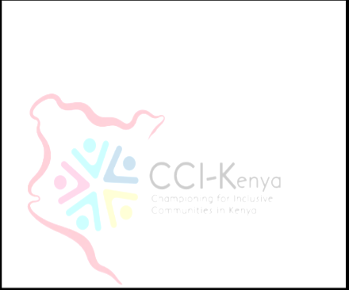Championing for Community Inclusion in Kenya (CCI-K) is a user movement of persons with lived experience in Kenya. Our main objective is to advocate for inclusions in the community in terms of access to services and opportunities on an equal basis with others. It is a national organisation that is also affiliated to Transforming for Community Inclusion (TCI) Global. As a result of the above, we held meetings with our members in order to popularize the Draft Guidelines and also get views from our members. It is our submission on the following issues:

1. On paragraph 35 of the Draft Guidelines, our submission is that there is need to include the role of the private and public media in creating awareness of the draft guidelines on deinstitutionalization. Articles 9 and 21 intersect on the issue of information and communication. Article 21 provides that States parties “shall take all appropriate measures to ensure that persons with disabilities can exercise the right to freedom of expression and opinion, including the freedom to seek, receive and impart information and ideas on an equal basis with others and through all forms of communication of their choice”. It goes on to describe in detail how the accessibility of information and communication can be ensured in practice. It requires that States parties “provide information intended for the general public to persons with disabilities in accessible formats and technologies appropriate to different kinds of disabilities” (art. 21 (a)). Furthermore, it provides for “facilitating the use of sign languages, Braille, augmentative and alternative communication, and all other accessible means, modes and formats of communication of their choice by persons with disabilities in official interactions” (art. 21 (b)). Private entities that provide services to the general public, including through the Internet, are urged to provide information and services in accessible and usable formats for persons with

disabilities (art. 21 (c)), and the mass media, including providers of information through the Internet, are encouraged to make their services accessible to persons with disabilities (art. 21 (d)). To enable effective and meaningful participation of representative organizations of persons with disabilities, the draft guidelines ought to be in accessible formats and technologies. Therefore, as highlighted above it is the duty of the State to consult and collaborate with organizations of persons with disabilities and the media to create easy to read formats of the draft guidelines and also create awareness of the same. Awareness raising should begin at the family level, the community, government institutions, private institutions etc.

1. Paragraph 46 of the Draft Guidelines calls against the improper separation of children from their parents. Our submission on this issue is that Parents should not be removed from their homes in the name of rehabilitation. This reinforces the stigma where the service can still be done in the community for instance drop-in centres. This includes serving prison sentences or staying in remand prison for long for petty offences.
2. Paragraph 49 of the Draft Guidelines calls upon state parties to develop and ensure access of support services in the community. Our submission is that early identification and a proper data management system will aid for proper planning on the support needs of children with disability.
3. The Draft Guidelines on paragraph 53 calls on State Parties to ensure that the right to legal capacity is guaranteed in order to ensure de- deinstitutionalization is successful. On this aspect, our submission is that peer support is a way to ‘help advance a view of autonomy and decision- making’. Peer support is also classified as an alternative to the conventional medical practice since it is empowering and removes the power imbalances that have been created by the conventional practice. Peer support has many

benefits and has been described as ‘a pure form of supported decision- making’;

* + an important tool during ‘emergency decision-making moments
  + an ‘integral part of recovery-based services
  + a source of valuable information about an extensive range of issues enabling persons with disabilities to make informed decisions.

The core principles embedded in peer support work are outlined in Article 3 of the CRPD which stipulates the letter and spirit of the Convention on the Rights of Persons with Disabilities key among this

* + Respect for inherent dignity, individual autonomy including the freedom to make one’s own choices, and independence of persons
  + Non-discrimination
  + Full and effective participation and inclusion in society
  + Respect for difference and acceptance of persons with disabilities as part of human diversity and humanity

1. The right to live independently as provided for under paragraph 54 should be provided by easy-to-read materials. In addition, our submission is that persons with psychosocial disability are often charged with petty offences like trespass or loitering. Due to lack of support services in the criminal justice system, petty offenders may remain in the penal institutions for a long time when compared to other offenders. Some of the discriminatory laws should be done away with. Alternative Dispute Resolution (ADR) mechanisms should replace the mainstream justice system where necessary.

It is our hope that our views will be take into consideration when the final guidelines are released.